Online Resource Table S1 Summary of a net sweeping surveys in selected rice paddy fields ¹⁾
Location  (Region, City, Prefecture) | Year | No. of fields | % of Stenotus rubrovittatus | Total | S. rubrovittatus | Trigonotylus caelestialium | Stenodema calcarata | Adelphocoris lineolatus | Rhopalus maculatus | Cletus punctiger | Leptocorisa chinensis | Eysarcoris aenus
Otomo, Rikuzentakata,  Iwate | 2019²⁾ | 9 | 82.5 | 268 | 221 | 0 | 12 | 0 | 0 | 0 | 33 | 2
 | 2020 | 10 | 46.7 | 15 | 7 | 1 | 2 | 0 | 0 | 0 | 3 | 2
Semine, Kurihara,  Miyagi | 2016 | 2 | 96.3 | 54 | 52 | 1 | 0 | 0 | 0 | 1 | 0 | 0
 | 2017 | 2 | 98.0 | 149 | 146 | 2 | 1 | 0 | 0 | 0 | 0 | 0
 | 2018 | 3 | 78.4 | 97 | 76 | 19 | 1 | 0 | 0 | 0 | 0 | 1
1) A net sweeping survey was conducted weekly from mid-July to early September in the Maesawa and Semine regions. We set two transects about 10m long beside a point of 10 meters from the corner of the paddy field and swept 20 times for each transect (i.e. total 40 sweeps) using a 36 cm of diameter sweeping net with 90cm long handle, which is a standard protocol recommended by Japanese law to investigate the abundance of rice pest
2) In the Otomo region, we did not conduct a net sweeping survey in 2018, however, three net sweeping surveys were conducted in nine rice paddy fields during early August to early September in 2019 to get reference data

Online Resource Table S2 Summary of One-way Multivariate Analysis of covariance model that examined the effects of the area of land uses (source habitat, soybean, and rice paddy) within a 300m radius, regions examined, and research years on the arcsine transformed pecky rice damage

 | SS | Df | F | P
Source habitat | 21.44 | 1 | 16.86 | < 0.001 ***
Soybean300 | 8.518 | 1 | 6.70 | 0.011 *
Rice paddy | 0.806 | 1 | 0.63 | 0.429
Region | 0.091 | 1 | 0.07 | 0.789
Year | 27.283 | 5 | 4.29 | 0.002 **
Source habitat * Region | 0.878 | 1 | 0.69 | 0.409
Soybean * Region | - | 0 | - | -
Rice paddy * Region | 0.026 | 1 | 0.0207 | 0.886
Source habitat * Year | 15.214 | 5 | 2.3931 | 0.047 *
Soybean * Year | 0.212 | 3 | 0.0555 | 0.983
Rice paddy * Year | 0.56 | 5 | 0.0882 | 0.994
Residuals | 81.375 | 64
*: < 0.05, **: < 0.01, ***: <0.001. Values without * are not significant
Bold characters indicate significant variables

Online Resource Fig. S1 Percentage of the area of (a) source habitat, (b) soybean field and (c) rice parry within a 300m radius at each region and year. The data are represented as box plots with median values as thick lines and mean values as diamonds, showing the 25th and 75th percentiles. Whiskers extend to the most extreme data point that is no more than 1.5 times the interquartile range from the box. Outliers are shown as open circles
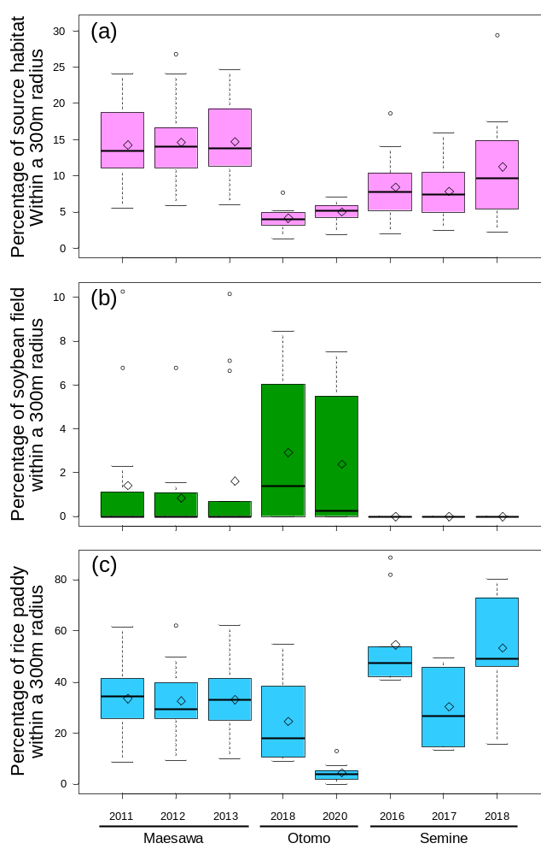
Online Resource Fig. S2 Relationship between field perimeter (m) and the area of field margin
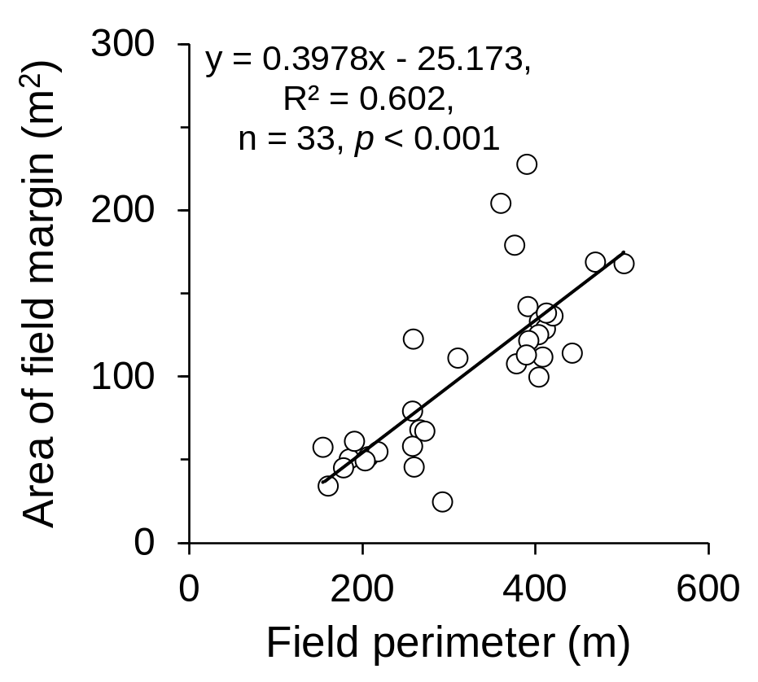
Online Resource Fig. S3 The area of rice fields examined (a) and the fields investigated land use in each region (b). The data are represented as box plots with median values as thick lines and mean values as diamonds, showing the 25th and 75th percentiles. Whiskers extend to the most extreme data point that is no more than 1.5 times the interquartile range from the box. Outliers are shown as open circles. Different letters above the box indicate significant differences (p < 0.001) by one-way ANOVA with Tukey-Kramer HSD test.
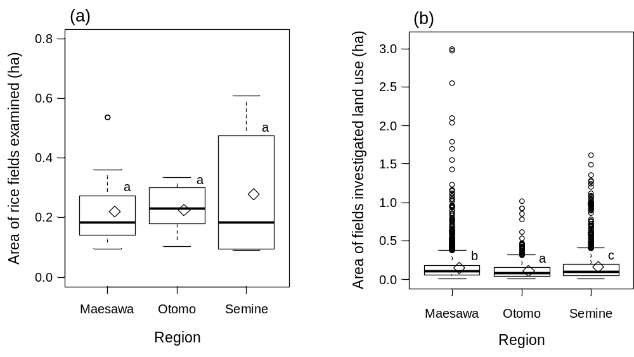
Online Resource Fig. S4 Percentage of hull-cracked rice grains at each region and year. The data are represented as box plots with median values as thick lines and mean values as diamonds, showing the 25th and 75th percentiles. Whiskers extend to the most extreme data point that is no more than 1.5 times the interquartile range from the box. Outliers are shown as open circles
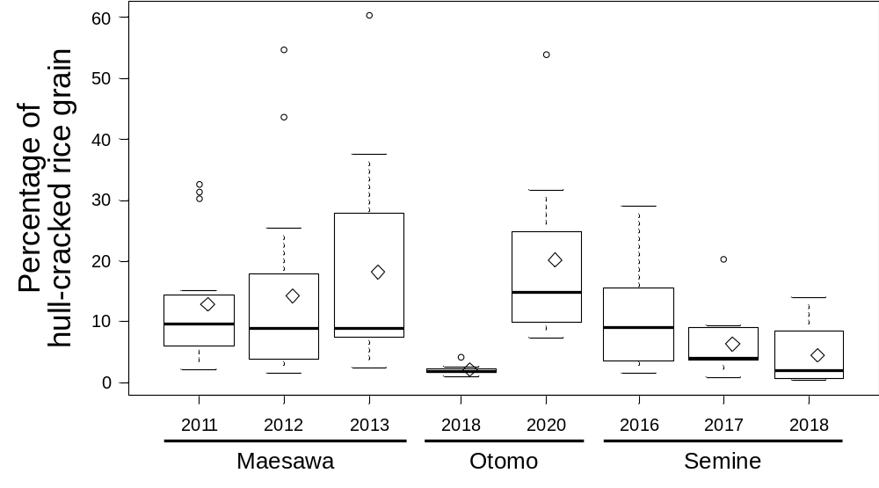
Online Resource Fig. S5 Arcsine transformed percentage of pecky rice damage at each region and year. The data are represented as box plots with median values as thick lines and mean values as diamonds, showing the 25th and 75th percentiles. Whiskers extend to the most extreme data point that is no more than 1.5 times the interquartile range from the box. Outliers are shown as circles

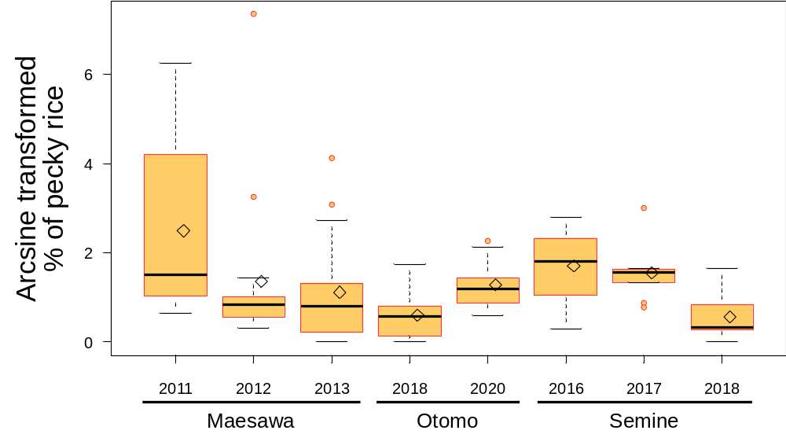
Online Resource Fig. S6 Map of the priority area map of potential pecky rice damage of the highest risk (upper) and the lowest risk (bottom) case with grid layer of 300-m hexagons. Shapes in the figure indicate the studied rice paddy fields. Regions: (1) Maesawa, (2) Otomo, and (3) Semine
