Online Resource Table S1 Summary of net sweeping surveys conducted in selected rice paddy fieldsª
Location  (Region, City, Prefecture) | Year | No. of fields | Stenotus rubrovittatus  (%) | Total | S. rubrovittatus | Trigonotylus caelestialium | Stenodema calcarata | Adelphocoris lineolatus | Rhopalus maculatus | Cletus punctiger | Leptocorisa chinensis | Eysarcoris aenus
Otomo, Rikuzentakata,  Iwate | 2019^{b} | 9 | 82.5 | 268 | 221 | 0 | 12 | 0 | 0 | 0 | 33 | 2
 | 2020 | 10 | 46.7 | 15 | 7 | 1 | 2 | 0 | 0 | 0 | 3 | 2
Semine, Kurihara,  Miyagi | 2016 | 2 | 96.3 | 54 | 52 | 1 | 0 | 0 | 0 | 1 | 0 | 0
 | 2017 | 2 | 98.0 | 149 | 146 | 2 | 1 | 0 | 0 | 0 | 0 | 0
 | 2018 | 3 | 78.4 | 97 | 76 | 19 | 1 | 0 | 0 | 0 | 0 | 1
ª A net sweeping survey was conducted weekly from mid-July to early September in the Maesawa and Semine regions. We established two transects about 10 m long beside a point 10 m from the corner of the paddy field and swept 20 times for each transect (i.e. 40 sweeps in total) using a 36-cm-diameter sweeping net with 90 cm long handle, which is a standard protocol recommended by Japanese law to investigate the abundance of rice pests
^{b} In the Otomo region, we did not conduct a net sweeping survey in 2018. However, three net sweeping surveys were conducted in nine rice paddy fields during early August to early September in 2019 to obtain reference data

Online Resource Table S2 Summary of one-way multivariate analysis of covariance model that examined the effects of the area of land uses (source habitat, soybean, and rice paddy) within a 300-m radius, regions examined, and research years on arcsine-transformed pecky rice damage
 | SS | df | F | P
Source habitat | 21.44 | 1 | 16.86 | <0.001 ***
Soybean300 | 8.518 | 1 | 6.70 | 0.011 *
Rice paddy | 0.806 | 1 | 0.63 | 0.429
Region | 0.091 | 1 | 0.07 | 0.789
Year | 27.283 | 5 | 4.29 | 0.002 **
Source habitat * Region | 0.878 | 1 | 0.69 | 0.409
Soybean * Region | – | 0 | – | –
Rice paddy * Region | 0.026 | 1 | 0.0207 | 0.886
Source habitat * Year | 15.214 | 5 | 2.3931 | 0.047 *
Soybean * Year | 0.212 | 3 | 0.0555 | 0.983
Rice paddy * Year | 0.56 | 5 | 0.0882 | 0.994
Residuals | 81.375 | 64
* p < 0.05, ** p < 0.01, *** p < 0.001. Values without an asterisk are not significant
Values highlighted in bold are significant variables

Online Resource Fig. S1 Percentage of the area of (a) source habitat, (b) soybean field, and (c) rice paddy within a 300 m radius at each region and in each research year. The data are presented as box plots with median values indicated by thick lines, mean values by diamonds, and the box indicates the 25th and 75th percentiles. Whiskers extend to the most extreme data point that is no more than 1.5 times the interquartile range from the box. Outliers are shown as open circles
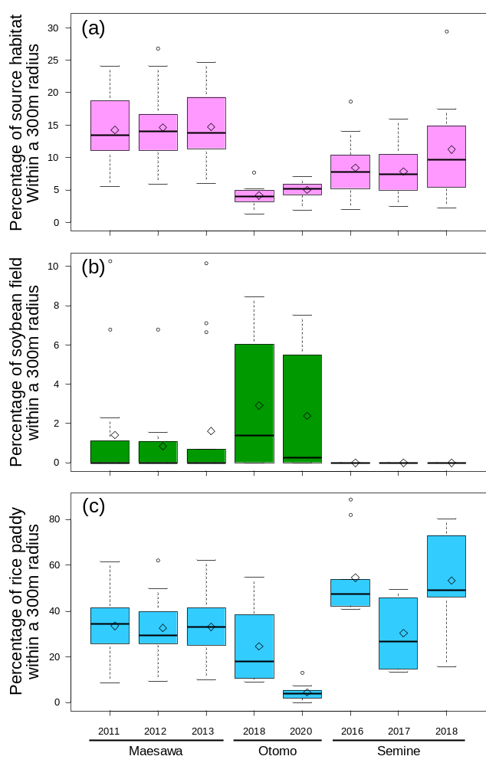
Online Resource Fig. S2 Relationship between field perimeter (m) and the area of the field margin
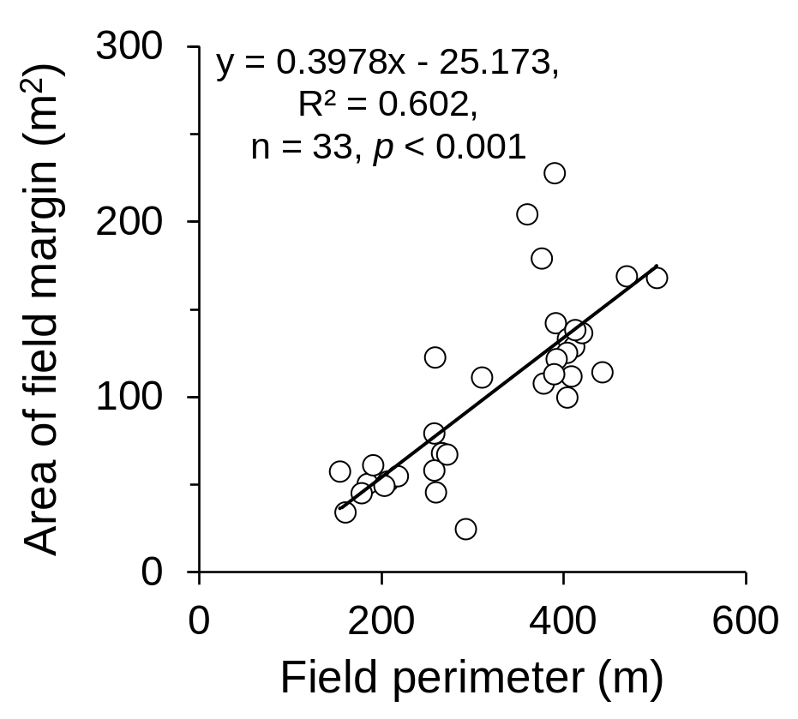
Online Resource Fig. S3 Area of the rice fields examined (a) and land use in the fields investigated in each region (b). The data are presented as box plots with median values indicated by thick lines, mean values by diamonds, and the box indicates the 25th and 75th percentiles. Whiskers extend to the most extreme data point that is no more than 1.5 times the interquartile range from the box. Outliers are shown as open circles. Different letters above the boxes indicate significant differences (p < 0.001; one-way ANOVA and Tukey–Kramer HSD test)
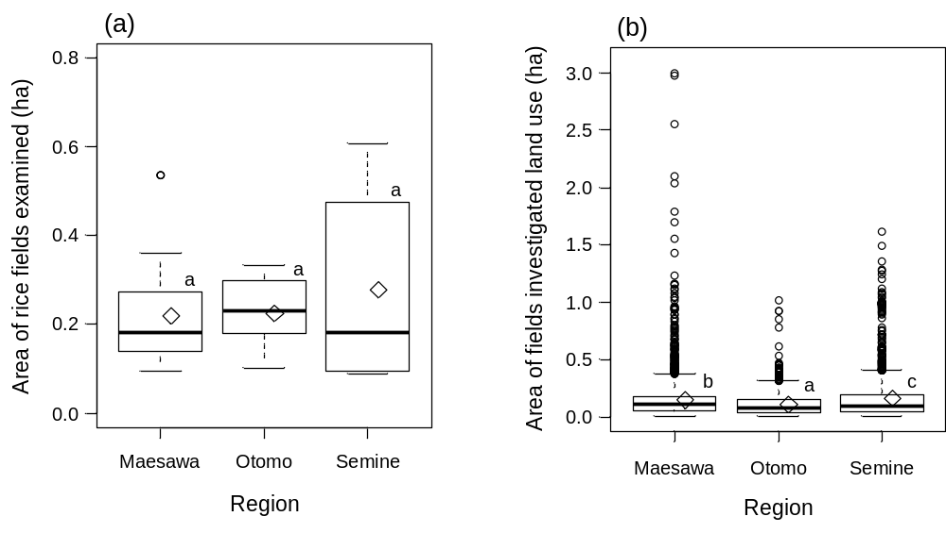
Online Resource Fig. S4 Percentage of hull-cracked rice grains in each region and research year. The data are presented as box plots with median values indicated by thick lines, mean values by diamonds, and the box indicates the 25th and 75th percentiles. Whiskers extend to the most extreme data point that is no more than 1.5 times the interquartile range from the box. Outliers are shown as open circles
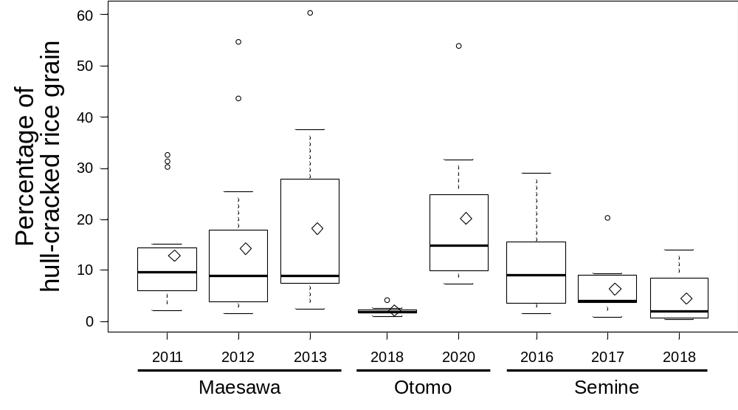
Online Resource Fig. S5 Arcsine-transformed percentage pecky rice damage in each region and research year. The data are presented as box plots with median values indicated by thick lines, mean values by diamonds, and the box indicates the 25th and 75th percentiles. Whiskers extend to the most extreme data point that is no more than 1.5 times the interquartile range from the box. Outliers are shown as circles

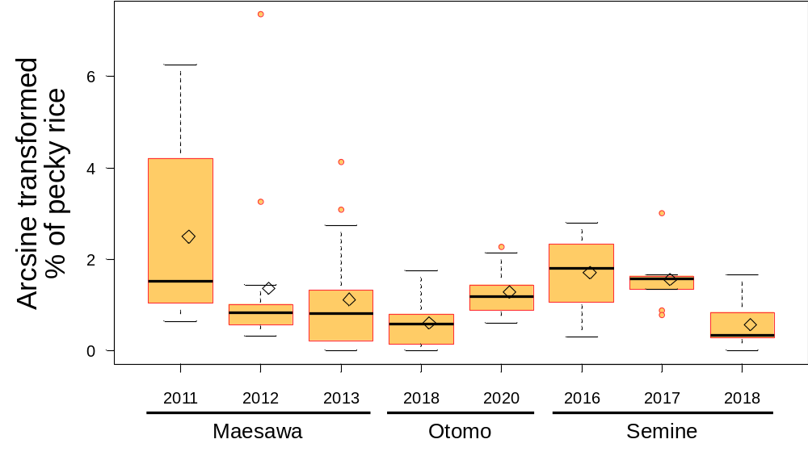
Online Resource Fig. S6 Map of the priority area for potential pecky rice damage of the highest-risk (upper) and the lowest-risk (bottom) cases with a grid layer of 300-m hexagons. Shapes in the figure indicate the studied rice paddy fields. Regions: (1) Maesawa, (2) Otomo, and (3) Semine
