Supplementary Materials

Supplementary Table 1. Association Between Baseline Characteristics and Missingness of 3- and 6-Month Follow-Up Outcomes
 | 1–3 month |  | 3–6 month
Variable | OR (95%CI) | p | OR (95%CI) | p
(Intercept) | 13.74 (1.7-110.75) | 0.014 | 49.88 (9.02-275.75) | ＜0.001
Age | 0.79 (0.73-0.87) | ＜0.001 | 0.78 (0.72-0.83) | ＜0.001
Illness Duration | 0.64 (0.43-0.96) | 0.032 | 0.7 (0.5-0.97) | 0.035
AIS | 1 (0.94-1.05) | 0.906 | 1 (0.95-1.04) | 0.938
HAMD-a | 0.98 (0.91-1.05) | 0.515 | 1.04 (0.98-1.1) | 0.207
HAMA-a | 1.04 (0.99-1.1) | 0.127 | 1 (0.95-1.04) | 0.875
Gender (Reference: Male)
Female | 1.26 (0.67-2.38) | 0.468 | 1.12 (0.69-1.82) | 0.654
Medication Use (Reference: Yes)
No | 0.78 (0.39-1.53) | 0.465 | 0.82 (0.48-1.43) | 0.490
Episode Status (Reference: First Episode)
Recurrent episode | 2.81 (1.49-5.31) | 0.001 | 1.76 (1.05-2.93) | 0.031
Lifetime Suicide Attempt (Reference: No)
1-2 times | 1.09 (0.62-1.91) | 0.763 | 0.97 (0.61-1.55) | 0.913
≥3 times | 0.41 (0.17-0.97) | 0.044 | 0.44 (0.23-0.85) | 0.015
Note. AIS: Athens Insomnia Scale; HAMD-a and HAMA-a denote adjusted totals with sleep-related items removed (HAMD items 4–6; HAMA item 4). Bold text is used to indicate statistically significant results.

Supplementary Table 2. Cox models for 6-month risk of suicide attempt（Daytime Functioning and Nocturnal Symptoms）
Variable | HR (95% CI) | p
AIS-Nocturnal | 1.06 (0.99-1.13) | 0.11
AIS-Daytime | 1.09 (0.94-1.25) | 0.251
Age | 0.92 (0.84-1) | 0.064
HAMD-a | 1.09 (1.02-1.17) | 0.019
HAMA-a | 0.97 (0.91-1.03) | 0.282
Medication Use (Reference: Yes)
No | 0.67 (0.31-1.44) | 0.311
Episode Status (Reference: First Episode)
Recurrent episode | 1.14 (0.65-2.01) | 0.648
Illness Duration (Reference: < 6 months)
6 – 24 months | 0.49 (0.28-0.85) | 0.013
> 24 months | 0.32 (0.14-0.75) | 0.021
Gender (Reference: Male)
Female | 1.67 (0.85-3.28) | 0.14
Suicide History (Reference: No)
Yes | 2.1 (1.21-3.67) | 0.015
Note. Hazard ratios (HRs) with 95% confidence intervals (CIs) were estimated using Cox models. The primary analyses were based on multiple imputation (m = 5 datasets) to account for missing data, while complete case analyses were conducted as sensitivity analyses. P-values are derived from Wald tests. AIS: Athens Insomnia Scale; HAMD-a and HAMA-a denote adjusted totals with sleep-related items removed (HAMD items 4–6; HAMA item 4). Bold text is used to indicate statistically significant results.

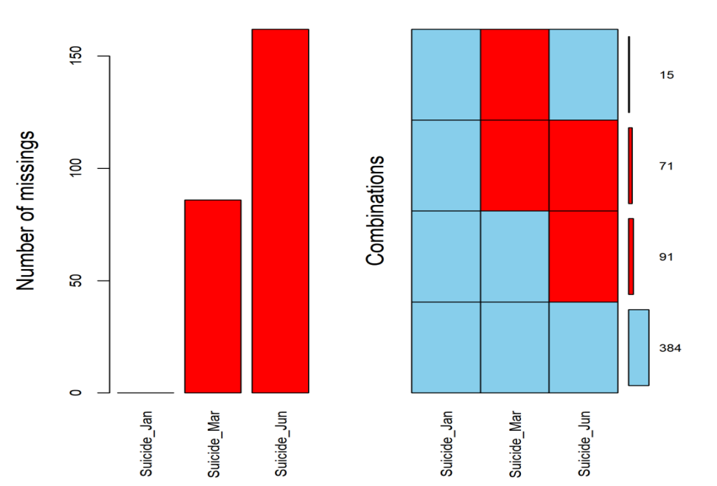
Supplementary Fig 1. Missing data patterns for suicide attempt assessments at 1-, 3-, and 6-month follow-ups. The plot shows the pattern of missing values for suicide attempt variables at each follow–up time point. Numbers above the bars indicate the count of observed values for each variable. The x-axis represents the three follow-up assessments, and the aggregation bars show combinations of missingness across these time points. This visualization was generated using the aggr() function from the VIM R package and informs the subsequent multiple imputation process.

