Supplementary information

Ruling out COVID-19 by chest CT at emergency admission when prevalence is low -
the prospective, observational SCOUT study
Ulf Teichgräber¹, Amer Malouh¹, Maja Ingwersen¹, Rotraud Neumann¹, Marina Reljic², Stefanie Deinhardt-Emmer³, Bettina Löffler³, Wilhelm Behringe⁴, Jan-Christoph Lewejohann⁴, Andreas Stallmach², Philipp Reuken²

¹Departments of Radiology, Friedrich-Schiller-University, Jena University Hospital, Am Klinikum 1, 07747 Jena, Germany
²Department of Internal Medicine, Friedrich-Schiller-University, Jena University Hospital, Am Klinikum 1, 07747 Jena, Germany.
³Department of Medical Microbiology, Friedrich-Schiller-University, Jena University Hospital, Am Klinikum 1, 07747 Jena, Germany.
⁴Department of Emergency Friedrich-Schiller-University, Jena University Hospital, Am Klinikum 1, 07747 Jena, Germany.

Methods
Measures of accuracy
Sensitivity represented the proportion of participants with COVID-19 who were correctly identified by chest CT (true positive rate), and specificity the proportion of participants without COVID-19 who were correctly identified by chest CT (true negative rate). Positive likelihood ratio (LR+) was defined as sensitivity/(1-specifity) and negative likelihood ratio (LR-) as (1-sensitivity)/specificity. LR+ denotes how much more likely a positive diagnosis was among COVID-19 participants than it was among those without COVID-19. Reversely, LR- denotes how much more likely a negative diagnosis was among participants in whom COVID-19 was absent than it was among COVID-19 participants. Posterior probability of present/overcome COVID-19 in case of positive chest CT result (positive predictive value [PPV]) and, reversely, absent COVID-19 in case of a negative chest CT diagnosis (negative predictive value [NPV]) were derived from likelihood ratios and prevalence (pre-test probability) [1].

References standard
For identification of SARS-CoV-2 from respiratory specimen, we extracted nucleic acids by using an automated EZ1-system (Qiagen, Hilden, Germany). The isolated and purified RNA was used for RT-PCR to determine the E-gene. For this purpose, TIB MOLBIOL RT-PCR (Berlin, Germany) was applied on a LightCycler 480 Roche system (Roche Diagnostics, Mannheim, Germany) with a specificity of 100% and a sensitivity of 5.2 copies/reaction (95% CI, 3.7 -9.6) [2].
Specific IgG and IgM antibodies were detected in participant’s serum by applying an enzyme-linked immunosorbent assay. We used the EDI™ Novel Coronavirus COVID-19 ELISA Kit (Epitope diagnostics Inc., San Diego, CA, USA) with a sensitivity of 100% and a specificity of 88% [3].
Assessors of RT-PCR and antibody (AB) tests were blinded to clinical information and chest CT results.

Table S1 COVID-19 pneumonia imaging classification

COVID-19 pneumonia imaging classification | CT Findings | Rationale
Typical appearance | - Peripheral, bilateral, GGO with or without consolidation or visible intralobular lines (“crazy-paving”)  - Multifocal GGO of rounded morphology with or without consolidation or visible intralobular lines (“crazy-paving”)  - Reverse halo sign or other findings of organizing pneumonia (seen later in the disease) | Commonly reported imaging features of greater specificity for COVID-19 pneumonia.
Nonspecific appearance | Absence of typical features  AND presence of:  - Multifocal, diffuse, perihilar, or unilateral GGO with or without consolidation lacking a specific distribution and are non-rounded or non-peripheral.  - Few very small GGO with a non-rounded and non-peripheral distribution | Nonspecific imaging features of COVID-19 pneumonia.
Atypical appearance | Absence of typical or nonspecific features AND presence of:  - Isolated lobar or segmental consolidation without GGO  - Discrete small nodules (centrilobular, “tree- in-bud”)  - Lung cavitation  - Smooth interlobular septal thickening with pleural effusion | Uncommonly or not reported features of COVID-19 pneumonia.
Negative for pneumonia | No CT features to suggest pneumonia. | No features of pneumonia
COVID-19, corona virus disease 2019; GGO, ground glass opacity.
Adapted from Simpson 2020 [4]

Table S2. Location and Time of Specimen Collection in Participants with Negative RT-PCR but Positive AB and/or Positive CT

RT-PCR negative and  CT and/or AB positive participants |  | 1. RT-PCR |  | 2. RT-PCR
 |  | Days from symptom onset | Specimen | Days from symptom onset | Specimen
CT positive  AB positive | Male, 70 years | 1 day | Nasopharyngeal | NA | NA
 | Male, 81 years | 1 day | Nasopharyngeal  Induced sputum | 2 days | Bronchoalveolar
 | Male, 82 years | 14 days | Nasopharyngeal | 19 days | Nasopharyngeal
 | Male, 86 years | 20 days | Nasopharyngeal | 21 days | Nasopharyngeal
 | Male, 85 years | 7 days | Nasopharyngeal | NA | NA
 | Male 48 years | 7 days | Nasopharyngeal  Induced sputum | 8 days | Nasopharyngeal
CT negative  AB positive | Male 60 years | 21 days | Nasopharyngeal | NA | NA
 | Female 83 years | Same day | Nasopharyngeal | NA | NA
CT positive  AB negative | Male 58 years | 6 days | Nasopharyngeal | NA | Nasopharyngeal
 | Female 86 years | 2 days | Nasopharyngeal | 4 days | Nasopharyngeal  Induced sputum
 | Male 70 years | 3 days | Nasopharyngeal  Induced sputum | NA | NA
 | Female 76 years | 1 day | Lower respiratory tract aspirate | 2 days | Lower respiratory tract aspirate
 | Male 72 years | 2-3 days | Lower respiratory tract aspirate | 3-4 days | Lower respiratory tract aspirate
 | Male 60 years | 5 days | Lower respiratory tract aspirate | 6 days | Lower respiratory tract aspirate
 | Female 91 years | 10 days | Lower respiratory tract aspirate | 11 days | Lower respiratory tract aspirate
 | Female 86 years | 12 days | Nasopharyngeal  Induced sputum | 13 days | Nasopharyngeal
AB, antibody test; NA, not available; CT, computed tomography; RT-PCR, reverse transcription polymerase chain reaction test

Table S3. Characteristics of participants diagnosed COVID-19 positive by means of chest CT and/or RT-PCR and/or AB-test

Positive diagnostic test | Participant | Chest CT findings | Symptom onset before admission | Contact and/or association to cluster | Fever ª  (≥ 37.5 C°) | Respiratory symptoms | Gastro-  intestinal symptoms | General  symptoms | Oxygen satu-ration
CT, RT-PCR, AB | Male, 61 years  Congestive heart failure | GGO, CP, UP,  peri-bronchial | 3 days | Yes | No | Dyspnea, ambient breathing noise, foaming sputum, cough | No | Weakness, headache | 98%
 | Female, 76 years | GGO, CP, UP, FS, SL,  peripheral and central | A few weeks | 14 days before admission | No | Cough | No | Slightly reduced general condition | 96%
 | Male, 76 years  Congestive heart failure | GGO, UP, FS, peripheral and central | 10 days | Yes | No | Dyspnea, cough | No | No | 92%
CT, RT-PCR | Female, 65 years, AB NA | GGO, peripheral and central | 3 days | Yes | Yes | Dyspnea, ambient breathing noise, purulent sputum | Diarrhea | Weakness, cough, dizziness | 88%
 | Male, 69 years, AB NA | GGO, UP, FS, SL, peripheral | No symptoms | Referral from another hospital | No | No | No | No | 96%
CT, AB | Male, 70 years | FS, peripheral and central | 1 day | No | Yes | No | No | Weakness, headache, dizziness | 96%
 | Male, 81 years  Congestive heart failure | GGO, UP, FS, SL, peripheral and central | 1 day | No | No | Attenuated breathing noise | No | Weakness, cough, headache, dizziness | 92%
(Continues)

Table S3 (Continued) Characteristics of participants diagnosed COVID-19 positive by means of chest CT and/or RT-PCR and/or AB-test

Positive diagnostic test | Participant | Chest CT findings | Symptom onset before admission | Contact and/or association to cluster | Fever ª  (≥ 37.5 C°) | Respiratory symptoms | Gastro-  intestinal symptoms | General  symptoms | Oxygen satu-ration
 | Male, 82 years  Congestive heart failure | GGO, UP, FS,  peripheral and central | 14 days | No | No | Dyspnea, ambient breathing noise | No | Weakness, arthralgia | 91%
 | Male, 86 years  Congestive heart failure | GGO, UP, N, peripheral | 20 days | No | Yes | Ambient breathing noise, rhinorrhea, | No | Weakness, dizziness | 97%
 | Male, 85 years | GGO, TB, UP, peripheral and central | 7 days | No | No | Dyspnea, Ambient breathing noise, tympanic resonance | No | Weakness, dizziness, arthralgia | 84%
 | Male, 48 years | GGO, TB, peripheral | 7 days | No | No | Sore throat | Diarrhea | No | 98%
AB | Male, 60 years | Pulmonary emphysema, pericardial effusion | 21 days | No | No | Dyspnea, cough | No | Weakness, dizziness | NA
 | Female, 83 years | FS, peripheral and central | Same day | No | Yes | No | No | Weakness | 100%
CT  (false positive) | Male, 58 years, AB NA | GGO, CP, UP, SL, peripheral and central | 6 days | No | No | Sore throat, cough | No | Weakness | 97%
 | Female, 86 years, AB NA  Congestive heart failure, exacerbating COPD | GGO, CP, UP, N, peripheral | 2 days | No | Yes | Dyspnea, cough, ambient breathing noise, tympanic resonance, purulent sputum | No | Weakness, dizziness | 97%
(Continues)

Table S3 (Continued) Characteristics of participants diagnosed COVID-19 positive by means of chest CT and/or RT-PCR and/or AB-test

Positive diagnostic test | Participant | Chest CT findings | Symptom onset before admission | Contact and/or association to cluster | Fever ª  (≥ 37.5 C°) | Respiratory symptoms | Gastro  -intestinal symptoms | General  symptoms | Oxygen satu-ration
 | Male, 70 years, AB neg  Congestive heart failure | GGO, peripheral and central | 3 days | No | Yes | No | No | Weakness, dizziness | 95%
 | Female, 76 years, AB neg  Congestive heart failure | GGO, UP, peripheral and central | 1 day | No | No | Dyspnea, cough, sore throat | NA | Weakness, dizziness | 92%
 | Male, 72 years, AB neg | GGO, UP, peripheral and central | 2-3 days | No | Yes | No | Vomiting | Weakness, dizziness | 95%
 | Male, 60 years, AB neg  Metastatic colorectal  cancer, pericarditis | GGO, UP, N, peripheral and central | 5 days | No | No | Dyspnea, cough, attenuated breathing noise, foaming sputum | No | Weakness, dizziness | NA
 | Female, 91 years, AB NA  Exacerbated COPD,  tuberculosis, asbestosis,  pleuritis, congestive heart failure | GGO, CP, UP, FS, SL, peripheral and central | 10 days | No | No | Dyspnea, foaming sputum | NA | Weakness, arthralgia | NA
(Continues)

Table S3 (Continued) Characteristics of participants diagnosed COVID-19 positive by means of chest CT and/or RT-PCR and/or AB-test

Positive diagnostic test | Participant | Chest CT findings | Symptom onset before admission | Contact and/or association to cluster | Fever ª  (≥ 37.5 C°) | Respiratory symptoms | Gastro-  intestinal symptoms | General  symptoms | Oxygen satu-ration
 | Male, 60 years, AB neg  Metastatic colorectal  cancer, pericarditis | GGO, UP, N, peripheral and central | 5 days | No | No | Dyspnea, cough, attenuated breathing noise, foaming sputum | No | Weakness, dizziness | 94%
 | Female, 91 years, AB NA  Exacerbated COPD,  tuberculosis, asbestosis,  pleuritis, congestive heart failure | GGO, CP, UP, FS, SL, peripheral and central | 10 days | No | No | Dyspnea, foaming sputum | NA | Weakness, arthralgia | 89%
 | Female, 86 years, AB neg  Congestive heart failure,  pericarditis | GGO, UP, SL, peripheral | 12 days | No | No | Dyspnea, ambient breathing noise | No | No | 93%
AB, antibody test; COPD, chronic pulmonary obstructive disease; CP, crazy paving; CT, low-dose chest computed tomography; FS, fibrous strips; GGO, ground-glass-opacity; NA, not available; N, nodules; RT-PCR, reverse transcription polymerase chain reaction test; SL, subpleural lines; UP, unspecific patterns.
ª tympanic or forehead temperature.

Table S4. Laboratory findings of participants diagnosed COVID-19 positive by means of chest CT and/or RT-PCR and/or AB-test

Positive diagnostic test | Participant | Leucocyte count, x 10⁹ per L | Lymphocyte count, x 10⁹ per L | C-reactive protein, mg/L | Procalci-tonin, ng/mL | D-dimers, mg/L | Fibrino-gen, g/L | hs-cTnI,  pg/mL | NT-proBNP, pg/mL | Serum Ferritin, μg/L
CT, PCR, AB | Male, 61 years  Congestive heart failure | 14.2 | NA | 8.7 | 0.1 | 88 | 5.4 | 2.9 | NA | 302
 | Female, 76 years | 5.9 | 0.8 | 4.9 | NA | NA | 2.8 | NA | NA | NA
 | Male, 76 years  Congestive heart failure | 7.4 | 1.5 | 126 | 0.1 | 497 | 5.7 | 7.1 | NA | 266
CT, PCR | Female, 65 years, AB NA | 10.4 | 0.7 | 254 | 0.1 | 310 | 6.4 | 6.7 | NA | 1315
 | Male, 69 years,  AB NA | 6.3 | 2.2 | 19 | NA | NA | NA | NA | NA | NA
CT, AB | Male, 70 years | 18.2 | 3.6 | 172 | 1.6 | 878 | 5.4 | 9.0 | NA | 172
 | Male, 81 years  Congestive heart failure | 14.4 | NA | 228 | 1.9 | NA | NA | NA | NA | NA
 | Male, 82 years  Congestive heart failure | 38.8 | NA | 2.0 | NA | 778 | 2.3 | 12.3 | 709 | NA
 | Male, 86 years  Congestive heart failure | 22.5 | 1.3 | 146 | NA | NA | NA | NA | NA | NA
(Continues)

Table S4. (Continued) Laboratory findings of participants diagnosed COVID-19 positive by means of chest CT and/or RT-PCR and/or AB-test

Positive diagnostic test | Participant | Leucocyte count, x 10⁹ per L | Lymphocyte count, x 10⁹ per L | C-reactive protein, mg/L | Procalci-tonin, ng/mL | D-dimers, mg/L | Fibrino-gen, g/L | hs-cTnI,  pg/mL | NT-proBNP, pg/mL | Serum Ferritin, μg/L
 | Male, 85 years | 11.3 | 1.6 | 137 | 0.1 | NA | NA | 23.6 | 317 | 114
 | Male, 48 years | 9.6 | 0.7 | 74 | NA | NA | NA | NA | NA | NA
AB | Male, 60 years | 11.6 | 1.4 | 21 | 0.1 | NA | NA | 79.0 | 35 | NA
 | Female, 83 years | 3.6 | NA | 12 | NA | NA | NA | NA | 79 | 1527
CT  (false positive) | Male, 58 years,  AB NA | 5.9 | 1.6 | 14 | 1.1 | 609 | 5.0 | 999 | NA | 47
 | Female, 86 years, AB NA  Congestive heart failure,  exacerbating COPD | 6.7 | 1.2 | 33 | 0.1 | 133 | 2.8 | 5.1 | NA | 135
 | Male, 70 years,  AB neg  Congestive heart failure | 13.3 | 0.6 | 39 | 0.2 | 195 | 4.0 | 21.5 | NA | 154
CT  (false positive) | Female, 76 years, AB neg  Congestive heart failure | 11.0 | NA | 2.1 | 0.1 | NA | NA | 9.2 | 374 | NA
 | Male, 72 years,  AB neg | 9.5 | NA | 22 | NA | 4481 | NA | 32.1 | NA | NA
(Continues)
Table S4. (Continued) Laboratory findings of participants diagnosed COVID-19 positive by means of chest CT and/or RT-PCR and/or AB-test

Positive diagnostic test | Participant | Leucocyte count, x 10⁹ per L | Lymphocyte count, x 10⁹ per L | C-reactive protein, mg/L | Procalci-tonin, ng/mL | D-dimers, mg/L | Fibrino-gen, g/L | hs-cTnI,  pg/mL | NT-proBNP, pg/mL | Serum Ferritin, μg/L
 | Male, 60 years,  AB neg  Metastatic colorectal  cancer, pericarditis | 3.3 | NA | 96 | 0.7 | NA | NA | NA | 496 | 1488
 | Female, 91 years, AB NA  Exacerbated COPD,  tuberculosis, asbestosis, pleuritis,  congestive heart failure | 7.9 | NA | 24 | NA | NA | 3.9 | NA | NA | NA
 | Female, 86 years, AB neg  congestive heart failure, pericarditis | 5.4 | 1.0 | 54 | 0.5 | 433 | 3.6 | 34.6 | NA | 4
AB = antibody test; COPD = chronic pulmonary obstructive disease; CT = low-dose chest computed tomography; hs-cTnI = high-sensitivity cardiac troponin I; NA = not available; RT-PCR = reverse transcription polymerase chain reaction test.

Fig. S1 In-hospital patient flow chart including number of participants. Ellipses indicate number of participants with regard to conducted index/reference standard tests (yellow), results (white), and proportion of participants with false negative results (determined by positive antibody test from 3 weeks after symptom onset) (black). COVID-19, coronavirus disease 2019; CT, low-dose chest computed tomography; RT-PCR, reverse transcription polymerase chain reaction

Fig. S2 Receiver operating curves and areas under curves showing performance of chest CT for detection of COVID-19. a and c Receiver operating curve (ROC) and area under curve (AUC [95% CI) are given for the reference standard of RT-PCR alone, and b and d for the reference standard of RT-PCR and/or AB test. a and b Curves refer to the dichotomous outcome of COVID-19-positive or -negative participants, and c and d to the four-stage COVID-19 pneumonia imaging classification of typical appearance (A), nonspecific appearance (B), atypical appearance (C), and negative (D).
AB, antibody test; CT, computed tomography; RT-PCR, reverse transcription polymerase chain reaction.

Fig. S3 Comparison of diagnostic performance of RT-PCR alone with RT-PCR complemented by chest CT. Participants were considered COVID positive if either RT-PCR or chest-CT or both were positive. a Area under receiver operating curves (AUROCs) and b contingency tables show diagnostic performance based on the reference standard of antibody test. Test characteristics are presented with 95% confidence intervals (Wald-type). AB, antibody test; COVID-19, coronavirus disease 2019; CT, low-dose chest computed tomography; LR+, positive likelihood ratio; LR-, negative likelihood ratio; RT-PCR, reverse transcription polymerase chain reaction.

Fig. S4 Areas under receiver operating curves showing distributing power of specific CT findings to detect COVID-19. a Areas under receiver operating curve (AUROC) are presented separately for patterns and b distributions of pathological signs. RT-PCR test- or, were available, AB test were considered as reference standard. CT, computed tomography, LR+, positive likelihood ratio; LR-, negative likelihood ratio

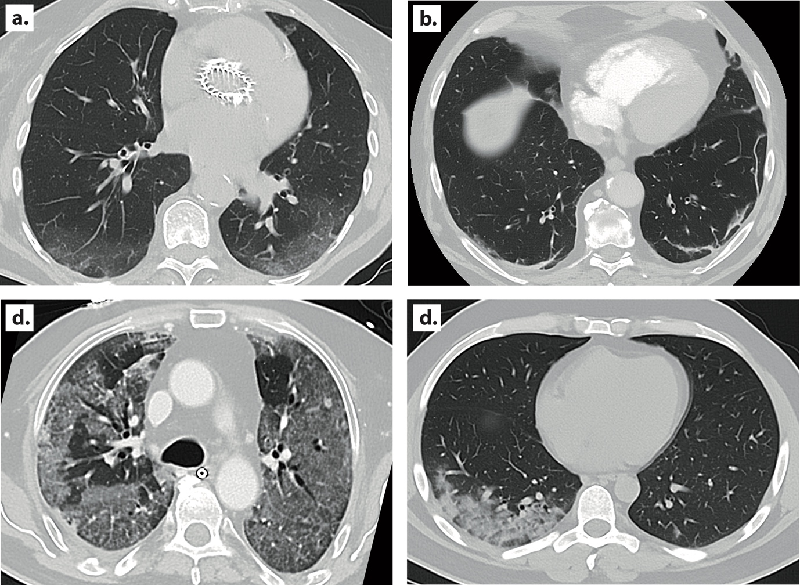

Fig. S5 Thin-section axial CT images showing lungs of four adults with COVID-19. a 88-year-old female presenting with fever 7 days after transcatheter aortic valve implantation, CT shows bilateral, peripheral, focal areas of alveolar attenuation (ground-glass opacity). b 66-year-old male presenting with acute dyspnea and cough, CT shows bilateral, peripheral fibrous strips (interlobular septal thickening). c 68-year-old male presenting with acute respiratory distress syndrome after COVID-19 pneumonia, CT shows diffuse bilateral opacities with crazy paving pattern (intralobular lines), subpleural lines, and interstitial septal thickening. d 43-year-old male presenting with dyspnea, CT shows alveolar infiltration (unspecific pattern).

References
1. Baeyens JP, Serrien B, Goossens M, Clijsen R. Questioning the "SPIN and SNOUT" rule in clinical testing. Arch Physiother 2019;9:4.

2. Corman VM, Landt O, Kaiser M, et al. Detection of 2019 novel coronavirus (2019-nCoV) by real-time RT-PCR. Euro Surveill 2020; 25(3).

3. Krüttgen A, Cornelissen CG, Dreher M, Hornef M, Imöhl M, Kleines M. Comparison of four new commercial serologic assays for determination of SARS-CoV-2 IgG. J Clin Virol 2020;128:104394.

4. Simpson S, Kay FU, Abbara S, et al. Radiological Society of North America Expert Consensus Statement on Reporting Chest CT Findings Related to COVID-19. Endorsed by the Society of Thoracic Radiology, the American College of Radiology, and RSNA - Secondary Publication. J Thorac Imaging. 2020;35(4):219-227.

