Supplementary information
Content
Methods 1
1 Biochar preparation 1
2 Field experiment 1
3 Field measurements of CH₄ flux 2
4 DNA and RNA extraction 2
Result 3
1 The Long-Term Methanogenic and Methanotrophic Activity Variation 3
2 Soil Physicochemical Divergence 3
3 Ammonia Inhibition on Methanotrophic Activity 4
Tables 4
Figures 5

Methods

1 Biochar preparation
Rice straw harvested from local paddy fields was used as the feedstock for biochar production. The straw was cut into 10 - 20 mm segments before being fed into a self-constructed automatic carbonization system. Under limited oxygen conditions, the straw was pyrolyzed at 500℃ for 2 hours (Nan et al., 2020b). After cooling to room temperature, the biochar was stored in a sealed container for later incorporation into the paddy soil. The physicochemical properties of the soil and biochar, along with the corresponding measurement methods, are provided in Tab. S1.

2 Field experiment
The experimental field was located in the Yuhang District, Hangzhou City, Zhejiang Province (N30°22′ E119°51′). The field soil was classified as a clay loam. The field was used as a conventional paddy before the experiment. The climate is a typical subtropical monsoon climate with an annual average temperature of 17.2 °C and rainfall of 1490 mm. The soil total C and N contents were 2.13 % and 0.28 %, respectively. The soil pH was 5.1, and the CEC was 8.91 cmol kg⁻¹. The soil had available nutrients including 7.3 mg P kg⁻¹ and 77.6 mg K kg⁻¹. The soil-specific surface area was 35.0 m² g⁻¹.
We designed three scenarios, RS, AL, and HS, to explore different biochar and rice straw application methods in paddy fields.
RS (Rice Straw): This scenario involves an annual application of 8 t ha⁻¹ of rice straw biomass, corresponding to the national annual rice straw output. This method represents the self-produced and self-consumed application of straw, where the straw produced from each hectare of rice cultivation is returned to the same field.
AL (Annual Low): In this scenario, the biomass from RS is converted to biochar, resulting in an annual production of 2.8 t ha⁻¹ of biochar. Both RS and AL involve the same biomass input but differ in the form of application—straw in RS and biochar in AL. This also represents a self-produced and self-consumed method, ensuring that the biomass from each hectare of rice cultivation is utilized in the same field.
HS (High Single): This scenario involves a one-time application of 22.8 t ha⁻¹ biochar, which is a popular application rate (1%). This rate equals 8 years of biochar application in the AL scenario. Therefore, to apply biochar to 1 hectare of paddy field at this rate, the biomass from 7 additional hectares is required. These 7 hectares will not have biochar applied in that year. In subsequent years, the biomass from these 7 hectares can be converted to biochar and applied to other hectares in a rotational manner. Essentially, the HS scenario distributes biochar application over time, rather than applying it all simultaneously.
Using conventional rice planting without biochar or biomass application for baseline treatment CK. In the 8-year field experiment, the experimental area and agricultural management were consistent across all treatments. Additionally, the total amount of rice straw incorporation was the same for the RS, AL, and HS scenarios.

3 Field measurements of CH₄ flux
Gas samples have been collected between 2015 and 2022. The static chamber method was used for methane monitoring. Each chamber consisted of a permanent base (55 × 55 × 12 cm), a lower frame (55 × 55 × 60 cm), and an upper frame (55 × 55 × 60 cm), accommodating nine seedlings per plot. A small fan (10 × 10 cm) in the upper cover ensured gas mixing, while a vacuum pump at the center of the cover facilitated gas sampling. The sampling was conducted at 9 o’clock in the morning according to Zheng et. al ³⁵. The gas concentrations during this period are representative of the daily average. Three replicates were collected for each sample. CH₄ fluxes were analyzed using a gas chromatograph (Shimadzu 14B, Japan). Cumulative CH₄ emissions were calculated using the area integration method of CH₄ fluxes. The emission rates (F) of CH₄ were determined through the following calculation:
$$F=ρ×\frac{V}{A}×\frac{dc}{dt}×\frac{273}{273+T}×\frac{P}{1013}$$
where, $ρ$, CH₄ density, 10.14 g cm⁻¹ at 273 K and 101.3 kPa, V, the chamber volume, L, A, enclosed surface area, m², dc/dt, change of CH₄ concentration per hour, T, the average temperature in the sampling box during sampling, P, the atmospheric pressure of the sampling point, 1013 kPa.

4 DNA and RNA extraction
Total genomic DNA was extracted from paddy soil samples using the Mag-Bind® Soil DNA Kit (Omega Bio-tek, Norcross, GA, U.S.) according to manufacturer’s instructions. Concentration and purity of extracted DNA was determined with TBS-380 and NanoDrop2000, respectively. DNA extract quality was checked on 1% agarose gel. DNA extract was fragmented to an average size of about 350 bp using Covaris M220 (Gene Company Limited, China) for paired-end library construction. Paired-end library was constructed using NEXTFLEX Rapid DNA-Seq (Bioo Scientific, Austin, TX, USA). Adapters containing the full complement of sequencing primer hybridization sites were ligated to the blunt-end of fragments. Paired-end sequencing was performed on Illumina NovaSeq (Illumina Inc., San Diego, CA, USA) at Majorbio Bio-Pharm Technology Co., Ltd. (Shanghai, China) using NovaSeq 6000 S4 Reagent Kit v1.5 (300 cycles) according to the manufacturer’s instructions (www.illumina.com).
Total RNA was isolated and purified using Soil RNA Extraction Kit (Majorbio, shanghai, China) following the manufacturer's procedure. The integrity and quantity of the extracted RNA were measured with a NanoDrop 2000 spectrophotometer (Thermo Scientific, MA, USA) and an Agilent 5300 Bioanalyzer (Agilent Technologies, Palo Alto, CA, USA). The RNA was subjected to standard Illumina library preparation with an Illumina® Stranded mRNA Prep, Ligation (Illumina, San Diego, CA, USA), and rRNA was depleted using a RiboCop rRNA Depletion Kit for Mixed Bacterial Samples (Lexogen, USA). Sequencing was performed on an Illumina Novaseq6000 sequencer (Illumina, San Diego, CA, USA) with paired-end sequencing method at Majorbio Bio-Pharm Technology Co., Ltd. (Shanghai, China).

Result

1 The Long-Term Methanogenic and Methanotrophic Activity Variation
The soil methanogenic and methanotrophic activities were measured over both long-term (12 years) and 7 years after (Fig. S1). For methanogenic activity (the source), neither the HS nor AL exerted a significant impact compared to the control (CK) after 7 years or over the 12-year period (Fig. S1a, c). These results suggest that biochar amendment, regardless of its application mode or aging status, has a negligible effect on the intrinsic CH₄ production potential of the soil.
In contrast, methanotrophic activity (the sink) exhibited distinct, time-dependent responses to biochar aging. Long-term tracking revealed that while the HS treatment initially stimulated CH₄ oxidation potential relative to CK, this enhancement was transient and attenuated over time, becoming non-significant in the later stages (Fig. S1b). However, the AL treatment sustained a robust methanotrophic potential, whose methanotrophic activity was significantly higher than those in both HS and CK treatments (Fig. S1d). Collectively, these findings indicate that CH₄ oxidation process is the key process mitigating CH₄ emission with biochar amendment.

2 Soil Physicochemical Divergence
To determine the abiotic drivers underlying the observed microbial shifts we monitored the temporal dynamics of soil physicochemical properties across treatments during the rice growing season.
Continuous fresh biochar amendment in the AL treatment maintained a significantly (p < 0.05) lower soil bulk density (0.83 g cm ⁻³) compared to CK (0.87 cm ⁻³), which indicates a sustained improvement in soil porosity and aeration structure (Fig. S2a). In contrast the soil bulk density in HS treatment rebounded to (0.95 cm ⁻³), which is significantly (p < 0.05) higher even than CK after eight years of weathering confirming that the physical benefits of biochar are transient without replenishment. Chemically the aging process significantly altered NH₄⁺ and NO₃⁻ levels. Ammonium concentrations in the HS treatment were significantly (p < 0.05) maintained at higher levels (27.7 mg kg⁻¹) compared to the AL (20.1 mg kg⁻¹) and CK (22.8 mg kg⁻¹) (Supplementary Fig. S3b). Nitrate dynamics acted as a sensitive indicator of the soil redox status where the aerated niche in AL facilitated a significantly (p < 0.05) recovery of nitrate (4.0 mg kg⁻¹, Fig. S3b) compared to HS (3.1 mg kg⁻¹). Dissolved organic carbon (DOC) dynamics underscored the influence of substrate quality on the soil chemical environment. The fresh organic inputs in RS significantly (p < 0.05) enriched the labile carbon pool, maintaining DOC concentrations above 80 mg kg⁻¹. In contrast, the DOC levels in AL and HS showed the comparable level with CK (Fig. S3d).

3 Ammonia Inhibition on Methanotrophic Activity
We conducted incubation assays across a gradient of NH₄⁺ concentrations relevant to our field conditions in 2021. Our field monitoring data indicated that NH₄⁺ levels in the HS treatment frequently exceeded 20 mg kg⁻¹, whereas the AL and control treatments generally maintained levels below 15 mg kg⁻¹ (Fig. S3a). Correspondingly, the incubation results demonstrated a distinct dose-dependent suppression of methanotrophic activity. While low NH₄⁺ concentrations supported high methane oxidation rates, concentrations exceeding 10 mg kg⁻¹ significantly (p < 0.05) inhibited activity at both 24 h and 48 h time points (Fig. S3b). This threshold aligns with the elevated ammonium levels observed in the HS plots, confirming that the accumulation of ammonium in aged biochar soils acts as a potent physicochemical stressor that functionally constrains the methane sink.

Tables
Table S1 Physicochemical properties of soil and biochar in the experiment
 | Soil | Biochar
TC（g kg⁻¹） | 49.3 | 596.9
TN（g kg⁻¹） | 2.8 | 11.7
C/N | 17.6 | 51.0
pH | 4.80 | 10.58
NH₄⁺-N（g kg⁻¹） | 1.50×10⁻³ | -
NO₃⁻-N（g kg⁻¹） | 1.13×10⁻³ | -
BET surface area（m² g⁻¹） | - | 69.6
Pore diameter（nm） | - | 6.82
Note: Soil properties were tested prior to the start of the trial. The soil pH was determined with a soil-water ratio of 1:2.5 (Dong et al., 2015), and the biochar pH was determined with a carbon-water ratio of 1:10 (Yi et al., 2020).

Figures
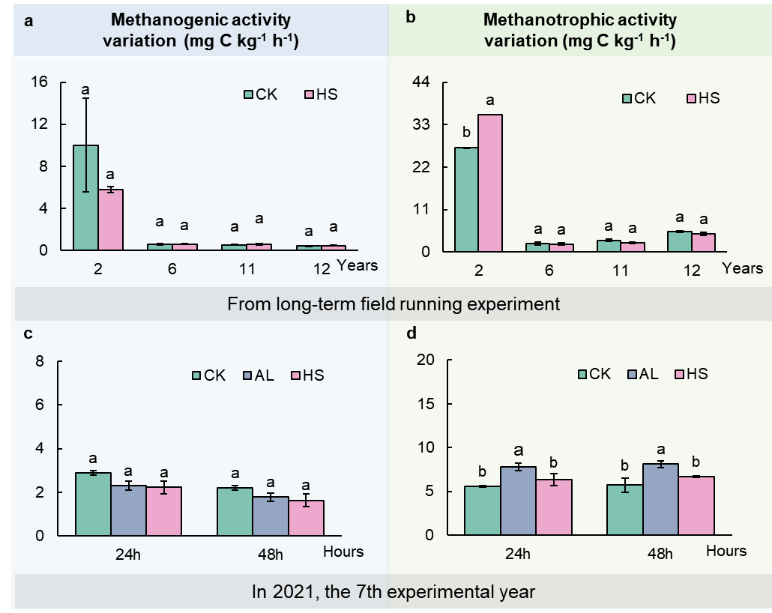
Fig. S1 | Changes in soil CH₄ metabolism relevant microbial activities under different treatments. Long-term field comparison of methanogenic activity (a) and methanotrophic activity (c) over time (2, 6, 11, and 12 years) between CK (control) and HS (high single treatment). Short-term field comparison of methanogenic activity (b) and methanotrophic activity (d) measured at 24 h and 48 h in 2021 (the 7th experimental year) among CK (control), AL (annual low-rate treatment), and HS (high single treatment). Lowercase letters above bars indicate statistically significant differences among treatments within each year (Tukey’s HSD test, p < 0.05; n=3).

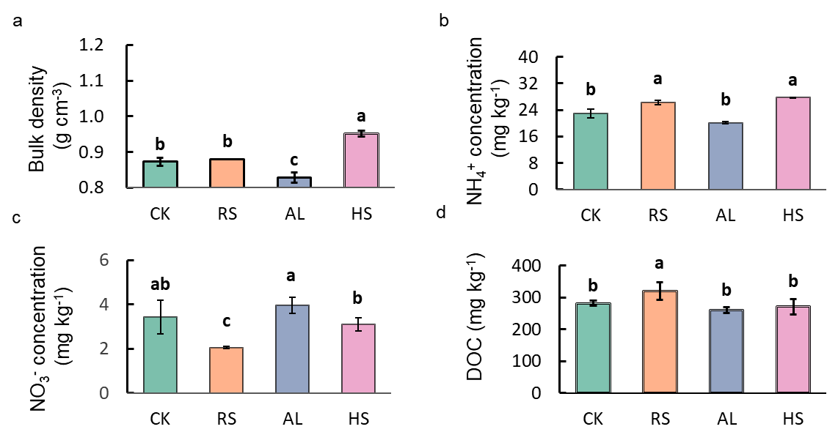
Fig. S2 | Differential effects of biochar and straw amendments on soil nitrogen availability, acidity, moisture, and dissolved organic carbon. Soil samples collected on four dates (20 July, 2 August, 23 August, and 17 September) in 2022 were analyzed for NO₃⁻, NH₄⁺, pH, and moisture content. Separately, soil bulk density and dissolved organic carbon (DOC) were determined using samples collected on 22 August 2022. Lowercase letters above bars indicate statistically significant differences among treatments within each year (Tukey’s HSD test, p < 0.05; n=3).

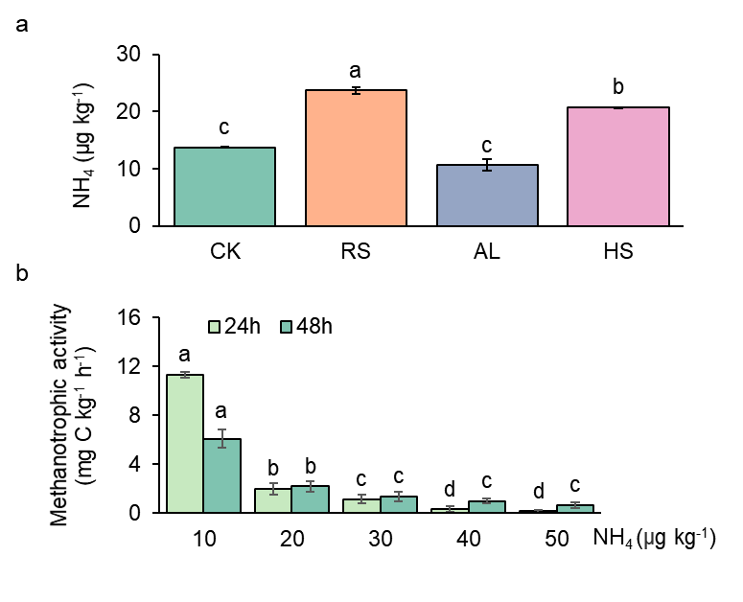
Fig. S3 | The effect of soil ammonium on methanotrophic activity. a, Soil ammonium nitrogen (NH₄⁺content under different treatments in 2021. Different lowercase letters indicate significant differences among treatments (p < 0.05). Different lowercase letters indicate significant differences among treatments (p < 0.05). b, Response of soil methanotrophic activity to a gradient of ammonium nitrogen concentration (10–50 µg NH₄⁺-N kg⁻¹), measured at 24 h and 48 h of incubation. Different lowercase letters indicate significant differences among ammonium concentrations within the same measurement time (Tukey’s HSD test, p < 0.05). Data are presented as mean ± SE.
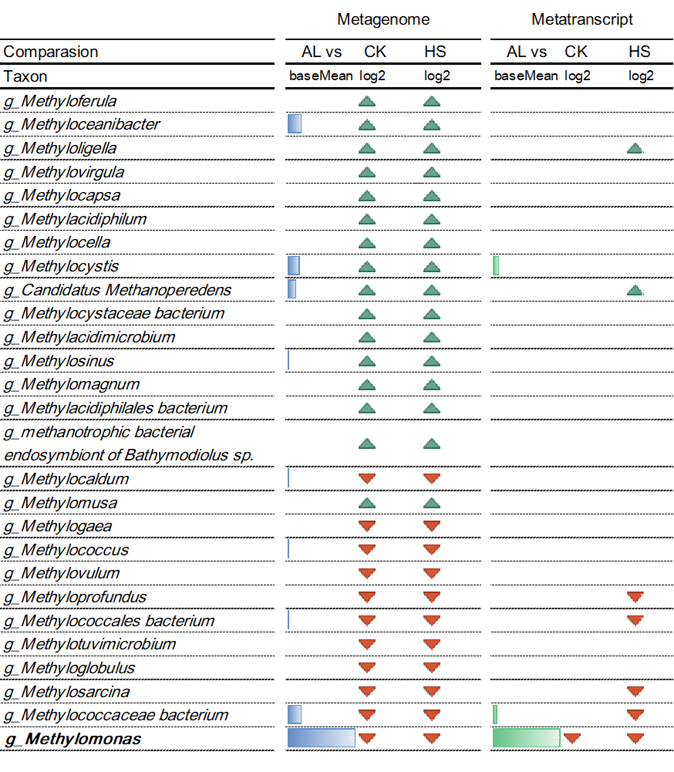
Fig. S4 | Taxon-specific decoupling between genomic potential and transcriptional activity in the methanotrophic community under contrasting biochar amendments. The contig-based taxonomic abundance profiles were generated using the SqueezeMeta pipeline. Contigs were classified based on the consensus taxonomy of their encoded genes, and their abundances were summarized to generate directly comparable metagenomic (reflecting potential presence) and metatranscriptomic (reflecting in situ metabolic activity) profiles at an identical taxonomic resolution. The table summarizes differentially abundant methanotrophic genera (taxon) in response to biochar amendments, based on DESeq2 analysis. Comparisons are made between the annual low-dose biochar application (AL) and the control (CK), as well as between AL and the high single-dose application (HS). For each genus, the bar length represents its relative population abundance (metagenome) or its aggregate transcriptional activity (metatranscriptome). Compared to CK and HS, a green upward arrow denotes a significant increase, and a red downward arrow denotes a significant decrease (FDR-adjusted p < 0.05) in AL treatments.
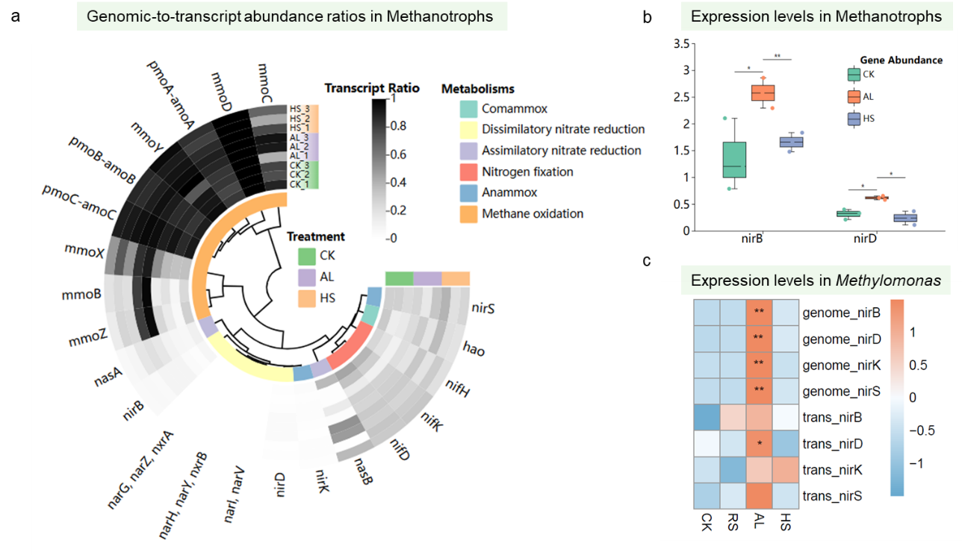
Fig. S5 | Contrasting transcriptional regulation in methanotrophic communities. a, Circular heatmap displaying the genomic-to-transcript abundance ratio for key methanotrophic functional genes across treatments. From inner to outer rings: treatment groups (Control, CK; Annual-low biochar, AL; Single-high biochar, HS). b, Box plots showing the expression levels of the nirB and nirD genes, encoding nitrite reductase subunits, within the total methanotrophic community. Different letters indicate significant differences among treatments (p < 0.05, Kruskal-Wallis test with Dunn’s post hoc; n=3). c, Heatmap of gene expression (Z-score) in the genus Methylomonas for a subset of core methanotrophic and denitrification genes. Rows are genes, columns are samples grouped by treatment.

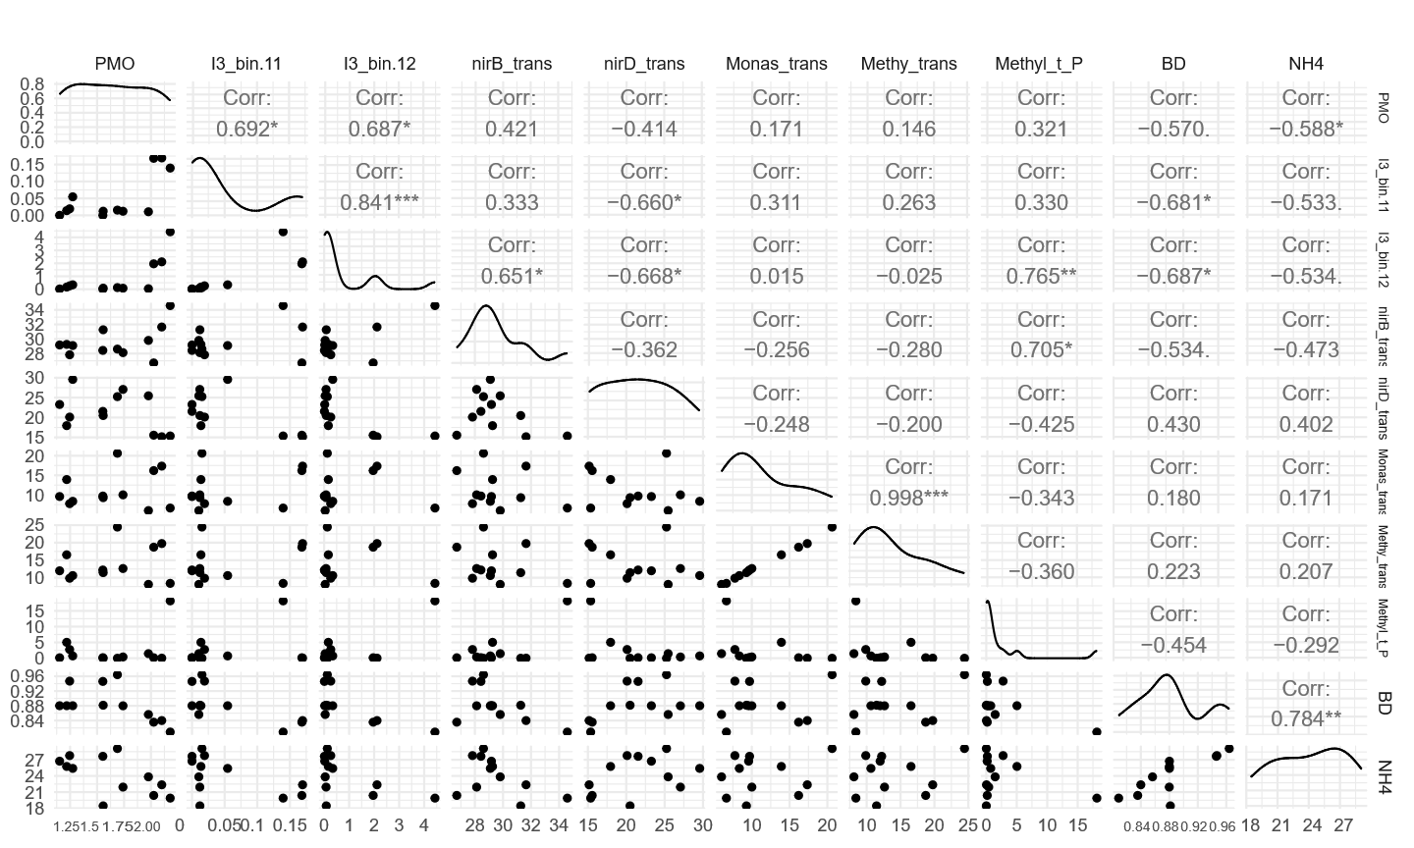
Fig. S6 | Pairwise correlations among soil properties, Methanotrophs genomic and transcriptomic features, and methane oxidation potential (PMO). Monas_trans and Methyl_trans represent the contig-based metatranscriptomic abundance (i.e., overall transcriptional activity) of the genus Methylomonas and of the methanotrophic community, respectively. Methyl_t_P denotes the abundance of temperate phages predicted to target methanotrophs. BD and NH4 represent soil bulk density and ammonium concentration, respectively.
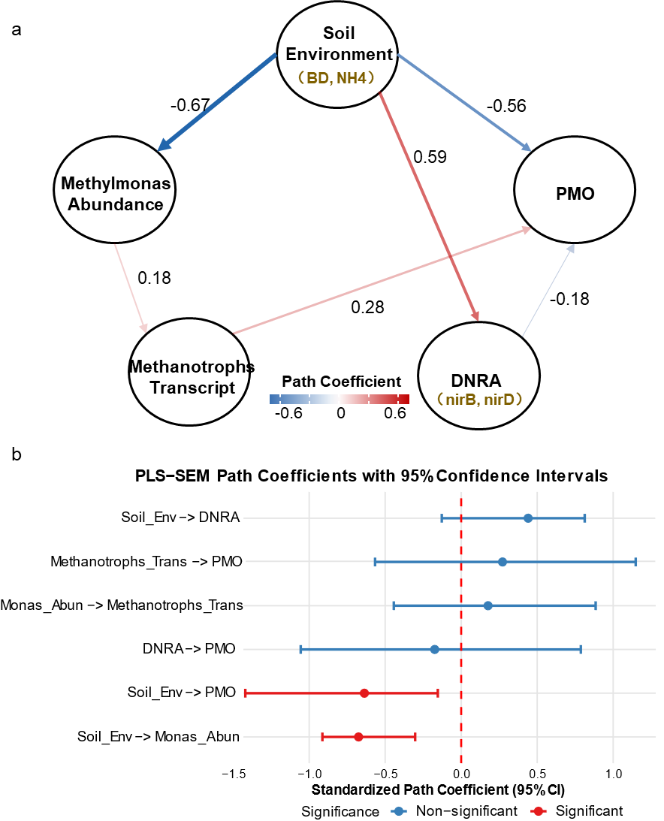
Fig. S7 | Results of Partial Least Squares Structural Equation Modeling (PLS-SEM) testing the hypothesized importance of soil environment, DNRA and Methylomonas significance on methane oxidation potential (PMO). a, PLS-SEM conceptual path model. Soil environment is an exogenous variable, while Methylomonas abundance (DNA level), Methylomonas transcriptional activity (RNA level), DNRA pathway activity, and PMO activity are endogenous variables. Arrows denote hypothesized directional paths. Red lines indicate positive relationships. Blue lines indicate negative relationships. Numbers on arrows are the standardized path coefficients (β) estimated by the model. b, Statistical evaluation of path coefficients.​ The forest plot displays the standardized path coefficients (points) with their 95% confidence intervals (bars) for each hypothesized relationship in the model. Paths are grouped by the dependent (outcome) variable. Red points and intervals indicate statistically significant paths (where the 95% CI does not cross zero), while blue points indicate non-significant paths. The exogenous variable Soil Env​ironment (Soil_Env in b) integrated bulk density and ammonium concentration. The endogenous variable Methylmonas Abundance (Monas_Abun in b) represented the relative abundance of two dominant Methylomonas MAGs (I3_bin.11 and I3_bin.12). Methanotrophs Transcripts (Methanotrophs_Trans in b) captured the in situ transcriptional activity of methanotrophs, combining with Methylomonas-specific expression. DNRA was reflected by the expression levels of the nirB and nirD genes.

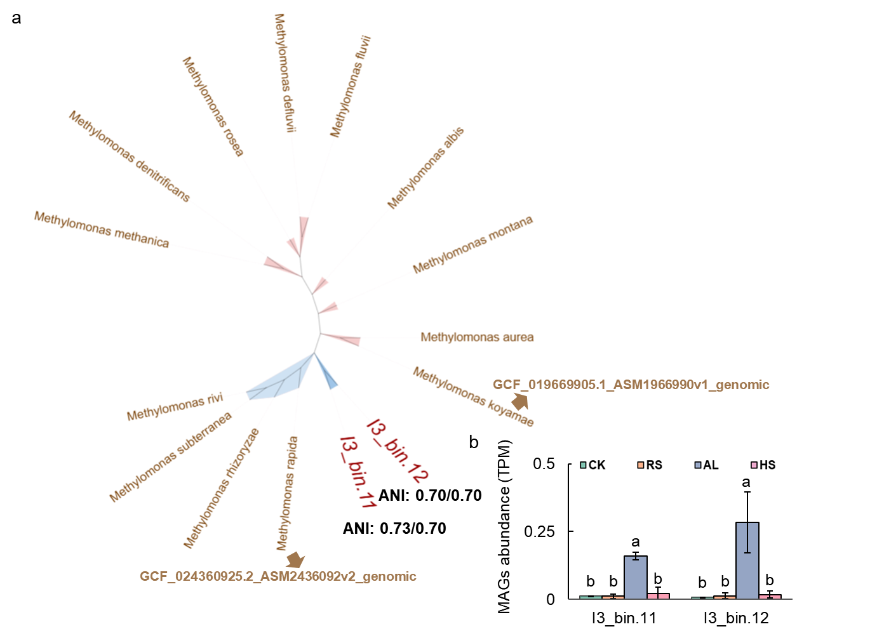
Fig. S8 | Phylogenetic identity of Methylomonas MAG. a, Maximum-likelihood phylogenetic tree of Methylomonas16S rRNA gene sequences, showing the placement of MAGs recovered in this study within the genus. Brown labels represent reference sequences obtained from the NCBI database; accession numbers beginning with ‘GCF’ correspond to their NCBI genome IDs. Red labels denote the MAGs identified in this study (e.g., 13_bin.11, 13_bin.12). The Average Nucleotide Identity (ANI) values (e.g., 0.73/70) indicate the genomic similarity between the labelled MAGs and their closest cultivated relatives (Methylomonas rapida and Methylomonas koyamae, respectively), suggesting they may represent novel species. b, The anudance of recovered Methyomonas MAGs. Different lowercase letters indicate significant differences among ammonium concentrations within the same measurement time (Tukey’s HSD test, p < 0.05, n=3). Data are presented as mean ± SE.

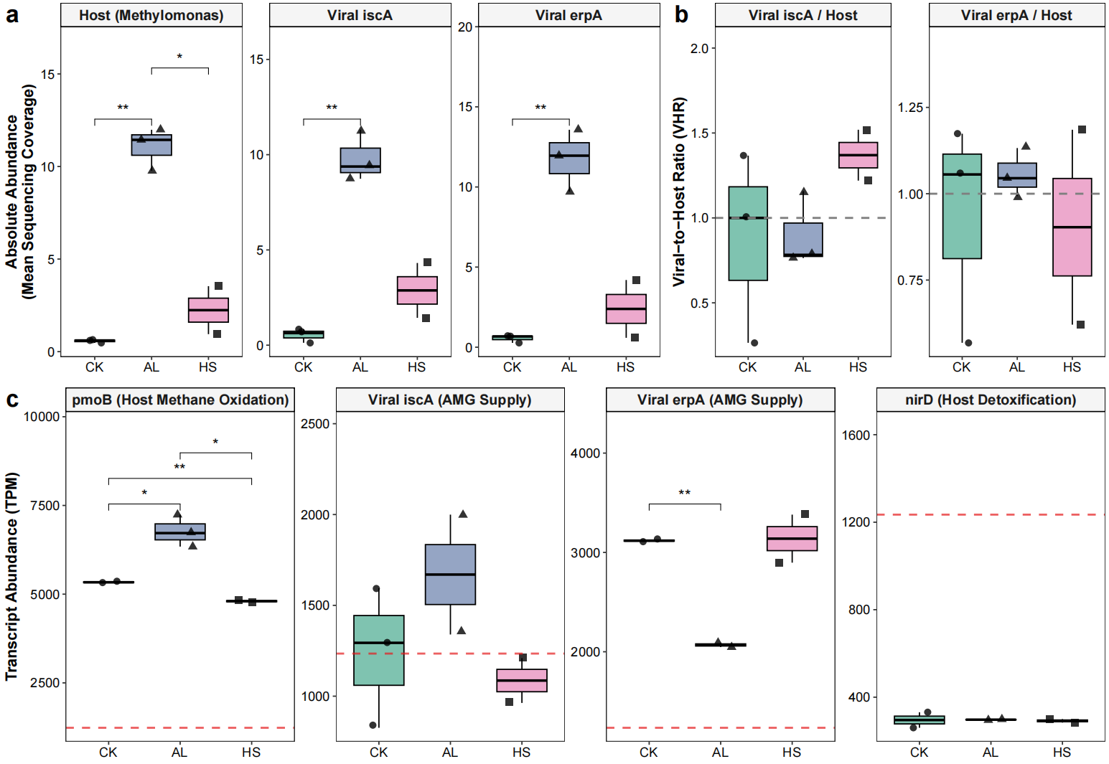
Fig. S9 | Genomic and transcriptomic dynamics reveal an active, synchronized phage-host mutualism driving the biochar-amended methane sink. a, Abundance (measured as mean sequencing coverage) of the primary methanotroph host (Methylomonas, MAG I3_bin.11) and the specific viral contigs encoding auxiliary metabolic genes (iscA and erpA) across the control (CK), fresh biochar (AL), and aged biochar (HS) treatments. The AL treatment induced a significant, synchronized massive expansion of both the host and viral genomic pools. b, The estimated Viral-to-Host Ratio (VHR) calculated from the DNA coverage values. The dashed line at y = 1.0 represents a theoretical 1:1 stoichiometric relationship characteristic of coupled prophage replication. The lack of a significant shift from this baseline during the massive host bloom indicates a pervasive carriage load. c, Intra-population transcript abundance (measured as Transcripts Per Million, TPM) of essential host metabolic genes (pmoB for methane oxidation, nirD for detoxification) and the viral AMGs. The horizontal red dashed line indicates the basal mean transcript abundance (TPM ≈ 1234) calculated across all contigs within the host MAG, serving as the genome-wide expression baseline. Pairwise significance was tested using Student’s t-tests. Asterisks denote statistical significance (*, p < 0.05; **, p < 0.01), with non-significant (ns) comparisons omitted for clarity.

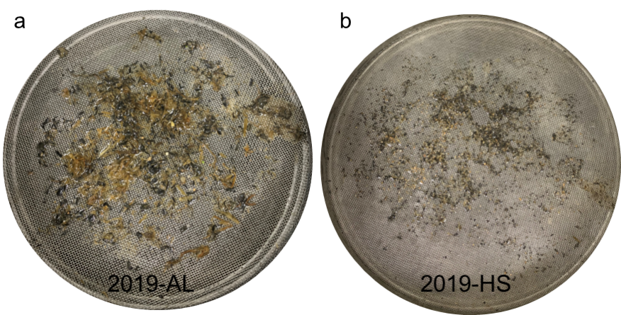
Fig. S10 | Physical appearance of biochar fragments recovered in the fifth year (2019) of the long-term field experiment initiated in 2015. a, Biochar particles in AL treatment. b, Biochar in HS showed significantly more finely dispersed biochar particles.

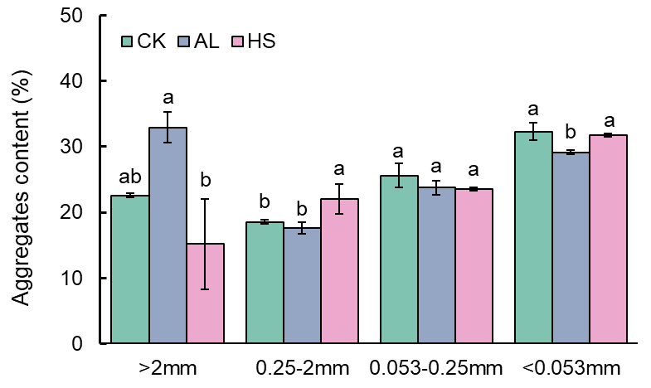
Fig. S11 | Distribution of aggregates content in paddy soil under different biochar management strategies. Large macroaggregates (>2 mm), small macroaggregates (0.25-2 mm), microaggregates (53-250 μm), and the silt and clay fraction (<53 μm). Different lowercase letters above bars within the same aggregate size class indicate statistically significant differences among treatments (p < 0.05, one-way ANOVA with Tukey’s HSD test).

