Supplementary information for

Programmable and reversible protein degradation via G-quadruplex assembled PROTACs for cancer therapy

This file includes:
Supplementary Tables 2
Supplementary Figures 17
Synthesis context and schemes 30
NMR and MS Characterization of synthetic compounds 39
MALDI-TOF MS of oligonucleotides 62

Supplementary Tables

Supplementary Table 1. The oligonucleotides used in this study.
Name | Sequencesª
6 mer DNA | 5’-d(TAGGGT)-3’
16 mer DNA | 5’-d(GGGTTAGGGTTAGGGT)-3’
Pm-6 mer | Pomalidomide-5’-d(TA^{F}GGGT)-3’
Pm-6 mer-Cy3 | Pomalidomide-5’-d(TA^{F}GGGT)-3’-Cy3
JQ1-6 mer | JQ1-5’-d(TA^{F}GGGT)-3’
JQ1-6 mer-Cy3 | JQ1-5’-d(TA^{F}GGGT)-3’-Cy3
JQ1-16 mer | JQ1-5’-d(^{F}GGGTTA^{F}G^{F}GGTTA^{F}GGGT)-3’
JQ1-16 mer-Cy5 | JQ1-5’-d(^{F}GGGTTA^{F}G^{F}GGTTA^{F}GGGT)-3’-Cy5
JQ1-16 mer-T | JQ1-5’-d(TTTTTTTTTTTTTTTT)-3’
ASO-1 | 5’-r(ACCCUAACCCUAACCCUAACGUCCG)-3’
ASO-2 | 5’-r(CGGACGUUAGGGUUAGGGUUAGGGU)-3’
JQ1-6 mer-R | JQ1-5’-r(UAGGGU)-3’
Cy5-6 mer-R | Cy5-5’-r(UAGGGU)-3’
JQ1-6 mer-U | JQ1-5’-r(UAUUUU)-3’
Cy5-6 mer-U | Cy5-5’-r(UAUUUU)-3’
CER-6 mer-R | Ceritinib-5’-r(UAGGGU)-3’
CER-6 mer-U | Ceritinib-5’-r(UAUUUU)-3’
ªThe ^{F}G represents 8-trifluoromethyl-2′-deoxyguanosine used in oligonucleotide.

Supplementary Table 2. Bi-G4 with varying linker length targeting BRD4 degradation.
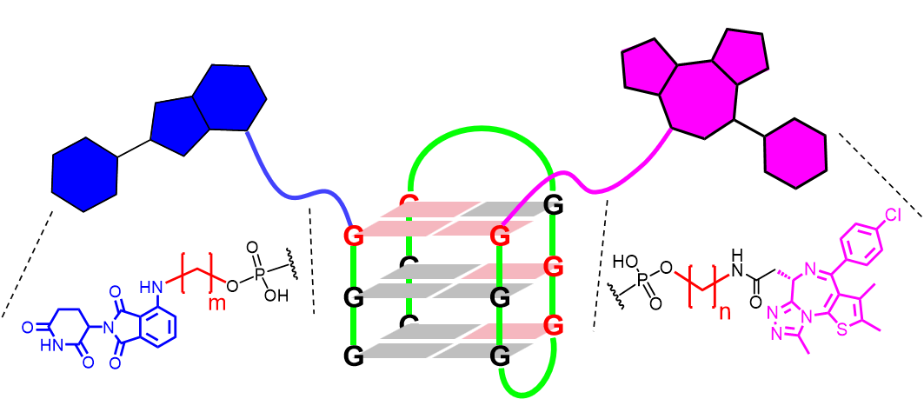
Bi-G4 with potential linker candidates:
Linker | Distance between  JQ1 and Pm (Å) | CHARMM energy (kcal/mol)
m = 1; n = 1 | 14.60 ± 2.52 | -3882.65
m = 1; n = 2 | 15.09 ± 3.34 | -4040.27
m = 1; n = 3 | 15.38 ± 2.56 | -3877.69
m = 2; n = 1 | 14.56 ± 3.64 | -3892.17
m = 2; n = 2 | 15.25 ± 1.25 | -3962.18
m = 2; n = 3 | 16.40 ± 3.89 | -4011.41
m = 3; n = 1 | 15.28 ± 4.12 | -4026.77
m = 3; n = 2 | 16.31 ± 2.73 | -3875.58
m = 3; n = 3 | 16.80 ± 2.27 | -4044.10
m = 4; n = 1 | 16.16 ± 1.68 | -3774.79
m = 4; n = 2 | 16.72 ± 3.92 | -3922.96
m = 4; n = 3 | 16.94 ± 3.95 | -3943.63
m = 4; n = 4 | 17.05 ± 3.21 | -3799.64
Supplementary Table 3. Ternary Bi-G4 bounding proteins with varying linker length targeting BRD4 degradation.
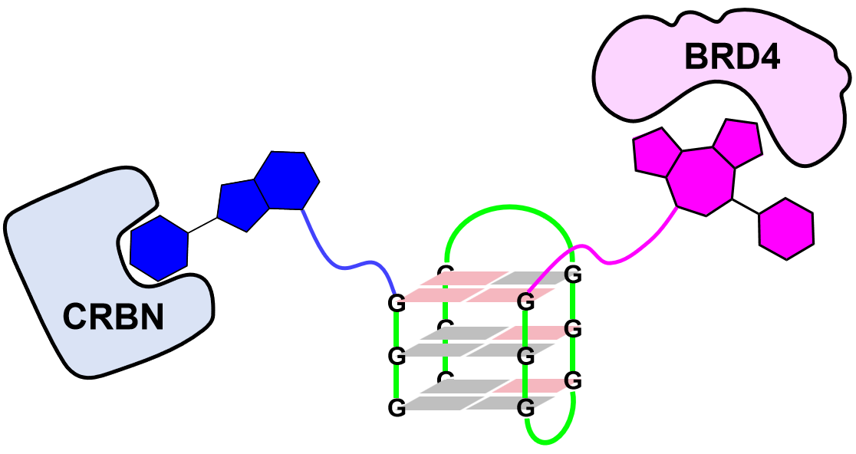
Ternary Bi-G4 bounding BRD4 and Pm:
Linker^{b} | Molecular docking  (Pm–CRBN)ª | Molecular docking  (JQ1–BRD4)ª | Docking score
m = 1; n = 1 | 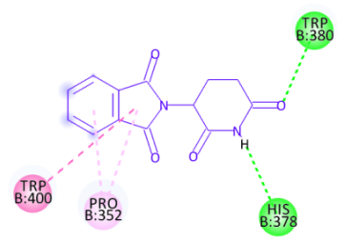 | 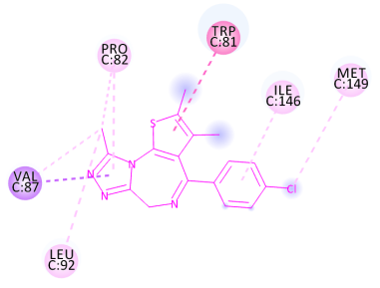 | -42.86
m = 1; n = 2 | 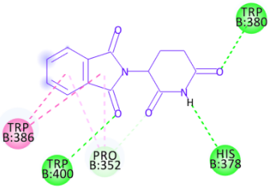 | 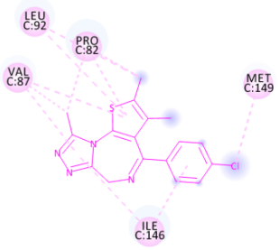 | -54.72
m = 1; n = 3 | 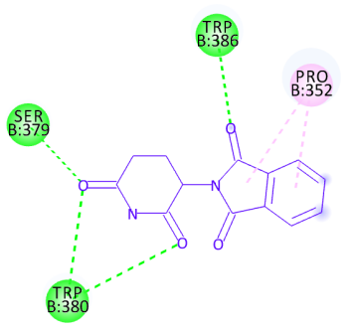 | 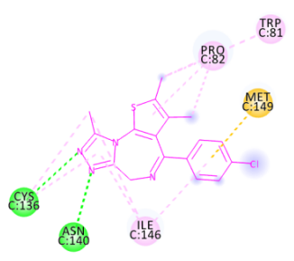 | -64.27
m = 2; n = 1 | 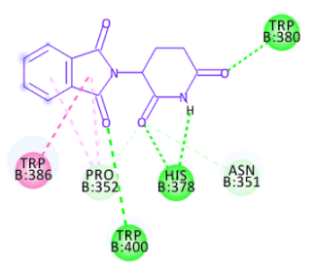 | 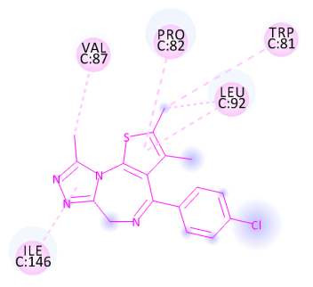 | -53.57
m = 2; n = 2 | 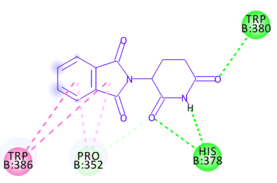 | 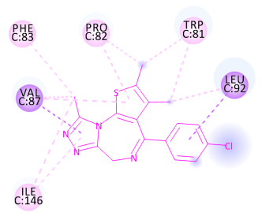 | -66.93
m = 2; n = 3 | 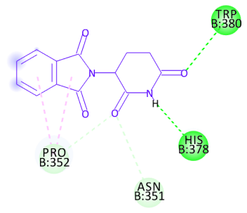 | 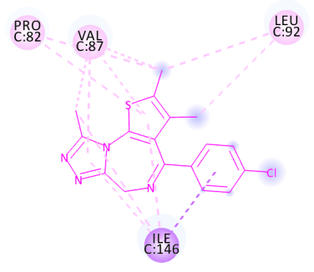 | -60.29
m = 3; n = 1 | 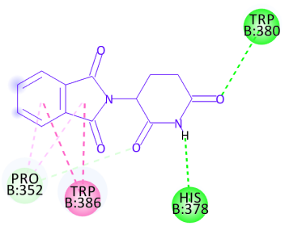 | 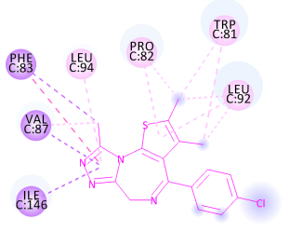 | -57.70
m = 3; n = 2 | 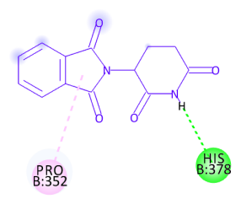 | 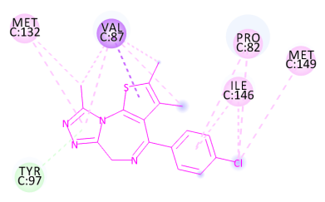 | -51.29
m = 3; n = 3 | 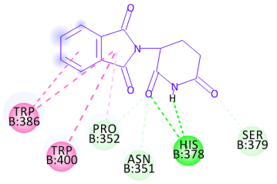 | 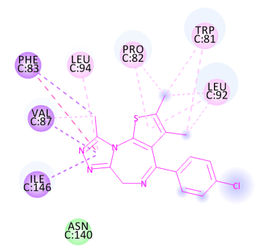 | -78.58
m = 4; n = 1 | 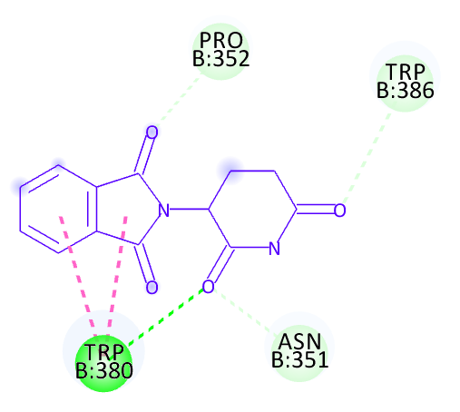 | 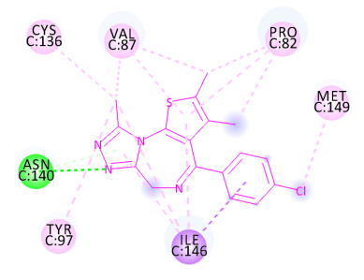 | -70.43
m = 4; n = 2 | 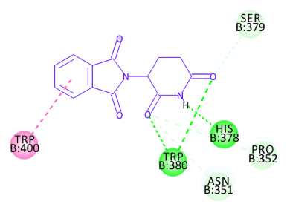 | 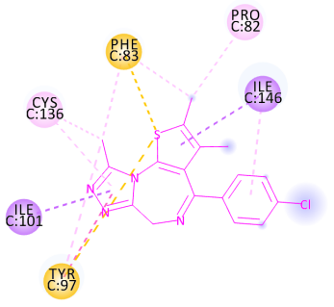 | -68.86
m = 4; n = 3 | 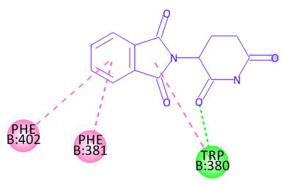 | 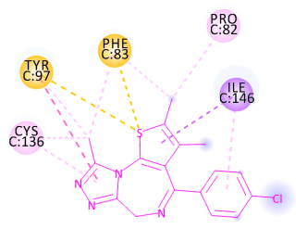 | -59.77
m = 4; n = 4 | 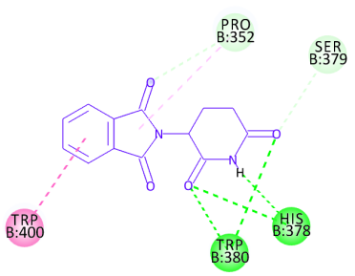 | 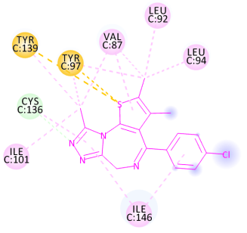 | -76.92
ªInteraction: van der Waals; Conventional H-bond; Carbon H-bond; Pi-Sigma;
Pi-Alkyl; Pi-Sulfur
^{b}Methylene numbers in linker were shown in Supplementary Table 2.
Supplementary Table 4. Trivalent Bi-G4L with varying linker length of Pm targeting BRD4 degradation.
Trivalent Bi-G4L with potential linker candidates:
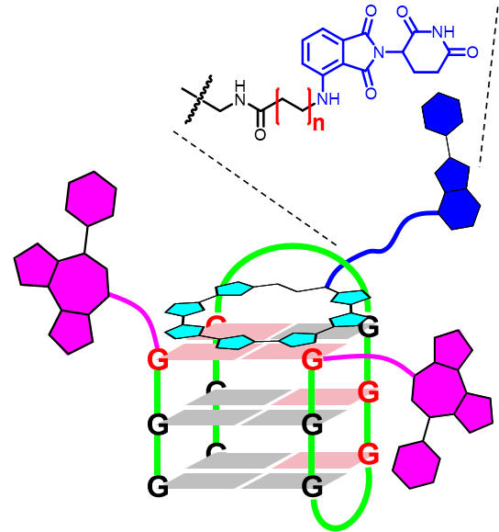
Linkers (n) | Distance between  JQ1 and Pm (Å) | CHARMM energy (kcal/mol)
1 | 22.25 ± 3.52; 22.68 ± 2.95 | -9831.72
2 | 24.14 ± 3.29; 22.83 ± 3.05 | -9842.04
3 | 26.81 ± 3.24; 26.70 ± 2.78 | -9876.06
4 | 21.92 ± 2.58; 13.57 ± 2.25 | -9867.85
5 | 23.69 ± 3.08; 16.32 ± 2.49 | -9850.21
6 | 28.14 ± 3.58; 21.88 ± 3.65 | -9856.94

Supplementary Table 5. Trivalent Bi-G4L bounding proteins with varying linker length targeting BRD4 degradation.
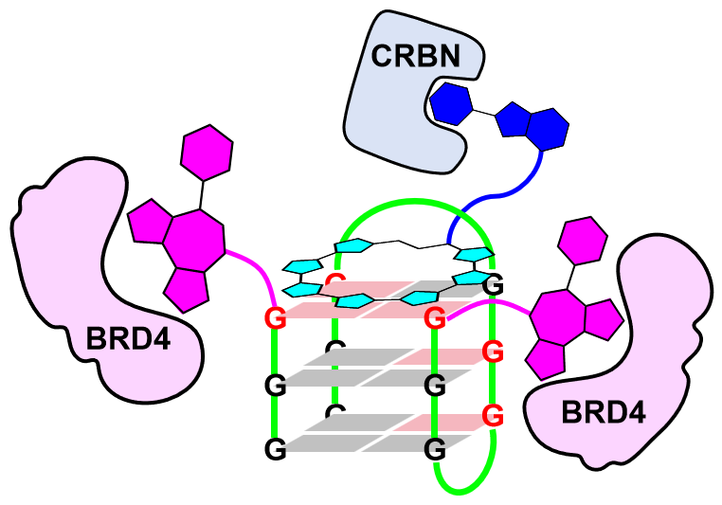
Trivalent Bi-G4L bounding BRD4 and CRBN:
Linkers (n)^{c} | Molecular docking  (Pm–CRBN)ª | Molecular docking  (JQ1–BRD4)^{a,b} | Docking score
1 | 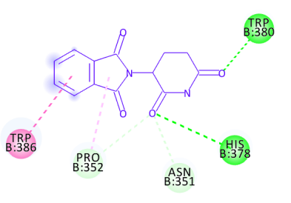 | 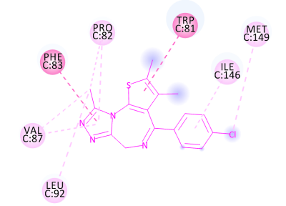 | -54.73
2 | 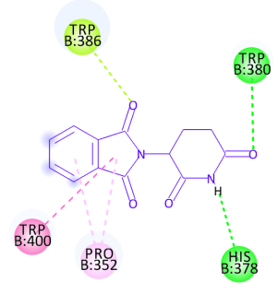 | 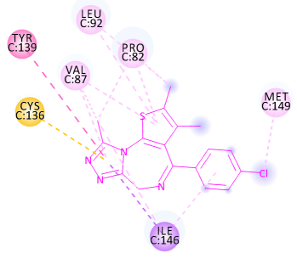 | -64.47
3 | 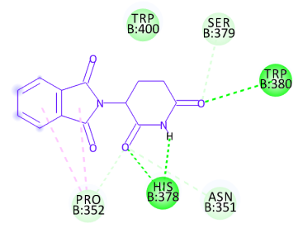 | 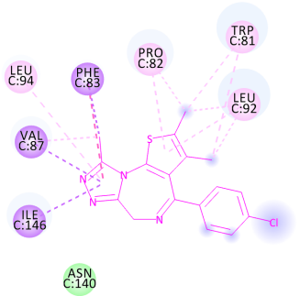 | -75.23
4 | 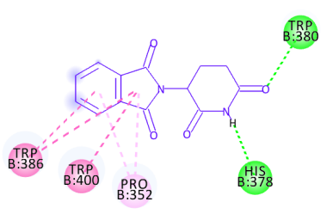 | 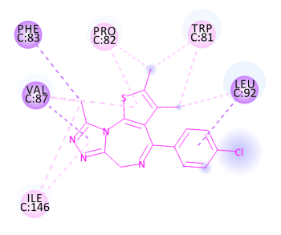 | -65.42
5 | 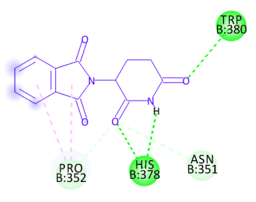 | 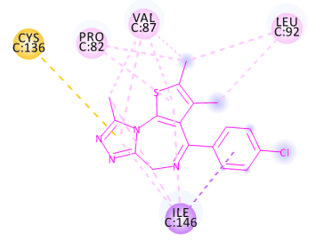 | -70.65
6 | 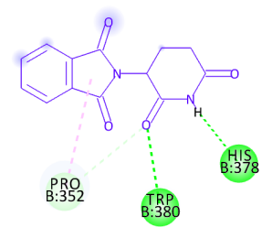 | 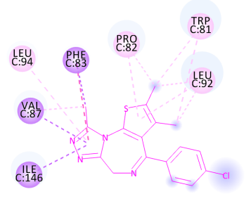 | -55.15
ªInteraction: van der Waals; Conventional H-bond; Carbon H-bond; Pi-Sigma;
Pi-Alkyl; Pi-Sulfur
^{b}Molecular docking between JQ1 and BRD4 represents the average result of two JQ1 molecules.
^{c}Ethyl numbers in linker were shown in Supplementary Table 4.

Supplementary Table 6. Pentavalent Tetra-G4L with varying linker length of Pm targeting BRD4 degradation.
Pentavalent Tetra-G4L with linker candidates:
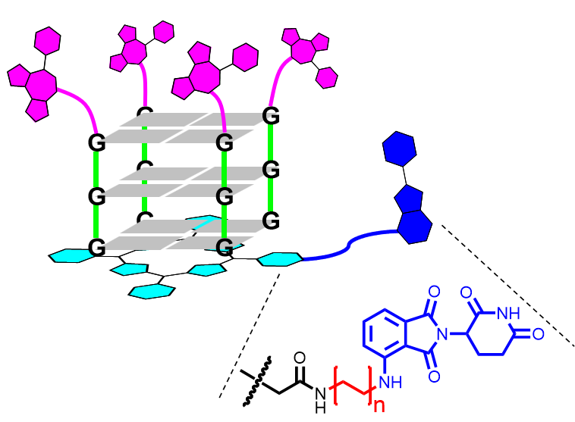
Linkers (n) | Average distance of  JQ1 to Pm (Å) | CHARMM energy (kcal/mol)
1 | 37.56 ± 5.36 | -12853.65
2 | 37.25 ± 5.92 | -12847.05
3 | 36.68 ± 4.80 | -12884.76
4 | 39.38 ± 5.07 | -12838.92
5 | 42.13 ± 6.22 | -12825.08
6 | 46.71 ± 6.76 | -12824.63
7 | 44.65 ± 5.99 | -12820.79
8 | 44.54 ± 4.84 | -12817.24

Supplementary Table 7. Pentavalent Tetra-G4L bounding proteins with varying linker length targeting BRD4 degradation.
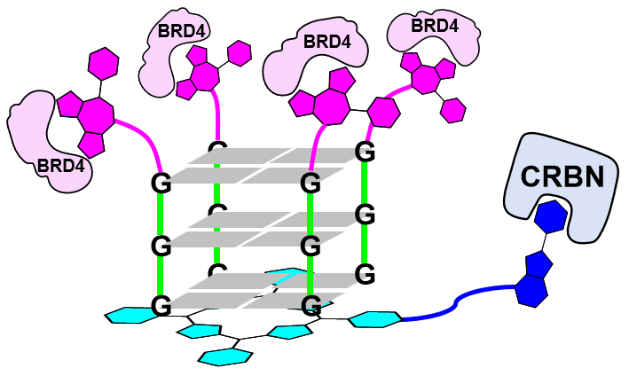
Pentavalent Tetra-G4L bounding BRD4 and CRBN:
Linkers (n)^{c} | Molecular docking  (Pm–CRBN)ª | Molecular docking  (JQ1–BRD4)^{a,b} | Docking score
1 | 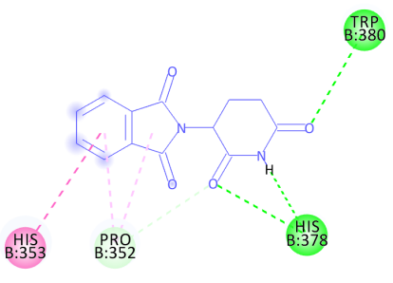 | 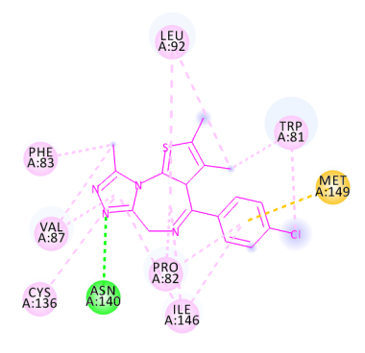 | -66.18
2 | 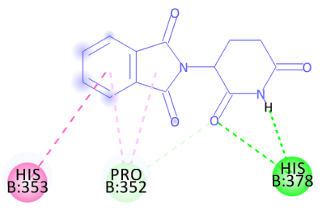 | 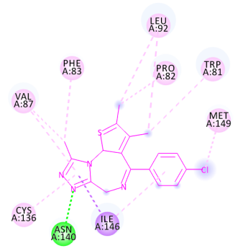 | -58.56
3 | 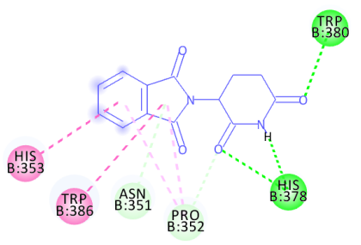 | 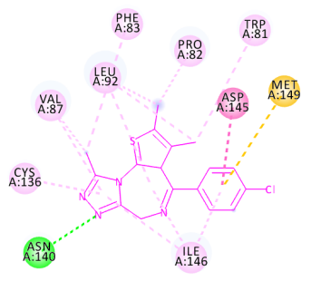 | -82.72
4 | 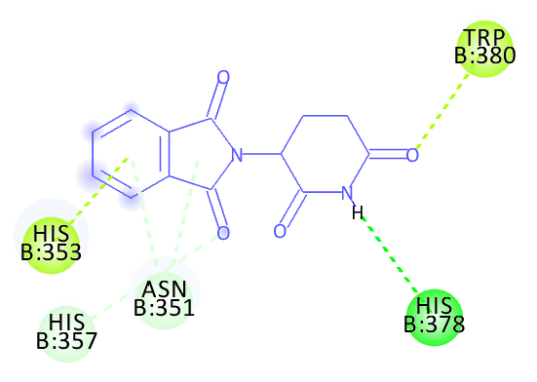 | 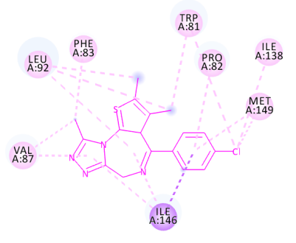 | -69.48
5 | 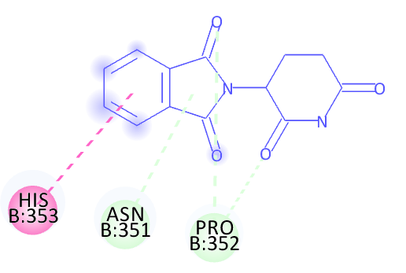 | 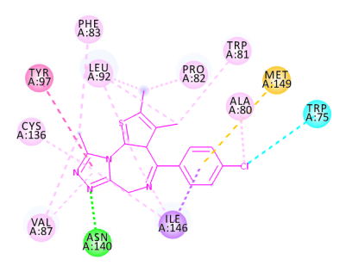 | -71.49
6 | 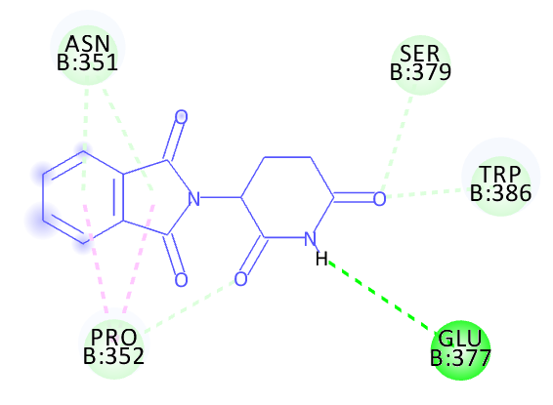 | 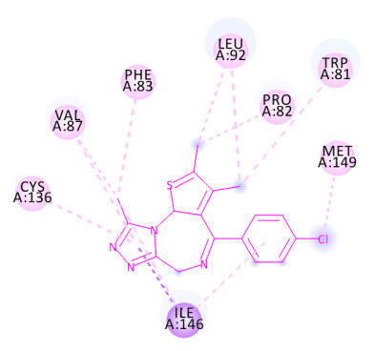 | -67.16
7 | 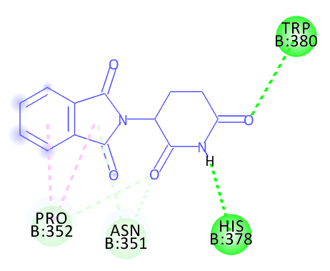 | 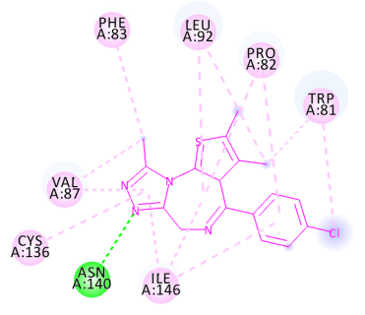 | -70.48
8 | 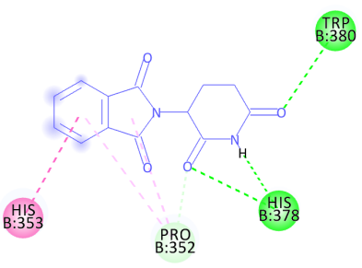 | 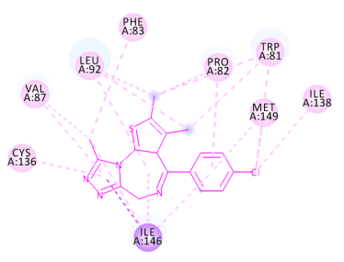 | -80.57
ªInteraction: van der Waals; Conventional H-bond; Carbon H-bond; Pi-Sigma;
Pi-Alkyl; Pi-Sulfur Halogen (Cl, Br, I)
^{b}Molecular docking between JQ1 and BRD4 represents the average result from four JQ1 molecules.
^{c}Ethyl numbers in linker were shown in Supplementary Table 6.

Supplementary Table 8. Pentavalent Tetra-G4L with varying linker length of ceritinib targeting ALK degradation.
Pentavalent Tetra-G4L with linker candidates:
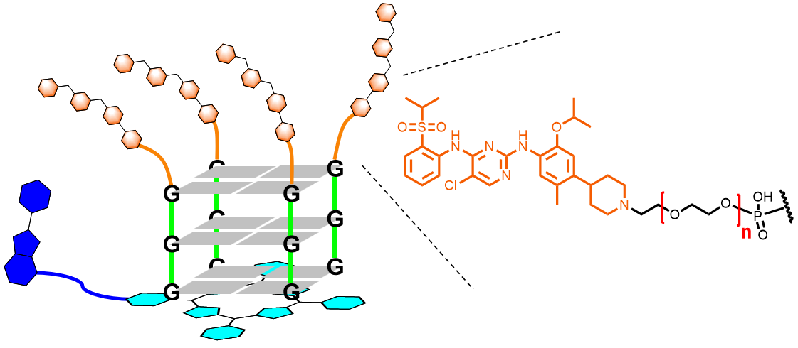
Linkers (n) | Average distance of  Pm to ceritinib (Å) | CHARMM energy (kcal/mol)
1 | 37.43 ± 6.08 | -12493.25
2 | 39.98 ± 6.83 | -13934.82
3 | 43.90 ± 7.26 | -13932.37
4 | 46.82 ± 7.40 | -13874.66
5 | 48.71 ± 7.94 | -13885.15

Supplementary Table 9. Pentavalent Tetra-G4L bounding proteins with varying linker length targeting ALK degradation.
Pentavalent Tetra-G4L bounding ALK and CRBN:
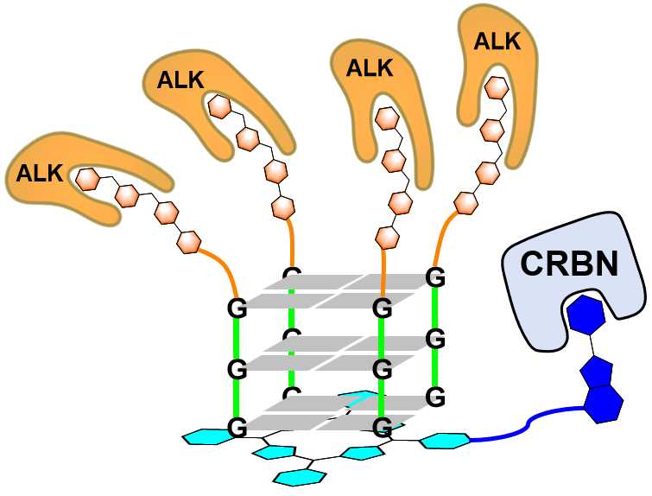
Linkers (n)^{c} | Molecular docking  (Pm–CRBN)ª | Molecular docking  (Ceritinib–ALK)^{a,b} | Docking score
1 | 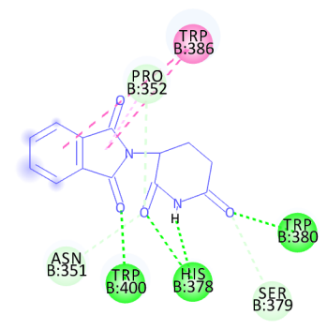 | 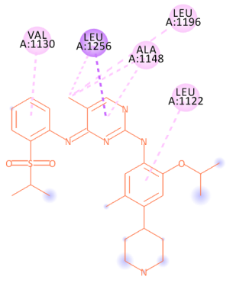 | -62.82
2 | 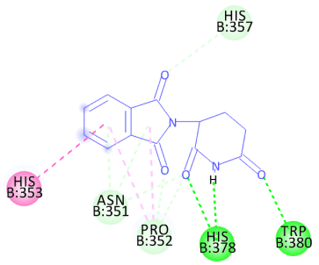 | 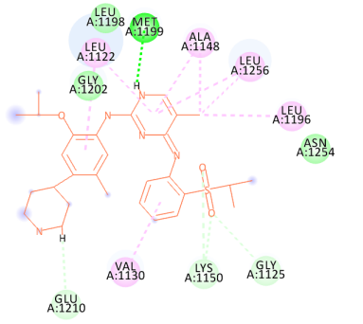 | -74.97
3 | 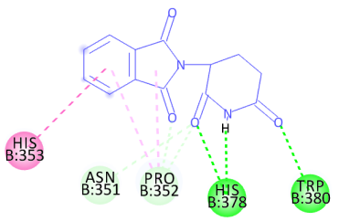 | 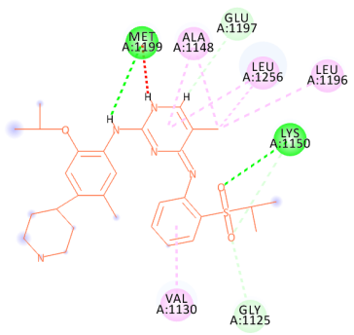 | -71.05
4 | 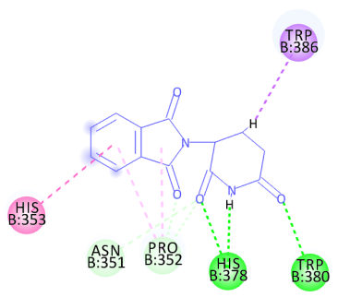 | 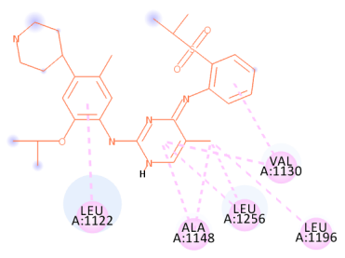 | -68.26
5 | 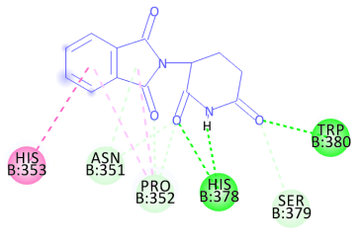 | 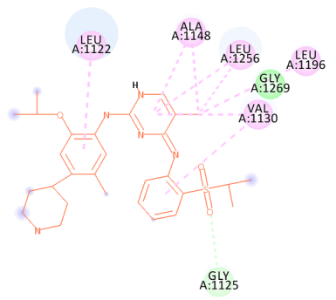 | -73.28
ªInteraction: van der Waals; Conventional H-bond; Carbon H-bond; Pi-Sigma;
Pi-Alkyl; Pi-Sulfur Halogen (Cl, Br, I)
^{b}Molecular docking between JQ1 and BRD4 represents the average result from four JQ1 molecules.
^{c}Ethylene glycol numbers in linker were shown in Supplementary Table 8.

Supplementary Figures

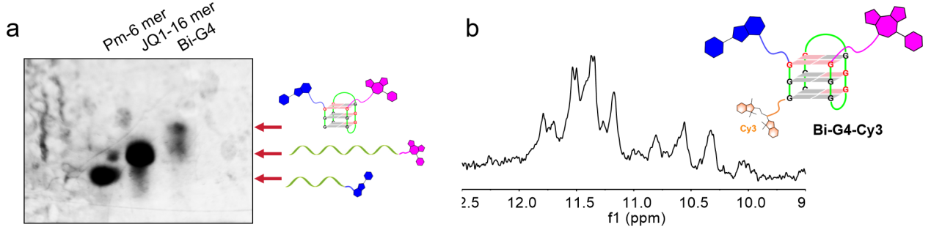

Supplementary Fig. 1. Structural identification of the Bi-G4 modified by JQ1 and Pm warheads. (a) Native gel electrophoresis indicates Bi-G4 structure formation. (b) Bi-G4 was modified at 3’-end of 6 mer DNA by Cy3 dye to get fluorescent labeling. Imimo-proton NMR spectroscopy shows Hoogesteen base pairs formation of G4 based on strong proton signals located in 10–12 ppm.

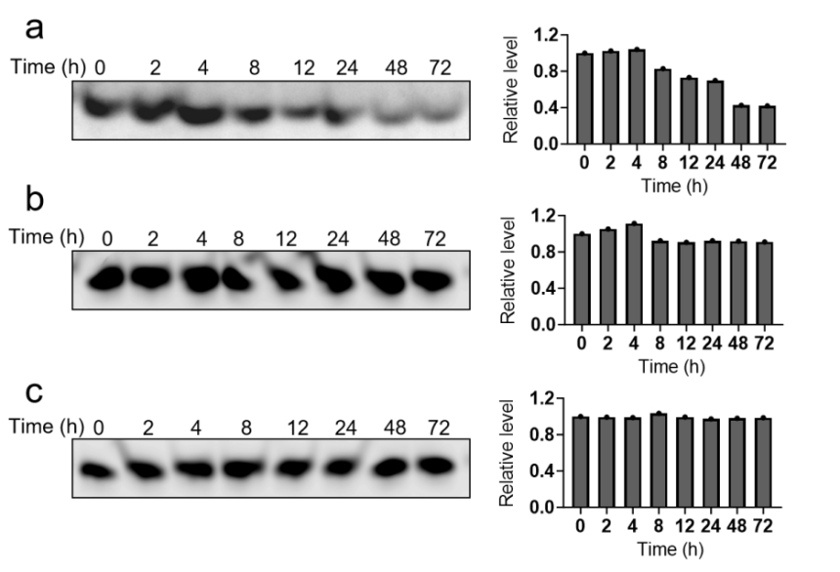
Supplementary Fig. 2. Physiological stability assay of G4TACs in cell lysate. PAGE analysis determines the G4TACs stability using Bi-G4 (a), Bi-G4L (b) and Tetra-G4L (c) with time dependence.
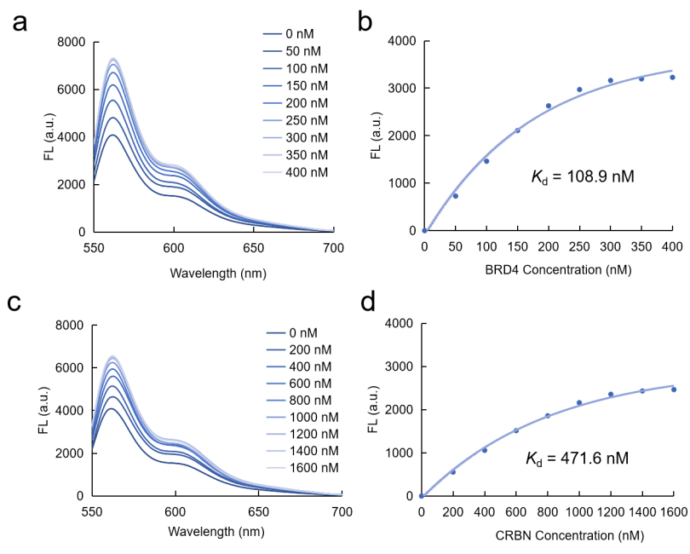
Supplementary Fig. 3. Fluorescence titration assay study Bi-G4-Cy3 bounding to BRD4 or CRBN protein. (a) Sequential fluorescence variation of Cy3 label of Bi-G4-Cy3 when BRD4 was added in concentration dependent. (b) Dissociation constants (K_{d}) between Bi-G4-Cy3 and BRD4 according to analyzing results of (a). (c) Sequential fluorescence variation of Cy3 label of Bi-G4-Cy3 when CRBN was added in concentration dependent. (d) Dissociation constants (K_{d}) between Bi-G4-Cy3 and CRBN according to analyzing results of (c).

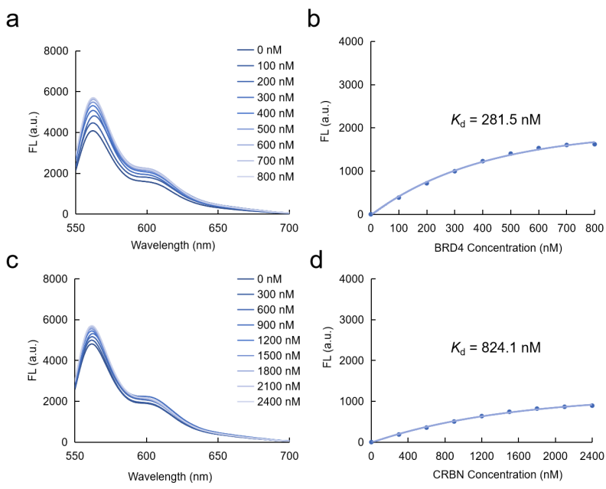
Supplementary Fig. 4. Fluorescence titration assay study Bi-G4-Cy3 competitively bounding to BRD4 or CRBN protein with JQ1 or Pm. (a) Sequential fluorescence variation of Cy3 label of Bi-G4-Cy3 when BRD4 was concentration-dependent added into the G4 solution with JQ1. (b) Dissociation constants (K_{d}) between Bi-G4-Cy3 and BRD4 according to analyzing results of (a). (c) Sequential fluorescence variation of Cy3 label of Bi-G4-Cy3 when BRD4 was concentration-dependent added into the G4 solution with Pm. (d) Dissociation constants (K_{d}) between Bi-G4-Cy3 and CRBN according to analyzing results of (c).

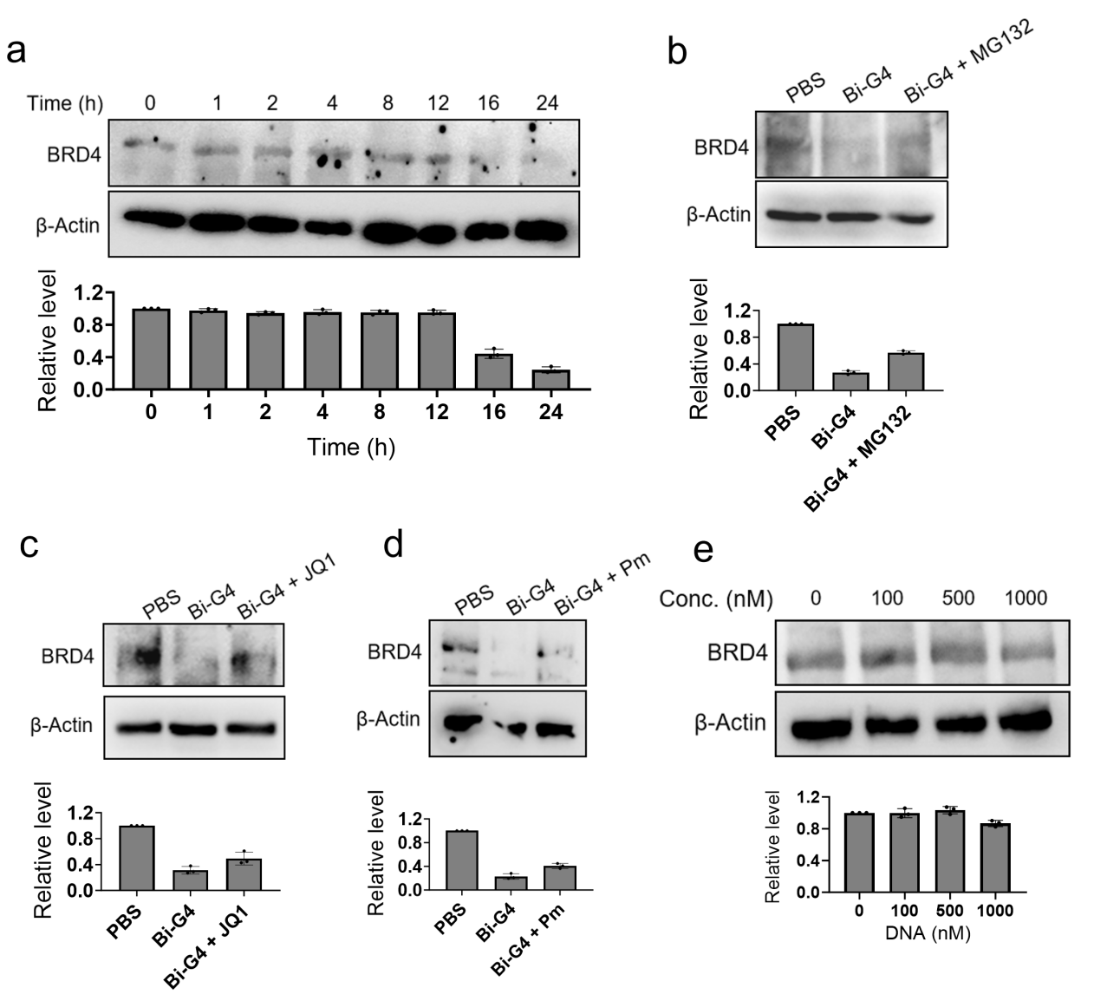
Supplementary Fig. 5. Bi-G4 degrades BRD4 in HeLa cells. (a) Western blotting analysis of BRD4 degradation in HeLa cells treated with Bi-G4 with time dependence. (b) Western blot assay of HeLa cells which were subjected to Bi-G4 with MG132 treatment. (c) Western blot assay of HeLa cells which were subjected to Bi-G4 with JQ1 treatment. (d) Western blot assay of HeLa cells which were subjected to Bi-G4 with Pm treatment. (e) Concentration-dependent assay of BRD4 degradation in HeLa cells using JQ1-16 mer-T and Pm-6 mer as controls. The error bars indicate the mean ± SD values; n = 3.

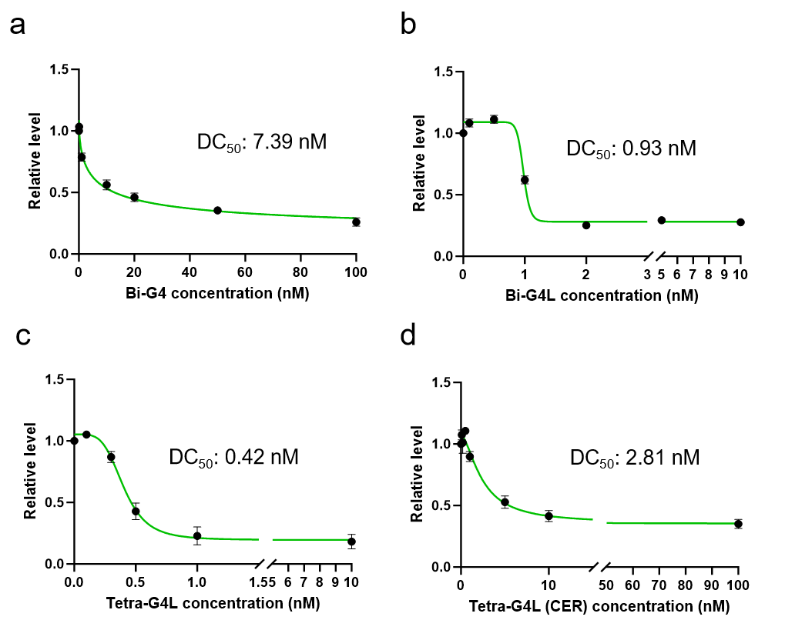
Supplementary Fig. 6. DC₅₀ comparison of G4TACs degrading proteins. Western blotting analysis proteins degradation capacity of Bi-G4 (a), Bi-G4L (b), Tetra-G4L (c) and Tetra-G4L (CER) (d) with concentration dependence, in which DC₅₀ values were indicated. The error bars indicate the mean ± SD values; n = 3.

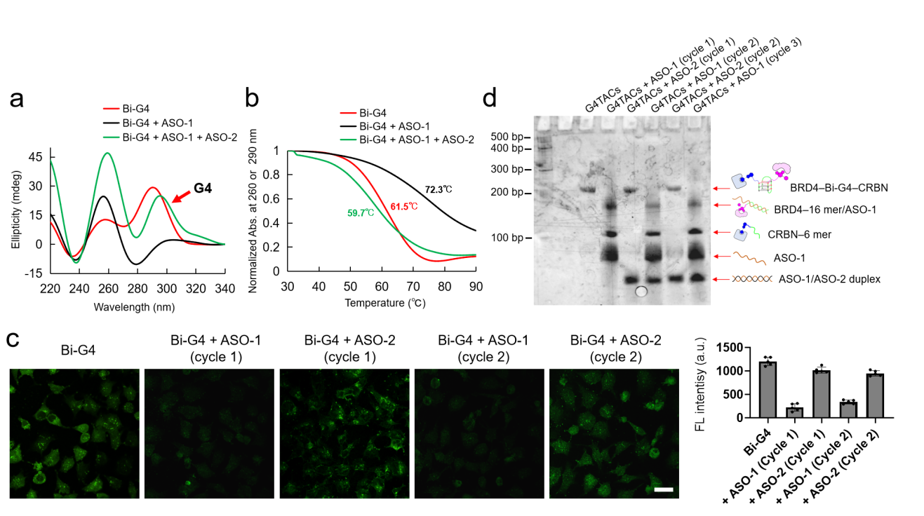
Supplementary Fig. 7. Reversible regulation of G4TACs using ASO strategy. (a) CD spectrum study the ASO regulated G4 switching of G4TACs. Red arrow indicate the positive band at 295 nm presenting G4 formation. (b) CD melting assay shows ASO-1 hijack JQ1-16 mer forming duplex with a higher stability (Tm = 72.3 ℃) than Bi-G4 (Tm = 61.5 ℃). Then, a lower Tm (59.7 ℃) represents Bi-G4 recovery following ASO-2 bounding to ASO-1 at longer duplex. (c) Western blot assay of HeLa cells which were subjected to Bi-G4 with JQ1 treatment. (d) BG4 immunofluorescence staining images show switching G4 formation by using Bi-G4 with alternative ASO-1 and ASO-2, in which 1 µM Bi-G4 and 5 µM ASO were used at each treatments. Scale bars, 30 µm. The error bars indicate the mean ± SD values; n = 5.

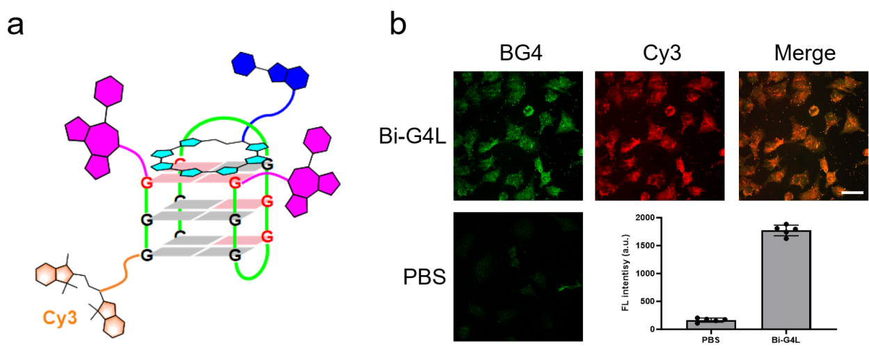

Supplementary Fig. 8. Immunofluorescent image determines the G4 structure of Bi-G4L in cells. (a) Cy3 dye was connected to the 3’-end of 6 mer DNA of Bi-G4L to get fluorescent labeling. (b) Immunofluorescence staining images of HeLa cells treated with 1 µM Bi-G4L or PBS for 8 h, in which the Bi-G4L was labeled by Cy3 dye. In-cell G4 structure was stained with BG4 in green (Ex. wavelength: 488 nm; Em. wavelength: 515 nm), and Cy3 was shown as red (Ex. wavelength: 530 nm; Em. wavelength: 570 nm). The merged layer was generated by overlapping BG4 and Cy3 channels. Scale bars, 30 µm. The error bars indicate the mean ± SD values; n = 5.

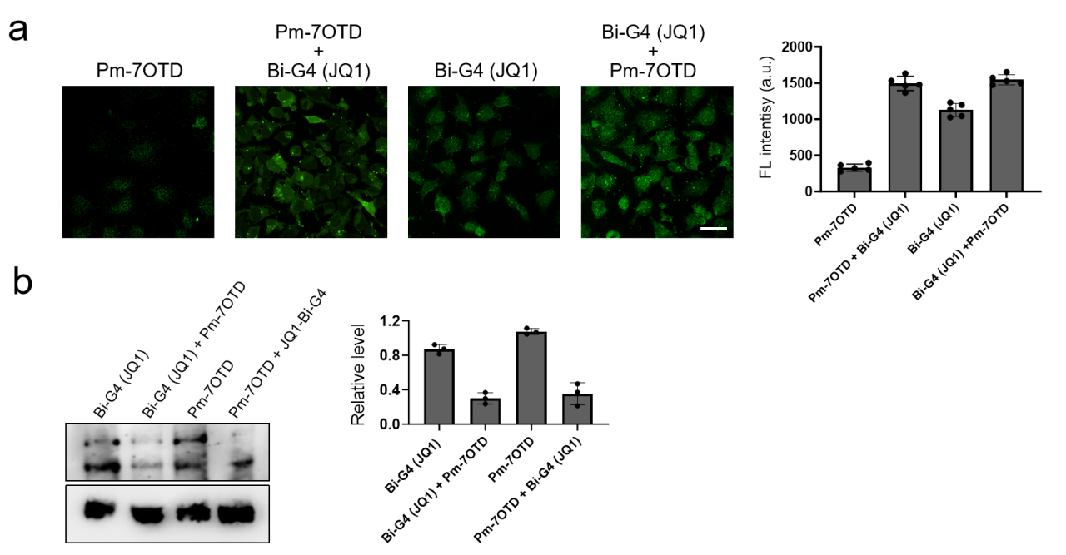

Supplementary Fig. 9. Pm-7OTD bounding Bi-G4 (JQ1) assemble into Bi-G4L degrading BRD4 in cells. (a) BG4 immunofluorescence staining images of HeLa cells treated by Pm-7OTD, Pm-7OTD + Bi-G4 (JQ1), Bi-G4 (JQ1) and Bi-G4 (JQ1) + Pm-7OTD respectively. Scale bars, 30 µm. The error bars indicate the mean ± SD values; n = 5. (b) Western blotting analysis of BRD4 degradation in HeLa cells treated with Pm-7OTD, Pm-7OTD + Bi-G4 (JQ1), Bi-G4 (JQ1) and Bi-G4 (JQ1) + Pm-7OTD respectively. The error bars indicate the mean ± SD values; n = 3.

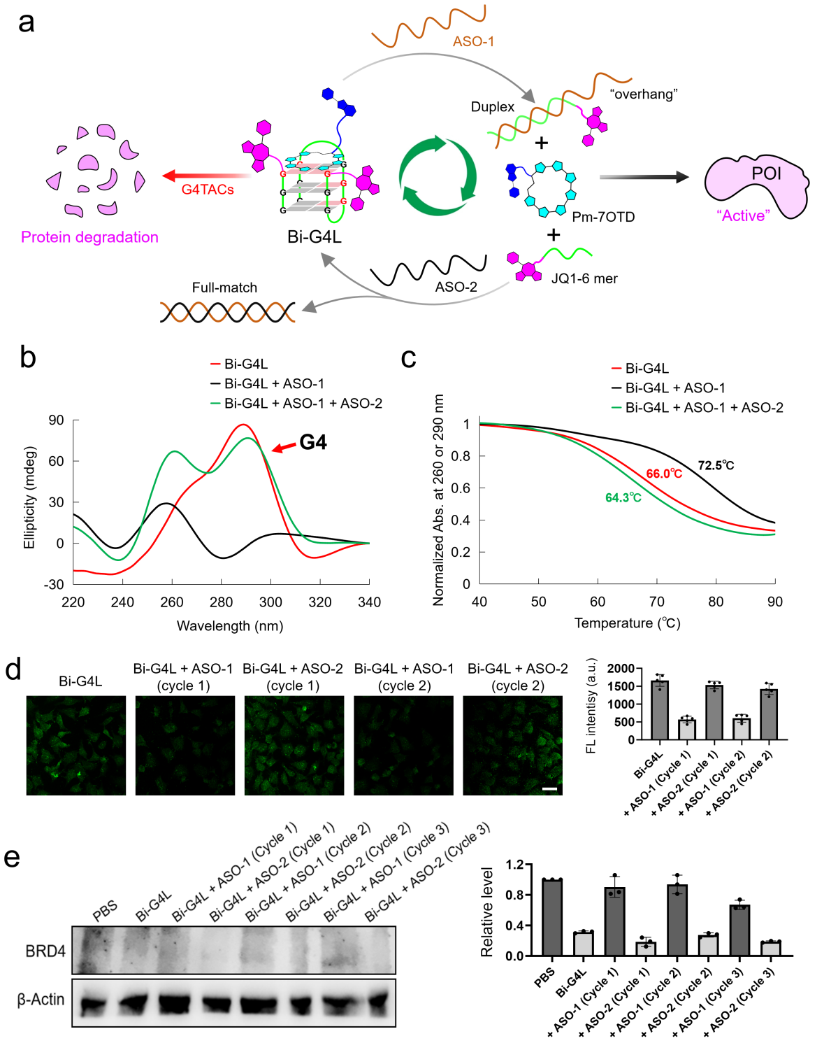

Supplementary Fig. 10. Reversible switching “on” and “off” for Bi-G4L induced BRD4 degradation using ASO strategy. (a) Molecular machine of switching Bi-G4L induced POI degradation through alternative ASO-1 disrupting as well as ASO-2 resorting G4 structure. (b) CD spectrum study the ASO regulated G4 switching of Bi-G4L. Red arrow indicate the positive band at 295 nm presenting G4 formation. (c) CD melting assay shows ASO-1 competitively form duplex with JQ1-16 mer possessing a higher stability (Tm = 74.2 ℃) than Bi-G4L (Tm = 66.0 ℃). (d) BG4 immunofluorescence staining images show switching Bi-G4L formation with alternative ASO-1 and ASO-2, in which 1 µM Bi-G4L and 5 µM ASO were used at each treatments. Scale bars, 30 µm. The error bars indicate the mean ± SD values; n = 5. (e) Western blotting analysis of ASO switching BRD4 degradation in HeLa cells, in which the interval time of alternative ASO-1 and ASO-2 treatments is 16 h. The error bars indicate the mean ± SD values; n = 3.
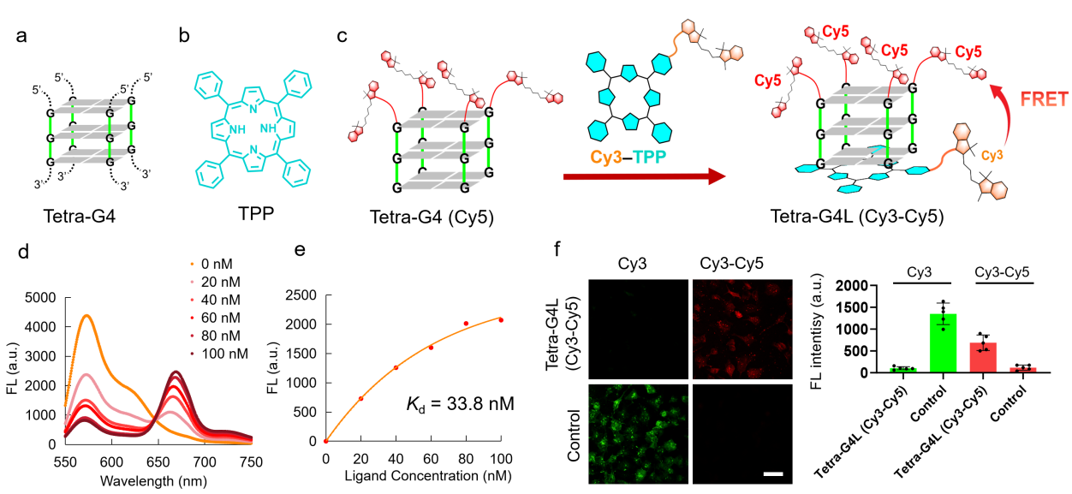

Supplementary Fig. 11. Cy3-to-Cy5 FRET study TPP bounding to Tetra-G4 in vitro and in cells. (a) A reported tetramolecular G4 structure constructed by 6 mer RNA, 5’-ends were labeled. (b) TPP is a potent ligand using for bounding and stabilizing G4 structure. (c) Cy3-TPP bounding to Tetra-G4 (Cy5) could indicate the adjacent Cy3-to-Cy5 FRET signal. (d) Fluorescence emission spectra study FRET by titrating Cy3-TPP into Tetra-G4 (Cy5) solution in concentration dependent. Ex. wavelength: 530 nm. (e) Dissociation constants (K_{d}) between Cy3-TPP and Tetra-G4 (Cy5) was analyzed using the FRET signals intensities at 670 nm of (d). (f) Tetra-G4L (Cy3-Cy5) was incorporated into HeLa cells to show FRET signal at physiological environment. For comparison, a control group of Cy3-TPP and Cy5-5’-(UAUUUU)-3’ RNA which lost function to form G4 structure, was used. The Cy3 channel with ex. 550 nm/em. 570 nm indicated green color and the Cy3-Cy5 channel with a filter of ex. 550 nm/em. 670 nm indicated red color, representing FRET signal. Scale bars, 30 µm. The error bars indicate the mean ± SD values; n = 5.

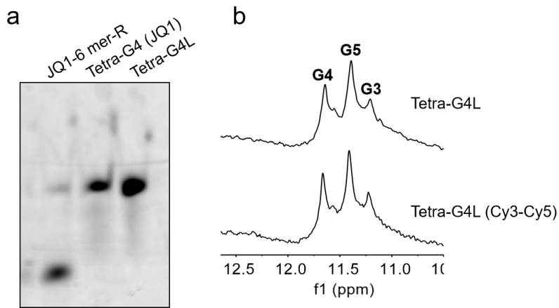

Supplementary Fig. 12. Pm-TPP bounding Tetra-G4 (JQ1) assay. (a) Native gel electrophoresis indicates Tetra-G4L assembly formation. (b) Comparison of imino proton NMR of Tetra-G4L and Tetra-G4L (Cy3-Cy5), showing the consistent structure.

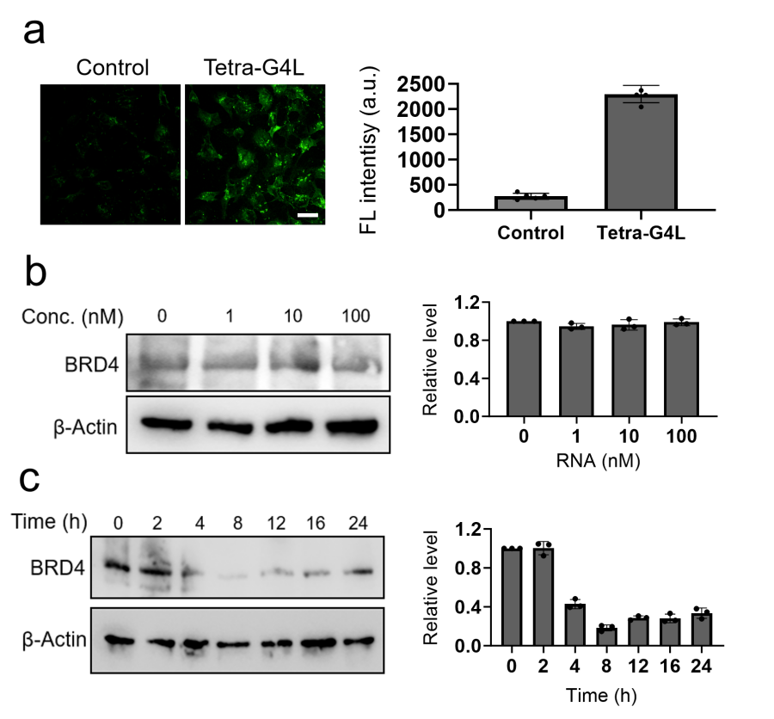
Supplementary Fig. 13. Study Tetra-G4L degrading BRD4 protein in cells. (a) Immunofluorescence staining images of HeLa cells treated with 1 µM Tetra-G4L or JQ1-5’-(UAUUUU)-3’ RNA and Pm-TPP as controls for 8 h, in which the G4 structure was stained with BG4 in green (Ex. wavelength: 488 nm; Em. wavelength: 515 nm). Scale bars, 30 µm. The error bars indicate the mean ± SD values; n = 5. (b) Concentration-dependent assay of BRD4 degradation in HeLa cells using JQ1-5’-(UAUUUU)-3’ RNA and Pm-TPP as controls. (c) Time-course analysis of Tetra-G4L–induced BRD4 degradation in HeLa cells by western blotting. The error bars indicate the mean ± SD values; n = 3.

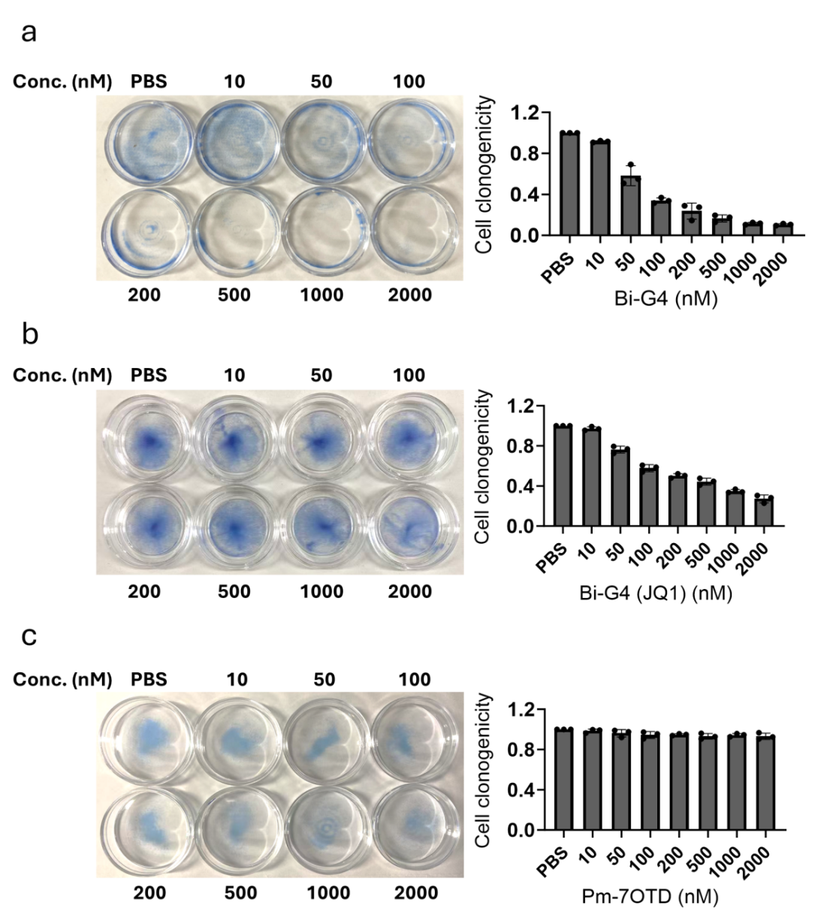

Supplementary Fig. 14. Clonogenic assay in HeLa cells. (a) Cells clonogenic assay using PBS and concentration-dependent Bi-G4 treated cells. Colonies of cells were stained with methylene blue. (b) Cells clonogenic assay using PBS and concentration-dependent Bi-G4 (JQ1) treated cells. Colonies of cells were stained with methylene blue. (c) Cells clonogenic assay using PBS and concentration-dependent Pm-7OTD treated cells. Colonies of cells were stained with methylene blue. The error bars indicate the mean ± SD values; n = 3.

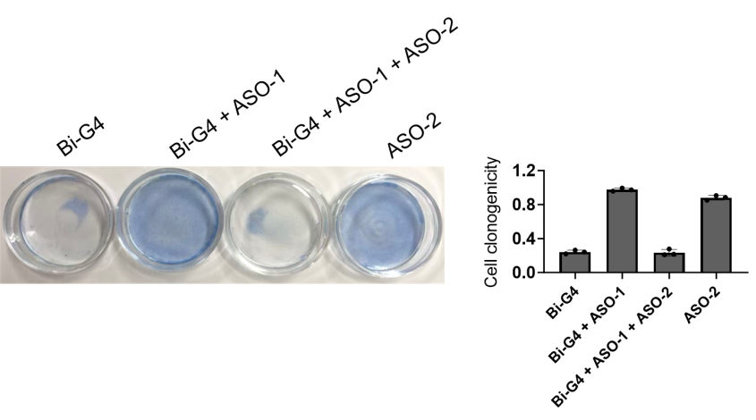
Supplementary Fig. 15. Clonogenic assay in HeLa cells. Cells clonogenic assay using Bi-G4, Bi-G4 + ASO-1, Bi-G4 + ASO-1 + ASO-2 and ASO-2 respectively treated cells. Colonies of cells were stained with methylene blue. Colonies of cells were stained with methylene blue. The error bars indicate the mean ± SD values; n = 3.

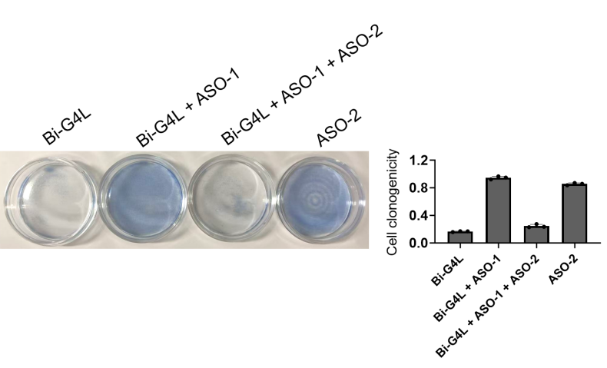

Supplementary Fig. 16. Clonogenic assay in HeLa cells. Cells clonogenic assay using Bi-G4L, Bi-G4L + ASO-1, Bi-G4L + ASO-1 + ASO-2 and ASO-2 respectively treated cells. Colonies of cells were stained with methylene blue. Colonies of cells were stained with methylene blue. The error bars indicate the mean ± SD values; n = 3.

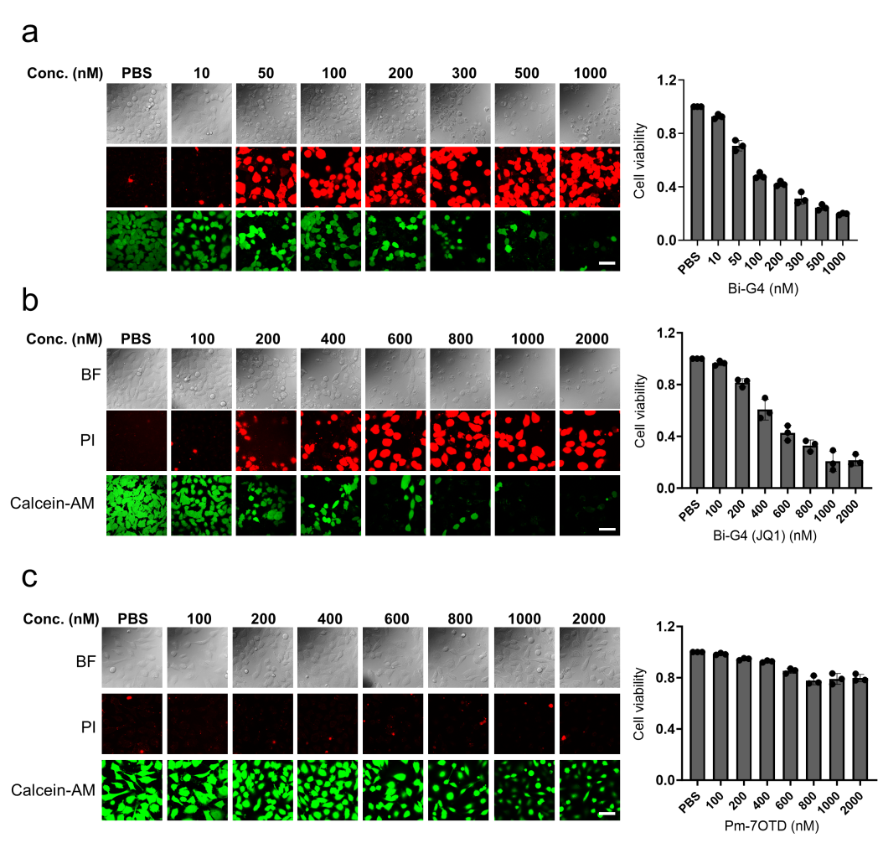
Supplementary Fig. 17. Cell viability assay after treatments of G4TACs. Bi-G4 (a), Bi-G4 (JQ1) (b) and Pm-7OTD (c) were used to treat cells respectively with concentration dependence. The resulting cells were incubated and imaged after 72 h. Dead and live cells at 72 h were stained with a nuclear counterstain and visualized as fluorescence. Dead cells were stained with PI and fluoresced red; live cells were stained with Calcein-AM and fluoresced green. The error bars indicate the mean ± SD values (n = 3).

Supplementary Fig. 18. Mouse body weight in adrenocortical carcinoma xenograft mouse model.

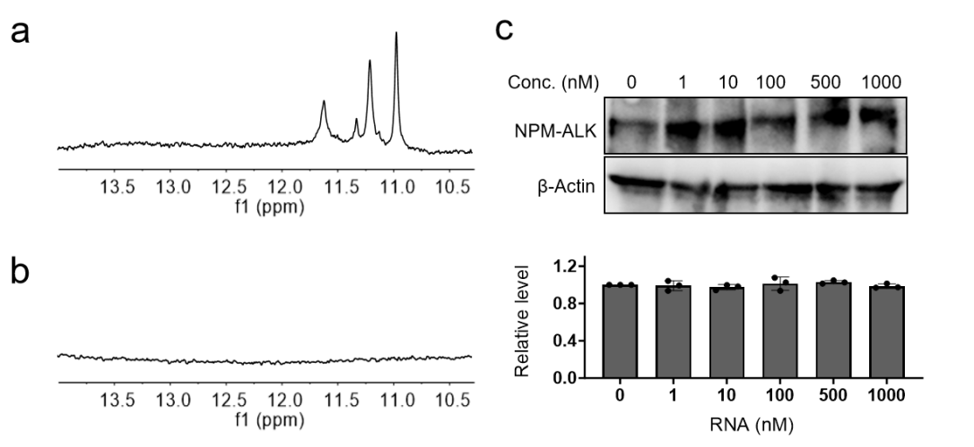
Supplementary Fig. 19. G4 structure determination of Tetra-G4L (CER). (a) Imino proton NMR spectrum of Tetra-G4L (CER) using ceritinib-5’-r(UAGGGU)-3’ and Pm-TPP. (b) No proton signals in NMR spectrum when ceritinib-5’-r(UAUUUU)-3’ was used. (c) Concentration-dependent assay of NPM-ALK degradation in TK‑ALCL1 cells using ceritinib-5’-r(UAUUUU)-3’ RNA and Pm-TPP as controls. The error bars indicate the mean ± SD values; n = 3.

Synthesis
All the reactions were performed under an atmosphere of argon. CDCl₃ or DMSO-d₆ was used as the solvents. Coupling constants (J) values are given in Hz and are correct to within 0.5 Hz. Signal patterns are indicated as s, singlet; d, doublet; t, triplet; q, quartet; m, multiplet. All reagents were purchased from Sigma-Aldrich, TCI (Tokyo Chemical Industry Co., Ltd.) or Wako (Wako Pure Chemical Industries, Ltd.). Thin layer chromatography was performed using TLC Silica gel 60 F254 (Merck). High-resolution mass spectra (HRMS) were recorded by electrospray ionization (ESI) on a Thermo Scientific Q Exactive instrument. ¹ H-NMR (400 MHz), ³¹P-NMR (162 MHz) and ¹³C NMR (100 MHz) spectra were recorded on a BRUKER (AV-400M) magnetic resonance spectrometer. Purification of products was performed on a middle pressure liquid chromatography (MPLC) systems (EPCLC-AI-580S, Yamazen Corporation) equipped with silica gel column (Hi-Flash Column, Yamazen Corporation) and recycling preparative HPLC system (LC-9201, Japan Analytical Industry) with JAIGEL-1H and 2H columns.
The abbreviations used here are listed as followings: ACN, acetonitrile; DCM, dichloromethane; NaCl, sodium chloride; Na₂SO₄, sodium sulfate; DCM, dichloromethane; DMF, dimethylformamide; DMSO, dimethyl sulfoxide; HBTU, hexafluorophosphate benzotriazole tetramethyl uronium; DIPEA, N, N- diisopropylethylamine; (OCH₂CH₂CN)(iPr₂N)PCl, 2-cyanoethoxy-N, N-diisopropylaminochlorophosphine; rt, room temperature.

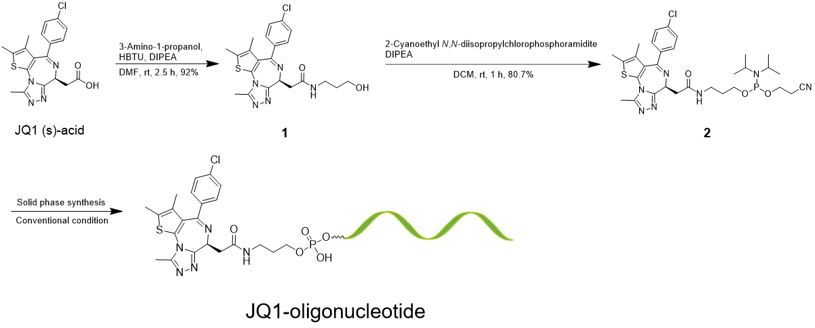

Supplementary Scheme 1. Synthesis of JQ1-oligonucleotide.

Compound 1
The JQ1 (s)-acid (300 mg, 0.75 mmol) was dissolved in 4 mL anhydrous DMF followed by additional 0.4 mL DIPEA (2.25 mmol) and 285 mg HBTU (0.75 mmol). The obtained mixture was placed at 0 ℃ for 10 min and mixed to 0.0636 mL 3-amino-1-propanol (0.825 mmol). The reaction was carried out for 2.5 hours at rt and washed with sat. aq. NaCl, then dried with Na₂SO₄. After evaporation of the solvent, the product was purified via MPLC with DCM/methanol 8:1 to give an orange solid. Yield: 562 mg (92 %). TLC (DCM/methanol 8:1): Rf = 0.36. ¹H NMR (400 MHz, DMSO-d₆) δ 8.20 (t, J = 5.7 Hz, NH, 1H), 7.57 – 7.48 (m, Aromatic-H, 2H), 7.47 – 7.41 (m, Aromatic-H, 2H), 4.52 (dd, J = 8.1, 6.1 Hz, OH, 1H), 4.45 (t, J = 5.2 Hz, CH, 1H), 3.64 (pd, J = 6.6, 3.9 Hz, CH, 1H), 3.46 (td, J = 6.4, 5.2 Hz, CH₂, 2H), 3.26 – 3.11 (m, CH + CH₂, 3H), 2.91 (s, CH₃, 3H), 2.75 (d, J = 0.7 Hz, CH₃, 3H), 2.61 (s, CH₃, 3H), 1.65 – 1.63 (m, CH₂, 2H). ¹³C NMR (126 MHz, DMSO-d₆) δ 172.39, 167.47, 153.03, 147.39, 138.96, 137.07, 135.53, 134.05, 132.15, 130.95, 129.26, 122.92, 60.88, 59.40, 43.28, 37.43, 32.15, 11.87, 10.18. HRMS calcd. for C₃₁H₄₃ClN₇O₃PS [M+H]⁺: 458.1334, found 458.1339.

Compound 2
To a flask of compound 1 (526 mg, 1.15 mmol), 10 mL ACN was added to carry out co-evaporation three times. The remained residue was dissolved in 7 mL anhydrous DCM followed by additional 0.88 mL DIPEA (5.0 mmol). The mixture was stirred at 0 ℃ for 10 min and 2-cyanoethoxy-N, N-diisopropylaminochlorophosphine (0.32 mL, 1.25 mmol) was added. The reaction was stirred for 30 min at 0 ℃ and 1 h at rt. Solution was washed with sat. aq. NaCl, then dried with Na₂SO₄. After evaporation of the solvent, the product was purified via recrystallization with 0.5% DCM in n-hexane to give a colorless solid. Yield: 610 mg (80.7 %). TLC (acetone/ethyl acetate 1:1): Rf = 0.32. ¹H NMR (400 MHz, DMSO-d₆) δ 8.25 (t, J = 5.6 Hz, NH, 1H), 7.51 – 7.48 (m, Aromatic-H, 2H), 7.43 (d, J = 6.6 Hz, Aromatic-H, 2H), 4.54 – 4.49 (m, CH, 1H), 4.26 – 3.95 (m, CH₂, 4H), 3.73 (dt, J = 6.9, 4.2 Hz, CH₂, 2H), 3.60 – 3.56 (m, CH + CH₂, 4H), 3.25 – 3.21 (m, CH₂, 2H), 2.91 (s, CH₃, 3H), 2.75 (s, CH₃, 3H), 2.61 (d, J = 1.2 Hz, CH₃, 3H), 1.75 (q, J = 6.7 Hz, CH₂, 2H), 1.17 – 1.11 (m, CH₃, 12H). ¹³C NMR (126 MHz, DMSO-d₆) δ 173.90, 169.54, 157.00, 147.57, 139.40, 137.22, 135.53, 132.85, 131.65, 130.67, 128.48, 120.03, 117.85, 63.77, 61.87, 59.90, 56.02, 44.97, 36.73, 33.35, 24.62, 21.52, 11.87, 10.18. ³¹P NMR (162 MHz, DMSO-d₆) δ 146.51, 146.49. HRMS calcd. for C₃₁H₄₂ClN₇O₃PS [M+H]⁺: 658.2468, found 658.2496.

JQ1-oligonucleotide
JQ1-oligonucleotide was prepared according to the conventional phosphoramidite protocol on a NTS H-6 DNA Synthesizer. After a standard procedure of ODN synthesis (20 min was used to incorporate JQ1 into oligonucleotide), the products were cleaved from CPG, followed by treatment of aqueous ammonia (28%) at rt for 48 h to remove the protecting groups. The crude ODNs were then purified by HPLC using the PLRP-S column (250 mm × 4.6 mm, 100 Å, 5 μm) after TBDMS-deprotection (when RNA was used). The aqueous solution of 0.05 M TEAA (triethylammonium acetate) with 50% CH₃CN was selected as buffer B, and the 0.05 M TEAA solution alone was selected as buffer A for the mobile phase. The ODNs were purified using a gradient of 20–80% buffer B over 30 min at a 1 mL/min flow rate. The purified products were collected, lyophilized, and then redissolved in water to remove salt by the NAP-10 before stored up at −20 °C for the following assays.

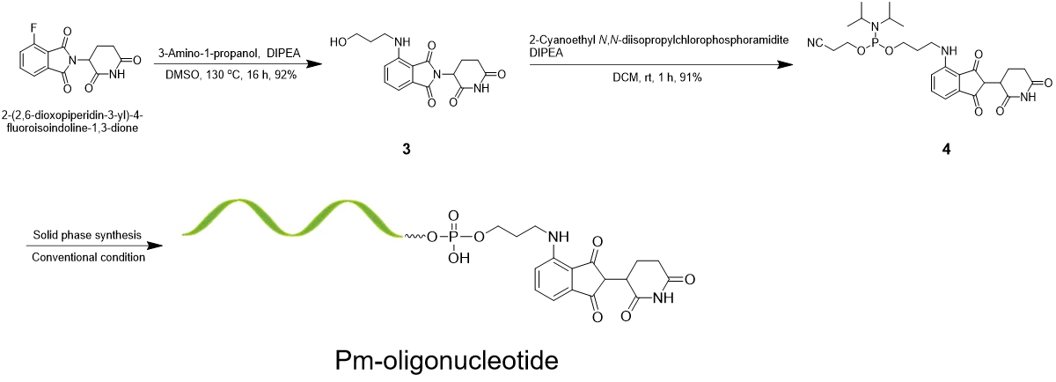
Supplementary Scheme 2. Synthesis of Pm-oligonucleotide.
Compound 3
The 2-(2,6-dioxopiperidin-3-yl)-4-fluoroisoindoline-1,3-dione (400 mg, 1.46 mmol) was dissolved in 4 mL DMSO followed by additional 0.78 mL DIPEA (4.36 mmol) and 0.135 mL 3-amino-1-propanol (1.75 mmol). The obtained mixture was placed at 130 ℃ for 16 hours and washed with sat. aq. NaCl, then dried with Na₂SO₄. After evaporation of the solvent, the product was purified via MPLC with DCM/ethyl acetate 1:3 to give a greenish solid. Yield: 315 mg (65.3 %). TLC (DCM/ethyl acetate 1:3): Rf = 0.29. ¹H NMR (400 MHz, DMSO-d₆) δ 11.11 (s, NH, 1H), 7.60 (dd, J = 8.6, 7.1 Hz, Aromatic-H, 1H), 7.08 (dd, J = 31.5, 7.8 Hz, Aromatic-H, 2H), 6.71 (d, J = 5.9 Hz, NH, 1H), 5.06 (dd, J = 9.8, 3.5 Hz, CH, 1H), 4.70 (dq, J = 12.9, 4.8 Hz, OH, 1H), 3.53 (q, J = 5.7 Hz, CH + CH₂, 5H), 2.89 (ddd, J = 18.5, 13.8, 4.9 Hz, CH₂, 1H), 2.71 – 2.56 (m, CH₂, 2H), 2.08 – 1.98 (m, CH₂, 2H), 1.74 (p, J = 6.4 Hz, CH₂, 2H). ¹³C NMR (126 MHz, DMSO-d₆) δ 175.38, 169.82, 168.34, 150.74, 135.74, 133.34, 117.15, 115.25, 113.27, 62.57, 59.90, 45.39, 35.53, 30.67, 22.01. HRMS calcd. for C₁₆H₁₇N₃O₅ [M-H]⁻: 332.1168, found 332.1162.

Compound 4
To a flask of compound 3 (427 mg, 1.29 mmol), 10 mL ACN was added to carry out co-evaporation three times. The remained residue was dissolved in 5 mL anhydrous DCM followed by additional 0.91 mL DIPEA (5.18 mmol). The mixture was stirred at 0 ℃ for 10 min and 2-cyanoethoxy-N, N-diisopropylaminochlorophosphine (0.36 mL, 1.42 mmol) was added. The reaction was stirred for 30 min at 0 ℃ and 1 h at rt. Solution was washed with sat. aq. NaCl, then dried with Na₂SO₄. After evaporation of the solvent, the product was purified via MPLC with DCM/ethyl acetate 1:3 to give a greenish solid. Yield: 626 mg (91 %). TLC (DCM/ethyl acetate 1:3): Rf = 0.86. ¹H NMR (400 MHz, DMSO-d₆) δ 11.11 (s, NH, 1H), 7.60 (dd, J = 8.6, 7.1 Hz, Aromatic-H, 1H), 7.08 (dd, J = 29.6, 7.8 Hz, Aromatic-H, 2H), 6.63 (t, J = 6.1 Hz, NH, 1H), 5.07 (dd, J = 12.9, 5.4 Hz, CH, 1H), 3.82 – 3.50 (m, CH₂, 6H), 3.42 (q, J = 8.2, 7.5 Hz, CH₂, 2H), 3.02 – 2.84 (m, CH, 2H), 2.78 (t, J = 5.9 Hz, CH₂, 2H), 2.65 – 2.54 (m, CH₂, 2H), 2.04 (ddt, J = 12.6, 5.6, 3.5 Hz, CH, 1H), 1.88 (p, J = 6.5 Hz, CH₂, 2H), 1.19 – 1.10 (m, CH₃, 10H), 0.96 (d, J = 6.5 Hz, CH₃, 8H). ¹³C NMR (126 MHz, DMSO-d₆) δ 198.55, 176.58, 148.76, 145.17, 142.99, 124.40, 120.03, 117.43, 64.26, 61.87, 58.21, 50.74, 44.48, 35.04, 32.36, 29.97, 24.90, 20.32. ³¹P NMR (162 MHz, DMSO-d₆) δ 146.41. HRMS calcd. for C₂₆H₃₆N₄O₆P [M+H]⁺: 531.2294, found 531.2364.

Pm-oligonucleotide
Pm-oligonucleotide was prepared according to the conventional phosphoramidite protocol on a NTS H-6 DNA Synthesizer. After a standard procedure of ODN synthesis (20 min was used to incorporate JQ1 into oligonucleotide), the products were cleaved from CPG, followed by treatment of aqueous ammonia (28%) at rt for 2 h to remove the protecting groups. The crude ODNs were then purified by HPLC using the PLRP-S column (250 mm × 4.6 mm, 100 Å, 5 μm) after TBDMS-deprotection (when RNA was used). The aqueous solution of 0.05 M TEAA (triethylammonium acetate) with 50% CH₃CN was selected as buffer B, and the 0.05 M TEAA solution alone was selected as buffer A for the mobile phase. The ODNs were purified using a gradient of 20–80% buffer B over 30 min at a 1 mL/min flow rate. The purified products were collected, lyophilized, and then redissolved in water to remove salt by the NAP-10 before stored up at −20 °C for the following assays.

Supplementary Scheme 3. Synthesis of compound 5.

Compound 5
The 2-(2,6-dioxopiperidin-3-yl)-4-fluoroisoindoline-1,3-dione (400 mg, 1.46 mmol) was dissolved in 4 mL DMSO followed by additional 0.78 mL DIPEA (4.36 mmol) and 253 mg 7-aminoheptanoic acid (1.75 mmol). The obtained mixture was placed at 130 ℃ for 16 hours and washed with sat. aq. NaCl, then dried with Na₂SO₄. After evaporation of the solvent, the product was purified via MPLC with DCM/methanol 10:1 to give a greenish solid. Yield: 94 mg (16.2 %). TLC (DCM/methanol 10:1): Rf = 0.79. ¹H NMR (500 MHz, DMSO-d₆) δ 11.07 (s, NH, 1H), 7.45 (s, NH, 1H), 6.99 (s, Aromatic-H, 2H), 6.49 (s, Aromatic-H, 2H), 5.04 (s, CH, 1H), 2.71 (t, J = 7.4 Hz, CH₂, 2H), 2.19 (d, J = 7.3 Hz, CH₂, 2H), 1.53 – 1.46 (m, CH₂, 4H), 1.31 – 1.24 (m, CH₂, 4H). ¹³C NMR (126 MHz, DMSO-d₆) δ 183.13, 176.09, 169.54, 165.45, 151.93, 136.23, 134.82, 118.34, 116.16, 111.37, 67.15, 54.62, 35.25, 31.87, 30.18, 26.80, 24.41, 21.03. HRMS calcd. for C₁₉H₂₂N₃O₆ [M+H]⁺: 388.1430, found 388.1510.

Supplementary Scheme 4. Synthesis of Pm-7OTD.

Pm-7OTD
Compound 5 (4.0 mg, 10 μmol) was dissolved in 400 μL DMF followed by additional 1.8 μL DIPEA (10 μmol) and 3.8 mg HBTU (10 μmol). Next, 7OTD (1.4 mg, 2 μmol) was added into above solution and the obtained mixture was placed at rt for 2.5 hours. The solvent was removed by evaporation to provide crude product as a residue which was purified by HPLC with 0-50 % ACN in H₂O with 0.05 M TEAA buffer. The target compound was given as a light yellow solid. Yield: 1.6 mg (80 %). TLC (DCM/methanol 10:1): Rf = 0.92. ¹H NMR (400 MHz, D₂O) δ 8.40 (m, 7OTD-NH, 6H), 7.85 (dd, J = 28.0, 8.8 Hz, NH, 2H), 7.71 (dd, J = 11.4, 4.7 Hz, Aromatic-H, 1H), 7.60 (s, Aromatic-H, 1H), 7.45 (s, Aromatic-H, 1H), 7.14 (d, J = 9.8 Hz, NH, 1H), 5.12 – 5.06 (m, CH₂, 2H), 3.27 (d, J = 7.3 Hz, CH, 1H), 2.98 (q, J = 7.3 Hz, CH₂, 4H), 2.91 (t, J = 7.7 Hz, CH₂, 1H), 2.82 – 2.77 (m, CH₂, 1H), 2.29 (t, J = 7.4 Hz, CH₂, 2H), 2.19 – 2.09 (m, CH₂, 2H), 1.56 (ddt, J = 38.8, 14.3, 7.3 Hz, CH₂, 8H), 1.07 (t, J = 7.3 Hz, CH₂, 4H). ¹³C NMR (126 MHz, DMSO-d₆) δ 178.06, 176.09, 173.20, 168.62, 163.55, 162.07, 159.40, 155.81, 147.57, 145.67, 143.27, 140.10, 134.54, 132.85, 130.17, 118.34, 114.05, 111.09, 66.16, 58.91, 54.33, 36.45, 33.56, 31.66, 29.69, 26.10, 23.42, 19.34. HRMS calcd. for C₄₇H₄₁N₁₂O₁₃ [M+H]⁺: 981.2838, found 981.2924.

Supplementary Scheme 5. Synthesis of compound 6.

Compound 6
2-(2,6-dioxopiperidin-3-yl)-4-fluoroisoindoline-1,3-dione (200 mg, 0.72 mmol), hexamethylenediamine (420 mg, 3.62 mmol) and DIPEA (0.64 mL, 3.62 mmol) were dissolved in 2 mL DMSO. The obtained mixture was placed at 110 ℃ for 13 hours. The solvent was removed by evaporation to provide crude product which was purified by MPLC with DCM/methanol 5:1 to give a greenish solid. Yield: 259 mg (96 %). TLC (DCM/methanol 4:1): Rf = 0.08. ¹H NMR (400 MHz, DMSO-d₆) δ 9.51 (s, NH, 1H), 7.94 (h, J = 6.4, 5.9 Hz, Aromatic-H, 1H), 7.87 – 7.74 (m, Aromatic-H, 1H), 7.53 (ddd, J = 9.7, 7.6, 5.6 Hz, Aromatic-H, 1H), 7.09 – 6.90 (m, NH₂, 2H), 6.48 (q, J = 6.3 Hz, NH, 1H), 3.96 (dd, J = 8.5, 4.5 Hz, CH, 1H), 3.50 (t, J = 7.0 Hz, CH₂, 2H), 3.07 – 3.04 (m, CH₂, 2H), 2.34 – 2.00 (m, CH₂, 3H), 1.93 – 1.76 (m, CH₂, 1H), 1.57 (tq, J = 14.2, 7.1, 5.5 Hz, CH₂, 4H), 1.40 (h, J = 8.9, 8.3 Hz, CH₂, 4H). ¹³C NMR (126 MHz, DMSO-d₆) δ 177.57, 173.20, 169.54, 147.36, 138.41, 135.74, 116.94, 115.25, 112.57, 67.85, 52.64, 46.66, 31.87, 28.00, 25.39, 22.50, 19.83. HRMS calcd. for C₁₉H₂₅N₄O₄ [M+H]⁺: 373.1798, found 373.1859.

Supplementary Scheme 6. Synthesis of Pm-TPP.

Pm-TPP
4-(10,15,20-triphenylporphyrin-5-yl)benzoic acid (50 mg, 0.076 mmol), HBTU (31.9 mg, 0.084 mmol) and DIPEA (26.8 μL, 0.152 mmol) were dissolved in 2 mL DMF. The obtained mixture was placed at 0 ℃ for 10 min. Next, compound 6 (31.3 mg, 0.084 mmol) was added and the reaction was kept for 2 hours at rt. The solvent was removed by evaporation and the residue was washed with sat. aq. NaCl, then dried with Na₂SO₄. After evaporation of the solvent, the product was purified via MPLC with methanol/DCM 1:10 to give a dark red solid. Yield: 11 mg (14.3 %). TLC (methanol/DCM 1:10): Rf = 0.43. ¹H NMR (400 MHz, DMSO-d₆) δ 9.51 (s, NH, 1H), 8.84 (s, Aromatic-H, 8H), 8.44 – 8.30 (m, Aromatic-H, Aromatic-H, 4H), 8.23 (d, J = 6.8 Hz, Aromatic-H, 5H), 8.02 – 7.70 (m, Aromatic-H, 10H), 6.99 (ddd, J = 28.2, 11.5, 6.8 Hz, Aromatic-H, 2H), 6.47 (t, J = 6.3 Hz, NH, 1H), 3.95 (dd, J = 8.6, 4.5 Hz, CH, 1H), 3.04 (td, J = 7.2, 6.6, 3.1 Hz, CH₂, 2H), 2.27 – 2.01 (m, CH₂, 2H), 1.83 (q, J = 5.2 Hz, CH₂, 2H), 1.55 (s, CH₂, 4H), 1.43 – 1.28 (m, CH₂, 11H). ¹³C NMR (126 MHz, DMSO-d₆) δ 177.07, 168.62, 167.43, 165.24, 150.45, 147.07, 144.96, 142.78, 137.71, 135.53, 134.33, 132.64, 131.65, 130.17, 127.08, 125.39, 123.41, 119.12, 117.85, 116.44, 114.96, 113.06, 67.15, 53.42, 44.97, 34.76, 32.64, 30.67, 26.80, 24.90, 22.72. HRMS calcd. for C₆₄H₅₃N₈O₅ [M+H]⁺: 1013.4099, found 1013.4159.

Supplementary Scheme 7. Synthesis of Cy3-TPP.

Compound 7
2,2,3-Trimethylindolenine (1.02 mL, 6.28 mmol) and 6-bromohexanoic acid (1.82 g, 9.0 mmol) were dissolved in 5 mL 1,2-dichlorobenzene. The obtained mixture was placed at 110 ℃ for 12 hours. Next, the precipitate was generated and filtered to give solid residue which was washed by 300 mL ethyl ester/ACN (1:1). The obtained residue was purified via MPLC with methanol/DCM 1:20 to give a pink solid. Yield: 530 mg (53 %). TLC (methanol/DCM 1:10): Rf = 0.59. ¹H NMR (400 MHz, DMSO-d₆) δ 8.02 (s, COOH, 1H), 7.93 – 7.79 (m, Aromatic-H, 1H), 7.69 – 7.52 (m, Aromatic-H, 2H), 4.48 (t, J = 7.7 Hz, CH₂, 2H), 2.87 (s, CH₃, 3H), 2.25 (t, J = 7.2 Hz, CH₂, 2H), 1.93 – 1.78 (m, CH₂, 2H), 1.56 (s, CH₂ + CH₃, 8H), 1.48 – 1.35 (m, CH₂, 2H). ¹³C NMR (126 MHz, DMSO-d₆) δ 194.47, 177.07, 146.37, 141.79, 129.75, 127.08, 123.91, 115.74, 58.70, 47.86, 36.94, 27.08, 24.19, 20.81, 10.89. HRMS calcd. for C₁₇H₂₄NO₂ [M]⁺: 274.1802, found 274.1796.

Compound 8
Compound 7 (995 mg, 2.82 mmol) and 2-(1,3,3-Trimethylindolin-2-ylidene)acetaldehyde (570 mg, 2.82 mmol) were dissolved in 15 mL acetic anhydride. The obtained mixture was placed at rt for 2.5 hours. Next, the solvent was evaporated to give a crude product which was purified via MPLC with methanol/DCM 1:15 to give a dark greenish solid. Yield: 1.1 g (73.2 %). TLC (methanol/DCM 1:10): Rf = 0.25. ¹H NMR (400 MHz, DMSO-d₆) δ 8.36 (t, J = 13.5 Hz, CH, 1H), 7.74 – 7.60 (m, Aromatic-H, 2H), 7.54 – 7.39 (m, Aromatic-H, 4H), 7.38 – 7.24 (m, Aromatic-H, 2H), 6.53 (d, J = 13.5 Hz, CH, 2H), 4.13 (t, J = 7.5 Hz, CH₂, 2H), 3.68 (s, CH₃, 3H), 3.18 (s, CH₃, 3H), 2.18 (t, J = 7.2 Hz, CH₂, 2H), 1.78 – 1.73 (m, CH₂, 2H), 1.71 (s, CH₃, 12H), 1.58 (p, J = 7.1 Hz, CH₂, 2H), 1.44 (ddt, J = 15.2, 10.2, 6.0 Hz, CH₂, 2H).¹³C NMR (126 MHz, DMSO-d₆) δ 177.28, 174.89, 173.69, 149.75, 145.88, 144.96, 143.48, 129.96, 128.27, 126.58, 124.19, 123.41, 117.43, 116.16, 112.57, 111.09, 58.49, 57.22, 54.12, 37.71, 36.24, 29.97, 28.28, 25.88, 24.41, 22.50. HRMS calcd. for C₃₀H₃₇N₂O₂ [M]⁺: 457.2850, found 457.2838.

Compound 9
Compound 8 (1.1 g, 2.06 mmol), HBTU (778.2 mg, 2.06 mmol) and DIPEA (0.54 mL, 3.09 mmol) were dissolved in 15 mL anhydrous DMF. The obtained mixture was allowed to stir at 0℃ for 10 min. Next, 1,3-diaminopropane (0.88 mL, 10.30 mmol) and DIPEA (0.36 mL, 2.06 mmol) were added into above solution. The mixture was reacted at rt for 2.5 hours. The solvent was removed by evaporation and the residue was washed with sat. aq. NaCl, then dried with Na₂SO₄. After evaporation of the solvent, the product was purified via MPLC with methanol/DCM 1:10 to give a dark red solid. Yield: 932 mg (76 %). TLC (methanol/DCM 1:10): Rf = 0.49. ¹H NMR (400 MHz, DMSO-d₆) δ 8.36 (t, J = 13.5 Hz, CH, 1H), 7.77 (t, J = 5.6 Hz, NH, 1H), 7.66 (dt, J = 8.1, 1.1 Hz, Aromatic-H, 2H), 7.54 – 7.42 (m, Aromatic-H, 4H), 7.32 (dtd, J = 7.9, 5.6, 2.5 Hz, Aromatic-H, 2H), 6.49 (d, J = 13.4 Hz, CH, 2H), 4.43 (t, J = 5.2 Hz, NH₂, 1H), 4.12 (t, J = 7.5 Hz, CH₂, 2H), 3.68 (s, CH₃, 3H), 3.39 (td, J = 6.3, 5.2 Hz, CH₂, 2H), 3.07 (q, J = 6.6 Hz, CH₂, 2H), 2.08 (t, J = 7.2 Hz, CH₂, 2H), 1.71 (s, CH₃, 12H), 1.55 (dp, J = 26.6, 7.0 Hz, CH₂, 4H), 1.46 – 1.31 (m, CH₂, 2H). ¹³C NMR (126 MHz, DMSO-d₆) δ 178.97, 175.59, 150.74, 147.85, 145.38, 142.99, 130.46, 129.26, 127.29, 125.10, 122.92, 118.63, 115.74, 109.19, 105.11, 63.07, 58.91, 57.71, 37.71, 36.02, 33.56, 32.36, 30.95, 28.00, 27.08, 23.70, 21.24. HRMS calcd. for C₃₃H₄₆N₄O [M+H]⁺: 514.3588, found 514.3640.

Cy3-TPP
4-(10,15,20-triphenylporphyrin-5-yl)benzoic acid (92 mg, 0.14 mmol), HBTU (58.5 mg, 0.154 mmol) and DIPEA (49.1 μL, 0.279 mmol) were dissolved in 4 mL DMF. The obtained mixture was placed at 0 ℃ for 10 min. Next, compound 9 (100 mg, 0.154 mmol) was added and the reaction was kept for 2 hours at rt. The solvent was removed by evaporation and the residue was washed with sat. aq. NaCl, then dried with Na₂SO₄. After evaporation of the solvent, the product was purified via MPLC with methanol/DCM 1:20 to give a dark red solid. Yield: 38.6 mg (22.8 %). TLC (methanol/DCM 1:10): Rf = 0.49. ¹H NMR (400 MHz, DMSO-d₆) δ 9.42 (s, Aromatic-H, 8H), 8.92 – 8.80 (m, Aromatic-H, 4H), 8.75 (dd, J = 7.5, 1.9 Hz, Aromatic-H, 6H), 8.36 (t, J = 13.5 Hz, CH, 1H), 8.12 – 7.96 (m, Aromatic-H, 10H), 7.79 (t, J = 5.6 Hz, NH, 1H), 7.71 – 7.60 (m, Aromatic-H, 2H), 7.55 – 7.40 (m, Aromatic-H, 4H), 7.39 – 7.26 (m, Aromatic-H, 2H), 6.49 (d, J = 13.4 Hz, CH₂, 2H), 4.12 (t, J = 7.6 Hz, CH₂, 2H), 3.72 (ddt, J = 10.3, 7.8, 5.8 Hz, CH₂, 2H), 3.68 (s, CH₂, 2H), 3.62 – 3.51 (m, CH₂, 3H), 3.09 (q, J = 6.6 Hz, CH₂, 2H), 2.77 (t, J = 5.9 Hz, CH₂, 2H), 2.08 (t, J = 7.2 Hz, CH₂, 2H), 1.60 (dq, J = 28.3, 6.8 Hz, CH₂, 4H), 1.40 (d, J = 7.5 Hz, CH₂, 2H), 1.21 – 1.08 (m, CH₃, 9H). ¹³C NMR (126 MHz, DMSO-d₆) δ 178.27, 176.37, 175.10, 153.41, 151.72, 150.24, 147.36, 145.38, 143.48, 141.58, 138.91, 137.71, 136.02, 134.54, 132.64, 131.16, 129.96, 128.98, 128.48, 128.27, 126.58, 125.88, 125.60, 123.91, 123.20, 122.01, 120.53, 118.63, 116.65, 113.06, 107.71, 104.33, 57.71, 56.31, 53.42, 36.94, 35.53, 32.15, 30.46, 28.77, 27.08, 26.10, 22.22. HRMS calcd. for C₇₈H₇₄N₈O₂ [M]⁺: 1154.3851, found 1154.3600.

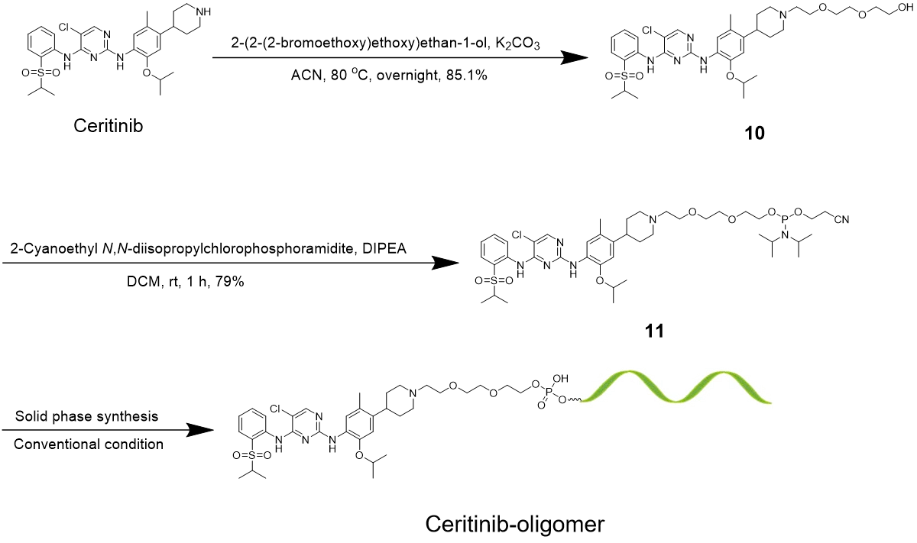
Supplementary Scheme 8. Synthesis of ceritinib-oligonucleotide.

Compound 10
Ceritinib (0.5 g, 0.9 mmol) was co-evaporated with 15 mL anhydrous ACN by three times and dissolved in 5 mL anhydrous ACN. 2-(2-(2-bromoethoxy)ethoxy)ethan-1-ol (0.18 mL, 1.08 mmol) and anhydrous K₂CO₃ (373 mg, 2.70 mmol) were added into above solution. The obtained mixture was allowed to stir at 80℃ overnight. Next, suspension was filtered and the filtration was evaporated. The product was purified via MPLC with methanol/DCM 1:10 to give a colorless solid. Yield: 528 mg (85.1 %). TLC (methanol/DCM 1:7): Rf = 0.15. ¹H NMR (400 MHz, DMSO-d₆) δ 9.46 (s, NH, 1H), 8.47 (d, J = 8.4 Hz, NH, 1H), 8.24 (s, Aromatic-H, 1H), 8.03 (s, Aromatic-H, 1H), 7.84 (dd, J = 7.9, 1.6 Hz, Aromatic-H, 1H), 7.65 – 7.58 (m, Aromatic-H, 1H), 7.52 (s, Aromatic-H, 1H), 7.39 – 7.29 (m, Aromatic-H, 1H), 6.85 (s, Aromatic-H, 1H), 4.58 (p, J = 6.0 Hz, CH, 1H), 3.57 – 3.47 (m, CH₂, 8H), 3.44 (t, J = 5.3 Hz, CH₂, 2H), 3.00 (dt, J = 11.8, 3.4 Hz, CH₂, 2H), 2.60 (tt, J = 10.6, 5.1 Hz, CH, 1H), 2.16 – 2.03 (m, CH + CH₂, 5H), 1.65 (tt, J = 8.4, 3.7 Hz, CH₂, 4H), 1.19 (dd, J = 29.0, 6.4 Hz, CH₃, 12H). ¹³C NMR (126 MHz, DMSO-d₆) δ 158.48, 155.86, 155.31, 147.08, 139.98, 138.51, 135.28, 131.39, 127.09, 126.86, 124.88, 124.19, 124.10, 124.02, 112.06, 104.71, 79.65, 72.83, 71.10, 70.24, 70.19, 68.98, 60.72, 58.14, 55.31, 54.95, 38.13, 32.87, 22.38, 19.39, 18.83, 15.32. HRMS calcd. for C₃₄H₄₉ClN₅O₆S [M+H]⁺: 690.3014, found 690.3046.

Compound 11
To a flask of compound 10 (520 mg, 0.75 mmol), 10 mL ACN was added to carry out co-evaporation three times. The remained residue was dissolved in 5 mL anhydrous DCM followed by additional 0.39 mL DIPEA (2.26 mmol). The mixture was stirred at 0 ℃ for 10 min and 2-cyanoethoxy-N, N-diisopropylaminochlorophosphine (0.20 mL, 0.825 mmol) was added. The reaction was stirred for 30 min at 0 ℃ and 1 h at rt. Solution was washed with sat. aq. NaCl, then dried with Na₂SO₄. After evaporation of the solvent, the product was purified via MPLC with DCM/ethyl acetate 1:3 to give a greenish solid. Yield: 526 mg (79 %). TLC (100% Ethyl acetate): Rf = 0.10. ¹H NMR (500 MHz, DMSO-d₆) δ 9.47 (s, NH, 1H), 8.47 (d, J = 8.4 Hz, NH, 1H), 8.25 (s, Aromatic-H, 1H), 8.06 (s, Aromatic-H, 1H), 7.84 (dd, J = 7.9, 1.6 Hz, Aromatic-H, 1H), 7.65 – 7.57 (m, Aromatic-H, 1H), 7.51 (d, J = 8.4 Hz, Aromatic-H, 1H), 7.35 (t, J = 7.6 Hz, Aromatic-H, 1H), 6.84 (s, Aromatic-H, 1H), 4.56 (p, J = 6.0 Hz, CH, 1H), 3.77 – 3.69 (m, CH₂, 2H), 3.69 – 3.60 (m, CH₂, 2H), 3.56 (dt, J = 14.7, 5.2 Hz, CH₂, 10H), 3.48 – 3.40 (m, CH₂, 2H), 3.07 (s, CH, 1H), 2.89 (t, J = 5.9 Hz, CH, 1H), 2.77 (t, J = 5.9 Hz, CH, 2H), 2.69 – 2.59 (m, CH₂, 2H), 2.12 (s, CH₃, 3H), 1.71 (d, J = 31.3 Hz, CH₂, 4H), 1.24 – 1.12 (m, CH₃, 28H). ¹³C NMR (126 MHz, DMSO-d₆) δ 158.47, 155.87, 155.32, 147.11, 138.50, 135.28, 131.40, 126.92, 124.89, 124.25, 124.10, 124.02, 119.48, 112.04, 104.72, 71.13, 71.00, 70.94, 70.30, 70.18, 62.95, 62.82, 58.81, 58.67, 55.38, 55.30, 45.00, 44.95, 42.98, 42.88, 24.86, 24.83, 24.80, 24.78, 23.08, 23.06, 22.53, 22.37, 20.31, 20.25, 18.82, 15.31. ³¹P NMR (162 MHz, DMSO-d₆) δ 147.37, 147.46. HRMS calcd. for C₄₃H₆₆ClN₇O₇PS [M+H]⁺: 890.4092, found 890.4135.

Ceritinib-oligonucleotide
Ceritinib-oligonucleotide was prepared according to the conventional phosphoramidite protocol on a NTS H-6 DNA Synthesizer. After a standard procedure of ODN synthesis (20 min was used to incorporate ceritinib into oligonucleotide), the products were cleaved from CPG, followed by treatment of aqueous ammonia (28%) at rt for 48 h to remove the protecting groups. The crude ODNs were then purified by HPLC using the PLRP-S column (250 mm × 4.6 mm, 100 Å, 5 μm) after TBDMS-deprotection (when RNA was used). The aqueous solution of 0.05 M TEAA (triethylammonium acetate) with 50% CH₃CN was selected as buffer B, and the 0.05 M TEAA solution alone was selected as buffer A for the mobile phase. The ODNs were purified using a gradient of 20–80% buffer B over 30 min at a 1 mL/min flow rate. The purified products were collected, lyophilized, and then redissolved in water to remove salt by the NAP-10 before stored up at −20 °C for the following assays.

NMR and MS Characterization of synthetic compounds

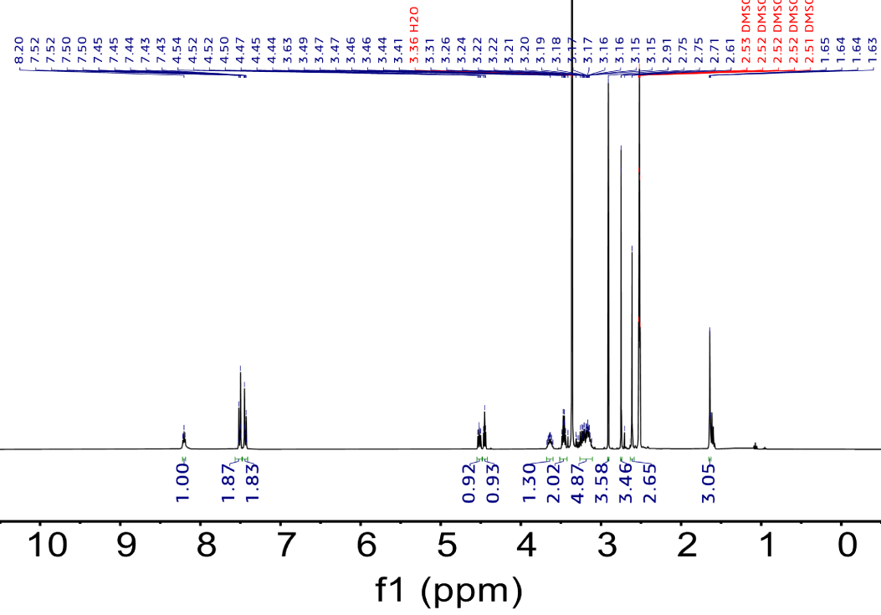
Supplementary Fig. 20. ¹H NMR spectra of compound 1.

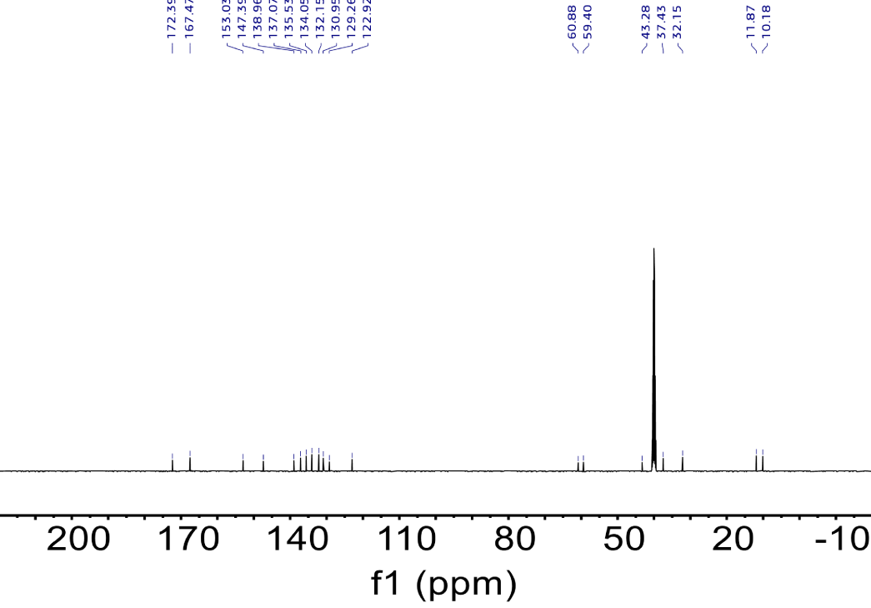
Supplementary Fig. 21. ¹³C NMR spectra of compound 1.
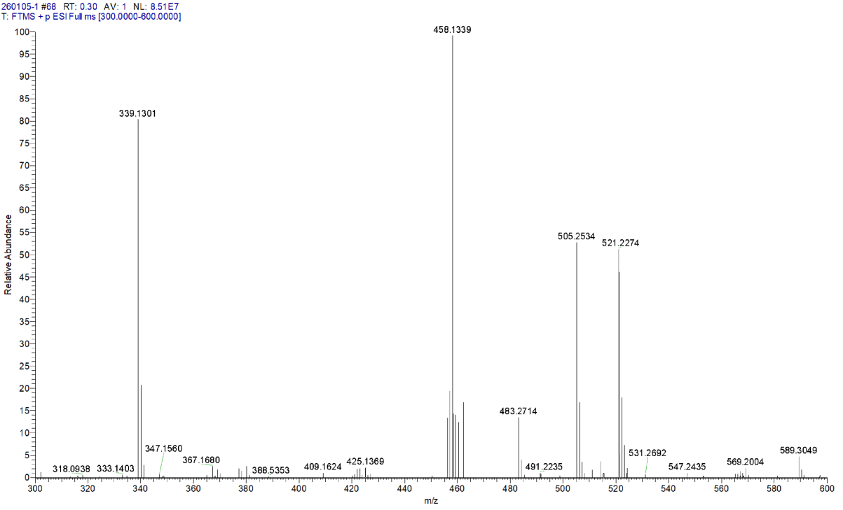
Supplementary Fig. 22. MALDI-TOF MS of compound 1.

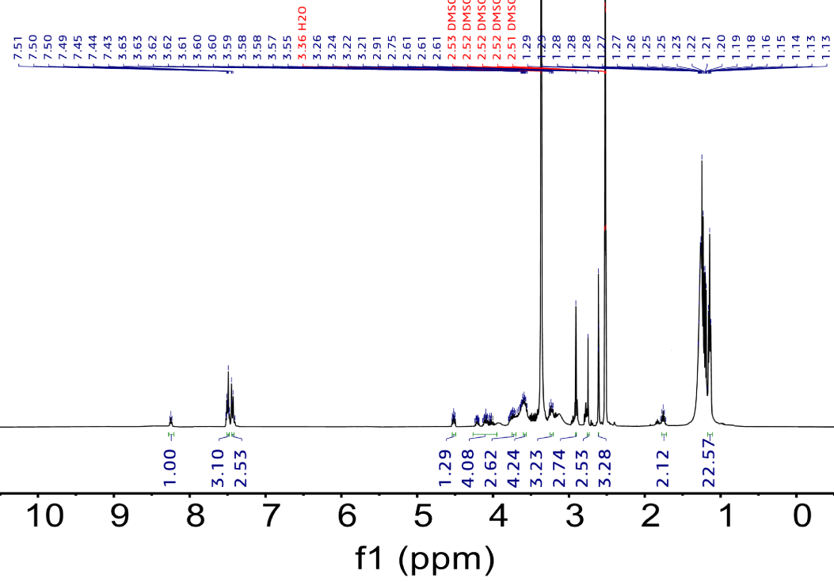
Supplementary Fig. 23. ¹H NMR spectra of compound 2.

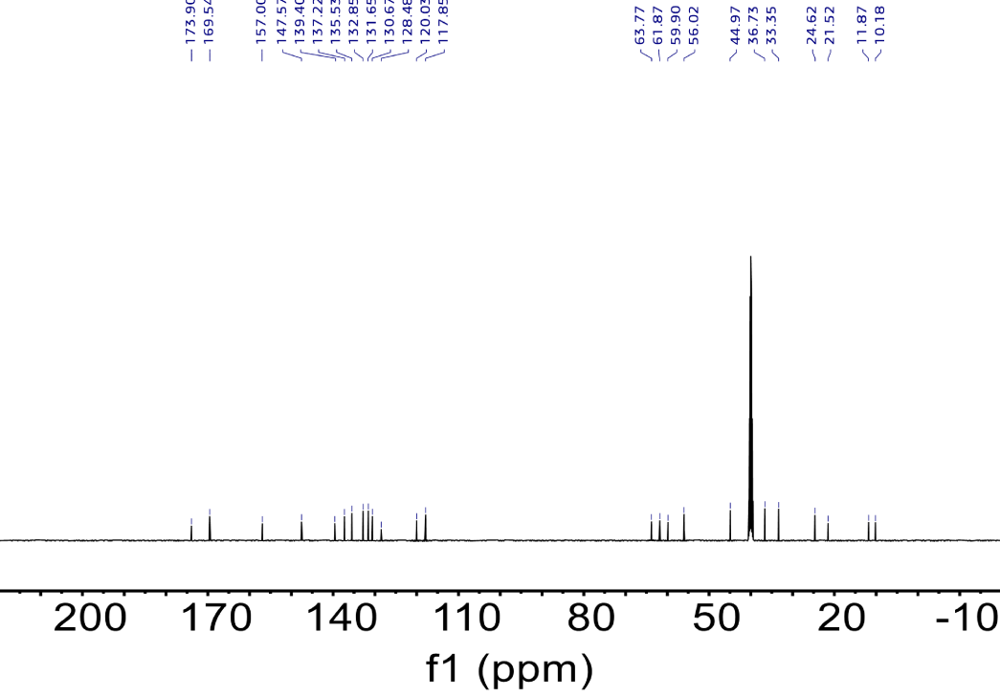
Supplementary Fig. 24. ¹³C NMR spectra of compound 2.

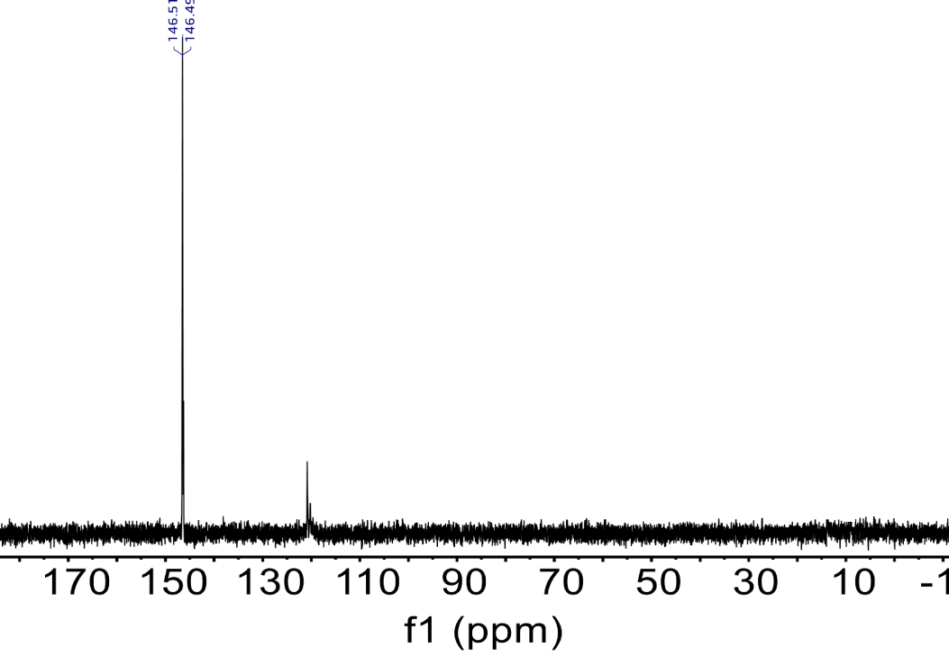
Supplementary Fig. 25. ³¹P NMR spectra of compound 2.

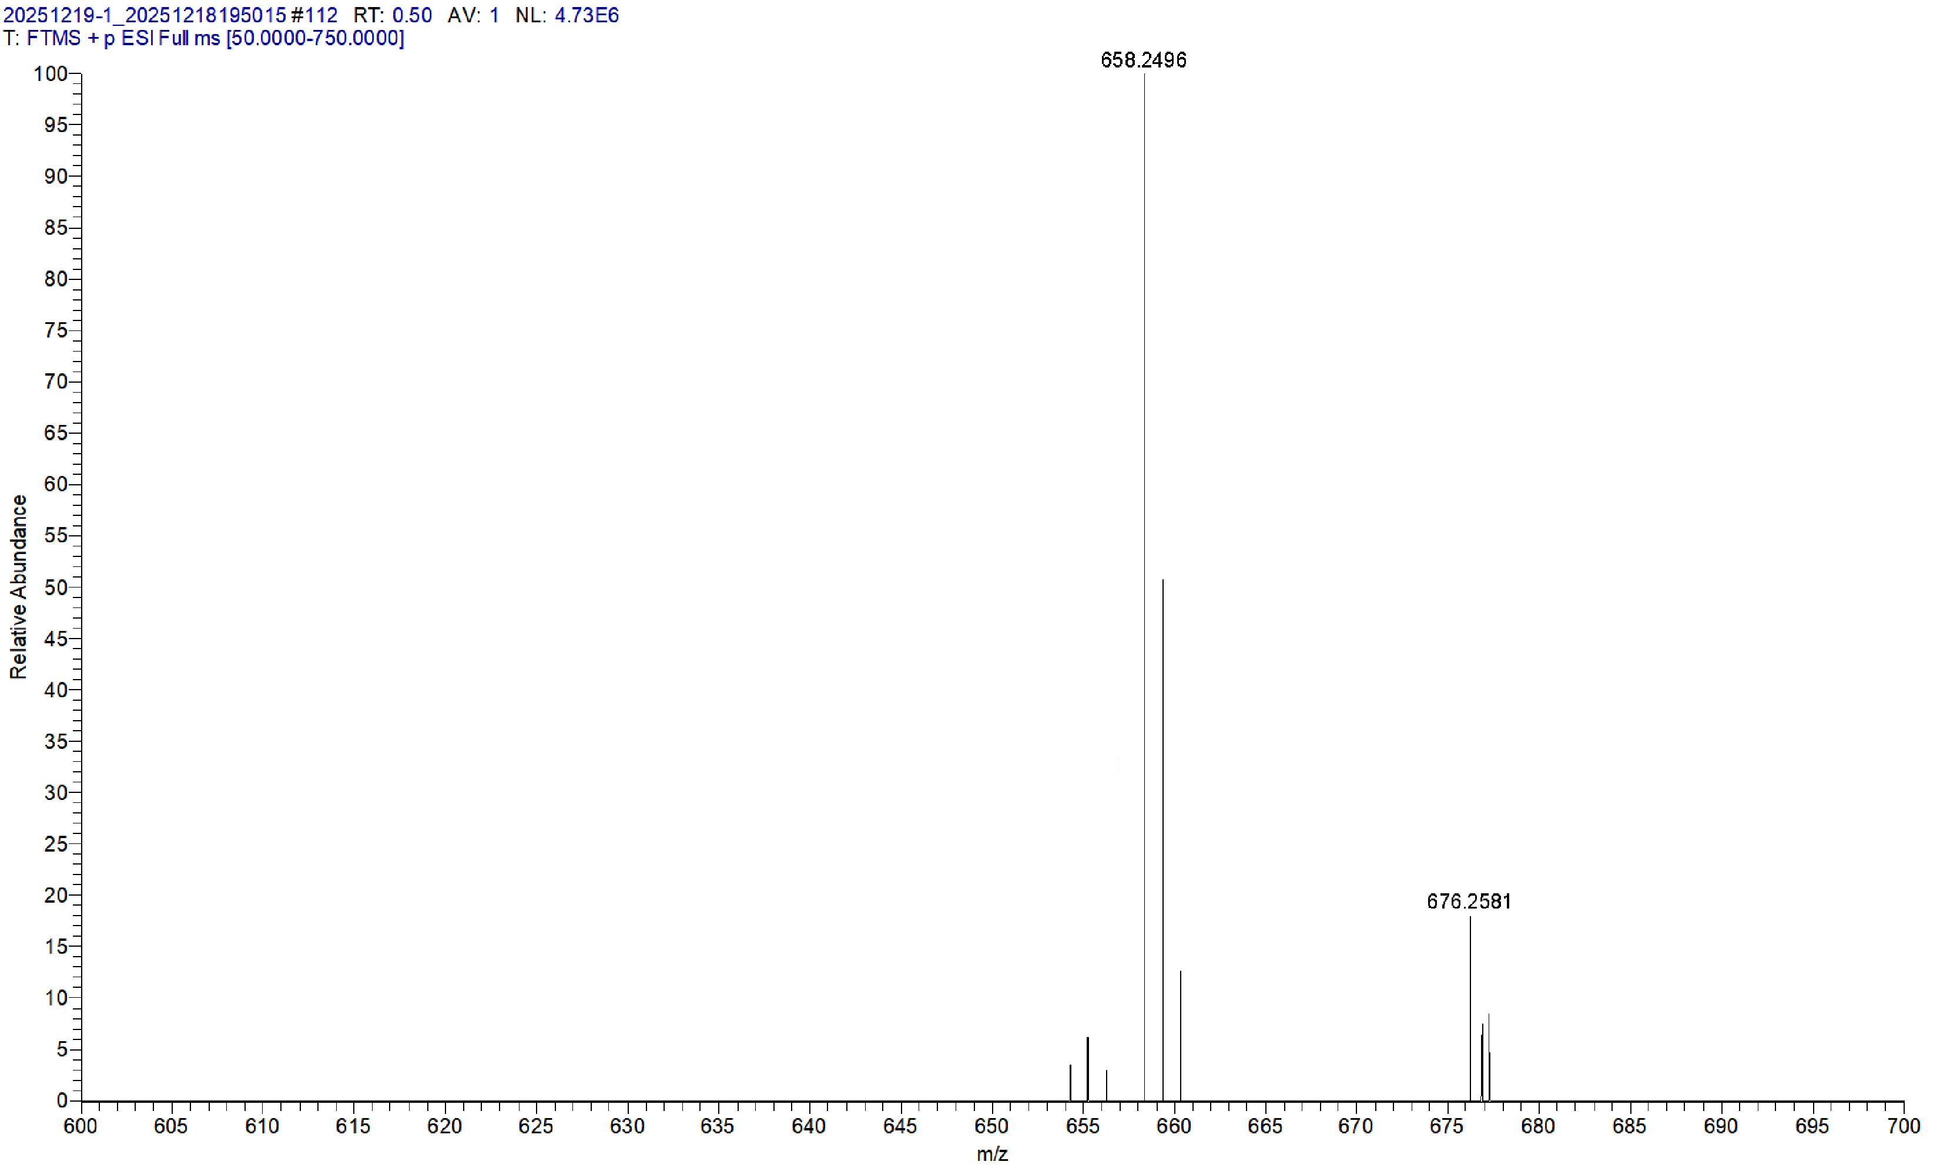
Supplementary Fig. 26. HRMS of compound 2.

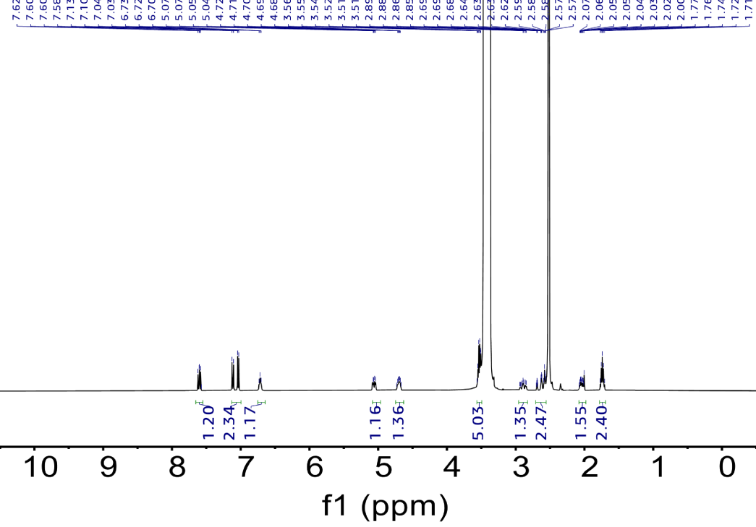
Supplementary Fig. 27. ¹H NMR spectra of compound 3.

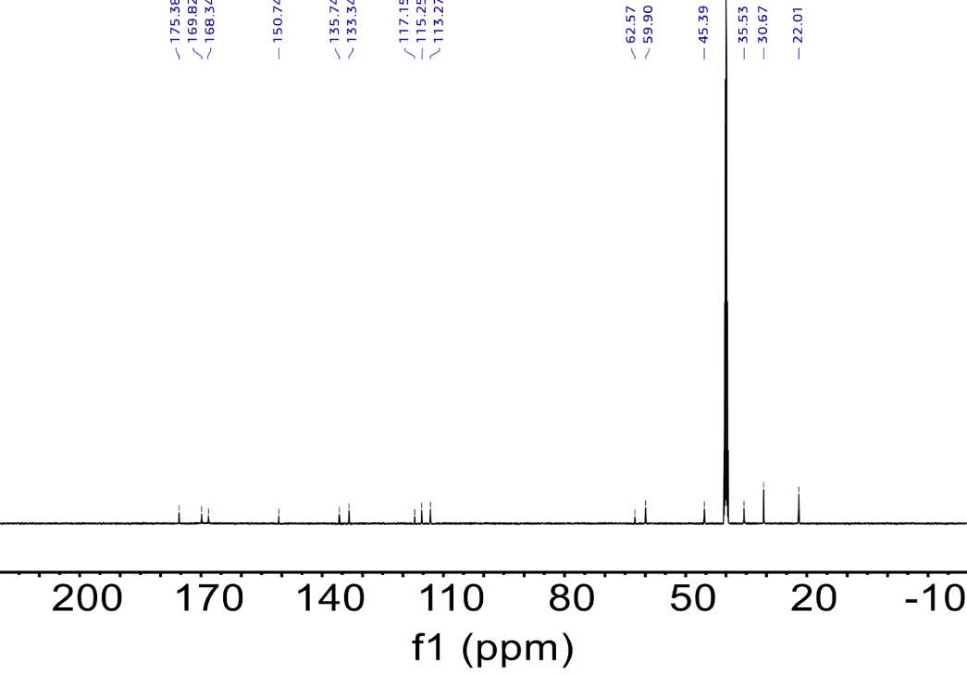
Supplementary Fig. 28. ¹³C NMR spectra of compound 3.

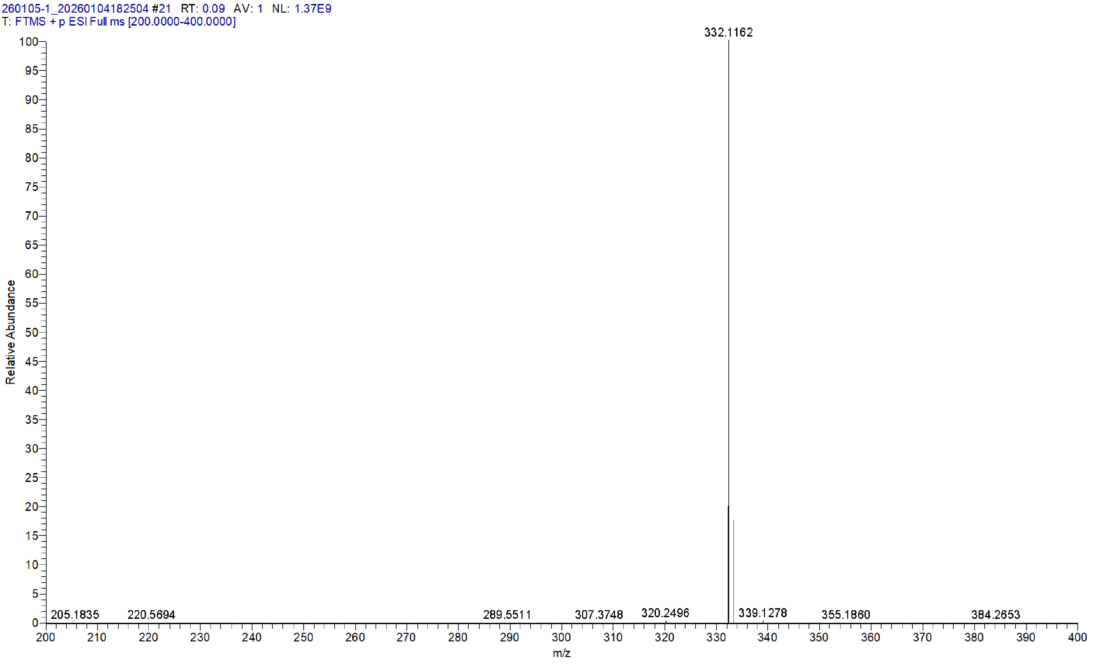
Supplementary Fig. 29. MALDI-TOF MS of compound 3.

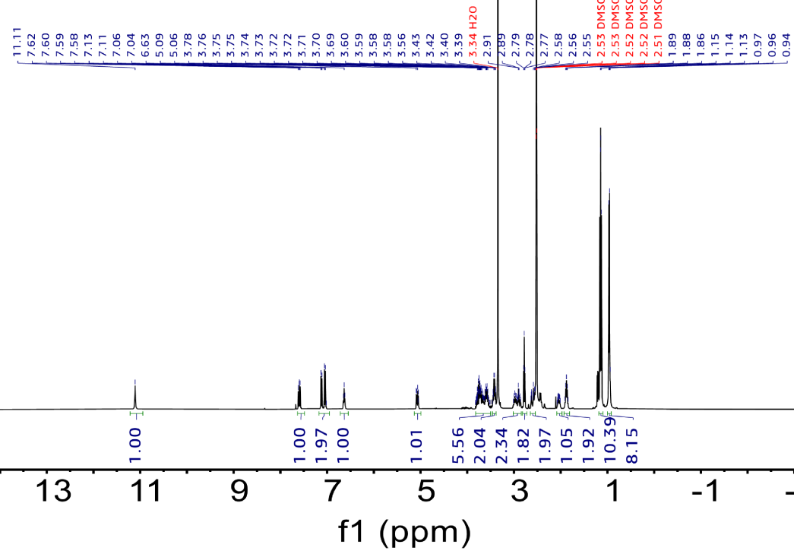
Supplementary Fig. 30. ¹H NMR spectra of compound 4.

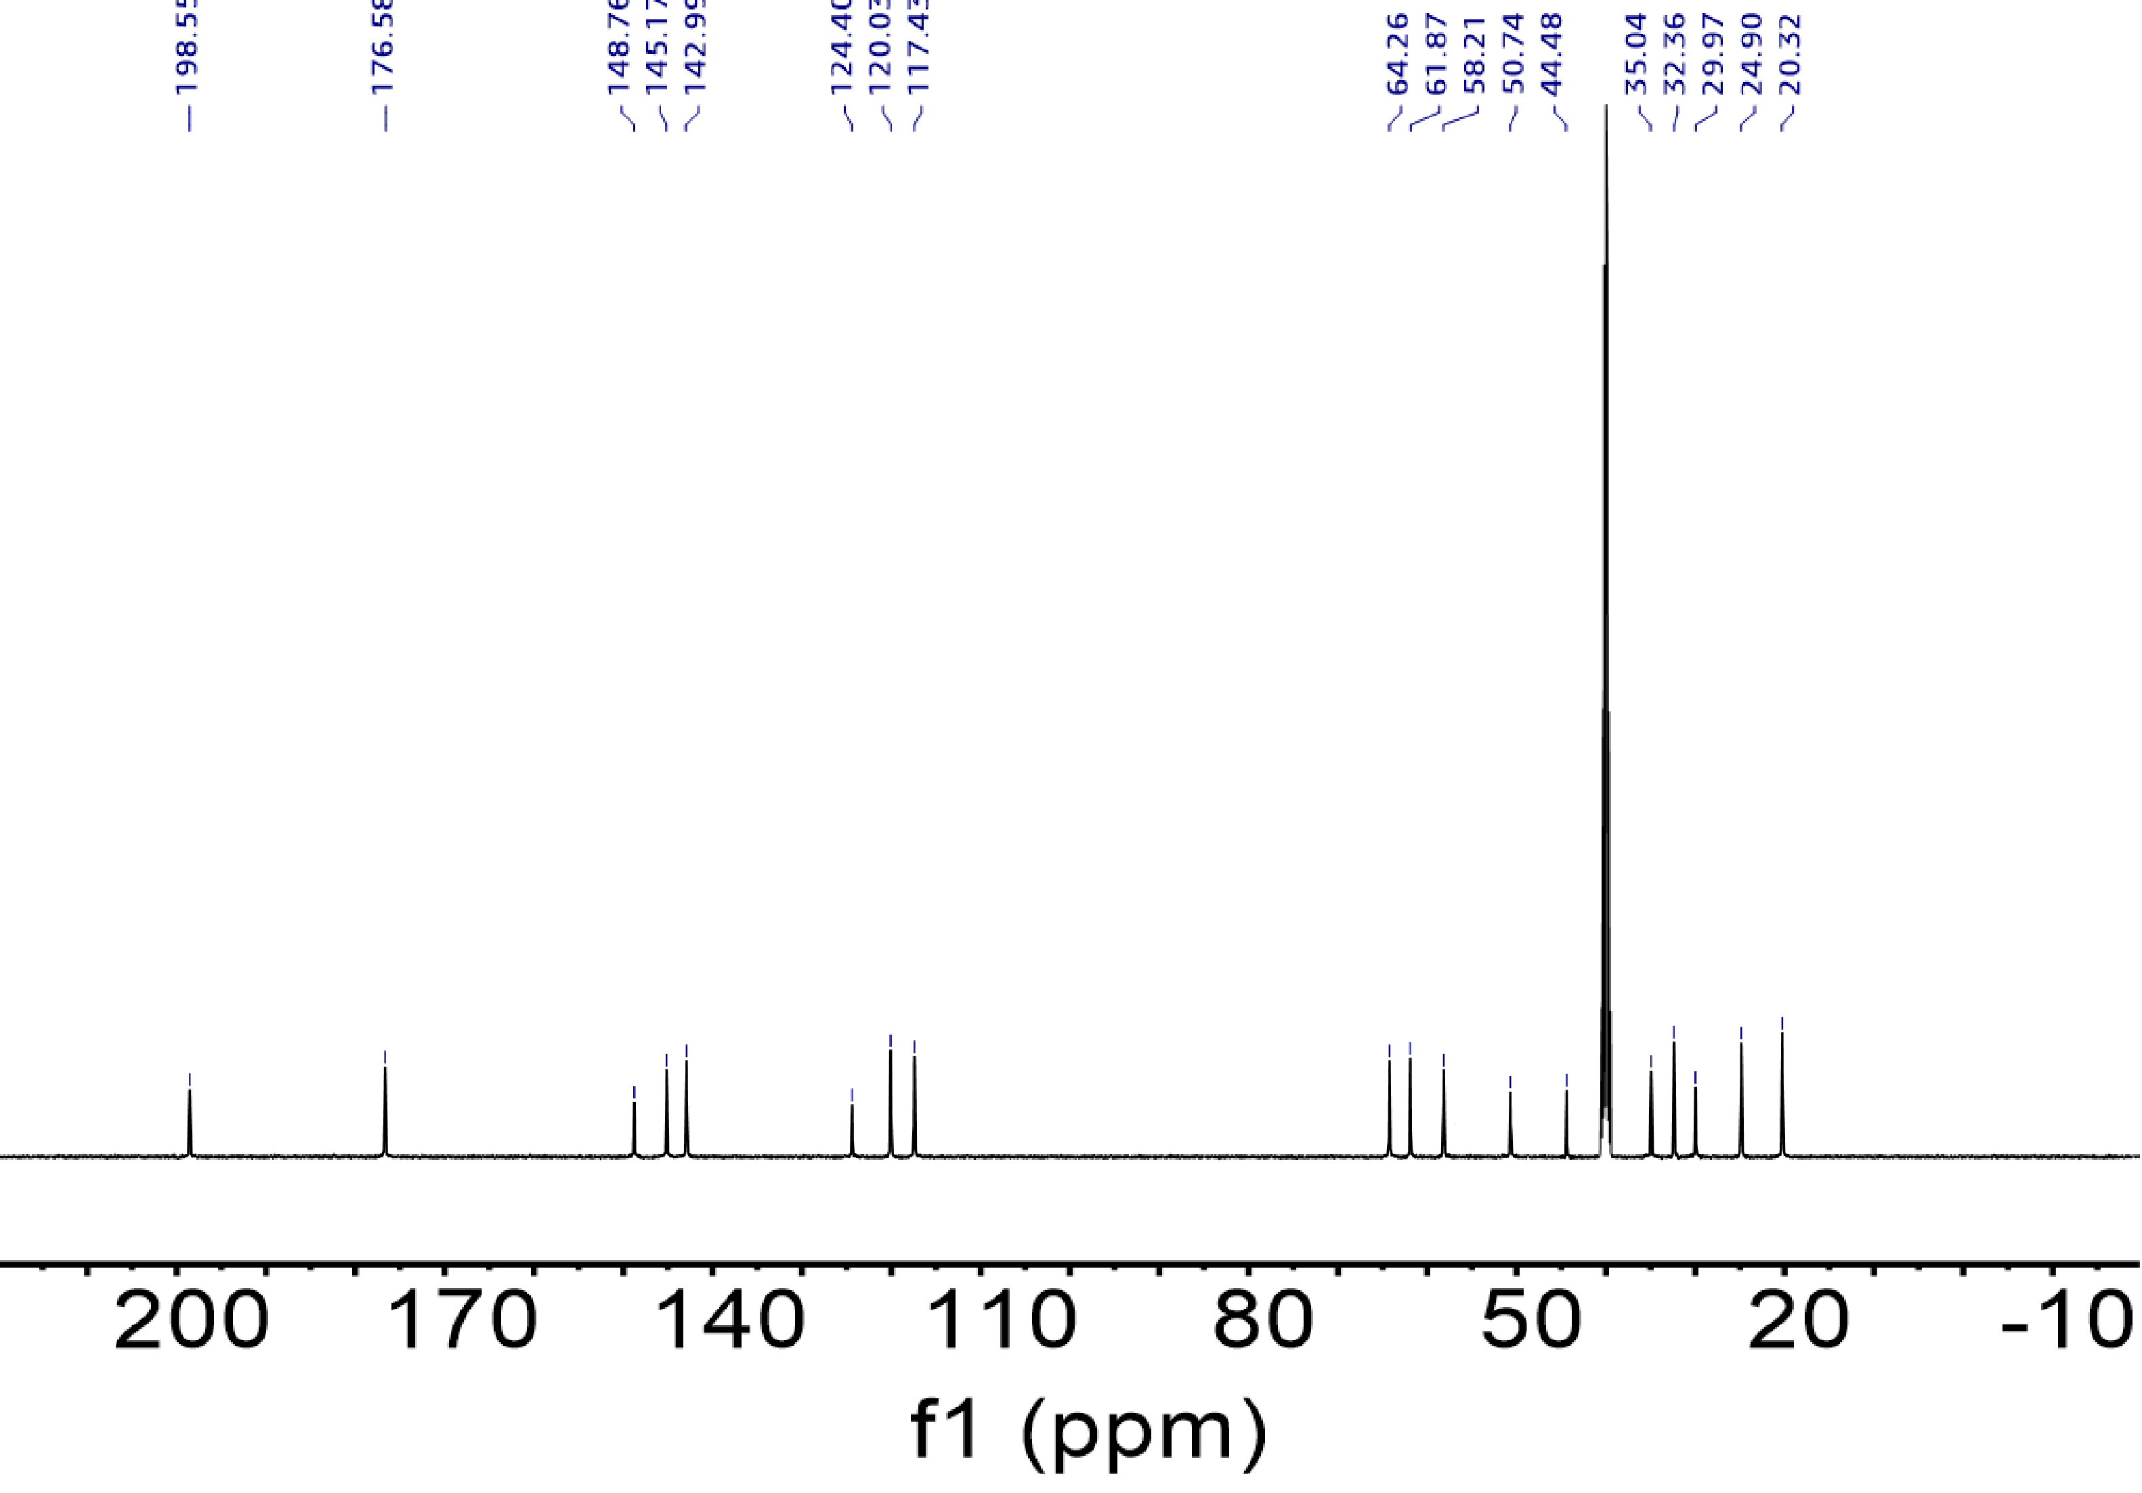
Supplementary Fig. 31. ¹³C NMR spectra of compound 4.

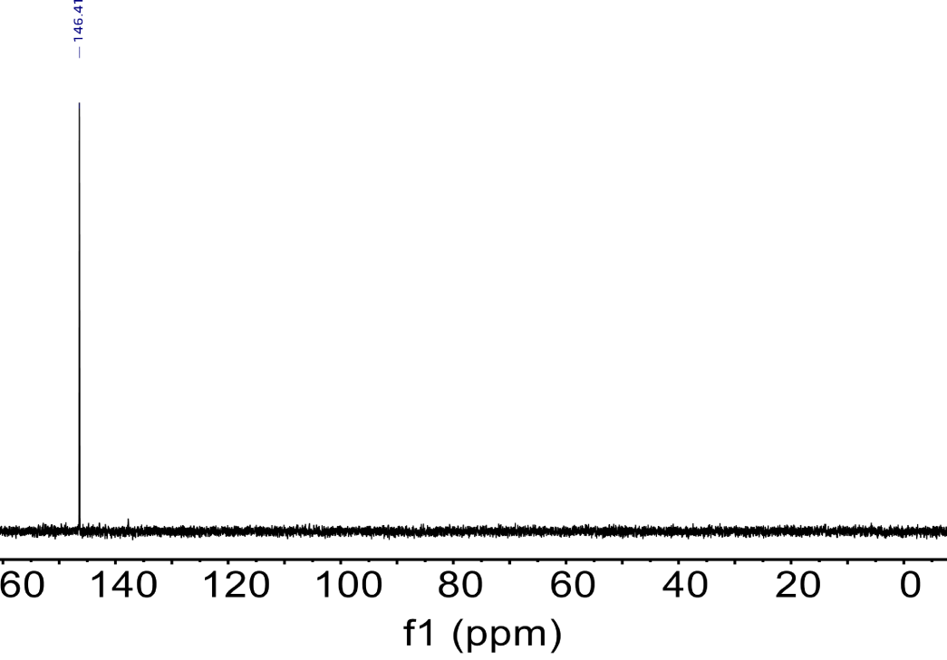
Supplementary Fig. 32. ³¹P NMR spectra of compound 4.

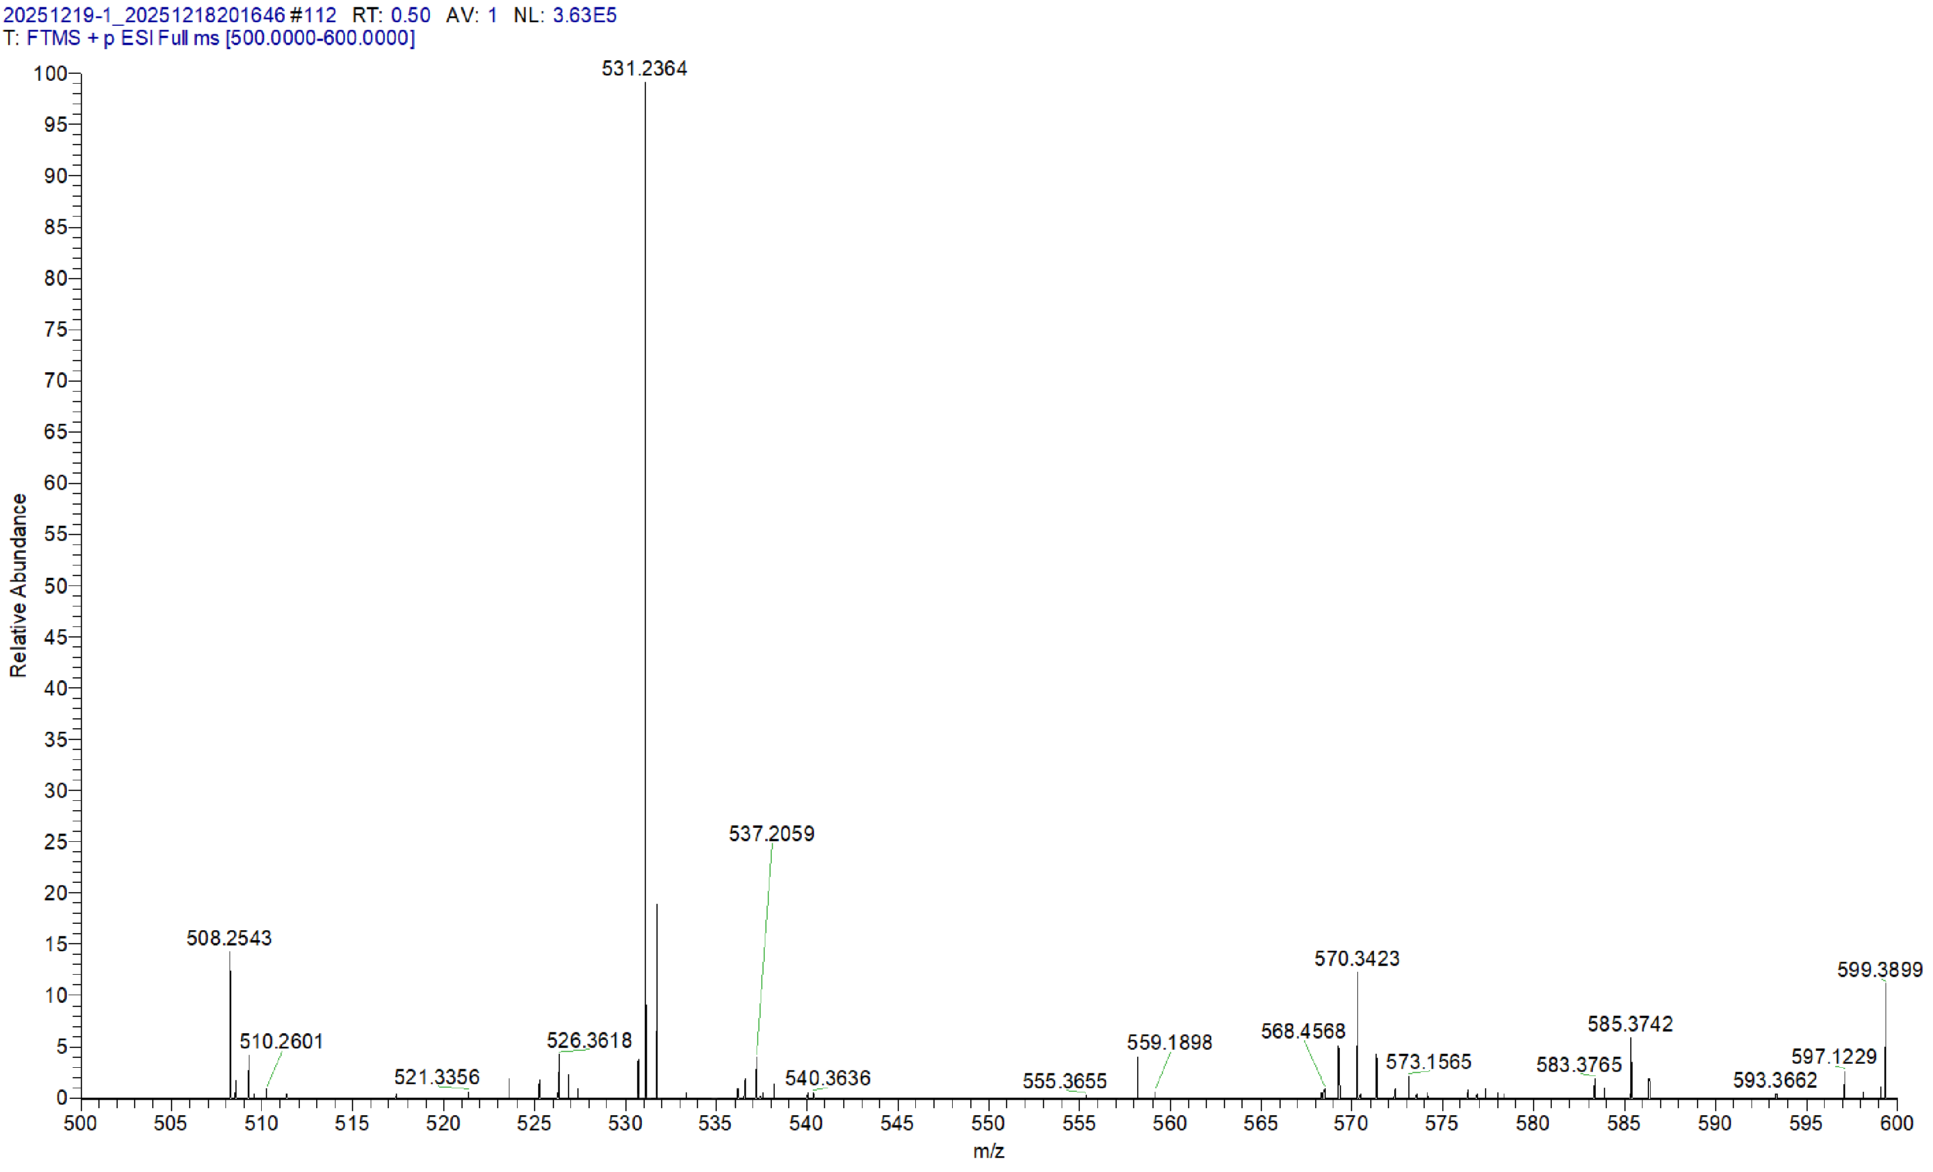
Supplementary Fig. 33. HRMS of compound 4.

Supplementary Fig. 34. ¹H NMR spectra of compound 5.

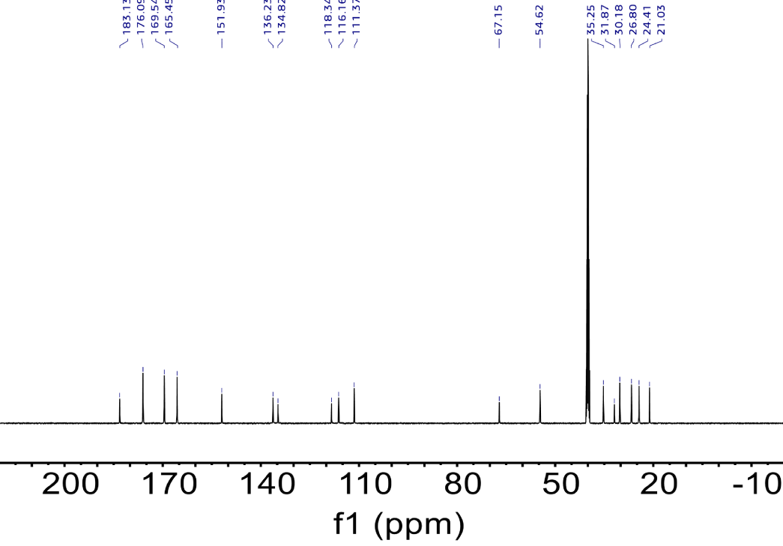
Supplementary Fig. 35. ¹³C NMR spectra of compound 5.

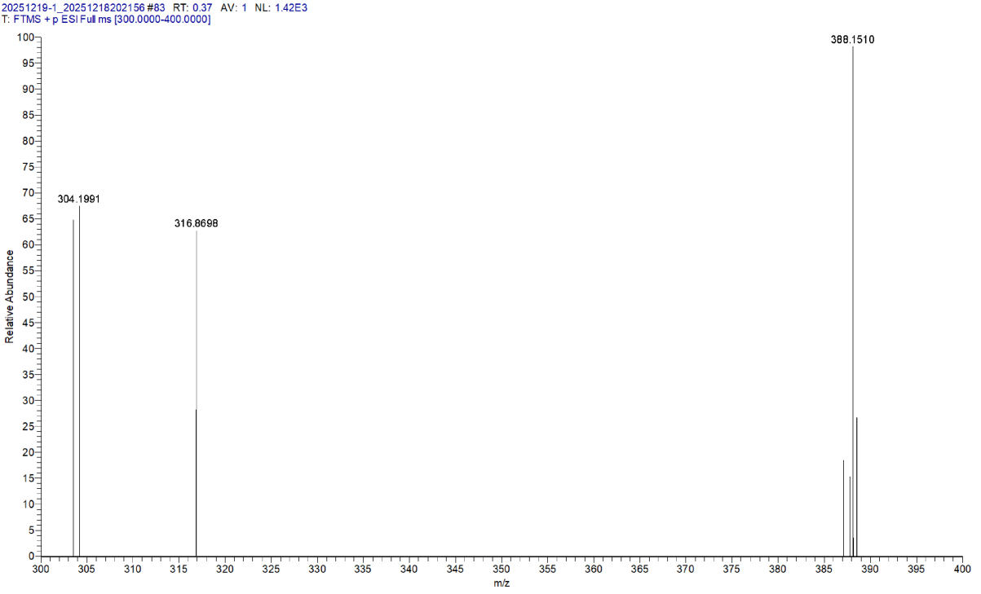
Supplementary Fig. 36. HRMS of compound 5.

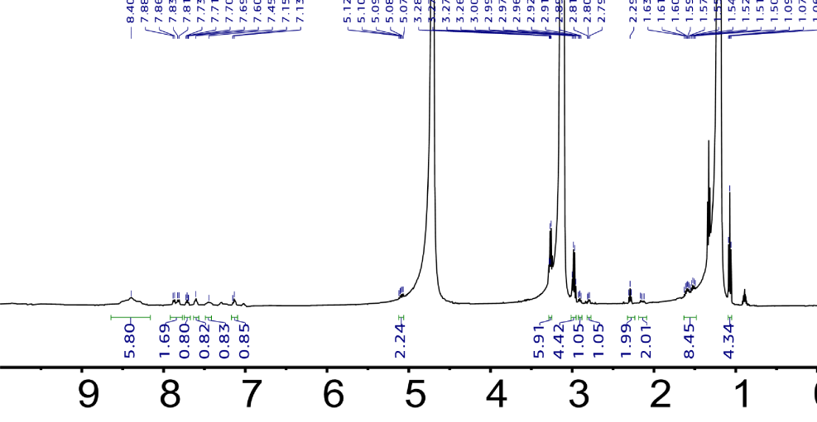
Supplementary Fig. 37. ¹H NMR spectra of Pm-7OTD.

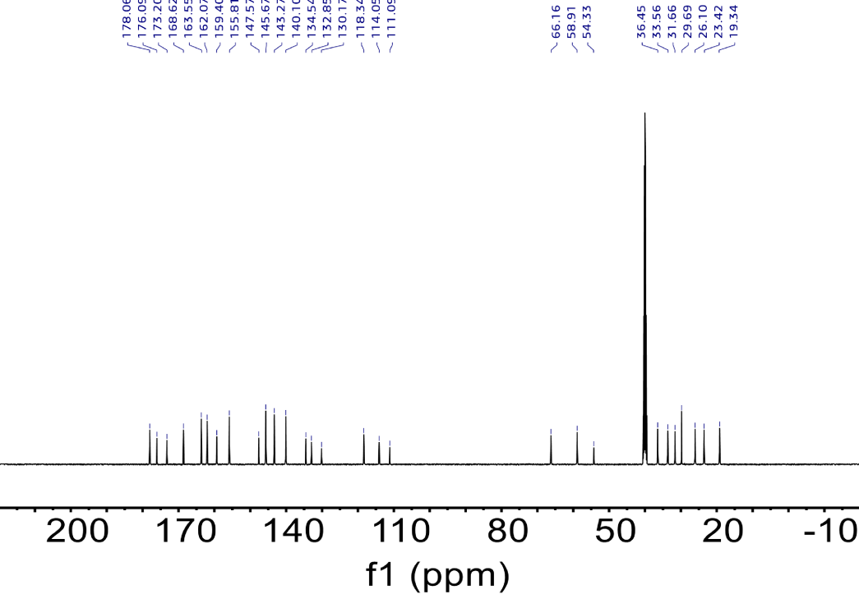
Supplementary Fig. 38. ¹³C NMR spectra of Pm-7OTD.

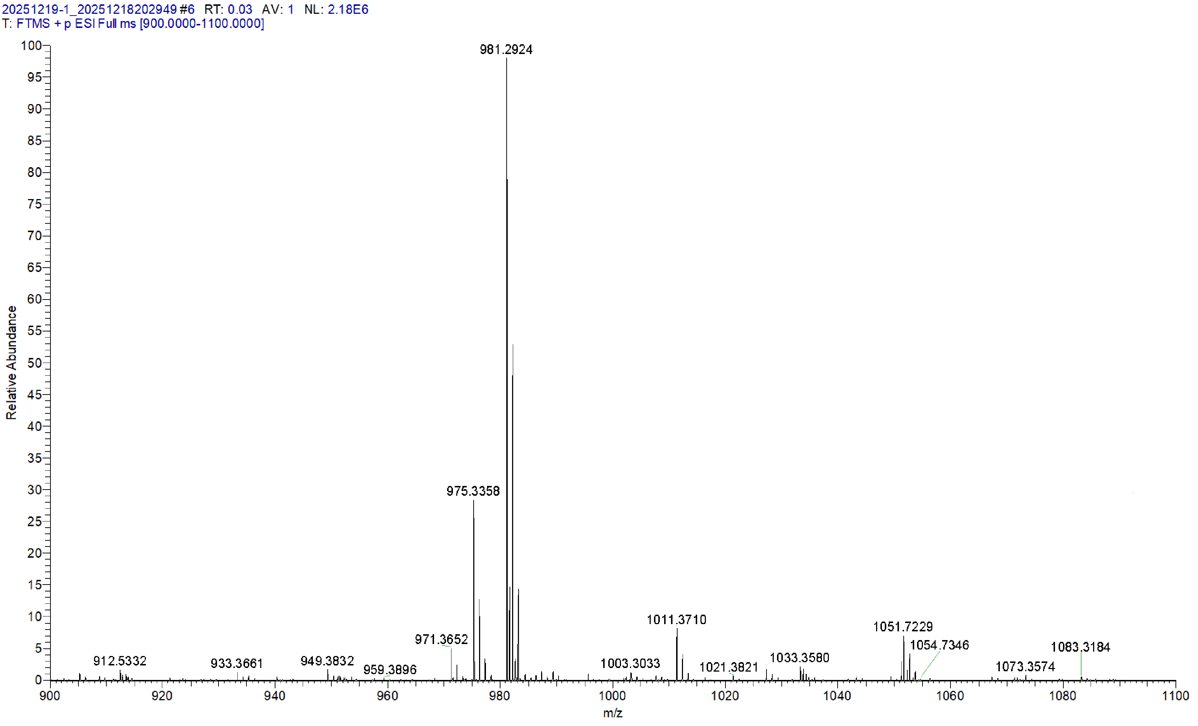
Supplementary Fig. 39. HRMS of Pm-7OTD.

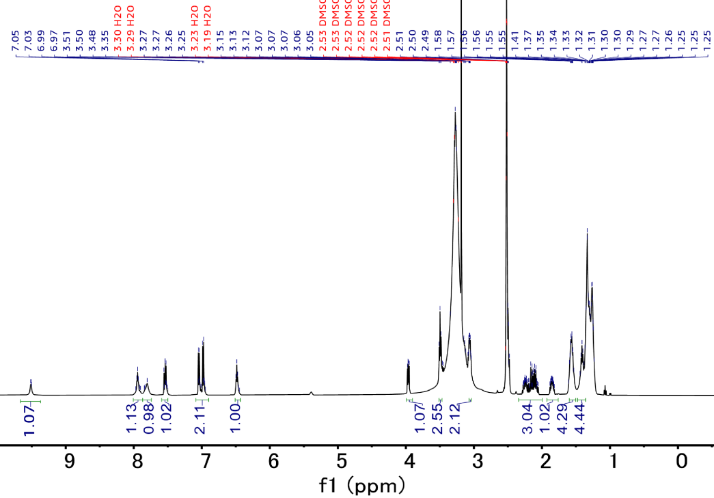
Supplementary Fig. 40. ¹H NMR spectra of compound 6.

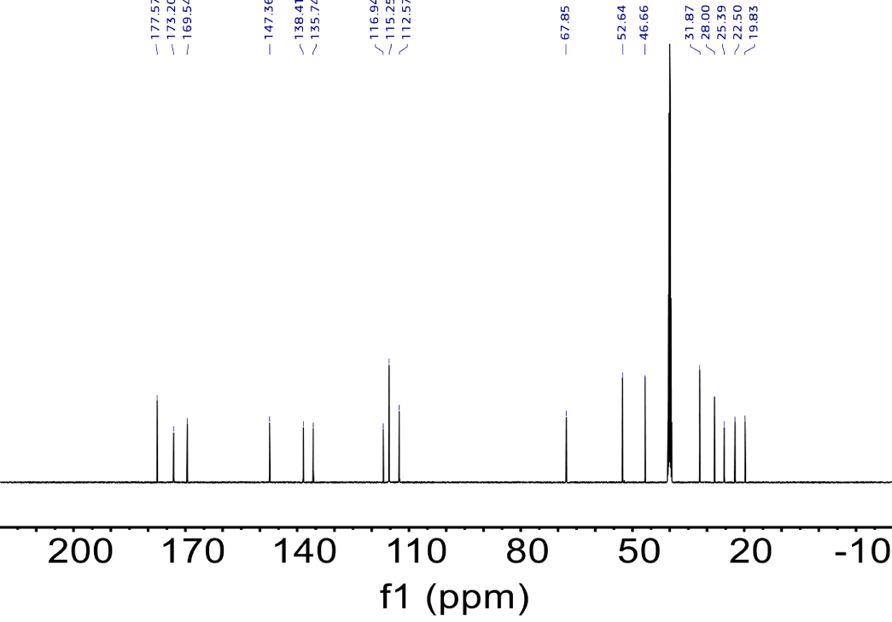
Supplementary Fig. 41. ¹³C NMR spectra of compound 6.

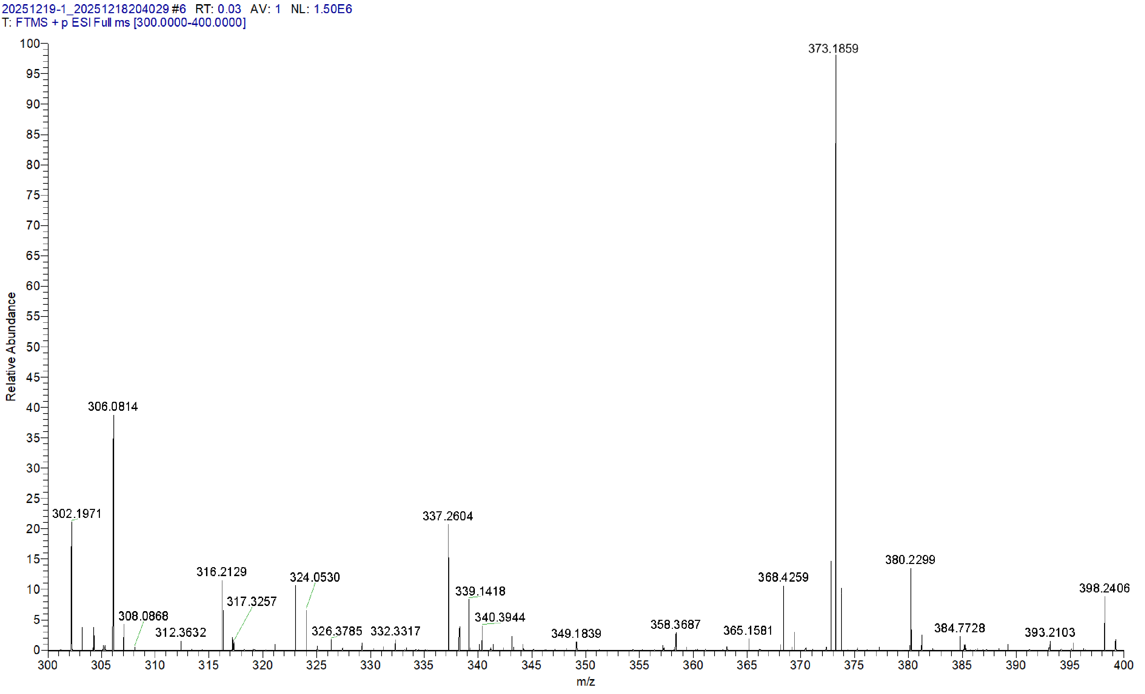
Supplementary Fig. 42. HRMS of compound 6.

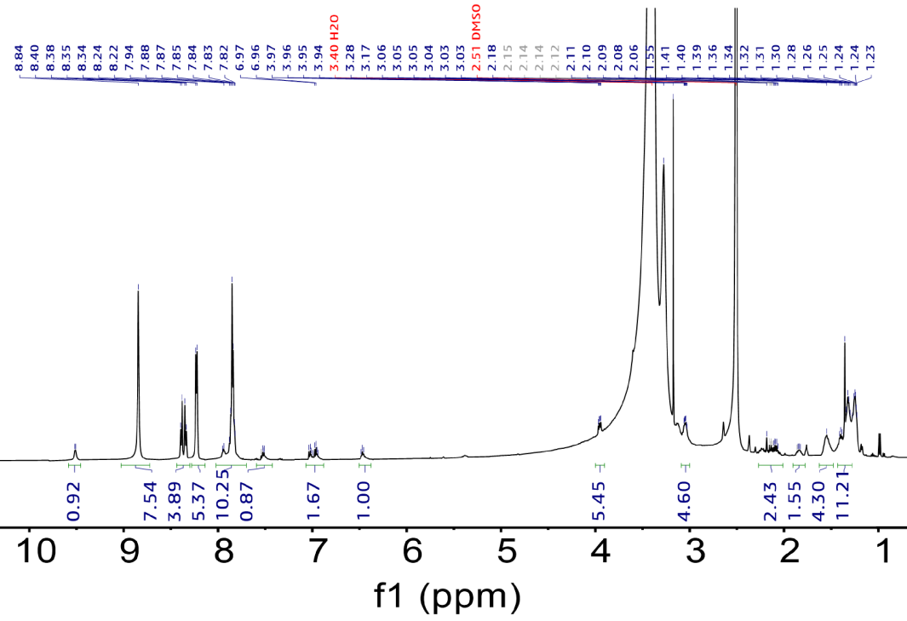
Supplementary Fig. 43. ¹H NMR spectra of Pm-TPP.

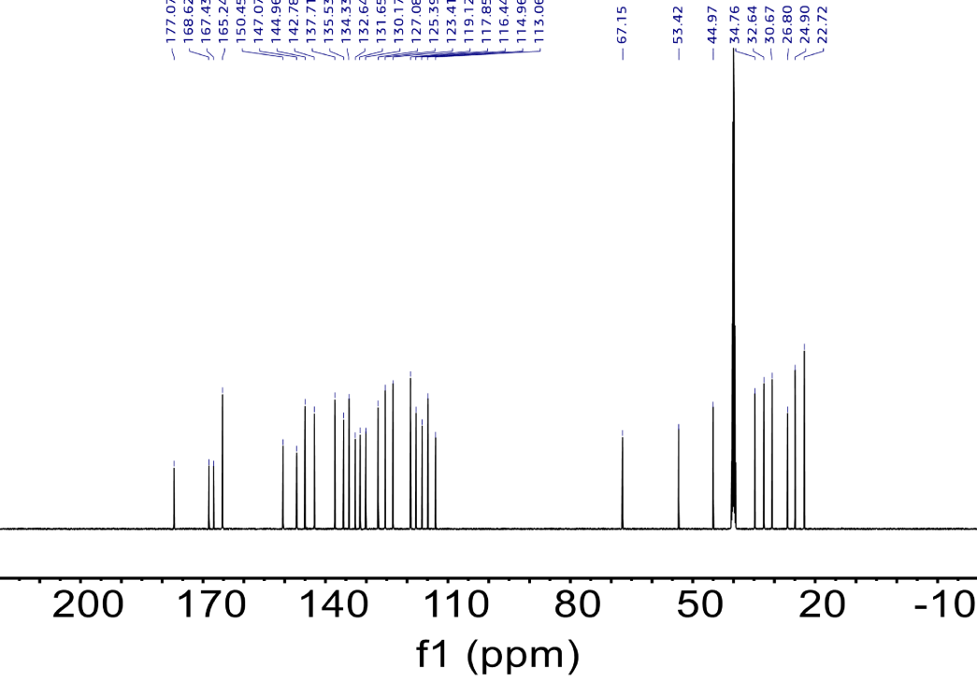
Supplementary Fig. 44. ¹³C NMR spectra of Pm-TPP.

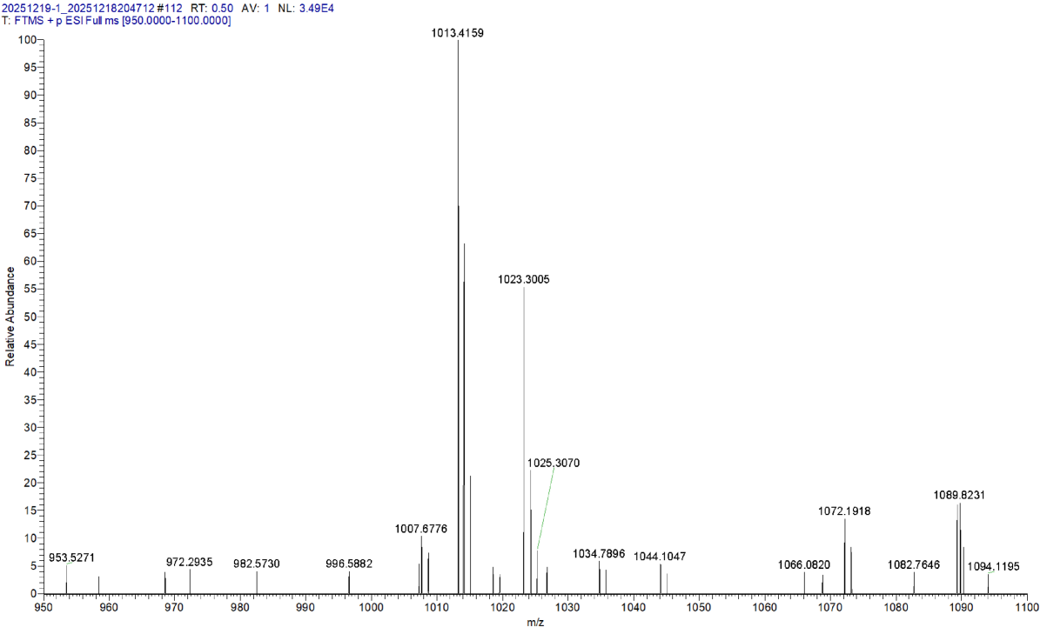
Supplementary Fig. 45. HRMS of Pm-TPP.

Supplementary Fig. 46. ¹H NMR spectra of compound 7.

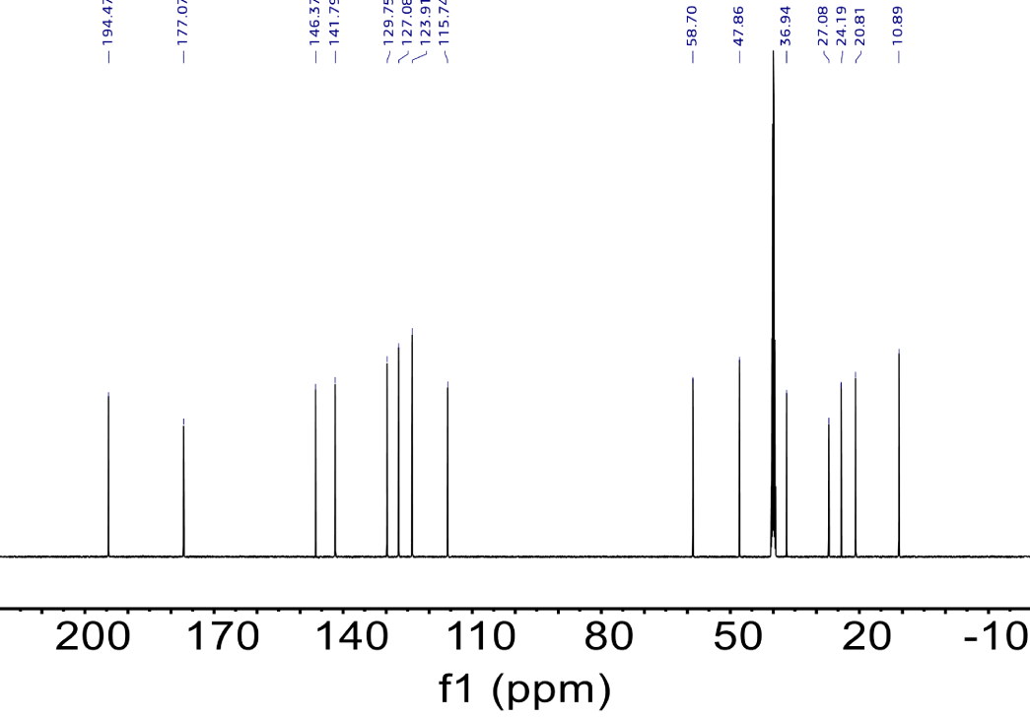
Supplementary Fig. 47. ¹³C NMR spectra of compound 7.

Supplementary Fig. 48. HRMS of compound 7.

Supplementary Fig. 49. ¹H NMR spectra of compound 8.

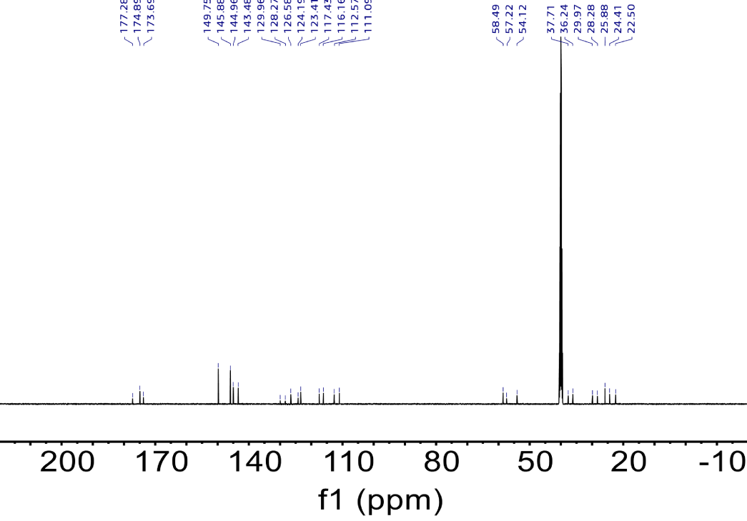
Supplementary Fig. 50. ¹³C NMR spectra of compound 8.

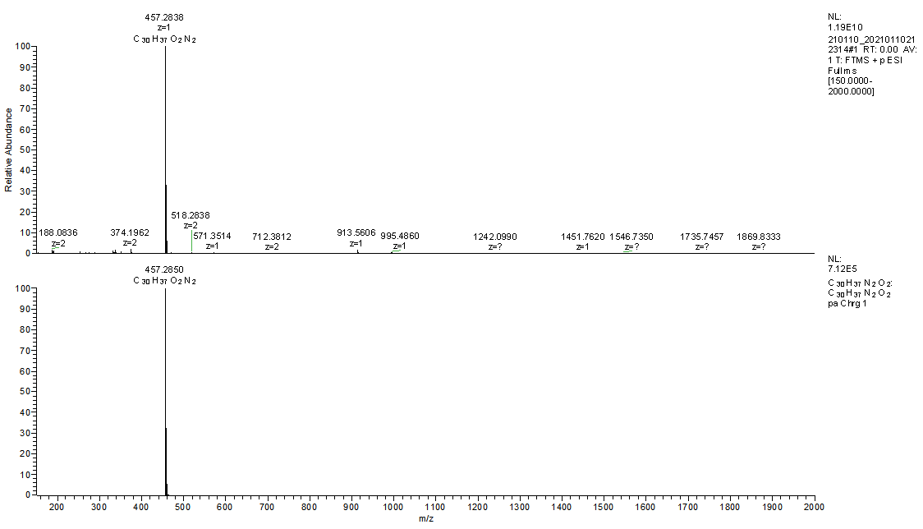
Supplementary Fig. 51. HRMS of compound 8.

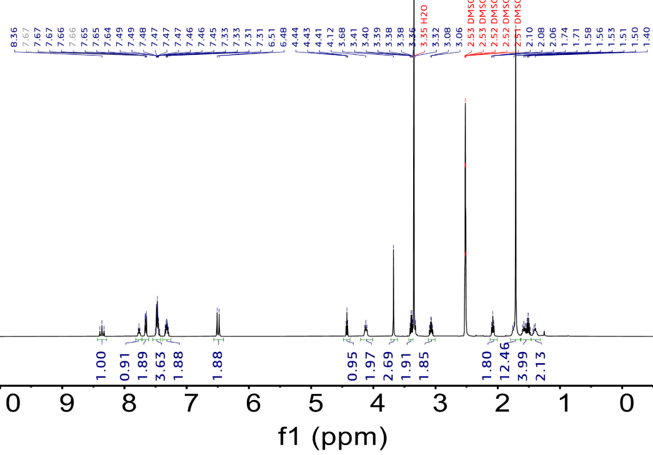
Supplementary Fig. 52. ¹H NMR spectra of compound 9.

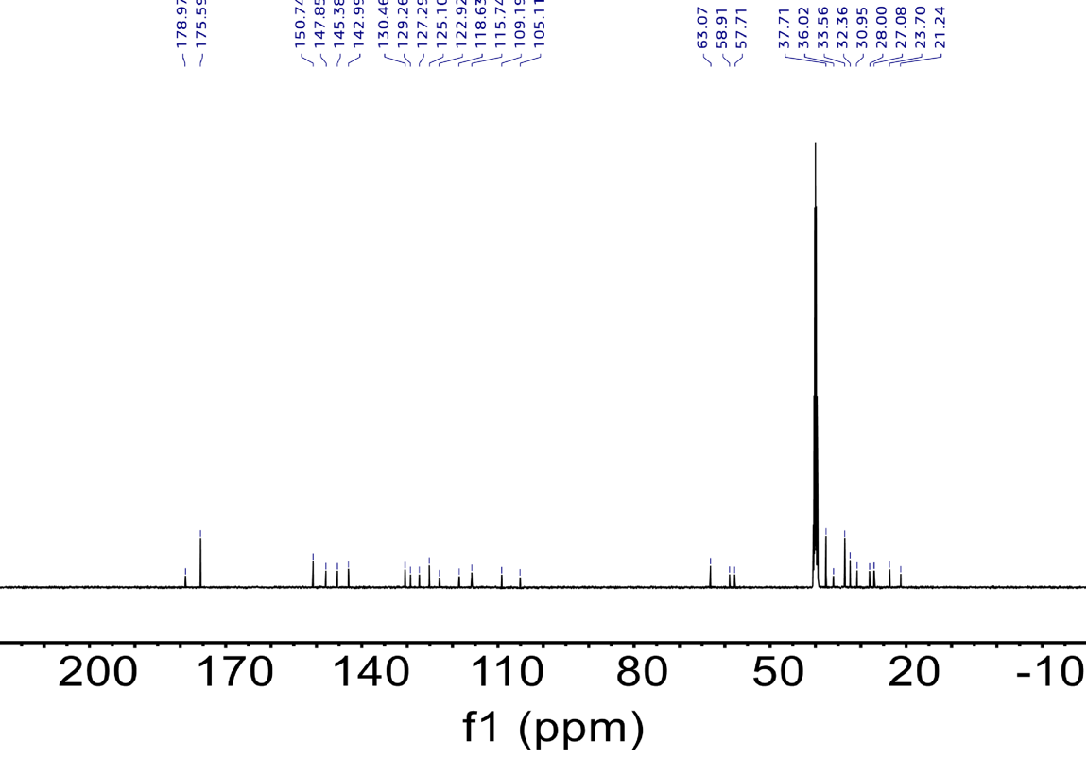
Supplementary Fig. 53. ¹³C NMR spectra of compound 9.

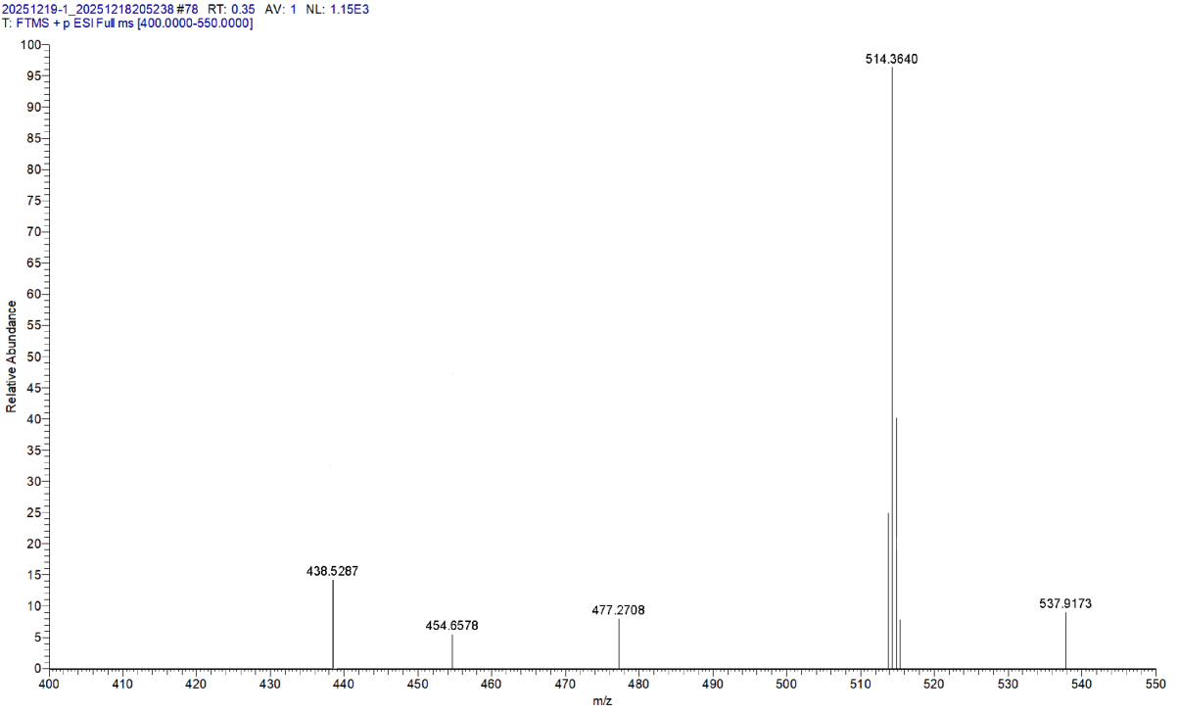
Supplementary Fig. 54. HRMS of compound 9.

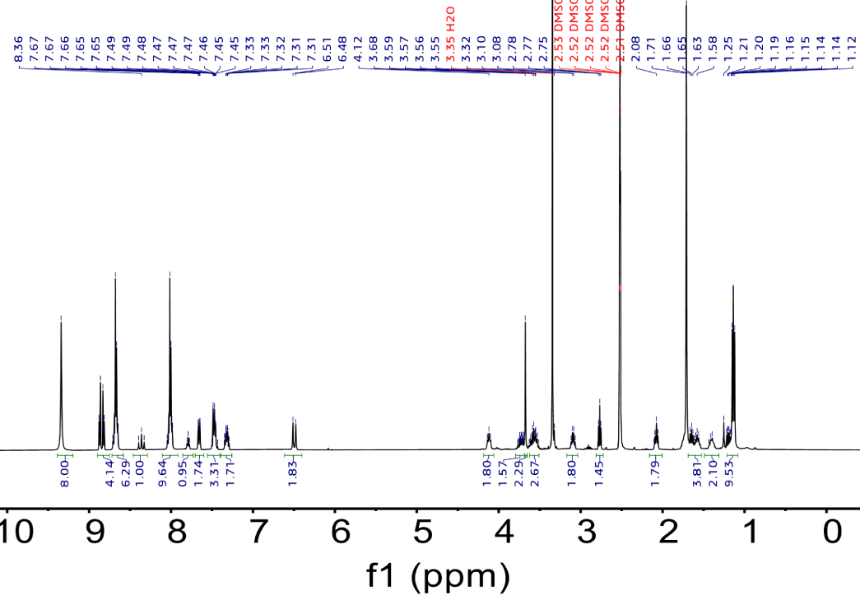
Supplementary Fig. 55. ¹H NMR spectra of Cy3-TPP.

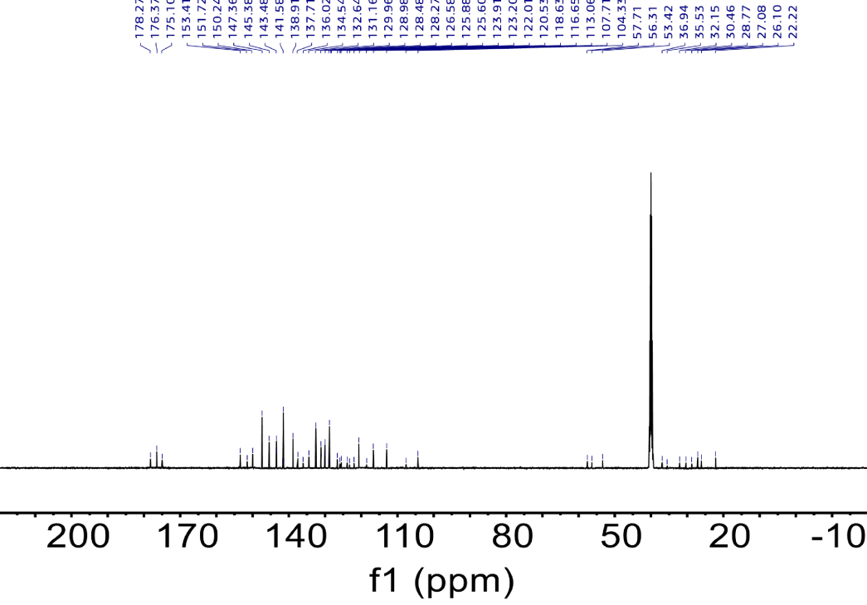
Supplementary Fig. 56. ¹³C NMR spectra of Cy3-TPP.

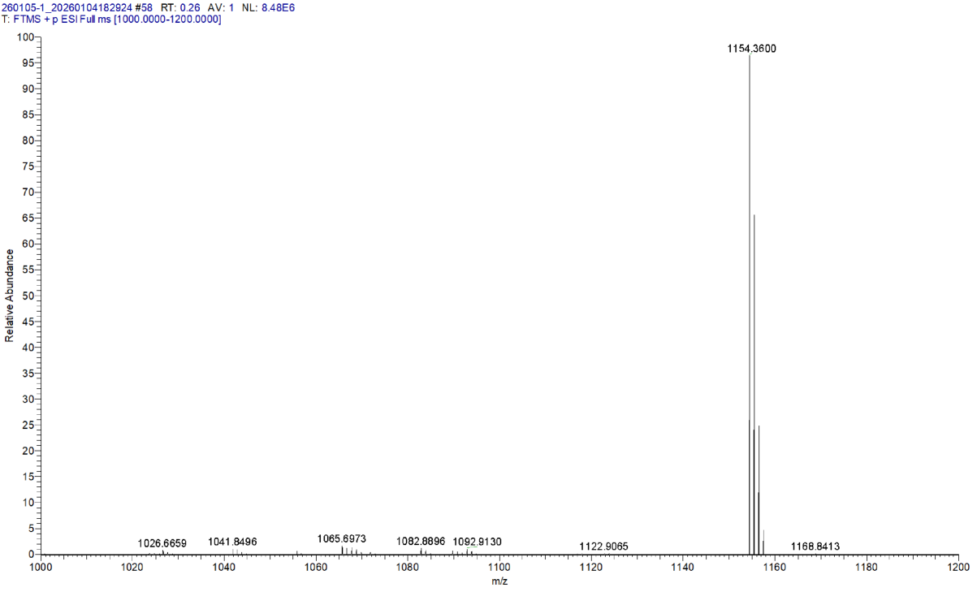
Supplementary Fig. 57. HRMS of Cy3-TPP.

Supplementary Fig. 58. ¹H NMR spectra of compound 10.

Supplementary Fig. 59. ¹³C NMR spectra of compound 10.

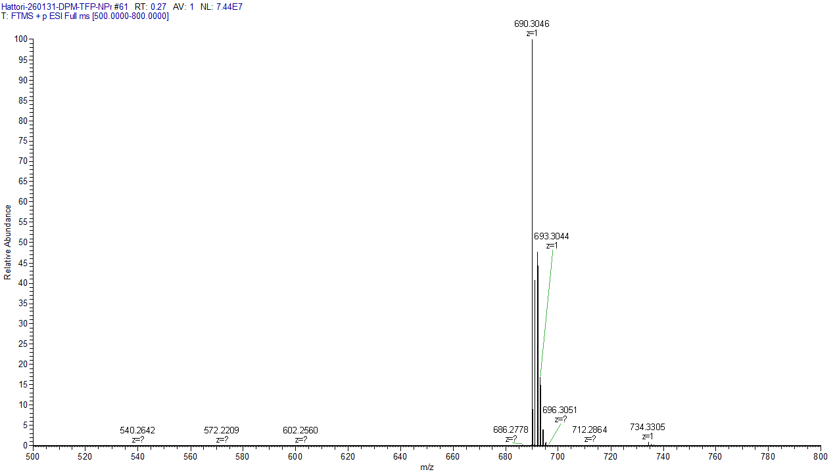
Supplementary Fig. 60. HRMS of compound 10.

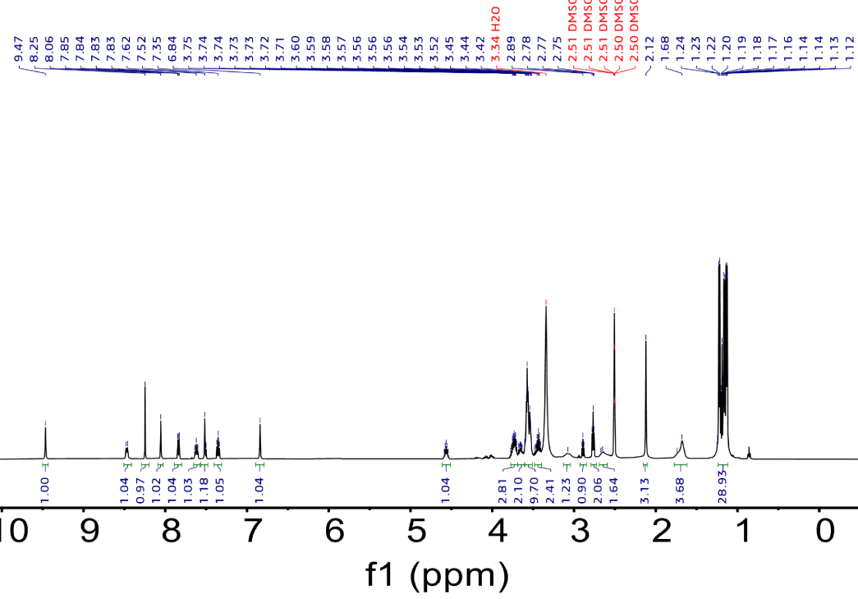
Supplementary Fig. 61. ¹H NMR spectra of compound 11.

Supplementary Fig. 62. ¹³C NMR spectra of compound 11.

Supplementary Fig. 63. ³¹P NMR spectra of compound 11.

Supplementary Fig. 64. HRMS of compound 11.

MALDI-TOF MS of oligonucleotides

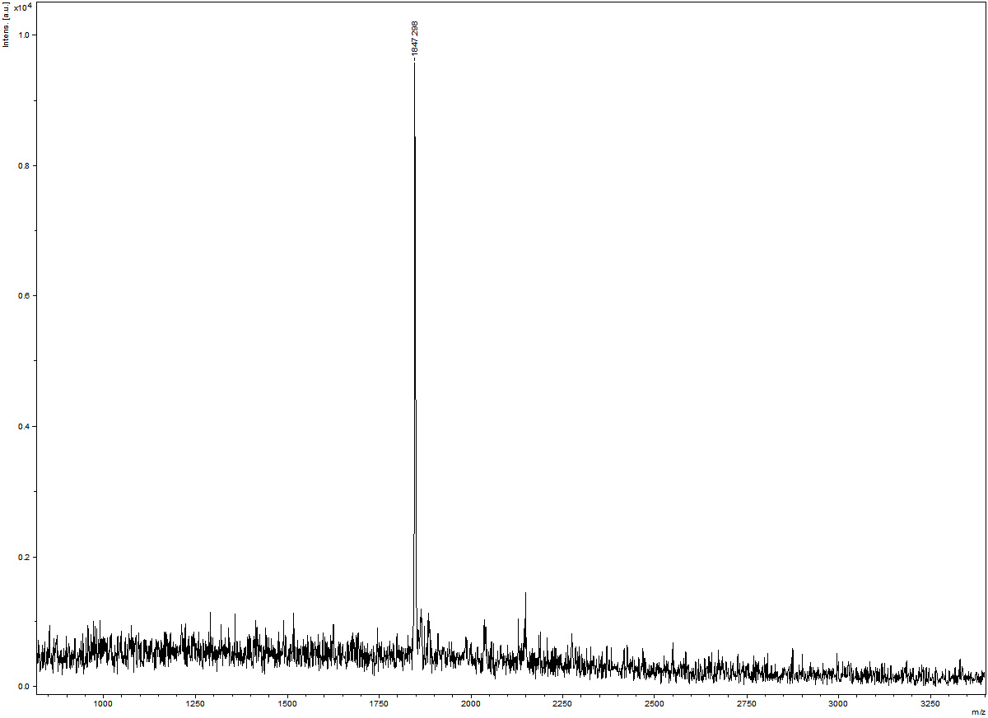
Supplementary Fig. 65. MALDI-TOF MS of 6 mer DNA.

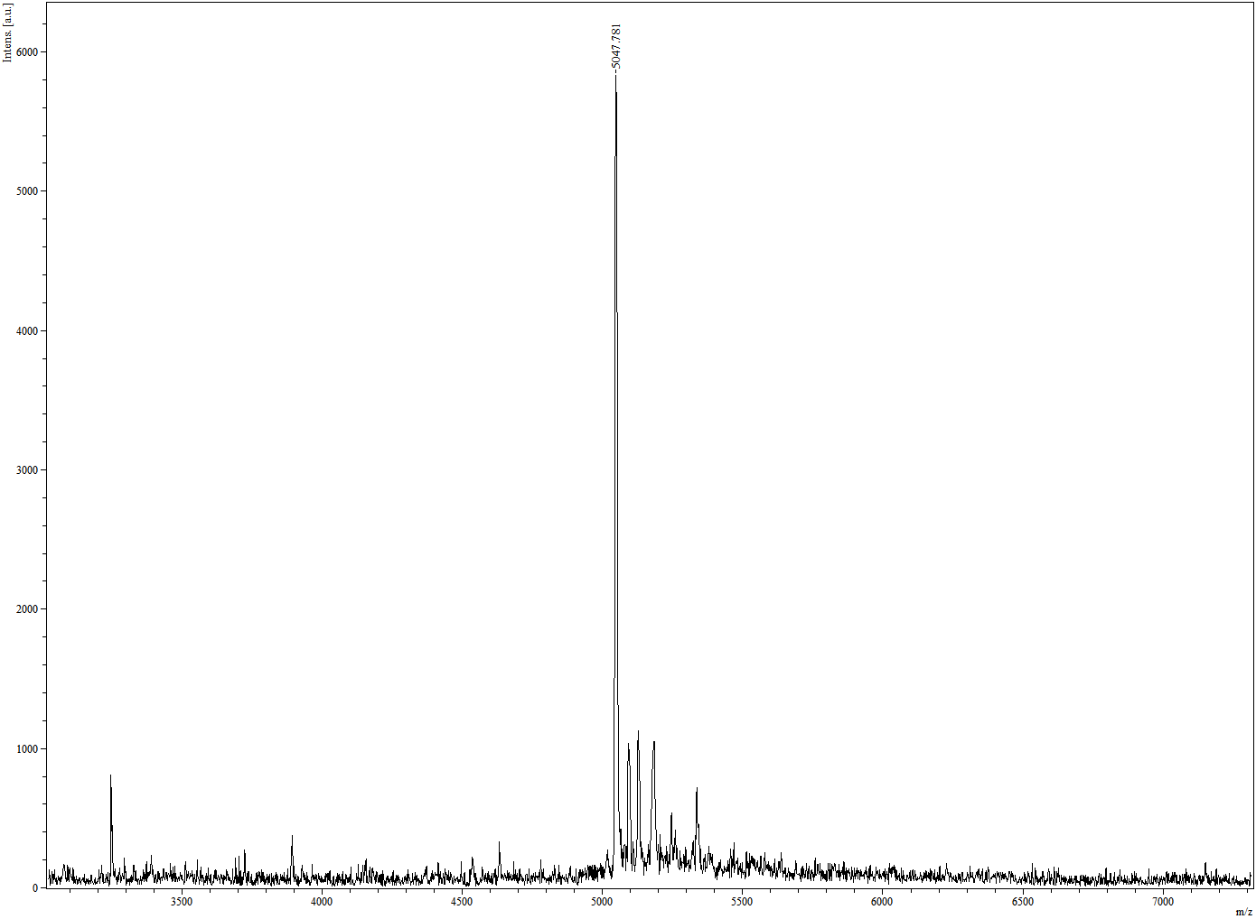
Supplementary Fig. 66. MALDI-TOF MS of 16 mer DNA.
Supplementary Fig. 67. MALDI-TOF MS of Pm-6 mer.

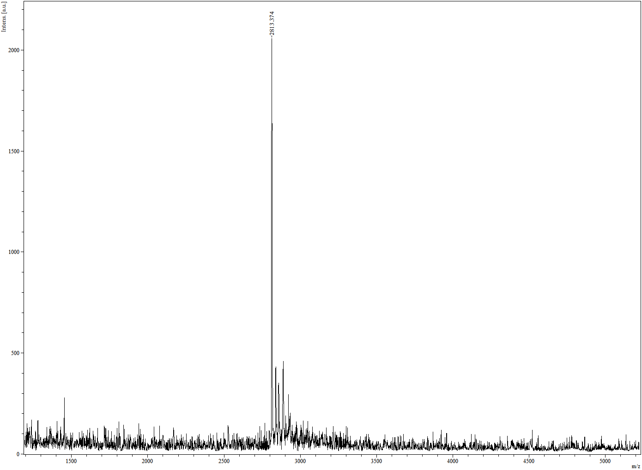

Supplementary Fig. 68. MALDI-TOF MS of Pm-6 mer-Cy3.

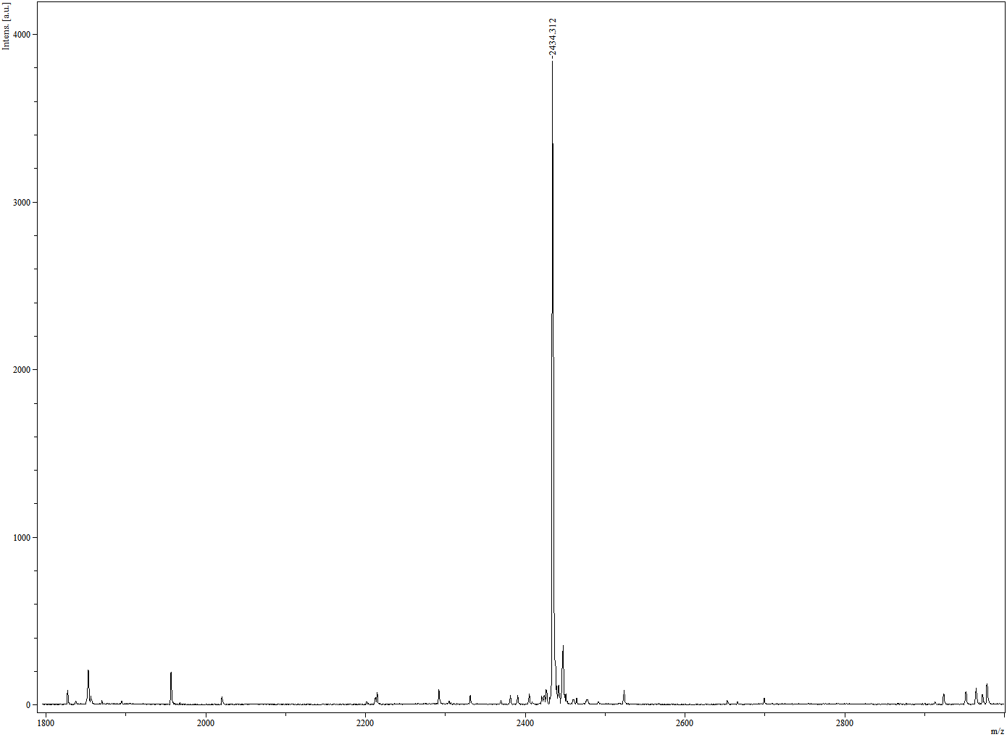
Supplementary Fig. 69. MALDI-TOF MS of JQ1-6 mer.

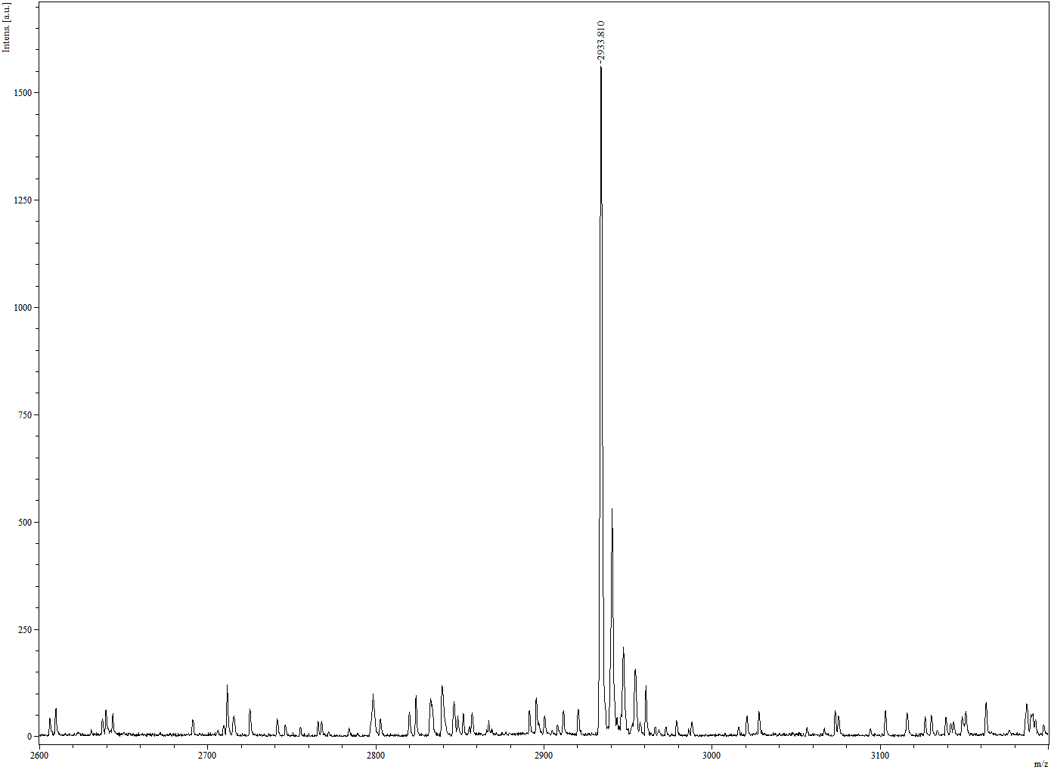
Supplementary Fig. 70. MALDI-TOF MS of JQ1-6 mer-Cy3.

Supplementary Fig. 71. MALDI-TOF MS of JQ1-16 mer.

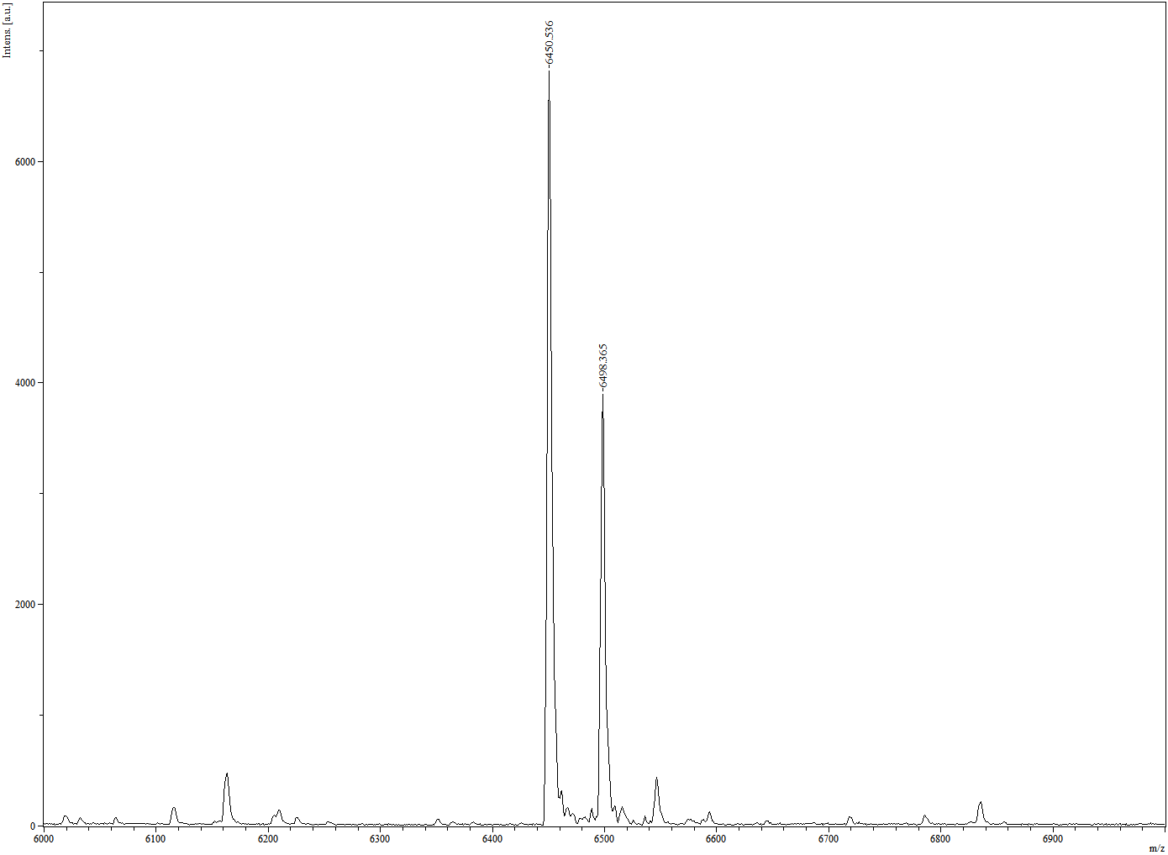.
Supplementary Fig. 72. MALDI-TOF MS of JQ1-16 mer-Cy5.

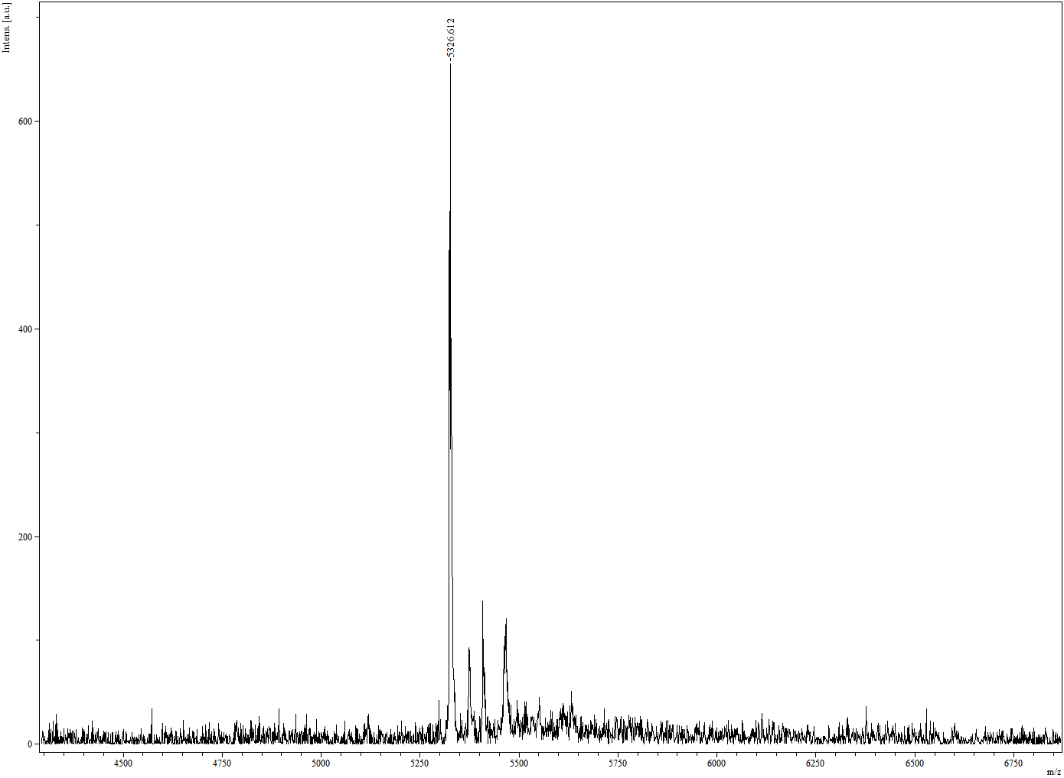
Supplementary Fig. 73. MALDI-TOF MS of JQ1-16 mer-T.

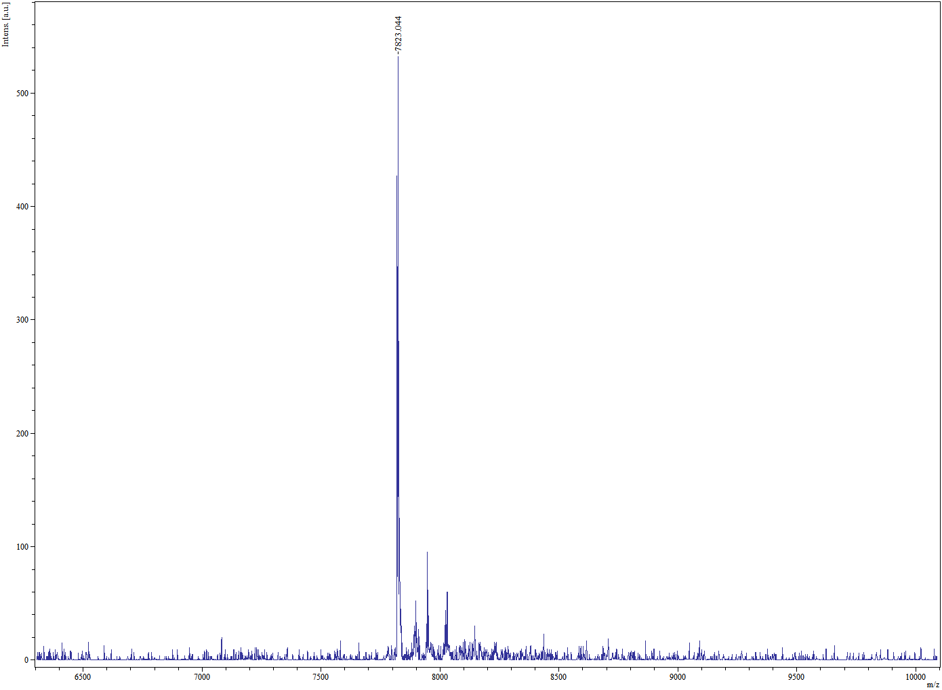
Supplementary Fig. 74. MALDI-TOF MS of ASO-1.

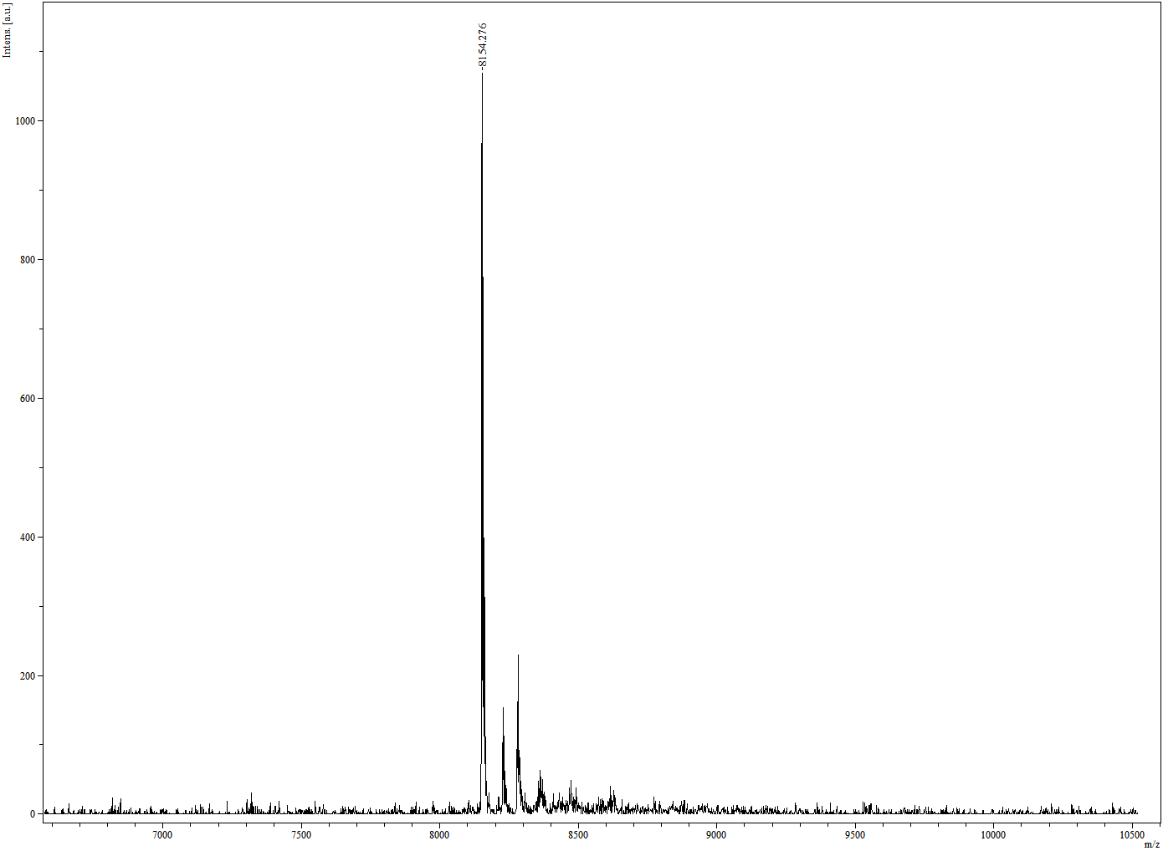
Supplementary Fig. 75. MALDI-TOF MS of ASO-2.

Supplementary Fig. 76. MALDI-TOF MS of JQ1-6 mer-R.

.
Supplementary Fig. 77. MALDI-TOF MS of JQ1-6 mer-U.

Supplementary Fig. 78. MALDI-TOF MS of Cy5-6 mer-R.
Supplementary Fig. 79. MALDI-TOF MS of Cy5-6 mer-U.

Supplementary Fig. 80. MALDI-TOF MS of Ceritinib-6 mer-R.

Supplementary Fig. 81. MALDI-TOF MS of Ceritinib-6 mer-U.

