Supplementary information

Table 1 Primer sets used in this study. RdRd and E sequences were based on the report done by Corman et al. (11). RP sequences were obtained from CDC reports (18).
Primers for each genetic target | SARS-CoV-2 target
GTG ARA TGG TCA TGT GTG GCG G  CAR ATG TT A AAA ACA CTA TTA GCA TA | RdRp-F  RdRp-R
ACA GGT ACG TTA ATA GTT AAT AGC GT  ATA TTG CAG CAG TAC GCA CAC A | Gen-E F  Gen-E R
AGA TTT GGA CCT GCG AGC G  GAG CGG CTG TCT CCA CAA GT | RP-F  RP-R
Probes
5' FAM-ACA CTA GCC ATC CTT ACT GCG CTT CG-BHQ1 3' | Gen-E Probe
5' ROX-CAG GTG GAA CCT CAT CAG GAG ATG C-BHQ1 3' | Gen-RdRp Probe
5' VIC-TTC TGA CCT GAA GGC TCT GCG CG-BHQ1 3' | Gen-RP Probe

Fig. 1 Death percentage of confirmed COVID-19 cases. Data shown as of September 17th, 2020. Ecuador was the country with the highest rate up to that date.

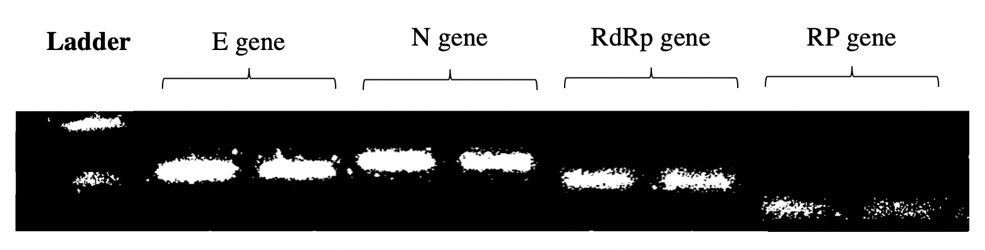
Fig. 2 Duplicate RT-qPCR products of the envelope protein gene E (113 bp), the nucleocapsid protein gene N (128 bp), RNA-dependent RNA polymerase gene RdRp (100 bp) and human ribonuclease gene “RP” (50 bp). The ladder corresponds to 200 bp (upper line) and 100 bp (lower line).

