Supplementary files

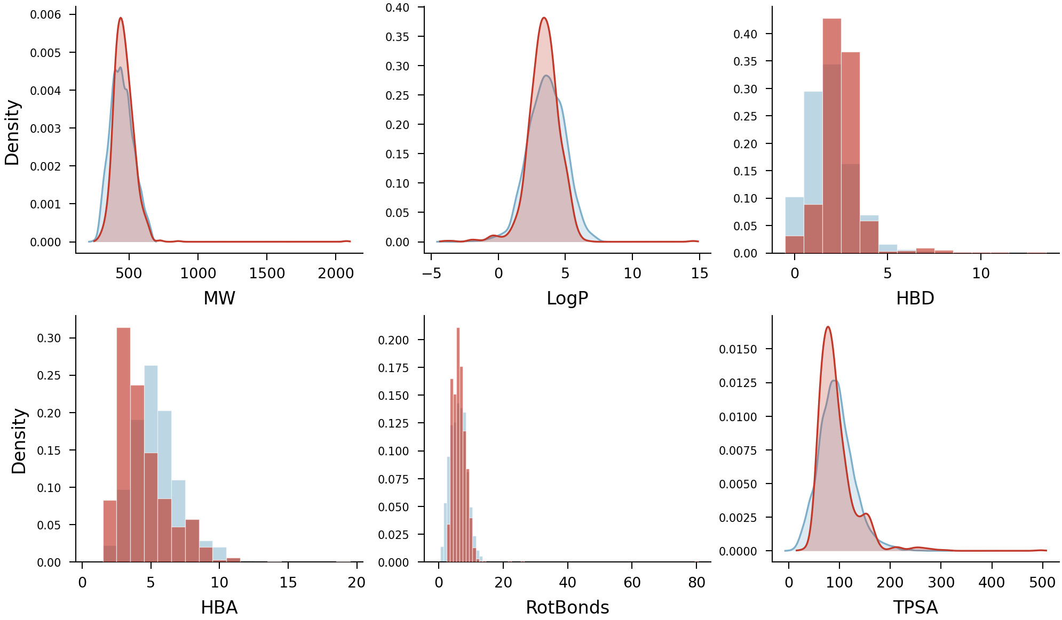
Additional file 1: Figure S1. Molecular property distributions for actives (orange) and decoys (blue). MW = molecular weight, LogP = calculated octanol–water partition coefficient, HBD/HBA = hydrogen bond donors/acceptors, RotBonds = rotatable bonds, TPSA = topological polar surface area. The overlap confirms property-matched decoy generation.

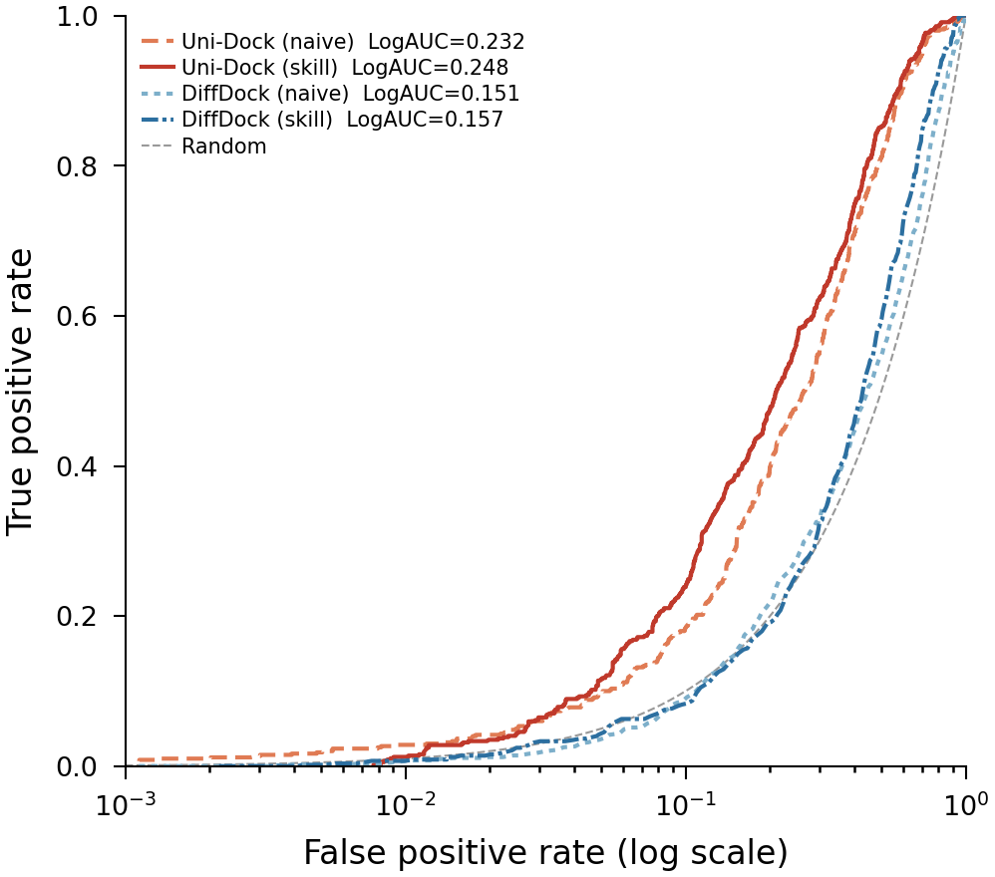
Additional file 2: Figure S2. Semi-logarithmic ROC curves (log10 FPR axis) for all four protocols. This representation emphasises early enrichment performance. The dashed line indicates random performance (LogAUC = 0.1446).

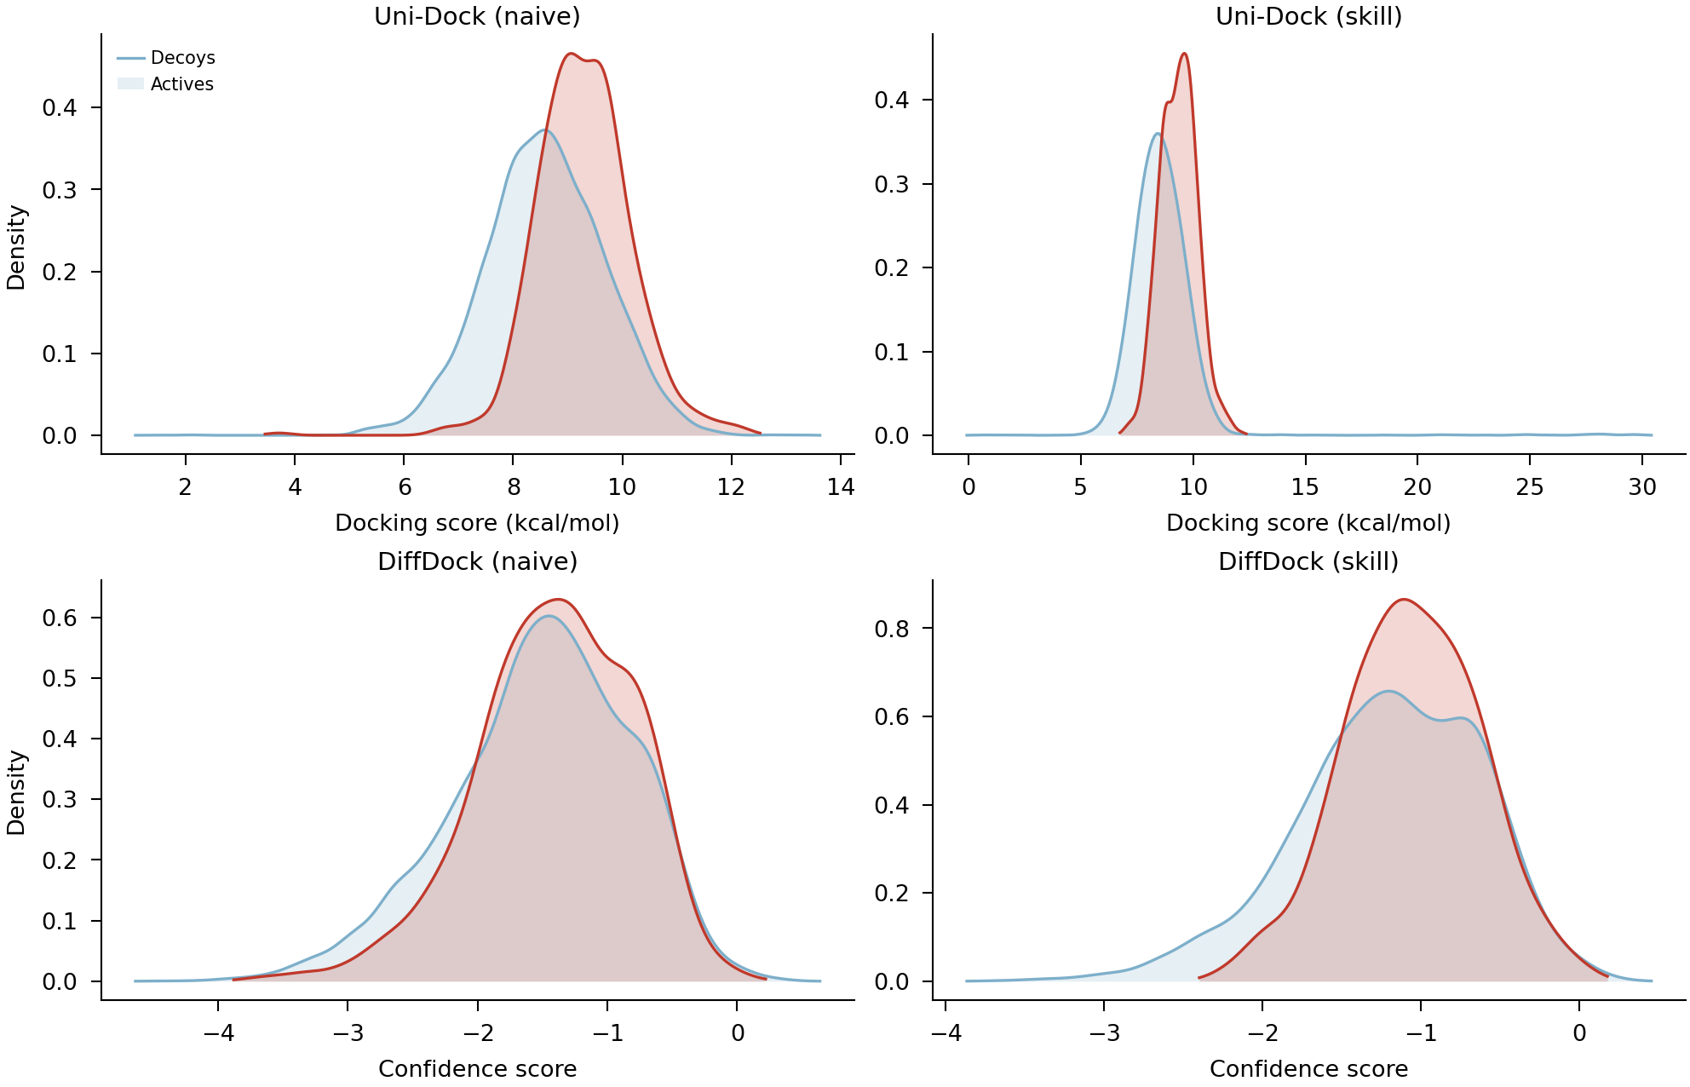
Additional file 3: Figure S3. Docking score distributions for actives and decoys across all four protocols. Kernel density estimates shown for actives (solid) and decoys (dashed). Greater separation indicates better discrimination.

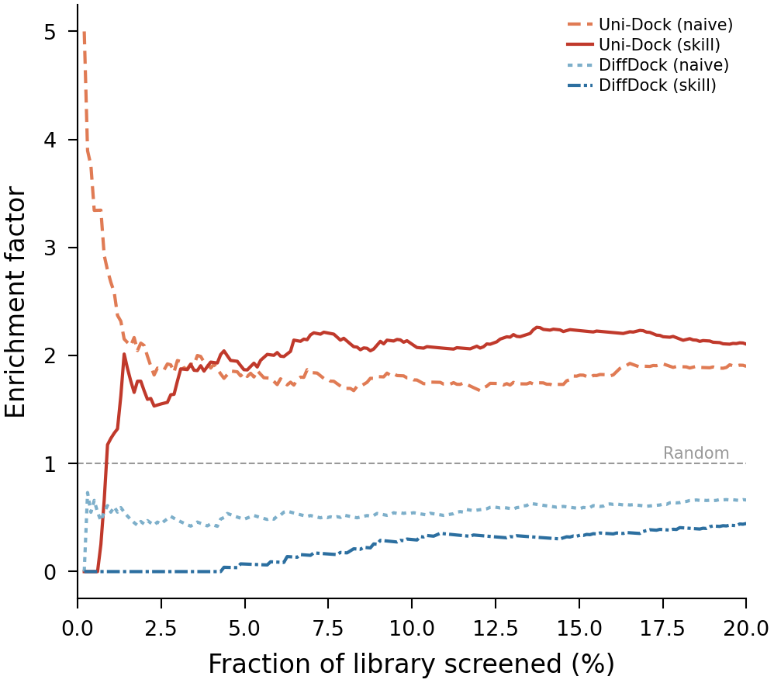
Additional file 4: Figure S4. Enrichment factor curves as a function of the fraction of the ranked library screened. EF = (fraction of actives found) / (fraction of library screened).

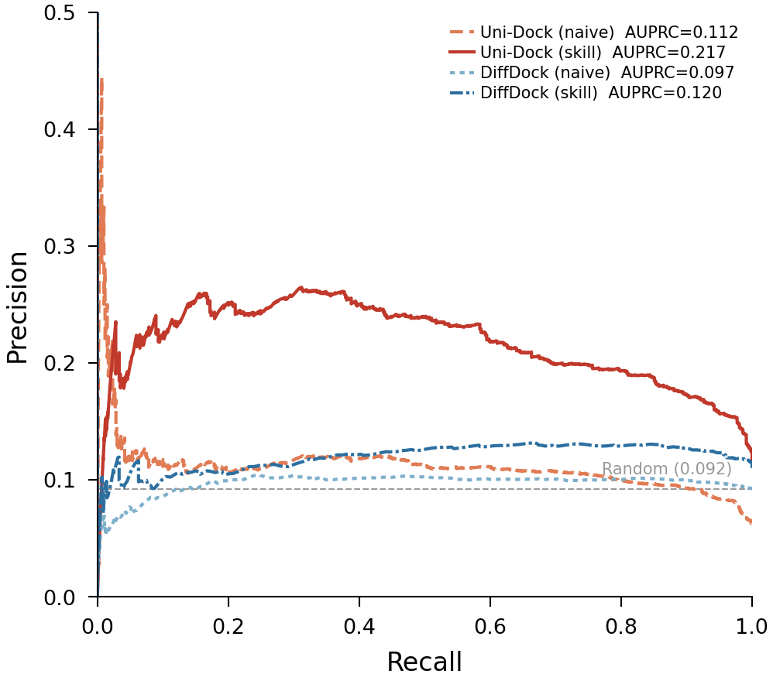
Additional file 5: Figure S5. Precision–recall curves for all four protocols. The dashed line indicates the baseline precision (active rate in the dataset).

