SUPPLEMENTS

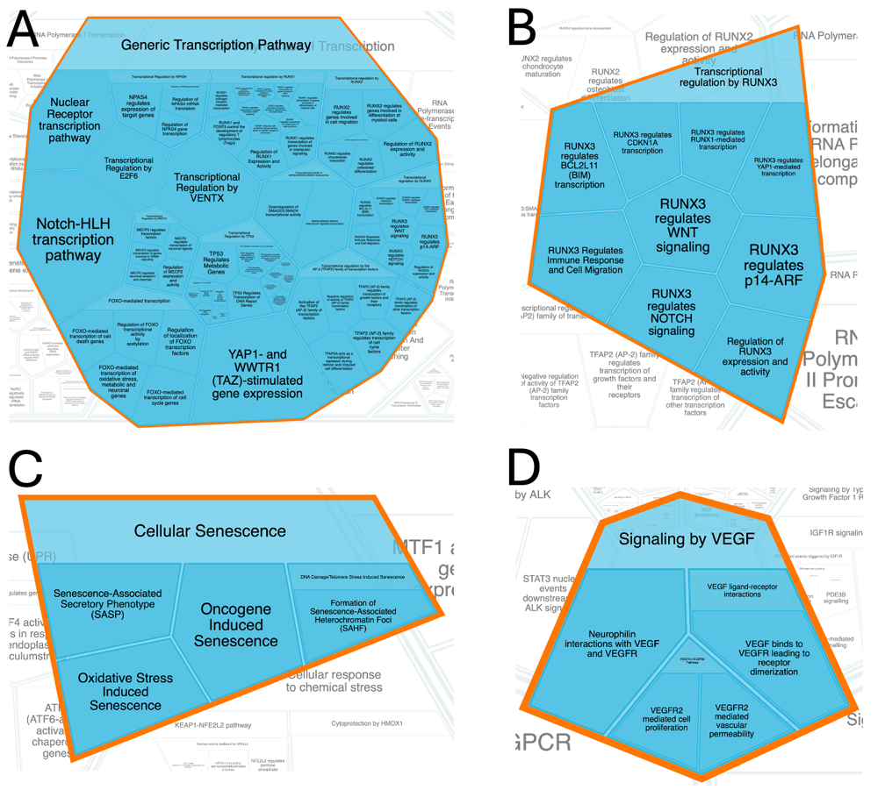
Figure S1. Reactome database pathways. (A) Generic transcriptomic pathway. (B)Transcriptional regulation by RUNX3. (C) Cellular senescence. (D) Signaling by VEGF. Adapted from Fabregat A, Sidiropoulos K, Viteri G, et al. Reactome diagram viewer: data structures and strategies to boost performance. Bioinformatics. Apr 1 2018;34(7):1208-1214. doi:10.1093/bioinformatics/btx752

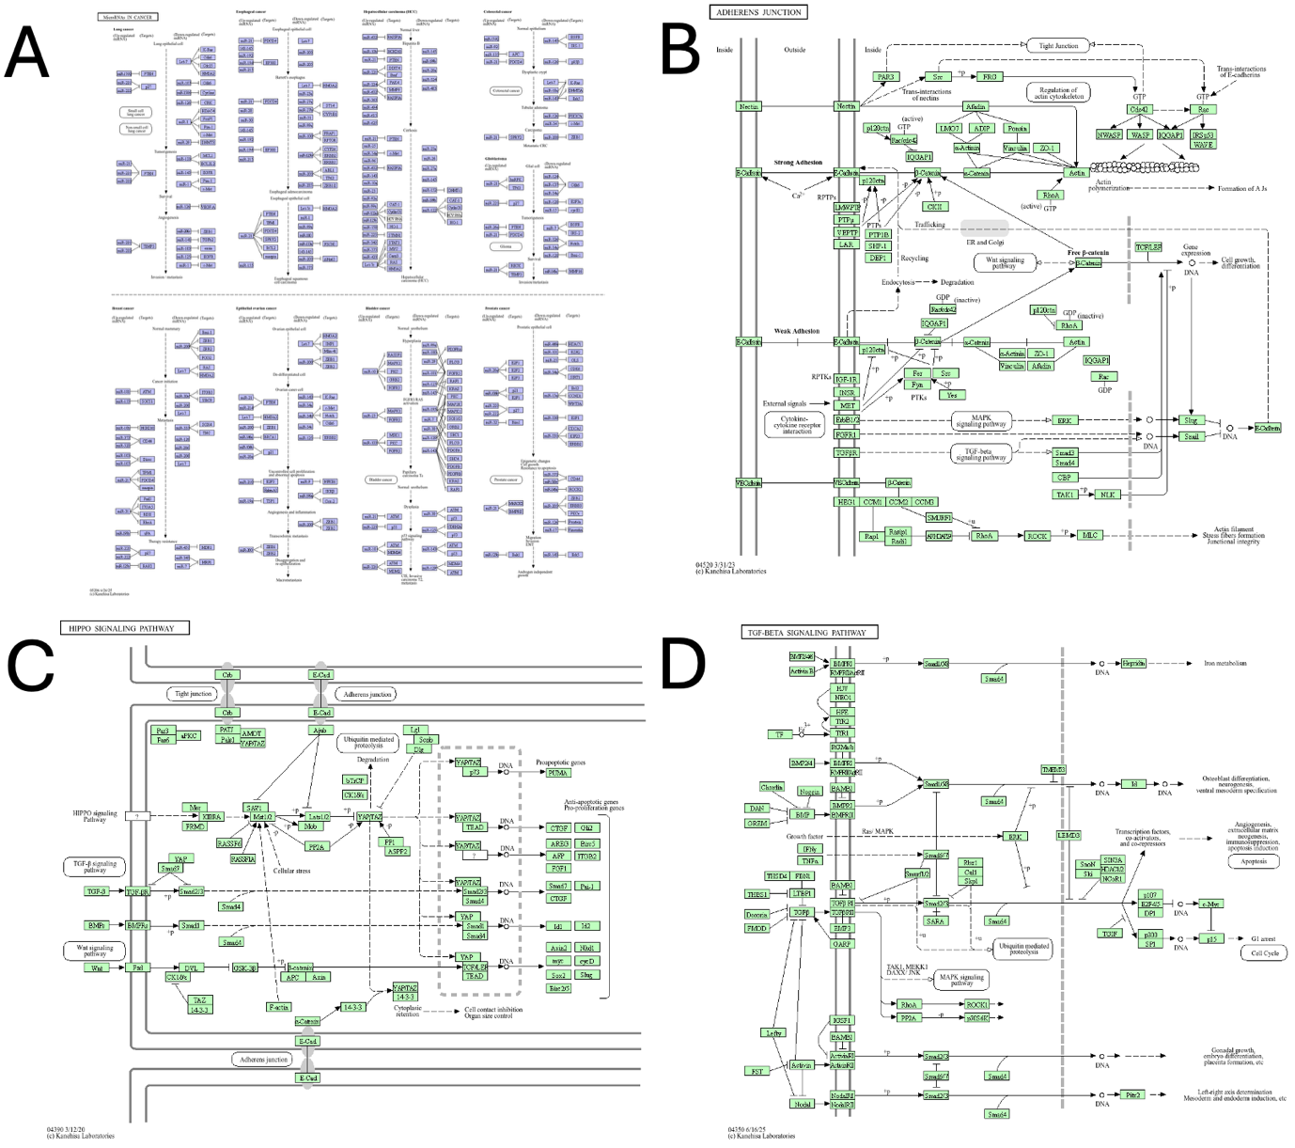
Figure S2. KEGG database pathways. (A) MicroRNAs in cancer. (B) Adherens junction. (C) HIPPO signaling pathway. (D) TGF-beta signaling pathway. Adapted from Kanehisa M, Goto S. KEGG: kyoto encyclopedia of genes and genomes. Nucleic Acids Res. Jan 1 2000;28(1):27-30. doi:10.1093/nar/28.1.27

Figure S3. miRNAs associated with different molecular pathways in the Reactome and KEGG databases, likely prognostic factors for overall survival in GBM (Excel database).

