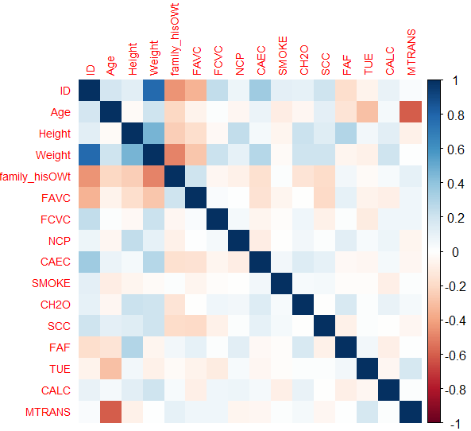
Figure 1 Correlation Heatmap

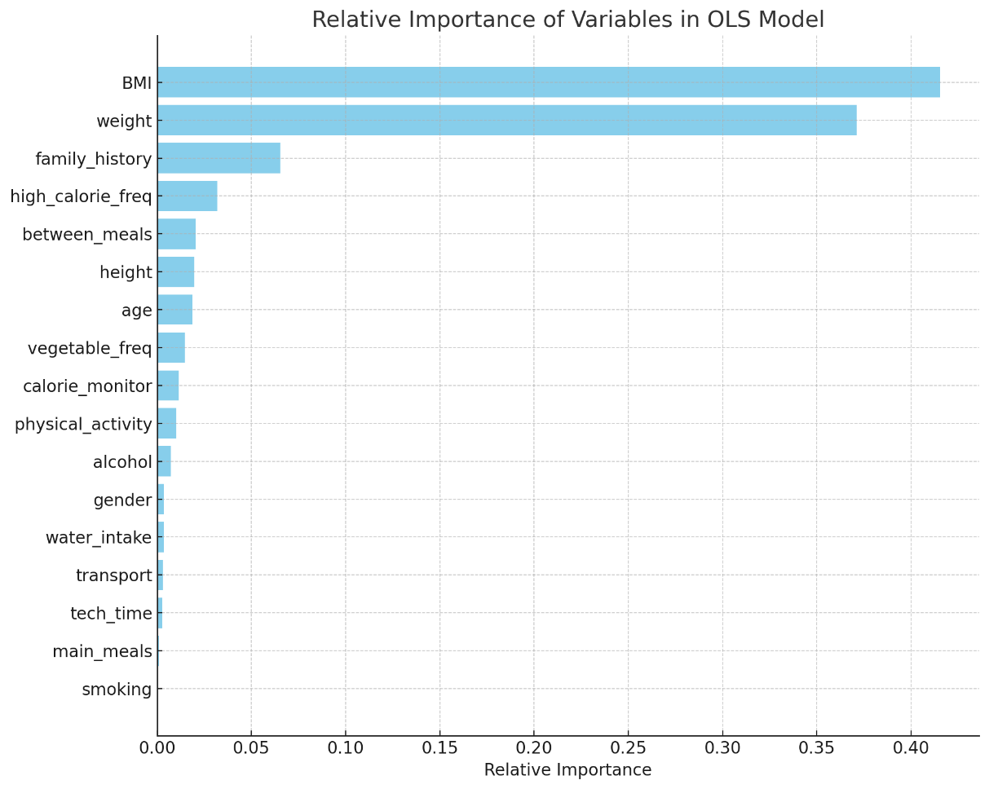

Figure 2 Relative importance of the variables in OLS model

