Supplementary file

Democracy’s crisis advantage seems conditional: evidence from excess mortality across island and non-island jurisdictions for the Covid-19 pandemic

Additional methodological details

Definition of island jurisdictions

Island jurisdictions were defined as those surrounded by water, while ignoring engineered connections to other land masses. The group of island jurisdictions included: individual sovereign islands, island archipelagos (eg, Indonesia, Philippines), island continents (ie, Australia), and where the jurisdiction had a land border with another jurisdiction on the same island (eg, Ireland, UK, Timor-Leste, Papua New Guinea, Brunei, Dominican Republic, Haiti, Cyprus). We excluded jurisdictions with mixed characteristics, but where the capital city was on a continental land mass (eg, Malaysia, Corsica [France], Sardinia and Sicily [Italy]). We excluded non-sovereign island states due to the ambiguous role local government played in pandemic-related decision-making (as opposed to the colonial power). This definition of islands was consistent with earlier work on Covid-19 outcomes (Boyd, Baker, Kvalsvig, & Wilson, 2025).

Excess mortality data

The estimation methods for the GBD’s excess mortality data 2020–21 have been described in detail previously (GBD 2021 Demographics Collaborators, 2024). Data is standardised across age groups to enable comparison between populations with different age structures. The GBD Collaborators employed six weighted excess mortality models across a decade of data prior to the Covid-19 pandemic to attenuate any risk of arbitrary or outlier baseline data. Excess mortality is the best available measure of the true mortality impact from the Covid-19 and is not subject to the high levels of under ascertainment seen with Covid-19 mortality surveillance. It also captures the Covid-19 pandemic related impacts on health system disruption which may have impacted mortality from other conditions.

GDP per capita growth

The World Bank defines GDP per capita as GDP divided by midyear population. Specifically, we obtained the World Bank GDP per capita purchasing power parity (PPP) (constant 2017 international $) data, which included adjustment for inflation, ie, the World Bank dataset “NY.GDP.PCAP.PP.KD”. We then calculated GDP growth from 2019 to 2020, and from 2020 to 2021, defined as the percentage change in five-year geometric means.

Causal model and covariate selection

We developed a causal diagram (Figure 6, main text) to make explicit our assumptions linking pre-pandemic political and social conditions to age-standardised cumulative excess mortality in 2020–2021. The diagram included liberal democracy (V-Dem Liberal Democracy Index, 2019) and income inequality (Gini coefficient; mean 2015–2019) as primary exposures, with pre-pandemic GDP per capita, population size, island status, preparedness capacity (Global Health Security [GHS] Index, 2019), and governance quality (proxied by a corruption index) as additional nodes.

In the diagram, governance quality was conceptualised as an institutional channel through which democracy may influence implementation effectiveness of pandemic control measures; therefore, to estimate the total effect of democracy, we did not condition on corruption in democracy models (also avoiding collinearity given strong correlation between democracy and corruption).

For inequality, we estimated a controlled direct effect (not mediated by governance quality) by additionally conditioning on the corruption index, thereby blocking the pathway from inequality to mortality operating through governance/implementation.

Across models, we included pre-pandemic GDP per capita, population size, preparedness (GHS Index), and island status (and, where relevant, exposure x island interaction terms) to address confounding and to assess effect modification by island status. We conceptualised “control strategy” as being on one of the pathways for how more democratic jurisdictions might impact pandemic mortality (but we could not include this variable in modelling given that so few jurisdictions had explicit control strategies, see (Boyd et al., 2025)).

Conditioning on corruption in inequality models is intended as a robustness/mechanism test consistent with a causal mechanism in which governance quality mediates part of the relationship between inequality and mortality.

Robustness checks

The island × LibDem interaction estimate was stable across all 163 jackknife resamples (range −5.40 to −3.84, median −4.51); the sign and p < 0.05 threshold persisted in every run; and while 10 observations showed DFBETA values exceeding ±2/√n, none individually altered the qualitative conclusion. This rules out the artefact concern and the result is distributed across the sample, not manufactured by one or two data points.

The island × LibDem interaction was robust to the inclusion of WHO supraregion fixed effects (β = −4.73, p = 0.008, compared with β = −4.51, p = 0.009 in the base model), while the Gini × island interaction remained non-significant in both specifications. The WHO supraregion fixed effects analysis provided reasonable geographic confounding control across most of the sample, but we note that the "High-Income" category conflates economic and geographic groupings, and since GDP is already a covariate, the dummy for that group is not providing the same geographic isolation as the other region dummies. The robustness of the interaction across all specifications remains meaningful, but the regional fixed effects analysis should be interpreted as partial rather than definitive control for confounding.

The within-island population gradient (population size confounding) could not be reliably tested across n = 29 islands with full data. However, the full-sample (including non-islands) test is consistent with the mechanism hypothesis (significant, predicted direction); and the main island × democracy finding is not explained away by population size.

Overall, the regional fixed effects analysis provides evidence against the most common spatial confounding critique of cross-national Covid-19 research. The LibDem × island interaction is not an artefact of, for example, high-democracy island nations clustering in one region that also happened to have low mortality for unrelated geographic or socio-cultural reasons. After absorbing all between-supraregion variation with dummy variables, the democracy–island interaction was essentially unchanged. Combined with the leave-one-out jackknife results, where the sign and significance persisted across all 163 leave-one-out runs, there are two independent lines of evidence that the interaction is a genuine within-data signal rather than a product of either outliers or regional clustering.

Additional results

Correlations and collinearity

Table S1 reports the Pearson correlations among the key variables. Based on our a priori Pearson correlation threshold (see Methods), the perceived government corruption index was excluded from the LibDem regressions due to its strong correlation with democracy (Pearson’s r = 0.797, which we took to be concerningly close to our 0.8 a priori threshold), but was retained in the Gini models.

Table S1: Pearson’s r correlations among variables
 | LibDem | Gini | Corruption | GHS_2019 | log_GDP_2019 | log_population
LibDem | - | -0.216 | -0.797 | 0.592 | 0.58 | -0.238
Gini | -0.216 | - | 0.357 | -0.317 | -0.398 | 0.157
Corruption | -0.797 | 0.357 | - | -0.633 | -0.734 | 0.234
GHS_2019 | 0.592 | -0.317 | -0.633 | - | 0.686 | 0.29
log_GDP_2019 | 0.58 | -0.398 | -0.734 | 0.686 | - | -0.119
log_population | -0.238 | 0.157 | 0.234 | 0.29 | -0.119 | -

For the LibDem models (with covariates log GDP per capita, log population size, and the GHS Index), variance inflation factor (VIF) values ranged from approximately 1.7 to 3.5 (LibDem ≈ 2.0, log GDP ≈ 2.3, log population ≈ 1.7, GHS ≈ 3.5; n = 163), well below conventional concern thresholds. For the income inequality models (Gini coefficient plus log GDP, log population size, GHS Index, and corruption index), VIFs were likewise modest (≈1.2–3.3; n = 117).

Personalist Autocracies and pandemic mortality

Seven of the jurisdictions studied can be considered personalist autocracies (ie, authoritarian regimes under the control of a single autocrat whose personal authority outweighs institutions, laws, and elite constraints; and where decision-making is typically highly centralised, unpredictable, and closely tied to the ruler’s personal preferences and survival). These personalist autocracies had excess mortality of 229 per 100,000 population vs 160 per 100,000 for all other jurisdictions (p < 0.01), and versus 193 per 100,000 for non-island jurisdictions (p = 0.14).

Additional figures

Figure S1: Visualisation of relationships between LibDem score or Gini coefficient (independent variables) and age-standardised cumulative excess mortality 2020–2021 (“mort”), GDP per capita growth 2019–2020 (“gdp20”), and 2020–2021 (“gdp21”); for non-island jurisdictions only.

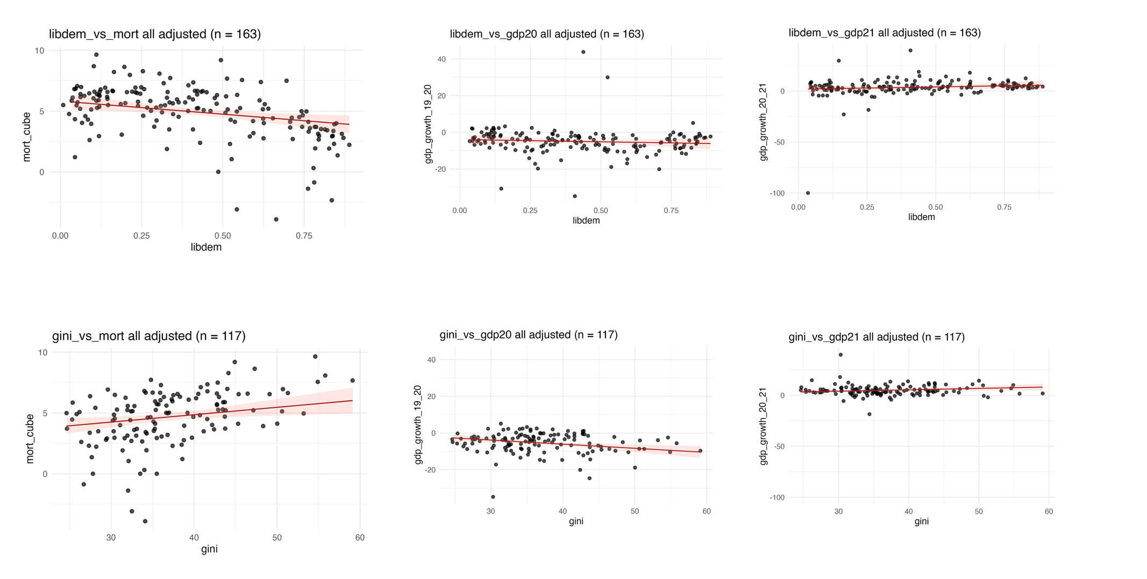
Figure S2: Relationship between LibDem score and cube root transformed age-standardised cumulative excess mortality per 100,000 population (2020–2021) for island jurisdictions (fully-adjusted model controlling for GDP, GHS Index, and population size)

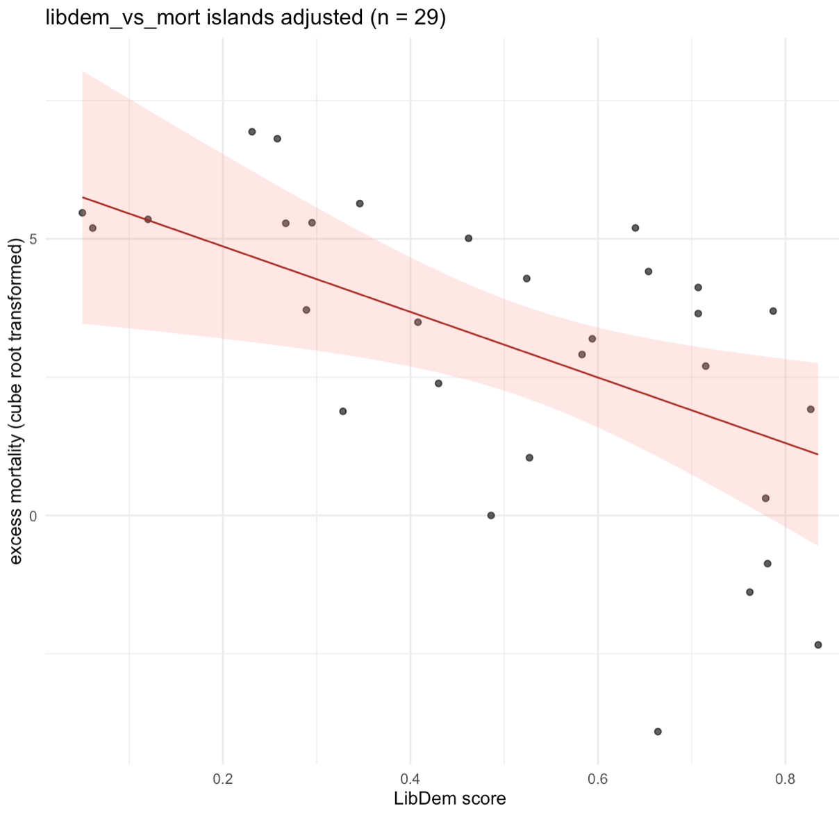

Figure S3: Relationship between Gini coefficient and cube root transformed age-standardised cumulative excess mortality per 100,000 population (2020–2021) for non-island jurisdictions (fully-adjusted model controlling for GDP, GHS Index, population size, and government corruption)

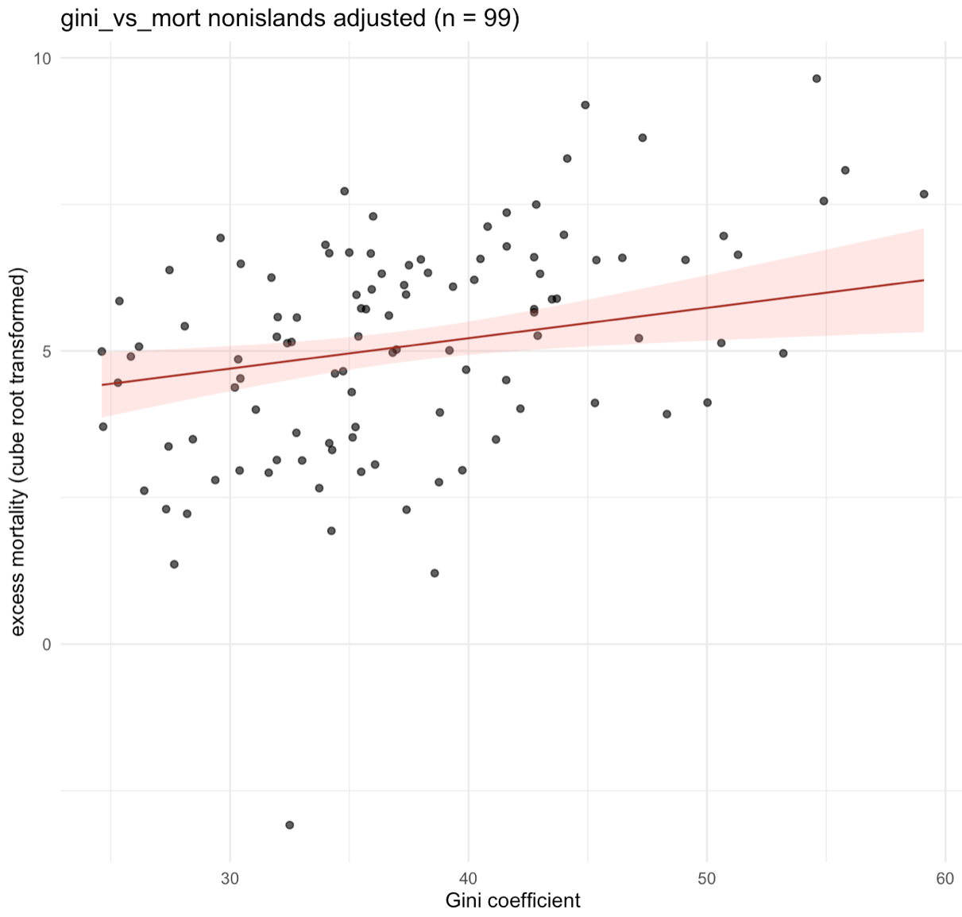

Table S2: Complete regression results across six analysis families (A1-A6: covering three outcomes of age-standardised cumulative excess mortality, GDP growth 2019-2020, and GDP growth 2020-21; for independent variables of LibDem score and Gini coefficient)

analysis | stratum_model | term | estimate | std.error | t statistic | p.value | r2 | Adj r2 | f_stat | p_overall | n
A1_libdem_mort | all_unadjusted | (Intercept) | 6.66927274 | 0.26339555 | 25.3203703 | 3.10E-59 | 0.27 | 0.26 | 60.97 | 5.95E-13 | 170
A1_libdem_mort | all_unadjusted | libdem | -4.2474021 | 0.54396901 | -7.8081692 | 5.95E-13 | 0.27 | 0.26 | 60.97 | 5.95E-13 | 170
A1_libdem_mort | all_adjusted | (Intercept) | 10.4628876 | 2.32001505 | 4.5098361 | 1.26E-05 | 0.40 | 0.39 | 26.74 | 6.00E-17 | 163
A1_libdem_mort | all_adjusted | libdem | -2.1567906 | 0.74459171 | -2.8966084 | 0.00430747 | 0.40 | 0.39 | 26.74 | 6.00E-17 | 163
A1_libdem_mort | all_adjusted | log_gdp_2019 | -0.6616933 | 0.1738988 | -3.8050481 | 2.02E-04 | 0.40 | 0.39 | 26.74 | 6.00E-17 | 163
A1_libdem_mort | all_adjusted | log_pop | 0.13993939 | 0.10311954 | 1.3570598 | 0.1766977 | 0.40 | 0.39 | 26.74 | 6.00E-17 | 163
A1_libdem_mort | all_adjusted | ghs_2019 | -0.0161122 | 0.01796039 | -0.8970964 | 0.37103237 | 0.40 | 0.39 | 26.74 | 6.00E-17 | 163
A1_libdem_mort | islands_unadjusted | (Intercept) | 6.64428582 | 0.93730206 | 7.08873493 | 1.03E-07 | 0.39 | 0.37 | 17.88 | 2.27E-04 | 30
A1_libdem_mort | islands_unadjusted | libdem | -7.1404562 | 1.6886435 | -4.2285161 | 2.27E-04 | 0.39 | 0.37 | 17.88 | 2.27E-04 | 30
A1_libdem_mort | islands_adjusted | (Intercept) | 8.96926261 | 7.89592387 | 1.1359358 | 0.26719988 | 0.46 | 0.37 | 5.19 | 0.00369011 | 29
A1_libdem_mort | islands_adjusted | libdem | -5.9235489 | 2.19932312 | -2.6933509 | 0.01269871 | 0.46 | 0.37 | 5.19 | 0.00369011 | 29
A1_libdem_mort | islands_adjusted | log_gdp_2019 | -0.6326351 | 0.5929045 | -1.0670101 | 0.29658354 | 0.46 | 0.37 | 5.19 | 0.00369011 | 29
A1_libdem_mort | islands_adjusted | log_pop | 0.21387519 | 0.34887457 | 0.61304324 | 0.54561396 | 0.46 | 0.37 | 5.19 | 0.00369011 | 29
A1_libdem_mort | islands_adjusted | ghs_2019 | -4.45E-04 | 0.06467577 | -0.0068788 | 0.99456839 | 0.46 | 0.37 | 5.19 | 0.00369011 | 29
A1_libdem_mort | nonislands_unadjusted | (Intercept) | 6.59085151 | 0.23772758 | 27.7243871 | 2.85E-58 | 0.23 | 0.22 | 40.19 | 3.05E-09 | 140
A1_libdem_mort | nonislands_unadjusted | libdem | -3.2229676 | 0.50836297 | -6.3398946 | 3.05E-09 | 0.23 | 0.22 | 40.19 | 3.05E-09 | 140
A1_libdem_mort | nonislands_adjusted | (Intercept) | 12.4545037 | 1.98888191 | 6.26206292 | 5.21E-09 | 0.48 | 0.46 | 29.49 | 2.04E-17 | 134
A1_libdem_mort | nonislands_adjusted | libdem | -0.4735164 | 0.6513885 | -0.7269339 | 0.46858358 | 0.48 | 0.46 | 29.49 | 2.04E-17 | 134
A1_libdem_mort | nonislands_adjusted | log_gdp_2019 | -0.5119684 | 0.14757268 | -3.4692624 | 7.10E-04 | 0.48 | 0.46 | 29.49 | 2.04E-17 | 134
A1_libdem_mort | nonislands_adjusted | log_pop | -0.0059082 | 0.09037224 | -0.0653761 | 0.94797573 | 0.48 | 0.46 | 29.49 | 2.04E-17 | 134
A1_libdem_mort | nonislands_adjusted | ghs_2019 | -0.0475499 | 0.01538414 | -3.0908406 | 0.00244585 | 0.48 | 0.46 | 29.49 | 2.04E-17 | 134
A2_gini_mort | all_unadjusted | (Intercept) | -0.6567231 | 0.92705276 | -0.7083988 | 0.47996592 | 0.21 | 0.20 | 33.64 | 4.77E-08 | 132
A2_gini_mort | all_unadjusted | gini | 0.14266679 | 0.02459686 | 5.80020444 | 4.77E-08 | 0.21 | 0.20 | 33.64 | 4.77E-08 | 132
A2_gini_mort | all_adjusted | (Intercept) | 7.57051291 | 2.80440584 | 2.69950689 | 0.00803099 | 0.46 | 0.44 | 18.90 | 1.47E-13 | 117
A2_gini_mort | all_adjusted | gini | 0.0607636 | 0.02337476 | 2.59953871 | 0.01060371 | 0.46 | 0.44 | 18.90 | 1.47E-13 | 117
A2_gini_mort | all_adjusted | log_gdp_2019 | -0.5689734 | 0.22474287 | -2.5316641 | 0.0127517 | 0.46 | 0.44 | 18.90 | 1.47E-13 | 117
A2_gini_mort | all_adjusted | log_pop | 0.0383101 | 0.11634817 | 0.32927124 | 0.74257117 | 0.46 | 0.44 | 18.90 | 1.47E-13 | 117
A2_gini_mort | all_adjusted | ghs_2019 | -0.0034607 | 0.01936098 | -0.1787479 | 0.85846152 | 0.46 | 0.44 | 18.90 | 1.47E-13 | 117
A2_gini_mort | all_adjusted | corruption | 0.48668723 | 0.19593413 | 2.48393287 | 0.01448803 | 0.46 | 0.44 | 18.90 | 1.47E-13 | 117
A2_gini_mort | islands_unadjusted | (Intercept) | -5.7836824 | 3.04737607 | -1.8979221 | 0.07032775 | 0.25 | 0.21 | 7.49 | 0.01177375 | 25
A2_gini_mort | islands_unadjusted | gini | 0.23430019 | 0.08563538 | 2.73602089 | 0.01177375 | 0.25 | 0.21 | 7.49 | 0.01177375 | 25
A2_gini_mort | islands_adjusted | (Intercept) | 21.0090142 | 23.9516638 | 0.87714216 | 0.39763011 | 0.37 | 0.10 | 1.39 | 0.29665492 | 18
A2_gini_mort | islands_adjusted | gini | -0.0549935 | 0.18917783 | -0.2906974 | 0.77624567 | 0.37 | 0.10 | 1.39 | 0.29665492 | 18
A2_gini_mort | islands_adjusted | log_gdp_2019 | -1.4476992 | 1.73524349 | -0.8342917 | 0.42041504 | 0.37 | 0.10 | 1.39 | 0.29665492 | 18
A2_gini_mort | islands_adjusted | log_pop | -0.2698176 | 0.52531932 | -0.513626 | 0.61683892 | 0.37 | 0.10 | 1.39 | 0.29665492 | 18
A2_gini_mort | islands_adjusted | ghs_2019 | 0.07623842 | 0.10548862 | 0.72271703 | 0.48370191 | 0.37 | 0.10 | 1.39 | 0.29665492 | 18
A2_gini_mort | islands_adjusted | corruption | 1.33565405 | 0.90589513 | 1.4744025 | 0.16611913 | 0.37 | 0.10 | 1.39 | 0.29665492 | 18
A2_gini_mort | nonislands_unadjusted | (Intercept) | 0.80132593 | 0.83462952 | 0.96009776 | 0.33921168 | 0.21 | 0.20 | 27.92 | 6.89E-07 | 107
A2_gini_mort | nonislands_unadjusted | gini | 0.11556203 | 0.02186906 | 5.28427065 | 6.89E-07 | 0.21 | 0.20 | 27.92 | 6.89E-07 | 107
A2_gini_mort | nonislands_adjusted | (Intercept) | 9.90746915 | 2.42392464 | 4.08736682 | 9.25E-05 | 0.53 | 0.50 | 20.70 | 7.64E-14 | 99
A2_gini_mort | nonislands_adjusted | gini | 0.05179719 | 0.01946532 | 2.6609993 | 0.00917762 | 0.53 | 0.50 | 20.70 | 7.64E-14 | 99
A2_gini_mort | nonislands_adjusted | log_gdp_2019 | -0.4312912 | 0.18924283 | -2.2790359 | 0.02495263 | 0.53 | 0.50 | 20.70 | 7.64E-14 | 99
A2_gini_mort | nonislands_adjusted | log_pop | -0.0587979 | 0.1048333 | -0.56087 | 0.57623498 | 0.53 | 0.50 | 20.70 | 7.64E-14 | 99
A2_gini_mort | nonislands_adjusted | ghs_2019 | -0.0359212 | 0.01728456 | -2.0782223 | 0.04044379 | 0.53 | 0.50 | 20.70 | 7.64E-14 | 99
A2_gini_mort | nonislands_adjusted | corruption | 0.19725911 | 0.17318437 | 1.13901217 | 0.25762349 | 0.53 | 0.50 | 20.70 | 7.64E-14 | 99
A3_libdem_gdp20 | all_unadjusted | (Intercept) | -3.7471233 | 1.07399732 | -3.4889504 | 6.25E-04 | 0.01 | 0.00 | 1.67 | 0.19862548 | 164
A3_libdem_gdp20 | all_unadjusted | libdem | -2.8124718 | 2.17892468 | -1.2907614 | 0.19862548 | 0.01 | 0.00 | 1.67 | 0.19862548 | 164
A3_libdem_gdp20 | all_adjusted | (Intercept) | 1.9830728 | 9.62725118 | 0.20598536 | 0.83706752 | 0.04 | 0.02 | 1.86 | 0.12035345 | 163
A3_libdem_gdp20 | all_adjusted | libdem | -2.4438134 | 3.08979523 | -0.7909306 | 0.43017016 | 0.04 | 0.02 | 1.86 | 0.12035345 | 163
A3_libdem_gdp20 | all_adjusted | log_gdp_2019 | -1.3505901 | 0.7216192 | -1.8716106 | 0.06310907 | 0.04 | 0.02 | 1.86 | 0.12035345 | 163
A3_libdem_gdp20 | all_adjusted | log_pop | 0.16023542 | 0.42791005 | 0.37446053 | 0.70856381 | 0.04 | 0.02 | 1.86 | 0.12035345 | 163
A3_libdem_gdp20 | all_adjusted | ghs_2019 | 0.09751013 | 0.07452936 | 1.30834524 | 0.19265632 | 0.04 | 0.02 | 1.86 | 0.12035345 | 163
A3_libdem_gdp20 | islands_unadjusted | (Intercept) | -8.1054951 | 4.87412624 | -1.6629637 | 0.10788671 | 0.00 | -0.03 | 0.06 | 0.81559547 | 29
A3_libdem_gdp20 | islands_unadjusted | libdem | 2.03365601 | 8.63537068 | 0.23550304 | 0.81559547 | 0.00 | -0.03 | 0.06 | 0.81559547 | 29
A3_libdem_gdp20 | islands_adjusted | (Intercept) | -4.0640782 | 38.9101426 | -0.1044478 | 0.91768199 | 0.06 | -0.10 | 0.36 | 0.83140371 | 29
A3_libdem_gdp20 | islands_adjusted | libdem | 4.06568611 | 10.8379941 | 0.37513271 | 0.71085658 | 0.06 | -0.10 | 0.36 | 0.83140371 | 29
A3_libdem_gdp20 | islands_adjusted | log_gdp_2019 | -1.7947464 | 2.92176051 | -0.6142688 | 0.54481735 | 0.06 | -0.10 | 0.36 | 0.83140371 | 29
A3_libdem_gdp20 | islands_adjusted | log_pop | 0.58306751 | 1.719211 | 0.33914832 | 0.73744768 | 0.06 | -0.10 | 0.36 | 0.83140371 | 29
A3_libdem_gdp20 | islands_adjusted | ghs_2019 | 0.08595784 | 0.31871423 | 0.26970193 | 0.78969497 | 0.06 | -0.10 | 0.36 | 0.83140371 | 29
A3_libdem_gdp20 | nonislands_unadjusted | (Intercept) | -3.3291829 | 0.9992174 | -3.3317903 | 0.00111745 | 0.01 | 0.01 | 1.87 | 0.17405592 | 135
A3_libdem_gdp20 | nonislands_unadjusted | libdem | -2.8679498 | 2.09859921 | -1.366602 | 0.17405592 | 0.01 | 0.01 | 1.87 | 0.17405592 | 135
A3_libdem_gdp20 | nonislands_adjusted | (Intercept) | 5.52722029 | 9.44500626 | 0.58520028 | 0.55943532 | 0.04 | 0.01 | 1.17 | 0.3257577 | 134
A3_libdem_gdp20 | nonislands_adjusted | libdem | -3.1567978 | 3.09338045 | -1.020501 | 0.30940095 | 0.04 | 0.01 | 1.17 | 0.3257577 | 134
A3_libdem_gdp20 | nonislands_adjusted | log_gdp_2019 | -1.159382 | 0.70080829 | -1.6543497 | 0.10048769 | 0.04 | 0.01 | 1.17 | 0.3257577 | 134
A3_libdem_gdp20 | nonislands_adjusted | log_pop | -0.1032447 | 0.42916898 | -0.2405689 | 0.81027119 | 0.04 | 0.01 | 1.17 | 0.3257577 | 134
A3_libdem_gdp20 | nonislands_adjusted | ghs_2019 | 0.08641381 | 0.07305776 | 1.18281489 | 0.23905792 | 0.04 | 0.01 | 1.17 | 0.3257577 | 134
A4_gini_gdp20 | all_unadjusted | (Intercept) | -1.0313678 | 2.57612387 | -0.4003564 | 0.68955624 | 0.02 | 0.01 | 2.93 | 0.08942012 | 131
A4_gini_gdp20 | all_unadjusted | gini | -0.1171339 | 0.06844539 | -1.7113487 | 0.08942012 | 0.02 | 0.01 | 2.93 | 0.08942012 | 131
A4_gini_gdp20 | all_adjusted | (Intercept) | -11.332381 | 8.42918394 | -1.344422 | 0.18155302 | 0.25 | 0.22 | 7.50 | 4.24E-06 | 117
A4_gini_gdp20 | all_adjusted | gini | -0.2246759 | 0.07025737 | -3.1978983 | 0.0018041 | 0.25 | 0.22 | 7.50 | 4.24E-06 | 117
A4_gini_gdp20 | all_adjusted | log_gdp_2019 | -0.9389451 | 0.67550814 | -1.3899833 | 0.1673152 | 0.25 | 0.22 | 7.50 | 4.24E-06 | 117
A4_gini_gdp20 | all_adjusted | log_pop | 1.43661894 | 0.3497069 | 4.10806571 | 7.66E-05 | 0.25 | 0.22 | 7.50 | 4.24E-06 | 117
A4_gini_gdp20 | all_adjusted | ghs_2019 | -0.0037617 | 0.05819317 | -0.064642 | 0.94857534 | 0.25 | 0.22 | 7.50 | 4.24E-06 | 117
A4_gini_gdp20 | all_adjusted | corruption | -0.1036144 | 0.58891791 | -0.1759402 | 0.86066148 | 0.25 | 0.22 | 7.50 | 4.24E-06 | 117
A4_gini_gdp20 | islands_unadjusted | (Intercept) | -0.3441951 | 12.4431863 | -0.0276613 | 0.97817088 | 0.02 | -0.02 | 0.52 | 0.47954045 | 25
A4_gini_gdp20 | islands_unadjusted | gini | -0.2513218 | 0.34967032 | -0.7187393 | 0.47954045 | 0.02 | -0.02 | 0.52 | 0.47954045 | 25
A4_gini_gdp20 | islands_adjusted | (Intercept) | -195.38413 | 72.2497656 | -2.7042874 | 0.01915682 | 0.56 | 0.37 | 3.04 | 0.05331655 | 18
A4_gini_gdp20 | islands_adjusted | gini | 0.56824576 | 0.57065155 | 0.99578414 | 0.33901129 | 0.56 | 0.37 | 3.04 | 0.05331655 | 18
A4_gini_gdp20 | islands_adjusted | log_gdp_2019 | 12.4565243 | 5.23433098 | 2.37977391 | 0.03477712 | 0.56 | 0.37 | 3.04 | 0.05331655 | 18
A4_gini_gdp20 | islands_adjusted | log_pop | 3.85984875 | 1.58461633 | 2.43582543 | 0.03139651 | 0.56 | 0.37 | 3.04 | 0.05331655 | 18
A4_gini_gdp20 | islands_adjusted | ghs_2019 | -0.4704987 | 0.31820454 | -1.4786045 | 0.16500962 | 0.56 | 0.37 | 3.04 | 0.05331655 | 18
A4_gini_gdp20 | islands_adjusted | corruption | -2.0961693 | 2.73261647 | -0.7670924 | 0.45785386 | 0.56 | 0.37 | 3.04 | 0.05331655 | 18
A4_gini_gdp20 | nonislands_unadjusted | (Intercept) | 0.72149137 | 2.00710062 | 0.35946946 | 0.71997278 | 0.06 | 0.05 | 6.92 | 0.0098185 | 106
A4_gini_gdp20 | nonislands_unadjusted | gini | -0.1385586 | 0.05267213 | -2.6305865 | 0.0098185 | 0.06 | 0.05 | 6.92 | 0.0098185 | 106
A4_gini_gdp20 | nonislands_adjusted | (Intercept) | 1.05932416 | 6.55480934 | 0.16161022 | 0.87196339 | 0.26 | 0.22 | 6.66 | 2.41E-05 | 99
A4_gini_gdp20 | nonislands_adjusted | gini | -0.242495 | 0.05263837 | -4.6068113 | 1.30E-05 | 0.26 | 0.22 | 6.66 | 2.41E-05 | 99
A4_gini_gdp20 | nonislands_adjusted | log_gdp_2019 | -0.893207 | 0.51175297 | -1.7453871 | 0.08422036 | 0.26 | 0.22 | 6.66 | 2.41E-05 | 99
A4_gini_gdp20 | nonislands_adjusted | log_pop | 0.95073333 | 0.28349161 | 3.35365592 | 0.00115509 | 0.26 | 0.22 | 6.66 | 2.41E-05 | 99
A4_gini_gdp20 | nonislands_adjusted | ghs_2019 | -0.0816904 | 0.04674115 | -1.7477197 | 0.08381312 | 0.26 | 0.22 | 6.66 | 2.41E-05 | 99
A4_gini_gdp20 | nonislands_adjusted | corruption | -0.6678714 | 0.46832749 | -1.4260778 | 0.15719409 | 0.26 | 0.22 | 6.66 | 2.41E-05 | 99
A5_libdem_gdp21 | all_unadjusted | (Intercept) | 0.33917216 | 1.50044778 | 0.22604729 | 0.82144958 | 0.04 | 0.04 | 6.94 | 0.00923371 | 164
A5_libdem_gdp21 | all_unadjusted | libdem | 8.02084685 | 3.04410694 | 2.63487683 | 0.00923371 | 0.04 | 0.04 | 6.94 | 0.00923371 | 164
A5_libdem_gdp21 | all_adjusted | (Intercept) | -4.7137176 | 13.6131095 | -0.3462631 | 0.72960566 | 0.05 | 0.03 | 2.24 | 0.06756072 | 163
A5_libdem_gdp21 | all_adjusted | libdem | 4.37371997 | 4.36902705 | 1.00107414 | 0.31832164 | 0.05 | 0.03 | 2.24 | 0.06756072 | 163
A5_libdem_gdp21 | all_adjusted | log_gdp_2019 | 0.87348918 | 1.02038276 | 0.85604071 | 0.39327163 | 0.05 | 0.03 | 2.24 | 0.06756072 | 163
A5_libdem_gdp21 | all_adjusted | log_pop | -0.2012301 | 0.60507264 | -0.3325717 | 0.73989841 | 0.05 | 0.03 | 2.24 | 0.06756072 | 163
A5_libdem_gdp21 | all_adjusted | ghs_2019 | 0.03853437 | 0.10538587 | 0.36565025 | 0.71511514 | 0.05 | 0.03 | 2.24 | 0.06756072 | 163
A5_libdem_gdp21 | islands_unadjusted | (Intercept) | 3.9167058 | 3.95494186 | 0.99033208 | 0.3308045 | 0.00 | -0.04 | 0.04 | 0.8416989 | 29
A5_libdem_gdp21 | islands_unadjusted | libdem | 1.41296359 | 7.00687412 | 0.20165391 | 0.8416989 | 0.00 | -0.04 | 0.04 | 0.8416989 | 29
A5_libdem_gdp21 | islands_adjusted | (Intercept) | -7.2009881 | 29.7050679 | -0.2424161 | 0.81051735 | 0.17 | 0.03 | 1.19 | 0.34223372 | 29
A5_libdem_gdp21 | islands_adjusted | libdem | -6.9692279 | 8.27402133 | -0.8423024 | 0.4079344 | 0.17 | 0.03 | 1.19 | 0.34223372 | 29
A5_libdem_gdp21 | islands_adjusted | log_gdp_2019 | 2.37368938 | 2.23055195 | 1.06417131 | 0.29784131 | 0.17 | 0.03 | 1.19 | 0.34223372 | 29
A5_libdem_gdp21 | islands_adjusted | log_pop | -0.7669838 | 1.31249274 | -0.5843719 | 0.56442342 | 0.17 | 0.03 | 1.19 | 0.34223372 | 29
A5_libdem_gdp21 | islands_adjusted | ghs_2019 | 0.09934129 | 0.24331517 | 0.40828235 | 0.6866862 | 0.17 | 0.03 | 1.19 | 0.34223372 | 29
A5_libdem_gdp21 | nonislands_unadjusted | (Intercept) | -0.0847277 | 1.63979674 | -0.0516696 | 0.95886946 | 0.05 | 0.04 | 6.83 | 0.00997852 | 135
A5_libdem_gdp21 | nonislands_unadjusted | libdem | 9.0027952 | 3.44397138 | 2.61407375 | 0.00997852 | 0.05 | 0.04 | 6.83 | 0.00997852 | 135
A5_libdem_gdp21 | nonislands_adjusted | (Intercept) | -4.7021843 | 15.6557527 | -0.3003487 | 0.76439471 | 0.05 | 0.02 | 1.78 | 0.13624921 | 134
A5_libdem_gdp21 | nonislands_adjusted | libdem | 7.00522194 | 5.12749256 | 1.36620812 | 0.17425053 | 0.05 | 0.02 | 1.78 | 0.13624921 | 134
A5_libdem_gdp21 | nonislands_adjusted | log_gdp_2019 | 0.53747496 | 1.16163833 | 0.46268701 | 0.64436826 | 0.05 | 0.02 | 1.78 | 0.13624921 | 134
A5_libdem_gdp21 | nonislands_adjusted | log_pop | -0.0245886 | 0.71137733 | -0.0345647 | 0.97248025 | 0.05 | 0.02 | 1.78 | 0.13624921 | 134
A5_libdem_gdp21 | nonislands_adjusted | ghs_2019 | 0.01871387 | 0.12109831 | 0.15453451 | 0.87742982 | 0.05 | 0.02 | 1.78 | 0.13624921 | 134
A6_gini_gdp21 | all_unadjusted | (Intercept) | 4.86014438 | 2.49582165 | 1.94731237 | 0.05366989 | 0.00 | -0.01 | 0.00 | 0.97408604 | 131
A6_gini_gdp21 | all_unadjusted | gini | 0.00215826 | 0.06631183 | 0.03254713 | 0.97408604 | 0.00 | -0.01 | 0.00 | 0.97408604 | 131
A6_gini_gdp21 | all_adjusted | (Intercept) | -8.4653578 | 8.60723379 | -0.9835167 | 0.32749214 | 0.18 | 0.14 | 4.80 | 5.21E-04 | 117
A6_gini_gdp21 | all_adjusted | gini | 0.13697825 | 0.07174141 | 1.90933292 | 0.05880082 | 0.18 | 0.14 | 4.80 | 5.21E-04 | 117
A6_gini_gdp21 | all_adjusted | log_gdp_2019 | 2.12669454 | 0.68977692 | 3.08316282 | 0.00258422 | 0.18 | 0.14 | 4.80 | 5.21E-04 | 117
A6_gini_gdp21 | all_adjusted | log_pop | -0.8685559 | 0.35709377 | -2.4322907 | 0.0166019 | 0.18 | 0.14 | 4.80 | 5.21E-04 | 117
A6_gini_gdp21 | all_adjusted | ghs_2019 | 0.05617327 | 0.05942239 | 0.94532172 | 0.34654789 | 0.18 | 0.14 | 4.80 | 5.21E-04 | 117
A6_gini_gdp21 | all_adjusted | corruption | 1.09334392 | 0.60135764 | 1.81812595 | 0.0717417 | 0.18 | 0.14 | 4.80 | 5.21E-04 | 117
A6_gini_gdp21 | islands_unadjusted | (Intercept) | 9.35004568 | 12.029464 | 0.77726203 | 0.44492569 | 0.00 | -0.04 | 0.10 | 0.75016276 | 25
A6_gini_gdp21 | islands_unadjusted | gini | -0.1089399 | 0.33804417 | -0.3222652 | 0.75016276 | 0.00 | -0.04 | 0.10 | 0.75016276 | 25
A6_gini_gdp21 | islands_adjusted | (Intercept) | 57.7737068 | 96.0285579 | 0.60163047 | 0.55861536 | 0.26 | -0.05 | 0.84 | 0.54934338 | 18
A6_gini_gdp21 | islands_adjusted | gini | -0.506051 | 0.75846398 | -0.667205 | 0.51726611 | 0.26 | -0.05 | 0.84 | 0.54934338 | 18
A6_gini_gdp21 | islands_adjusted | log_gdp_2019 | 0.05034741 | 6.95705033 | 0.00723689 | 0.99434477 | 0.26 | -0.05 | 0.84 | 0.54934338 | 18
A6_gini_gdp21 | islands_adjusted | log_pop | -3.0315113 | 2.10614414 | -1.4393655 | 0.17561873 | 0.26 | -0.05 | 0.84 | 0.54934338 | 18
A6_gini_gdp21 | islands_adjusted | ghs_2019 | 0.42671967 | 0.42293179 | 1.00895624 | 0.33290786 | 0.26 | -0.05 | 0.84 | 0.54934338 | 18
A6_gini_gdp21 | islands_adjusted | corruption | 6.50049582 | 3.63197328 | 1.78979726 | 0.09873209 | 0.26 | -0.05 | 0.84 | 0.54934338 | 18
A6_gini_gdp21 | nonislands_unadjusted | (Intercept) | 4.08345172 | 2.20984224 | 1.84784762 | 0.06746623 | 0.00 | -0.01 | 0.11 | 0.7398716 | 106
A6_gini_gdp21 | nonislands_unadjusted | gini | 0.0193064 | 0.05799266 | 0.33291104 | 0.7398716 | 0.00 | -0.01 | 0.11 | 0.7398716 | 106
A6_gini_gdp21 | nonislands_adjusted | (Intercept) | -10.541647 | 7.25500676 | -1.4530168 | 0.14958505 | 0.22 | 0.18 | 5.28 | 2.59E-04 | 99
A6_gini_gdp21 | nonislands_adjusted | gini | 0.14584256 | 0.0582613 | 2.50324939 | 0.01405008 | 0.22 | 0.18 | 5.28 | 2.59E-04 | 99
A6_gini_gdp21 | nonislands_adjusted | log_gdp_2019 | 1.74147686 | 0.56641942 | 3.07453596 | 0.0027675 | 0.22 | 0.18 | 5.28 | 2.59E-04 | 99
A6_gini_gdp21 | nonislands_adjusted | log_pop | -0.5510004 | 0.31377474 | -1.7560381 | 0.08237405 | 0.22 | 0.18 | 5.28 | 2.59E-04 | 99
A6_gini_gdp21 | nonislands_adjusted | ghs_2019 | 0.05364812 | 0.05173413 | 1.03699674 | 0.30242618 | 0.22 | 0.18 | 5.28 | 2.59E-04 | 99
A6_gini_gdp21 | nonislands_adjusted | corruption | 0.64728212 | 0.51835514 | 1.24872325 | 0.21490056 | 0.22 | 0.18 | 5.28 | 2.59E-04 | 99

Table notes: adjr2: adjusted r-squared metric; corruption: government corruption index score; f_stat: F-statistic; gdp20: growth in gross domestic product (PPP) per capita 2019 to 2020; gdp21: growth in gross domestic product (PPP) per capita 2020 to 2021; ghs_2019: Global Health Security Index score (2019); gini: Gini income inequality coefficient; mort: age-standardised cumulative excess mortality 2020–2021; pop: population size; r2: r-squared metric.

References

Boyd, M., Baker, M., Kvalsvig, A., & Wilson, N. (2025). Impact of Covid-19 Control Strategies on Health and GDP Growth Outcomes in 193 Sovereign Jurisdictions. PLoS Global Public Health. doi:10.1371/journal.pgph.0004554
GBD 2021 Demographics Collaborators. (2024). Global age-sex-specific mortality, life expectancy, and population estimates in 204 countries and territories and 811 subnational locations, 1950-2021, and the impact of the COVID-19 pandemic: a comprehensive demographic analysis for the Global Burden of Disease Study 2021. Lancet, 403(10440), 1989-2056. doi:10.1016/s0140-6736(24)00476-8

