Supplementary Figures
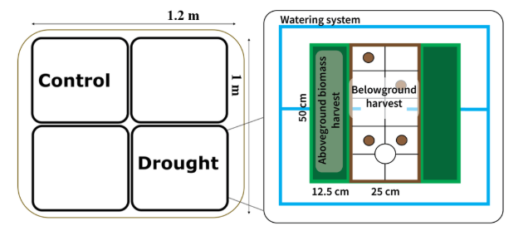Fig. S1 Experimental and data collection setup in BioCliVE
Visual of the sampling frame used for the belowground harvest. The frame is divided into ten sections, each numbered; five of these sections are randomly selected for sampling. Soil sampling is conducted with a 2.5 cm diameter soil corer. We divide the samples by 0-10 cm and 10-20 cm while coring. The holes created by coring are refilled with soil from the BioCliVE

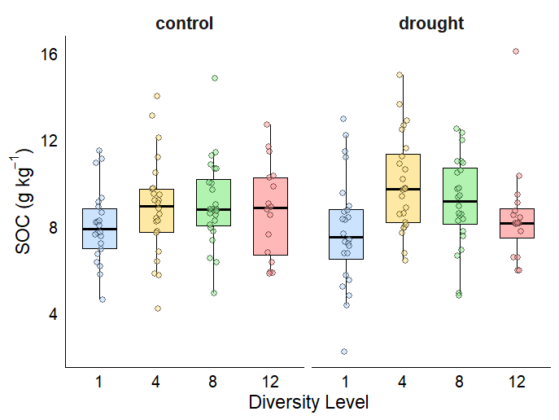
Fig. S2 SOC across plant diversity levels (1, 4, 8, and 12 species) under control and drought conditions. Post-hoc letters indicate Tukey-adjusted pairwise comparisons among diversity levels. Across treatments, SOC was significantly higher in 4-species mixtures compared to monocultures (p = 0.006), while no other pairwise differences among diversity levels were significant (all p > 0.11; Supplementary Table S1). No main effect of drought or diversity × drought interaction was detected
Table S1 Two-way ANOVA results testing the effects of species diversity (div.factor), drought treatment, and their interaction on soil organic carbon (SOC, g kg⁻¹). The table reports degrees of freedom (df), sums of squares (Sum Sq), mean squares (Mean Sq), F values, and p-values (Pr(>F)). Significant pathways (p < 0.05) are highlighted in bold
Source of variation | df | Sum Sq | Mean Sq | F value | Pr(>F)
Diversity (div.factor) | 3 | 51.97 | 17.324 | 4.240 | 0.0065
Treatment | 1 | 2.51 | 2.505 | 0.613 | 0.4347
Diversity × Treatment | 3 | 15.96 | 5.319 | 1.302 | 0.2757
Residuals | 163 | 666.00 | 4.086

Table S2 Results of Tukey-adjusted post hoc pairwise comparisons testing the effect of plant diversity (1, 4, 8, and 12 species) on SOC, averaged over drought and control treatments. The analysis revealed that SOC was significantly higher in 4-species mixtures compared to monocultures (1 species) (estimate = –1.40, p = 0.006). No other pairwise differences among diversity levels were significant. Significant pathways (p < 0.05) are highlighted in bold
Comparison Type | Contrast | Estimate | SE | df | t ratio | p-value
Diversity (averaged over treatment) | 1 − 4 species | -1.398 | 0.419 | 163 | -3.332 | 0.0058
 | 1 − 8 species | -0.946 | 0.422 | 163 | -2.244 | 0.1160
 | 1 − 12 species | -0.344 | 0.472 | 163 | -0.728 | 0.8858
 | 4 − 8 species | 0.452 | 0.415 | 163 | 1.089 | 0.6968
 | 4 − 12 species | 1.054 | 0.466 | 163 | 2.263 | 0.1111
 | 8 − 12 species | 0.603 | 0.468 | 163 | 1.288 | 0.5720

Table S3 Results of a two-way ANOVA testing the effects of plant diversity (monoculture vs. mixture) and drought treatment (control vs. drought) on SOC. The analysis revealed a significant main effect of diversity, while treatment and the interaction were not significant. Significant pathways (p < 0.05) are highlighted in bold
Source of variation | df | Sum Sq | Mean Sq | F value | Pr(>F)
Mixture | 1 | 37.25 | 37.25 | 8.90 | 0.003
Treatment | 1 | 0.55 | 0.55 | 0.13 | 0.718
Mixture × Treatment | 1 | 2.01 | 2.01 | 0.48 | 0.489
Residuals | 167 | 699.34 | 4.19

Table S4 Summary of mean (± SE) values of biomass, SOC, soil temperature, and soil moisture under control and drought conditions in monocultures and mixtures. Under control conditions, mixtures produced 2.6× more biomass than monocultures (268.9 vs. 102.4 g/m²), SOC was ~10% higher (8.91 vs. 8.02 g/kg), soil temperature was slightly cooler (19.5 vs. 20.4 °C), and soil moisture was comparable (0.240 vs. 0.255 m³/m³). Under drought conditions, mixtures produced 1.8× more biomass than monocultures (192.1 vs. 104.0 g/m²), SOC was ~19% higher (9.27 vs. 7.77 g/kg), soil temperature was marginally cooler (20.2 vs. 20.9 °C), and soil moisture was slightly lower (0.123 vs. 0.136 m³/m³)
Treatment | Mixture | Biomass (g/m²) | SOC gkg⁻¹ | Temperature (°C) | Soil moisture (m³/m³)
Control | Monoculture | 102.36 ± 20.43 | 8.02 ± 0.36 | 20.37 ± 0.22 | 0.255 ± 0.007
Control | Mixture | 268.92 ± 14.71 | 8.91 ± 0.27 | 19.50 ± 0.07 | 0.240 ± 0.005
Drought | Monoculture | 104.04 ± 18.49 | 7.77 ± 0.52 | 20.91 ± 0.18 | 0.136 ± 0.007
Drought | Mixture | 192.14 ± 10.04 | 9.27 ± 0.28 | 20.23 ± 0.07 | 0.123 ± 0.003

Table S5 Standardized path coefficients (Std. Est.) and p-values from multigroup SEM comparing control and drought conditions. Models tested the effects of plant diversity (monoculture vs. mixture), aboveground biomass, and soil microclimate (soil temperature and soil moisture) on SOC. Significant pathways (p < 0.05) are highlighted in bold. R² values represent the proportion of variance explained for each endogenous variable
Pathway | Control (Std. Est., p) | Drought (Std. Est., p)
mixture → biomass | 0.568, p < 0.001 | 0.461, p < 0.001
biomass → soil temperature | –0.266, p = 0.024 | –0.033, p = 0.780
mixture → soil temperature | –0.327, p = 0.006 | –0.373, p = 0.002
biomass → soil moisture | –0.120, p = 0.371 | –0.128, p = 0.295
mixture → soil moisture | –0.161, p = 0.230 | –0.256, p = 0.036
biomass → SOC | 0.163, p = 0.229 | 0.319, p = 0.006
soil temperature → SOC | –0.169, p = 0.187 | 0.085, p = 0.464
soil moisture → SOC | 0.054, p = 0.632 | 0.012, p = 0.915
mixture → SOC | 0.015, p = 0.912 | 0.120, p = 0.340
R² biomass | 0.323 | 0.212
R² soil temperature | 0.276 | 0.152
R² soil moisture | 0.062 | 0.112
R² SOC | 0.082 | 0.137

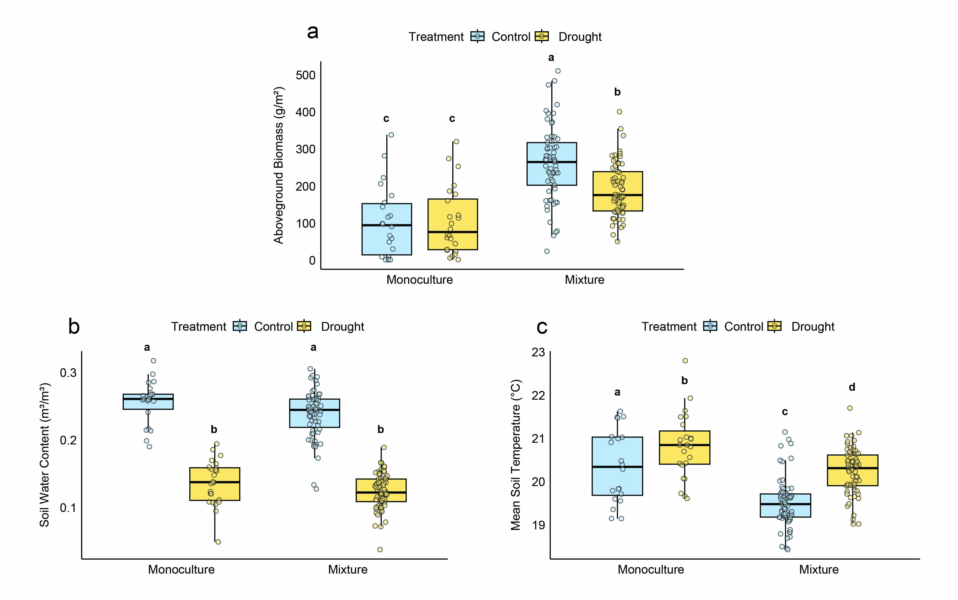Fig. S3 Relationships between plant diversity (monoculture vs. mixture) and intermediate variables included in the SEM. (a) Aboveground biomass, (b) soil moisture, and (c) soil temperature. Different letters indicate significant differences between treatments based on Tukey’s HSD post-hoc test (α = 0.05)
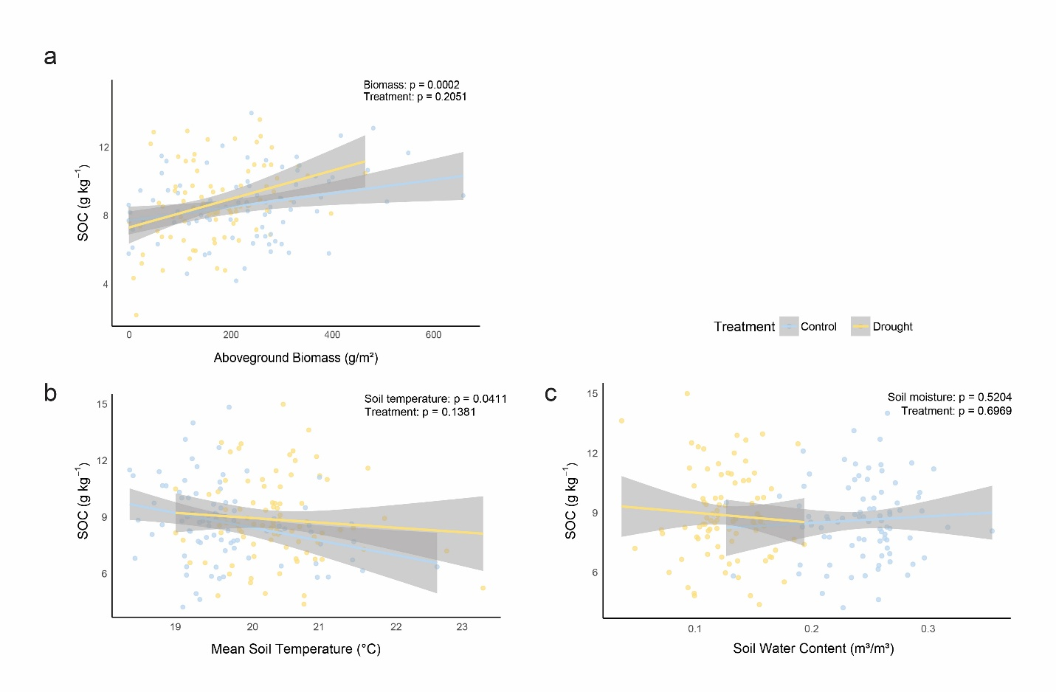Fig. S4 Relationships between SOC and continuous predictors included in the SEM. (a) SOC vs. aboveground biomass, (b) SOC vs. soil temperature, and (c) SOC vs. soil moisture. Each point represents a plot, colored by treatment (control vs. drought). Lines show fitted relationships from GLS models with treatment included as a factor

