Supplementary

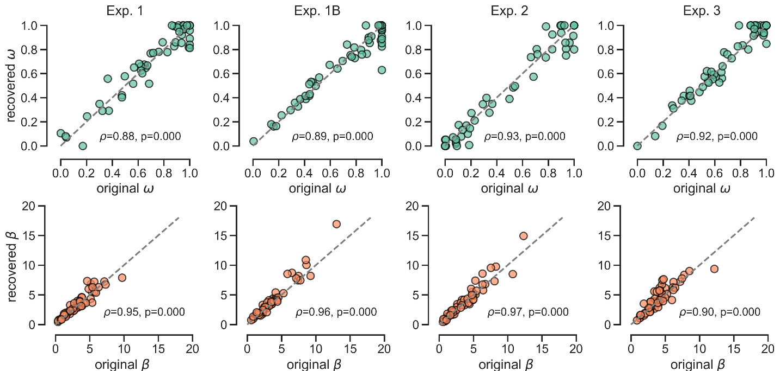
Figure S1. Parameter recovery analysis. Scatter plots comparing the original parameter estimates (x-axis) obtained from the empirical data against the recovered parameter estimates (y-axis) obtained by fitting the model to synthetic data generated with the original parameters. The top row displays the recovery for the weighting parameter $ω$ across the four experiments (Exp. 1, Exp. 1B, Exp. 2, and Exp. 3), while the bottom row displays the recovery for the inverse temperature parameter $β$. Each point represents a single participant. The dashed gray line indicates the identity line ($x=y$), representing perfect recovery. Spearman’s rank correlation coefficients ($ρ$) and corresponding p-values are reported for each panel, indicating high recoverability for both parameters across all experiments.

Parameter recovery
To assess the identifiability of the model parameters and the robustness of our fitting procedure, we performed a parameter recovery analysis. For each participant, we generated a synthetic dataset using the normative policy model instantiated with that participant’s best-fitting parameters (estimated from the empirical data) and preserving their specific experimental schedule. We then fitted the model to these synthetic datasets using the exact same optimization pipeline used for the empirical data (BADS), minimizing the negative log-likelihood of the simulated choices given the model constants. We evaluated the recovery performance by computing the Spearman’s rank correlation coefficient ($ρ$) between the generating parameters and the recovered parameters separately for each experiment (Fig. S1). This analysis confirmed that the parameters were well-recoverable, with high correlations observed for both the weighting parameter $ω$ (Exp. 1: $ρ=0.88$; Exp. 1B: $ρ=0.89$; Exp. 2: $ρ=0.93$; Exp. 3: $ρ=0.92$; all $p<.001$) and the inverse temperature $β$ (Exp. 1: $ρ=0.95$; Exp. 1B: $ρ=0.96$; Exp. 2: $ρ=0.97$; Exp. 3: $ρ=0.90$; all $p<.001$).

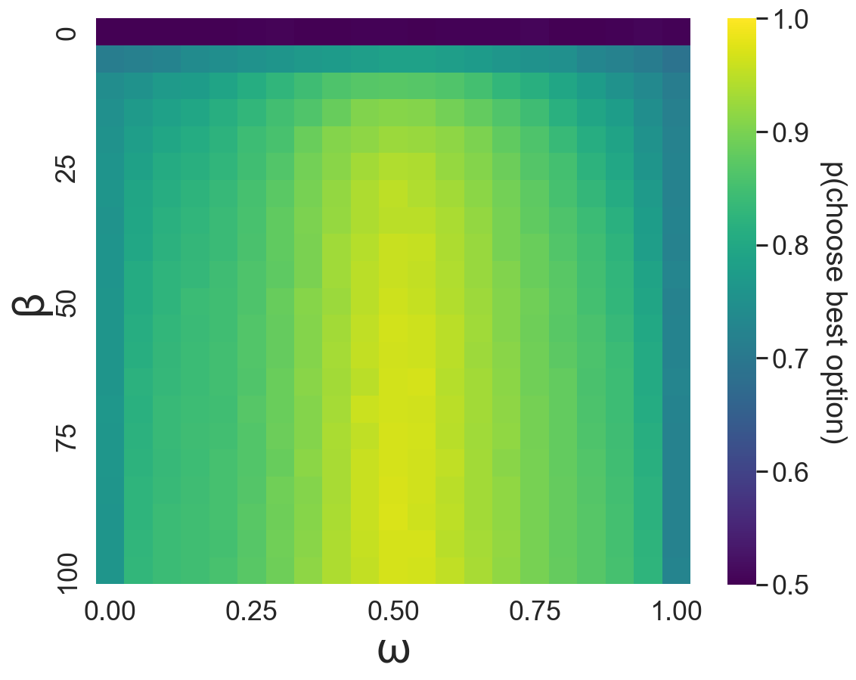
Figure S2. Simulated choice performance across the computational parameter space. Heatmap displaying the simulated probability of choosing the best option (color scale) as a function of the weighting parameter $ω$(x-axis) and the inverse temperature parameter β (y-axis). Simulations were generated by running the hybrid computational model through the exact trial histories (spaceship and shield pairs) encountered by each participant in Experiment 1A. The parameter $ω$ dictates the arbitration strategy, ranging from 0 (pure value-based) to 1 (pure perceptual). The parameter β governs choice consistency, where values closer to 0 represent random, exploratory behavior, and higher values represent
Optimal choice requires a balanced parameter weighting
To evaluate the theoretical performance limits of our computational model given the specific constraints of our task, we simulated choice behavior across a comprehensive parameter grid (Fig. S2). For each participant in Experiment 1A, we ran the model through their unique history of presented shield and spaceship pairs, systematically varying the weighting parameter $ω$ from 0 to 1 and the inverse temperature parameter β from 0 to 100.
As expected given the orthogonal design of the task, the simulations demonstrate that the highest probability of choosing the best option is achieved when $ω$ is centered at 0.5. This peak confirms that an optimal agent maximizes expected value by weighting perceptual and value-based information equally. Conversely, moving toward the extremes of the parameter space ($ω$ approaching 0 or 1) restricts the agent to a single dimension, yielding strictly suboptimal decision accuracy.
Furthermore, the heatmap illustrates the expected interaction between strategy and choice stochasticity. When β decreases toward 0, the probability of choosing the best option drops to chance levels (0.5) across the entire spectrum of ω, reflecting random choice behavior regardless of the integrated evidence. The optimal peak at $ω$ = 0.5 only emerges at higher values of β, where the integrated signal is sufficiently amplified to drive a deterministic exploitation strategy. Together, these simulations visually confirm that the strong "perceptual-first" bias predominantly observed in human participants during Experiment 1A (characterized by $ω$ shifted toward 1) inherently caps their maximum achievable accuracy in this task environment.

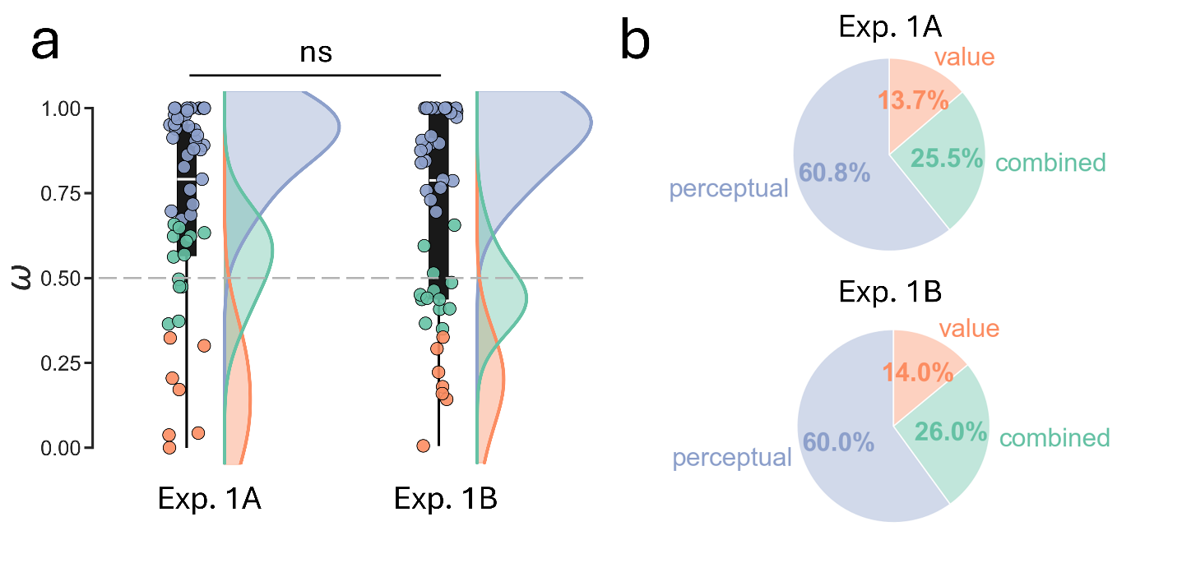Figure S3. Replication of behavioral strategies across Experiment 1A and 1B. (a) Comparison of the weighting parameter $ω$ distributions between Experiment 1A ($N=51$) and Experiment 1B ($N=50$). The boxplots show the median and interquartile range, while the half-violin plots show the density distribution. There is no significant difference (ns) between the two independent cohorts, confirming that the bias toward perceptual cues is stable. (b) Pie charts illustrating the proportion of participants classified into each strategy (perceptual-dominant, combined, and value-dominant). The prevalence of strategies is nearly identical across experiments, with the perceptual-dominant strategy consistently accounting for approximately 60% of the population, followed by the combined (~26%) and value-dominant (~14%) strategies.

Replication of biases observed in Exp. 1A
To ensure that the "perceptual-dominant" bias observed in Experiment 1A was a robust feature of human decision-making in our hybrid task, and not an artifact of a specific sample, we compared the behavioral results of Exp. 1A with Exp. 1B.
Exp. 1B ($N=50$) followed the exact same experimental protocol as Exp. 1A ($N=51$) regarding the training and combination tasks. The only difference was the addition of the Holt and Laury task and DOSPERT questionnaire at the end of the session to assess risk aversion.
We compared the fitted weighting parameter $ω$ across both cohorts. As shown in Figure S3a, the distribution of $ω$ in Exp. 1B was virtually identical to that of Exp. 1A. We observed no significant difference in the mean weighting parameter between the two groups (

t(98.75) = -0.22, P = 0.82, d = 0.044, 95% CI = [-0.13, 0.1]), confirming that the magnitude of the perceptual bias is stable across independent samples.
We next applied the same tercile-split classification method used in the main text to determine the prevalence of the three decision-making profiles (Perceptual-dominant, Value-dominant, and Combined). The distribution of strategies in Experiment 1B replicated the pattern observed in Experiment 1A with high precision (Fig. S3b).
The specific counts and proportions for each group were as follows. (i) Perceptual-dominant: In Exp 1A, 31 participants (60.8%) fell into this category, compared to 30 participants (60.0%) in Exp 1B. (ii) Value-dominant: In Exp 1A, 7 participants (13.7%) were classified as value-dominant, compared to 7 participants (14.0%) in Exp 1B –(iii) Combined: In Exp 1A, 13 participants (25.5%) adopted a combined strategy, compared to 13 participants (26.0%) in Exp 1B.

