Table 1: Detailed list of names, codes, and core characteristics for the eight photovoltaic array mounting systems within the photovoltaic field
No. | Mounting System | Code | Adjustment Angle | Spacing | Key Features | Shade Intensity | Image
1 | Flexible Fixed Mounting | R | Vertical single row, 45° tilt | East-west 19.044m, North-south 8.9m | Pre-stressed cable structure, large span , strong terrain adaptability | Heavy  (8) | 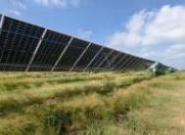
2 | Flat Single-axis Tracker | P | Horizontal axis ±60° | 1.2–1.4m ground clearance, 8–8.8m spacing | E-W tracking with N-S tilt optimization, 15–25% power gain | Moderate  (4) | 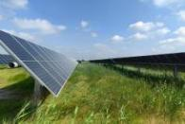
3 | Full-Dimensional Dual-Axis Tracker | Q | N-S 0°–23°, E-W ±60° | No fixed spacing (dynamic avoidance) | Dual-axis tracking, all-weather azimuth/elevation tracking | Light  (1) | 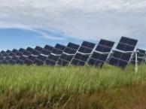
4 | Seasonally Adjustable Mount | J | Periodic tilt 53° to 16° (Jan–Dec) | Standard fixed mount spacing | Manual seasonal tilt adjustment, 5–8% annual power gain | Moderate  (7) | 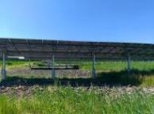
5 | Tilted Single-Axis Tracker | X | E-W 45°–135°, Fixed 12°/25° tilt | E-W 11–15 m, N-S 18–23 m | Fixed Tilt + Azimuth Tracking, Simple Structure Low Cost | Light  (5) | 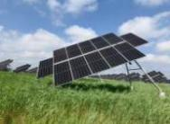
6 | Dual-Axis Tracker | S | N-S 0° to 70°, E-W -90° to 90° | Lateral 3×4rows horizontally | Vertical + horizontal axis tracking | Light  (2) | 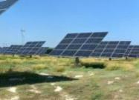
7 | Vertical Single-Axis Tracker | C | 0° to +180° | 37°, 45° tilt | 37°, 45° tilt , axis rotates E-W, tracking solar azimuth | Light  (6) | 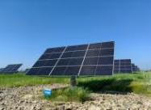
8 | Fixed Mount | G | Fixed 40° | Single span ≤30m, typically set at 18m | Lowest cost (0.15-0.3 RMB/W), high stability, no power gain | Heavy  (9) | 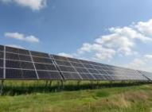
9 | Control Group (Non-PV) | CK | Blank control groups set up inside and outside PV site fencing | Undisturbed area ~100 m from fence | Reference for ecological comparison | None  (0) | 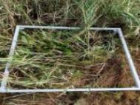
Note:The shading severity score (ranging from 1 to 9) was determined based on the tracking capability and structural parameters of each mounting system. A higher score indicates a larger proportion and longer duration of sustained, stable shaded area beneath the photovoltaic panels. The primary criteria for scoring were as follows: (1) Dynamic tracking mounts (e.g., P, Q, S) received lower scores due to constant shadow movement resulting in lighter shading; (2) Fixed-angle mounts (e.g., G, R) received the highest scores, representing the most severe shading conditions; (3) Adjustable but non-real-time tracking mounts (e.g., J, X, C) scored intermediately. This quantitative scoring system facilitates subsequent correlation analysis with vegetation and soil indicators, helping to reveal the gradient effects of shading intensity on ecological factors.

