Table S1. Clinical characteristics of subtype 1 and subtype 2 in non-converted RBD patients.
Group differences were assessed using two-sample t-tests, with positive t-values indicating higher values in subtype 2 compared with subtype 1. Among the examined variables, age at RBD onset showed a trend toward a difference between subtypes, whereas no other clinical characteristics differed significantly between the two subtypes.
 | Subtype 1 | Subtype 2 | T-value (2>1) | P-value
Age | 68.00 ± 6.51 | 69.47 ± 6.19 | -1.27509 | 0.261
MDS-UPDRS-III | 1.02 ± 2.10 | 1.00 ± 1.99 | 0.103107 | 0.961
KVSS | 1.56 ± 3.35 | 1.68 ± 3.94 | -0.13987 | 0.889
MMSE | 28.30 ± 1.61 | 28.09 ± 1.31 | 0.888213 | 0.522
MoCA | 26.65 ± 2.64 | 25.70 ± 2.48 | 1.738063 | 0.087
RBDQ-KR | 43.86 ± 19.24 | 38.86 ± 18.72 | 1.15127 | 0.211
ESS | 4.61 ± 3.32 | 6.14 ± 4.65 | -1.88979 | 0.078
GDS | 8.48 ± 6.64 | 9.05 ± 5.51 | -0.5595 | 0.654
PSQI | 7.45 ± 4.39 | 7.72 ± 4.47 | -0.35308 | 0.770
SCOPA-AUT | 13.36 ± 8.65 | 14.49 ± 7.40 | -0.62184 | 0.500
RBD duration, yr | 6.92 ± 8.25 | 5.51 ± 4.19 | 1.06 | 0.291
Age at RBD onset, yr | 61.14 ± 8.04 | 63.96 ± 6.33 | -1.91 | 0.060

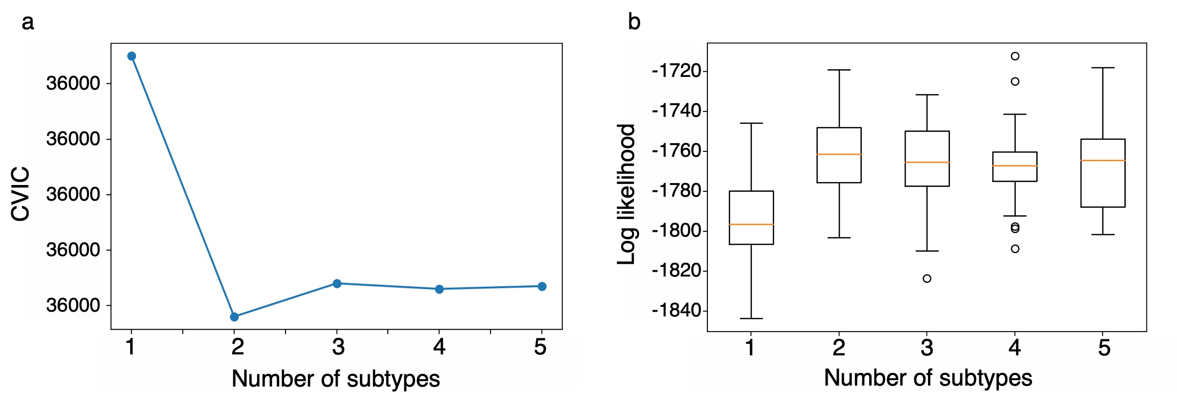
Figure S1. SuStaIn model selection criteria.
a. The Cross-Validation Information Criterion (CVIC) showed a sharp decrease from one to two subtypes, indicating a substantial improvement in model fit when introducing a second subtype. In contrast, increasing the number of subtypes beyond two resulted in only minor fluctuations in CVIC, with a slight increase at three subtypes and nearly flat values thereafter, suggesting minimal additional benefit from more complex models.
b. Consistent with the CVIC results, test set log-likelihood increased markedly from one to two subtypes but exhibited only marginal changes from two to five subtypes, indicating that additional subtypes provided little improvement in model fit.

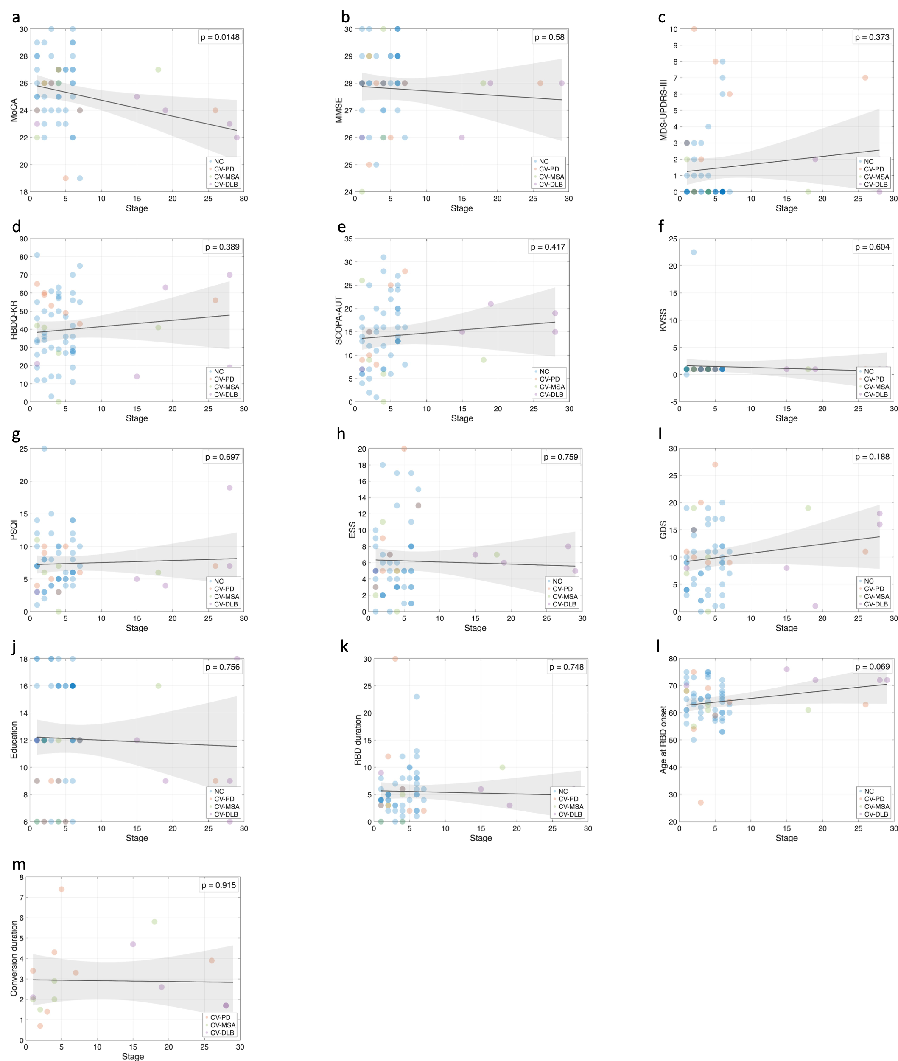
Figure S2. Associations between SuStaIn stage and neurophysiological scores and clinical characteristics in subtype 2.
Scatter plots illustrate the relationships between SuStaIn stage and multiple neurophysiological scores and clinical characteristics within subtype 2. Each point represents an individual subject, color-coded by diagnostic group (NC, CV-PD, CV-MSA, and CV-DLB). Solid lines indicate linear regression fits with shaded areas representing 95% confidence intervals, and regression p-values are shown in each panel. With the exception of MoCA, SuStaIn stage did not show significant associations with any neurophysiological scores or clinical characteristics

