A Multimodal Semi-Supervised Learning Framework for Pharmaceutical Cocrystals Prediction
Mohammad Amin Ghanavati¹, Seyed Mohamad Moosavi^{2,3}, Sohrab Rohani^{1,}*
1 Chemical and Biochemical Engineering, Western University, London, Ontario N6A 5B9, Canada
2 Chemical Engineering & Applied Chemistry, University of Toronto, Toronto, ON, Canada
3 Vector Institute for Artificial Intelligence, Toronto, ON M5G 0C6, Canada

*Corresponding author: srohani@uwo.ca

S1. Diversity analysis of the cocrystal dataset
Data-driven model development depends not only on the quantity of available data but also critically on its chemical quality and diversity. In the context of cocrystal versus physical mixture classification, it is essential that both classes span a wide range of molecular interaction patterns relevant to cocrystal formation, so that the model can learn meaningful and generalizable structure–property relationships. Chemical diversity ensures exposure to a broad spectrum of structural motifs and intermolecular interaction potentials rather than biasing the learning process toward a narrow subset of favorable chemotypes.
Given that hydrogen bonding is the primary driving forces in supramolecular assembly and cocrystal stabilization, we examined the distributions of hydrogen bond donors (HBDs) and acceptors (HBAs) in the cocrystal and physical mixture datasets, as shown in Fig. S1. Both datasets exhibit their highest frequencies at low HBD and HBA counts, with the values corresponding to one HBD and two HBAs, accounting for approximately 30–35% of molecules in each class. This similarity suggests that, at a coarse level, both cocrystal-forming and physical mixture pair molecules share comparable baseline hydrogen-bonding capacities. Notably, however, the fraction of molecules lacking any hydrogen bond donors (HBD = 0) is substantially higher in the cocrystal dataset than in the physical mixture dataset (≈33% versus ≈19%). Such molecules may still participate in cocrystal formation through alternative interaction mechanisms, including acting solely as hydrogen bond acceptors, engaging in π–π stacking between aromatic systems, or relying on dispersion- and electrostatics-driven complementarity. This observation highlights that cocrystal formation is not exclusively dependent on donor–acceptor hydrogen bonding but can arise from a balance of multiple noncovalent interactions.
Across both classes, the HBD distribution decays sharply beyond its peak, indicating that molecules with multiple hydrogen bond donors are relatively rare. In contrast, the decrease in HBA frequency is more gradual, reflecting the generally higher prevalence and chemical accessibility of acceptor functionalities. Interestingly, for very low counts (0–1), the relative proportion of HBD-containing molecules exceeds that of HBA-containing ones, whereas for counts ≥2, HBAs dominate consistently. This asymmetry is chemically intuitive, as many functional groups contribute acceptor sites without introducing additional donors. Taken together, these trends indicate that while both datasets are enriched in low hydrogen-bonding capacities, the cocrystal set contains a broader range of interaction strategies, including donor-deficient molecules that may rely on π–π stacking or complementary electrostatic surfaces. Such diversity is crucial for developing predictive models that capture the multifactorial nature of cocrystal formation rather than overemphasizing a single interaction motif.
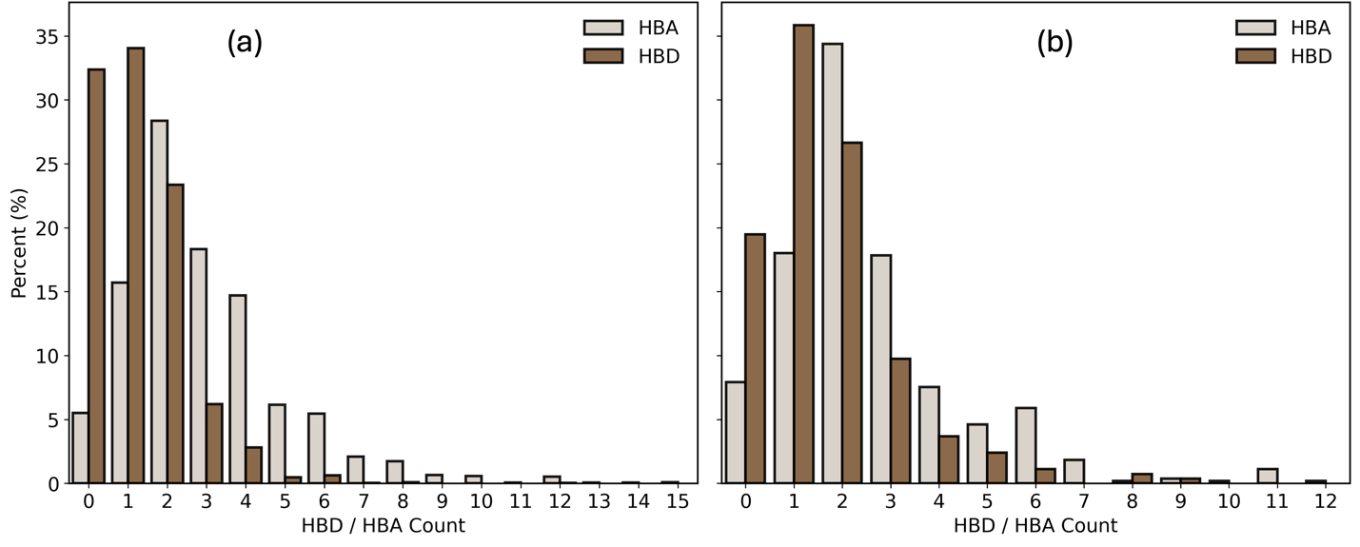
Fig. S1. Distribution of hydrogen bond donor (HBD) and hydrogen bond acceptor (HBA) counts for molecules involved in (a) cocrystal (CC) and (b) physical mixture (PM) pairs.

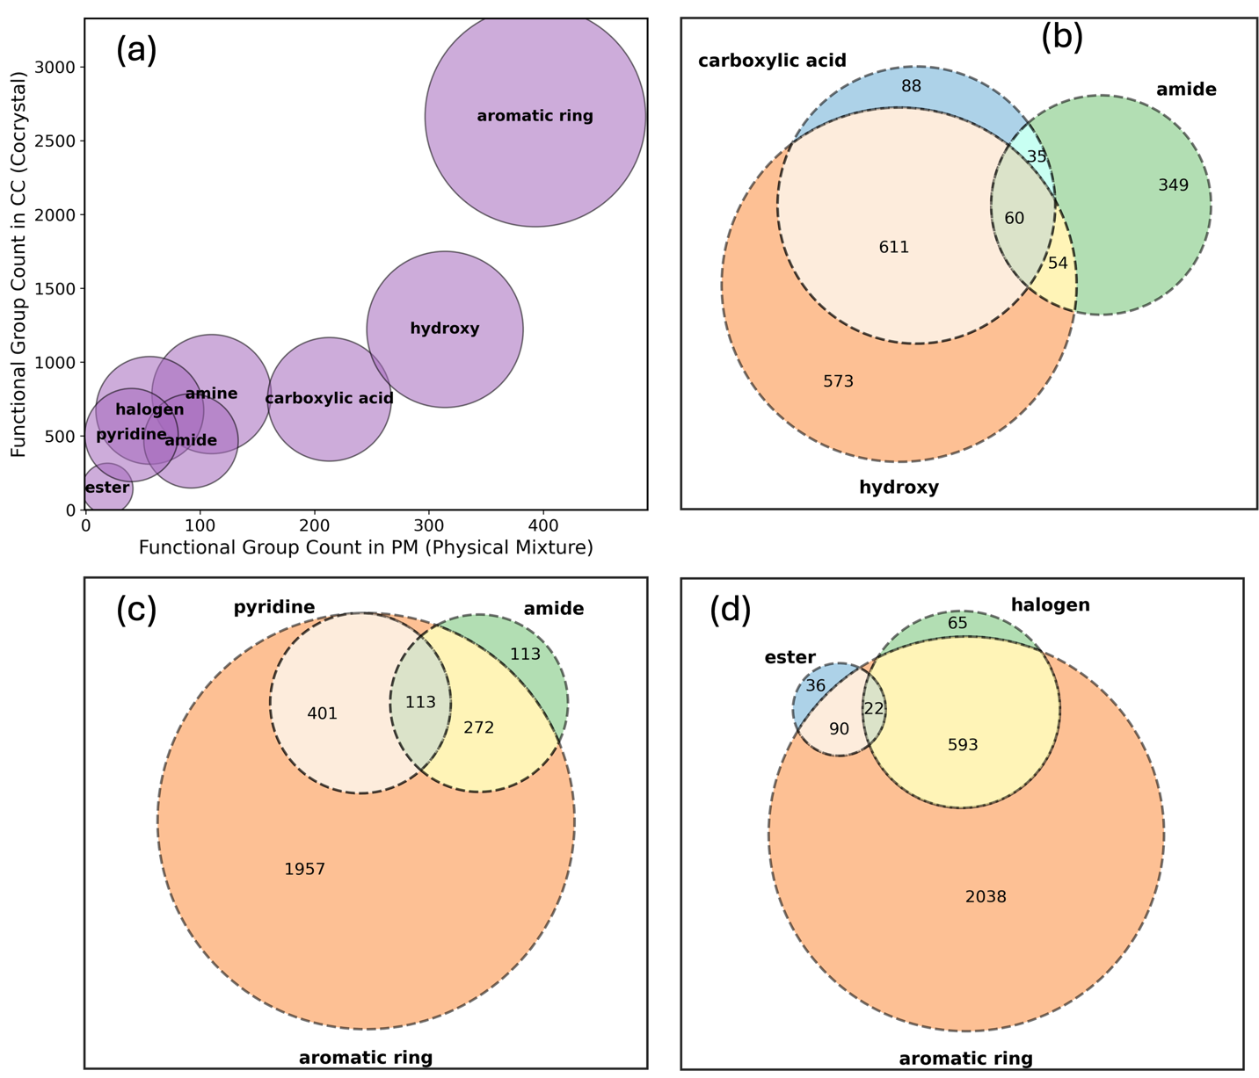
Fig. S2. Functional group prevalence and combinatorial diversity in cocrystal (CC) and physical mixture (PM) datasets. (a) Comparative distribution of key functional groups between CC and PM classes. (b–d) Venn diagrams illustrating the overlap and co-occurrence of unique molecules containing chemically relevant functional groups

Functional groups such as carboxylic acids, amides, hydroxy groups, heterocycles (notably pyridines), and aromatic rings play a central role in cocrystal formation, as they define the dominant supramolecular synthons through hydrogen bonding, π–π stacking, and complementary electrostatic interactions. Fig. S2a compares the distribution of these key motifs in the cocrystal (CC) and physical mixture (PM) datasets, where bubble size denotes overall occurrence and position reflects relative enrichment between the two classes. Aromatic rings are the most prevalent structural motif in both CC and PM, underscoring the ubiquitous role of π-rich systems in multicomponent solids. Hydroxy and carboxylic acid groups emerge as the second and third most frequent motifs and exhibit comparatively lower class imbalance, occurring in approximately 1,400 and 800 CC pairs and 320 and 200 PM pairs, respectively. This high presence across both classes is consistent with their well-established ability to form strong, directional hydrogen-bonded synthons that are relevant in both successful and unsuccessful cocrystallization outcomes. In contrast, esters, halogens, and certain heterocycles appear at lower frequencies in both datasets, suggesting that these functionalities primarily act as secondary contributors that fine-tune intermolecular packing rather than serving as dominant drivers of cocrystal formation.
Fig. S2b–d extend this analysis by examining chemical diversity at a deeper level through the co-occurrence of multiple functional groups within individual molecules, independent of their overall class frequency. A substantial fraction of molecules contains combinations of hydrogen-bond donors and acceptors—such as carboxylic acid, amide, and hydroxy motifs (Fig. S2b)—providing multiple, and sometimes competing, interaction sites that enhance synthon diversity and structural adaptability. At the same time, Fig. S2c and Fig. S2d reveal large populations of aromatic-only molecules, as well as aromatic systems combined with polar functionalities (e.g., amide, ester, pyridine, or halogen), highlighting the coexistence of dispersion-dominated and hydrogen-bond-assisted interaction regimes within the dataset. This balance between simple and multifunctional molecular architectures ensures that both CC and PM classes span a broad range of supramolecular interaction patterns, which is critical for training predictive models that generalize beyond narrow chemical motifs and avoid shortcut learning. Moreover, this analysis provides practical guidance for future data collection by identifying underrepresented functional group combinations that could be prioritized to further improve dataset coverage and model robustness.

S2. Features used for construction of molecular graphs
Table S1 summarizes the atom- and bond-level features used to construct molecular graph representations in this study, along with their corresponding value ranges. All features were derived using the RDKit cheminformatics toolkit. Atom-level attributes capture elemental identity, hybridization state, aromaticity, connectivity, and formal charge, while bond-level features encode bond order, aromaticity, and ring membership. Together, these descriptors provide a comprehensive representation of local chemical environments for downstream graph-based learning models.

Table S1. List of atom and bond features and corresponding range of them
Atom/Bond Feature name | Range of values
Atomic number | 1-119
Hybridization type | S, SP, SP2, SP3, SP3D, SP3D2
Atom aromaticity | False, True
Atom degree | 0, 1, 2, 3, 4, 5, 6, 7
Formal charge | -4, -3, -2, -1, 0, 1, 2, 3, 4
Bond type | Single, double, triple
Bond aromaticity | False, True
Part of a ring | False, True

S3. GATv2 convolutional layers
In our molecular graph encoder, we adopt the GATv2 architecture, a refinement of the original Graph Attention Network that reorders the computation of attention scores to preserve sensitivity to the untransformed input features. By doing so, the attention mechanism can more flexibly adapt to variations in local atomic environments and emphasize chemically meaningful neighbors—an essential capability for modeling diverse atom–bond configurations in molecular systems.
First, molecular graphs are processed, where the atom features are mapped into continuous vectors and summed to form initial atom representation vectors ( $h_{i}∈R^{F}$). Similarly, the feature vectors for bonds are mapped to continoues vectorized represeantion, $f_{ij}∈R^{F_{e}}$, where $F_{e}$ is the edge feature dimension. This vector is linearly projected into the model’s learned edge space. Each atom is encoded using discrete attributes such as atomic number, valence, hybridization, and chirality. These categorical descriptors are mapped into continuous vectors of dimension F through learned embedding layers, and their sum forms the initial node state.
For each bond (i,j), an edge descriptor $f_{ij}∈R^{F_{e}}$ (containing features such as bond types and stereochemical flags) is linearly projected into the model’s edge feature space prior to attention computation. Now the operations of GATv2 are performed as follows:
Node–edge triplets are concatenated and passed through a learnable transformation to obtain raw attention logits:
$e_{ij}=a^{⊤}⋅\text{LeakyReLU}\left(W_{e}\left[h_{i} ∥ h_{j} ∥ f_{ij}\right]\right) (1)$
Where $∥$ denotes Concatenation operator, $W_{e}∈R^{F^{''}×\left(2F^{'}+F_{e}\right)}$ is the shared projection matrix, $a∈R^{F^{''}}$are attention vector. Also, $F$, $F_{e}$, $F^{'}$, $F^{''}$ are the embedding, edge, hidden, and attention dimensions, respectively.
Then, the coefficients are normalized across the neighborhood of node i using a softmax:
$$α_{ij}=\frac{\exp\left(e_{ij}\right)}{\sum_{k∈N_{i}}{\exp\left(e_{ik}\right)}} (2)$$

where $N_{i}$ denotes the neighbors of node i in the graph. Node representations are updated by computing a weighted sum over transformed neighbor features:
$$h_{i}^{'}=σ\left(\sum_{j∈N_{i}}{α_{ij}}⋅Wh_{j}\right) (3)$$

Where $σ$ is a non-linear activation function (e.g., ReLU) and $W$ is a learnable weight matrix for transforming node features before aggregation.

To enrich representational capacity, we use K independent attention heads:

$$h_{i}^{final}=σ\left(\frac{1}{K}\sum_{k=1}^{K}{\sum_{j∈N_{i}}{a_{ij}^{k}W^{k}d_{j}}}\right) (4)$$
where $a_{ij}^{k}$ and $W^{k}$ correspond to the attention parameters and weight matrix for the head k.
A graph-level vector for layer $l$ is produced by applying a READOUT operator (summation in our implementation):
$$g^{\left(l\right)}=\text{READOUT}\left(\{h_{i}^{\left(l\right)} ∣ i∈G\}\right) (5)$$
The final graph embedding is obtained by concatenating the READOUT outputs from all L layers:
$$g=\left[g^{\left(1\right)} ∥ g^{\left(2\right)} ∥ … ∥ g^{\left(L\right)}\right] (6)$$

S4. Hyperparameter tuning
Bayesian hyperparameter optimization was employed to identify optimal model configurations for all modality specific deep learning architectures. For all models 100 optimization trials were performed. The criterion for the objective function was balanced accuracy (BACC) on validation data split which is the fairest evaluation in our problem. Table S2 summarizes the hyperparameter ranges explored during Bayesian optimization for each model. For Mordred-based, Freq-ESP and ESP-Net models, only the MLP classification head was tuned as the feature representation were already prepared, whereas GAT included both graph convolution and classification components.

Table S2. Hyperparameter search space used for Bayesian optimization
Model | Hyperparameter | Search range
Mordred | Number of MLP layers | 2–5
 | Neurons per MLP layer | 32–512 (step: 32)
 | Dropout | 0.1–0.5
Freq-ESP | Number of MLP layers | 2–5
 | Neurons per MLP layer | 32–512 (step: 32)
 | Dropout | 0.1–0.5
ESPNet | Number of MLP layers | 2–5
 | Neurons per MLP layer | 32–512 (step: 32)
 | Dropout | 0.1–0.5
GAT | Number of graph convolution layers | 2–6
 | Embedding dimension | 100–400
 | Number of attention heads | 1–3
 | Number of FC layers | 1–5
 | FC layer size | 50–500 (per layer)
 | Dropout ratio | 0.1–0.5
 | Learning rate | 1×10⁻⁴–1×10⁻² (log-uniform)

After optimization, the following configurations yielded the best validation performance:
- Mordred: MLP layer sizes = [384, 416]; dropout = 0.258
- Freq-ESP: MLP layer sizes = [384, 160]; dropout = 0.103
- ESPNet: MLP layer sizes = [256, 128, 64, 32]; dropout = 0.4;
- GAT: Six graph convolution layers with an embedding dimension of 300 and three attention heads; classification head consisting of two fully connected layers with 400 and 250 neurons, respectively
Across all models, the optimal learning rate was 3 × 10⁻⁴, and ReLU was selected as the activation function based on consistent performance gains relative to tanh.

S5. Performance evaluation metrics
Cocrystal prediction is formulated as a binary classification task with a pronounced imbalance between positive (successful cocrystal formation) and negative (physical mixture) samples. To ensure a fair and informative comparison of model performance under these conditions, we employed a set of complementary evaluation metrics that explicitly account for class imbalance and different error types. The metrics are calculated based on counts of true positive (TP), true negative (TN), false positive (FP) and false negative (FN).
The true positive rate (TPR), also known as recall, measures the proportion of correctly identified positive samples:
$TPR =\frac{TP }{TP + FN}$ (7)
The true negative rate (TNR), or specificity, quantifies the ability of the model to correctly identify negative samples:
$TNR =\frac{TN }{TN + FP}$ (8)
To provide an unbiased overall measure that treats both classes equally, we report the balanced accuracy (BACC), defined as the mean of recall and specificity:

$BACC = \frac{TPR+TNR }{2}$ (9)
The F1-score summarizes the trade-off between precision and recall through their harmonic mean:

F1-score $=\frac{2× Precision× Recall}{Precision+Recall}$ (10)
The precision metric evaluates the reliability of positive predictions by measuring the fraction of predicted positives that are correct:
$Precision =\frac{TP }{TP + FP}$ (11)

In addition to threshold-dependent metrics, model discrimination capability was evaluated using the receiver operating characteristic (ROC) curve and the corresponding area under the curve (AUC). These measures are independent of class prevalence and provide a global assessment of ranking performance across all decision thresholds.

S6. SSL performance across cycles and Distributional Analysis
Performance evolution across SSL cycles is shown in FigS3. Starting from the GAT-Pretrained model trained on experimentally labeled data, 500 high-confidence pseudo-negative pairs were incorporated per cycle. Balanced accuracy increased progressively and converged after five augmentation rounds according to early-stopping criteria. The largest improvement was observed on the external test set (0.76 → 0.81), indicating enhanced generalization to chemically distinct data (FigS3a). Class imbalance was simultaneously reduced from a positive-to-negative ratio of ~4.0 to 1.45, stabilizing the decision boundary without overwhelming the labeled core dataset (FigS3b).
To quantify distributional shift, GAT embeddings were projected into PCA space and compared using kernel density estimation (KDE) (FigS3b) and Wasserstein distances (W), revealing a clear distributional hierarchy: training and validation overlap is high (W = 5.21), the internal test set shows moderate divergence (W = 14.48), and the external test set exhibits the largest shift (W = 27.75). This substantial motif shift makes the external test set the most challenging for robustness evaluation, and the observed performance gains on this external split further support the generalization capacity of the SSL-enhanced GAT model.

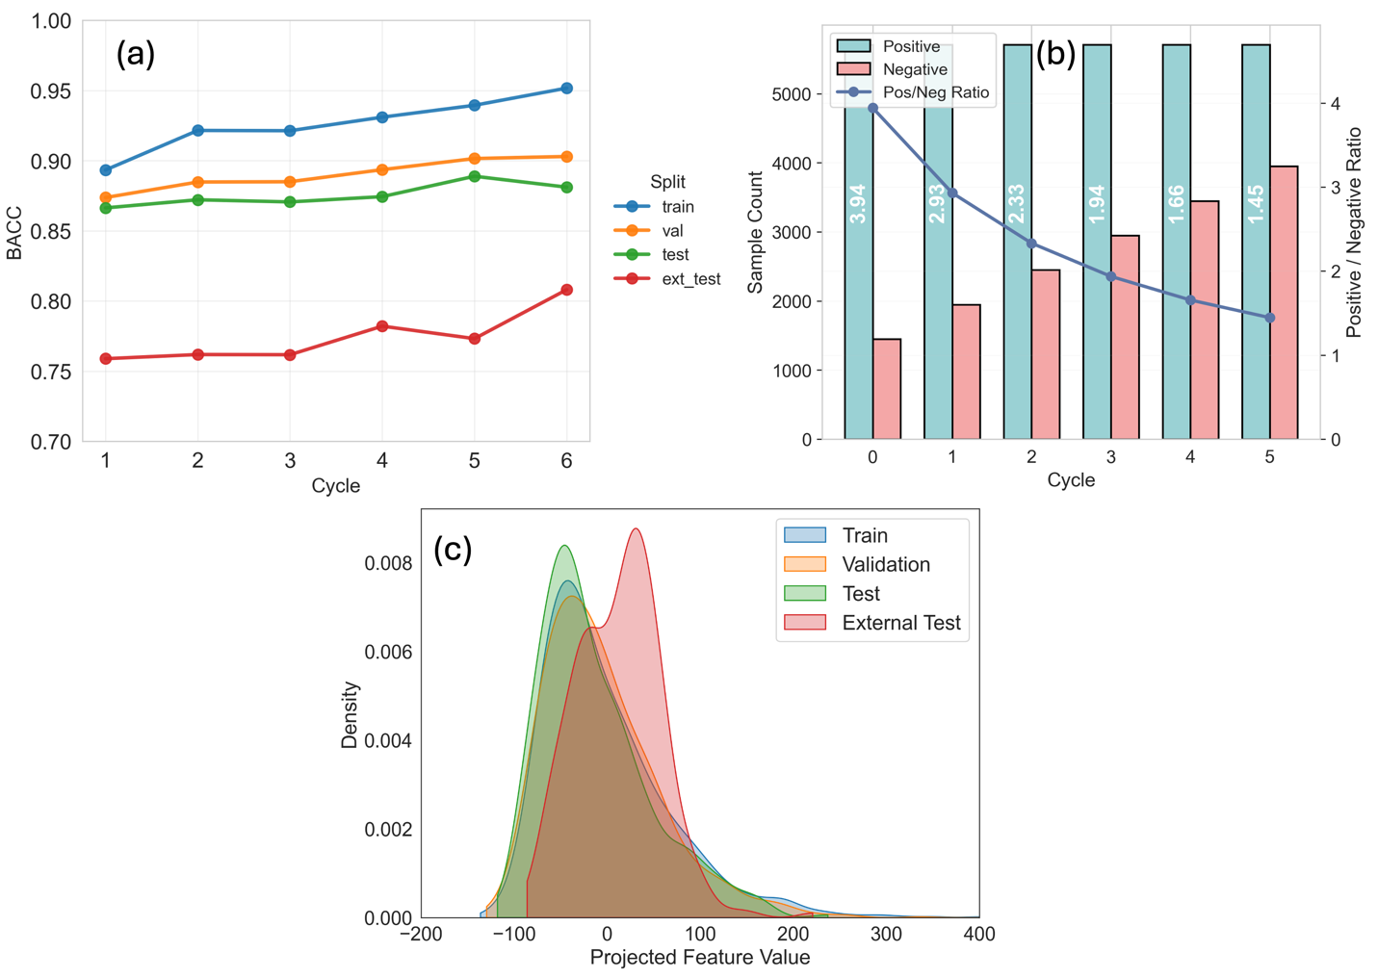
FigS3. SSL framework performance evolution. (a) BACC across cycles for all data splits (b) class imbalance reduction (color-coded), and (c) distributional shifts quantified by projecting GAT embedding into one dimensional PCA, highlighting the external test set as the most challenging benchmark.

S7. Pair-Level Feature and Enrichment Definitions
For mechanistic analysis, we computed seven pairwise descriptors as follows:

HOMO–LUMO Cross-Gap: The HOMO–LUMO cross-gap quantifies frontier orbital energetic compatibility between partners and serves as a proxy for donor–acceptor alignment. Smaller values indicate stronger potential energetic matching.
${\text{HOMO–LUMO}}_{\text{cross}}=\left|HOMO_{1}-LUMO_{2}\right|+\left|HOMO_{2}-LUMO_{1}\right|$ (12)

Here, $HOMO_{i}$ and $LUMO_{i}$ denote the frontier orbital energies of molecule i.

ESP Spectral L1​ Distance: To compare electrostatic surface structure in the frequency domain, we computed the L1​ distance between Fourier spectra of ESP surface histograms. Lower values indicate more similar electrostatic spectral content, whereas larger values reflect distinct electrostatic patterns. This metric captures spectral similarity rather than direct spatial complementarity.
$${\text{Spectral}}_{L_{1}}=\sum_{k}{\left|S_{1}\left(k\right)-S_{2}\left(k\right)\right| (13)​​}$$
Here, $S_{i}\left(k\right)$ denotes the discrete Fourier transform spectrum of the ESP surface histogram of molecule $i$.

ESP Entropy Difference: Electrostatic heterogeneity was quantified by the absolute difference in Shannon entropy of normalized ESP histograms. This captures differences in charge localization versus dispersion between molecular surfaces.

$$ΔH_{\text{ESP}}=\left|H\left(ESP_{1}\right)-H\left(ESP_{2}\right)\right| (14)$$
$$H\left(ESP_{i}\right)=-\sum_{j}{p_{ij}}\log{p_{ij}} (15)$$
Here, $p_{ij}$​ denotes the normalized probability density of histogram bin $j$ for molecule $i$.

Donor–Acceptor Balance: Hydrogen-bonding asymmetry was summarized by comparing net donor–acceptor imbalance between partners. Larger values indicate greater disparity in hydrogen-bonding character. This descriptor measures asymmetry rather than optimal complementarity.
$${\text{DA}}_{\text{balance}}=\left|\left(D_{1}-A_{1}\right)-\left(D_{2}-A_{2}\right)\right| (16)$$
Here, $D_{i}$ and $A_{i}$ denote the number of hydrogen-bond donors and acceptors of molecule $i$.

Dipole Product: Overall polarity magnitude of the pair was approximated by the product of dipole magnitudes. Larger values indicate both molecules are strongly polar, potentially enhancing dipole–dipole interactions.

Volume Ratio (Max/Min): Steric size matching relevant to packing efficiency was approximated using the ratio of larger to smaller molecular volume. Values near unity indicate size-matched pairs.

Electronegativity Ratio (Max/Min): Electronic asymmetry between partners was captured by the ratio of larger to smaller molecular electronegativity descriptor. Higher ratios indicate stronger electronic disparity that may contribute to polarity- or acid–base-driven interactions.

Synthon–Regime Enrichment Quantification: Synthon enrichment across prediction regimes was quantified as a relative overrepresentation ratio comparing conditional and baseline frequencies. Values greater than unity indicate overrepresentation of a synthon within a regime, values less than unity indicate underrepresentation, and unity indicates no deviation from dataset baseline.
$$E\left(p,r\right)=\frac{P\left(p ∣ r\right)}{P\left(p\right)} (17)$$
Here, $p$ denotes a synthon pattern, $r$ a prediction regime, $P\left(p ∣ r\right)$ the empirical proportion of molecular pairs within regime $r$ exhibiting pattern $p$, and $P\left(p\right)$ the overall proportion of pairs exhibiting pattern $p$ across the test set.

