Appendix
MARKETING CONTENT ANALYSIS CODE BOOK REFERENCE GUIDE
DATA CODED MAY 2020-AUGUST 2020
Evaluation focus:
- Visuals - What visual elements are utilized to promote healthy behaviors?
- Purpose - What product or behavior is being promoted (change in diet, selection of a specific food item, change in physical activity, etc.) . How is the message is promoted and who it is promoted by?
- Strategy - What strategies are being utilized to promote healthy behaviors?
- Language/Literacy - Are the visuals, purpose, and strategies of the marketing relevant to the population of the school they are located at? (age, demographic, etc.)

Purpose:
Behavior Change Theme | Definition/Examples
Nutrition  behavchg_ntr | Marketing promotes nutrition-related behavior change. Message must be associated with an action that can be taken. A marketing material that has nutrition related images (such as fruits and vegetables) but does not convey a specific behavior change does not count.  Ex:  - Eat more fruits and vegetables  - Eat Healthy!  - Eat the colors of the rainbow!  - Snack on!  - Crunch a carrot  - Grab a milk with every school meal
Physical activity  behavchg_pa | Marketing promotes physical-activity related behavior change. Message must be associated with an action that can be taken. A marketing material that has physical activity related images (such as characters playing sports or dancing) but does not convey a specific behavior change does not count.  - Play outside 60 minutes a day  - Be active  - Fruits and vegetables will help you be your best at school and play  - Keep on moving  - Play on and off the field
Food safety  behavchg_fs | Marketing encourages food-safety related behavior change. Message must be associated with an action that can be taken. A marketing material that has food safety related images (such as fruits and vegetables) but does not convey a specific behavior change does not count.  - “Wash your hands before eating lunch”  - Expiration date reminders  - Equipment reminders (i.e. gloves, hairnet, etc.)

F/V Behavior Target | Definition/Examples
Taking a fruit or vegetable  fv_take | Marketing promotes the selection of fresh (or frozen or canned) fruits and/or vegetables.  - Take 3 fruits or vegetables  - Include at least ½ cp fruit, ½ cup vegetable  - Make half your plate fruits and vegetables  - Choose dark-green veggies at meals and snacks  - Prominent MyPlate Logo (text is not a necessity)
Consuming a fruit or vegetable  fv_consume | Marketing promotes consumption of fresh (or frozen or canned) fruits and/or vegetables.  - Eating fruit gives you energy all day long  - Savor a sweet potato  - Taste a tomato  - Be sure to eat all of your fruits and vegetables!  - Eating an apple a day keeps the doctor away

Educational Themes | Definition/Examples
*The education components may include charts, picture-based diagrams or written explanations
Fruit  educ_fruit | Marketing contains educational information about fruit such as a fact, infographic or Q&A.  - There are 200 seeds in the average strawberry.  - A fruit is the part of the plant that develops from the flower  - Citrus fruit, green peppers, and tomatoes belong to the fruit group  - Fruit contains dietary fiber that will keep you full and satisfied.
Vegetable  educ_veg | Marketing contains educational information about vegetables such as a fact, infographic or Q&A  - In the United States, more tomatoes are consumed than any other single fruit or vegetable!  - Vary your veggies color to ensure a variety of vitamins and minerals  - Peppers have vitamins A, C, and potassium
Vitamin/Mineral  edu_vitmin | Marketing contains educational information about a vitamin or mineral such as a fact, infographic or Q&A. Marketing that mentions that a food item provides/contains/is a good source of etc. a vitamin or mineral also counts.  - Oranges contain Vitamin C, Calcium in milk makes your bones strong, fruits and vegetables contain lots of vitamins and minerals to keep you healthy  - The nutrients found in spinach are iron, calcium, and vitamin K.  - Vitamin C helps keep your teeth and gums healthy  - Potassium helps you maintain a healthy blood pressure
USDA NSLP Meal Guidelines  edu_nslp | Marketing contains educational information about or related to USDA NSLP Meal Guidelines such as a fact, infographic or Q&A. In the NSLP, schools must offer five food components (milk, fruits, vegetables, grains, meat/meat alternates). Students are allowed to decline 2 of the 5 required food components under Offer vs. Serve (OVS) at lunch  - You must take 3 of 5 food items for a complete meal  - Diagrams that explain what each student must take  - This logo alongside educational material. Note that not all marketing containing this logo contain educational components  - 
Portion Sizes  edu_portion | Marketing piece contains information about portion sizes such as a fact, infographic or Q&A.  - A serving of protein should be about the size of the palm of your hand, fruits and vegetables should take up half of your plate  - Find your balance between food and fun (with a plate of fruit, vegetable, grains, and protein)  - All meals come with a ½ serving of fruit or vegetable
Seasonal Fruits/Vegetables  edu_seasonal | Marketing pieces contains information about seasonal fruits and vegetables such as a fact, infographic or Q&A.  - Winter Squash is an excellent source of vitamins A and C. A one-cup serving of winter squash provides about half of the daily requirement of vitamin C, and 4.5 times the daily requirement of vitamin A  - Buy vegetables in season when flavors and prices are the best  - Arizona grown vegetables and fruits taste best and cost less when purchased in season
MyPlate  edu_myplate | Marketing piece provides information about MyPlate.  - features a picture of MyPlate Diagram, an activity where the students take pictures of food and place them on a MyPlate Diagram, “Make half your plate fruits and vegetables” next to a MyPlate diagram.  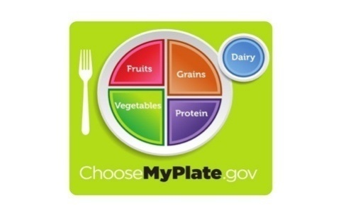
Sustainability  edu_sustain | Marketing piece refers to or provides information about sustainable food practices  - Eat what you take so you don’t waste food  - Food waste is not cool  - Eating local produce helps our environment  - A plant-based diet is better for the earth  - Eat more Arizona grown  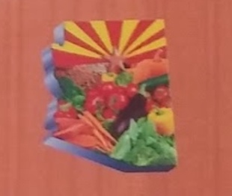  - Healthy harvest for Arizona schools or any marketing with the following logo

Food Group Promoted | Definition/Examples  *Any image of a food item counts, even if it’s just in the background of a piece of marketing.
Fruit  foodgroup_fruit | Marketing contains pictures of fruit(s) or descriptions about fruit
Vegetable  foodgroup__veg | Marketing contains pictures of vegetable(s) or descriptions about vegetable(s)
Dairy  foodgroup_dairy | Marketing contains pictures of dairy product(s) or descriptions about dairy product(s)
Whole Grain  foodgroup_grain | Marketing contains pictures of whole grain food product(s) or descriptions about whole grain food product(s)
Meat/Meat Alternative (Protein)  foodgroup_meat | Marketing contains pictures of meat/meat alternative(s) or descriptions about meat/meat alternative(s)  *beans/legumes contribute to both vegetables and meat/meat alternative for NSLP  *eggs count as meat/meat alternative for NSLP

Message Structure (Command, Encourage, Remind, Slogan) | Definition/Examples  *These codes are not mutually exclusive of one another. A marketing material may contain an encouragement and reminder .
Food directed command is present  food_command | Marketing is directly instructing (commanding) student(s) to engage in a food-based action (i.e. take or consume a F/V). The language is assertive, and the message implies the student must follow the command. The message is often phrased as a rule that must be followed.  Examples:  - You must take 3 fruits and vegetables  - Do not take more food than you can eat from the salad bar.  - Wash your hands before eating  - You must have 4 food groups on your lunch tray.  - You must take a fruit and vegetable for a reimbursable lunch.
Food directed encouragement is present  food_encourage | Marketing encourages students to do a food-based action using ‘soft’ language but does NOT directly instruct nor remind the student(s) to complete a food-based action but encourages them towards making a specific choice.  Examples:  - Be brave and try some new food  - Consider adding more fruits and veggies to your plate  - Strawberries are delicious, try some today!  - Eating more fruits and veggies will make you play hard and feel great.
Food directed reminder is present  food_remind | Marketing reminds students to engage in a food-based action using ‘soft’ language. Often uses language such as, “don’t forget, remember to, please be aware”, etc.  Examples:  - Don’t forget to wash your hands before eating.  - Be sure to take a fruit and vegetable at lunch.  - Remember to wash your hands before eating  - Remember to eat fruits and vegetables with every meal!
Food directed slogans present  Food_slogan | Marketing contains a phrase that can be categorized as a slogan. This can be checked by inputting the phrase into a google search and seeing if nutrition promotion materials come up.  Examples:  - Start Simple with MyPlate  - Eat Well, Live Well  - Eat Better Feel Better  - Fuel Up to Play 60

Associated Campaign/Organization | Definition/Examples
Fuel Up to Play 60  campaign_fuelup60 | Marketing is associated with a campaign or organization. The campaign/organization logo is usually present. Often, marketing materials are produced by different campaigns/organizations.  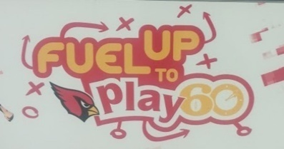
Healthy Harvest for Arizona Schools  Campaign_azhealthyharvest | 
Champions for Change (3)  campaign_champchang | 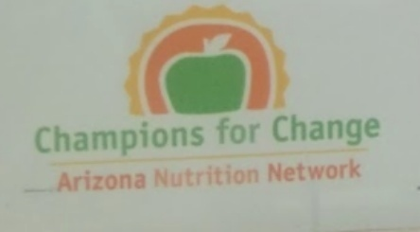
Triple Play (4)  Campaign_tripleplay | 
Dig in! (5)  campaign_digin | 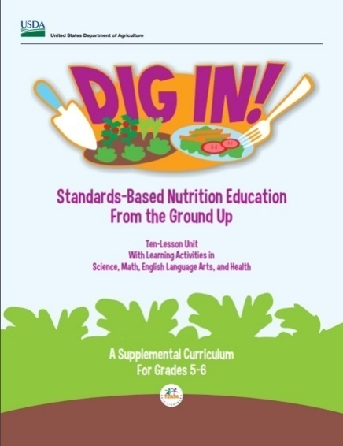
Got Milk? (6)  campaign_gotmilk | 
Arizona Grown (7)  campaign_azgrown | 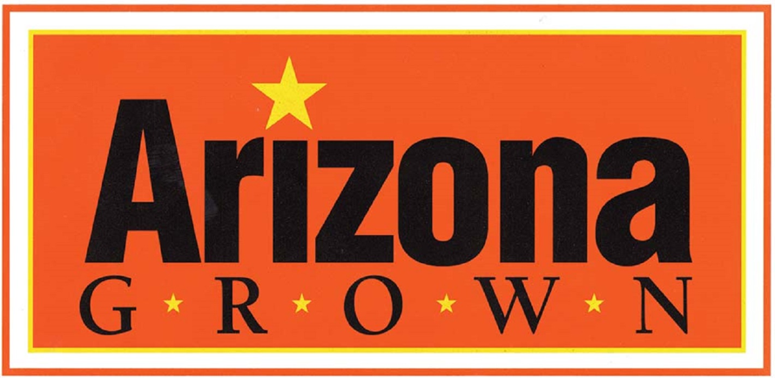
National Dairy Council (8)  campaign_dairyco | 
USDA (9)  campaign_USDA | 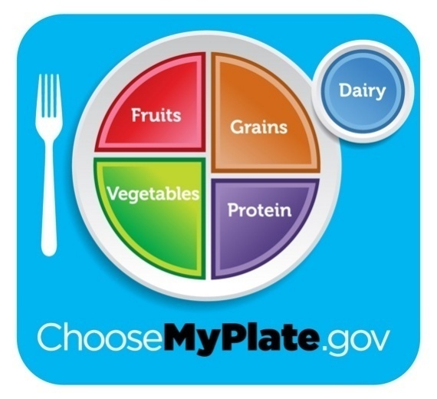

Visuals:
Type of marketing | Definition/Examples
Paper flyer  type_flyer | Marketing is approx. 8inx11in, the size of a printer piece of paper.
Poster  type_poster | Marketing is a poster of any size as long as it is bigger than a standard paper flyer. This can be handmade or printed
Sticker  type_sticker | 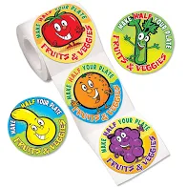  Marketing is a small sticker, an adhesive label or notice, generally printed or illustrated.
Table Tent  type_tabletent | Marketing is a self-standing promotional unit created from printed and folded cardstock. As the name implies, table tents are designed to be placed on tables…as well as counters, desks, or any other horizontal surface.  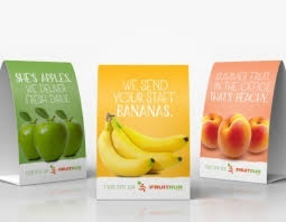
Decals  type_decals | Marketing is a decal that easily sticks and peels back off of surfaces. Normally present on sneeze guards in the cafeteria line.  
Banner  type_banner |   Marketing is a large vinyl banner; the material is thicker than a poster and usually much bigger than a standard poster.
misc. Cafeteria decoration  type_cafedec | 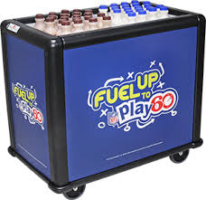  Any marketing that cannot be described as a flyer, poster, sticker, table tent, decal, banner or technological display should be categorized as ‘miscellaneous cafeteria decoration”  Ex:  - f/v images on cooler  - food images on service line equipment  - decorations created by the students
Technological display  type_tech | Marketing is presented on a computer output surface and projecting mechanism that shows text and often graphic images.  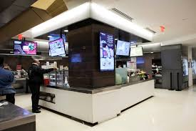  Ex:  - TVs in the cafeteria  - Touch screen monitors in the cafeteria

Size of Marketing | Definition/Examples
Small  size_small | 8x11 flyers (or smaller) , table tents, stickers
Medium  size_med | 24x36 poster, small TV display, poster board
Large  size_large | banner, large poster, large display that takes up more room than a ~24x36 poster

Visual appeals | Definition/Examples
Word art  visual_wordart | 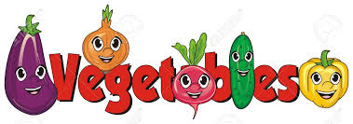  Marketing contains eye-catching word art that draws attention to the text. The text is different than standard type font and is emphasized artistically.
Eye-catching patterns and textures  visual_pattern |   Marketing contains eye-catching patterns and textures.
Diagrams  visual_diagram | Marketing contains information that is diagrammed visually such as a pie chart, bar graph, lunch tray diagram etc. MyPlate images count as a diagram. The diagram must be a focus in the marketing piece, MyPlate logos in the corner of the marketing do not count.  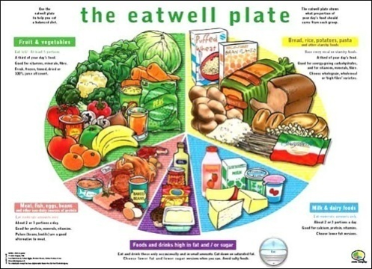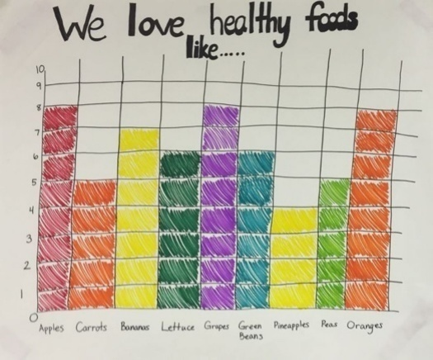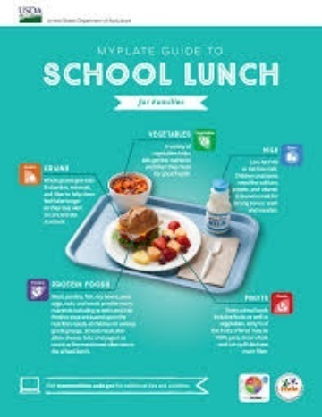
3-D displays  visual_3D | 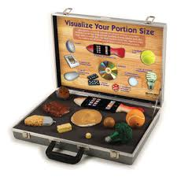  Marketing is presented three-dimensionally. 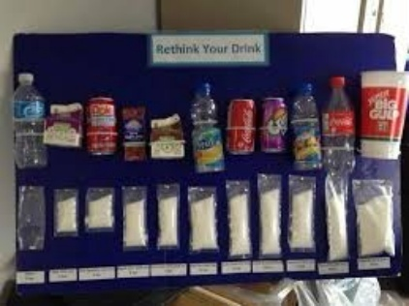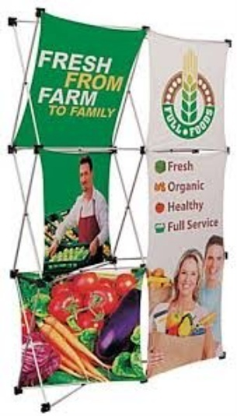
Eye-catching photos of fruits and vegetables  visual_fv |   Marketing contains images of fruits and vegetables that are portrayed decoratively, are visually appealing and emphasizes the fruits and vegetables. Images of fruit(s) and/or vegetable(s) that are in the background do not count. 

Strategy
Antecedents | Definition/Examples
Associative (paired) learning  anteced_paired_learn | Marketing pairs food item with other stimuli (existing products, well-known people, funny words) that already elicit positive emotions. A particular FV may be paired visually with another brand or attractive people having a good time. Typically, there is no educational component.  Ex: Placing carrots and celery in McDonalds fry boxes, pairing known brands with a specific food item (e.g. cartoon brands with FV), pairing celebrities with a food item (note that if a celebrity is modeling a behavior such as eating the FV item, see social modeling).
Social Modeling  anteced_socialmodel | Marketing piece contains an antecedent technique used to demonstrate the target behavior(s) to be emulated. A student who matches their own behavior to a real person, celebrity, animated character or social group who “models” a target behavior can result in similar implied or explicit consequences. The real person, character, group, celebrity or animated character must be modeling the target behavior highlighted in the messaging of the marketing.

Message Framing
Gain-framed (positive) / positive reinforcement  frame_gain_pos / | Gain frame: when a message is framed to focus on a positive outcome of engaging in the target behavior.  Positive reinforcement: Gaining something positive by engaging in target behavior.  Marketing emphasizes a positive consequence the student will gain by following the nutrition message. The marketing is framed in a way that shows the child will gain something positive by engaging in the target nutrition behavior.  Ex:  - Eat protein before and after you exercise to build strong muscles.  - Make your heart and lungs stronger with activities that get your heart pumping  - Eat carrots for super vision like Superman!  - Try something new at lunch today and you’ll get “Today is a Try day” sticker  - Eat citrus fruit to get more vitamin C in your diet and keep your immune system strong.
Gain-framed (negative) /negative reinforcement  frame_gain_neg | Gain frame: when a message is framed to focus on a positive outcome of engaging in the target behavior.  Negative reinforcement: Avoiding a negative consequence by engaging in the target behavior.  Marketing emphasizes a negative consequence the student will avoid from engaging in the target health message. The marketing is framed in a way that shows the child will avoid a negative consequence by engaging in the target nutrition behavior.  Ex:  - Eat citrus fruit which is high in vitamin C to avoid getting sick!  - Take a fruit and vegetable at lunch so you don’t get charged for your lunch.  - Eat a balanced diet of fruits, vegetables, whole grain and lean protein to avoid feeling sluggish at soccer practice.  - Drink high calcium foods like milk to prevent broken bones.  - Wash your hands before eating so you don’t get yourself or your friends sick.
Loss-framed (positive) / positive punishment  frame_loss_pos | Loss Frame: A loss-frame is when a message is focused on the costs or the loss (such as opportunity cost) of not engaging in the target behavior or by engaging in an undesired behavior.  Positive punishment: A negative consequence caused by not engaging in the target behavior.  Marketing emphasizes a consequence for not following the targeted health message. The marketing is framed in a way that emphasizes the negative consequence that NOT engaging in the target nutrition behavior may cause.  Ex:  - Eating junk food (undesired behavior) will make you gain weight (aversive consequence)  - Eat breakfast every day or your grades could drop.  - Eating excessive junk food may cause undesired weight gain.  - Not eating enough before sports practice will make you feel sluggish and slow.  - If you don’t get enough calcium, zinc and antioxidants in your diet, you’re more likely to get sick during flu season.
Loss-framed (negative) / negative punishment  frame_loss_neg | Loss Frame: A loss-frame is when a message is focused on the costs or the loss (such as opportunity cost) of not engaging in the target behavior or by engaging in an undesired behavior.  Negative punishment: Taking a positive consequence away (that the student already had) away to decrease undesirable behavior  Marketing emphasizes a positive consequence (that they possess or have already earned) the student will lose by engaging in an undesirable behavior or not engaging in the target behavior. The marketing is framed in a way that shows the child will lose a positive consequence by not engaging in the target nutrition behavior or engaging in a less desirable nutrition behavior.  Ex:  - If you leave any fruits and vegetables on your plate you won’t get to go outside for recess.  - Eating too many sugary sweets will cause your energy to crash.  - If you don’t select a fruit or vegetable, whole grain, protein and milk during lunch, your meal will not be free.  - If you have a green barcode tray, don’t share your food with other students or you won’t get your prize.  - Not consuming enough calcium can cause healthy bones to lose their strength over time.

Proximal v. Distal Outcome Message
Proximal  message_prox | Marketing emphasizes health outcomes related to the immediate/short term future of a student.  Ex:  - Eating more fiber will help you feel fuller after meals.  - Eating healthy meals will give your body more energy for sports practice  - Eating more fruits and vegetables can put you in a better mood and make it easier to focus.  - Eating too much junk food can cause stomach aches  - Eat lots of protein to gain muscle
Distal  message_dist | Marketing emphasizes health outcomes related to the long-term future of a student.  Ex:  - Milk contains a lot of calcium which is beneficial for bone health.  - Tomatoes are great for your heart!  - Eating lots of fruits and vegetables reduces risk of heart disease.  - Eating carrots can improve your eyesight  - Eat a healthy diet so you grow to be a healthy and strong adult.

Marketing Strategy | Definition/Examples
Celebrity/Athlete endorsements  strategy_endorsed | Marketing contains an image of a famous celebrity or athlete that is endorsing a food product.  Ex: Got Milk Posters
Cartoon characters  strategy_cartoon | Marketing contains images of cartoons endorsing a food product.  Ex: Disney characters, cartoon fruits & vegetables, cartoon students
Social media / websites  strategy_media | Marketing utilizes social media or website links to engage with students.  Ex: link to website, QR Code, reference to Facebook or Instagram
Interactivity  strategy_interactive | Marketing contains content that students can engage with via touch screen, answering questions, playing a game, etc.  Ex: technology display that gives you a trivia questions, eye spy w/ vegetables, matching a color with a food group
Humor  strategy_humor | Marketing contains humor and jokes  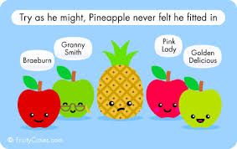
Emotional Appeal  strategy_emotion | 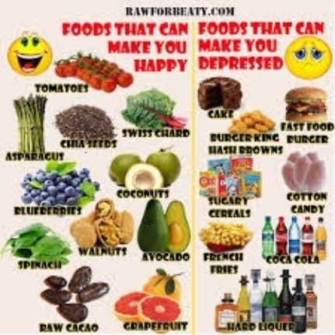 Marketing contains content that appeals to specific emotions using strong wording or images. The words must state a specific emotion and images must have an obvious emotional association.  Ex:  - “Eating fruits and vegetables will make you happy!”  - “Eating junk food will make you feel bad!”  - Cartoon characters showing strong emotional expressions that can be easily defined (happy, sad, crying, distraught, confused etc.)  - Models/actors showing strong emotional expression that can be easily defined (happy, sad, crying, distraught, confused etc.)
Brand Appeal  strategy_brand | Marketing contains content that displays an affiliation between the food product/message and a specific brand(s)

Message Specificity | Definition/Examples
message_broad | Marketing promotes a general message about a broad topic.  Ex: Eat your fruits and vegetables, take what you can eat
Specific  message_specific | Marketing promotes a specific message that discusses a specific action, item or topic.  Ex: Eat 5 servings of fruits and vegetables a day, eating oranges is great a great way to boost your immunity, let's talk about seasonal vegetables

Relevance
Reading Level Appropriateness | Definition/Examples  Flecsh Kincaid Calculator Link  Enter the text components present in the marketing into the Flecsh Kincaid Calculator linked above. See what reading level the text components are and if it matches the grade level of the school (elementary = 1-5th grade, middle school = 6th-8th grade or high school = 9th-12th grade). Note the grade level in the notes section.
Reading level appropriate for target audience  readinglevel_app | Reading level of text according to Flesch Kincaid score indicates that the text in the marketing material matches the grade levels present in the school the marketing photo was taken in (elementary = 1-5th grade, middle school = 6th-8th grade or high school = 9th-12th grade)  Ex: The Flesch Kincaid score states that the reading level is at a 5th grade level and the marketing is in an elementary school.
Reading level NOT appropriate for target audience (too high)  reading level not appropriate  readinglevel_notapp_high | Reading level of text according to Flesch Kincaid score indicates that the text in the marketing material does NOT match because it is higher than the grade levels present in the school the marketing photo was taken in (elementary = 1-5th grade, middle school = 6th-8th grade or high school = 9th-12th grade).  Ex: The Flesch Kincaid score states that the reading level is at an 8th grade level and the marketing is in an elementary school.
Reading level NOT appropriate for target audience (too low)  reading level not appropriate  readinglevel_notapp_low | Reading level of text according to Flesch Kincaid score indicates that the text in the marketing material does NOT match because it is lower than the grade levels present in the school the marketing photo was taken in (elementary = 1-5th grade, middle school = 6th-8th grade or high school = 9th-12th grade).  Ex: The Flesch Kincaid score states that the reading level is at a 2nd grade level and the marketing is in a high school.

Language | Definition/Examples
English  lang_eng | Marketing text is written in English
Spanish  lang_span | Marketing text is written in Spanish

