Supplementary Material
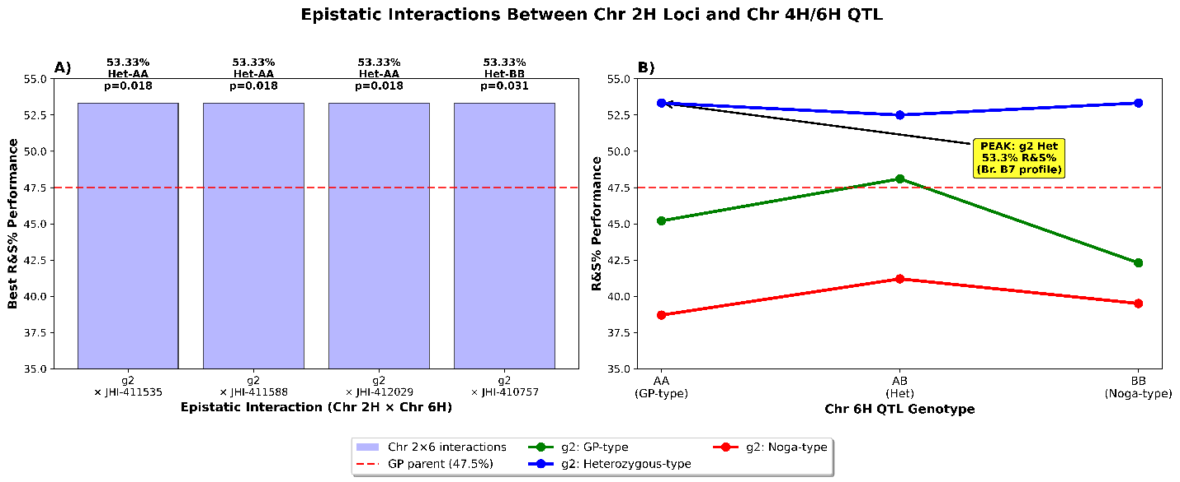
Supplementary Figure 1. Epistatic interactions between chromosome 2H markers and chromosome 4H/6H QTL markers. (A) Top four significant interactions showing g2 heterozygous advantage, achieving 53.3% R&S performance. (B) g2 heterozygous genotypes consistently outperform homozygous genotypes across chromosome 6H backgrounds.GP parent performance (47.5%) dashed line. Colors indicate g2 genotypes: green=GP-type (AA), blue=heterozygous (AB), red=Noga-type (BB).

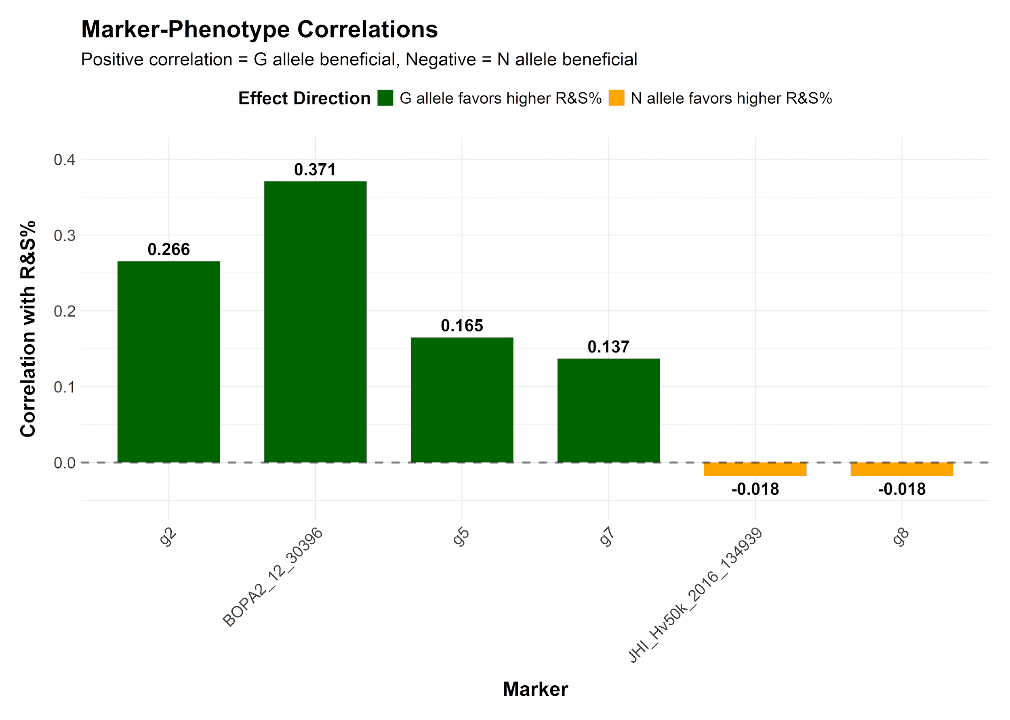
Supplementary Figure 2. Marker-phenotype correlations for R&S% trait across 22 lines. Green bars indicate GP alleles favour higher R&S%, orange bars indicate Noga alleles are beneficial. BOPA2_12_30396 shows the strongest positive correlation (r = 0.371).

Supplementary Table 1. List of markers used for genotyping.
Marker | Primer 5'-3' | ID | Position (Morexv3) | Amplicon Size (bp) | Digestion Enzyme/Difference Type | Digested/Differece Genotype | Expected Digestion Sizes (bp)
g2 | TGCAATCCGCATGGCGATCT | 13E1 | 2H:626786360-626786379 | 836 | Deletion | Deletion in Noga | Noga: 724
g2 | GTGGGTTAGTGGAGCTTGGA | 13E2 | 2H:626787176-626787195
BOPA2-12-30396 | CACCCGTGTCAACCCTAACT | 11E6 | 2H:634401113-634401132 | 729 | AclI | GP | 385 & 344
BOPA2-12-30396 | TGTGGTCCATGAGAGTCCAA | 11E7 | 2H:634401822-634401841
g5 | GAGCGATAGTTTTAGAGAAAATCA | 13E5 | 2H:637960812-637960835 | 697 | SNPs | Pos. 637960863 -> C in GP/ G in Noga ||| Pos. 637961227 -> T in GP/ C in Noga | 697
g5 | ACTCGGCCATATCTTGTTTG | 13E6 | 2H:637961489-637961508
g7 | GAGAACGATCAAGAGCCTTA | 12B6 | 2H:642586495-642586514 | 2281 | Deletion | Deletion in Noga | Gene (g7) not found in Noga
g7 | CACGTACGGCCCACTCATTT | 12B5 | 2H:642588756-642588775
JHI-Hv50k-2016-134939 | CTGAACCGGCCACGGATCAT | 6C3 | 2H:643181060-643181079 | 965 | NdeI | GP | 760 & 205
JHI-Hv50k-2016-134939 | GACAGTACCTCGCTCTTGAG | 6C4 | 2H:643182005-643182024
g8 | CCCTACAATTGCACTAGCAT | 13E3 | 2H:643193401-643193420 | 742 | Deletion | Deletion in GP | GP: 502
g8 | CCAGATAGATCGTGCTCACT | 13E4 | 2H:643194123-643194142

Supplementary Table 2. Top epistatic interactions between chromosome 2H and chromosome 4H/6H QTL markers. All significant interactions involve g2 marker with chromosome 6H QTL, showing heterozygous advantage exceeding GP parent performance (47.5%). AA = GP-type homozygous; BB = Noga-type homozygous; AB = heterozygous.
Rank | Chr 2H Marker | Modifier QTL Marker | Modifier Chr | Optimal Genotypes | R&S% Performance | P-value | F-statistic | Sample Size
1 | g2 | JHI-Hv50k-2016-411535 | Chr 6H | AB-AA | 53.33 | 0.017925443 | 6.18 | 17
2 | g2 | JHI-Hv50k-2016-411588 | Chr 6H | AB-AA | 53.33 | 0.017925443 | 6.18 | 17
3 | g2 | JHI-Hv50k-2016-412029 | Chr 6H | AB-AA | 53.33 | 0.017925443 | 6.18 | 17
4 | g2 | JHI-Hv50k-2016-410757 | Chr 6H | AB-BB | 53.33 | 0.030830392 | 5.25 | 14
5 | g2 | BOPA1_ConsensusGBS0241-3 | Chr 6H | AB-BB | 53.33 | 0.030830392 | 5.25 | 14
6 | g2 | JHI-Hv50k-2016-411613 | Chr 6H | AB-BB | 53.33 | 0.033106013 | 4.35 | 17
7 | g2 | JHI-Hv50k-2016-411509 | Chr 6H | AB-BB | 53.33 | 0.033106013 | 4.35 | 17
8 | g2 | BOPA1_5187-752 | Chr 6H | AB-BB | 53.33 | 0.033106013 | 4.35 | 17
9 | g2 | JHI-Hv50k-2016-411580 | Chr 6H | AB-BB | 53.33 | 0.033106013 | 4.35 | 17
10 | g2 | BOPA2_12_10393 | Chr 6H | AB-BB | 53.33 | 0.033106013 | 4.35 | 17

