Hydrothermal Transformation of Mixed Plastic–Lignocellulosic Waste: Polymer Degradation Pathways and Environmental Implications

Ran darzi ª, Sandra Khuri ^{b}, Yael Dubowski ª, Lilach Iasur Kruh ^{b}, Roy Posmanik ^{a,c*}
ª Faculty of Civil and Environmental Engineering, Technion, Israel Institute of Technology, Haifa, 32000, Israel
^{b} Department of Biotechnology Engineering, Braude College of Engineering, Karmiel, Israel
^{c} Institute of Soil, Water and Environmental Science, Volcani Institute, Newe Ya'ar Research Center, 30095, Israel

Supplementary Information
Fig. S1 depicts a digital-microscope images of the co-processed LDPE and wheat straw feedstocks, and of the resulting products after 200°C hydrothermal treatment. At 200°C both feedstocks showed negligible reactivity. The LDPE granules and the straw retained similarity to their original shape (Fig. S1). Key analytical examinations show only a minor change after 200°C treatment; therefore, it was excluded from more complex and resource-intensive measurements.
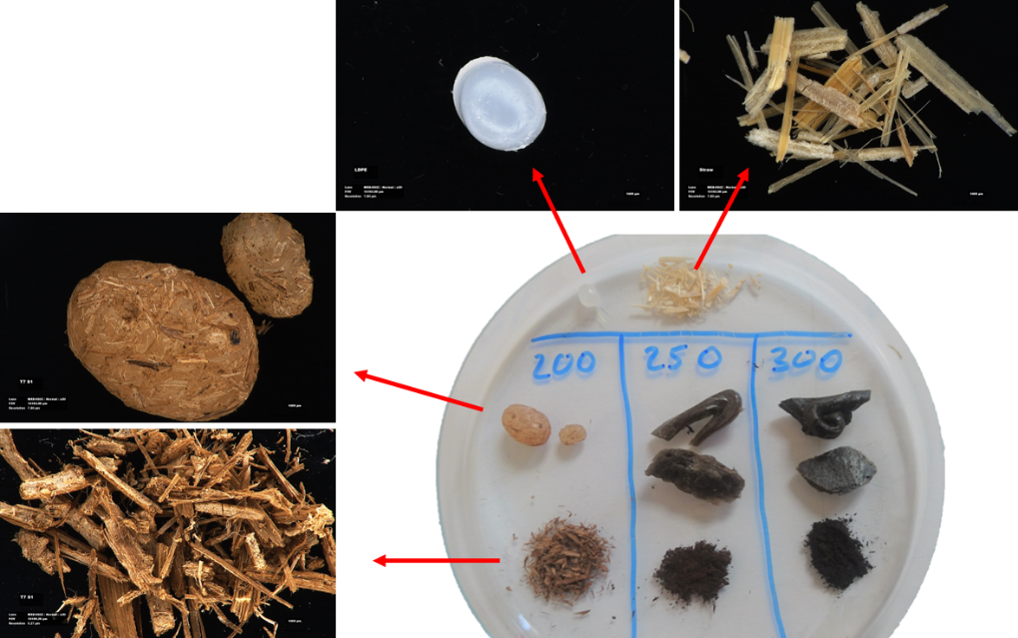
Fig. S1 Solid Product images after HTP at 200°C. Products were similar to the original feedstock

Soil incubation experiments were conducted to assess the impact of hydrothermal co-processing (HTP) liquid-phase effluent on the soil microbiome (Fig. S2). Two soils were incubated at 25°C under aerobic conditions for two weeks — ‘Hamra’ (sandy-loam soil common in the coastal region of Israel) and ‘Grumusol’ (alluvial clay soil common in the valleys of Israel). Soils were irrigated with liquid products from HTP at 250°C and 300°C, with sterile distilled water as a control. To maintain field-capacity water content, solutions were added every three days. After incubation, samples were collected for DNA extraction.
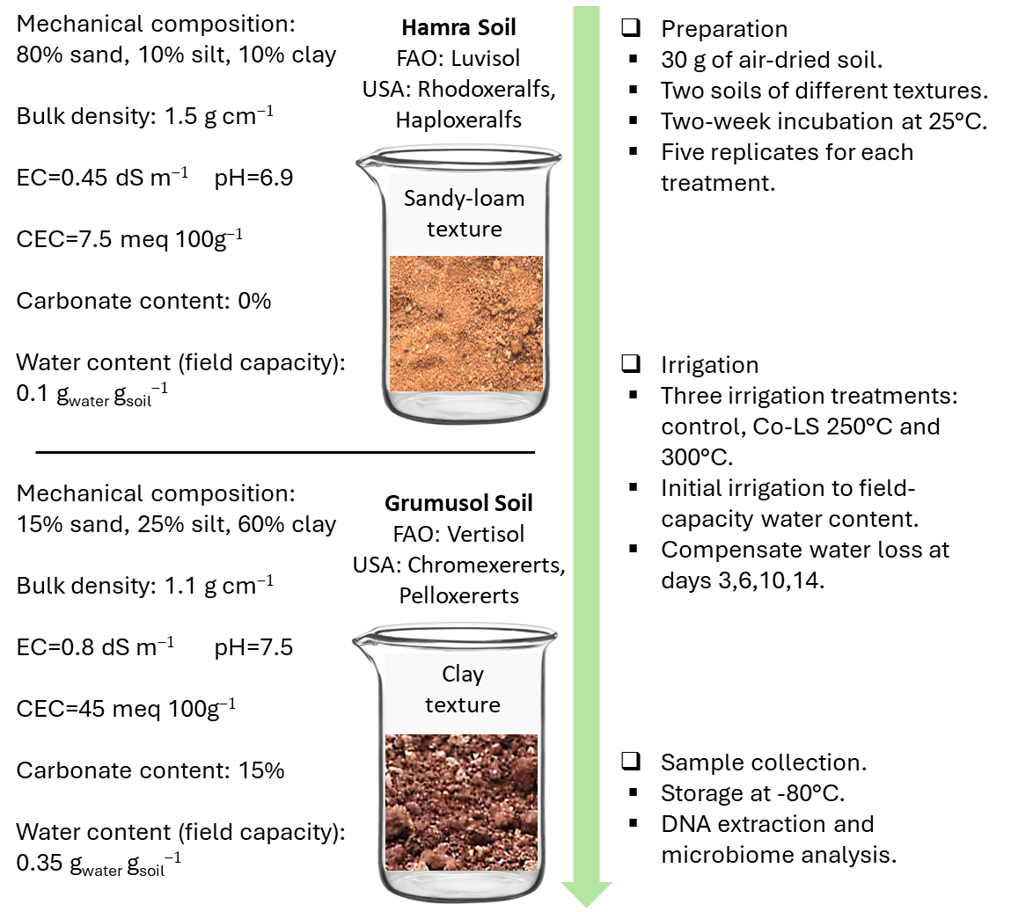
Fig. S2 Soil incubation experiment to evaluate the effect of irrigation with HTP effluent on the soil microbiome

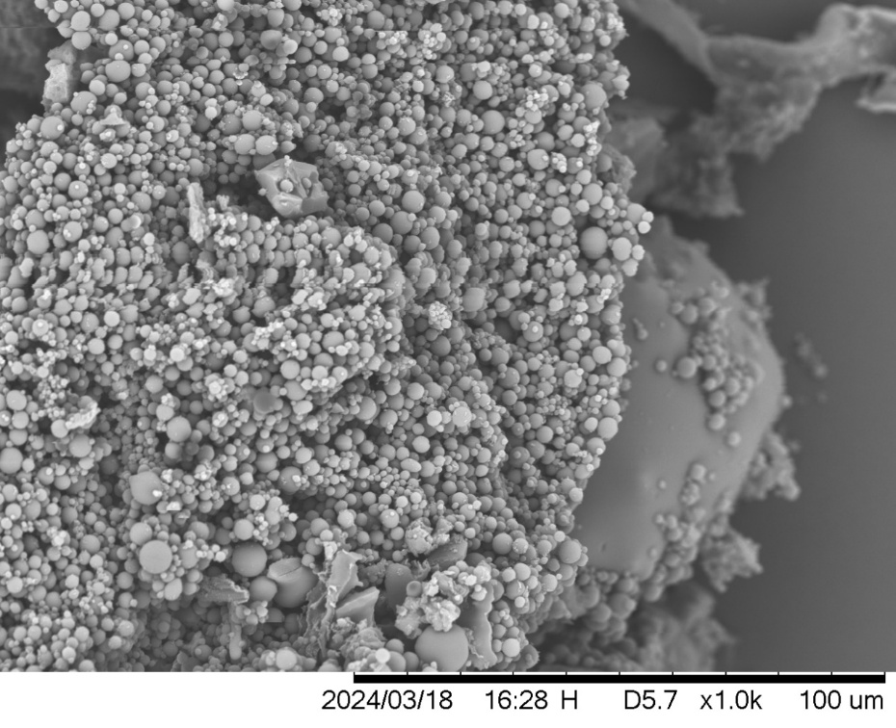
Fig. S3 The hydrochar produced at 300°C was extensively covered with microspheres, indicating a higher degree of degradation and structural alteration

Table S1. Summary of solid product mass and recovery from Individual and Co-HTP of LDPE and straw. Polymeric solid yield is calculated relative to the LDPE input; hydrochar yield is calculated relative to the straw input. All values are expressed as a mean ± standard deviation (n = 4).
 |  | Feedstock [g] |  | Solid product recovery [g] |  | Yield [%]
Treatment | Temp. [°C] | LDPE | Straw | Polymeric-solid | Hydrochar | Polymeric-solid | Hydrochar
pLDPE | 250 | 8.0±0.0 | --- | 7.5±0.1 | --- | 93.9±0.8% | ---
pLDPE | 300 | 9.0±1.0 | --- | 8.3±1.2 | --- | 92.2±5.4% | ---
pSTR | 250 | --- | 2.0±0.0 | --- | 0.4±0.0 | --- | 17.6±0.2%
pSTR | 300 | --- | 2.0±0.0 | --- | 0.3±0.0 | --- | 13.5±0.3%
Co-LS | 250 | 8.0±0.0 | 2.0±0.0 | 8.4±0.2 | 0.3±0.0 | 104.5±2.7% | 15.4±1.5%
Co-LS | 300 | 8.0±0.0 | 2.0±0.0 | 8.1±0.2 | 0.1±0.0 | 101.0±2.8% | 4.0±1.5%

Table S2. Elemental composition of LDPE and straw feedstocks, and of solid products recovered from their co-processing. All values are expressed as a mean percentage (w/w) ± standard deviation (n = 3).
 | C | H | N | O | ash
LDPE feed | 85.9±0.2 | 13.3±0.2 | ND | ND | 0.8±0.4
straw feed | 38.8±1.8 | 5.2±0.2 | 0.6±0.1 | 49.0±2.0 | 6.4±0.4
Polymeric-solid 250°C | 83.7±0.1 | 14.5±0.8 | ND | ND | 1.8±0.8
Polymeric-solid 300°C | 84.4±0.4 | 14.5±0.0 | ND | ND | 1.1±0.1
Hydrochar 250°C | 58.5±0.2 | 5.9±0.2 | 0.2±0.1 | 21.4±0.1 | 14.1±1.1
Hydrochar 300°C | 69.2±0.2 | 5.3±0.1 | 0.9±0.1 | 8.8±0.3 | 15.8±1.1
ND, non-detectable

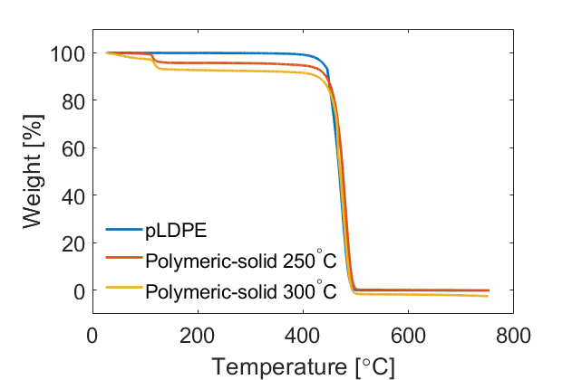
Fig. S4 TGA curve of the polymeric-solid product after HTP (250 and 300°C), compared to the corresponding LDPE feedstock

Fig. S5 GC-MS chromatogram of the non-polar liquid phase after hydrothermal co-processing of LDPE and straw

Table S3. Evaluation of minimal inhibitory concentration (MIC) of liquid effluent, created by different hydrothermal conditions, on model bacteria. U/I = Un-inhibitory.
 | Staphylococcus albus | Escherichia coli | Entrococcus aerogenes | Bacillus cereus | Bacillus subtilis | Serratia marcescens
pLDPE 250°C 60’ | U/I | U/I | U/I | U/I | U/I | U/I
pLDPE 300°C 30’ | U/I | U/I | U/I | U/I | U/I | U/I
pLDPE 300°C 60’ | U/I | U/I | U/I | U/I | U/I | U/I
pSTR 250°C 60’ | 1:1 | 1:2 | 1:1 | 1:2 | 1:4 | 1:2
pSTR 300°C 60’ | 1:4 | 1:4 | 1:2 | 1:4 | 1:8 | 1:2
Co-LS 250°C 60’ | 1:2 | 1:2 | 1:1 | 1:1 | 1:8 | 1:1
Co-LS 300°C 60’ | 1:8 | 1:2 | 1:1 | 1:2 | 1:8 | 1:2

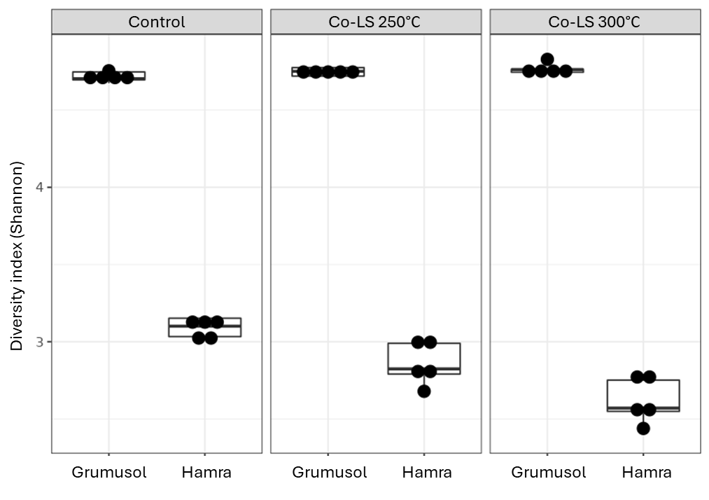
Fig. S6 Alpha-diversity parameters (Shannon’s index) from the two incubated soils (Grumusol and Hamra) irrigated with water (control) and the effluent after hydrothermal co-processing of straw and LDPE (60 min) at 250°C and 300°C

Fig. S7 Principal Component Analysis (PCA) biplots of soil bacterial community structure at the phylum-level for ‘Grumusol’ (a) and ‘Hamra’ (b) soils. The biplots illustrate the structural shifts in the microbiome following irrigation with HTP liquid products generated at 250°C (light red) and 300°C (dark red) compared to the control (blue)
Table S4. Species-level microbial clusters identified in Grumosol soil samples based on hierarchical clustering of amplicon sequence variants. For each cluster, the number of species included, the most representative species, and the proportion of variance explained by the cluster are reported. Taxonomic classification is presented from domain to species level when available. The proportion of variance explained reflects the internal coherence of each cluster and indicates the similarity in abundance patterns of species grouped within each cluster across the Grumosol samples.
Cluster | Number of species | Most representative specie | Cluster proportion of variation explained
1 | 12 | Bacteria;Firmicutes;Bacilli;Bacillales;Planococcaceae;Solibacillus;Other | 0.823
2 | 23 | Bacteria;Bacteroidota;Bacteroidia;Cytophagales;Spirosomaceae;Dyadobacter;psychrophilus | 0.918
3 | 17 | Bacteria;Actinobacteriota;Actinobacteria;Micromonosporales;Micromonosporaceae;Catellatospora;tagetis | 0.852
4 | 18 | Bacteria;Proteobacteria;Gammaproteobacteria;Burkholderiales;Oxalobacteraceae;Janthinobacterium;Other | 0.832
5 | 14 | Bacteria;Actinobacteriota;Actinobacteria;Micrococcales;Other;Other;Other | 0.882
6 | 16 | Bacteria;Proteobacteria;Gammaproteobacteria;Pseudomonadales;Other;Other;Other | 0.828
7 | 12 | Bacteria;MBNT15;Other;Other;Other;Other;Other | 0.975
8 | 11 | Bacteria;Cyanobacteria;Cyanobacteriia;Cyanobacteriales;Chroococcidiopsaceae;Other;Other | 0.956
9 | 13 | Bacteria;Bacteroidota;Bacteroidia;Cytophagales;Hymenobacteraceae;Pontibacter;deserti | 0.854
10 | 8 | Bacteria;Planctomycetota;Planctomycetes;Pirellulales;Pirellulaceae;Bythopirellula;Other | 0.877
11 | 15 | Bacteria;Acidobacteriota;Blastocatellia;Blastocatellales;Blastocatellaceae;OLB17;Other | 0.841
12 | 14 | Bacteria;Proteobacteria;Gammaproteobacteria;Pseudomonadales;Pseudomonadaceae;Pseudomonas;putida | 0.821
13 | 13 | Bacteria;Actinobacteriota;Actinobacteria;Propionibacteriales;Nocardioidaceae;Aeromicrobium;flavum | 0.95
14 | 10 | Bacteria;Proteobacteria;Gammaproteobacteria;Xanthomonadales;Xanthomonadaceae;Xanthomonas;Other | 0.876
15 | 13 | Bacteria;Actinobacteriota;Actinobacteria;Corynebacteriales;Nocardiaceae;Other;Other | 0.884
16 | 15 | Bacteria;Actinobacteriota;Actinobacteria;Streptomycetales;Streptomycetaceae;Streptomyces;haliclonae | 0.775
17 | 14 | Bacteria;Actinobacteriota;Actinobacteria;Micrococcales;Microbacteriaceae;Subtercola;boreus | 0.79
18 | 10 | Bacteria;Actinobacteriota;Actinobacteria;Micrococcales;Intrasporangiaceae;Other;Other | 0.727
19 | 7 | Bacteria;Proteobacteria;Gammaproteobacteria;Burkholderiales;Comamonadaceae;Piscinibacter;Other | 0.585
20 | 6 | Bacteria;Bacteroidota;Bacteroidia;Cytophagales;Cytophagaceae;Rhodocytophaga;Other | 0.711
21 | 7 | Bacteria;Firmicutes;Bacilli;Bacillales;Other;Other;Other | 0.676
22 | 7 | Bacteria;Actinobacteriota;Actinobacteria;Micromonosporales;Micromonosporaceae;Actinoplanes;Other | 0.638
23 | 8 | Bacteria;Proteobacteria;Gammaproteobacteria;Burkholderiales;Comamonadaceae;Other;Other | 0.641
24 | 5 | Bacteria;Deinococcota;Deinococci;Deinococcales;Trueperaceae;Truepera;Other | 0.781
25 | 6 | Bacteria;Proteobacteria;Gammaproteobacteria;Burkholderiales;Oxalobacteraceae;Other;Other | 0.784
26 | 8 | Bacteria;Bacteroidota;Bacteroidia;Sphingobacteriales;AKYH767;Other;Other | 0.643
27 | 7 | Bacteria;Gemmatimonadota;Gemmatimonadetes;Gemmatimonadales;Gemmatimonadaceae;Gemmatimonas;Other | 0.636
28 | 8 | Bacteria;Bacteroidota;Bacteroidia;Sphingobacteriales;Sphingobacteriaceae;Pedobacter;Other | 0.579
29 | 5 | Archaea;Crenarchaeota;Nitrososphaeria;Nitrososphaerales;Nitrososphaeraceae;Candidatus Nitrososphaera;Other | 0.791
30 | 4 | Bacteria;Proteobacteria;Alphaproteobacteria;Sphingomonadales;Sphingomonadaceae;Qipengyuania;Other | 0.668
31 | 7 | Bacteria;Actinobacteriota;Actinobacteria;Micromonosporales;Micromonosporaceae;Allocatelliglobosispora;scoriae | 0.72
32 | 7 | Bacteria;Firmicutes;Bacilli;Thermoactinomycetales;Thermoactinomycetaceae;Shimazuella;kribbensis | 0.713
33 | 6 | Bacteria;Actinobacteriota;Actinobacteria;Frankiales;Nakamurellaceae;Nakamurella;Other | 0.657
34 | 5 | Bacteria;Bacteroidota;Bacteroidia;Cytophagales;Hymenobacteraceae;Adhaeribacter;aerophilus | 0.714
35 | 8 | Bacteria;Actinobacteriota;Actinobacteria;Pseudonocardiales;Pseudonocardiaceae;Pseudonocardia;Other | 0.679
36 | 29 | Bacteria;Chloroflexi;Gitt-GS-136;Other;Other;Other;Other | 0.857
37 | 6 | Bacteria;Actinobacteriota;Actinobacteria;Micromonosporales;Micromonosporaceae;Couchioplanes;Other | 0.717
38 | 6 | Bacteria;Planctomycetota;Phycisphaerae;CCM11a;Other;Other;Other | 0.673
39 | 8 | Bacteria;Actinobacteriota;Acidimicrobiia;Microtrichales;Microtrichaceae;Other;Other | 0.607
40 | 7 | Bacteria;Myxococcota;Myxococcia;Myxococcales;Myxococcaceae;Other;Other | 0.755
41 | 5 | Bacteria;Bacteroidota;Bacteroidia;Chitinophagales;Chitinophagaceae;Niastella;yeongjuensis | 0.6
42 | 5 | Bacteria;Chloroflexi;Anaerolineae;Ardenticatenales;Ardenticatenaceae;Other;Other | 0.631
43 | 7 | Bacteria;Proteobacteria;Alphaproteobacteria;Sphingomonadales;Sphingomonadaceae;Sphingomonas;Other | 0.724
44 | 7 | Bacteria;Verrucomicrobiota;Verrucomicrobiae;Pedosphaerales;Pedosphaeraceae;Ellin517;Other | 0.721
45 | 5 | Bacteria;Actinobacteriota;Actinobacteria;Pseudonocardiales;Pseudonocardiaceae;Actinophytocola;Other | 0.758
46 | 4 | Bacteria;NB1-j;Other;Other;Other;Other;Other | 0.689
47 | 6 | Bacteria;Deinococcota;Deinococci;Deinococcales;Deinococcaceae;Deinococcus;Other | 0.585
48 | 2 | Bacteria;Proteobacteria;Alphaproteobacteria;Rhizobiales;Rhizobiaceae;Allorhizobium-Neorhizobium-Pararhizobium-Rhizobium;Other | 0.746
49 | 5 | Bacteria;Gemmatimonadota;AKAU4049;Other;Other;Other;Other | 0.655
50 | 8 | Bacteria;Proteobacteria;Gammaproteobacteria;Burkholderiales;Comamonadaceae;Azohydromonas;Other | 0.646
51 | 4 | Bacteria;Actinobacteriota;Actinobacteria;Propionibacteriales;Nocardioidaceae;Marmoricola;Other | 0.713
52 | 6 | Bacteria;Planctomycetota;Planctomycetes;Pirellulales;Pirellulaceae;Pir4 lineage;Other | 0.726
53 | 3 | Bacteria;Chloroflexi;Dehalococcoidia;SAR202 clade;Other;Other;Other | 0.788
54 | 3 | Bacteria;Myxococcota;Polyangia;Polyangiales;Polyangiaceae;Aetherobacter;rufus | 0.706
55 | 5 | Bacteria;Proteobacteria;Alphaproteobacteria;Rhizobiales;Devosiaceae;Devosia;Other | 0.718
56 | 7 | Bacteria;Actinobacteriota;Actinobacteria;Frankiales;Geodermatophilaceae;Blastococcus;endophyticus | 0.79
57 | 3 | Bacteria;Proteobacteria;Alphaproteobacteria;Caulobacterales;Caulobacteraceae;PMMR1;Other | 0.749
58 | 3 | Bacteria;Bacteroidota;Bacteroidia;Cytophagales;Hymenobacteraceae;Nibribacter;Other | 0.885
59 | 7 | Bacteria;Proteobacteria;Gammaproteobacteria;Burkholderiales;Nitrosomonadaceae;IS-44;Other | 0.656
60 | 6 | Bacteria;Bacteroidota;Bacteroidia;Chitinophagales;Saprospiraceae;Other;Other | 0.677
61 | 7 | Bacteria;Gemmatimonadota;Longimicrobia;Longimicrobiales;Longimicrobiaceae;YC-ZSS-LKJ147;Other | 0.655
62 | 3 | Bacteria;Actinobacteriota;Acidimicrobiia;Other;Other;Other;Other | 0.76
63 | 5 | Bacteria;Firmicutes;Bacilli;Paenibacillales;Paenibacillaceae;Ammoniibacillus;agariperforans | 0.601
64 | 6 | Bacteria;Firmicutes;Bacilli;Erysipelotrichales;Erysipelotrichaceae;Turicibacter;sanguinis | 0.717
65 | 7 | Bacteria;Proteobacteria;Alphaproteobacteria;Rhizobiales;D05-2;Other;Other | 0.711
66 | 8 | Bacteria;Actinobacteriota;Actinobacteria;0319-7L14;Other;Other;Other | 0.799
67 | 3 | Bacteria;Proteobacteria;Alphaproteobacteria;Sphingomonadales;Sphingomonadaceae;Novosphingobium;ginsenosidimutans | 0.821
68 | 5 | Bacteria;Planctomycetota;Planctomycetes;Planctomycetales;Other;Other;Other | 0.71
69 | 8 | Bacteria;Proteobacteria;Gammaproteobacteria;Burkholderiales;Oxalobacteraceae;Massilia;Other | 0.806
70 | 4 | Bacteria;Proteobacteria;Alphaproteobacteria;Rhizobiales;Rhizobiaceae;Shinella;Other | 0.792
71 | 4 | Bacteria;Proteobacteria;Alphaproteobacteria;Azospirillales;Other;Other;Other | 0.704
72 | 4 | Bacteria;Firmicutes;Bacilli;Paenibacillales;Paenibacillaceae;Paenibacillus;thermoaerophilus | 0.854
73 | 4 | Bacteria;Proteobacteria;Alphaproteobacteria;Rhodobacterales;Rhodobacteraceae;Oceanicella;Other | 0.715
74 | 3 | Bacteria;Nitrospirota;Nitrospiria;Nitrospirales;Nitrospiraceae;Nitrospira;Other | 0.737
75 | 2 | Bacteria;Firmicutes;Bacilli;Alicyclobacillales;Alicyclobacillaceae;Tumebacillus;Other | 0.832
76 | 6 | Bacteria;Gemmatimonadota;Other;Other;Other;Other;Other | 0.667
77 | 3 | Bacteria;Bacteroidota;Bacteroidia;Chitinophagales;Chitinophagaceae;Flavisolibacter;Other | 0.766
78 | 6 | Bacteria;Actinobacteriota;Actinobacteria;Micromonosporales;Micromonosporaceae;Asanoa;Other | 0.645
79 | 5 | Bacteria;Proteobacteria;Alphaproteobacteria;Azospirillales;Azospirillaceae;Skermanella;stibiiresistens | 0.721
80 | 2 | Bacteria;Elusimicrobiota;Lineage IIb;Other;Other;Other;Other | 0.771
81 | 5 | Bacteria;Proteobacteria;Gammaproteobacteria;Pseudomonadales;Pseudomonadaceae;Pseudomonas;Other | 0.746
82 | 3 | Bacteria;Actinobacteriota;Actinobacteria;Streptosporangiales;Streptosporangiaceae;Nonomuraea;Other | 0.826
83 | 3 | Bacteria;Proteobacteria;Gammaproteobacteria;Pseudomonadales;Moraxellaceae;Acinetobacter;Other | 0.834
84 | 4 | Bacteria;Proteobacteria;Alphaproteobacteria;Acetobacterales;Acetobacteraceae;Acidicaldus;Other | 0.774
85 | 3 | Bacteria;Proteobacteria;Alphaproteobacteria;Tistrellales;Geminicoccaceae;Other;Other | 0.719
86 | 2 | Bacteria;Acidobacteriota;Acidobacteriae;Solibacterales;Solibacteraceae;Candidatus Solibacter;Other | 0.829
Table S5. Species-level microbial clusters identified in Hamra soil samples based on hierarchical clustering of amplicon sequence variants. For each cluster, the number of species included, the most representative species, and the proportion of variance explained by the cluster are reported. Taxonomic classification is presented from domain to species level when available. The proportion of variance explained reflects the internal coherence of each cluster and indicates the similarity in abundance patterns of species grouped within each cluster across the Grumosol samples.
Cluster | Number of species | Most representative specie | Cluster proportion of variation explained
1 | 28 | Bacteria;Firmicutes;Bacilli;Bacillales;Planococcaceae;Domibacillus;tundrae | 0.871
2 | 12 | Bacteria;Proteobacteria;Alphaproteobacteria;Azospirillales;Azospirillaceae;Skermanella;Other | 0.899
3 | 23 | Bacteria;Acidobacteriota;Blastocatellia;Pyrinomonadales;Pyrinomonadaceae;RB41;Other | 0.848
4 | 18 | Bacteria;Acidobacteriota;Blastocatellia;11-24;Other;Other;Other | 0.877
5 | 19 | Bacteria;Methylomirabilota;Methylomirabilia;Rokubacteriales;Other;Other;Other | 0.843
6 | 15 | Bacteria;Actinobacteriota;Acidimicrobiia;Microtrichales;Iamiaceae;Iamia;Other | 0.856
7 | 11 | Bacteria;Bacteroidota;Bacteroidia;Cytophagales;Hymenobacteraceae;Pontibacter;populi | 0.844
8 | 11 | Bacteria;Proteobacteria;Alphaproteobacteria;Caulobacterales;Hyphomonadaceae;SWB02;Other | 0.846
9 | 11 | Bacteria;Firmicutes;Bacilli;Paenibacillales;Paenibacillaceae;Ammoniibacillus;Other | 0.781
10 | 11 | Bacteria;Bacteroidota;Bacteroidia;Cytophagales;Cyclobacteriaceae;Other;Other | 0.908
11 | 8 | Bacteria;Firmicutes;Bacilli;Alicyclobacillales;Alicyclobacillaceae;Tumebacillus;Other | 0.835
12 | 9 | Bacteria;Proteobacteria;Gammaproteobacteria;Xanthomonadales;Xanthomonadaceae;Thermomonas;Other | 0.95
13 | 9 | Bacteria;Proteobacteria;Alphaproteobacteria;Sphingomonadales;Sphingomonadaceae;Erythrobacter;Other | 0.899
14 | 9 | Bacteria;Firmicutes;Bacilli;Bacillales;Bacillaceae;Falsibacillus;Other | 0.773
15 | 9 | Bacteria;Firmicutes;Clostridia;Clostridiales;Clostridiaceae;Clostridium sensu stricto 10;Other | 0.776
16 | 5 | Bacteria;Firmicutes;Bacilli;Thermoactinomycetales;Thermoactinomycetaceae;Thermoflavimicrobium;Other | 0.876
17 | 8 | Bacteria;Proteobacteria;Gammaproteobacteria;Pseudomonadales;Alcanivoracaceae1;Alcanivorax;Other | 0.674
18 | 8 | Bacteria;Actinobacteriota;Actinobacteria;Frankiales;Geodermatophilaceae;Blastococcus;Other | 0.68
19 | 19 | Bacteria;Actinobacteriota;Actinobacteria;Propionibacteriales;Nocardioidaceae;Nocardioides;hankookensis | 0.843
20 | 8 | Bacteria;Sumerlaeota;Sumerlaeia;Sumerlaeales;Sumerlaeaceae;Sumerlaea;Other | 0.807
21 | 7 | Bacteria;Proteobacteria;Alphaproteobacteria;Acetobacterales;Acetobacteraceae;Roseomonas;Other | 0.615
22 | 3 | Bacteria;Proteobacteria;Alphaproteobacteria;Puniceispirillales;Puniceispirillales Incertae Sedis;Constrictibacter;Other | 0.716
23 | 4 | Bacteria;Proteobacteria;Alphaproteobacteria;Rhizobiales;Rhizobiaceae;Other;Other | 0.819
24 | 6 | Bacteria;Firmicutes;Bacilli;Bacillales;Planococcaceae;Planococcus;Other | 0.713
25 | 6 | Bacteria;Bacteroidota;Bacteroidia;Sphingobacteriales;Sphingobacteriaceae;Arcticibacter;Other | 0.696
26 | 4 | Bacteria;Proteobacteria;Alphaproteobacteria;Tistrellales;Geminicoccaceae;Other;Other | 0.769
27 | 3 | Bacteria;Actinobacteriota;Thermoleophilia;Gaiellales;Gaiellaceae;Gaiella;Other | 0.782
28 | 3 | Bacteria;Firmicutes;Clostridia;Clostridiales;Clostridiaceae;Clostridium sensu stricto 1;Other | 0.76
29 | 6 | Bacteria;Bacteroidota;Bacteroidia;Cytophagales;Cyclobacteriaceae;Fulvivirga;Other | 0.762
30 | 2 | Bacteria;Proteobacteria;Alphaproteobacteria;Caulobacterales;Caulobacteraceae;Other;Other | 0.795

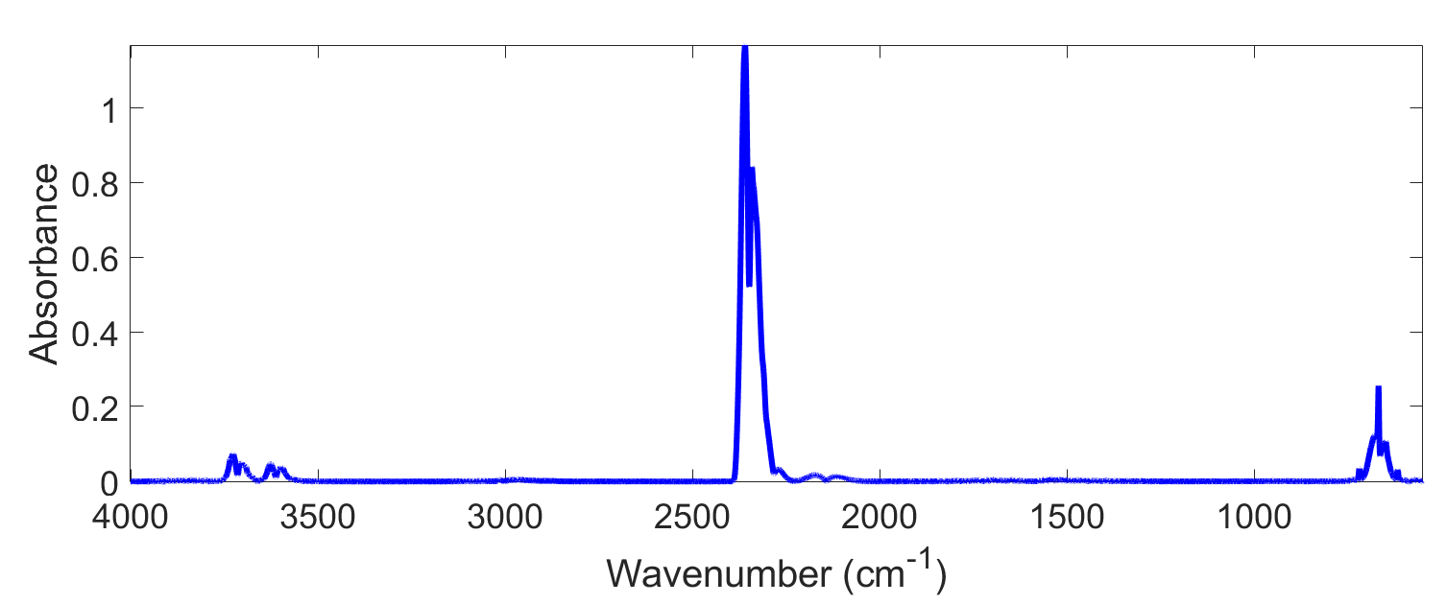
Fig. S8 Absorbance spectrum of the emitted gas from LDPE reference treatment at 300°C. No significant absorbance related to organic compounds was observed, supporting that the alkene-related gases detected in the co-treatment of LDPE with straw likely originate from the straw component

Phenolic compounds with methoxy (R−O−CH₃) or di-methoxy functional groups were identified in the non-polar liquid after 300°C treatment (Fig. S9), and matches straw decomposition and scission (red dotted line). The remaining part, 2-propenol, might go hydrodeoxygenation to propene.
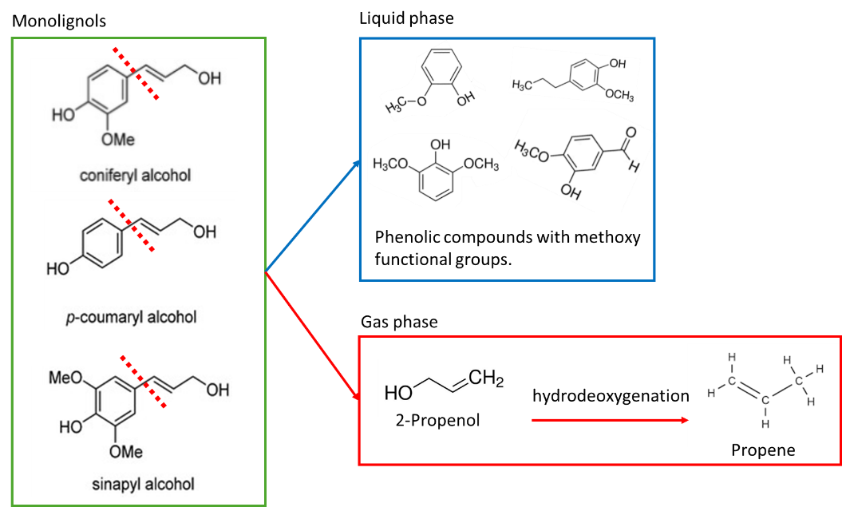
Fig. S9 Monolignol scission (red dotted line) and the identified products in the non-polar liquid phase and gas phase

Table S6–7 summarizes the integrated absorbance values of the standard propene spectrum (from the PNNL database) and the corresponding integration values obtained from the FTIR signals of gases emitted during the co-processing of LDPE and straw. Theoretical calculations of gas concentration and total emission load were based on the standard spectrum for 1 ppm propene at a 1 m path length. Using this reference, calculations were performed for three distinct spectral integration ranges. Variations in the calculated concentrations between spectral regions are expected, due to differences in vibrational mode intensity, integration band properties, and spectral noise. To improve robustness, three regions were evaluated, and the mean value was reported. All standard absorbance values were normalized to a 5 m path length to match the experimental setup. Gas concentrations (in ppm) were determined by taking the ratio between the measured integrated absorbance and the reference values. These values were then converted to mg L⁻¹ using the molar mass of propene and the ideal gas law at standard conditions. The resulting concentrations were multiplied by the total collected gas volume (5 L) to estimate the total mass of emitted propene.
Table S6. Integrated absorbance values of the standard propene spectrum (from the PNNL database) and the corresponding integration values of Co-LS treatments.
Integration  spectral region (cm⁻¹) | Reference signal | Reference signal  normalized to 5 m | Co-LS 250°C integral | ppm | Co-LS 300°C integral | ppm
2800–3200 | 0.01716 | 0.0858 | 8.631 | 100.6 | 107.000 | 1247.1
1600–1700 | 0.001935 | 0.001935 | --- | --- | 3.012 | 311.3
800–1100 | 0.01012 | 0.0506 | 4.491 | 88.8 | 42.480 | 839.5

Table S7. Quantification of propene in the emitted gas based on FTIR absorbance, using standard reference spectra of 1 ppm at 1 m path length (PNNL): calculated concentrations across three spectral regions and corresponding mean values.
Integration  spectral region | Co-LS 250°C |  |  | Co-LS 300°C
Integration  spectral region | C [ppm] | C [mg m⁻³] | Total in 5 L [mg] | C [ppm] | C [mg m⁻³] | Total in 5 L [mg]
2800–3200 cm⁻¹ | 100.6 | 172.8 | 0.9 | 1247.1 | 2142.1 | 10.7
1600–1700 cm⁻¹ | N/A | N/A | N/A | 311.3 | 534.7 | 2.7
800–1100 cm⁻¹ | 88.8 | 152.5 | 0.8 | 839.5 | 1442.0 | 7.2
Mean value (±std) | 94.7±8.4 | 162.6±14.4 | 0.8±0.1 | 799.3±469.8 | 1373.0±805.9 | 6.9±4.0

