Appendix A
Example 1: The question asked by retail investor related to ESG issues on Hu Dong Yi

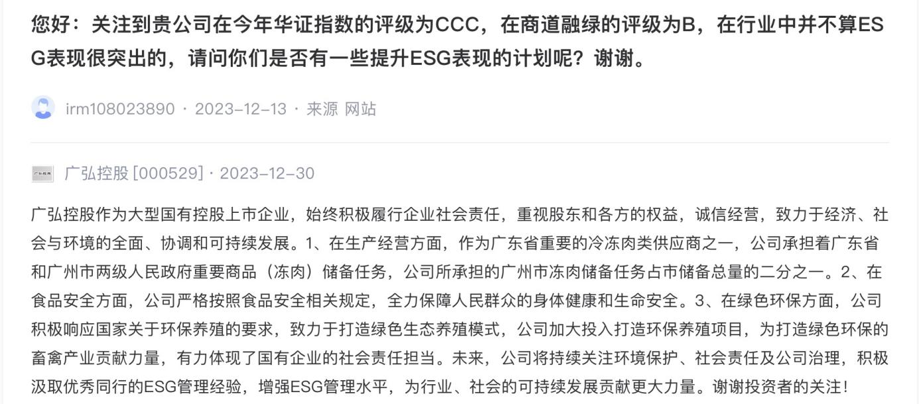
Question: Hello, noting that your company’s rating in this year’s Huazheng Index is CCC, and the rating in Shangdao Ronglv is B, which is not considered outstanding in ESG performance within the industry. Do you have any plans to enhance ESG performance? Thank you.
Answer: Guanghong Holdings, as a large state-owned holding listed company, has consistently fulfilled corporate social responsibility, prioritizing the rights and interests of shareholders and various stakeholders. We operate with integrity and are committed to the comprehensive, coordinated, and sustainable development of the economy, society, and environment. 1. In terms of production and operations, as one of the important frozen meat suppliers in Guangdong province, the company undertakes significant commodity (frozen meat) reserve tasks assigned by both the provincial and municipal governments. The frozen meat reserve task undertaken by the company accounts for half of the total reserve in the city. 2. Regarding food safety, the company strictly adheres to relevant food safety regulations, ensuring the health and safety of the general public. 3. In the area of green environmental protection, the company actively responds to national requirements for environmentally friendly breeding, striving to create a green ecological breeding model. The company has increased investment in environmentally friendly breeding projects, contributing to the development of a green and environmentally friendly livestock and poultry industry, showcasing the strong commitment of a state-owned enterprise to social responsibility. In the future, the company will continue to focus on environmental protection, social responsibility, and corporate governance. We will actively learn from the ESG management experience of outstanding peers, enhance our ESG management level, and contribute even more to the sustainable development of the industry and society. Thank you for the investors’ attention!

Example 2: The question asked by retail investor related to ESG issues on e Hu Dong
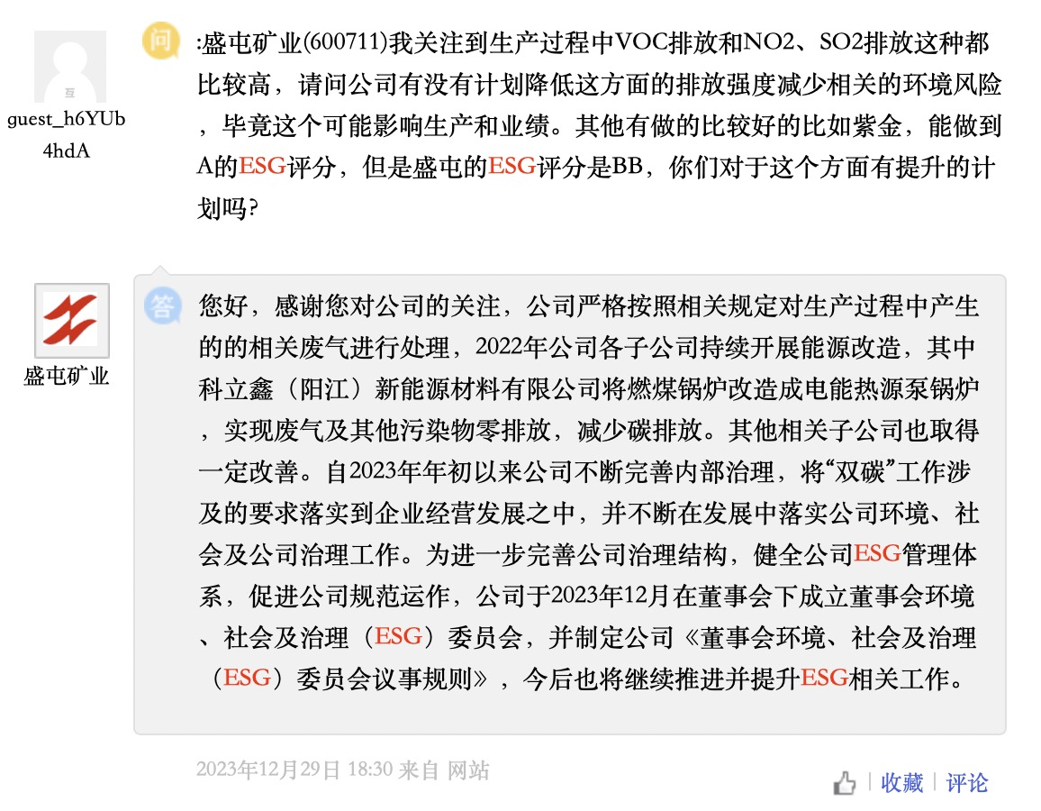 Question: I am concerned about the relatively high VOC emissions, as well as NO2 and SO2 emissions in the production process. Does the company have any plans to reduce emission intensity in this area and mitigate the related environmental risk? After all, this may impact production and performance. Some companies, like Zijin, have achieved an ESG score of A, while the ESG score of Shengtun is BB. Are there any plans to improve this aspect?
Answer: Hello, thank you for your attention to the company. The company strictly adheres to relevant regulations for the treatment of related emissions generated during the production process. In 2022, various subsidiaries of the company continued to carry out energy transformations. For example, Kelixin (Yangjiang) New Energy Materials Co., Ltd. transformed its coal-fired boiler into an electric heat pump boiler, achieving zero emissions of waste gases and other pollutants and reducing carbon emissions. Other related subsidiaries have also shown improvement. Since the beginning of 2023, the company has been continuously improving internal governance, integrating the requirements related to the "dual carbon" initiative into the company’s business development, and consistently implementing environmental, social, and corporate governance work in its development. To further improve the company’s governance structure, enhance the company’s ESG management system, and promote standardized operations, the company established the Board Environment, Social, and Governance (ESG) Committee under the board of directors in December 2023. The company formulated the "Rules of Procedure for the Board Environment, Social, and Governance (ESG) Committee" and will continue to advance and enhance ESG-related work in the future.

Appendix B
Table B The details of the sample selection procedure
Procedure | Number of observations
Initial data for retail investors’ ESG attention and firms’ ESG risk | 3578
Merged with data for all control variables | -460
Excluding observations with financial leverage over one | -9
Excluding observations with ST and *ST | -0
Excluding observations from financial sectors | -282
Excluding observations with missing data | -113
Remaining number of observations | 2,714

