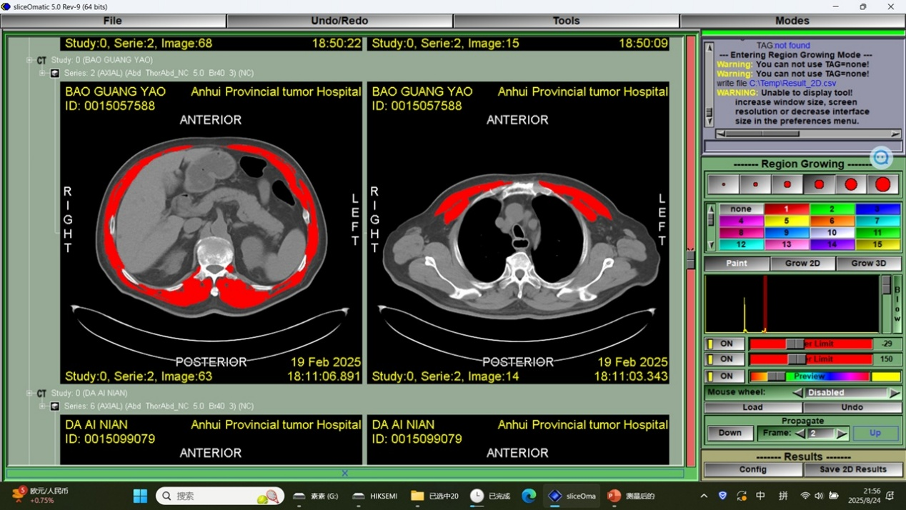
Figure 2. Skeletal muscle area on transverse computed tomography images at (a) pectoralis, (b) first lumbar level.( Axial CT images in DICOM format were exported from the hospital electronic medical record system, and Slice-O-Matic software v5.0 (Tomovision, Montreal, Quebec, Canada) was used for cross-sectional muscle area measurement and analysis.)
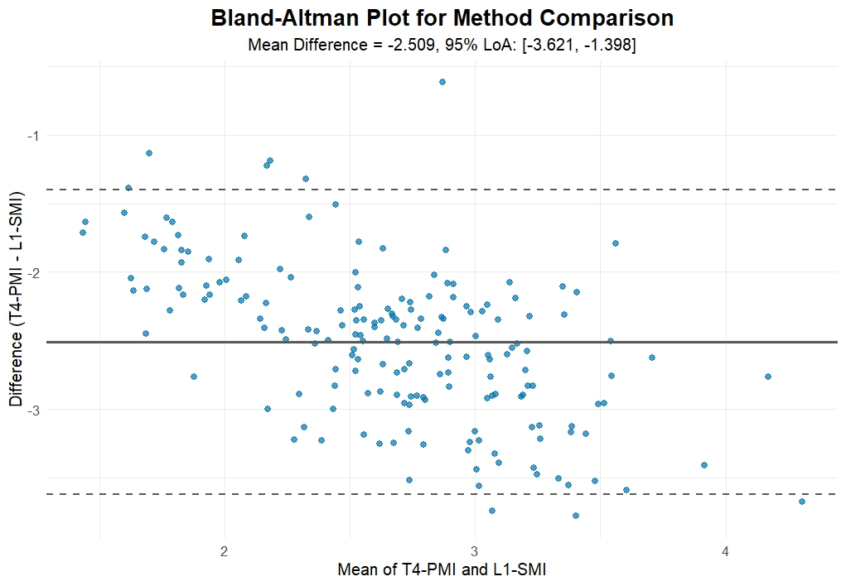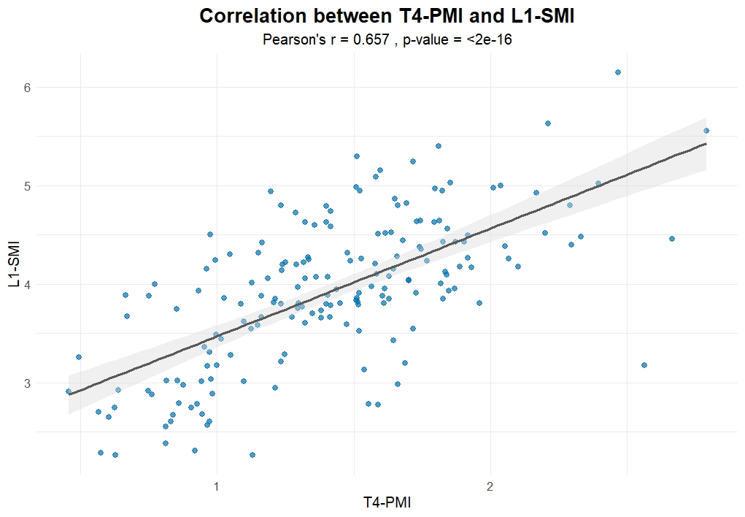
Figure 3. (a) Pearson correlation analysis of baseline levels of T4-PMI and L1-SMI showed a moderate positive correlation (r=0.657, P<0.001); (b) Bland–Altman plots show differences between T4-PMI and L1-SMI. The upper and lower dashed horizontal lines represent the upper and lower limits of the 95% confidence interval, and the solid middle line represents the average of the differences.( The figures/plots were generated using R (version 4.4.3) in the RStudio environment.)
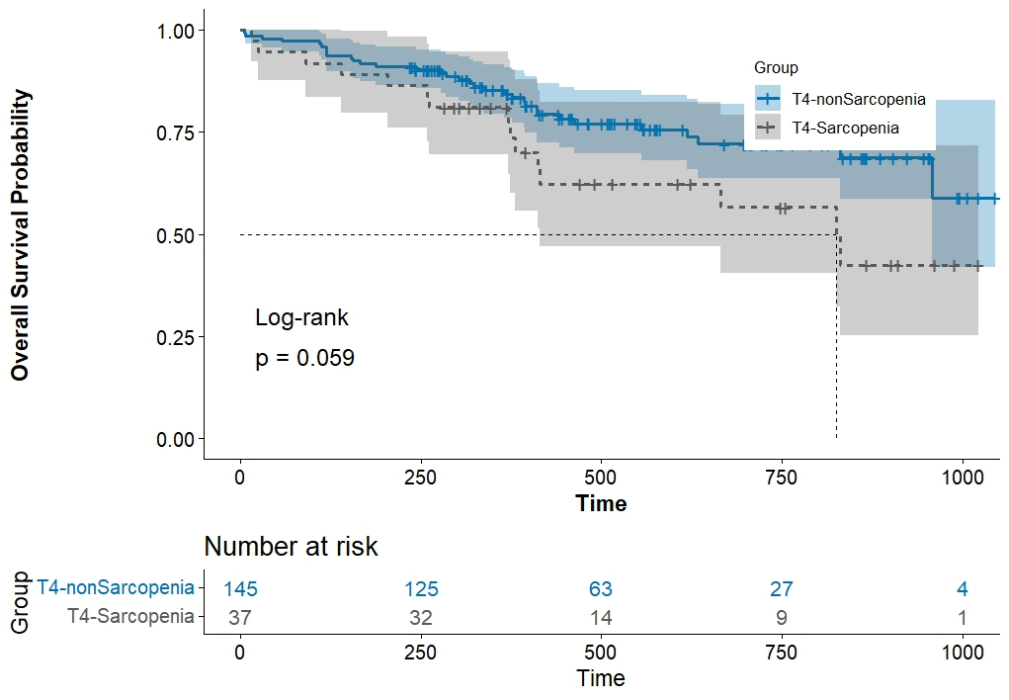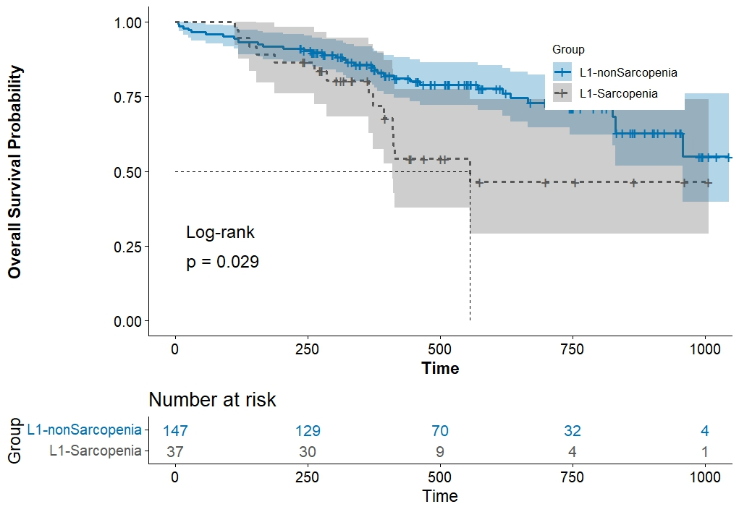
Figure 4. Kaplan-Meier survival curves and Log-Rank test: (a) The median survival time of the L1-sarcopenia group was significantly shorter than that of the non-sarcopenia group (χ²=4.753, P=0.029); (b) no statistically significant difference in survival was observed between the T4-sarcopenia and non-sarcopenia groups (χ²=3.567, P=0.059). ( The figures/plots were generated using R (version 4.4.3) in the RStudio environment.)
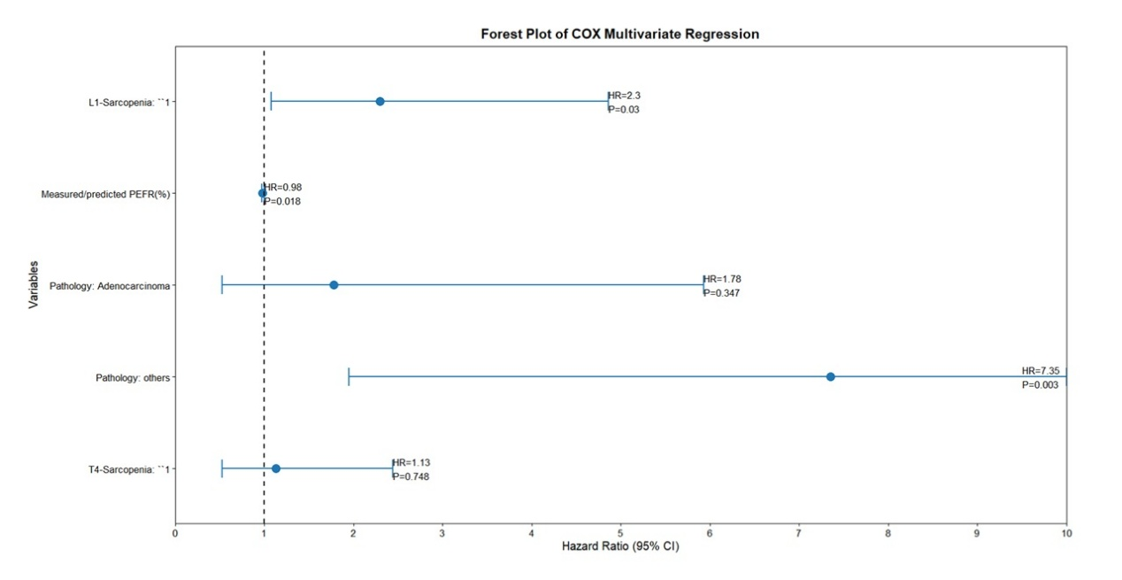
Figure 5. Forest plot of multivariate Cox proportional hazards regression analysis: L1-sarcopenia was an independent risk factor for survival (HR=2.297, 95%CI: 1.085–4.863, P=0.030); measured/predicted PEFR (%) was a protective factor (HR=0.984, 95%CI: 0.970–0.997, P=0.018).( The figures/plots were generated using R (version 4.4.3) in the RStudio environment.)

