Graphical Abstract
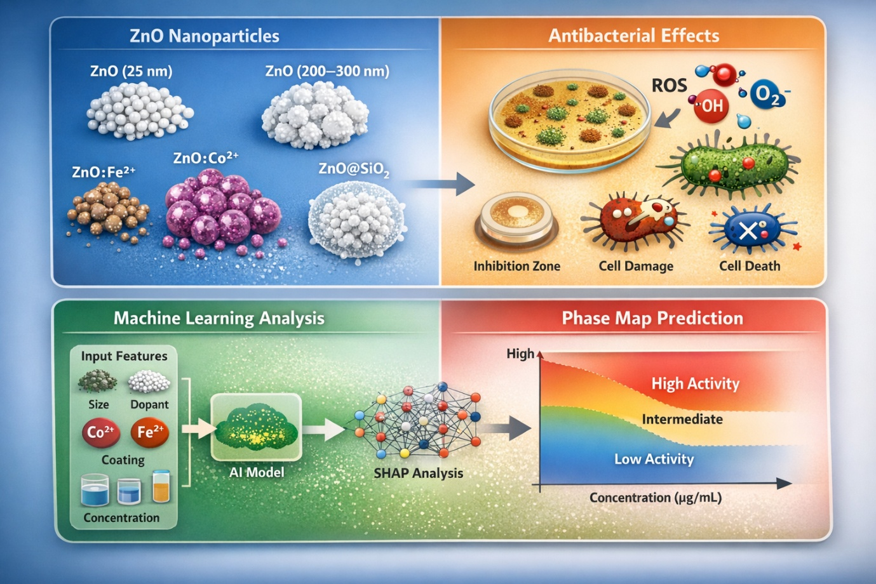
A data-driven framework integrating experimental nanomaterials characterization with interpretable machine-learning models reveals the key physicochemical descriptors controlling antibacterial activity in engineered ZnO nanostructures.

