Supplementary Tables

Supplementary Table 1. Scores of inflammation. The peripheral skin inflammation was assessed clinically at the level of the external orifice and the endoscopic inflammation score was assessed at the level of the internal orifice.

Peripheral skin inflammation score |  |  |  | Endoscopic inflammation score
 | Rat model | Pig model
Peripheral erythema | Lessthan 2 mm | Less than 5 mm | 0 | Ulceration | No ulceration | 0
Peripheral erythema | Between 2 and 3 mm | Between 5 and 10 mm | 1 | Ulceration | Superficial ulceration | 1
Peripheral erythema | Above 3 mm | Above 10 mm | 2 | Ulceration | Deep ulceration and/or necrosis | 2
Ulceration | No ulceration |  | 0 | Bleeding | No bleeding | 0
Ulceration | Superficial ulceration |  | 1 | Bleeding | Presence of bleeding | 1
Ulceration | Deep ulceration and/or necrosis |  | 2 | Aspect of the mucosa | Normal mucosa | 0
Final score (from 0 to 4) : sum of the 2 parameters |  |  |  | Aspect of the mucosa | Eythematous mucosa | 1
 |  |  |  | Aspect of the mucosa | Hemorrhagic seeping | 2
 |  |  |  | Final score (from 0 to 5) : sum of the 3 parameters

Supplementary Table 2. ADSC EV mean, modal and median size assessed by NTA. Results are presented as mean ± SD of all 13 productions.
 | Turbulence-triggered production |  |  | After ultracentrifugation
 | T0 | T2 | T4 | After ultracentrifugation
Mean size (nm) | 150.91 (21.99) | 164.71 (18.92) | 159.36 (26.20) | 179.70 (26.53)
Modal size (nm) | 103.8 (15.45) | 104.7 (9.30) | 103.73 (11.56) | 113.13 (12.17)
Median size (nm) | 156.68 (4.08) | 153.89 (14.06) | 150.1 (14.87) | 167.00 (2.13)

Supplementary Table 3. Histological scoring. The total histological score was calculated as the sum of all 3 parameters.
Parameter | 0 | 1 | 2 | 3 | Total
Epithelial damage | None | Hyperproliferative | < 50% crypt loss | > 50% crypt loss, and/or ulceration | 0-3
Mucosal inflammation | None | Mild | Moderate | Severe | 0-3
Submucosal inflammation | None | Mild | Moderate | Severe | 0-3

Supplementary Table 4. FDG-PET-CT assessment of inflammation in the control, gel, EV, EVG and ADSC groups in the rat model at postoperative day 44. EV: treatment with extracellular vesicles. EVG: treatment with extracellular vesicles + gel. ADSC: treatment with adipose-derived stromal cells. Results are expressed as mean ± standard error of the mean.
 | Groups of treatment |  |  |  |  | p-value
 | Control  (n = 2) | Gel  (n = 3) | EV  (n = 5) | EVG  (n = 5) | ADSC  (n = 4) | p-value
SUV_{max} | 7.815  +/- 0.44 | 9.103  +/- 7.89 | 3.966  +/- 2.05 | 2.440  +/- 0.56 | 4.718  +/- 1.15 | 0.153
Hot average | 7.591  +/- 0.45 | 8.526  +/- 7.45 | 3.782  +/- 1.98 | 2.368  +/- 0.52 | 4.426  +/- 1.15 | 0.152
Total Lesion Glycolysis (TLG) | 0.202  +/- 0.08 | 0.136  +/- 0.09 | 0.068  +/- 0.052 | 0.099  +/- 0.038 | 0.122  +/- 0.10 | 0.478

Supplementary Table 5. Comparison of gastrocutaneous fistula healing in the control, gel and EVG groups in the pig model according to clinical, endoscopic and radiologic outcomes at postoperative day 28.

 | All | Control |  | Gel |  | EVG | p
 | (n=24) |  | (n=8) | (n=8) | (n=8) |  | All | C vs G | C vs EVG | G vs EVG
Fistula output; n (%) | 14 (58.3) |  | 7 (87.5) | 6 (75.0) | 1 (12.5) |  | 0.005 | 1 | 0.010 | 0.041
External fistula orifice closed; n (%) | 10 (41.6) |  | 1 (12.5) | 2 (25.0) | 7 (87.5) |  | 0.005 | 1 | 0.010 | 0.041
Peripheral skin inflammation score; mean (SD) | 1.13 (1.03) |  | 2.0 (1.19) | 1.0 (0.53) | 0.38 (0.51) |  | 0.002 | 0.0406 | 0.007 | 1
Internal fistula orifice closed; n (%) | 6 (25.0) |  | 0 (0.0) | 1 (12.5) | 5 (62.5) |  | 0.009 | 1 | 0.026 | 0.119
Endoscopic inflammation score; mean (SD) | 2.0 (1.75) |  | 3.5 (1.77) | 2 (1.07) | 0.50 (0.75) |  | <0.001 | 0.0256 | 0.0073 | 0.012
Fistula tract closed upon radiological assessment; n (%) | 9 (37.5) |  | 1 (12.5) | 2 (25.0) | 6 (75.0) |  | 0.024 | 1 | 0.041 | 0.132
Fistula volume estimated by radiological assessment (mm³); mean (SD) | 46.32  (77.66) |  | 90.01  (91.56) | 48.29  (82.84) | 0.66  (1.62) |  | 0.0053 | 0.1936 | 0.002 | 0.018
Zühlke score; mean (SD) | 2.0 (1.10) |  | 2.75 (1.28) | 1.88 (0.83) | 1.38 (0.74) |  | 0.087 | 0.3147 | 0.1189 | 1
EVG: treatment with extracellular vesicles + gel. n: number of cases. SD: standard deviation. All: comparison between all 3 groups. C vs G: control group versus gel group. C vs EVG: control group versus EVG group. G vs EVG: control group versus EVG group. For categorical variables, comparisons between more than 2 groups were done with the Chi-square test; and pair-wise comparisons were performed with Fisher’s exact test for 2 by 2 contingency tables or the Chi-square test otherwise. For unpaired continuous variables, comparisons between more than two groups were done with the Kruskal-Wallis test; and pair-wise comparisons were performed with the Mann-Whitney test. p < 0.05 was considered significant.

Supplementary Figures

Supplementary Figure 1. Procedure of sleeve gastrectomy and gastro-cutaneous fistula induction in a rat model. A. General disposition and landmarks for sleeve gastrectomy. Pa: pancreas. Py: pylorus. L: liver. OGJ: oesogastric junction. GC: great curvature of the stomach. R: rumen. The discontinuous line represents the sectional plane for sleeve gastrectomy, beginning 5 mm from the pylorus. B. Section of the stomach and application of a vertical stapler. C. Definitive aspect after vertical sleeve gastrectomy. D. Creation of the fistula following a staggered passage through the abdominal muscles and subcutaneous tissues. E. Creation of the external fistula orifice. F. Definitive aspect of the fistula at post-operative day 45.
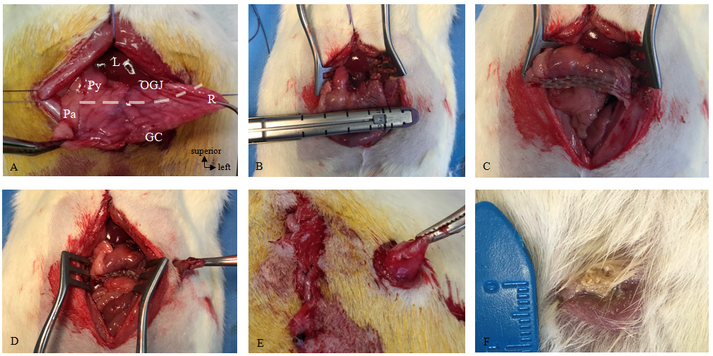

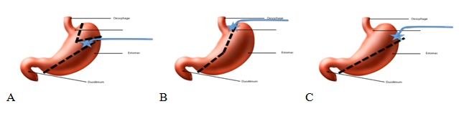
Supplementary Figure 2. Three experimental protocols for gastrocutaneous fistula induction following sleeve gastrectomy in a pig model. A. The fundic pouch was preserved with the stapling ending at the greater curvature just below the fundic pouch. B. The fundic pouch was resected with the stapling ending at the cardia near the oesogastric junction. C. The fundic pouch was partially resected and a light stenosis was induced at the level of the lesser curvature; with the stapling ending at the fundus, 4 to 6 cm from the oesogastric junction.

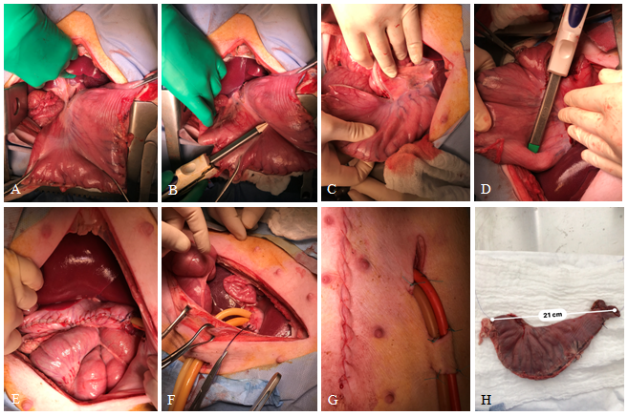
Supplementary Figure 3. Procedure of sleeve gastrectomy and gastrocutaneous fistula induction in a pig model. A. Gastric dissection. B and C. Gastric calibration with a 36-French bougie tube advanced to the level of the pylorus and sleeve gastrectomy beginning 3 to 4 cm from the pylorus. D. Firing of 3-4 vertical staplers along the calibration tube. E. Final aspect of the sleeve gastrectomy after manual suture over the staple line. F and G. Creation of gastrocutaneous fistula through the insertion of 2 catheters between the stomach at the top of the staple line and the skin. H. Excluded stomach removed after surgery.

Supplementary Figure 4. Representative ADSC EV size distribution after ultracentrifugation assessed by NTA. Results are presented as the average concentration in function of the size measured as determined by the Finite Track Length Adjustement method over 5 videos of 60 seconds for one representative EV production.
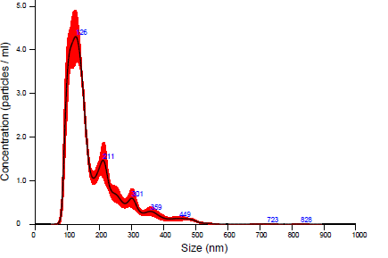

Supplementary Figure 5 (see below). Histological assessment of local inflammation, vascularization and fibrosis at post-operative day 45 in the rat model. Local infiltration by lymphocytes (A.), monocytes (B.), plasmocytes (C.), macrophages (D.), neutrophils (E.), eosinophils (F.), the extent of fibrosis (G.), local infiltration by fibroblasts (H.), and vascularisation (I.) were quoted semi-quantitatively from 0 (none) to 3 (severe) on Haematoxylin Eosin, Periodic acid-Schiff, and Sirius Red staining. Data were analyzed with the Chi-square test followed by Fisher’s exact test.
** p ≤ 0.01. EV: extracellular vesicles. EVG: extracellular vesicles embedded in gel. ADSC: adipose-derived stromal cells.

Supplementary Figure 6. Histological scoring in rats at post-operative day 45. A. Epithelial damage. B. Mucosal inflammation. C. Submucosal inflammation. D. Overall histological scoring. Data were analyzed with the Chi-square test.
EV: extracellular vesicles. EVG: extracellular vesicles embedded in gel. ADSC: adipose-derived stromal cells.

Supplementary Figure 7. Immunohistochemical analysis in the rat model at post-operative day 45. A. The density of CD31 was evaluated semi-quantitatively from 0 (none) to 3 (important) as a marker of vascularisation. B. The density of smooth muscle actin was similarly assessed as a marker of myofibroblasts. Data were analyzed with the Chi-square test. EV : extracellular vesicles. EVG : extracellular vesicles embedded in gel. ADSC : adipose-derived stromal cells.

Supplementary Figure 8. Comparison of the maximal fistula diameter in the control, gel and EVG groups in the pig model according to histological evaluation at postoperative day 28. Results correspond to the average of two independent replicates per rat, and are shown for each group as mean ± standard deviation with individual values. Data were analyzed with the Kruskal-Wallis test (p = 0.0045), followed by Mann-Whitney’s test for two-by-two comparisons. ns : not significant. * : p ≤ 0.05. ** : p ≤ 0.01. EVG : extracellular vesicles embedded in gel.

Supplementary Figure 9 (see below). Histological assessment of local inflammation, vascularization and fibrosis at post-operative day 28 in the pig model. Local infiltration by lymphocytes (A.), monocytes (B.), plasmocytes (C.), macrophages (D.), neutrophils (E.), eosinophils (F.), the extent of fibrosis (G.), local infiltration by fibroblasts (H.), and vascularisation (I.) were quoted semi-quantitatively from 0 (none) to 3 (severe) on Haematoxylin Eosin, Periodic acid-Schiff, and Sirius Red staining. Data were analyzed with the Chi-square test followed by Fisher’s exact test. ** p ≤ 0.01. ns : not significant. EVG: extracellular vesicles embedded in gel.
Supplementary Figure 10. Histological scoring in pigs at post-operative day 28. A. Epithelial damage. B. Mucosal inflammation. C. Submucosal inflammation. D. Overall histological scoring. Data were analyzed with the Chi-square test followed by Fisher’s exact test.
ns : not significant. * : p ≤ 0.05. ** : p ≤ 0.01. EVG: extracellular vesicles embedded in gel.

