Supplementary Materials: Performance measures and availability of European power plants

Authors
Eric Jahnke*, Armin Ardone

Affiliations
Karlsruhe Institute of Technology (KIT), Institute for Industrial Production (IIP), Chair of Energy Economics, Hertzstr. 16, 76187 Karlsruhe, Germany

*corresponding author: Eric Jahnke (eric.jahnke@kit.edu)

Data cleaning and pre-processing

This section describes the various cases differentiated to cluster and label multiple overlapping outage reports with different types, reasons and updates.

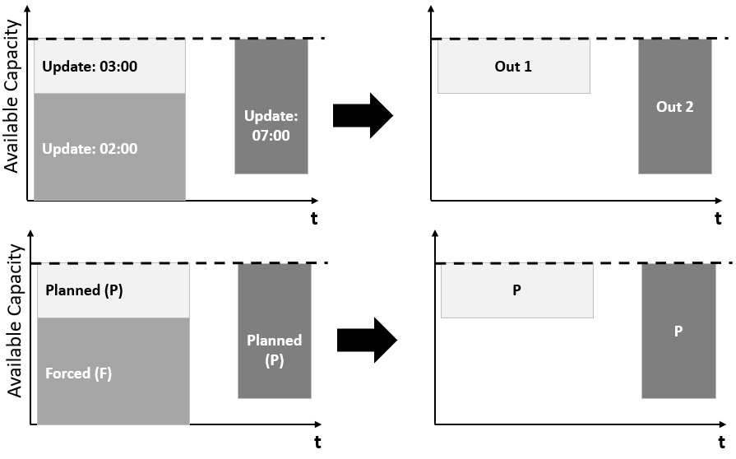
Figure 1: Most recent update between two overlapping reports

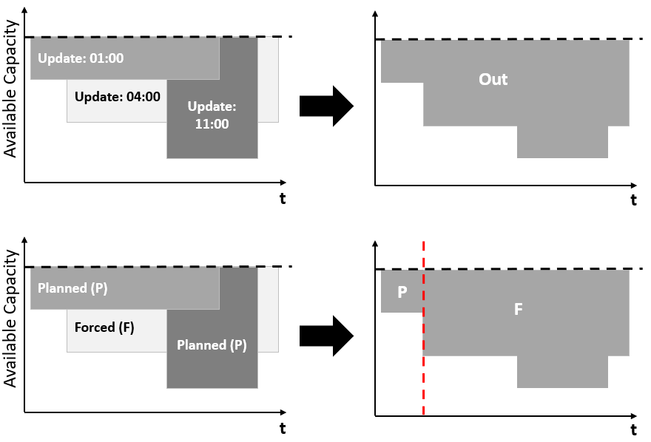
Figure 2: Start time is planned, but forced > planned for overlapping

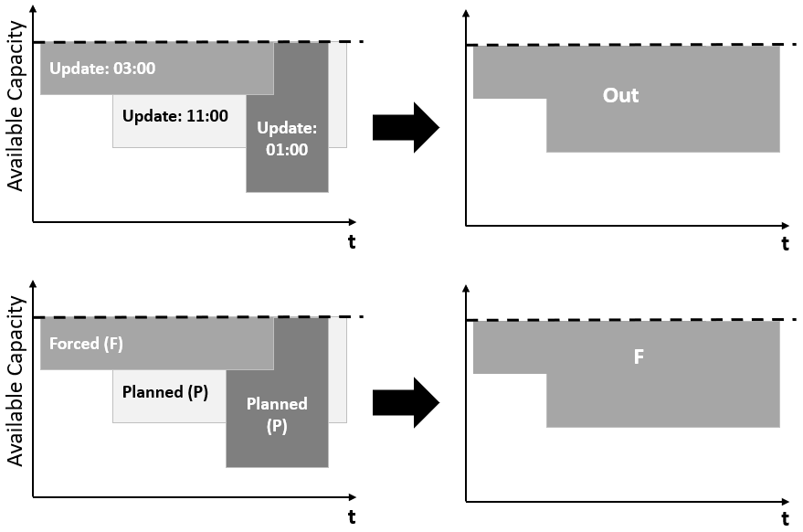
Figure 3: Start time sets label, forced > planned for overlapping and most recent update time deletes big outage

Description of performance measures

Abbreviation | Description | Equation
ACTH | Active hours of observation horizon per unit | Full year with observations per powerplant
SH | Service hours of a unit without hours in total outage | ACTH – (FOH + MOH + POH)
DH | Observed hours | ACTH – SOH
FOH | Number of hours a unit was in forced outage (excluding maintenance) | $$\sum_{t}{\sum_{u}{1 \{if FO in t}}\}$$
POH | Number of hours a unit was in planned outage (excluding maintenance) | $$\sum_{t}{\sum_{u}{1 \{if PO in t}}\}$$
MOH | Number of hours a unit was in outage due to maintenance (either planned or forced) | $$\sum_{t}{\sum_{u}{1 \{if MO in t}}\}$$
UOH | Number of hours a unit was in forced unplanned outage (including maintenance) | $$\sum_{t}{\sum_{u}{1 \{if UO in t}}\}$$
SOH | Number of hours a unit was in planned scheduled outage (including maintenance) | $$\sum_{t}{\sum_{u}{1 \{if SO in t}}\}$$
FDH | Number of hours a unit was in forced deration (excluding maintenance) | $$\sum_{t}{\sum_{u}{1 \{if FD in t}}\}$$
PDH | Number of hours a unit was planned derated (excluding maintenance) | $$\sum_{t}{\sum_{u}{1 \{if PD in t}}\}$$
MDH | Number of hours a unit was derated due to maintenance (either planned or forced) | $$\sum_{t}{\sum_{u}{1 \{if MD in t}}\}$$
UDH | Number of hours a unit was forced unplanned deration (including maintenance) | $$\sum_{t}{\sum_{u}{1 \{if UD in t}}\}$$
SDH | Number of hours a unit was planned scheduled derated (including maintenance) | $$\sum_{t}{\sum_{u}{1 \{if SD in t}}\}$$
Table 1: Description of temporal factors

Abbreviation | Equation
AF | $$\frac{(POH+MOH+FOH)}{ACTH}$$
FOF | $$\frac{FOH}{ACTH}$$
POF | $$\frac{POH}{ACTH}$$
MOF | $$\frac{MOH}{ACTH}$$
UOF | $$\frac{UOH}{ACTH}$$
SOF | $$\frac{SOH}{ACTH}$$
EAF | $$\frac{(POH+MOH+FOH+PDH+MDH+FDH)}{ACTH}$$
EFOF | $$\frac{(FOH+FDH)}{ACTH}$$
EPOF | $$\frac{(POH+PDH)}{ACTH}$$
EMOF | $$\frac{(MOH+MDH)}{ACTH}$$
EUOF | $$\frac{(UOH+UDH)}{ACTH}$$
ESOF | $$\frac{(SOH+SDH)}{ACTH}$$
Table 2: Performance measure factors

Abbreviation | Equation
FOR | $$\frac{FOH}{(SH+FOH)}$$
POR | $$\frac{POH}{(SH+POH)}$$
MOR | $$\frac{MOH}{(SH+MOH)}$$
UOR | $$\frac{UOH}{(SH+UOH)}$$
SOR | $$\frac{SOH}{(SH+SOH)}$$
EFOR | $$\frac{(FOH+FDH)}{(SH+FOH)}$$
EPOR | $$\frac{(POH+PDH)}{(SH+POH)}$$
EMOR | $$\frac{(MOH+MDH)}{(SH+MOH)}$$
EUOR | $$\frac{(UOH+UDH)}{(SH+UOH)}$$
ESOR | $$\frac{(SOH+SDH)}{(SH+SOH)}$$
RR_fo | $$\frac{N_{fo}}{TOT_{fo}}$$
FR | $$\frac{FOH}{DH}$$
RR_un | $$\frac{N_{uo}}{{TOT}_{uo}}$$
UR | $$\frac{UOH}{DH}$$
Table 3: Performance measure rates

Description of powerplant database

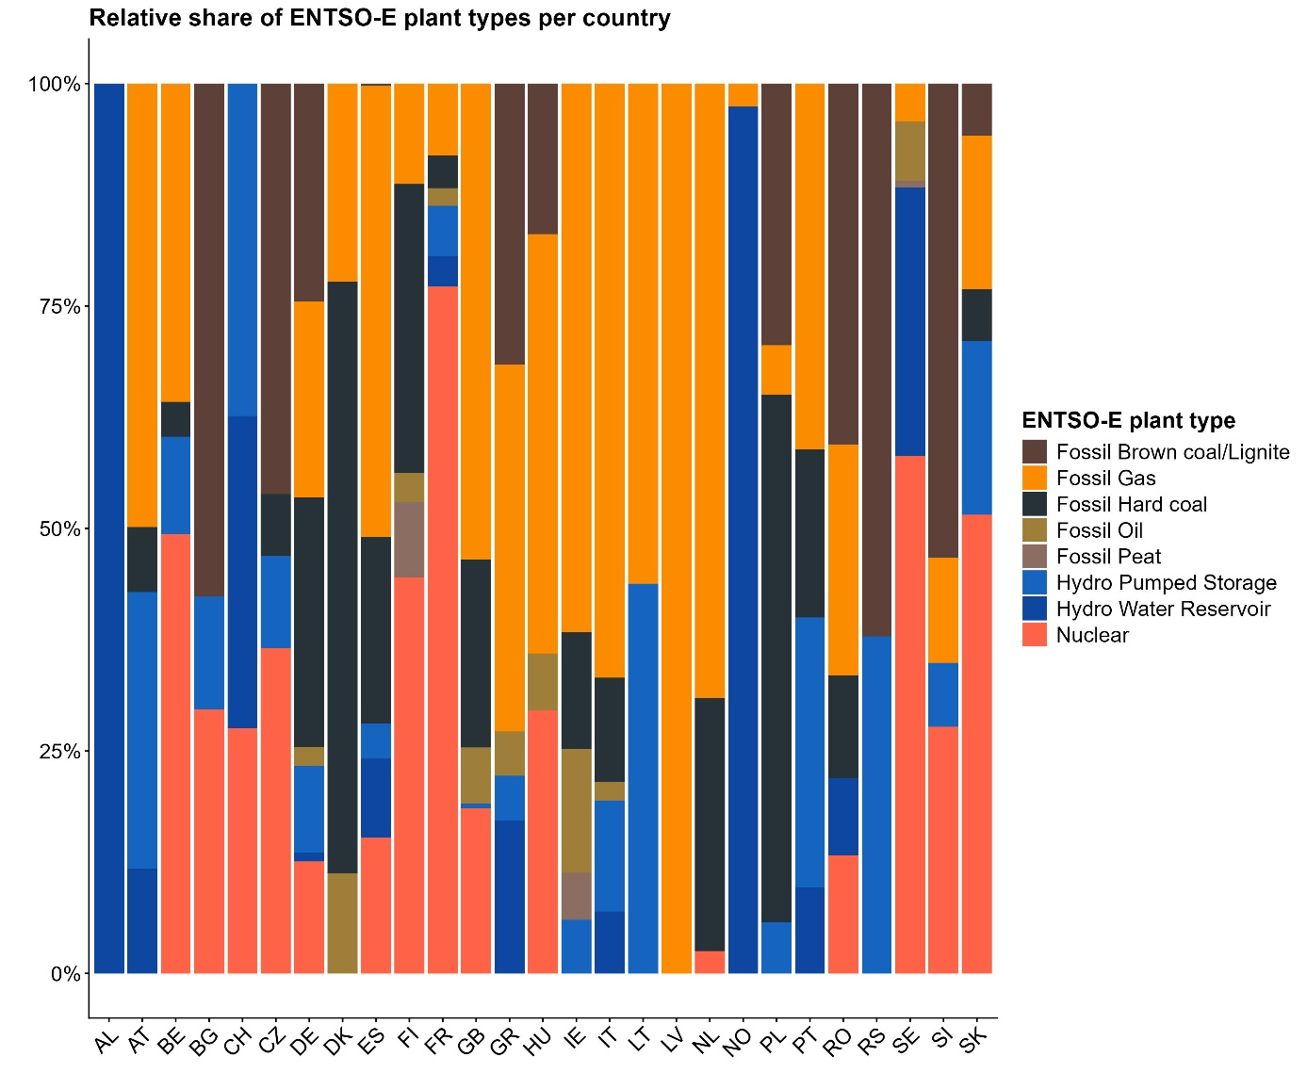
Figure 4: Share of ENTSO-E plant type domains per country in the dataset

Plant type* | Country | No. units | Unit cap. [MW] | No. units [%] | Unit cap. [%]
Hydro Water Reservoir | AL | 14 | 1421 | 100% | 100%
Fossil Gas | AT | 13 | 4295.2 | 36% | 40%
Fossil Hard coal | AT | 3 | 915 | 8% | 9%
Hydro Pumped Storage | AT | 7 | 2463.8 | 19% | 23%
Hydro Run-of-river and poundage | AT | 9 | 2060.9 | 25% | 19%
Hydro Water Reservoir | AT | 4 | 935.2 | 11% | 9%
Biomass | BE | 1 | 268 | 3% | 2%
Fossil Gas | BE | 17 | 4281.7 | 49% | 35%
Fossil Hard coal | BE | 2 | 470 | 6% | 4%
Hydro Pumped Storage | BE | 7 | 1308 | 20% | 11%
Nuclear | BE | 8 | 5919 | 23% | 48%
Fossil Brown coal/Lignite | BG | 18 | 3888 | 75% | 57%
Hydro Pumped Storage | BG | 4 | 908 | 17% | 13%
Nuclear | BG | 2 | 2000 | 8% | 29%
Hydro Pumped Storage | CH | 13 | 4471 | 38% | 36%
Hydro Run-of-river and poundage | CH | 2 | 220 | 6% | 2%
Hydro Water Reservoir | CH | 14 | 4288 | 41% | 35%
Nuclear | CH | 5 | 3373 | 15% | 27%
Fossil Brown coal/Lignite | CZ | 20 | 4191 | 56% | 42%
Fossil Hard coal | CZ | 4 | 748 | 11% | 8%
Hydro Pumped Storage | CZ | 6 | 1110 | 17% | 11%
Nuclear | CZ | 6 | 3936 | 17% | 39%
Fossil Brown coal/Lignite | DE | 43 | 21017 | 16% | 24%
Fossil Coal-derived gas | DE | 7 | 1140 | 3% | 1%
Fossil Gas | DE | 70 | 18979 | 26% | 21%
Fossil Hard coal | DE | 59 | 24090 | 22% | 27%
Fossil Oil | DE | 12 | 1674 | 5% | 2%
Hydro Pumped Storage | DE | 49 | 7110 | 19% | 8%
Hydro Run-of-river and poundage | DE | 2 | 246 | 1% | 0%
Hydro Water Reservoir | DE | 7 | 860 | 3% | 1%
Nuclear | DE | 9 | 12085 | 3% | 14%
Waste | DE | 1 | 109 | 0% | 0%
Fossil Gas | DK | 4 | 1315.2 | 25% | 24%
Fossil Hard coal | DK | 10 | 3772 | 63% | 67%
Fossil Oil | DK | 2 | 520 | 13% | 9%
Fossil Oil shale | EE | 12 | 1981 | 100% | 100%
Fossil Brown coal/Lignite | ES | 1 | 142.3 | 0% | 0%
Fossil Gas | ES | 73 | 25176.3 | 32% | 48%
Fossil Hard coal | ES | 30 | 10414.8 | 13% | 20%
Hydro Pumped Storage | ES | 11 | 1950.9 | 5% | 4%
Hydro Water Reservoir | ES | 34 | 5485.8 | 15% | 10%
Nuclear | ES | 8 | 7572.4 | 4% | 14%
Biomass | FI | 1 | 125 | 2% | 1%
Fossil Gas | FI | 12 | 1105 | 28% | 11%
Fossil Hard coal | FI | 16 | 3169 | 37% | 32%
Fossil Oil | FI | 2 | 326 | 5% | 3%
Fossil Peat | FI | 5 | 820 | 12% | 8%
Nuclear | FI | 7 | 4352 | 16% | 44%
Fossil Gas | FR | 20 | 6583 | 13% | 7%
Fossil Hard coal | FR | 13 | 4810 | 8% | 5%
Fossil Oil | FR | 20 | 6668 | 13% | 8%
Hydro Pumped Storage | FR | 27 | 4861 | 17% | 6%
Hydro Run-of-river and poundage | FR | 3 | 333 | 2% | 0%
Hydro Water Reservoir | FR | 14 | 2037 | 9% | 2%
Nuclear | FR | 58 | 63130 | 37% | 71%
Biomass | GB | 3 | 1935 | 1% | 3%
Fossil Gas | GB | 81 | 36488 | 38% | 47%
Fossil Hard coal | GB | 30 | 14829 | 14% | 19%
Fossil Oil | GB | 23 | 4186 | 11% | 5%
Hydro Pumped Storage | GB | 3 | 399 | 1% | 1%
Hydro Run-of-river and poundage | GB | 49 | 7846 | 23% | 10%
Nuclear | GB | 22 | 12638 | 10% | 16%
Fossil Brown coal/Lignite | GR | 17 | 4411 | 30% | 31%
Fossil Gas | GR | 17 | 5756 | 30% | 41%
Fossil Oil | GR | 4 | 698 | 7% | 5%
Hydro Pumped Storage | GR | 4 | 699 | 7% | 5%
Hydro Run-of-river and poundage | GR | 2 | 69 | 4% | 1%
Hydro Water Reservoir | GR | 12 | 2404 | 21% | 17%
Biomass | HU | 2 | 106 | 4% | 2%
Fossil Brown coal/Lignite | HU | 12 | 1089 | 25% | 17%
Fossil Gas | HU | 23 | 3070.2 | 48% | 47%
Fossil Oil | HU | 3 | 410 | 6% | 6%
Nuclear | HU | 8 | 1899.4 | 17% | 29%
Fossil Gas | IE | 21 | 4180 | 42% | 59%
Fossil Hard coal | IE | 3 | 855 | 6% | 12%
Fossil Oil | IE | 8 | 1326 | 16% | 19%
Fossil Peat | IE | 3 | 344 | 6% | 5%
Hydro Pumped Storage | IE | 4 | 292 | 8% | 4%
Hydro Run-of-river and poundage | IE | 11 | 151 | 22% | 2%
Biomass | IT | 4 | 150 | 1% | 0%
Fossil Gas | IT | 117 | 39530 | 24% | 54%
Fossil Hard coal | IT | 25 | 7911 | 5% | 11%
Fossil Oil | IT | 25 | 5448 | 5% | 7%
Geothermal | IT | 3 | 93 | 1% | 0%
Hydro Pumped Storage | IT | 17 | 6600 | 4% | 9%
Hydro Run-of-river and poundage | IT | 200 | 7541 | 41% | 10%
Hydro Water Reservoir | IT | 57 | 3696 | 12% | 5%
Fossil Gas | LT | 6 | 1755 | 60% | 66%
Hydro Pumped Storage | LT | 4 | 900 | 40% | 34%
Fossil Gas | LV | 4 | 881 | 80% | 90%
Hydro Run-of-river and poundage | LV | 1 | 100 | 20% | 10%
Fossil Gas | NL | 36 | 14039 | 75% | 65%
Fossil Hard coal | NL | 11 | 7203 | 23% | 33%
Nuclear | NL | 1 | 492 | 2% | 2%
Fossil Gas | NO | 23 | 525 | 5% | 3%
Hydro Run-of-river and poundage | NO | 14 | 210.5 | 3% | 1%
Hydro Water Reservoir | NO | 434 | 20593.2 | 92% | 97%
Biomass | PL | 1 | 225 | 1% | 1%
Fossil Brown coal/Lignite | PL | 31 | 9278 | 23% | 32%
Fossil Gas | PL | 5 | 1572 | 4% | 5%
Fossil Hard coal | PL | 79 | 16186 | 59% | 56%
Hydro Pumped Storage | PL | 18 | 1706 | 13% | 6%
Fossil Gas | PT | 10 | 3828 | 13% | 33%
Fossil Hard coal | PT | 6 | 1756 | 8% | 15%
Hydro Pumped Storage | PT | 20 | 2843 | 27% | 24%
Hydro Run-of-river and poundage | PT | 32 | 2436 | 43% | 21%
Hydro Water Reservoir | PT | 7 | 897 | 9% | 8%
Fossil Brown coal/Lignite | RO | 14 | 4011 | 33% | 41%
Fossil Gas | RO | 16 | 2626.1 | 38% | 27%
Fossil Hard coal | RO | 6 | 1150 | 14% | 12%
Hydro Water Reservoir | RO | 4 | 674.8 | 10% | 7%
Nuclear | RO | 2 | 1354.5 | 5% | 14%
Fossil Brown coal/Lignite | RS | 4 | 1007 | 29% | 34%
Hydro Pumped Storage | RS | 2 | 614 | 14% | 21%
Hydro Run-of-river and poundage | RS | 6 | 1098.9 | 43% | 37%
Biomass | SE | 1 | 106 | 2% | 1%
Fossil Gas | SE | 3 | 698 | 5% | 4%
Fossil Oil | SE | 7 | 1370 | 12% | 8%
Fossil Peat | SE | 1 | 120 | 2% | 1%
Hydro Water Reservoir | SE | 29 | 4658 | 51% | 28%
Nuclear | SE | 16 | 9525 | 28% | 58%
Fossil Brown coal/Lignite | SI | 7 | 1351 | 39% | 49%
Fossil Gas | SI | 5 | 297 | 28% | 11%
Hydro Pumped Storage | SI | 1 | 180 | 6% | 7%
Hydro Run-of-river and poundage | SI | 4 | 242 | 22% | 9%
Nuclear | SI | 1 | 696 | 6% | 25%
Fossil Brown coal/Lignite | SK | 4 | 440 | 18% | 11%
Fossil Gas | SK | 2 | 577.6 | 9% | 15%
Fossil Hard coal | SK | 2 | 220 | 9% | 6%
Hydro Pumped Storage | SK | 6 | 734.4 | 27% | 19%
Nuclear | SK | 8 | 1940 | 36% | 50%
*NAs, Others, undefined Hydro or RES were ignored in this table
Table 4: Descriptive statistics of plant types in ENTSO-E domain per country of the merged power plant database.

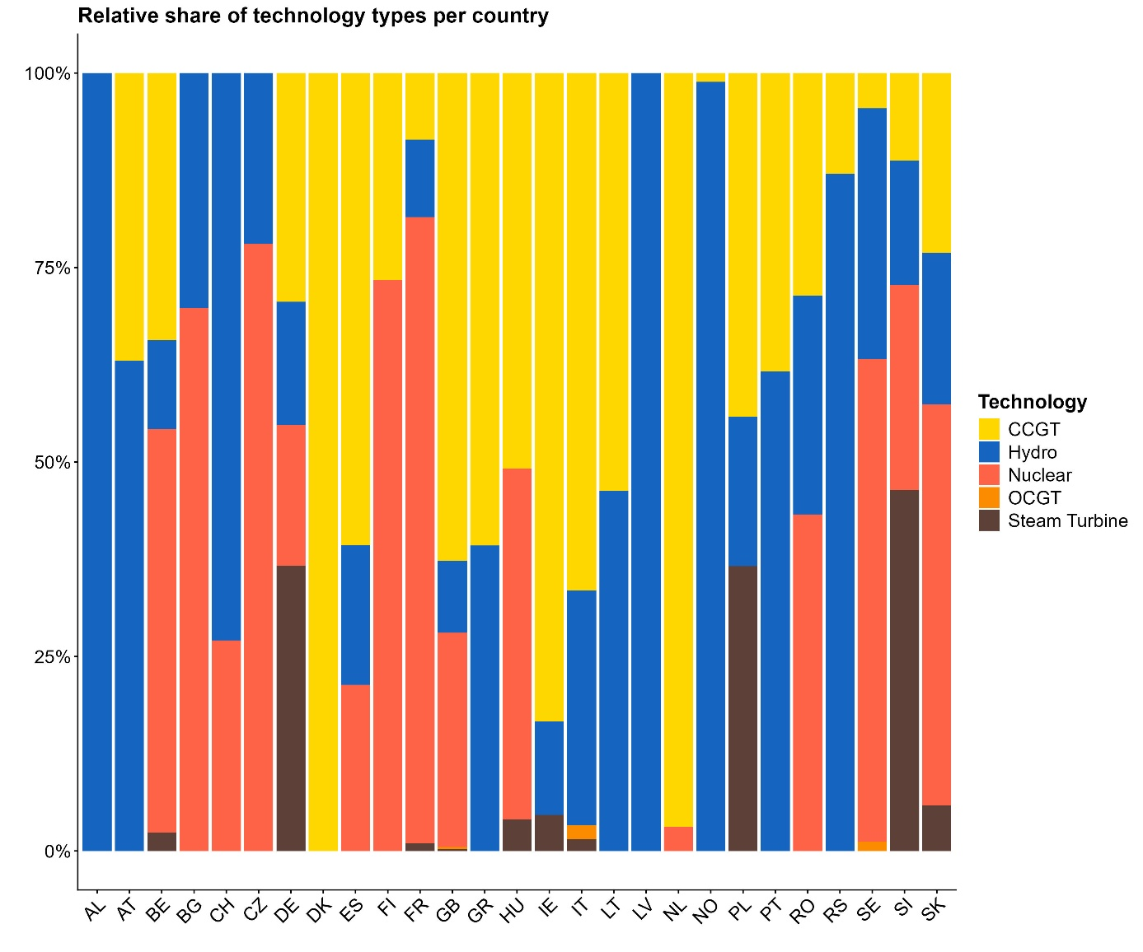
Figure 5: Share of technology types per country in the dataset

Technology* | Country | No. units | Unit cap. [MW] | No. units [%] | Unit cap. [%]
Hydro | AL | 14 | 1421 | 100% | 100%
CCGT | AT | 10 | 3502.2 | 28% | 33%
Hydro | AT | 20 | 5459.9 | 56% | 51%
CCGT | BE | 16 | 3905.3 | 46% | 32%
Hydro | BE | 7 | 1308 | 20% | 11%
Nuclear | BE | 8 | 5919 | 23% | 48%
Steam Turbine | BE | 1 | 268 | 3% | 2%
Hydro | BG | 4 | 908 | 17% | 13%
Nuclear | BG | 2 | 2000 | 8% | 29%
Hydro | CH | 29 | 8979 | 85% | 73%
Nuclear | CH | 5 | 3373 | 15% | 27%
Hydro | CZ | 6 | 1110 | 17% | 11%
Nuclear | CZ | 6 | 3936 | 17% | 39%
CCGT | DE | 62 | 17676 | 23% | 20%
Hydro | DE | 58 | 8216 | 22% | 9%
Nuclear | DE | 9 | 12085 | 3% | 14%
Steam Turbine | DE | 45 | 21658 | 17% | 24%
CCGT | DK | 2 | 500.2 | 13% | 9%
CCGT | ES | 63 | 21513.3 | 27% | 41%
Hydro | ES | 45 | 7436.7 | 20% | 14%
Nuclear | ES | 8 | 7572.4 | 4% | 14%
Reservoir | ES | 74 | 1913.3 | 32% | 4%
CCGT | FI | 16 | 1576 | 37% | 16%
Nuclear | FI | 7 | 4352 | 16% | 44%
CCGT | FR | 21 | 6691 | 14% | 8%
Hydro | FR | 44 | 7231 | 28% | 8%
Nuclear | FR | 58 | 63130 | 37% | 71%
Steam Turbine | FR | 5 | 796 | 3% | 1%
CCGT | GB | 61 | 28782 | 29% | 37%
Hydro | GB | 52 | 8245 | 25% | 11%
Nuclear | GB | 22 | 12638 | 10% | 16%
OCGT | GB | 1 | 140 | 1% | 0%
Steam Turbine | GB | 2 | 100 | 1% | 0%
CCGT | GR | 13 | 4910 | 23% | 35%
Hydro | GR | 18 | 3172 | 32% | 23%
CCGT | HU | 18 | 2196 | 38% | 33%
Nuclear | HU | 8 | 1899.4 | 17% | 29%
Steam Turbine | HU | 1 | 170 | 2% | 3%
CCGT | IE | 19 | 4388 | 38% | 61%
Hydro | IE | 15 | 443 | 30% | 6%
Steam Turbine | IE | 4 | 208 | 8% | 3%
CCGT | IT | 128 | 40107 | 27% | 54%
Hydro | IT | 274 | 17837 | 57% | 24%
OCGT | IT | 8 | 1188 | 2% | 2%
Steam Turbine | IT | 5 | 871 | 1% | 1%
CCGT | LT | 5 | 1645 | 50% | 62%
Hydro | LT | 4 | 900 | 40% | 34%
Hydro | LV | 1 | 100 | 20% | 10%
CCGT | NL | 40 | 16613 | 83% | 76%
Nuclear | NL | 1 | 492 | 2% | 2%
CCGT | NO | 5 | 230 | 1% | 1%
Hydro | NO | 448 | 20803.7 | 95% | 98%
CCGT | PL | 16 | 3865 | 12% | 13%
Hydro | PL | 18 | 1706 | 13% | 6%
Steam Turbine | PL | 15 | 3159 | 11% | 11%
CCGT | PT | 10 | 3828 | 13% | 33%
Hydro | PT | 59 | 6176 | 79% | 53%
CCGT | RO | 4 | 857 | 10% | 9%
Hydro | RO | 4 | 674.8 | 10% | 7%
Nuclear | RO | 2 | 1354.5 | 5% | 14%
CCGT | RS | 2 | 255 | 14% | 9%
Hydro | RS | 8 | 1712.9 | 57% | 58%
CCGT | SE | 3 | 698 | 5% | 4%
Hydro | SE | 29 | 4658 | 51% | 28%
Nuclear | SE | 16 | 9525 | 28% | 58%
OCGT | SE | 3 | 440 | 5% | 3%
CCGT | SI | 5 | 297 | 28% | 11%
Hydro | SI | 5 | 422 | 28% | 15%
Nuclear | SI | 1 | 696 | 6% | 25%
Steam Turbine | SI | 6 | 1226 | 33% | 44%
CCGT | SK | 4 | 797.6 | 18% | 20%
Hydro | SK | 6 | 734.4 | 27% | 19%
Nuclear | SK | 8 | 1940 | 36% | 50%
Steam Turbine | SK | 4 | 440 | 18% | 11%
*NAs were ignored in this table.
Table 5: Descriptive statistics of technology types per country of the merged power plant database.

Data overview
The following section contains an illustrative overview of figures showing descriptive statistics for the calculated performance measures.
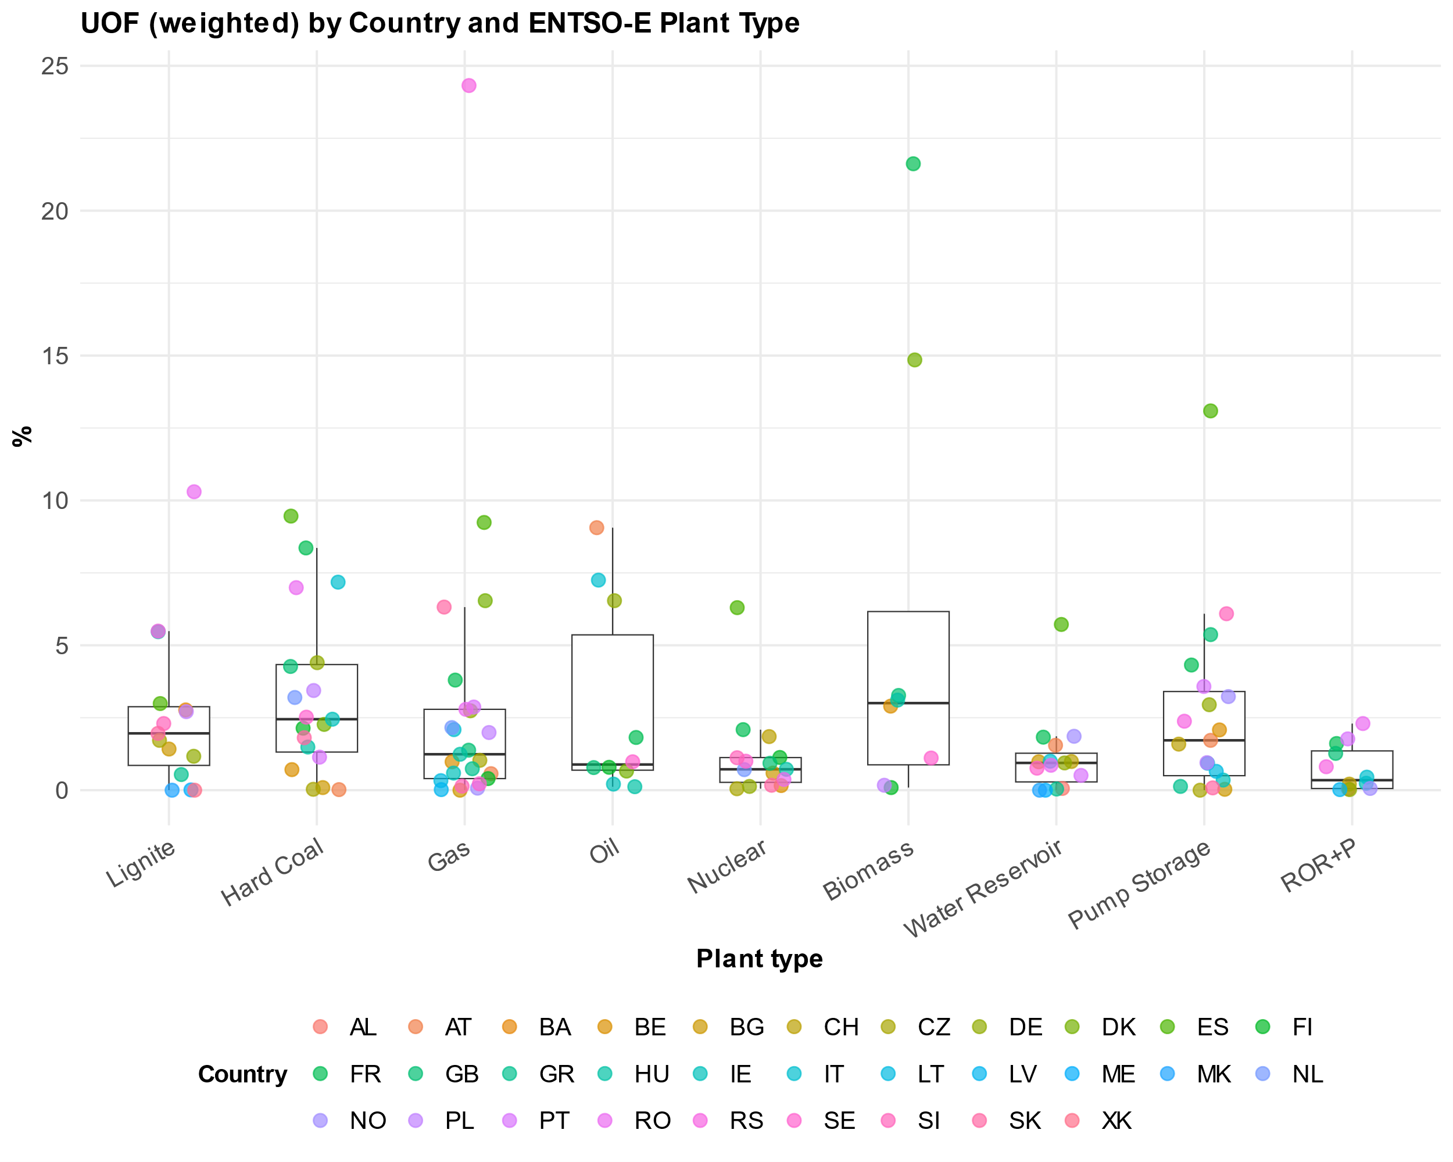
Figure 6: Distribution of weighted unplanned outage factors for plant types and countries of the data set

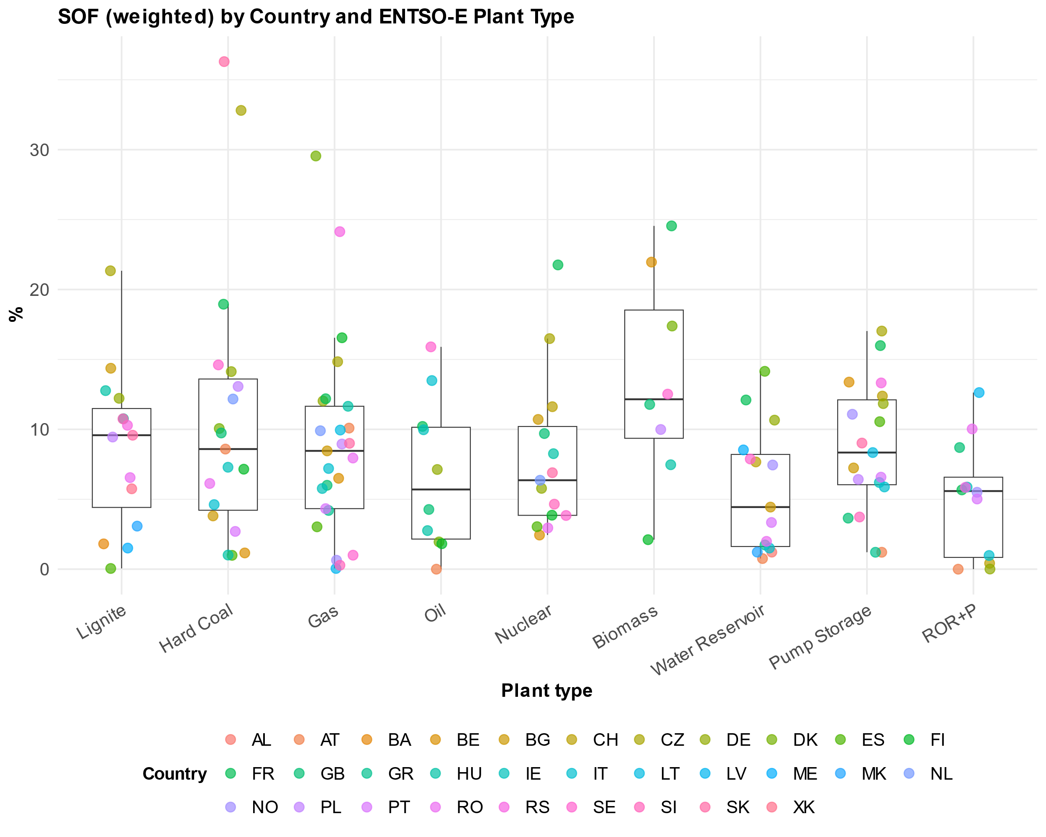
Figure 7: Distribution of weighted scheduled outage factors for plant types and countries of the data set
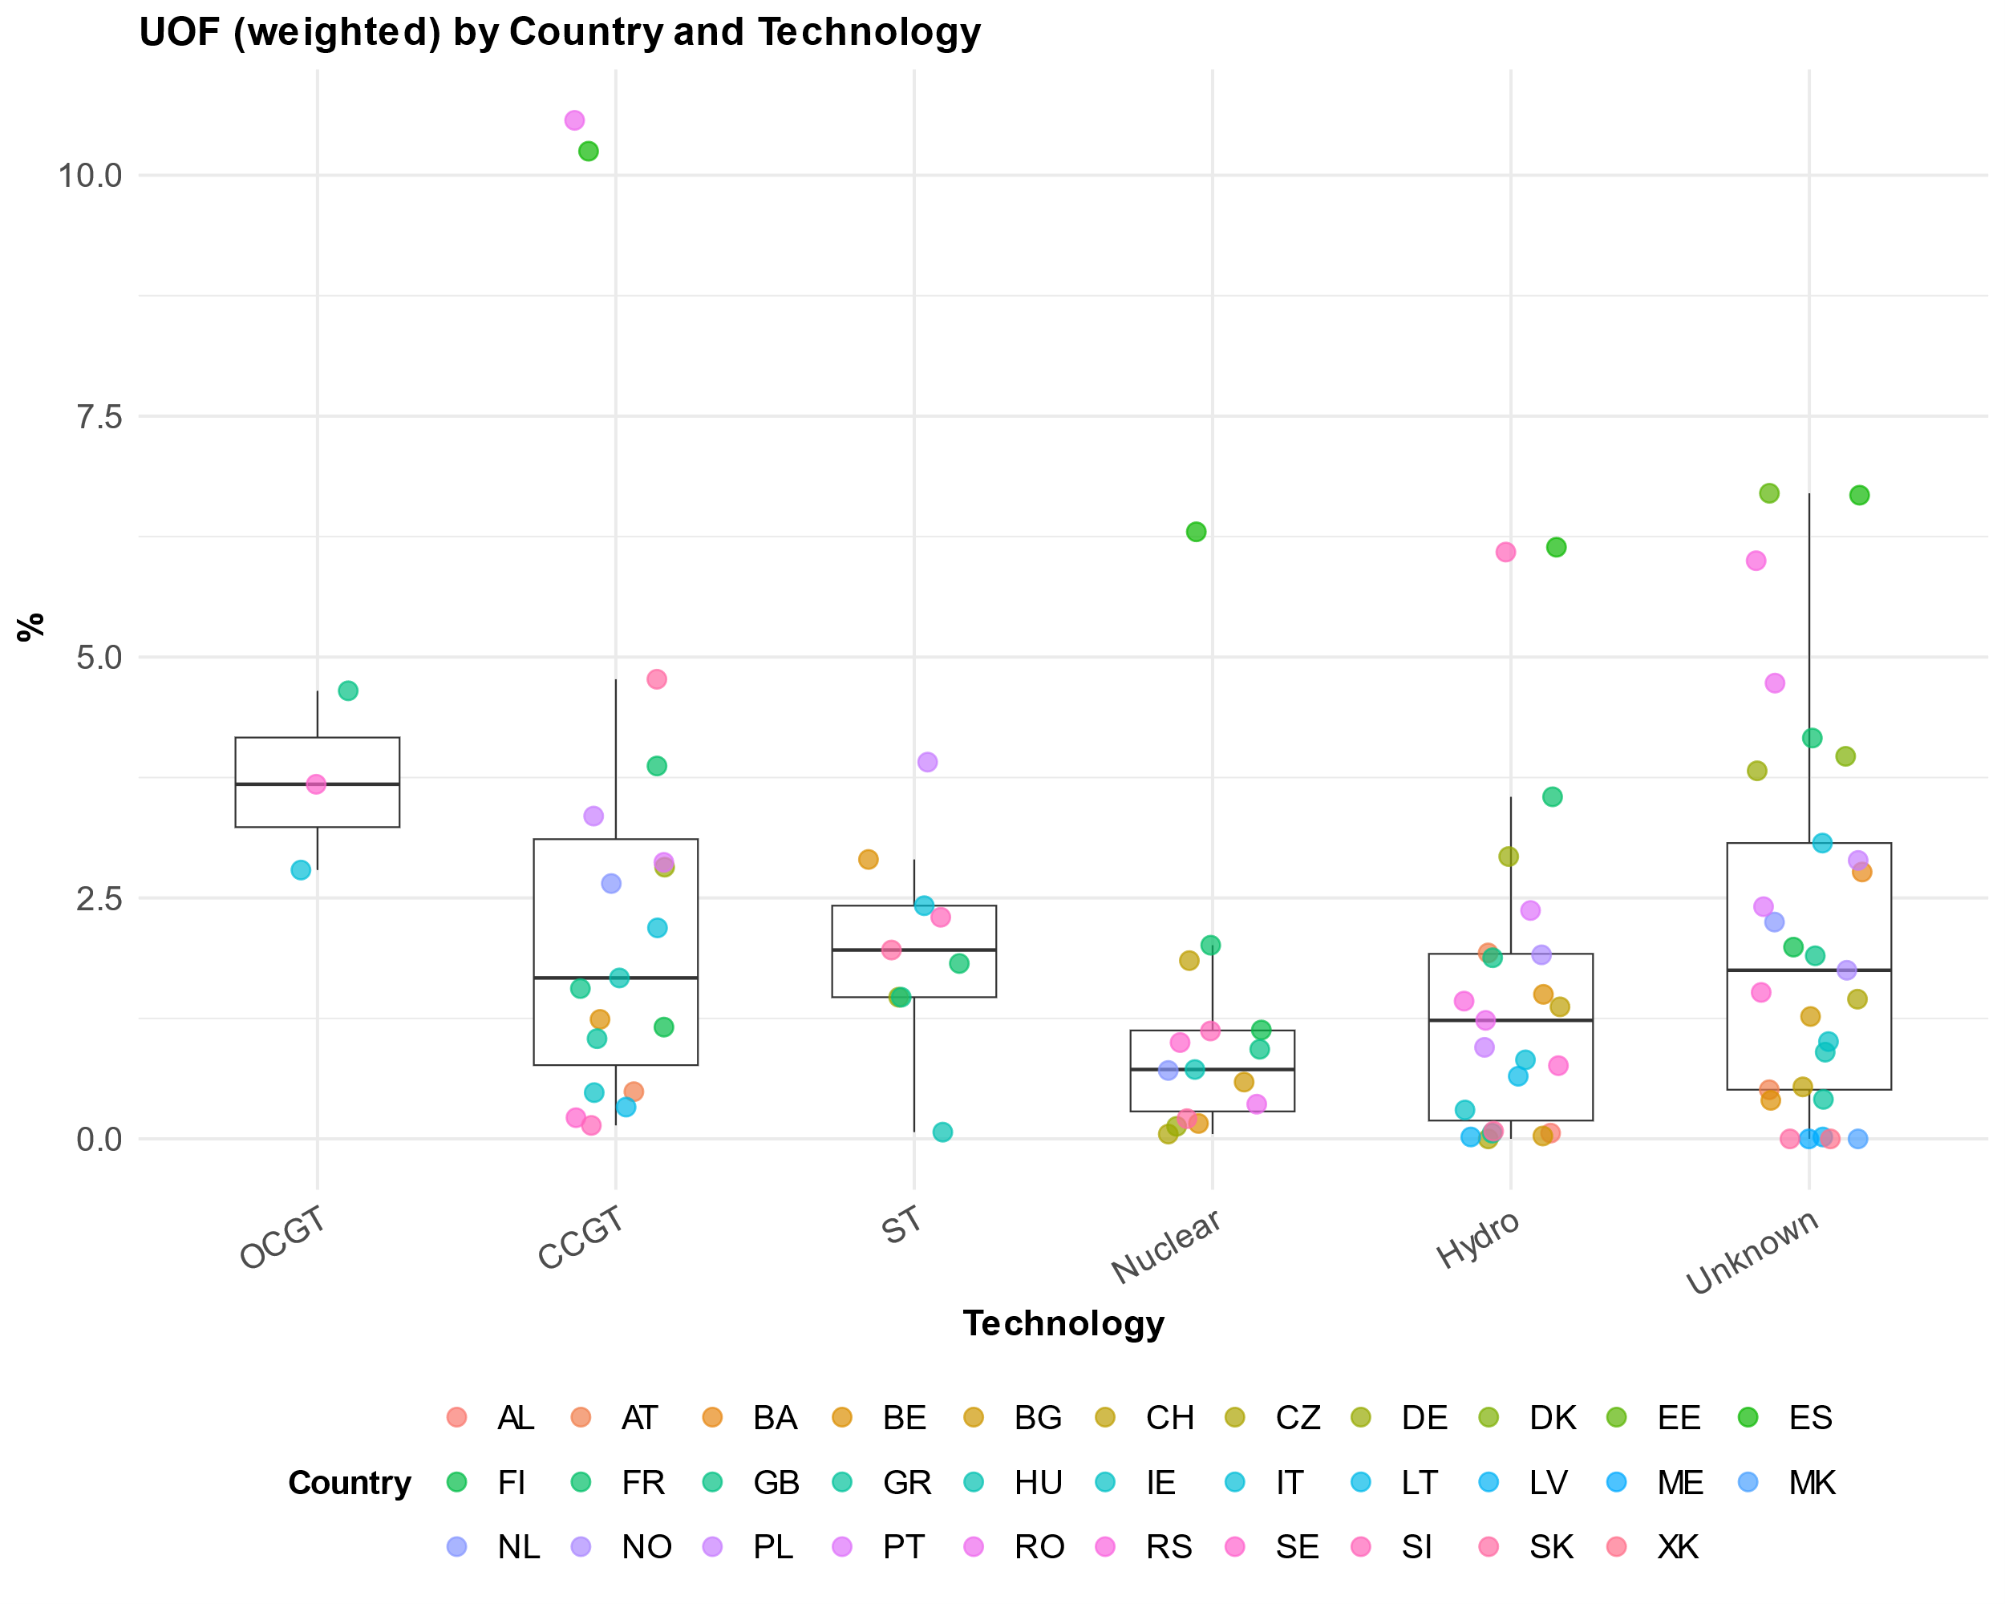
Figure 8: Distribution of weighted unplanned outage factors for plant technologies and countries of the data set
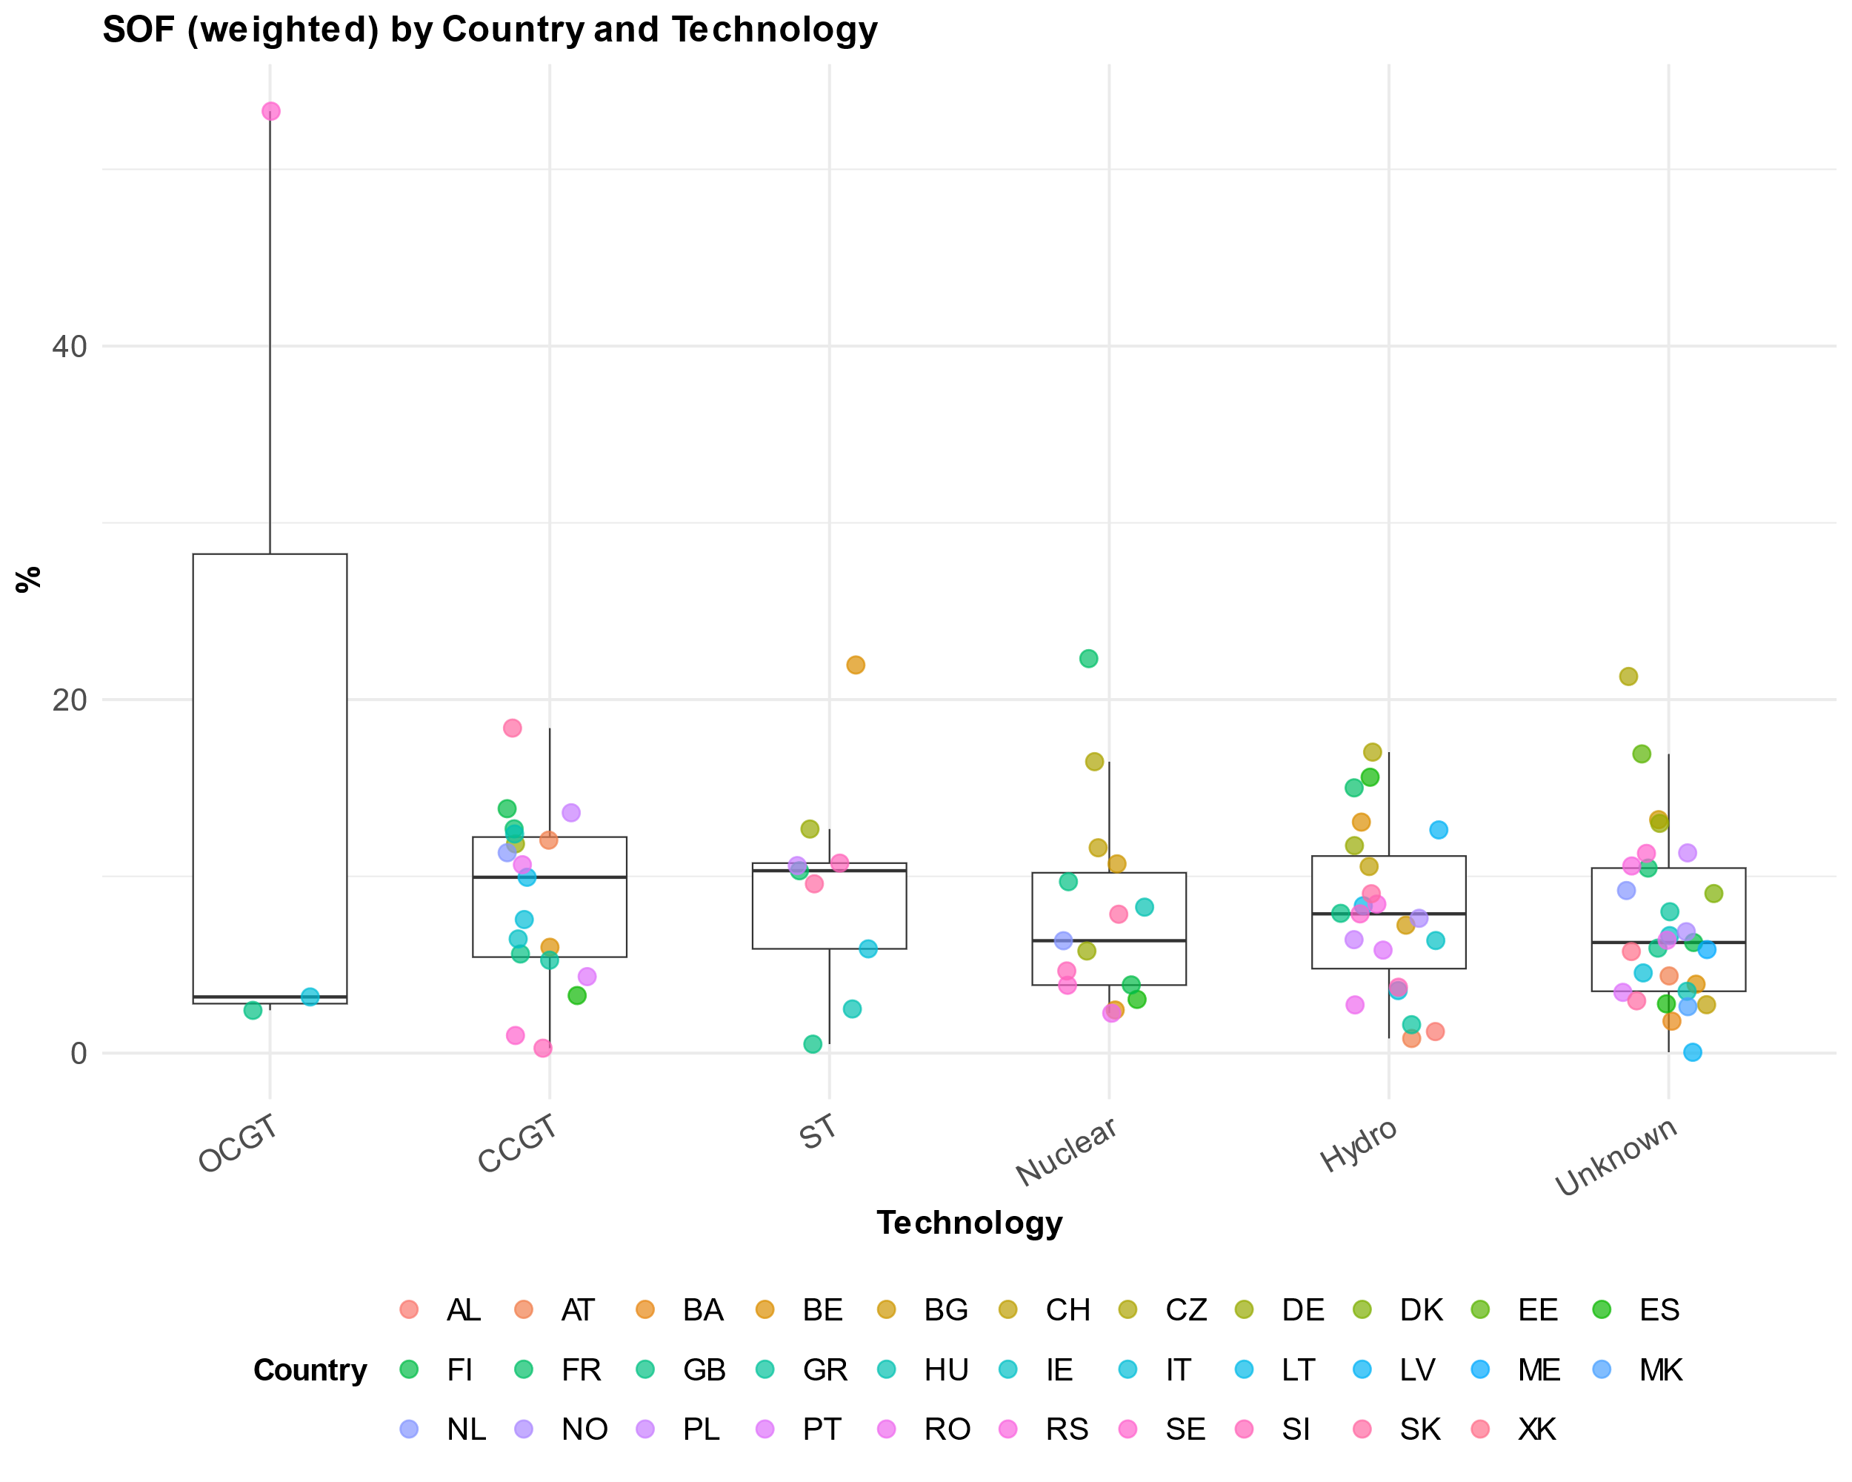
Figure 9: Distribution of weighted scheduled outage factors for plant technologies and countries of the data set
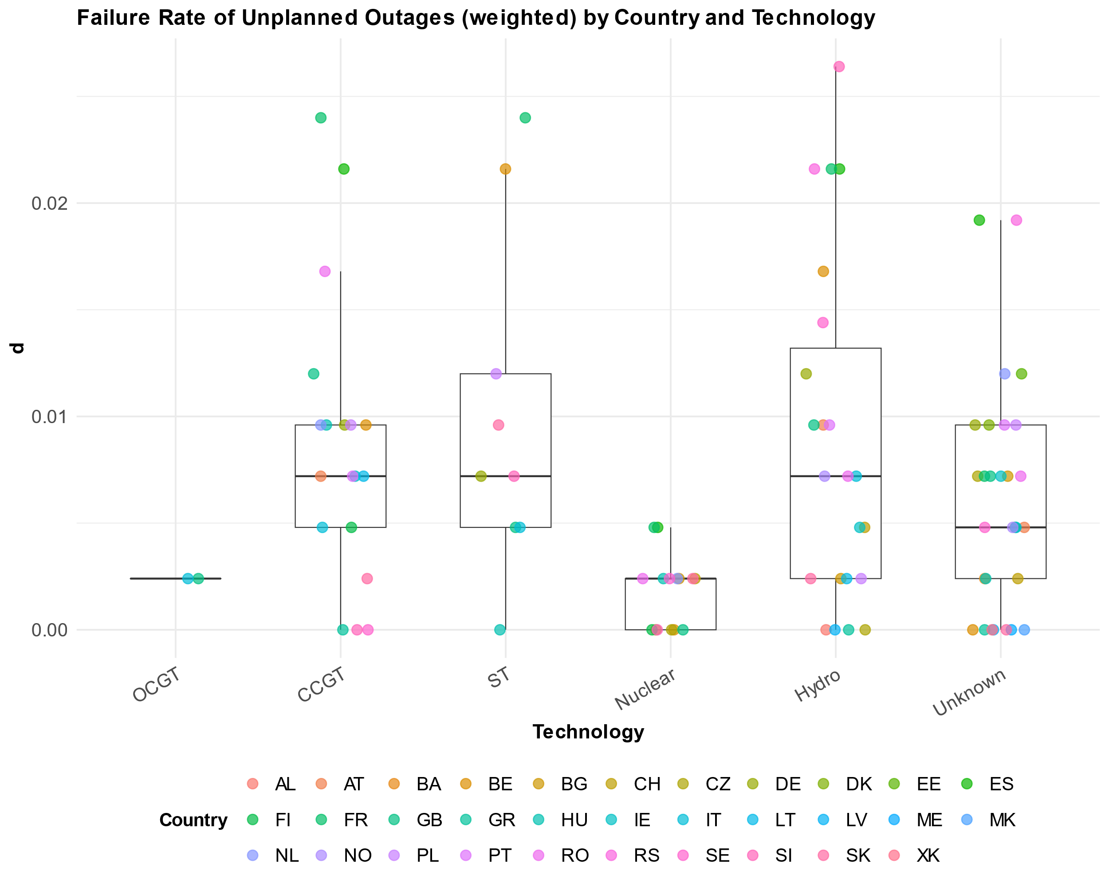
Figure 10: Distribution of weighted failure rates by unplanned outages for plant technologies and countries of the data set

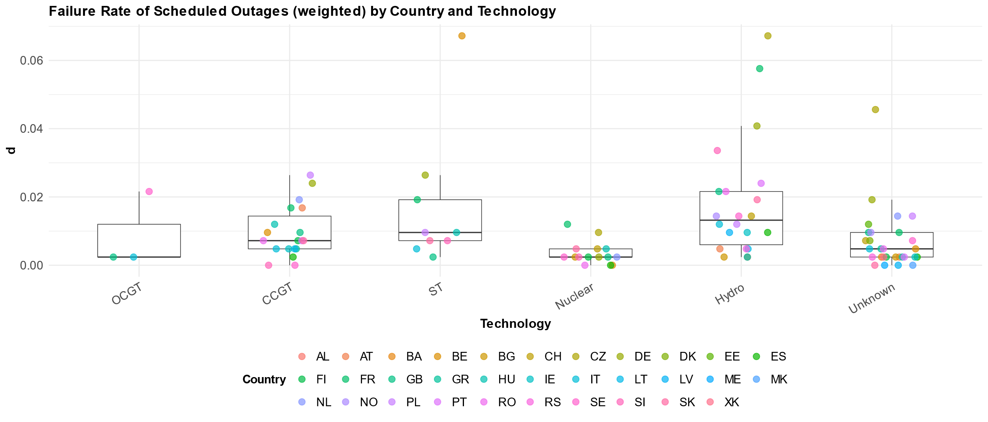
Figure 11: Distribution of weighted failure rates by scheduled outages for plant technologies and countries of the data set

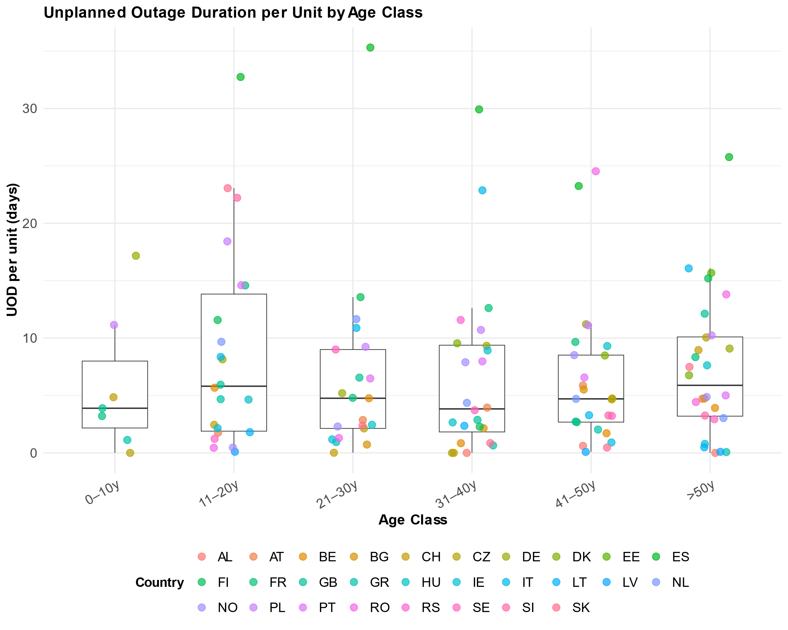
Figure 12: Distribution of duration for unplanned outages for age classes and countries of the data set

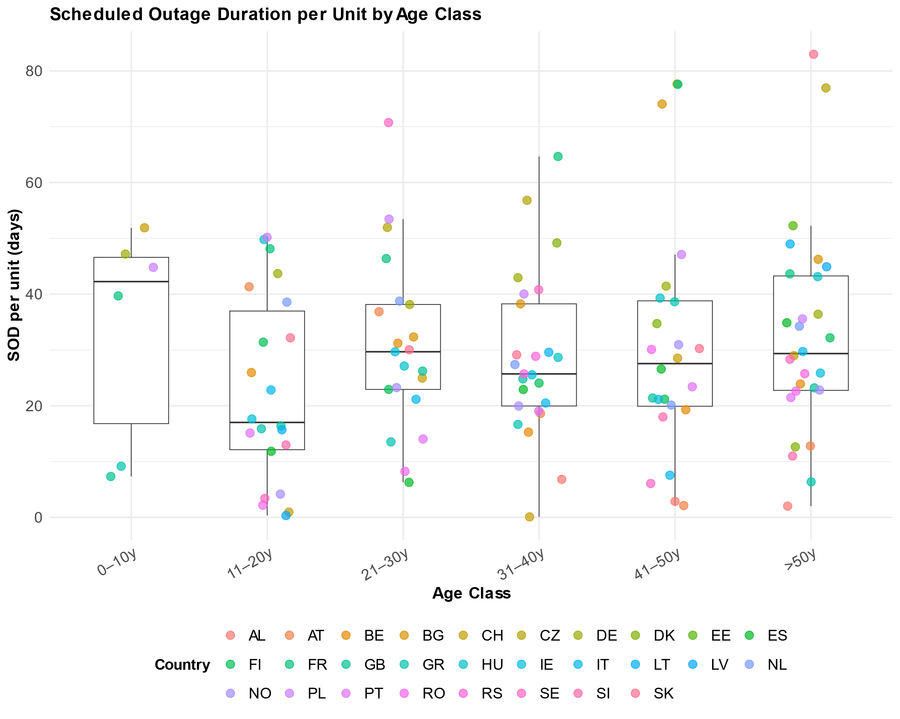
Figure 13: Distribution of duration for scheduled outages for age classes and countries of the data set

Validation of performance measures

Other studies

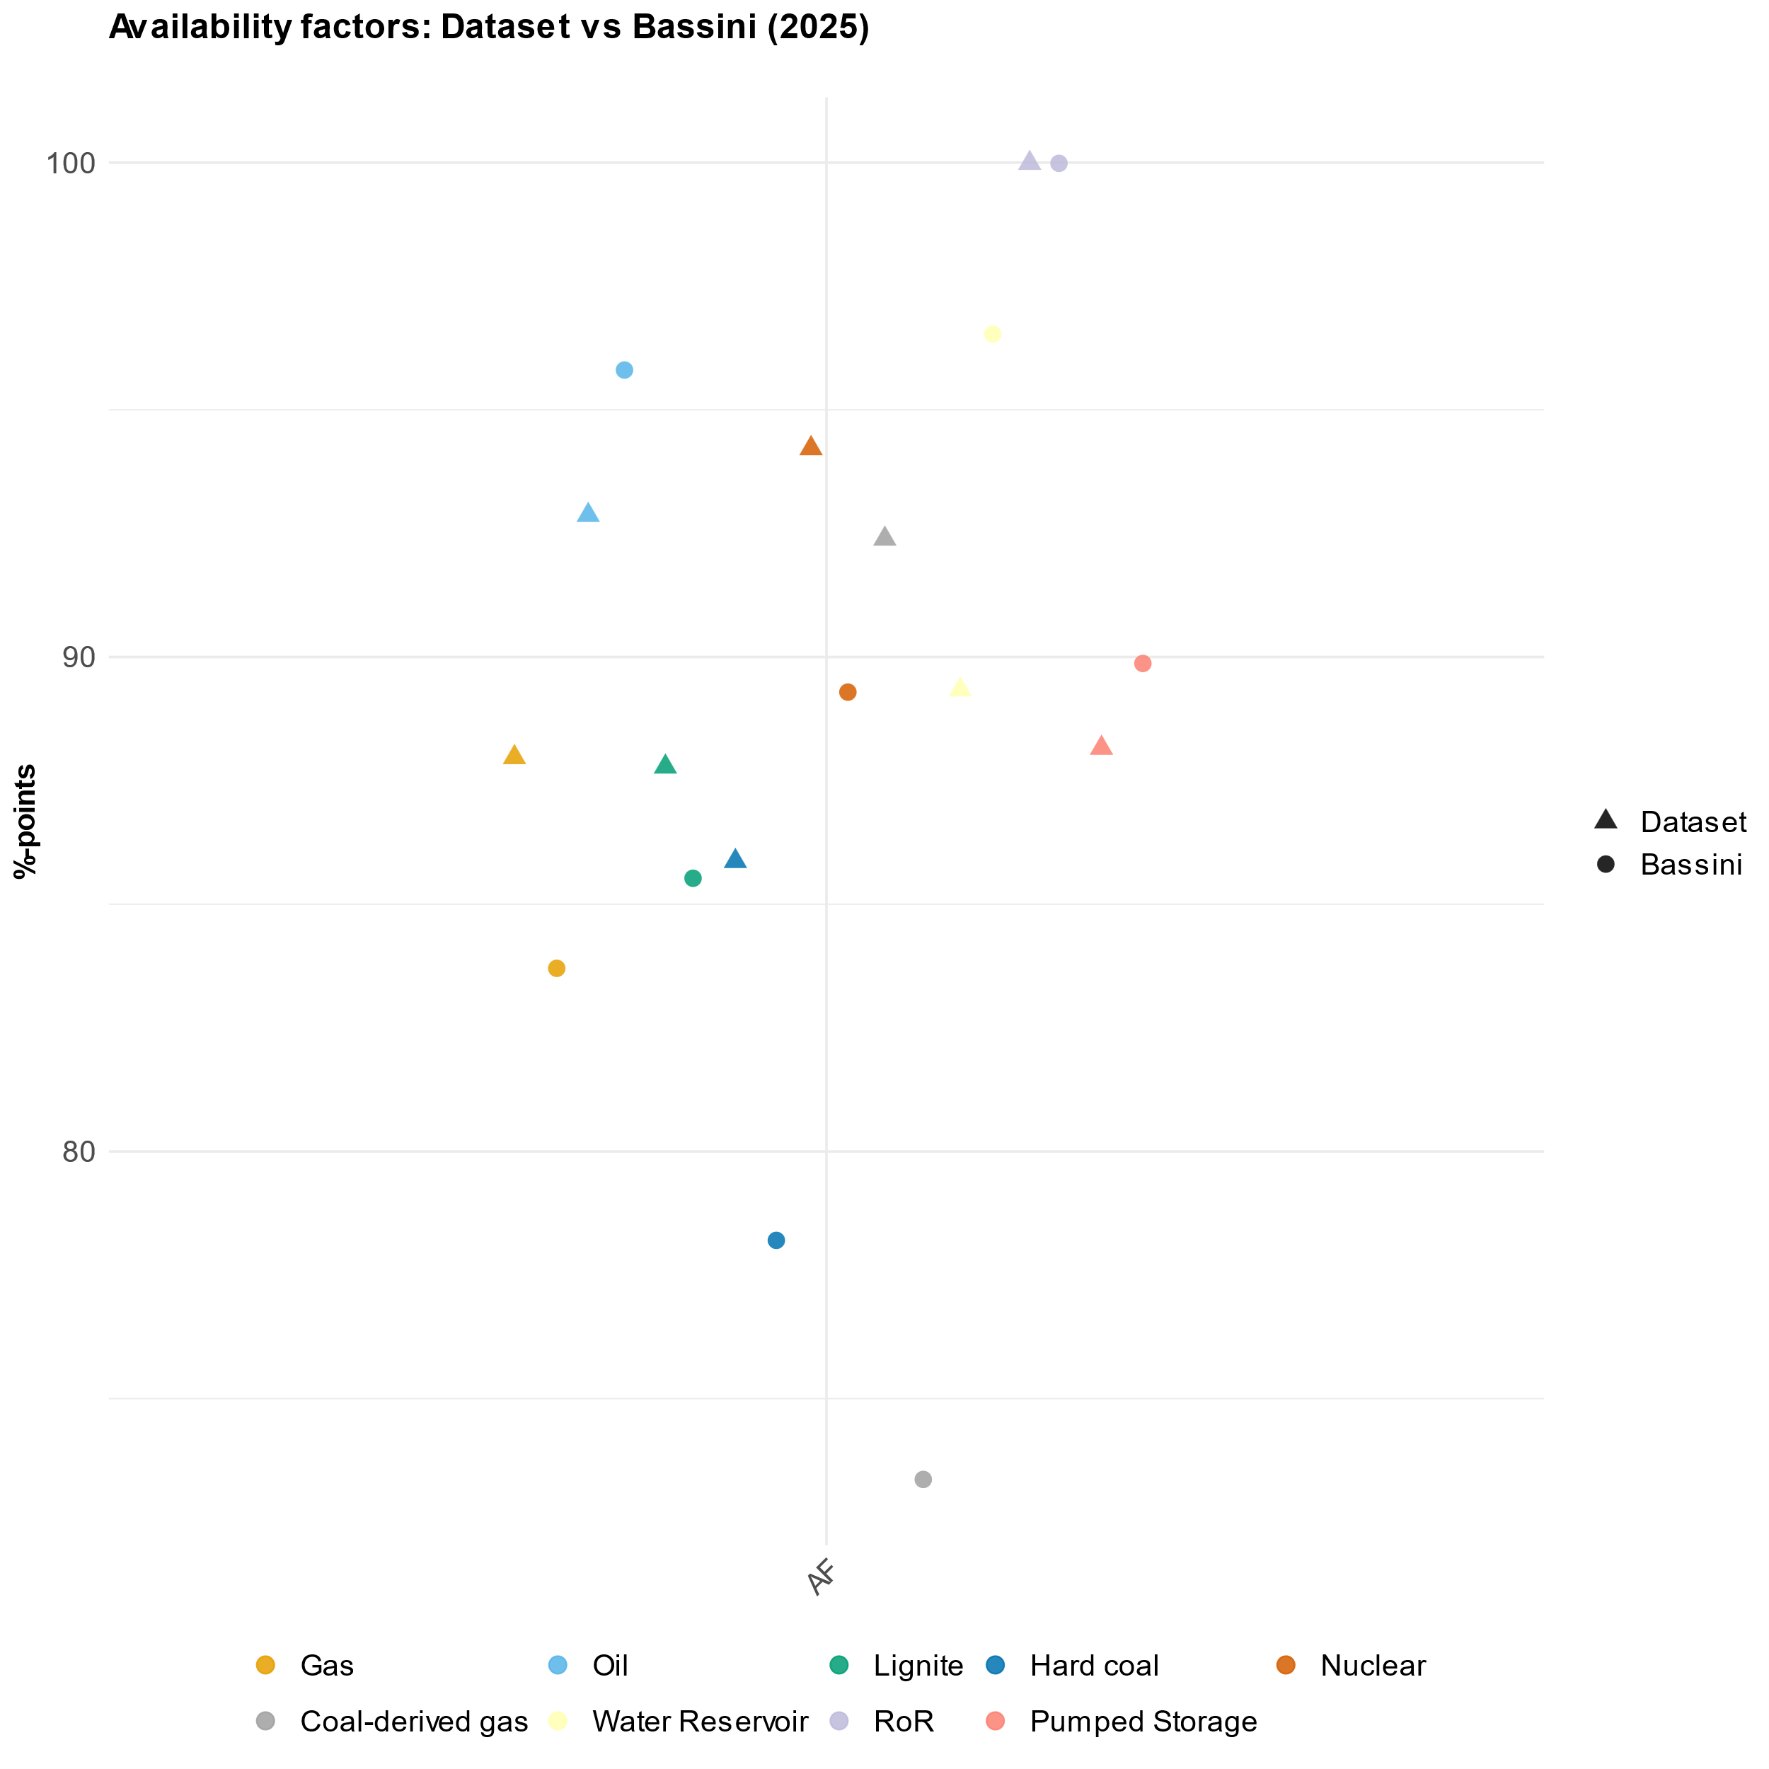
Figure 14: Comparison of aggregated availability factors for German plant types from Bassini 2025.

Historical generation

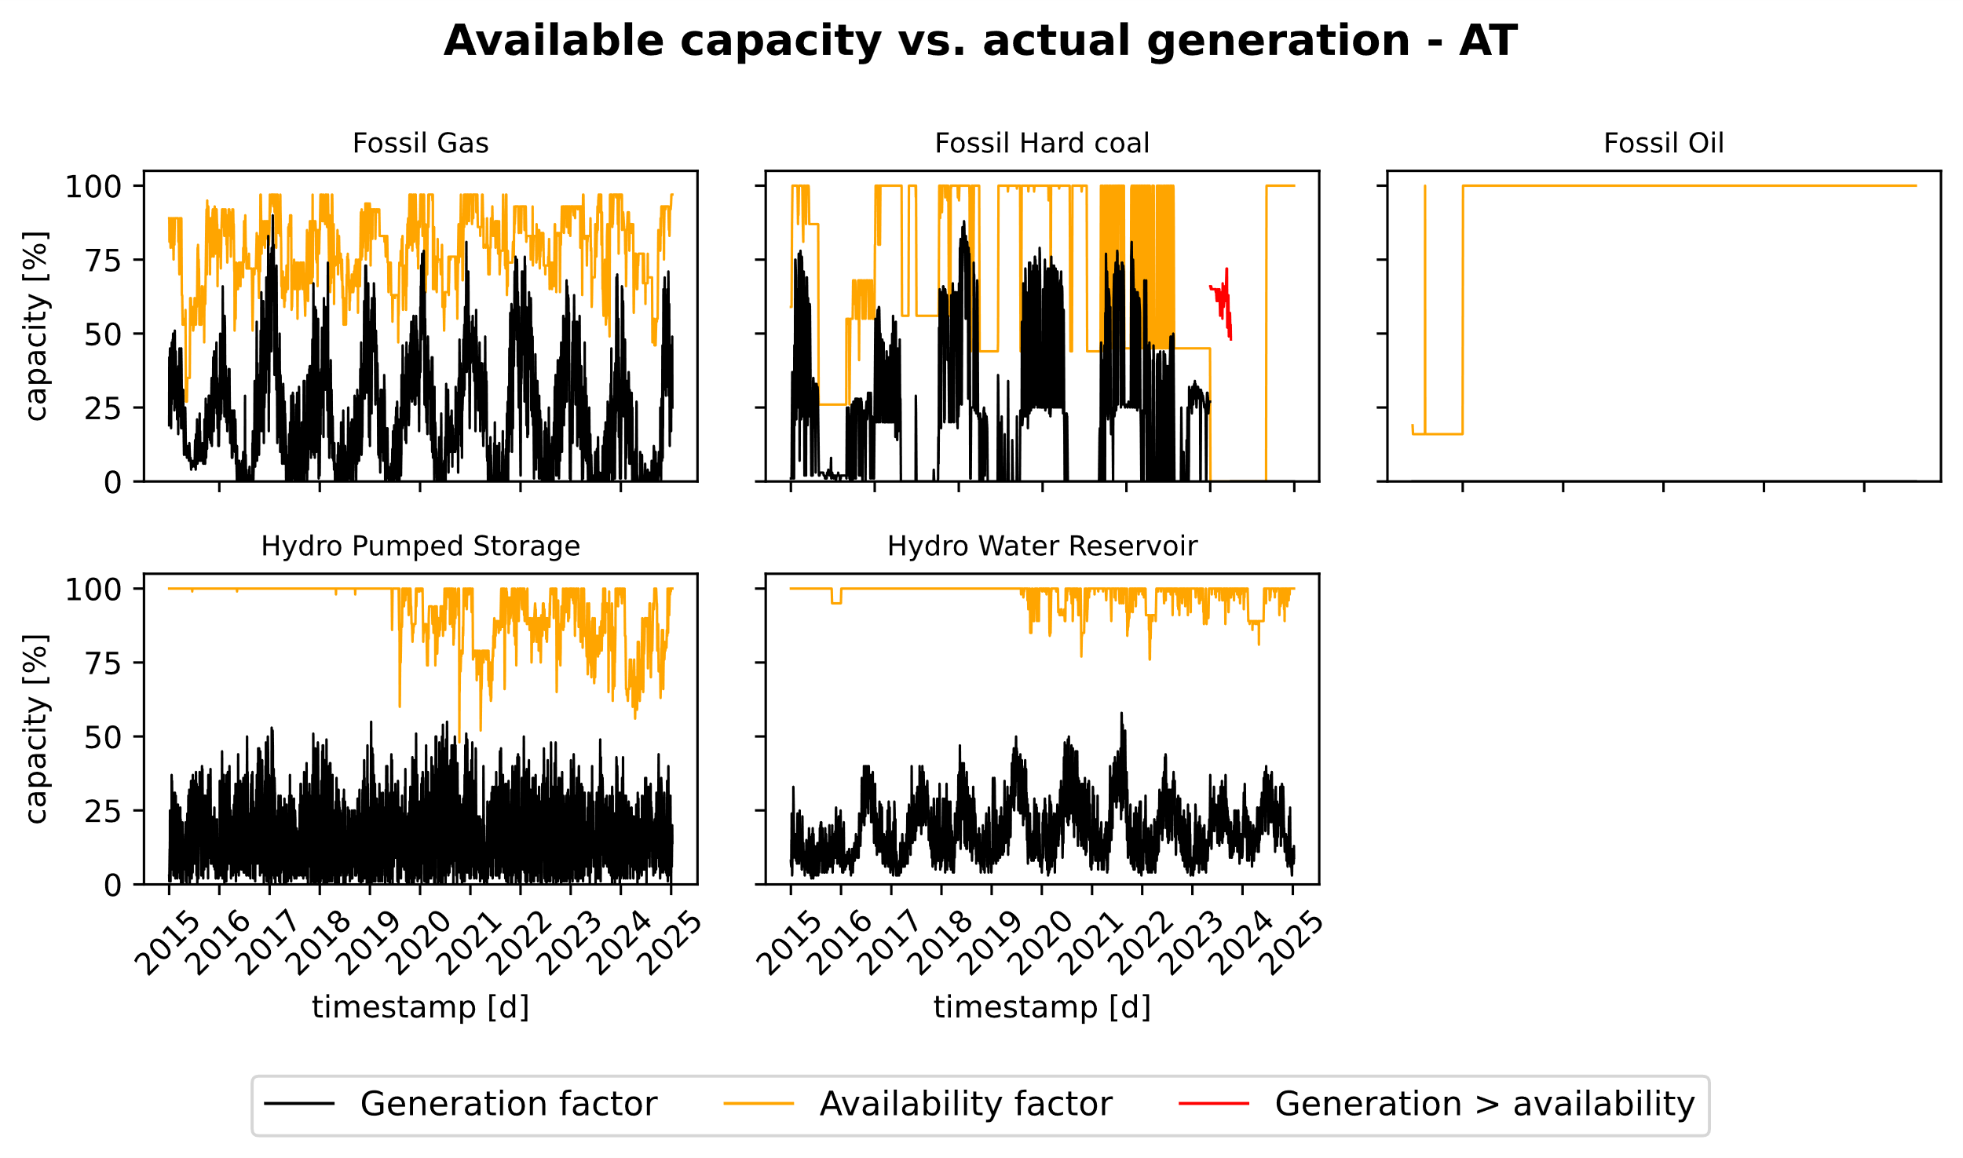
Figure 15: Comparison of aggregated available capacity vs daily generation for Austria

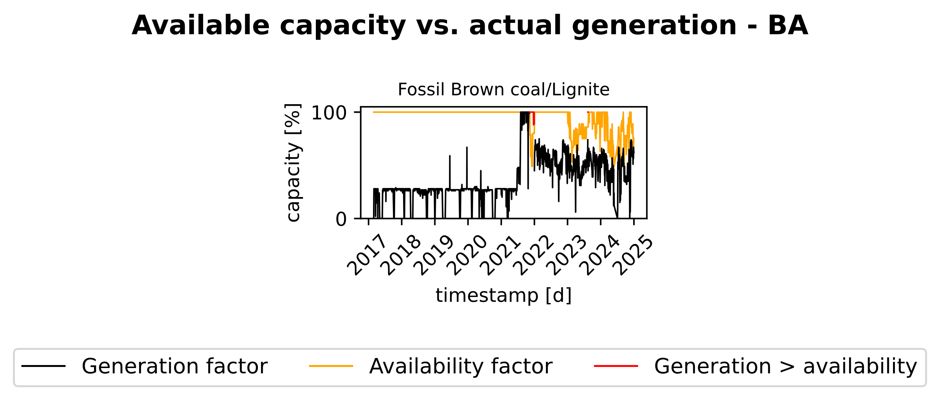
Figure 16: Comparison of aggregated available capacity vs daily generation for Bosnia-Herzegovina

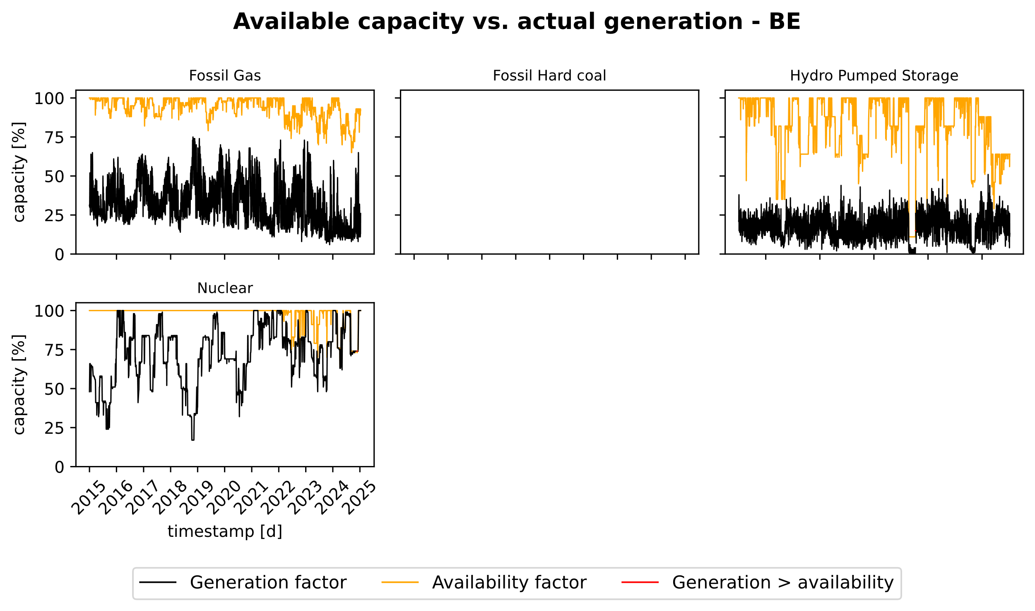
Figure 17: Comparison of aggregated available capacity vs daily generation for Belgium

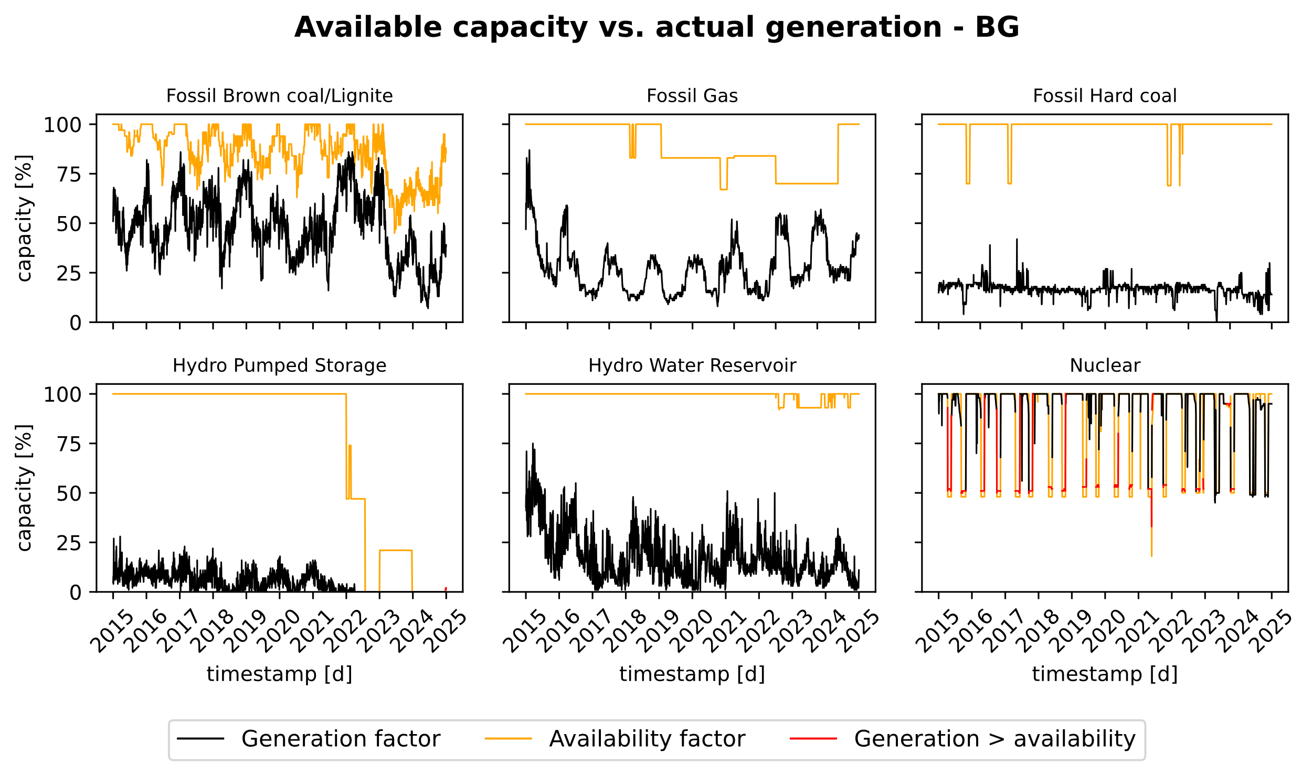
Figure 18: Comparison of aggregated available capacity vs daily generation for Bulgaria

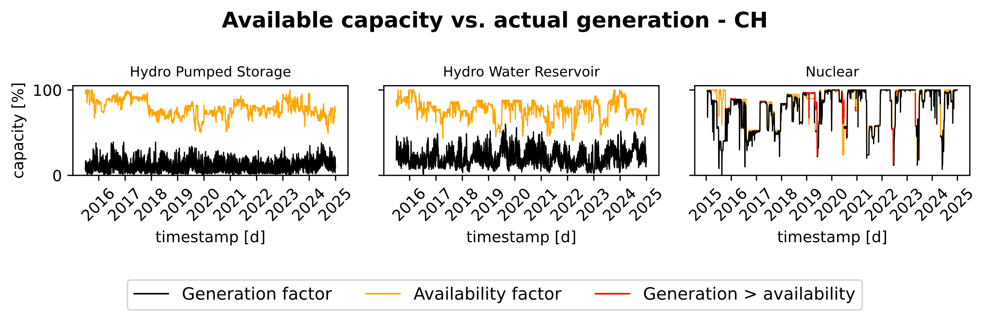
Figure 19: Comparison of aggregated available capacity vs daily generation for Switzerland

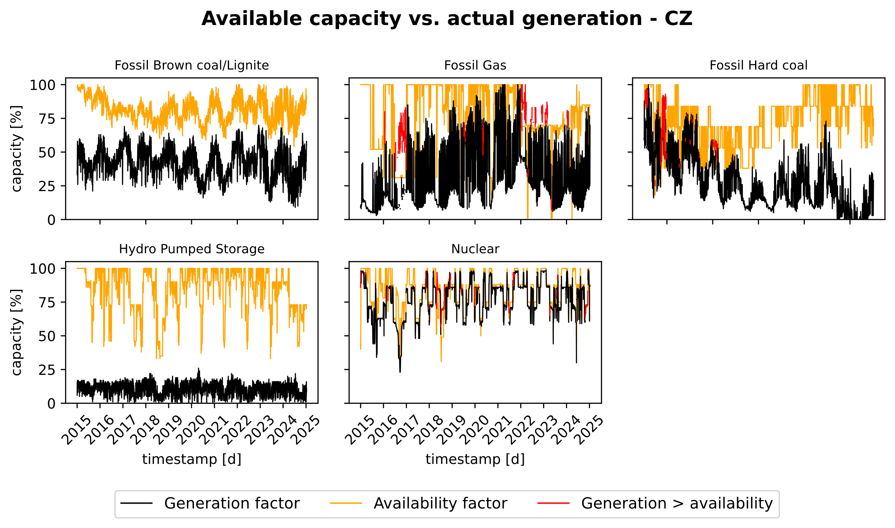
Figure 20: Comparison of aggregated available capacity vs daily generation for Czech Republic

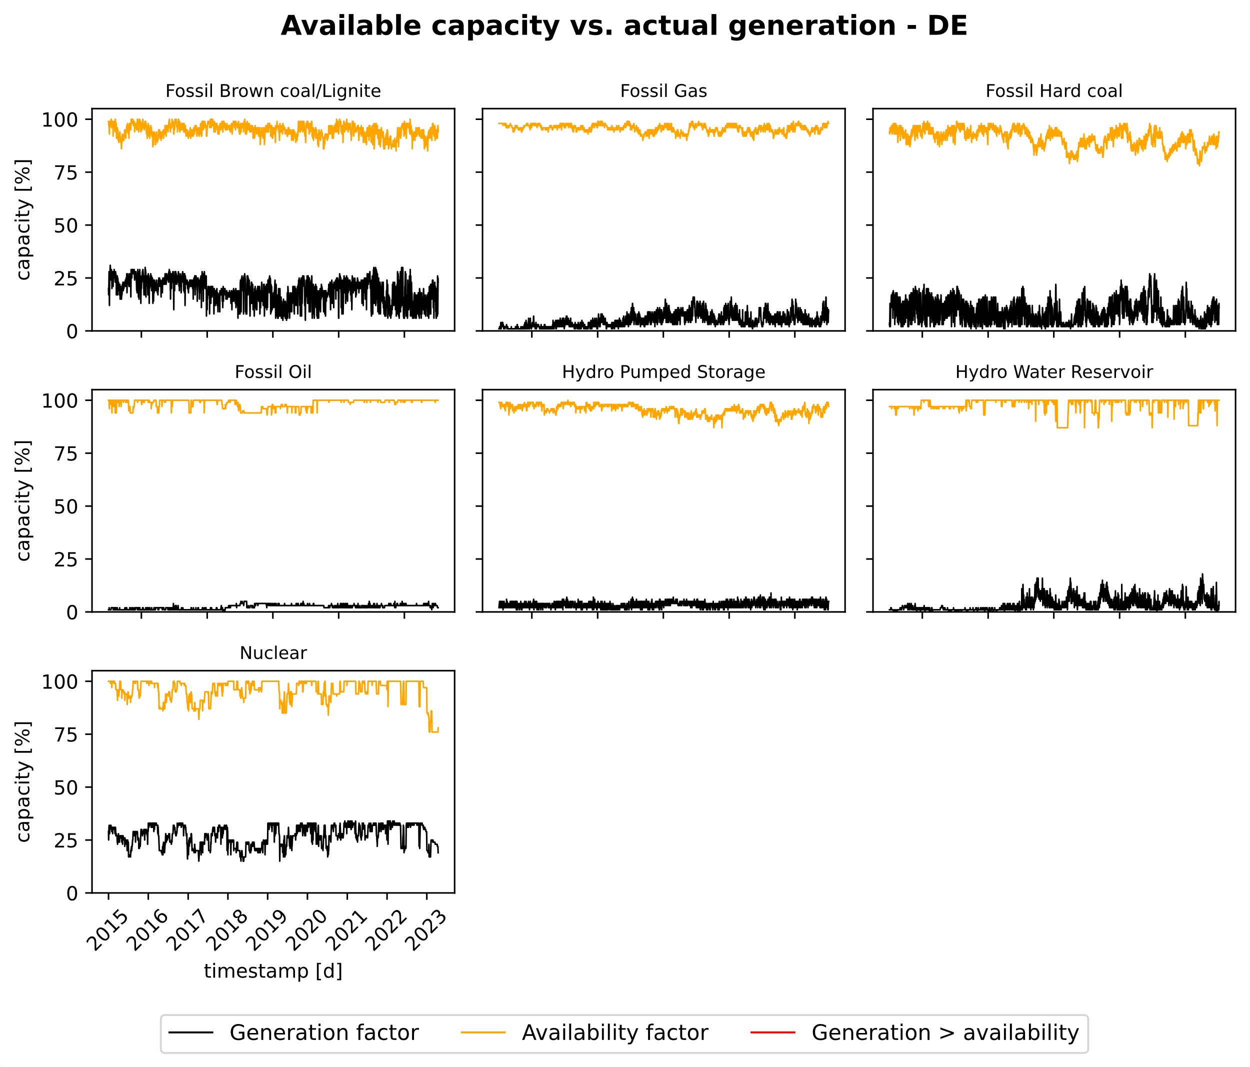
Figure 21: Comparison of aggregated available capacity vs daily generation for Germany

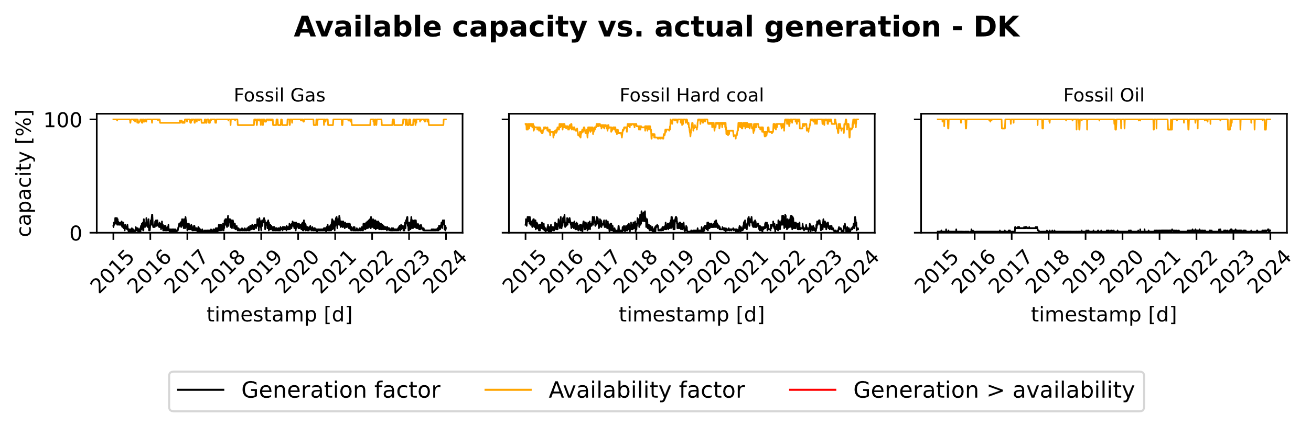
Figure 22: Comparison of aggregated available capacity vs daily generation for Denmark

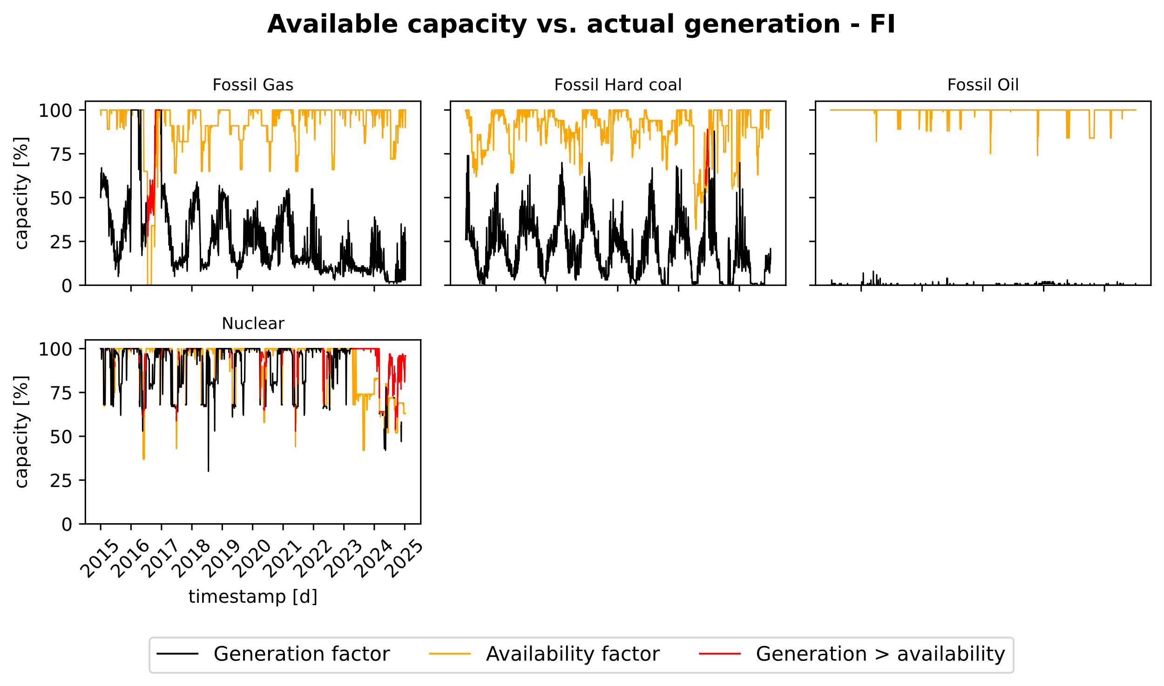
Figure 23: Comparison of aggregated available capacity vs daily generation for Finland

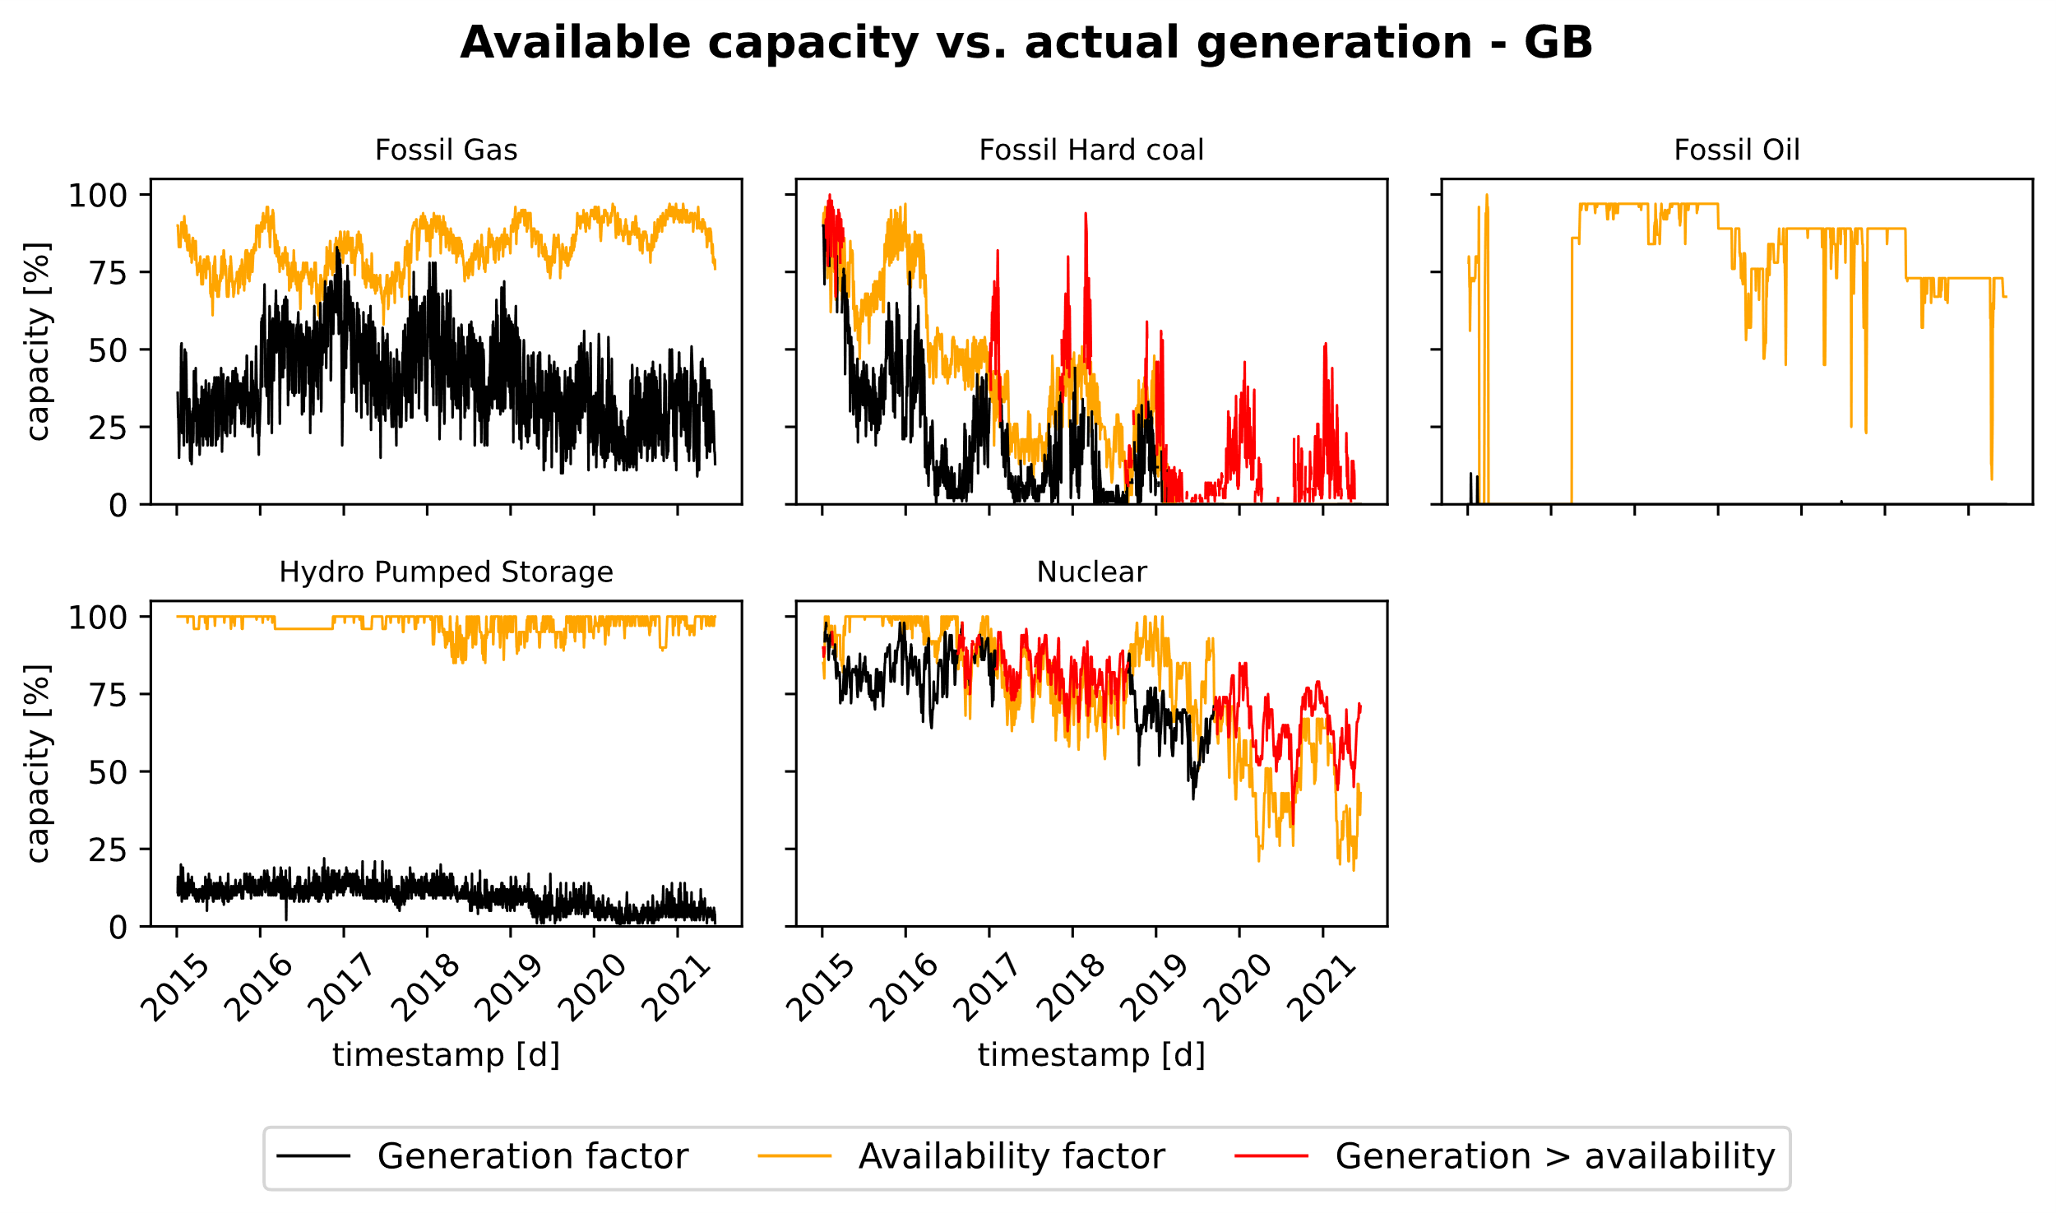
Figure 24: Comparison of aggregated available capacity vs daily generation for Great Britain

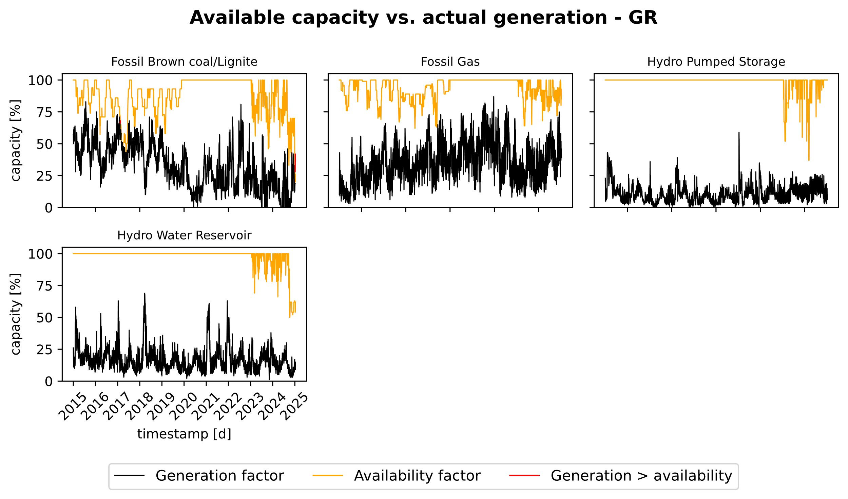
Figure 25: Comparison of aggregated available capacity vs daily generation for Greece

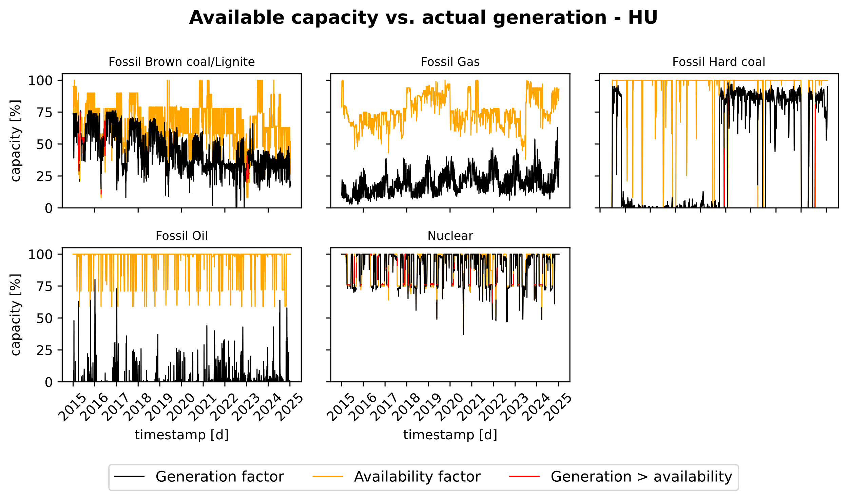
Figure 26: Comparison of aggregated available capacity vs daily generation for Hungary

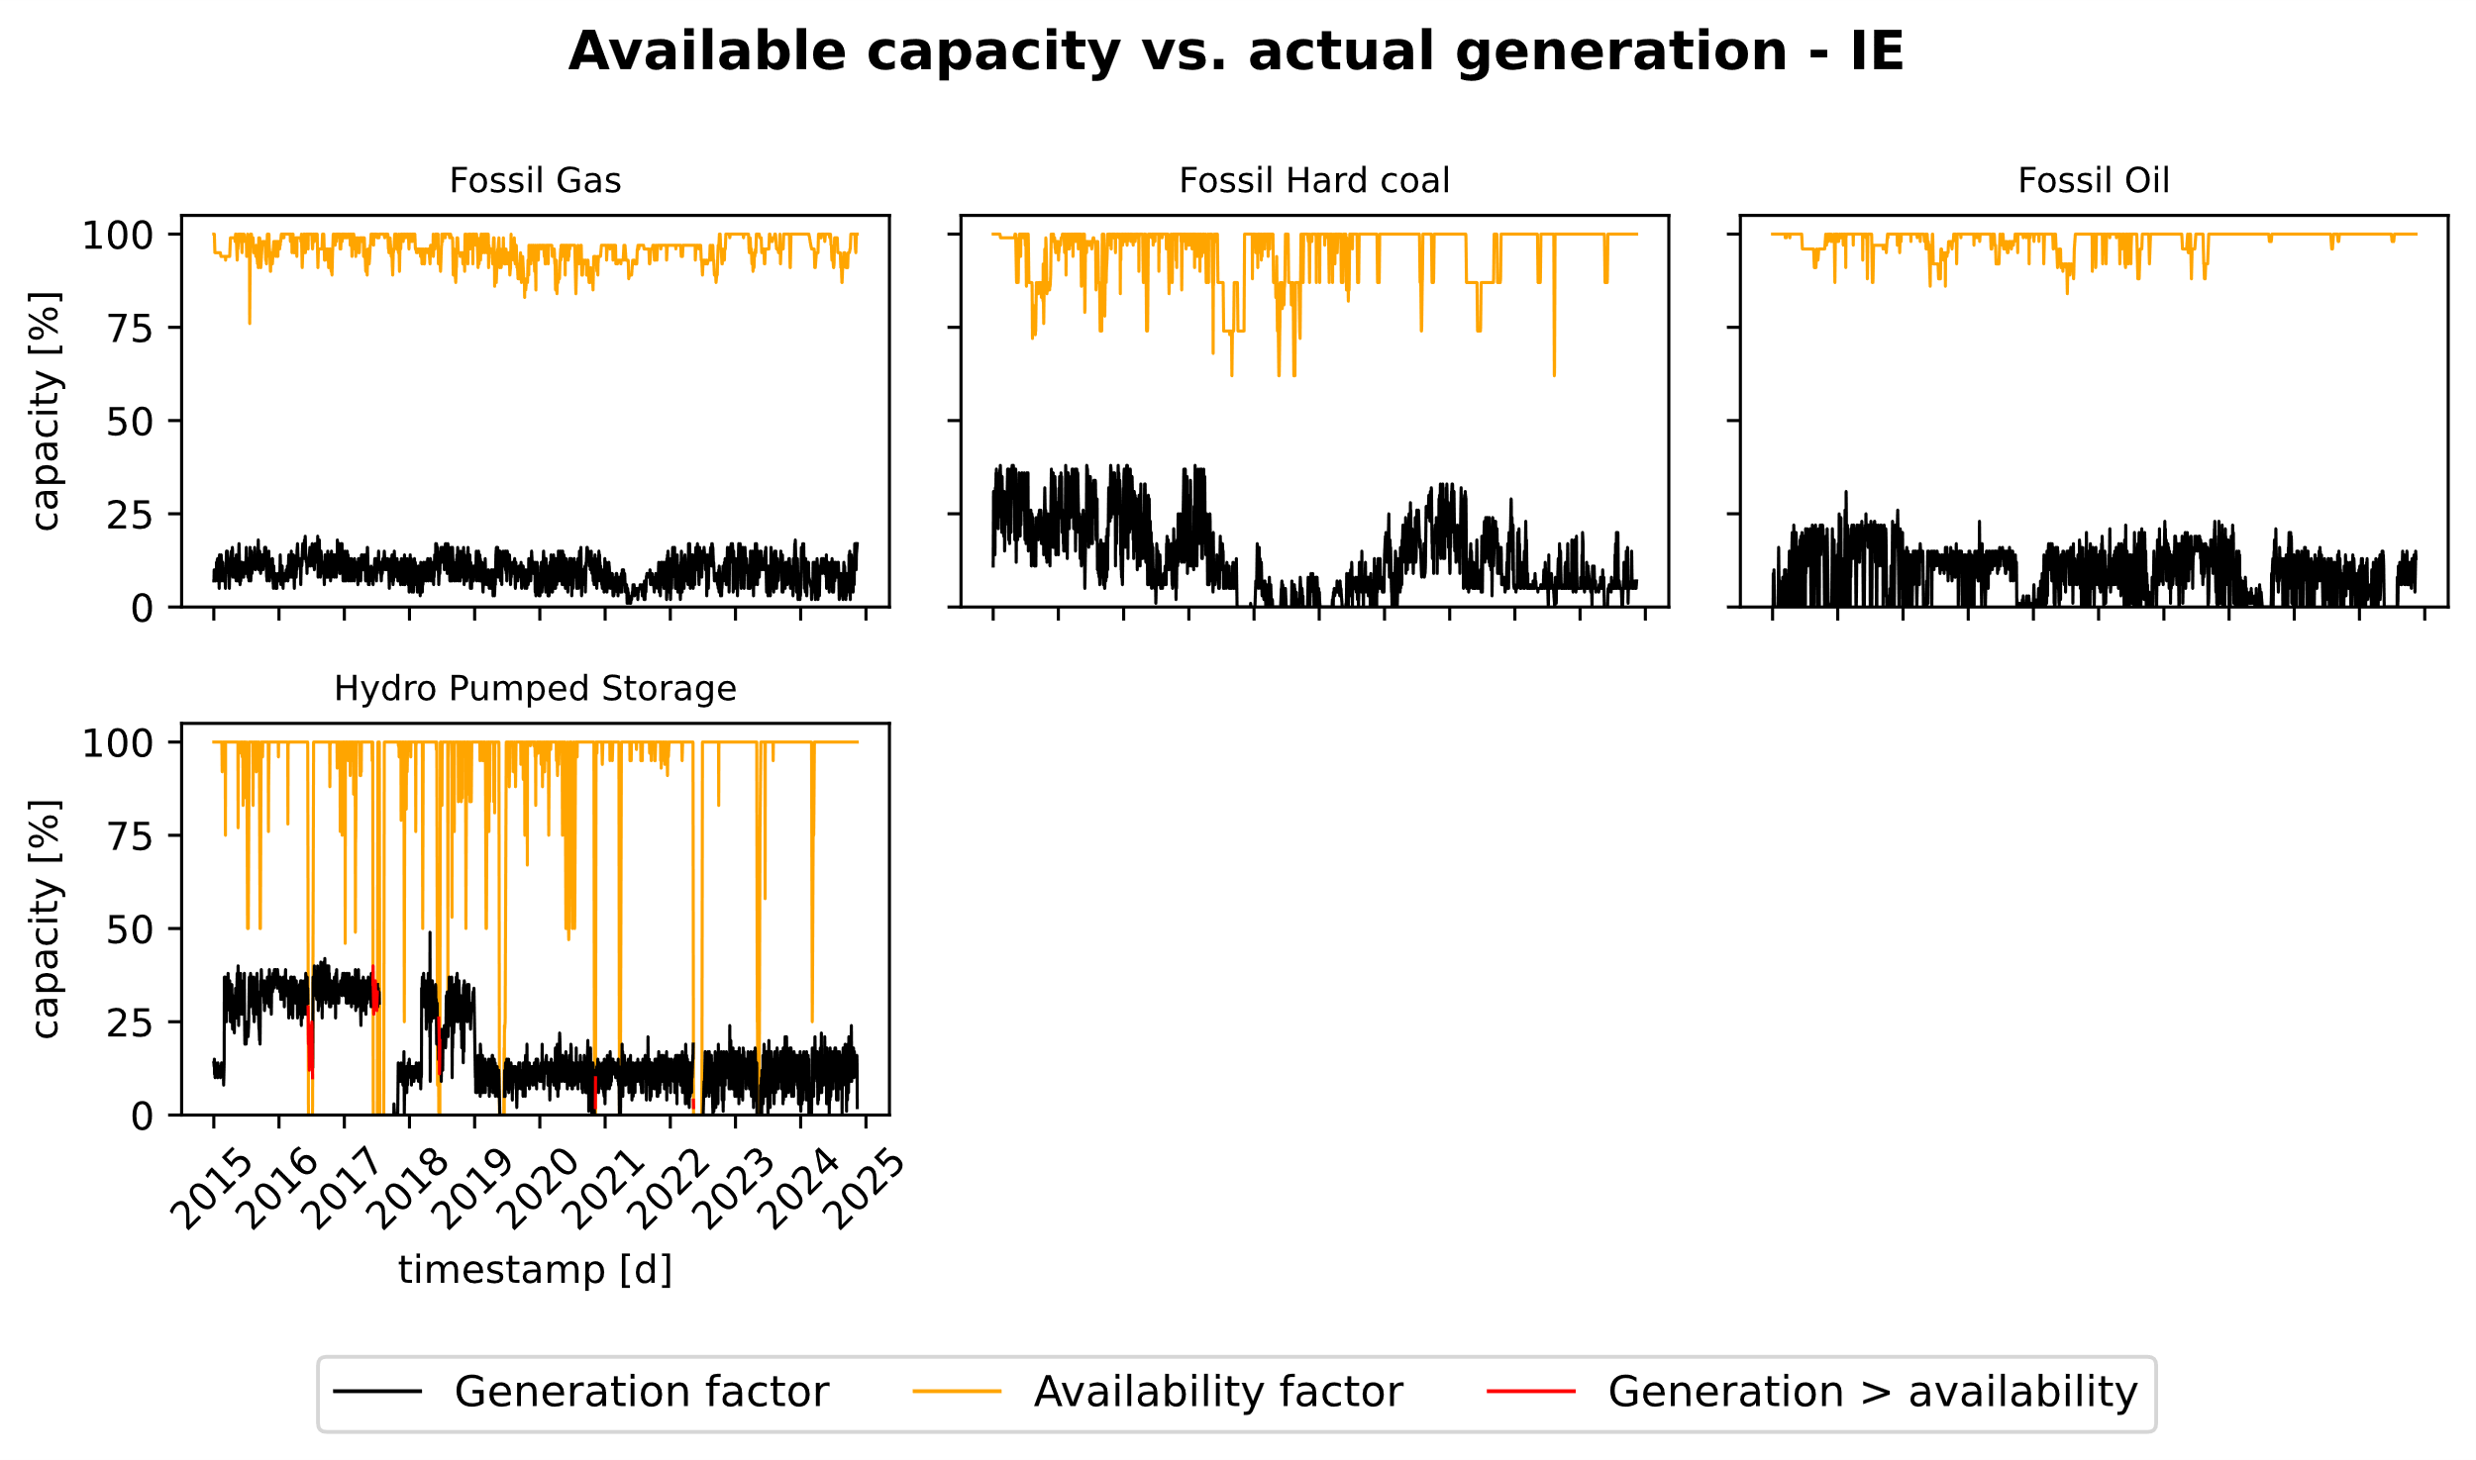
Figure 27: Comparison of aggregated available capacity vs daily generation for Ireland

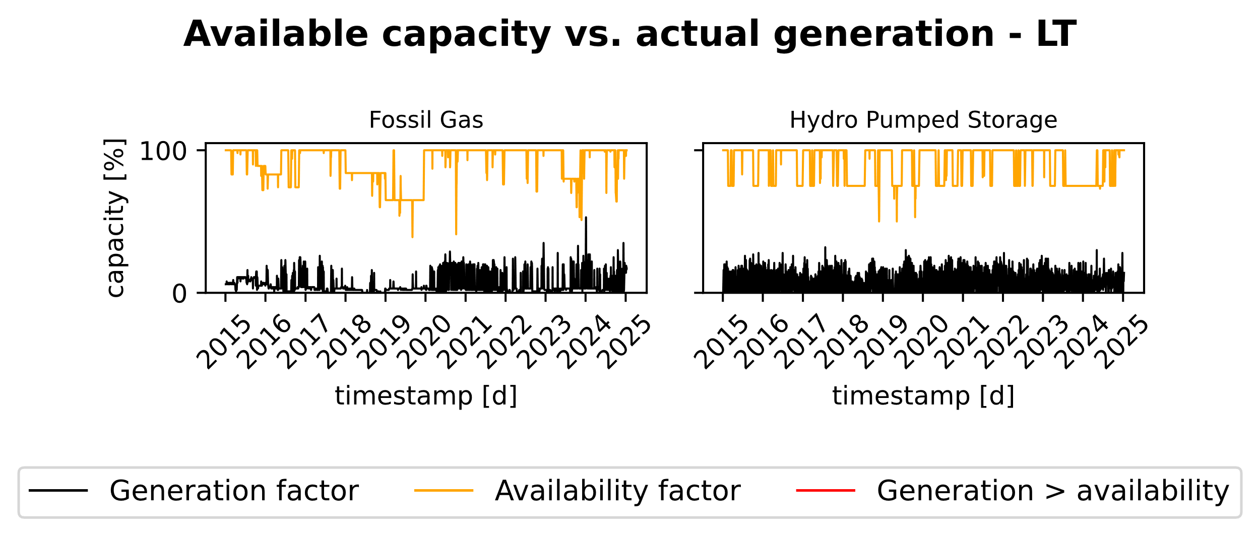
Figure 28: Comparison of aggregated available capacity vs daily generation for Lithuania

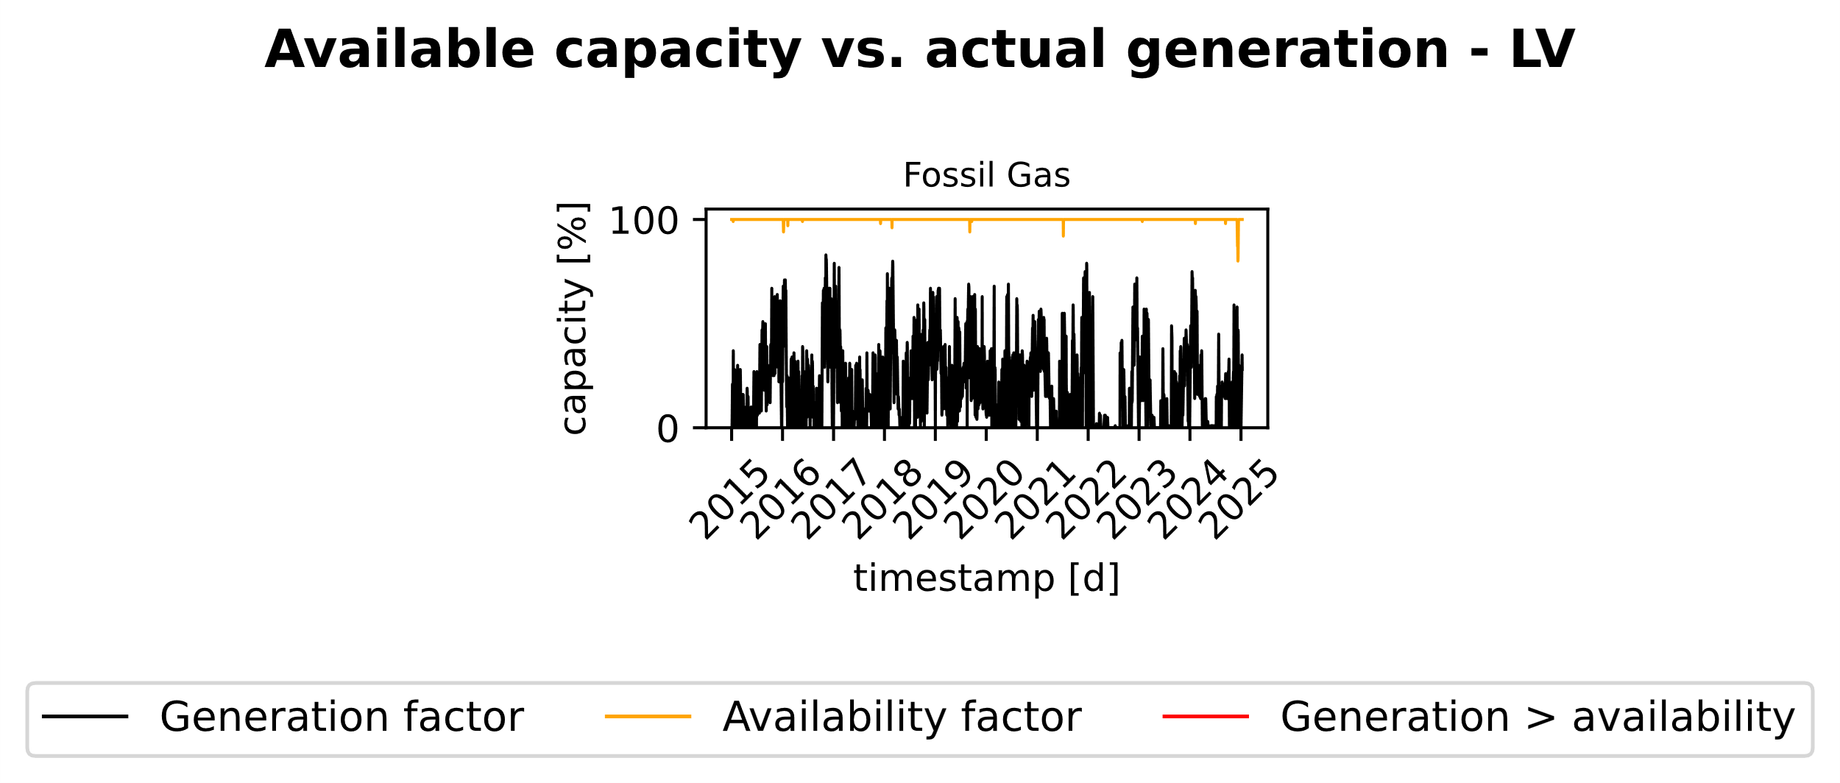
Figure 29: Comparison of aggregated available capacity vs daily generation for Latvia

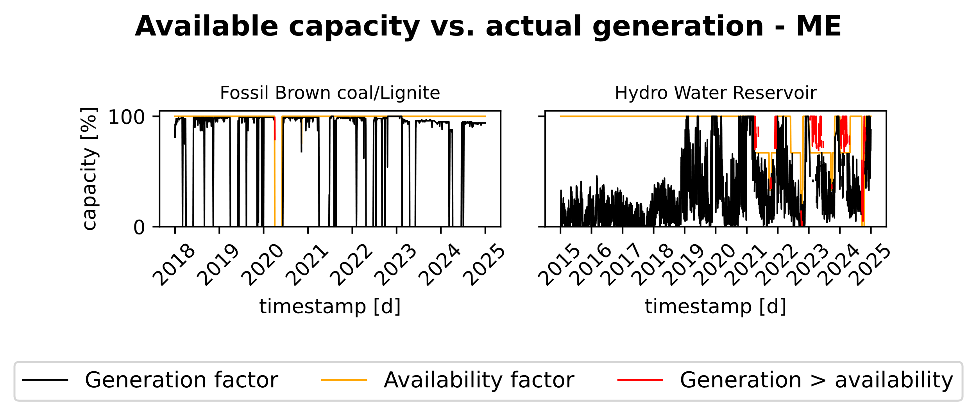
Figure 30: Comparison of aggregated available capacity vs daily generation for Montenegro

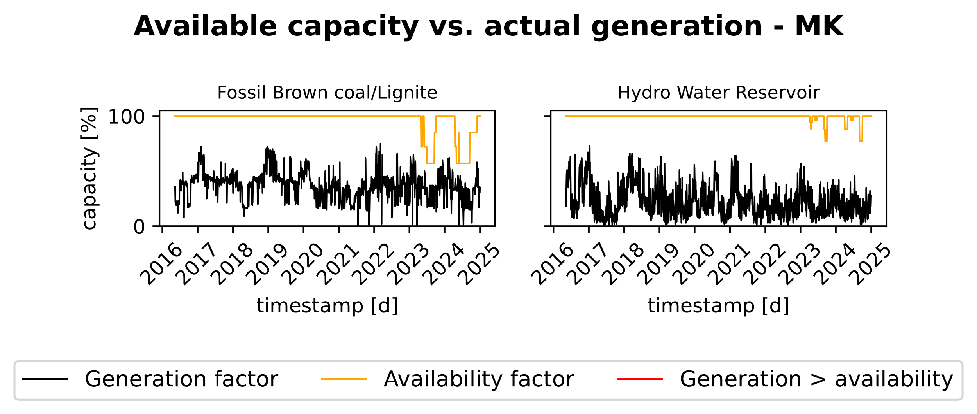
Figure 31: Comparison of aggregated available capacity vs daily generation for North-Macedonia

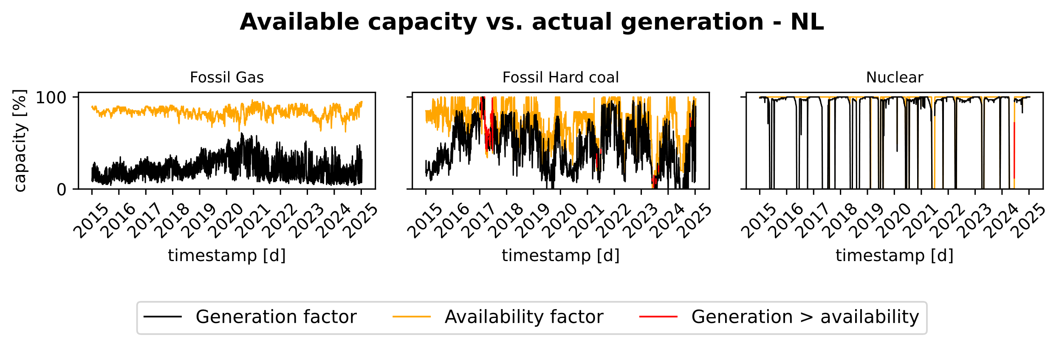
Figure 32: Comparison of aggregated available capacity vs daily generation for The Netherlands

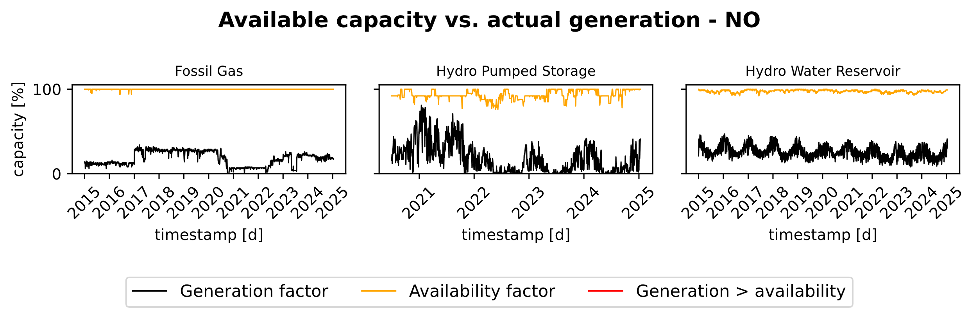
Figure 33: Comparison of aggregated available capacity vs daily generation for Norway

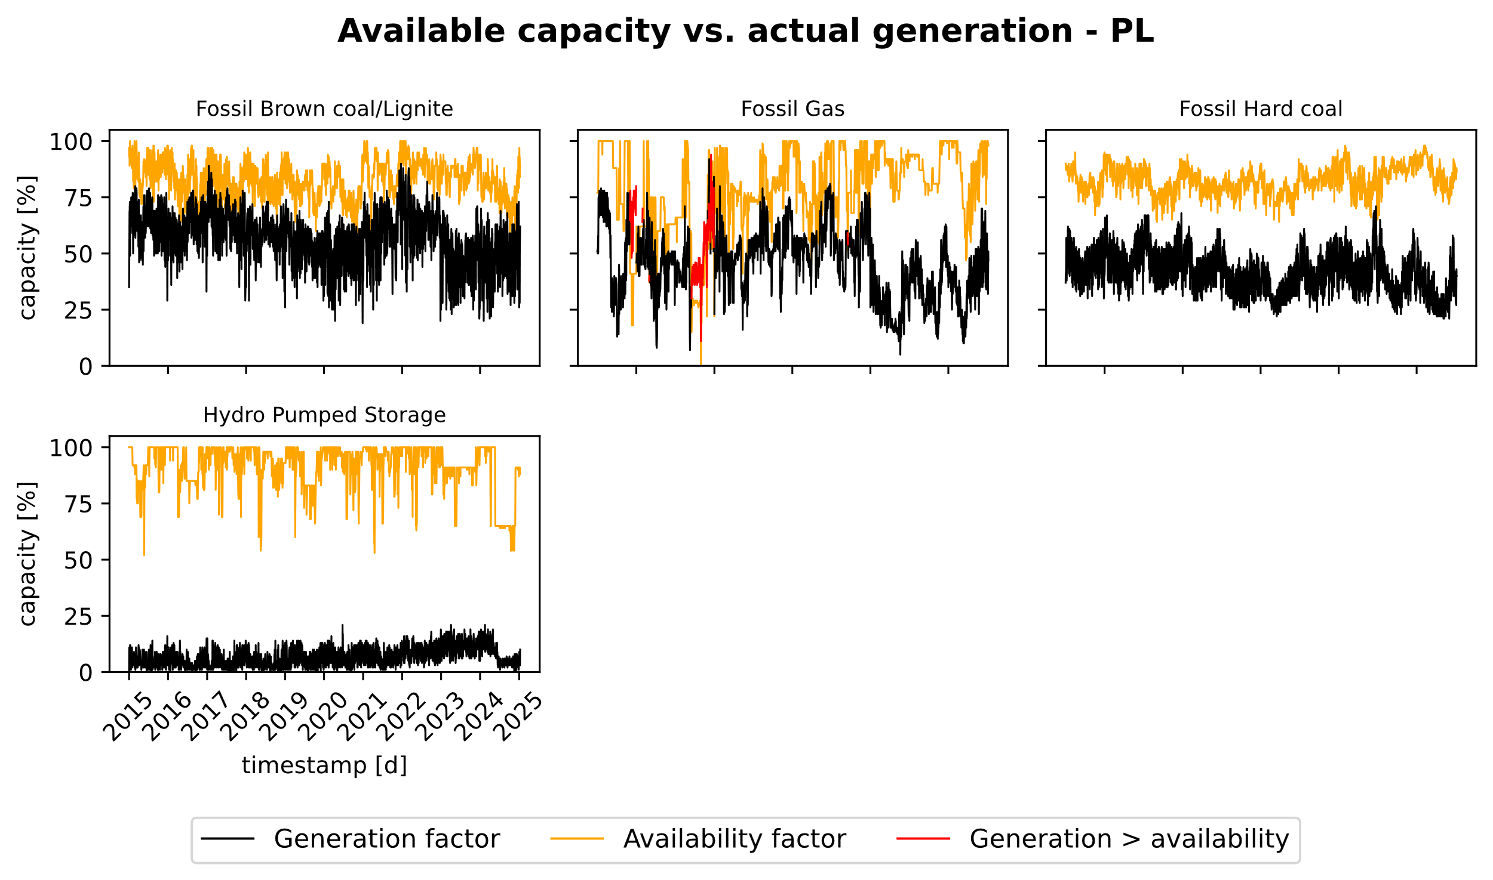
Figure 34: Comparison of aggregated available capacity vs daily generation for Poland

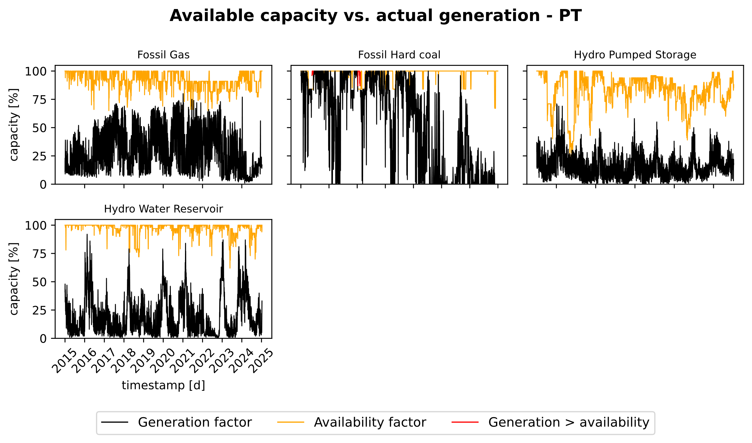
Figure 35: Comparison of aggregated available capacity vs daily generation for Portugal

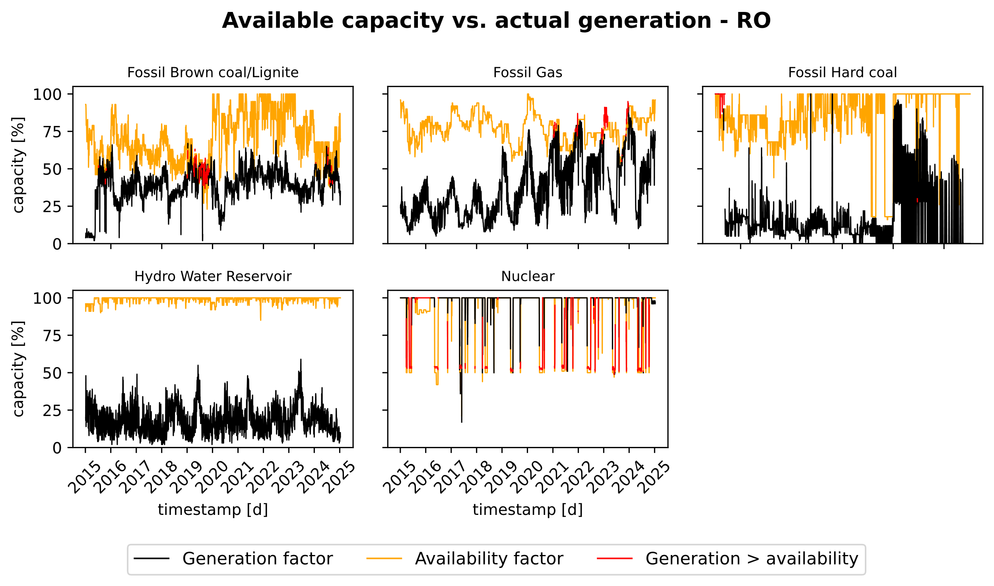
Figure 36: Comparison of aggregated available capacity vs daily generation for Romania

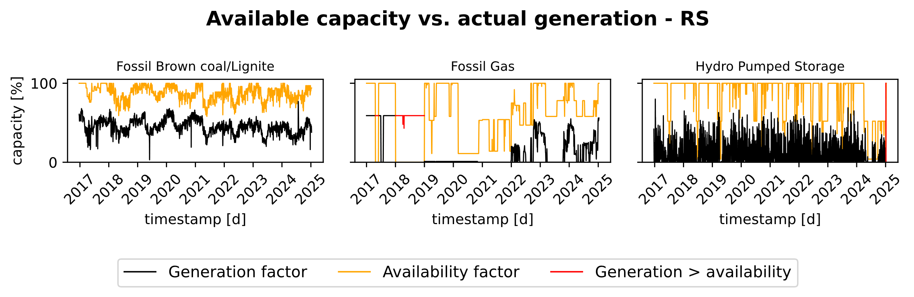
Figure 37: Comparison of aggregated available capacity vs daily generation for Serbia

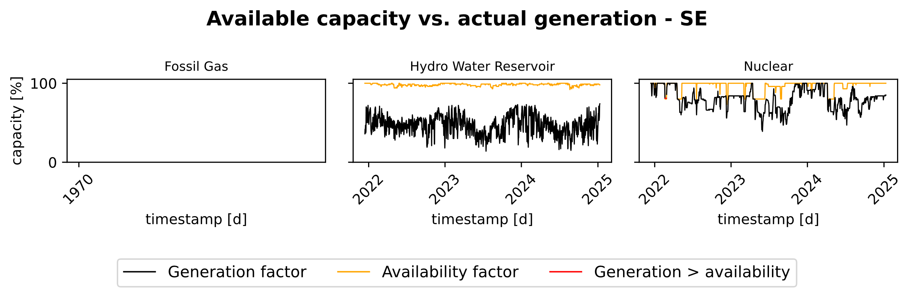
Figure 38: Comparison of aggregated available capacity vs daily generation for Sweden

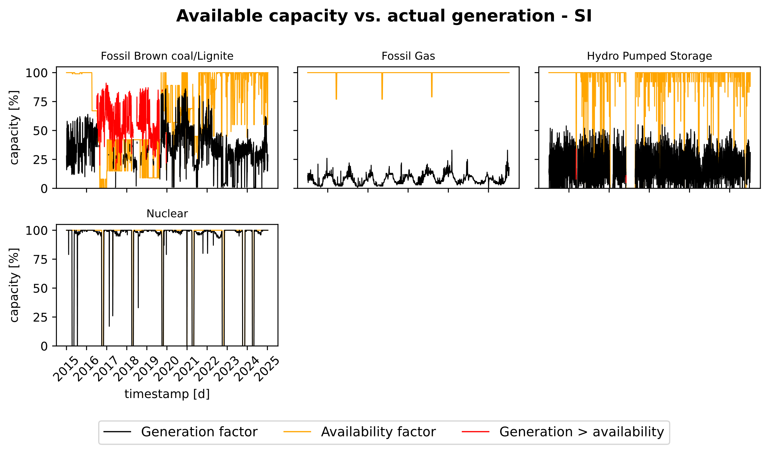
Figure 39: Comparison of aggregated available capacity vs daily generation for Slovenia

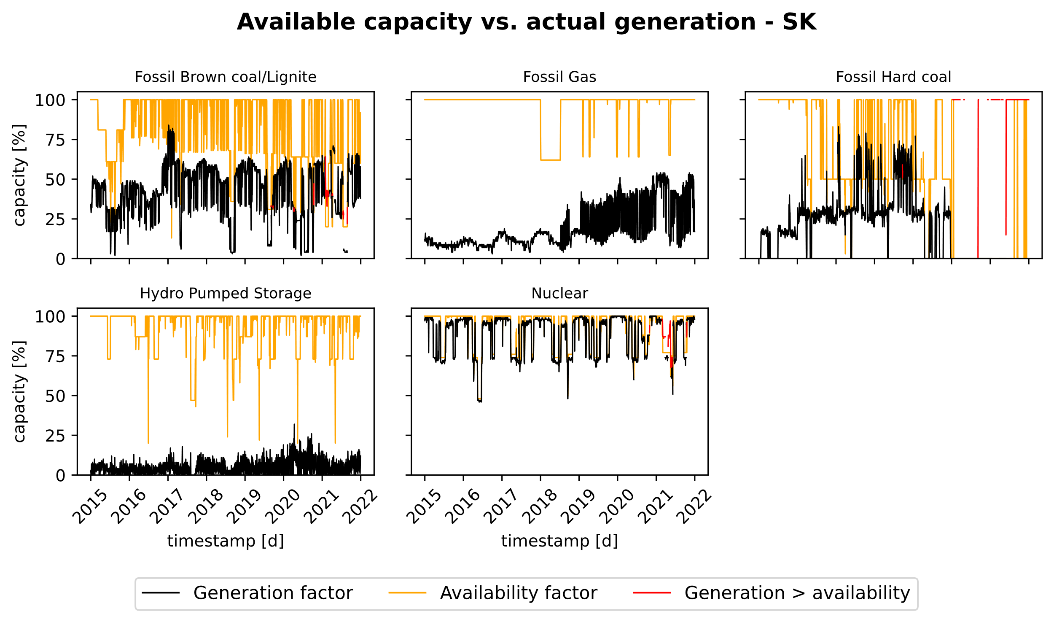
Figure 40: Comparison of aggregated available capacity vs daily generation for Slovakia

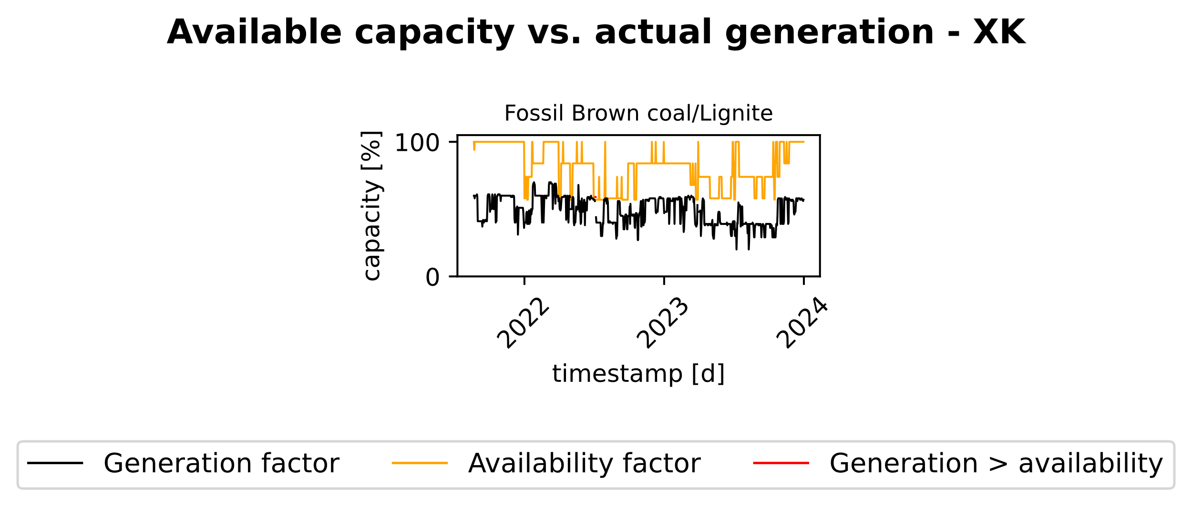
Figure 41: Comparison of aggregated available capacity vs daily generation for Kosovo

Example algorithm for outages simulation
This section describes two example algorithms for deriving simulation parameters for individual power plant units or aggregated at the technology level from the performance indicators in the data set, as well as the subsequent simulation of a time series of unplanned outages for a unit.

Algorithm 1: Calibration of outage model parameters

Input:
KPI table K with rows indexed by (c, g, m), where
c : country
g : technology / plant type
m : calendar month (1,…,12)
Columns in K:
FR_fo_h(c,g,m) -- forced-outage failure rate [events/hour]
FOD_h(c,g,m) -- mean forced-outage duration [hours/event]
mu_EFD_MW(c,g,m) -- capacity-weighted mean deration (wEFD_mw_mean) [MW]
sigma_EFD_MW(c,g,m) -- capacity-weighted std. dev. (wEFD_mw_std) [MW]
Unit fleet table U with rows indexed by units i, containing:
c(i), g(i) -- country/technology of unit i
P_i -- installed capacity P_i [MW]
Hyperparameters:
r_min ∈ (0, 1) -- minimum relative deration to count as event
r_sat ∈ (r_min, 1) -- saturation threshold for “full” outage

Output:
For each (c,g,m):
p_start_day(c,g,m) -- daily event start probability
α(c,g,m), β(c,g,m) -- Beta parameters for relative deration

Steps:

1: For each pair (c,g) do
2: Compute reference capacity C_ref(c,g) from U, e.g.
3: C_ref(c,g) ← mean of P_i over all units i with c(i)=c, g(i)=g
4: end for

5: For each triple (c,g,m) do
6: // (a) Daily start probability from failure rate
7: λ ← FR_fo_h(c,g,m) // events per hour
8: Λ_day ← 24 · λ // expected events per day
9: p_start_day(c,g,m) ← 1 − exp(−Λ_day) // Poisson(Λ_day) ⇒ P(N≥1)

10: // (b) Relative deration moments
11: μ_MW ← mu_EFD_MW(c,g,m)
12: σ_MW ← sigma_EFD_MW(c,g,m)
13: if C_ref(c,g) ≤ 0 or μ_MW or σ_MW are missing then
14: mark α(c,g,m), β(c,g,m) as undefined
15: continue to next (c,g,m)
16: end if

17: m_rel ← μ_MW / C_ref(c,g) // relative mean in (0,1)
18: s_rel ← σ_MW / C_ref(c,g) // relative std. deviation
19: v_rel ← s_rel² // relative variance

20: Clamp m_rel into (ε, 1−ε), e.g. ε = 10⁻⁶
21: v_max ← m_rel · (1 − m_rel) − ε // max feasible Beta variance
22: if v_rel > v_max then
23: v_rel ← v_max // enforce feasible variance
24: end if

25: // (c) Method-of-moments fit for Beta(α,β)
26: τ ← m_rel · (1 − m_rel) / v_rel − 1
27: if τ ≤ 0 then
28: mark α(c,g,m), β(c,g,m) as undefined
29: continue to next (c,g,m)
30: end if
31: α(c,g,m) ← m_rel · τ
32: β(c,g,m) ← (1 − m_rel) · τ
33: end for

Algorithm 2: Outage simulation for single units

Input:
Unit i:
country c(i), technology g(i), installed capacity P_i
Time horizon:
hourly grid {t_k}_{k=0,…,K−1}, with step size Δt = 1 hour
calendar mapping m(t_k) ∈ {1,…,12} (month of time t_k)
Parameters from Algorithm 1:
p_start_day(c,g,m) for all (c,g,m)
α(c,g,m), β(c,g,m) for all (c,g,m)
FOD_h(c,g,m) for all (c,g,m) // mean outage duration [h/event]
Hyperparameters:
r_min ∈ (0,1) -- minimum relative deration
r_sat ∈ (r_min,1) -- saturation threshold for “full” outage
duration_law -- e.g. "uniform" or "geometric"
V ∈ (0,1) -- shape parameter for duration_law

Output:
Hourly forced-outage profile FO_i(t_k) [MW], for k = 0,…,K−1

Steps:

1: Initialize hourly profile:
2: For all k = 0,…,K−1: FO_i(t_k) ← 0
3: Initialize state variables:
4: S ← UP // current state: UP or DOWN
5: Δ_rem ← 0 // remaining outage duration [hours]
6: A ← 0 // current outage magnitude [MW]

7: Partition the horizon into consecutive calendar days {d}.
8: For each day d with time interval [t_d_start, t_d_end) do
9: Let H_d be the set of hourly indices k with t_k ∈ [t_d_start, t_d_end)
10: Let m_d be the month such that m_d = m(t_k) for t_k in this day

11: // Case A: ongoing outage at day start
12: if S = DOWN and Δ_rem > 0 then
13: Δ_day ← min(Δ_rem, length of day in hours)
14: For all k ∈ H_d with t_k < t_d_start + Δ_day:
15: FO_i(t_k) ← A
16: Δ_rem ← Δ_rem − Δ_day
17: if Δ_rem = 0 then
18: S ← UP
19: end if
20: // If the outage ends within the day, the remaining part of the day
21: // is processed by Case B (unit available) below.
22: end if

23: // Case B: unit available at the current time within day d
24: if S = UP then
25: // (1) Decide whether a new event starts today
26: p_day ← p_start_day(c(i), g(i), m_d)
27: Draw B_d ∼ Bernoulli(p_day)
28: if B_d = 0 then
29: // no new event: remain UP, FO_i stays 0 for remaining hours
30: continue with next day d+1
31: end if

32: // (2) Draw event duration D [hours] with mean FOD_h
33: μ_D ← FOD_h(c(i), g(i), m_d)
34: if duration_law = "uniform" then
35: Choose d_min, d_max from μ_D and V
36: Draw D ∼ Uniform(d_min, d_max)
37: else if duration_law = "geometric" then
38: Choose parameters F, G from μ_D and V
39: Draw G_geom ∼ Geometric(p_geom)
40: Set D ← F + G_geom
41: end if

42: // (3) Draw relative deration R and magnitude A [MW]
43: α ← α(c(i), g(i), m_d)
44: β ← β(c(i), g(i), m_d)
45: if α, β are defined and α>0, β>0 then
46: Draw R ∼ Beta(α, β)
47: if R < r_min then
48: R_eff ← 0
49: else if R < r_sat then
50: R_eff ← R
51: else
52: R_eff ← 1
53: end if
54: else
55: R_eff ← 0
56: end if
57: A ← R_eff · P_i

58: // (4) Apply event over the current day
59: Δ_day ← min(D, length of day in hours)
60: For all k ∈ H_d with t_k < t_d_start + Δ_day:
61: FO_i(t_k) ← A
62: Δ_rem ← D − Δ_day
63: if Δ_rem > 0 then
64: S ← DOWN // outage continues into next day(s)
65: else
66: S ← UP // outage ends within the current day
67: end if
68: end if

69: end for

70: Return FO_i(t_k) for all k = 0,…,K−1

Since only power plants or their units with a rated capacity greater than or equal to 100 MW are published on the ENTSO-E Transparency Platform, many open-cycle gas turbines are not included. For this reason, they could not be matched with other open-source power plant lists, and the share of OCGTs is relatively low compared to CCGT units.

