Supplementary information for

Anthropogenic emissions drive elevated HCl and particulate chloride in polluted urban air
Rakesh Maity¹, Vikram Singh², Dilip Ganguly^{3*}, Mayank Kumar^{1*}
¹Department of Mechanical Engineering, Indian Institute of Technology Delhi, New Delhi, 110016, India
²Department of Chemical Engineering, Indian Institute of Technology Delhi, New Delhi, 110016, India
³Center for Atmospheric Sciences, Indian Institute of Technology Delhi, New Delhi, 110016, India

Supplementary Text 1
In this work, the physical and chemical processes governing chloride formation were investigated through simulations using the Weather Research and Forecasting model coupled with Chemistry (WRF-Chem) (Version 4.2.2)¹. The model configuration comprised the Grell–Freitas (GF)² method for cumulus parameterization, the Rapid Radiative Transfer Model for GCMs (RRTMG)³ for both shortwave and longwave radiation, and the Lin et al. ⁴ microphysics scheme for cloud and precipitation processes. The Yonsei University planetary boundary layer (PBL)⁵ scheme was used to treat boundary layer dynamics, while the Noah land surface model⁶ was used to depict surface–atmosphere interactions. MOZART (Model for Ozone and Related Tracers)⁷ was used to simulate gas-phase chemistry, and MOSAIC (Model for Simulating Aerosol Interactions and Chemistry)⁸ was used to represent aerosol processes.
The European Centre for Medium-Range Weather Forecasts (ECMWF) provided the ERA5 reanalysis ⁹, which had a 6-hourly temporal resolution and a spatial resolution of 0.25° × 0.25°, from which meteorological initial and boundary conditions were obtained. The Emissions Database for Global Atmospheric Research (EDGAR v6.1)^{10,11}, which offers monthly mean data at 0.1° × 0.1° resolution, was used to obtain anthropogenic emissions with reference to 2018. The Model of Emissions of Gases and Aerosols from Nature (MEGAN)¹² was used to generate biogenic emissions, and the NCAR Fire Inventory (FINN)¹³ was used to incorporate fire emissions. The Whole Atmosphere Community Climate Model (WACCM)¹⁴ provided the initial and chemical lateral boundary conditions.

Supplementary Figures
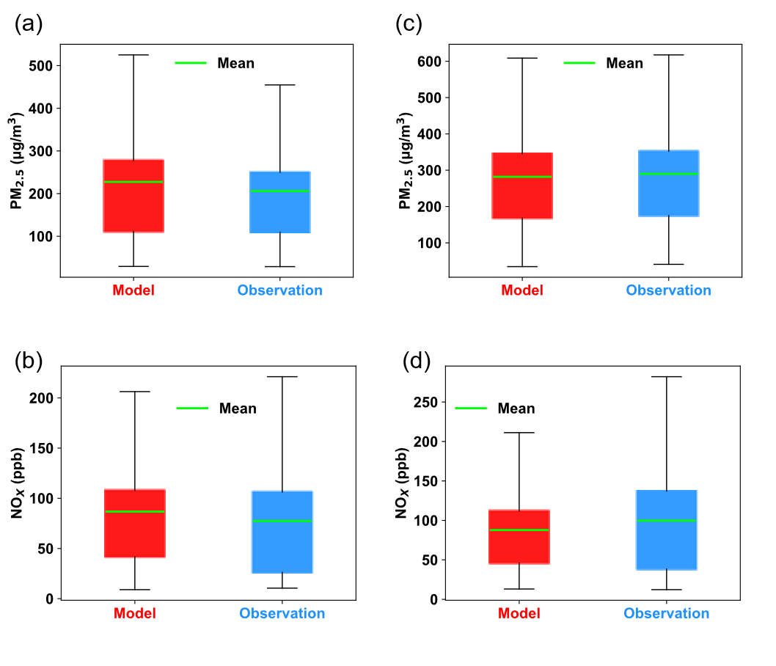
Supplementary Fig. 1 | Box and whiskers plot for PM_{2.5}, NO_{x} for post-monsoon (a, b) and winter (c, d) respectively.

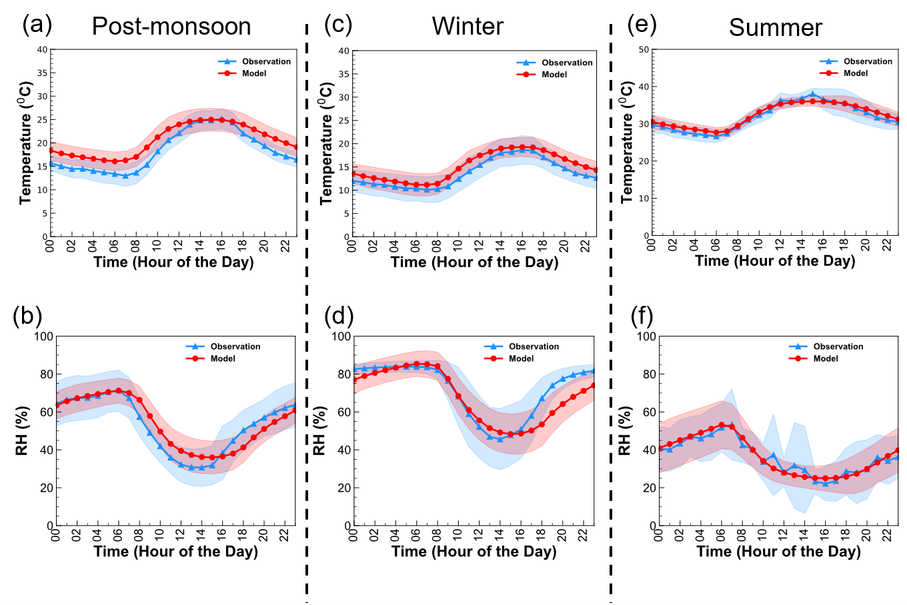

Supplementary Fig. 2 | Meteorological variable diurnal variation. a, b, Temperature and Relative Humidity diurnal in post-monsoon; c, d, Temperature and Relative Humidity diurnal in winter; e, f, Temperature and Relative Humidity diurnal in summer.

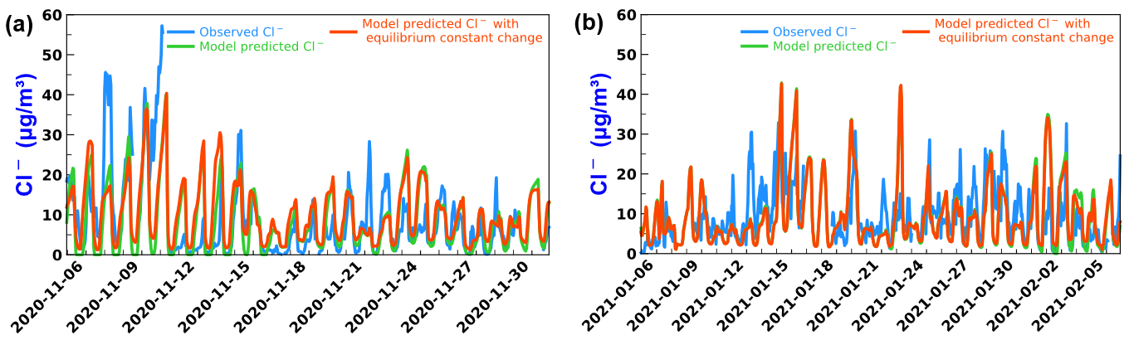
Supplementary Fig. 3 | chloride time series for post-monsoon (a) and winter (b).
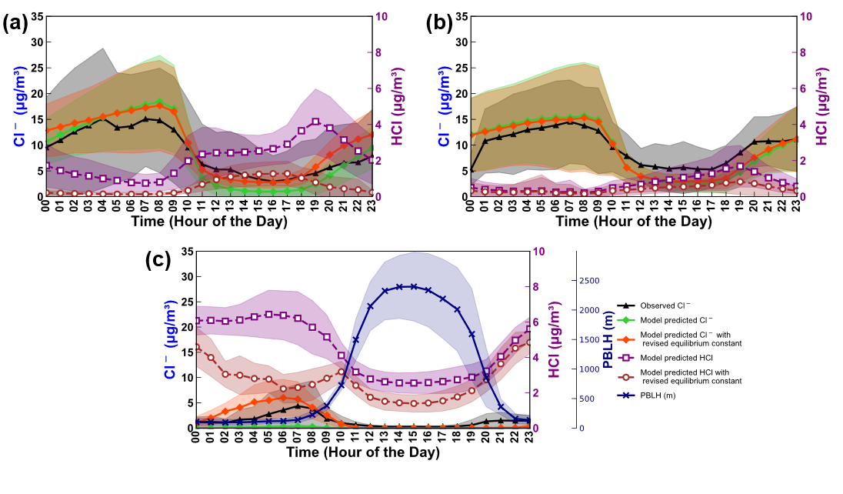
Supplementary Fig. 4 | Diurnal variation of Cl⁻ and HCl (black – observed particulate chloride; green – base model predicted particulate chloride; red – model predicted particulate chloride with revised equilibrium constant; purple – base model predicted HCl; brown - model predicted HCl with revised equilibrium constant). a, Cl⁻ and HCl variation in post-monsoon; b, Cl⁻ and HCl variation in winter; c, Cl⁻, HCl and Planetary Boundary Layer Height (PBLH) (meters) variation in summer (Diurnal of HCl in summer is different compared to other two seasons, which we attribute to the higher PBLH).

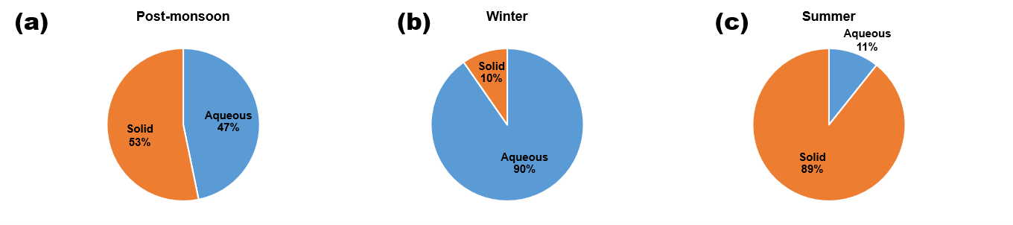
Supplementary Fig. 5 | Final model simulated particulate chloride solid and aqueous phase contribution across seasons. (Represented using simulation type 6 and subtracting from simulation type 2). a, Post-monsoon; b, Winter; c, Summer.

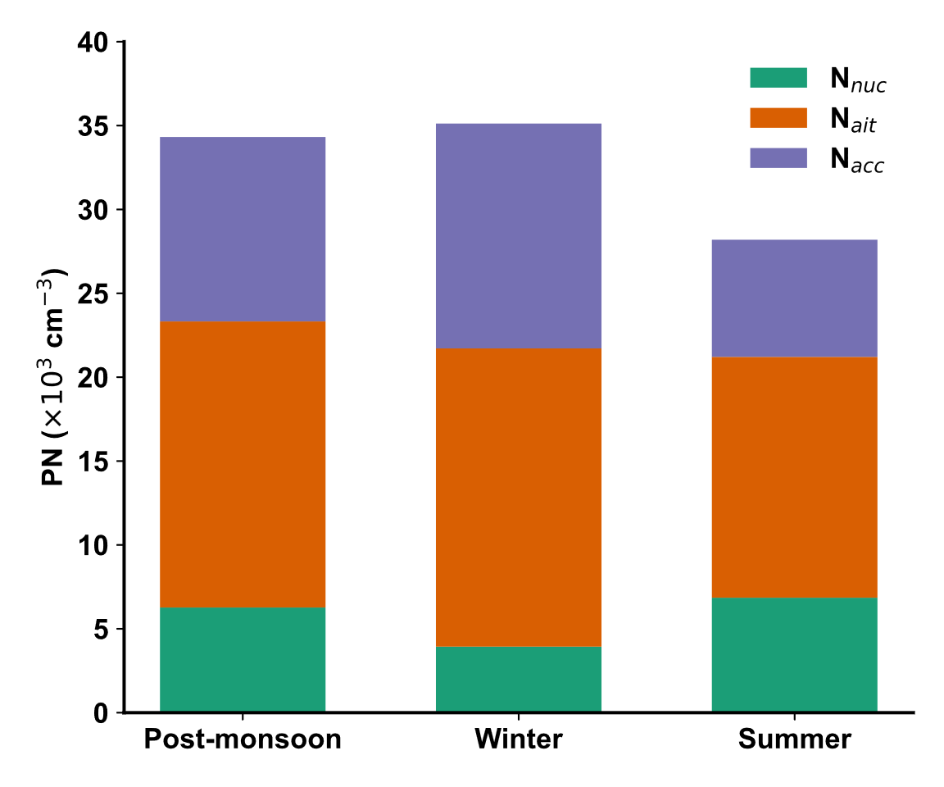
Supplementary Fig. 6 | Seasonal average particle number concentrations in Delhi measured using a scanning mobility particle sizer (SMPS) at IIT Delhi. Green, orange, and purple segments represent nucleation-, Aitken-, and accumulation-mode particles, respectively. The data corresponds to measurements from 2022 and are shown to illustrate typical seasonal particle number concentrations in Delhi rather than the exact model simulation period.

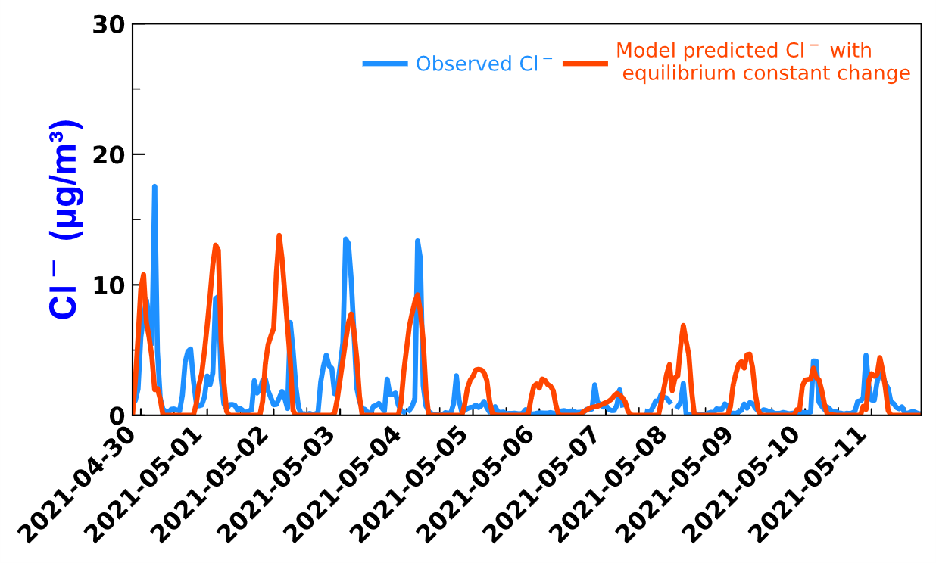
Supplementary Fig. 7 | Chloride timeseries for Summer

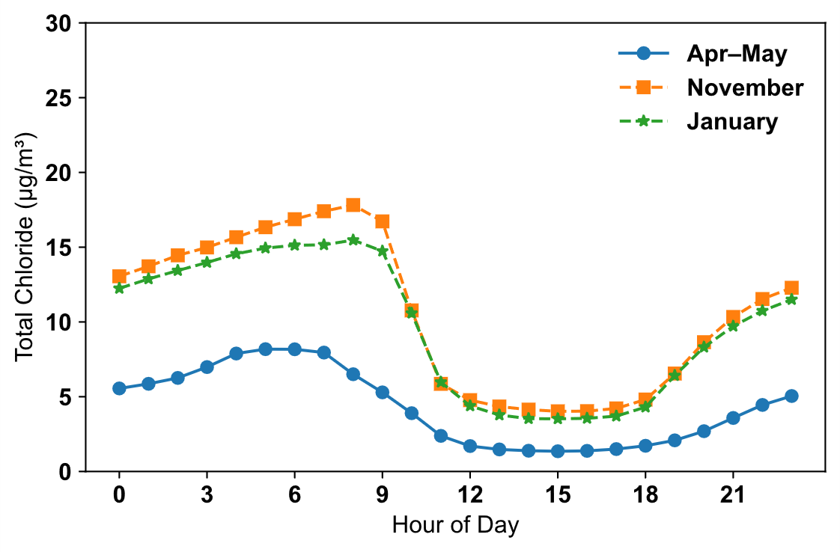
Supplementary Fig. 8 | Model predicted total Chloride (particulate chloride + HCl×(35.45/36.46)) diurnal across seasons.

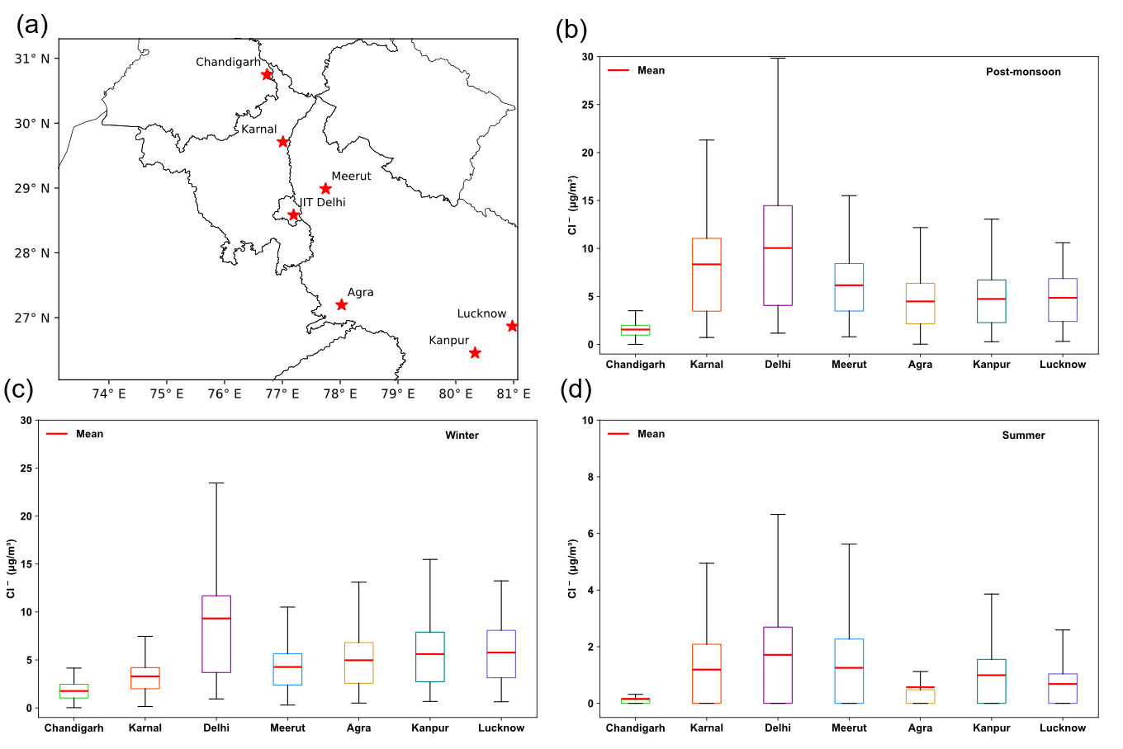
Supplementary Fig. 9 | Particulate chloride concentration over seven major cities in the domain. a, Location of the different cities in the domain; b, Box and whiskers plot in post-monsoon; c, Box and whiskers plot in winter; d, Box and whiskers plot in summer.
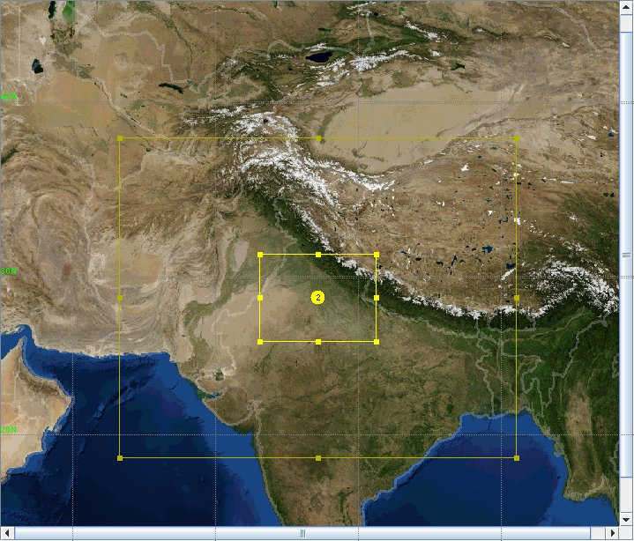
Supplementary Fig. 10 | Two nested domains used for all the simulation cases

Supplementary Table 1

 | Simulations Performed
Simulation type 1 | Standard model simulations for post-monsoon (5th to 30th Nov. 2020), winter (5th Jan. to 5th Feb. 2021), summer (30th April to 11th May 2021)
Simulation type 2 | Equilibrium constant changed model simulations for post-monsoon (5th to 30th Nov. 2020), winter (5th Jan. to 5th Feb. 2021), summer (30th April to 11th May 2021)
Simulation type 3 | Without open waste burning HCl and pCl emissions simulation for post-monsoon (5th to 30th Nov. 2020), winter (5th Jan. to 5th Feb. 2021)
Simulation type 4 | Without agricultural residue burning HCl and pCl emissions simulation for post-monsoon (5th to 30th Nov. 2020), winter (5th Jan. to 5th Feb. 2021)
Simulation type 5 | Without energy related HCl and pCl emissions simulation for post-monsoon (5th to 30th Nov. 2020), winter (5th Jan. to 5th Feb. 2021)
Simulation type 6 | Simulation with thermodynamic equilibrium constant very high (nearly 5 orders of magnitude high compared to standard model) for gas to solid partitioning to differentiate solid and aqueous phase contributions for all seasons

References
1. Grell, G. A. et al. Fully coupled “online” chemistry within the WRF model. Atmos. Environ. 39, 6957–6975 (2005).
2. Freitas, S. R., Grell, G. A. & Li, H. The GF convection parameterization: Recent developments, extensions, and applications. Geoscientific Model Development Discussions 2020, 1–28 (2020).
3. Iacono, M. J. et al. Radiative forcing by long-lived greenhouse gases: Calculations with the AER radiative transfer models. Journal of Geophysical Research: Atmospheres 113, (2008).
4. Lin, Y.-L., Farley, R. D. & Orville, H. D. Bulk parameterization of the snow field in a cloud model. J. Appl. Meteorol. Climatol. 22, 1065–1092 (1983).
5. Hong, S. Y. & Pan, H. L. Nonlocal boundary layer vertical diffusion in a medium-range forecast model. Mon. Weather Rev. 124, 2322–2339 (1996).
6. Chen, F., review, J. D.-M. weather & 2001, undefined. Coupling an advanced land surface–hydrology model with the Penn State–NCAR MM5 modeling system. Part I: Model implementation and sensitivity. journals.ametsoc.org https://journals.ametsoc.org/view/journals/mwre/129/4/1520-0493_2001_129_0569_caalsh_2.0.co_2.xml?tab_body=fulltext-display.
7. Emmons, L. K. et al. Description and evaluation of the Model for Ozone and Related chemical Tracers, version 4 (MOZART-4). Geosci. Model Dev. 3, 43–67 (2010).
8. Zaveri, R. A., Easter, R. C., Fast, J. D. & Peters, L. K. Model for simulating aerosol interactions and chemistry (MOSAIC). Journal of Geophysical Research: Atmospheres 113, (2008).
9. CISL RDA. ERA5 Reanalysis (0.25 Degree Latitude-Longitude Grid). https://rda.ucar.edu/datasets/ds633.0/index.html#!description.
10. Crippa, M. et al. High-resolution temporal profiles in the Emissions Database for Global Atmospheric Research (EDGAR). Sci. Data 7, 187 (2020).
11. Monforti Ferrario, F. et al. EDGAR v6.1 Global Air Pollutant Emissions. Preprint at http://data.europa.eu/89h/df521e05-6a3b-461c-965a-b703fb62313e (2022).
12. Guenther, A. B. et al. The model of emissions of gases and aerosols from nature version 2.1 (MEGAN2.1): An extended and updated framework for modeling biogenic emissions. Geosci. Model Dev. 5, 1471–1492 (2012).
13. Wiedinmyer, C. et al. The Fire INventory from NCAR (FINN): A high resolution global model to estimate the emissions from open burning. Geosci. Model Dev. 4, 625–641 (2011).
14. WACCM Download Subset. https://www.acom.ucar.edu/waccm/download.shtml.

