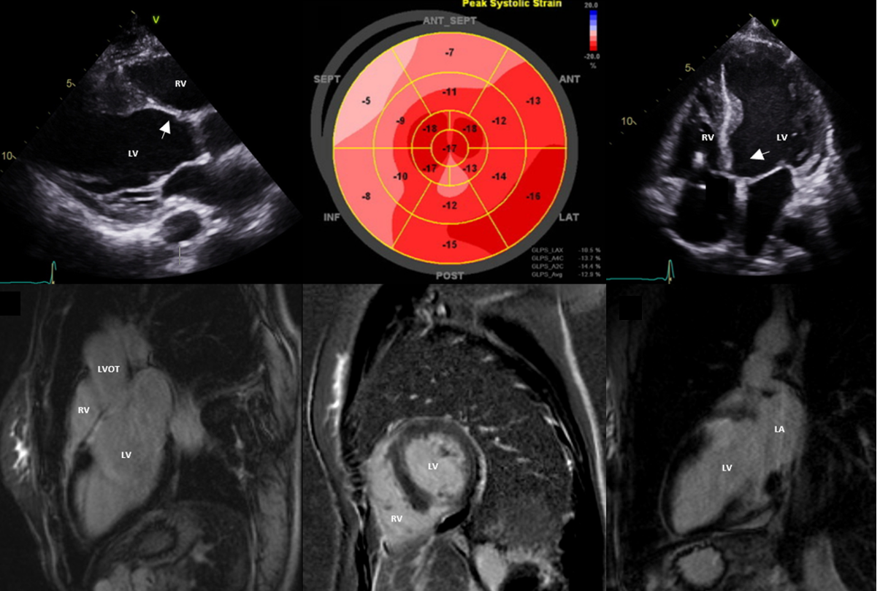

A high index of suspicion is needed for a diagnosis of cardiac sarcoiodsis that requires the exclusion of other mimics, including genetic cardiomyopathies and viral myocarditis. A combination of multimodality imaging, endomyocardial biopsy, and a multidisciplinary team approach is required to identify red flags suggestive of the disease and to determine whether an individual is likely to have cardiac sarcoidosis.

