Supplemental Information
ConTP: Reshaping transporter functional space to resolve substrate specificity beyond evolutionary proximity
Chenjie Feng^{1,2,3,4,*}, Wenjia He ^{1,3,4,*}, Junbo Yin^{1,3,4}, Xiaopeng Xu^{1,3,4}, Min Zhou^{1,3,4}, Yunchuan Wang⁵, Mark Tester⁵, Xin Gao^{1,3,4,†}

¹Computer Science Program, Computer, Electrical and Mathematical Sciences and Engineering Division (CEMSE), King Abdullah University of Science and Technology (KAUST), Thuwal 23955-6900, Kingdom of Saudi Arabia.
²College of Medical Information and Engineering, Ningxia Medical University, Yinchuan 750004, China;
³Center of Excellence for Smart Health (KCSH), King Abdullah University of Science and Technology (KAUST), Thuwal 23955-6900, Kingdom of Saudi Arabia.
⁴Center of Excellence on Generative AI, King Abdullah University of Science and Technology (KAUST), Thuwal 23955-6900, Kingdom of Saudi Arabia.
⁵Plant Science Program, Biological and Environmental Sciences and Engineering Division (BESE), King Abdullah University of Science and Technology (KAUST), Thuwal 23955-6900, Kingdom of Saudi Arabia.

*Co-first author: Chenjie Feng and Wenjia He contributed equally to this work.
†Corresponding authors: Xin Gao: xin.gao@kaust.edu.sa

Content
Supplementary Note 1. Literature survey and limitations of existing methods 2
Supplementary Note 2. Homology-based dataset expansion based on UniRef90 4
Supplementary Note 3. Model training procedures and detail information 6
Supplementary Note 4. Classical machine-learning baselines and feature comparison 8
Supplementary Note 5. Additional analysis for substrate-type prediction task 9
Supplementary Note 6. Additional analysis for TC family classification task 10
Supplementary Note 7. Additional information for the CLIC6 Case Study 12
Supplementary Note 8. Inference efficiency comparison 13

Supplementary Note 1. Literature survey and limitations of existing methods
Table S1. Summary of existing computational methods for transporter function prediction.

Table S1 summarizes representative computational approaches that have been proposed over the past decade for transporter function prediction, including TrSSP, TranCEP, TooT-SC, TTRBF, KNN-TC, TransportTP, PortPred, SPOT and related variants. A common pattern across these studies is the limited scale and heterogeneity of the training data. Most methods were trained on datasets derived from early versions of TCDB containing only a few hundred to a few thousand labeled transporters, with typical sample sizes ranging from ~300 to <6,000 sequences. Several works further restrict their focus to narrow subsets of the transporter landscape, such as seven substrate super-classes or a few hundred TC families, often excluding multi-functional, poorly annotated, or rare families. As a result, these models are necessarily tuned to a small, relatively well-studied portion of TCDB and provide only partial coverage of the currently known transporter universe.

In terms of label granularity, nearly all surveyed methods operate at a coarse functional resolution. Substrate-specific predictors such as TrSSP, TranCEP and TooT-SC typically collapse chemically distinct substrates (e.g. Na⁺, K⁺, Ca²⁺, H⁺, Zn²⁺) into 7–12 broad categories (e.g. “cation,” “anion,” “amino acid,” “sugar,” “protein/RNA,” “electron,” “other”), thereby obscuring fine-grained differences in ion selectivity or metabolite specificity. Likewise, TC-number predictors usually consider only 22–557 TC families, far below the >1,500 families currently catalogued in TCDB. Some approaches are further restricted to specific transporter subsets, such as ion channels or selected SLC/MFS families, which limits their applicability for genome-wide annotation. Overall, Table S1 highlights that existing methods neither exploit the full breadth of TCDB nor provide the fine-grained resolution needed to distinguish closely related substrate types or TC families.

From a methodological perspective, most earlier systems rely on handcrafted sequence descriptors—amino-acid composition, dipeptide frequencies, PSSM-based features, AAindex-derived physicochemical properties—and classical machine-learning classifiers such as SVMs, k-nearest neighbours, random forests, or shallow neural networks. More recent methods, including PortPred and SPOT, begin to leverage protein language-model embeddings and deep architectures, but they still inherit the coarse label spaces and small training sets of previous work. Moreover, evaluation protocols in the literature are highly heterogeneous: some studies report only cross-validation on relatively small, randomly split datasets; others use non-standard test sets or lack explicit control over sequence identity between training and test sequences. Very few works attempt systematic out-of-distribution assessment or explicitly analyze performance on rare, long-tail families.

Taken together, the literature survey in Table S1 underscores three major limitations of the current landscape: (i) restricted data scale, with training sets typically limited to a few thousand transporters; (ii) coarse and inconsistent label spaces, both for substrates and TC families; and (iii) lack of unified, high-resolution benchmarks and rigorous OOD evaluation. These constraints make it difficult to compare methods fairly and prevent existing models from capturing the full diversity and functional granularity of membrane transporters.

Our work directly addresses these gaps. By systematically integrating and normalizing TCDB annotations, performing large-scale homology expansion against UniRef90, and refining substrate labels into a chemically coherent taxonomy, we construct two benchmarks, TP-Substrate and TP-TC, that expand existing datasets by an order of magnitude in both sample size and label coverage. TP-Substrate spans 70 curated substrate types across eight super-classes, while TP-TC covers 1,352 TC families, providing the broadest and most fine-grained benchmark to date. Building on these resources, ConTP combines pretrained ESM-2 embeddings with supervised contrastive learning and prototype-based zero-shot annotation, enabling direct comparison against prior methods on a unified label space and supporting systematic in-distribution and out-of-distribution evaluations that were previously not possible.

Supplementary Note 2. Homology-based dataset expansion based on UniRef90
We selected UniRef90 as the homology-retrieval database because it provides an optimal balance between sequence diversity, functional consistency, and computational efficiency. UniRef90 clusters all UniProtKB entries at 90% identity with full-length coverage, a threshold widely regarded as sufficient to preserve conserved biochemical function among homologs for most enzyme and transporter families. Compared with UniRef100, UniRef90 reduces redundancy arising from organism-specific variants and prevents the augmented dataset from being dominated by nearly identical paralogs. Conversely, more aggressive clustering thresholds such as UniRef50 introduce numerous remote homologs whose substrate specificity or TC-family assignments are often not conserved. Empirically, TCDB annotations show high functional stability above ~80–85% identity, making UniRef90 a suitable compromise for retrieving homologs that are evolutionarily diverse yet still reliable for function transfer. For these reasons, UniRef90 serves as an effective retrieval space for expanding transporter datasets without compromising label accuracy.

For fast and scalable homology retrieval, we employed DHR due to its ultrafast performance. Once UniRef90 is indexed, DHR retrieves homologs for several thousand reference sequences within minutes. In contrast, commonly used tools such as JackHMMER typically require more than thirty minutes per reference sequence, rendering them impractical for large-scale augmentation workflows. DHR therefore enables efficient and comprehensive expansion of TP-Substrate and TP-TC.

Here we provide an illustrative example of the augmentation process. The reference sequence in this case is the TCDB entry 1.A.1.13.10, a potassium channel protein comprising 343 amino acids with two N-terminal transmembrane segments. The homologs retrieved by DHR are shown in Figure S1, yielding a total of eight UniRef90 sequences, and the corresponding multiple sequence alignment is shown in Figure S2.

Among these eight homologs, UniRef90_Q58752 is identical to the reference sequence and therefore excluded from augmentation. UniRef90_C9RFC5, however, shares >90% identity with 100% coverage and is consequently incorporated into the dataset. Following our curation guidelines—requiring (i) ≥90% pairwise identity and (ii) ≥90% alignment coverage—such homologs are considered to retain both the substrate specificity and TC assignment of the reference sequence and are included in TP-Substrate and TP-TC.

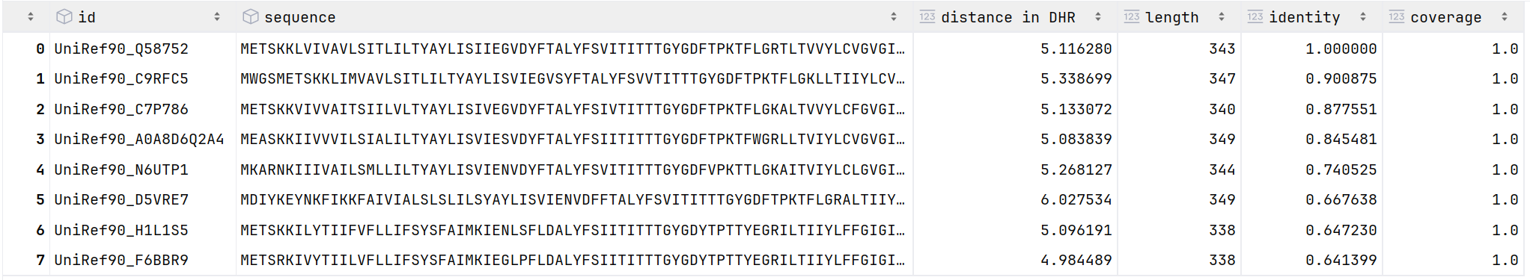
Figure S1. Homologs of transporter 1.A.1.13.10 retrieved by DHR. Entries with <60% pairwise sequence identity were removed during post-processing.

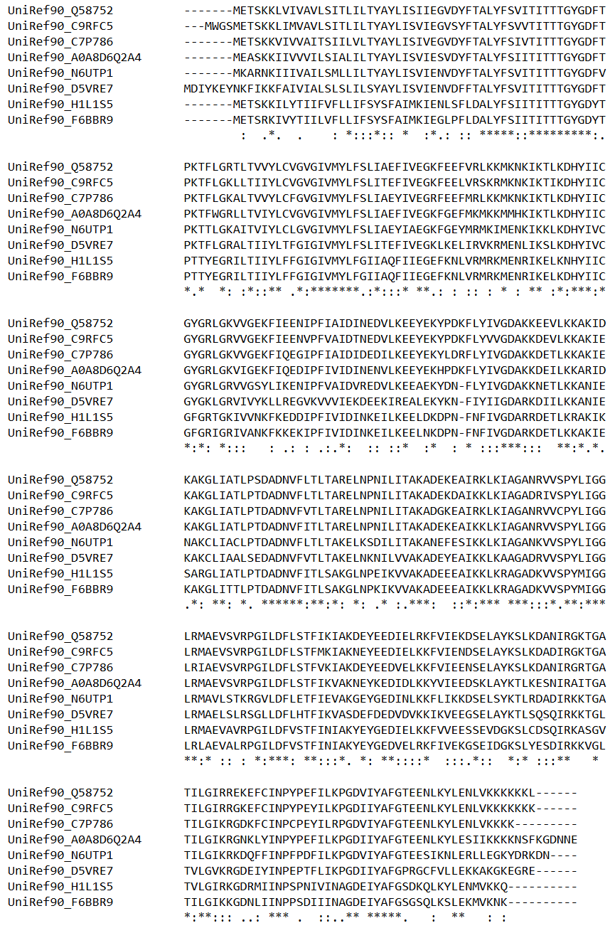
Figure S2. Multiple sequence alignment of homologous sequences retrieved for 1.A.1.13.10. The aligned homologs display a strongly conserved structural backbone with only minor residue-level variations, reflecting the high evolutionary conservation of this TC family.

Supplementary Note 3. Model training procedures and detail information
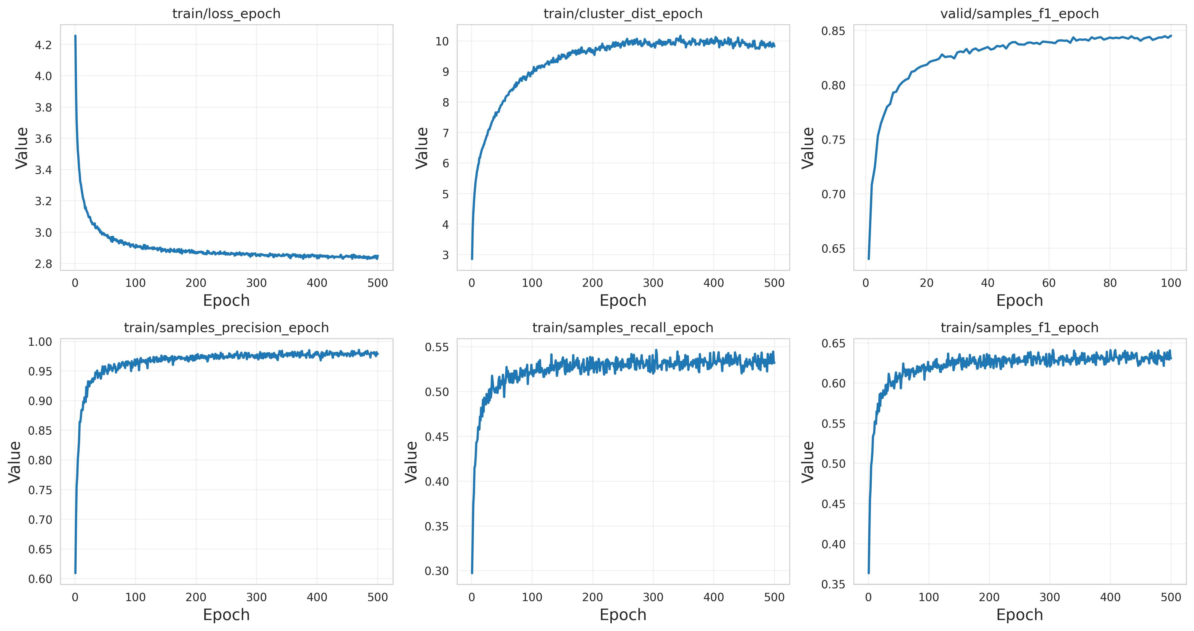
Figure S3. Training dynamics of ConTP on the substrate classification task. (A) train/loss_epoch: The training loss decreases rapidly during the first ~50 epochs, followed by a gradual decline toward convergence, indicating stable optimization and the absence of overfitting. (B) train/cluster_dist_epoch: The average distance between positive and negative pairs in the contrastive latent space increases steadily throughout training and plateaus after 300 epochs, reflecting progressive improvement in representation separability. (C) valid/samples_f1_epoch: The validation sample-wise F1-score rises sharply during early training and continues to improve more slowly before stabilizing around 0.84, consistent with effective generalization under the IID setting. (D) train/samples_precision_epoch: Precision increases quickly during the first 50 epochs and approaches ~0.95 at convergence, indicating that ConTP increasingly reduces false-positive predictions during training. (E) train/samples_recall_epoch: Recall improves more gradually compared to precision, reaching ~0.54 at convergence; this asymmetry reflects the inherent class imbalance in TP-Substrate and the model’s emphasis on minimizing false positives under the contrastive learning objective. (F) train/samples_f1_epoch: The training sample-wise F1 exhibits a characteristic rise-and-plateau trend, stabilizing at ~0.63, consistent with the combined precision–recall behaviors observed in panels (D) and (E). Together, these curves show that ConTP undergoes rapid early optimization, maintains stable long-term training behavior, and progressively improves representation separability and predictive performance across epochs.

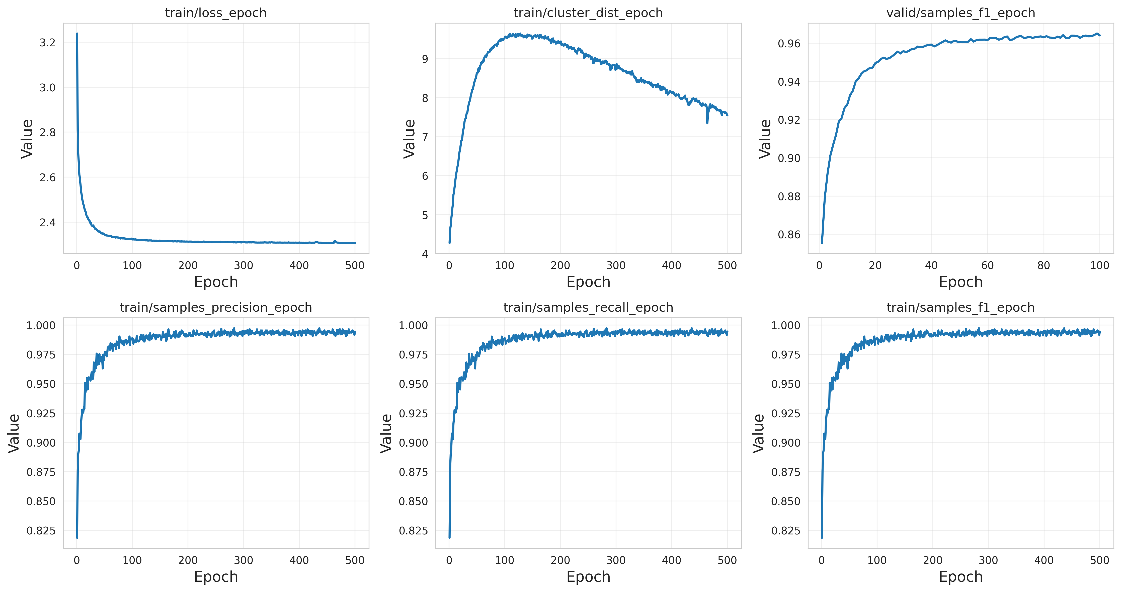
Figure S4. Training dynamics of ConTP on the TC-family classification task. (A) train/loss_epoch: The training loss decreases steeply within the first ~50 epochs and then gradually declines toward convergence, indicating smooth optimization and stable learning behavior. (B) train/cluster_dist_epoch: The contrastive cluster-distance increases rapidly during early training, reaching a peak at ~120 epochs, followed by a slow decline. This rise–plateau–adjust pattern reflects the progressive tightening of positive-pair neighbourhoods and refinement of class boundaries as the embedding space stabilizes. (C) valid/samples_f1_epoch: The validation sample-wise F1-score increases quickly from ~0.86 to ~0.95 within the first 40 epochs and continues improving toward ~0.97, demonstrating strong generalization ability in the TC classification task. (D) train/samples_precision_epoch: Precision rises rapidly and remains consistently above 0.98 after ~100 epochs, indicating that ConTP maintains very low false-positive rates across the highly imbalanced TC label space. (E) train/samples_recall_epoch: Recall exhibits a similar trend, increasing to >0.98 early in training and remaining stable throughout, suggesting that ConTP effectively captures the majority of true TC labels. (F) train/samples_f1_epoch: The training F1-score reflects the combined precision–recall trend, rising sharply to ~0.98 and stabilizing with minimal fluctuations, consistent with effective representation learning under the contrastive objective. Overall, these training curves demonstrate that ConTP rapidly converges, achieves highly stable performance, and maintains near-perfect precision and recall on the TC-family task, highlighting the robustness of its contrastive representations in capturing fine-grained functional distinctions.

Supplementary Note 4. Classical machine-learning baselines and feature comparison
Table S2. Benchmark comparison with machine-learning methods for transporter function prediction.
Table S2 provides a systematic comparison between ConTP’s building blocks, pretrained sequence embeddings and contrastive learning, and conventional machine-learning pipelines. Three families of input features were evaluated: One-hot encoding, which captures only residue composition and length; AAIndex-PCA-20, which summarizes physicochemical descriptors but discards evolutionary context; ESM2 mean embeddings, which provide contextualized high-dimensional representations learned from large-scale protein corpora.

Across all classifiers and both tasks (substrate and TC classification), One-hot and AAIndex-PCA-20 features plateau at relatively low F1-scores (e.g. 0.68–0.78 for substrate classification), illustrating their limited representational capacity. These approaches cannot model long-range interactions, conserved motifs, or subtle sequence signatures that determine substrate specificity.

When switching to ESM2 embeddings, the best-performing classical method Random Forest (ESM2 + RF) achieves substantial improvements (F1 ≈ 0.82–0.85), confirming that large-scale protein language models encode function-relevant features not captured by manually engineered descriptors.

However, even the strongest classical pipeline (ESM2 + RF) remains outperformed by ConTP. This gap highlights an important insight: although ESM embeddings contain functional information, classical classifiers cannot fully exploit it, especially when facing long-tailed TC-family distributions and fine-grained substrate categories. ConTP’s contrastive objective aligns representations directly with functional similarity, yielding a more structured and discriminative embedding space.

To exclude potential confounding effects of feature dimensionality, we further reduced the original ESM2 embeddings to 320 dimensions, matching ConTP’s latent representation size using PCA. The RF model trained on ESM2-PCA features showed no significant change in performance (F1-score ≈ 0.82), confirming that ConT’s improvement stems from contrastive representation learning rather than lower embedding dimensionality.

Overall, Table S2 demonstrates that ConTP’s gains arise not only from using ESM2 embeddings, but from reorganizing them into a function-oriented geometry via contrastive learning, enabling consistently superior performance across diverse transporter classes.

Supplementary Note 5. Additional analysis for substrate-type prediction task
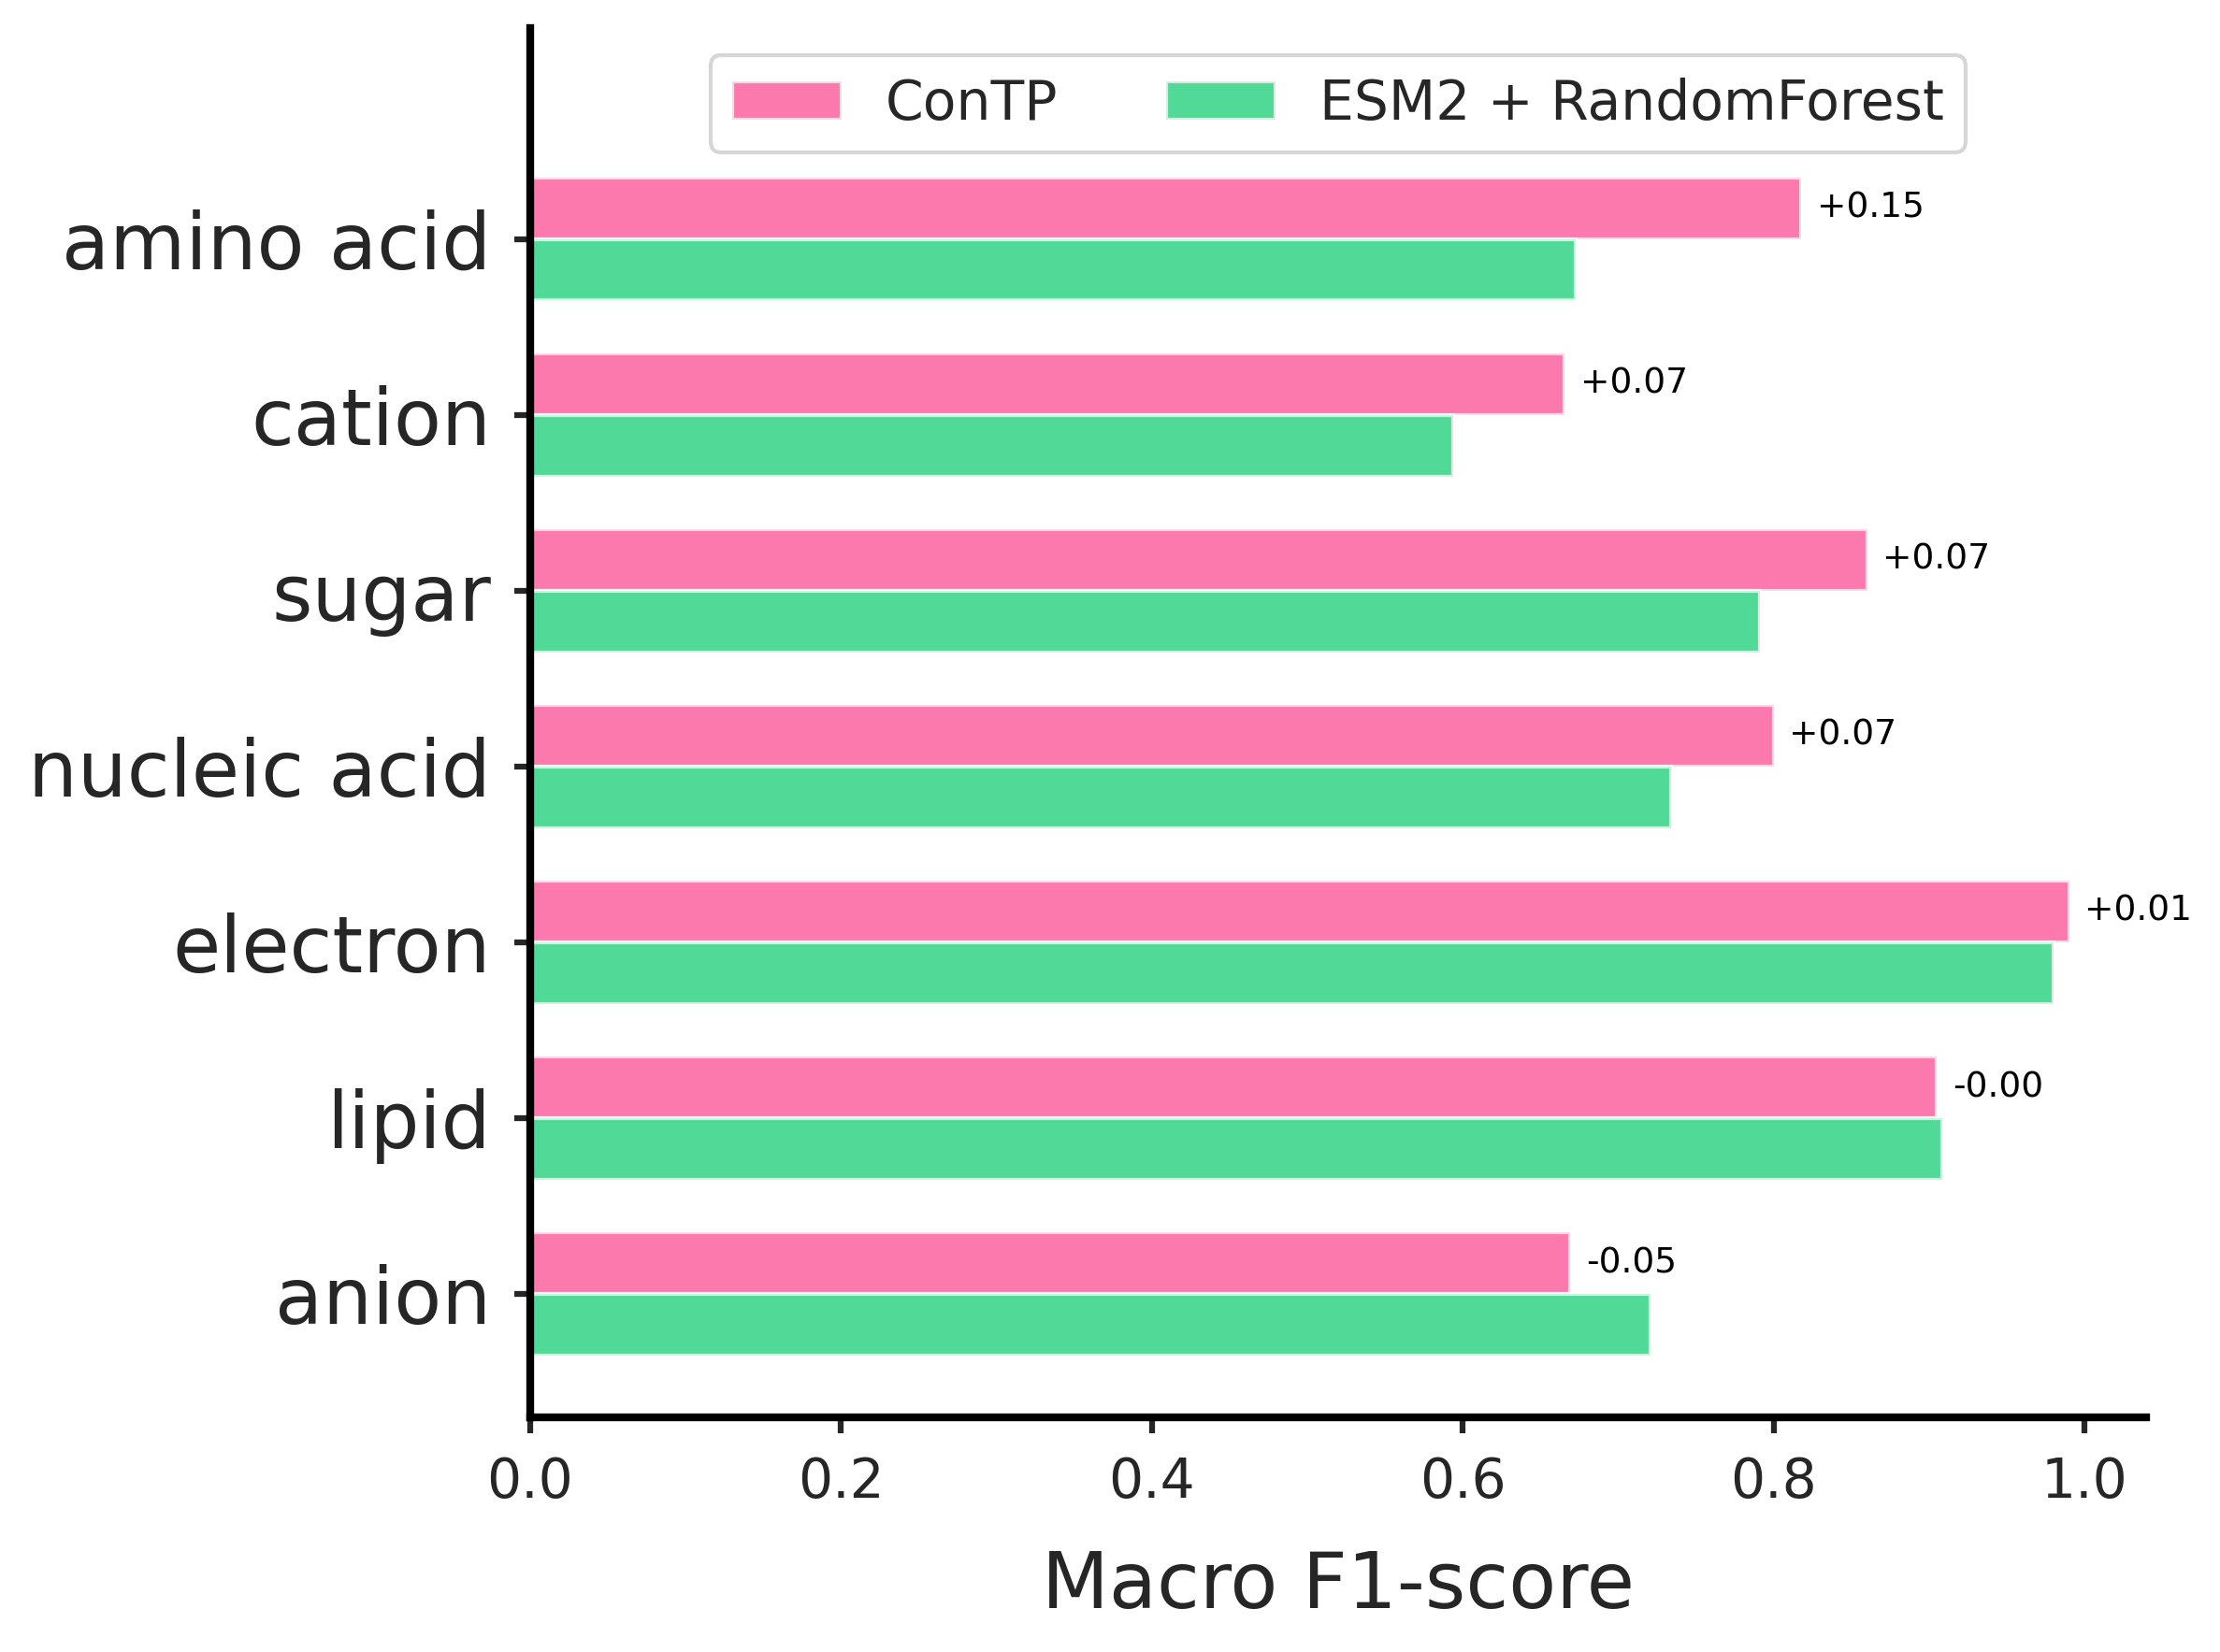
Figure S5. Class-wise F1-score comparison between ConTP and the strong baseline (ESM2 + Random Forest) across seven high-level substrate categories. Bars show the per-class F1-scores achieved by ConTP (pink) and RF (green), with the numerical difference annotated to the right of each pair. ConTP yields consistent improvements for most categories, including amino acid (+0.15), cation (+0.07), sugar (+0.07), nucleic acid (+0.07), and electron (+0.01), reflecting its ability to learn function-oriented representations that generalize across heterogeneous transporter families. Performance is similar for lipid transporters (–0.00), while a slight decrease is observed for anion transporters (–0.05), likely reflecting their substantial intra-class mechanistic diversity. Overall, ConTP demonstrates more robust and discriminative substrate-specific prediction than classical ML approaches.

Supplementary Note 6. Additional analysis for TC family classification task
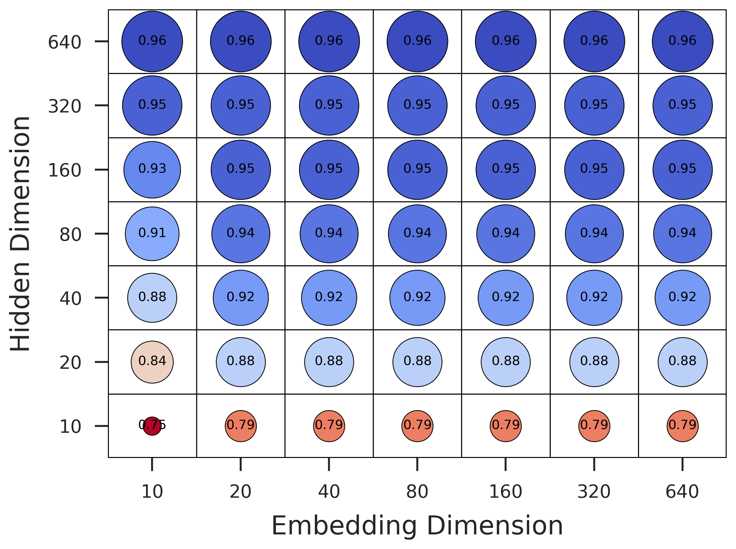
Figure S6. Hyperparameter grid search over embedding and hidden dimensions for the TC-family classification task. Each circle represents the sample-averaged F1-score achieved by ConTP under a specific combination of embedding dimension (x-axis) and hidden dimension (y-axis); circle size and color denote performance magnitude. Across all embedding dimensions, performance increases substantially with larger hidden dimensions, indicating that the hidden layer capacity is the dominant factor shaping model effectiveness. In contrast, the choice of embedding dimension has only a minor influence on performance once the hidden dimension exceeds ~40 units. Notably, configurations with a hidden dimension of 10 consistently yield poor F1-scores (~0.79), whereas settings ≥160 achieve uniformly strong performance (≥0.93). These results demonstrate that ConTP benefited primarily from a sufficiently expressive hidden representation to disentangle transporter functional features, while the downstream embedding size plays a comparatively secondary role.

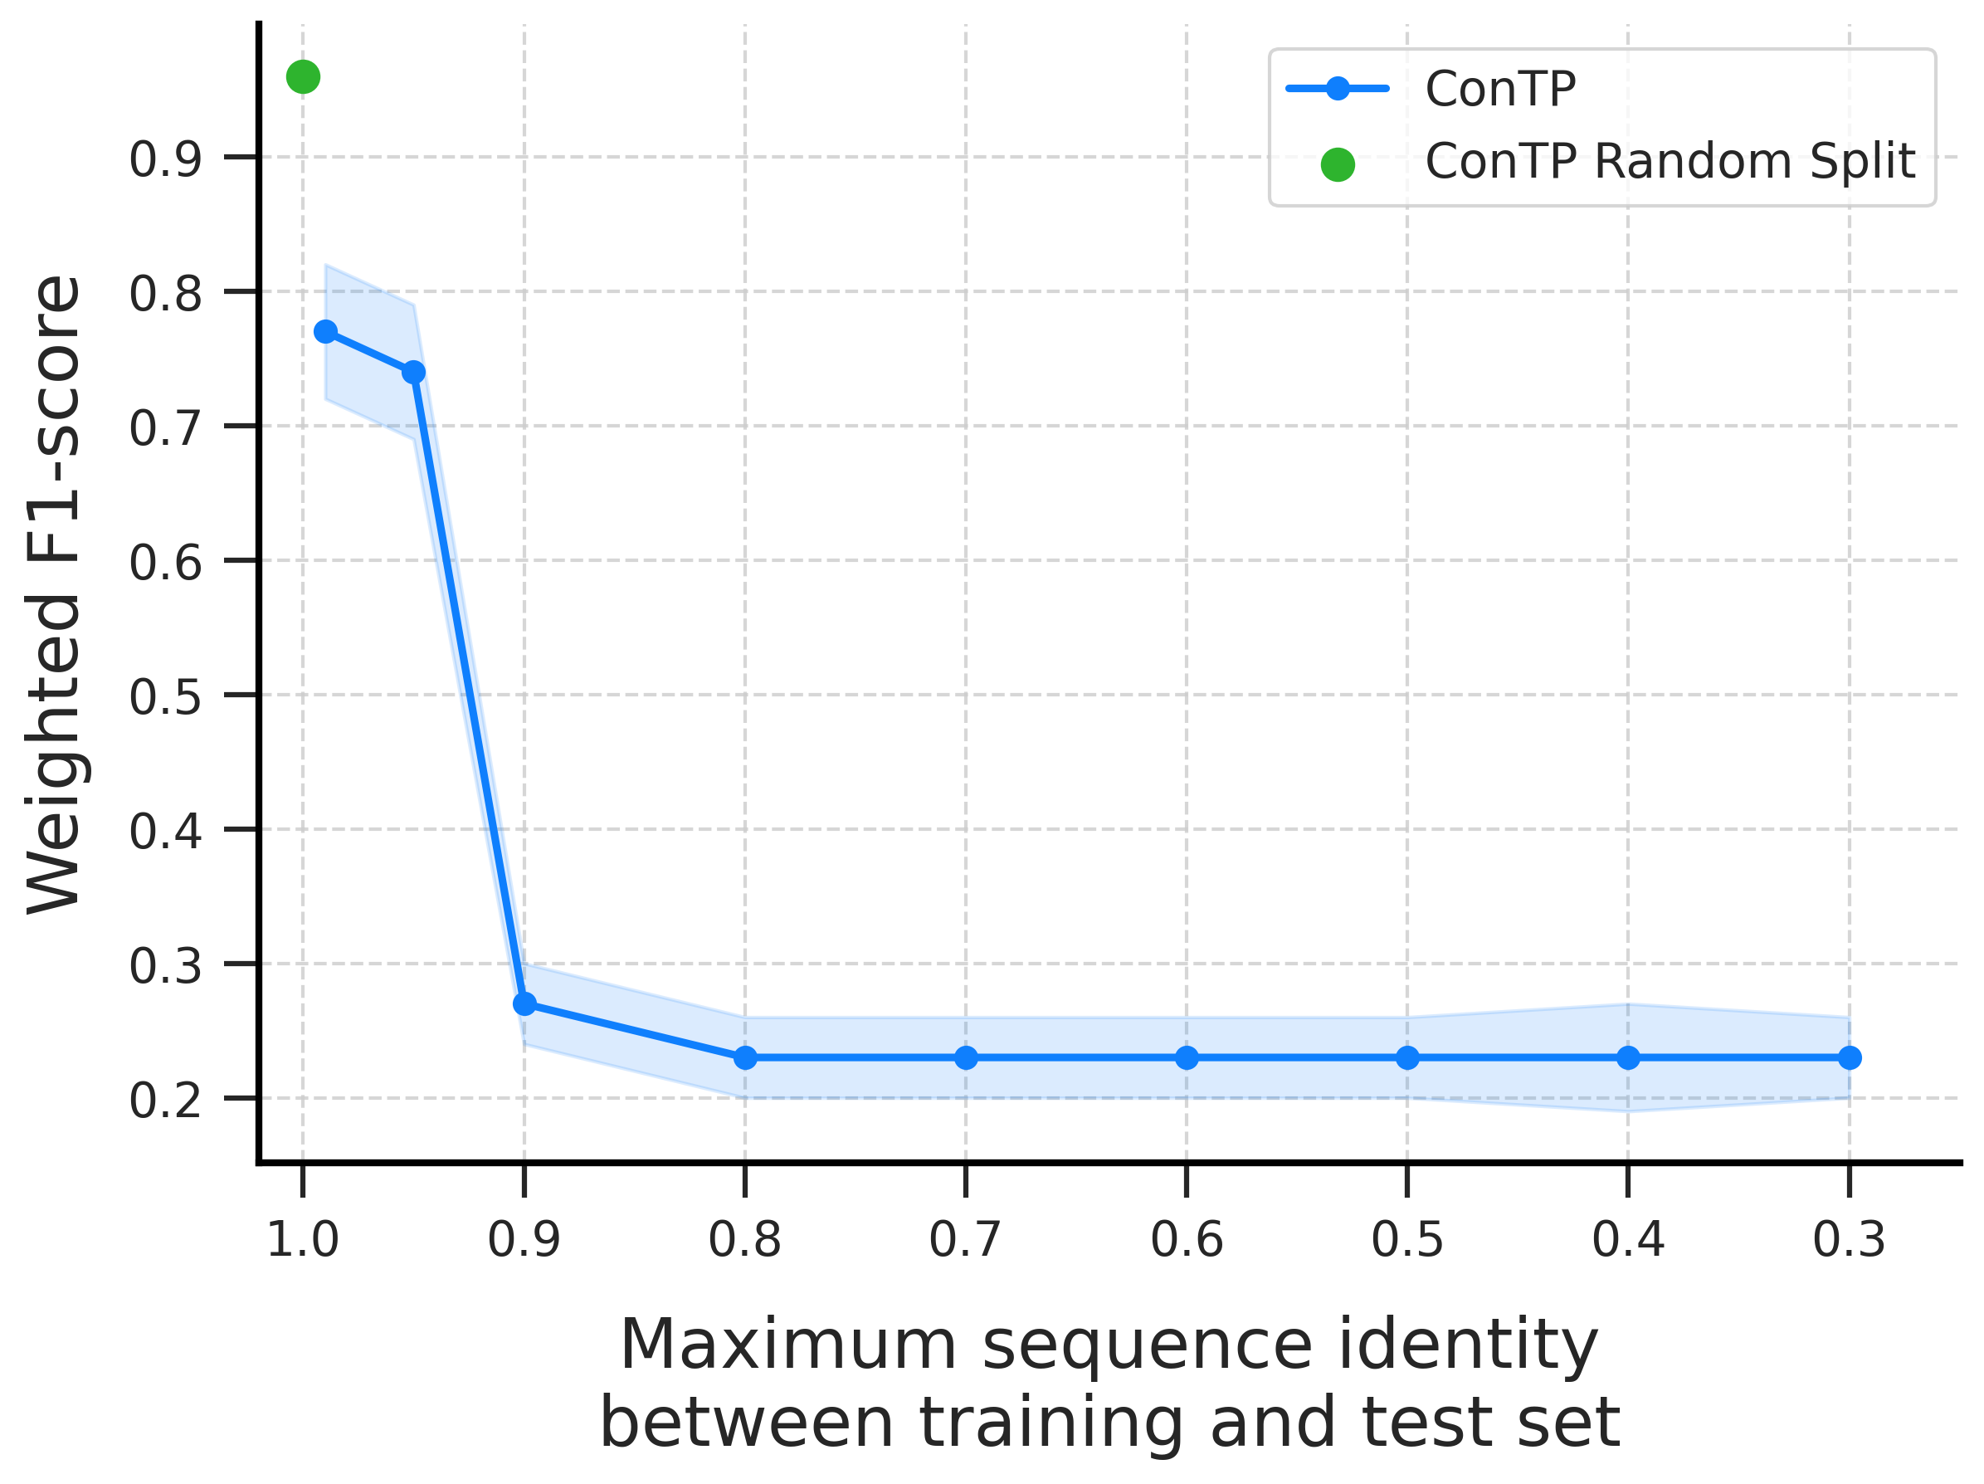
Figure S7. Weighted F1-score of ConTP under increasingly stringent out-of-distribution (OOD) splits defined by maximum allowed sequence identity between training and test sets. Using MMseqs2-based cluster splits, we restricted the highest sequence identity between any training–test pair from 0.99 down to 0.30. ConTP exhibits a pronounced performance drop when the threshold is reduced from 0.95 to 0.90, reflecting the point at which a large fraction of substrate types and TC families in the test set no longer appear in training, creating a near zero-shot inference scenario. At 0.90, there are 727 TC families are absent from the training set, compared with only 224 at 0.95. This creates a large-scale, near zero-shot setting for TC-family prediction, naturally resulting in reduced accuracy. Below 0.90 identity, performance stabilizes at ~0.22–0.25, indicating that ConTP retains meaningful discriminative ability even for remote homologues with ≤30% identity. The green point denotes ConTP's performance under a standard random split, which serves as an approximate upper bound and highlights the difficulty of the OOD benchmarks. Together, these results illustrate ConTP’s robustness to distributional shift and its ability to generalize beyond sequence homology.

Supplementary Note 7. Additional information for the CLIC6 Case Study
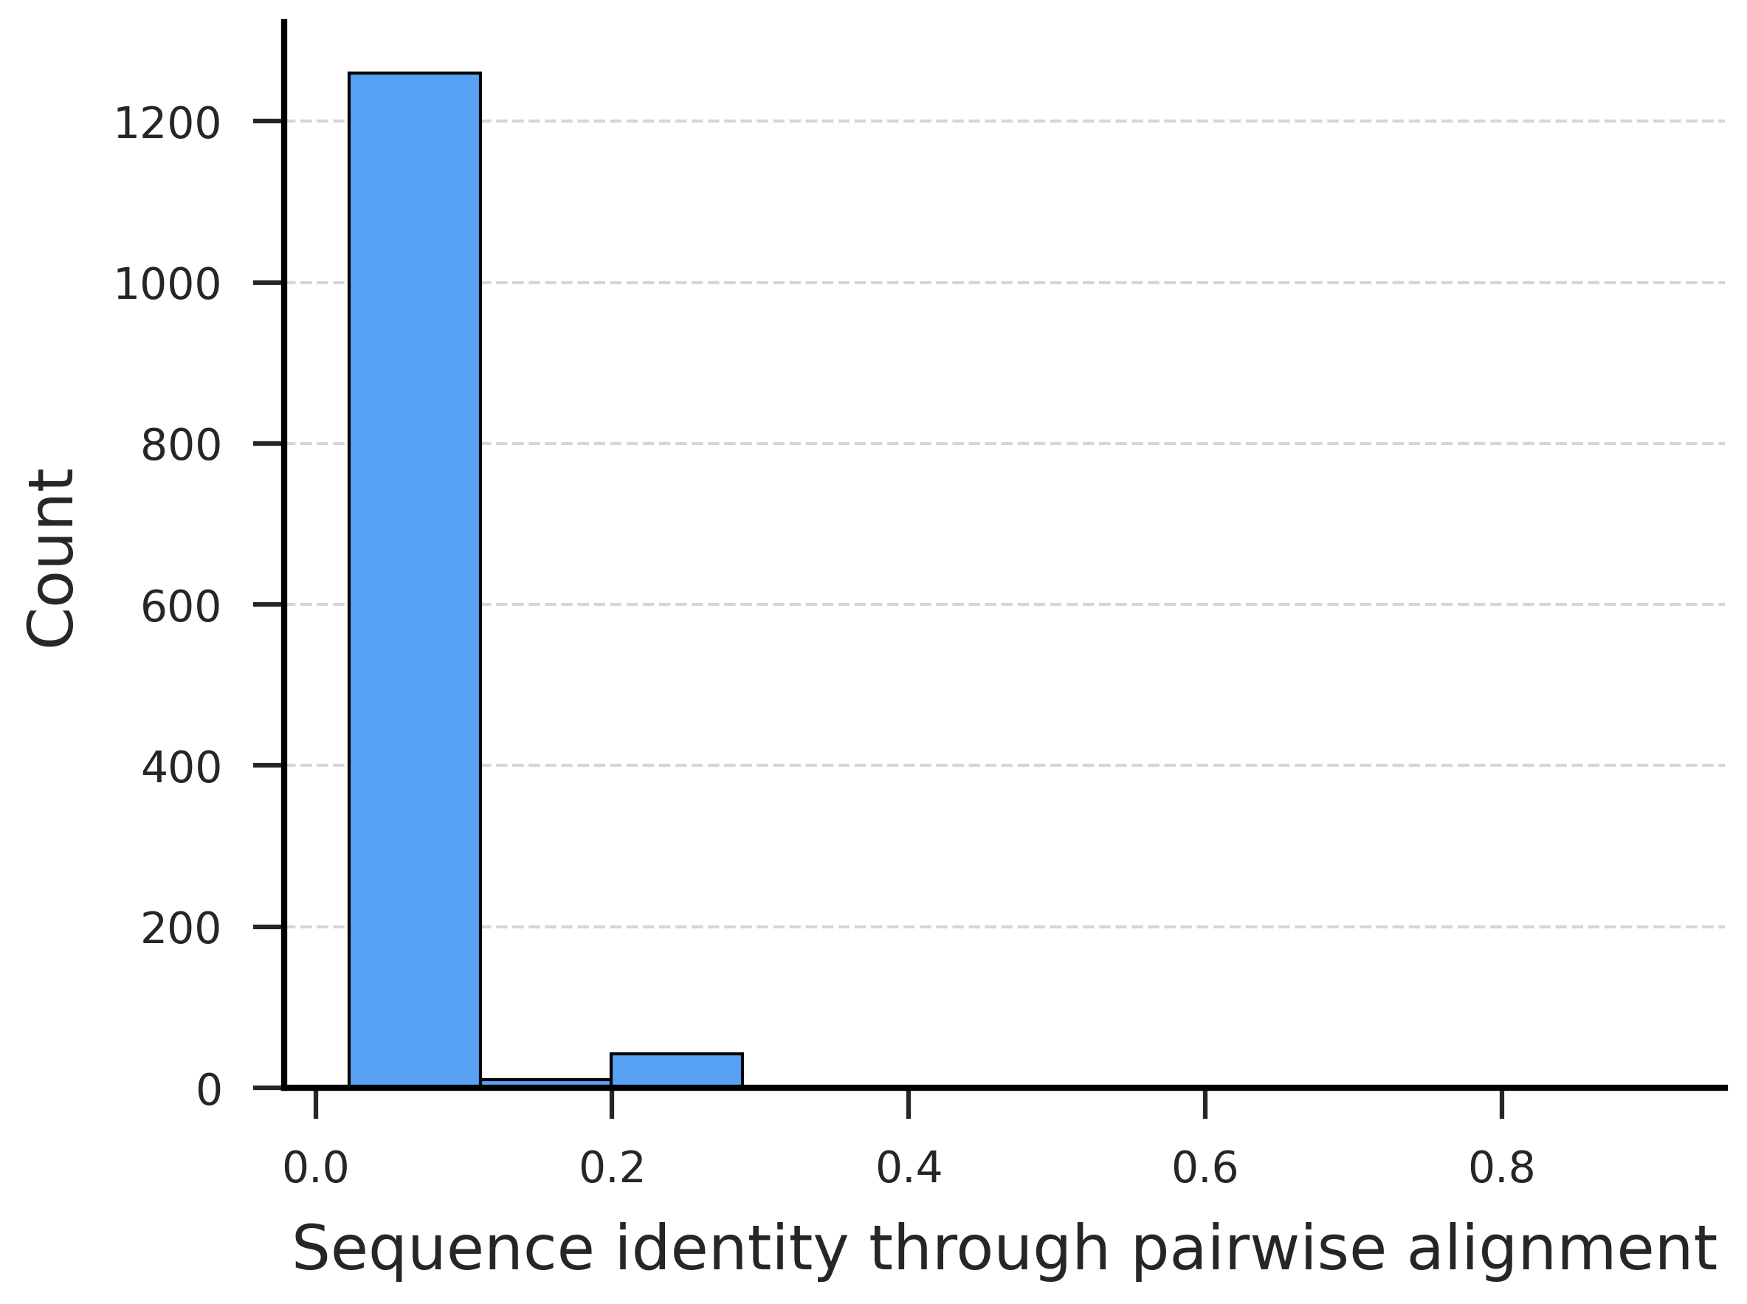
Figure S8. Distribution of sequence identities between CLIC6 and the training sequences. CLIC6 is a test-set protein (TCDB ID 1.A.12.1.4, UniProt ID Q96NY7) belonging to the intracellular chloride channel family. As shown in Figure S8, the vast majority of training sequences exhibit extremely low sequence identity to CLIC6 (median ≈ 7.4%, interquartile range 6–8%). Only a small tail extends to ~20%, and only a single sequence in the entire training set exceeds 25% identity (UniRef90_F6Q8V4, retrieved through homology-based augmentation from UniRef90). This distribution confirms that CLIC6 lies in a deep out-of-distribution (OOD) region with respect to the training data, making it a stringent test case for functional generalization.

Supplementary Note 8. Inference efficiency comparison
To systematically benchmark the inference efficiency of ConTP against existing substrate-prediction methods, we measured the wall-clock time required to process 1,000 query transporter sequences under standard computing environments (Table S3). The results highlight substantial differences across methods, largely driven by their computational paradigms.

Table S3. Wall-clock inference time across representative methods.
Method | Time (minutes / 1,000 samples) | Availability
ConTP | 2-5 | Open-source
SPOT | 10-15 | Server-only
TooT-SC | 90-100 | Open-source
TranCEP | 2000-5000 | Open-source
TrSSP | 10-15 | Server-only

Inference efficiency summary. ConTP achieves the fastest inference among all tested methods (2–5 minutes per 1,000 proteins), owing to two key design advantages:
- GPU-accelerated embedding using ESM-2. The most time-consuming component of ConTP is the forward pass through the ESM-2 language model to compute embeddings of query transporters. This process is highly parallelizable and benefits significantly from GPU computation. In contrast to alignment-based methods, ConTP avoids all online homology search, enabling extremely high throughput.
- Prototype-based functional annotation with constant-time complexity. After embedding, ConTP performs prediction by computing distances between the query embedding and precomputed functional prototypes. This procedure reduces to batched tensor multiplications on the GPU, with negligible computational overhead (typically <0.1 ms per sequence).

Why existing methods are much slower. Most open-source methods with available local pipelines (TooT-SC, TranCEP) rely heavily on BLAST-based homology search. Because BLAST scales poorly with dataset size and cannot be efficiently batched on GPUs, these pipelines incur orders-of-magnitude slower inference and are impractical for large-scale genome annotation tasks.
Server-only methods (SPOT, TrSSP) have moderate inference times but are constrained by:
- latency and throughput limitations of shared servers,
- CPU-bound execution of feature extraction steps, and
- restricted batch size during inference.
Consequently, none of the existing approaches support high-throughput annotation at the genomic or metagenomic scale.

Implications for high-throughput transporter annotation
By integrating:
- an alignment-free representation model (ESM-2),
- DHR-based homology-driven data augmentation during training, and
- a prototype-based prediction architecture,
ConTP eliminates the need for online sequence search or MSA construction. This design translates directly into high scalability, enabling genome-wide functional annotation in minutes rather than hours or days.
Thus, ConTP represents a practically deployable platform-level tool for high-throughput membrane transporter annotation at the scale required by modern comparative genomics, metagenomics, and protein design applications.

