Supplemental Digital Content

Figure S1 2

Figure S1

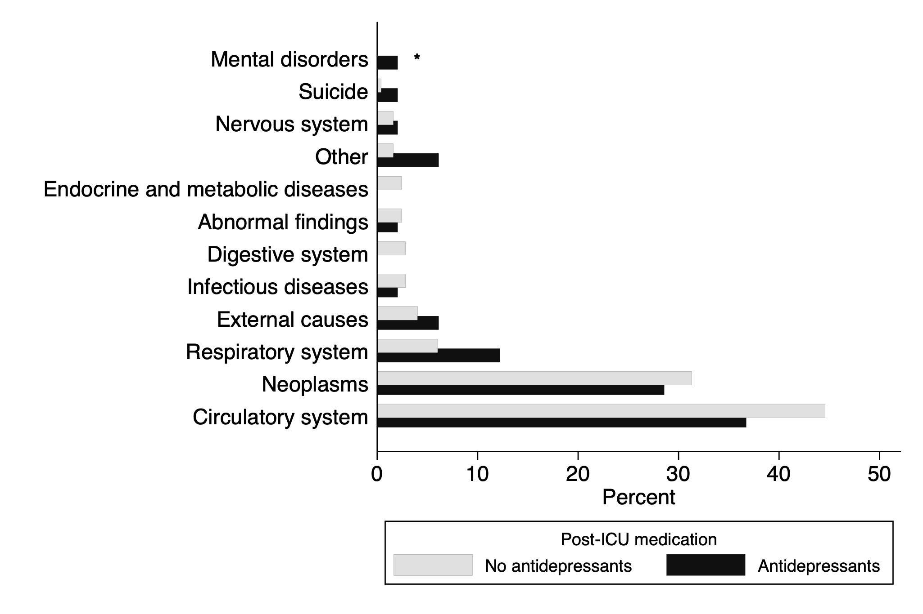

Causes of death for cardiothoracic ICU survivors who died 12–18 months after admission (n = 298). The figure contrasts the distribution of causes of death between non-antidepressant users (grey bars, n = 249) and new antidepressant users (black bars, n = 49). A significant difference was found between the groups (* p < 0.05 by Chi-square test), with higher mortality rates due to mental and behavioral disorders observed among antidepressant users.

