Supplementary Materials
Explainable machine learning-based identification of Chinese college students at risk of problematic social media use: a multicenter cross-sectional online survey

Supplementary methods
The full questionnaire included a broader set of modules than those retained in the cleaned analytic export used for machine-learning modeling. The present supplementary file therefore serves two purposes: (1) to document the derivation and coding of the analytic variables that entered the PSMU models; and (2) to make transparent the broader survey domains that were collected but not used in the current prediction analysis.
Because the present study focused on a predefined prediction task, only harmonized variables available in the cleaned analytic dataset were eligible for model fitting. Questionnaire modules that were not part of that cleaned modeling export are listed below for transparency, but were not analyzed in the present manuscript.
Institution-name responses were used only to characterize the recruitment setting. The sample covered a broad range of institutions and was regionally concentrated in Zhejiang, Jiangsu, and Shanghai, consistent with the WeChat/QQ recruitment networks used in this online survey.
Supplementary Table S1. Derivation and coding of the analytic variables.
Analytic variable | Questionnaire source | Analytic coding | Role / interpretation
Potential PSMU (BSMAS ≥19) | BSMAS, 6 items | Binary outcome: 1 if total score ≥19, else 0 | Screening-positive potential PSMU
Sex | Basic information | 0 = female; 1 = male | Demographic predictor
Grade level | Basic information | 1 = freshman/sophomore; 2 = junior/senior/fifth-year; 3 = master/doctoral | Educational stage
University city tier | Institution location / city-tier classification | Original city classification (tier 1, new tier 1, tier 2, tier 3, tier 4, tier 5) collapsed to 1 = tier 3/4/5 city; 2 = tier 2 city; 3 = tier 1/new tier 1 city | Contextual predictor derived from institution location
Only-child status | Basic information | 0 = no; 1 = yes | Family structure indicator
Highest parental education | Socioeconomic status | 1 = junior high or below; 2 = high school/technical secondary; 3 = college or above | Socioeconomic predictor
Monthly expenditure | Socioeconomic status | 1 = <CNY 1500; 2 = CNY 1500–2000; 3 = CNY 2000–3000; 4 = CNY 3000–4000; 5 = >CNY 4000 | Ordered socioeconomic predictor
Family structure | Socioeconomic status | 0 = non-intact family; 1 = complete family | Family stability indicator
Residence before college | Socioeconomic status | 0 = rural/suburban county; 1 = urban | Pre-college environmental indicator
Sexual orientation | Behavioral risk factors | 0 = other sexual orientation; 1 = heterosexual | Binary predictor; shrunk to zero in LASSO
Smoking | Behavioral risk factors | 0 = no; 1 = yes | Binary health-behavior indicator
Drinking | Behavioral risk factors | 0 = no; 1 = yes | Binary health-behavior indicator
Social media use frequency | Pattern of social media use | 1 = rarely; 2 = sometimes; 3 = often; 4 = always | Ordered digital-exposure predictor
Platform count | Pattern of social media use | Count of self-reported social-media platforms used | Continuous/count predictor
Short-video platform use | Pattern of social media use | 0 = no; 1 = yes | Binary digital-behavior indicator; shrunk to zero in LASSO
Dating app use | Pattern of social media use | 0 = no; 1 = yes | Binary digital-behavior indicator
Shared health information online | HPV awareness and social media / online health behavior | 0 = no; 1 = yes | Binary online health-behavior indicator
Sought health information online | HPV awareness and online health information seeking | 0 = no; 1 = yes | Binary online health-seeking indicator
DASS | DASS-21 | 0 = no DASS subscale in the moderate-or-higher range; 1 = at least one subscale moderate or above | Mental distress indicator
Supplementary Table S2. Questionnaire modules collected but not entered into the current PSMU prediction models.
Questionnaire module | Example instrument or item set | Reason not modeled in the current manuscript
Childhood sexual abuse | Adapted CSA items (severity-classified) | Collected but not entered into the prespecified PSMU modeling export
Sexual behaviors | Sexual behavior questions (masturbation, intercourse, casual sex, multiple partners, contraceptive use) | Collected but not entered into the current analytic dataset used for PSMU prediction
Adverse sex-related outcomes | Unintended pregnancy / abortion / STI history composite | Collected but not entered into the current modeling set
Condom use and condom attitudes | Condom-use frequency items and Multidimensional Condom Attitudes Scale (MCAS) | Collected for broader survey aims; not included in the PSMU prediction models
STI awareness | Awareness of common sexually transmitted infections | Collected for descriptive sexual-health profiling; not modeled here
eHealth literacy | Eight-item eHealth literacy scale | Not entered into the cleaned analytic export used for PSMU prediction
HPV awareness and knowledge | HPV awareness, vaccine awareness, HPV-related cancer knowledge | Collected for broader HPV-related study aims; not modeled here
Sex-biased HPV vaccination information | Social-media HPV information, norms, susceptibility, severity, benefits, barriers, self-efficacy | Collected but outside the prespecified predictor set for this manuscript
Sexual health literacy | Twenty-nine-item sexual health literacy module | Collected but not included in the final analytic export used here
HPV vaccine and cervical cancer literacy | Nine-item literacy/intention module | Collected for broader questionnaire scope; not modeled here
Supplementary Table S3. Final tuned hyperparameters used in each predictive model.
Model | Parameters
Logistic regression | {'C': 1, 'class_weight': 'balanced', 'solver': 'saga'}
Random forest | {'class_weight': 'balanced', 'max_depth': 10, 'min_samples_leaf': 3, 'min_samples_split': 10, 'n_estimators': 200}
XGBoost | {'gamma': 0, 'learning_rate': 0.01, 'max_depth': 5, 'min_child_weight': 1, 'n_estimators': 500, 'scale_pos_weight': 1, 'subsample': 0.5}
LightGBM | {'class_weight': None, 'colsample_bytree': 0.8, 'learning_rate': 0.1, 'max_depth': -1, 'min_child_samples': 20, 'n_estimators': 100, 'num_leaves': 8, 'subsample': 0.5}
Gaussian naive Bayes | {'var_smoothing': 1e-09}
k-nearest neighbors | {'algorithm': 'kd_tree', 'leaf_size': 30, 'metric': 'minkowski', 'n_neighbors': 9, 'p': 2, 'weights': 'uniform'}
Supplementary Table S4. Full LASSO coefficient table.
Feature entered into LASSO | Coefficient | Direction | Selected
Social media use frequency | 0.815 | Positive | Yes
Platform count | 0.087 | Positive | Yes
Monthly expenditure | 0.274 | Positive | Yes
University city tier | 0.216 | Positive | Yes
Grade level | 0.073 | Positive | Yes
Highest parental education | 0.028 | Positive | Yes
Dating app use | 0.558 | Positive | Yes
DASS_ | 0.763 | Positive | Yes
Drinking | 0.682 | Positive | Yes
Smoking | 0.406 | Positive | Yes
Only-child status | 0.350 | Positive | Yes
Residence before college | -0.513 | Negative | Yes
Family structure | 0.374 | Positive | Yes
Sexual orientation | 0.000 | Zero | No
Short-video platform use | 0.000 | Zero | No
Sex | -0.131 | Negative | Yes
Shared health information online | -0.427 | Negative | Yes
Sought health information online | 0.001 | Positive | Yes
Supplementary Table S5. Broad regional concentration of self-reported institution locations.
Region group | Count | Percent of sample
Zhejiang | 1041 | 43.1%
Jiangsu | 694 | 28.8%
Shanghai | 527 | 21.8%
Beijing | 18 | 0.7%
Other provinces/regions | 133 | 5.5%

Supplementary figures
Figure S1. SHAP summary bar plot ranking features by mean absolute SHAP value in the XGBoost model.
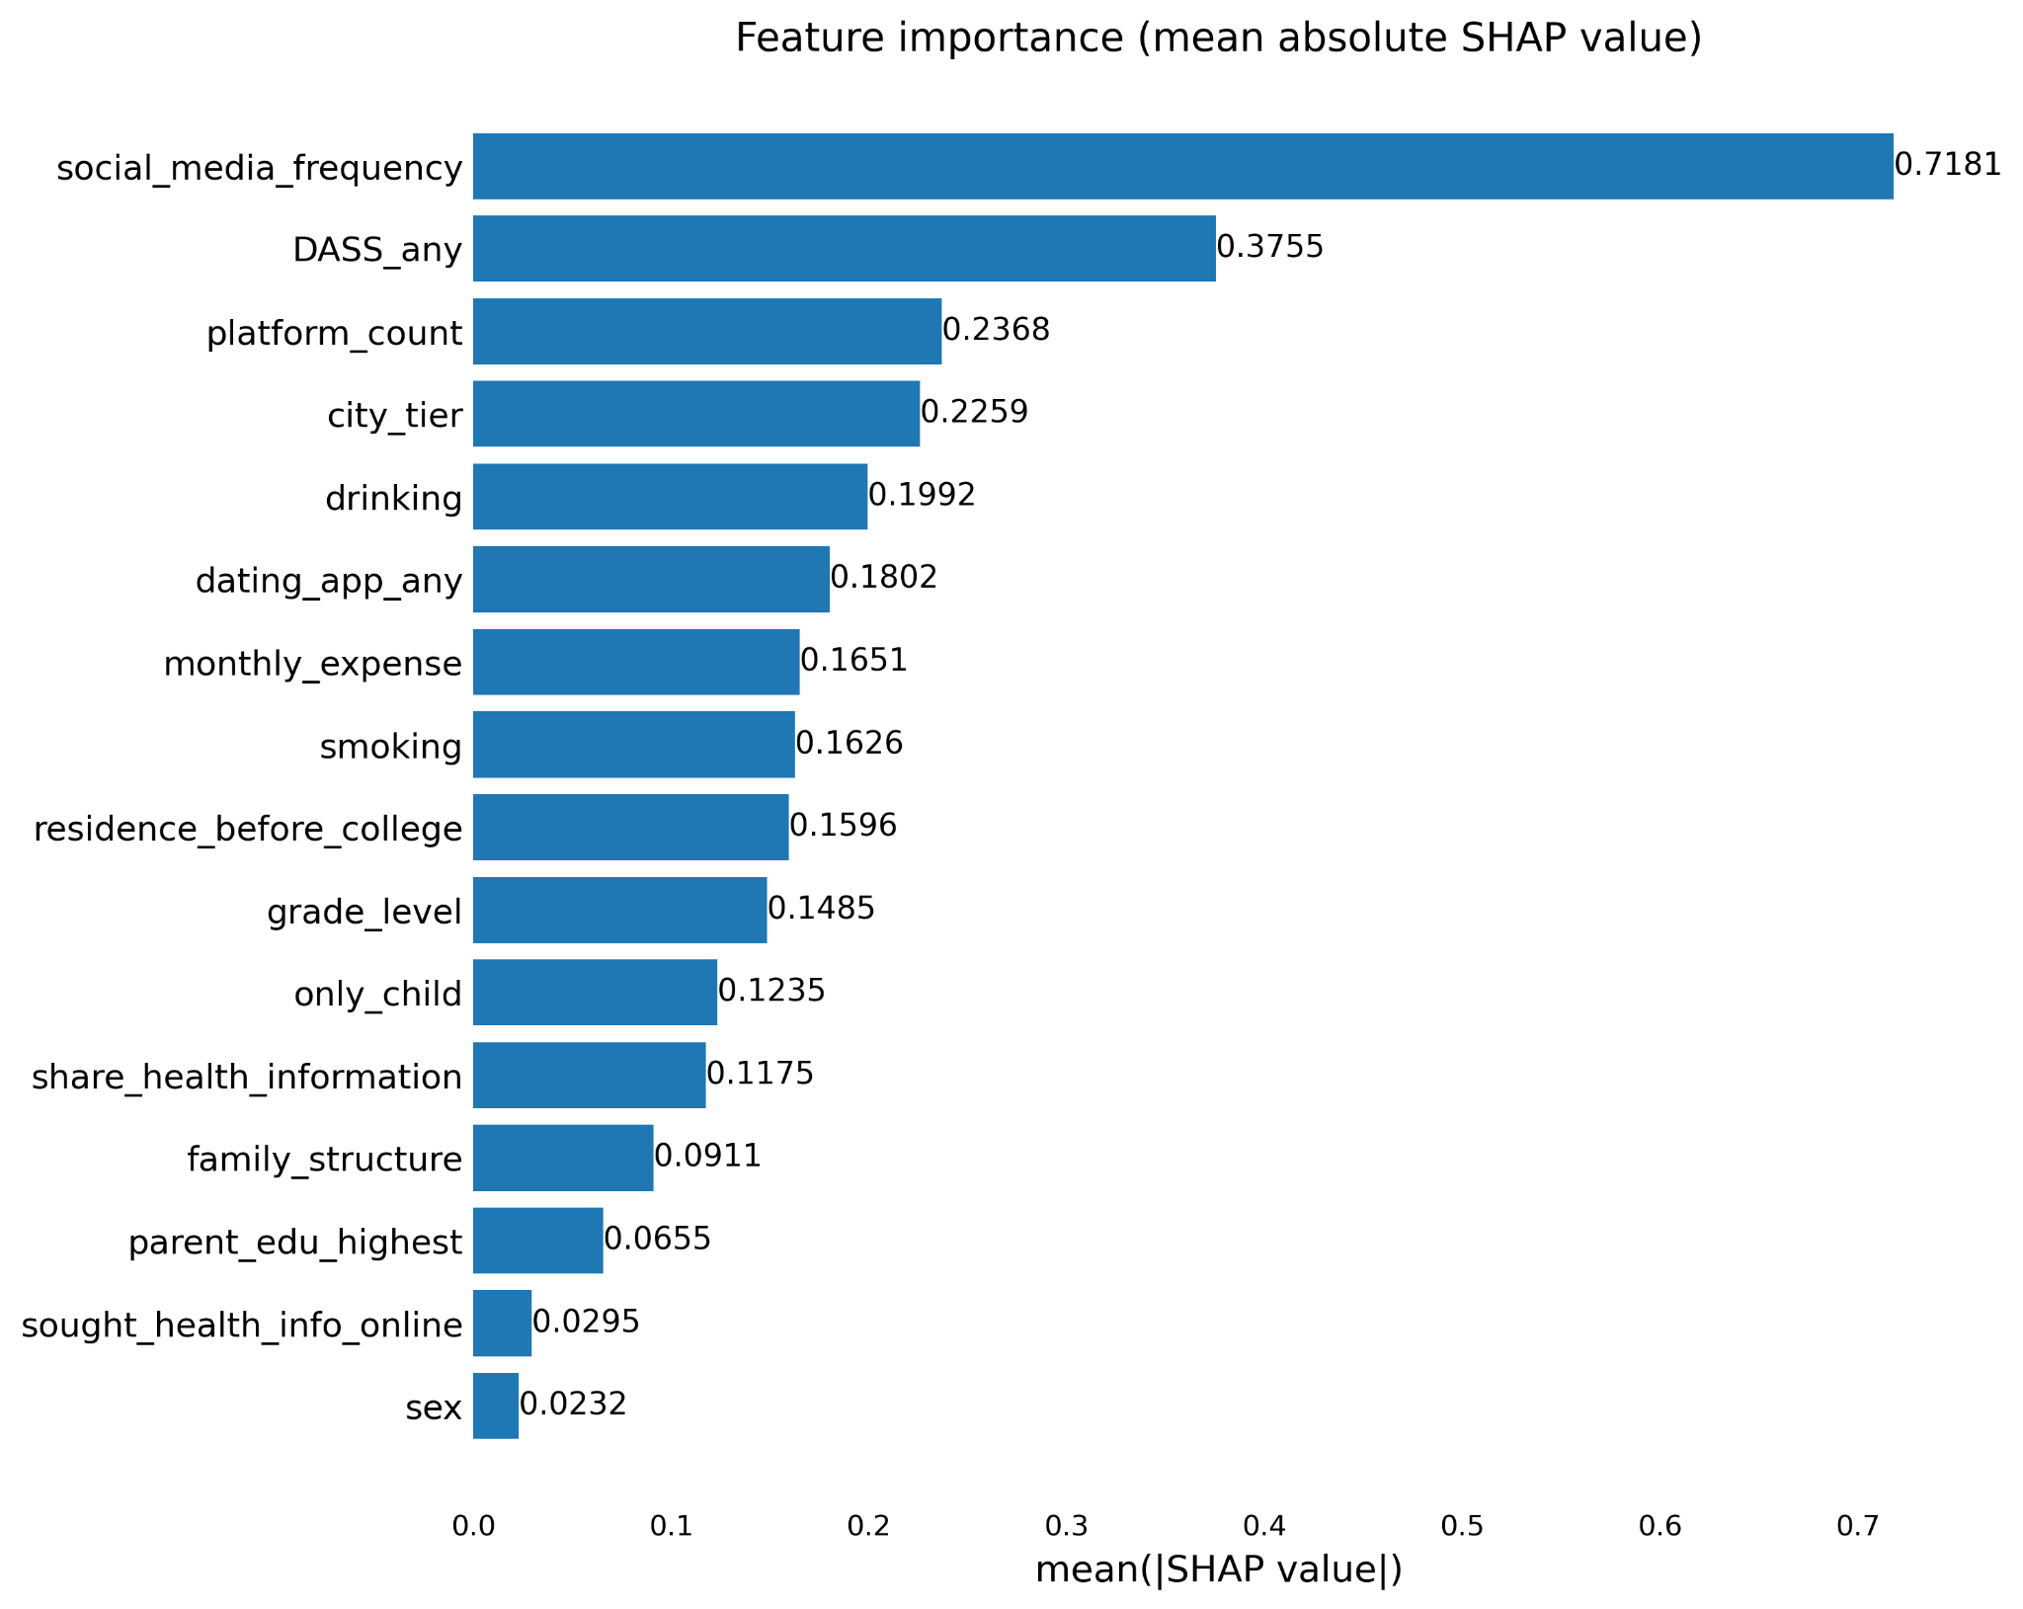
Figure S2. SHAP heatmap showing feature-level contributions across participants in the XGBoost model.
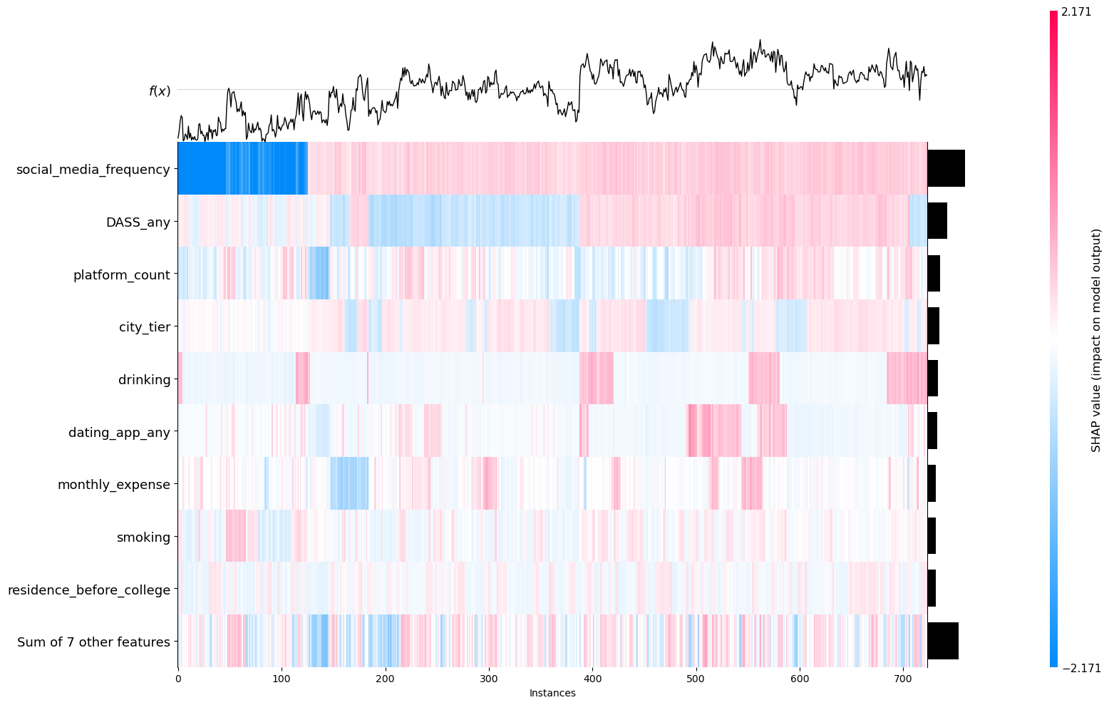
Figure S3. SHAP decision plot illustrating cumulative feature contributions to model output for individual participants.
