APPENDIX

TABLE A1
Description of each item of Mental health, ADL/IADL, Receive care for ADL/IADL, Diagnosed with chronic diseases, Take medicine for chronic diseases variables
Variables | Widowed | Married | T-test
Panel A: Mental Health (CESD score)
Felt depressed | 2.103 | 1.852 | 0.251***
Everything an effor | 2.148 | 1.884 | 0.265***
Sleep was restless | 2.327 | 2.031 | 0.296***
Was happy | 2.662 | 2.900 | -0.238***
Felt lonely | 2.190 | 1.446 | 0.743***
Bothered by little things | 2.022 | 1.900 | 0.122***
Could not get going | 1.678 | 1.338 | 0.340***
Had trouble keeping in mind on what is doing | 2.043 | 1.858 | 0.185***
Feel hopeful about the future | 2.361 | 2.678 | -0.316***
Feel fearful | 1.531 | 1.334 | 0.197***
Panel B: Have difficulty in ADL & IADL
Some Diff-Dressing | 0.122 | 0.0530 | 0.069***
Some Diff-Bathing, shower | 0.158 | 0.0640 | 0.095***
Some Diff-Eating | 0.0480 | 0.0230 | 0.025***
Some Diff-Get in/out bed | 0.136 | 0.0560 | 0.079***
Some Diff-Using the toilet | 0.208 | 0.110 | 0.098***
Some Diff-controling urination and defecation
Some Diff-cleaning house | 0.253 | 0.105 | 0.148***
Some Diff-Prepare hot meal | 0.196 | 0.0860 | 0.111***
Some Diff-Shop for grocery | 0.183 | 0.0770 | 0.106***
Some Diff-Take medications | 0.102 | 0.0500 | 0.052***
Some Diff-Use telephone | 0.254 | 0.102 | 0.152***
Some Diff-Managing money | 0.184 | 0.105 | 0.079***
Panel C: Receive care of ADL & IADL
Whether anyone helps dress | 0.390 | 0.461 | -0.071**
Whether anyone helps bathe | 0.587 | 0.590 | -0.00300
Whether anyone helps eat | 0.527 | 0.474 | 0.0530
Whether anyone helps get in/out of bed | 0.324 | 0.302 | 0.0220
Whether anyone helps use the toilet | 0.228 | 0.165 | 0.063***
Whether anyone helps with housework | 0.587 | 0.628 | -0.041*
Whether anyone helps prepare hot meals | 0.668 | 0.759 | -0.091***
Whether anyone helps with grocery shopping | 0.808 | 0.785 | 0.0230
Whether anyone helps with taking medication | 0.668 | 0.640 | 0.0290
Whether anyone helps with making phone calls | 0.710 | 0.727 | -0.0170
Whether anyone helps with managing money | 0.537 | 0.708 | -0.171***
Panel D: Diagnosed with chronic disease
Ever had high blood pressure | 0.499 | 0.334 | 0.165***
Ever had diabetes | 0.162 | 0.111 | 0.051***
Ever had cancer | 0.031 | 0.021 | 0.010***
Ever had lung disease | 0.214 | 0.142 | 0.073***
Ever had heart problem | 0.293 | 0.176 | 0.117***
Ever had stroke | 0.107 | 0.051 | 0.056***
Ever had emotional problem | 0.056 | 0.026 | 0.029***
Ever had arthritis | 0.555 | 0.402 | 0.153***
Ever had dyslipidemia | 0.273 | 0.201 | 0.072***
Ever had liver disease | 0.084 | 0.069 | 0.015***
Ever had kidney disease | 0.130 | 0.100 | 0.030***
Ever had stomach/digestive disease | 0.393 | 0.305 | 0.088***
Ever had memory problem | 0.084 | 0.035 | 0.049***
Panel E: Take medicine of chronic disease
Takes any meds for high blood pressure | 0.365 | 0.235 | 0.130***
Takes any meds for diabetes | 0.083 | 0.061 | 0.022***
Takes any meds for cancer | 0.010 | 0.007 | 0.003*
Takes any meds for lung disease | 0.111 | 0.071 | 0.040***
Takes any meds for heart problem | 0.157 | 0.099 | 0.057***
Takes any meds for stroke | 0.043 | 0.0240 | 0.020***
Takes any meds for emotional problem | 0.014 | 0.007 | 0.007***
Takes any meds for arthritis | 0.261 | 0.169 | 0.092***
Takes any meds for dyslipidemia | 0.110 | 0.080 | 0.030***
Takes any meds for liver disease | 0.030 | 0.020 | 0.010***
Takes any meds for kidney disease | 0.047 | 0.036 | 0.011**
Takes any meds for stomach/digestive disease | 0.201 | 0.162 | 0.039***
Takes any meds for memory problem | 0.025 | 0.011 | 0.014***
Note: This table presents summary statistics on each item of mental health, ADL/IADL, receive care for ADL/IADL, diagnosed with chronic diseases, take medicine for chronic diseases variables of widowed individuals and married individuals of CHARLS. Unit of observation is at individual-wave level. The last column reports the T-test on dependent variables. ***, **, and * represent statistical significance at the 1%, 5%, and 10% levels, respectively.

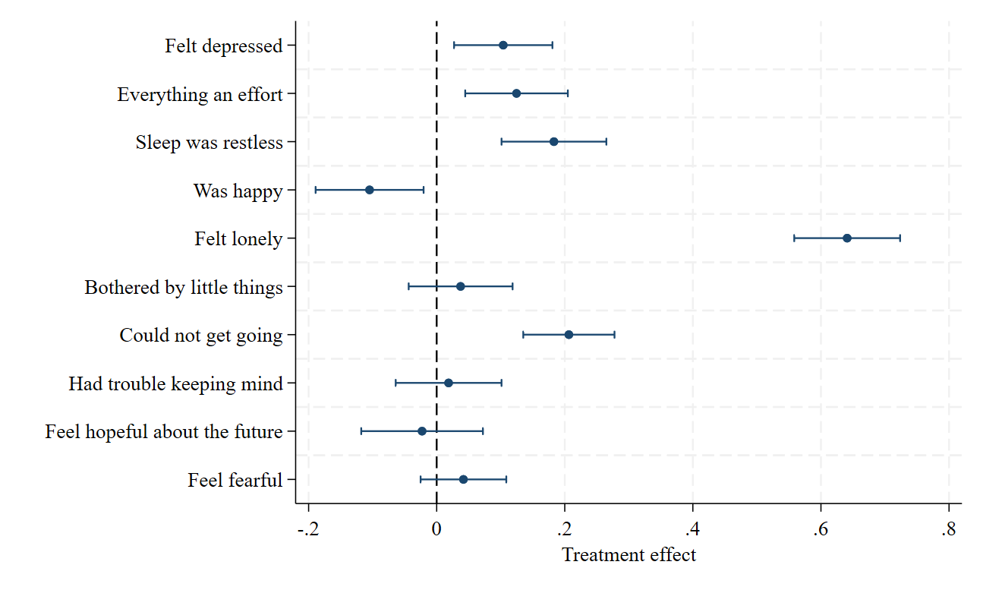
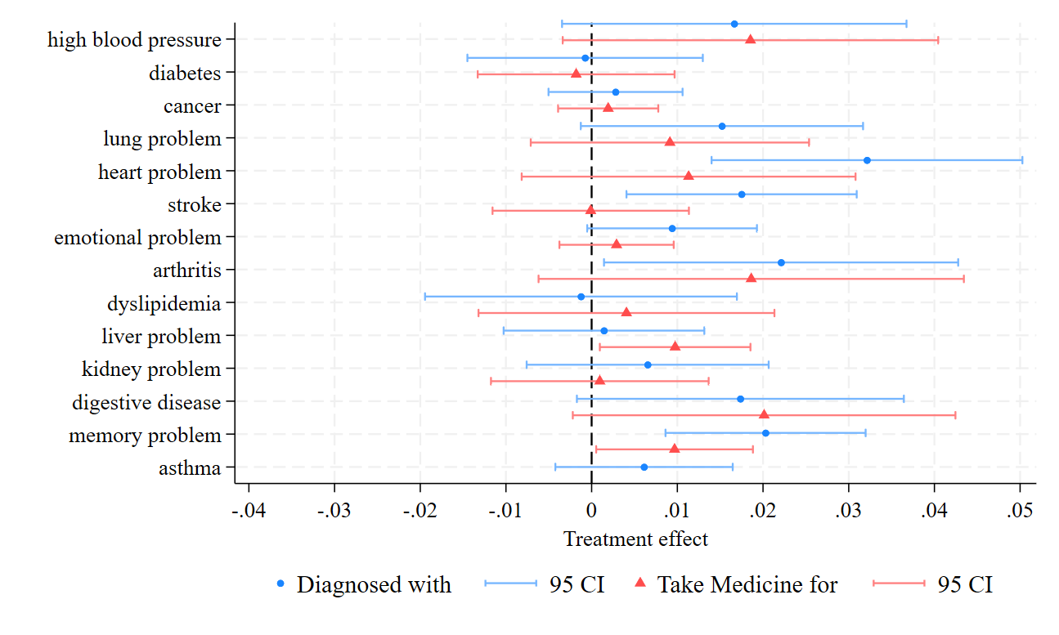
Fig. A1. Effect of widowhood on each item of mental health
Note: This figure shows the effect of widowhood on mental health. Specifically, it presents estimates of coefficient β from equation (1) specification, including survey-wave fixed effects, individual fixed effects, and controls. The bars represent 95 percent confidence intervals. Standard errors are clustered at the individual level.
Fig. A2. Effect of widowhood on each item of chronic diseases and medicine taking
Note: This figure shows the effect of widowhood on chronic diseases and medicine taking. Specifically, it presents estimates of coefficient β from equation (1) specification, including survey-wave fixed effects, individual fixed effects, and controls. The bars represent 95 percent confidence intervals. Standard errors are clustered at the individual level.

