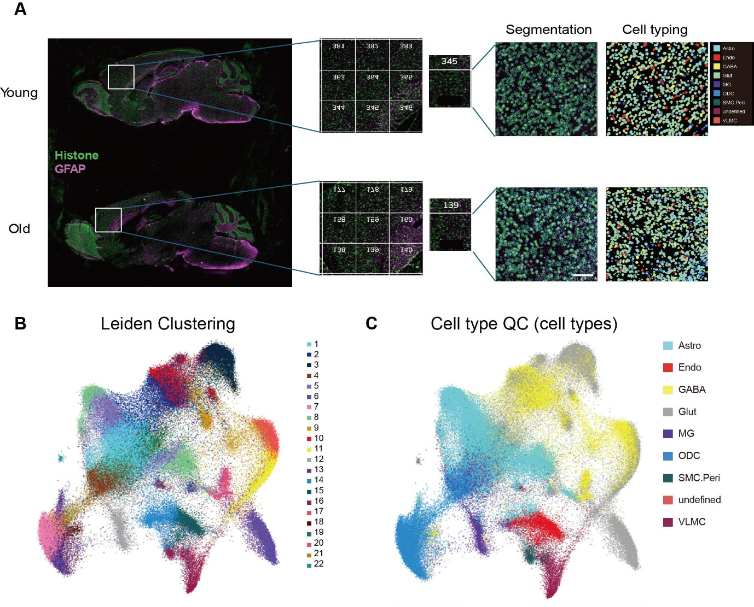

Figure S1. CosMx spatial transcriptomics across young and aged mouse brains. A) Whole-slide preview scans of brain sections from young and aged mice processed using CosMx SMI. Regions of interest (ROIs) were selected from the frontal cortex (FOV345 for young, FOV139 for aged). Representative high-resolution segmentation and cell-type annotation images are shown for each FOV. Cell types were classified based on marker and color-coded as indicated in the legend. B) UMAP clustering by Leiden algorithm. C) Cell type classification using NanoString’s AtoMx platform. Color-coded as indicated in the legend; astrocytes (Astro), endothelial cells (Endo), GABAergic neurons (GABA), glutamatergic neurons (Glut), microglia (MG), oligodendrocytes (ODC), smooth muscle cells and pericytes (SMC.Peri), and vascular leptomeningeal cells (VLMC), annotated by comparison to the Allen Brain Atlas reference.

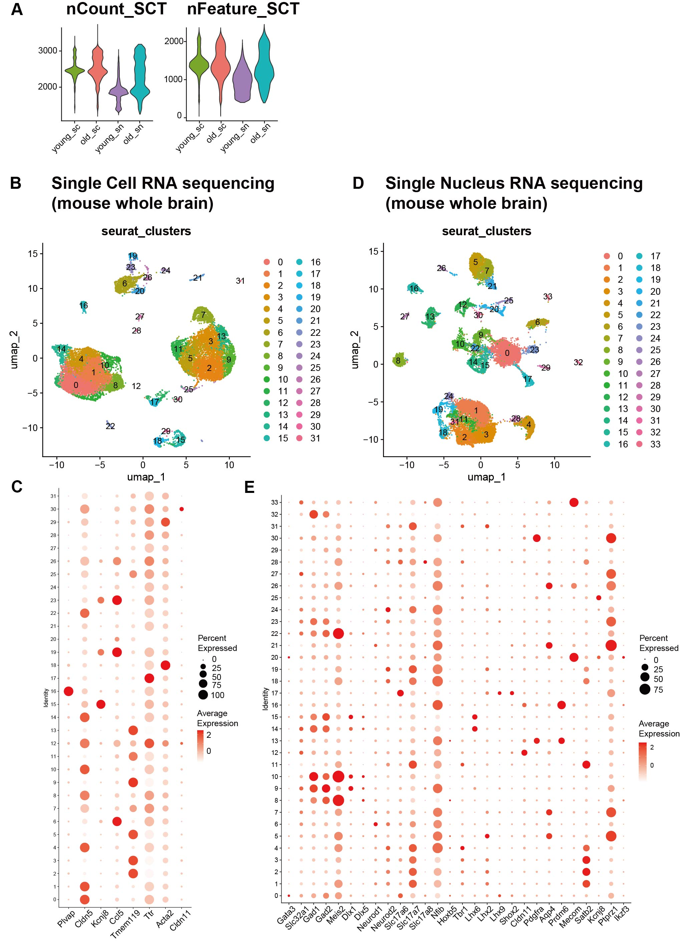
Figure S2. A) Violin plots of SCTransform normalized scRNA-seq and snRNA-seq datasets, depicting QC metrics. B-E) UMAP clustering of two brains from young and old mouse based on scRNA-seq data (B) and two brains based on snRNA-seq data (E). RNA expression levels of canonical marker genes in each cluster of the integrated scRNA-seq dataset (C) and the integrated snRNA-seq dataset (E).

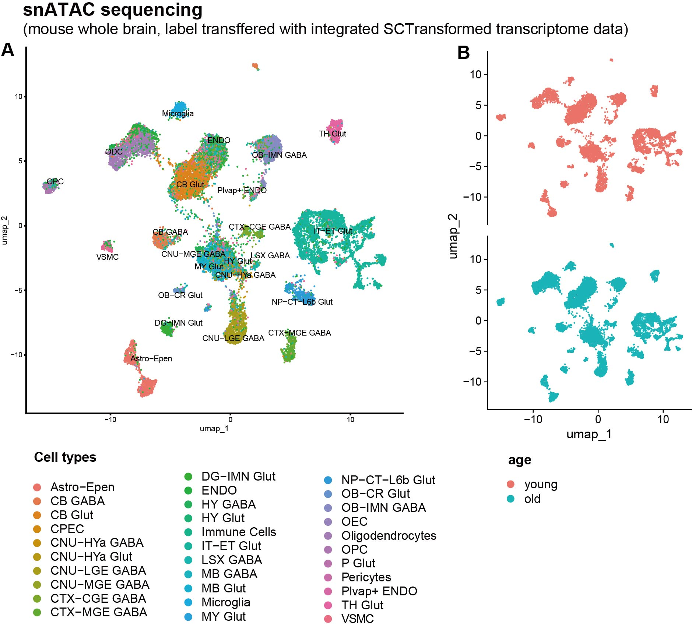

Figure S3. A UMAP dimensional reduction of snATAC-seq datasets.
A) UMAP clustering of two brains from young and old mouse based on snATAC-seq datasets, which of colors represents different cell types. B) UMAP clustering distributed across young (pink) and old (blue) group based on A). Color schemes for A-B) are shown in the key at the bottom of the figures. Astro-Epen: Astrocyte-Ependymal cells; CB: cerebellum gabaergic/glutamatergic neurons; CPEC: choroid plexus epithelial cells; CNU: cerebral nuclei; HYa: anterior hypothalamic; LGE: lateral ganglionic eminence; MGE: medial ganglionic eminence; CTX: cerebral cortex; CGE: caudal cortex; DG: dentate gyrus; IMN: immature neurons; ENDO: endothelial cells; HY: hypothalamus; IT-ET: intratelencephalic-extratelencephalic; LSX: lateral septal complex; MB: midbrain; MY: medulla; NP: near-projecting; CT: corticothalamic; L6b: layer 6b; OB: olfactory bulb; CR: Cajal-Retzius; OEC: olfactory ensheathing cells; OPC: oligodendrocyte precursor cells; P: pons; TH: thalamus; VSMC: vascular smooth muscle cells.
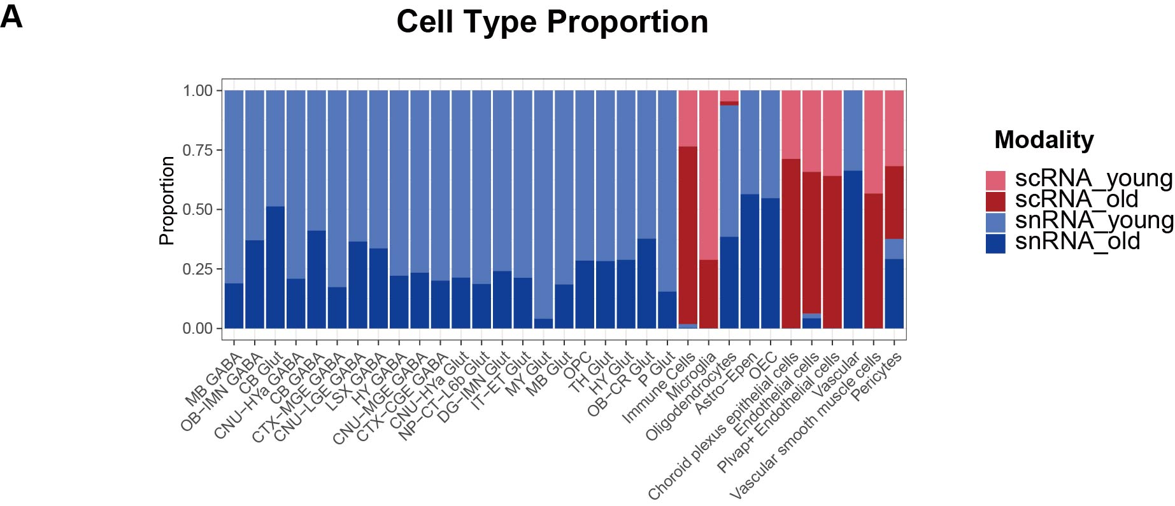

Figure S4. Cell type composition comparison between four datasets of one young and one old mouse brains both in scRNA-seq and snRNA-seq. A) Percentage of each cell type for the 4 brains (one young and one old brain in scRNA-seq; one young and one old brain in snRNA-seq).

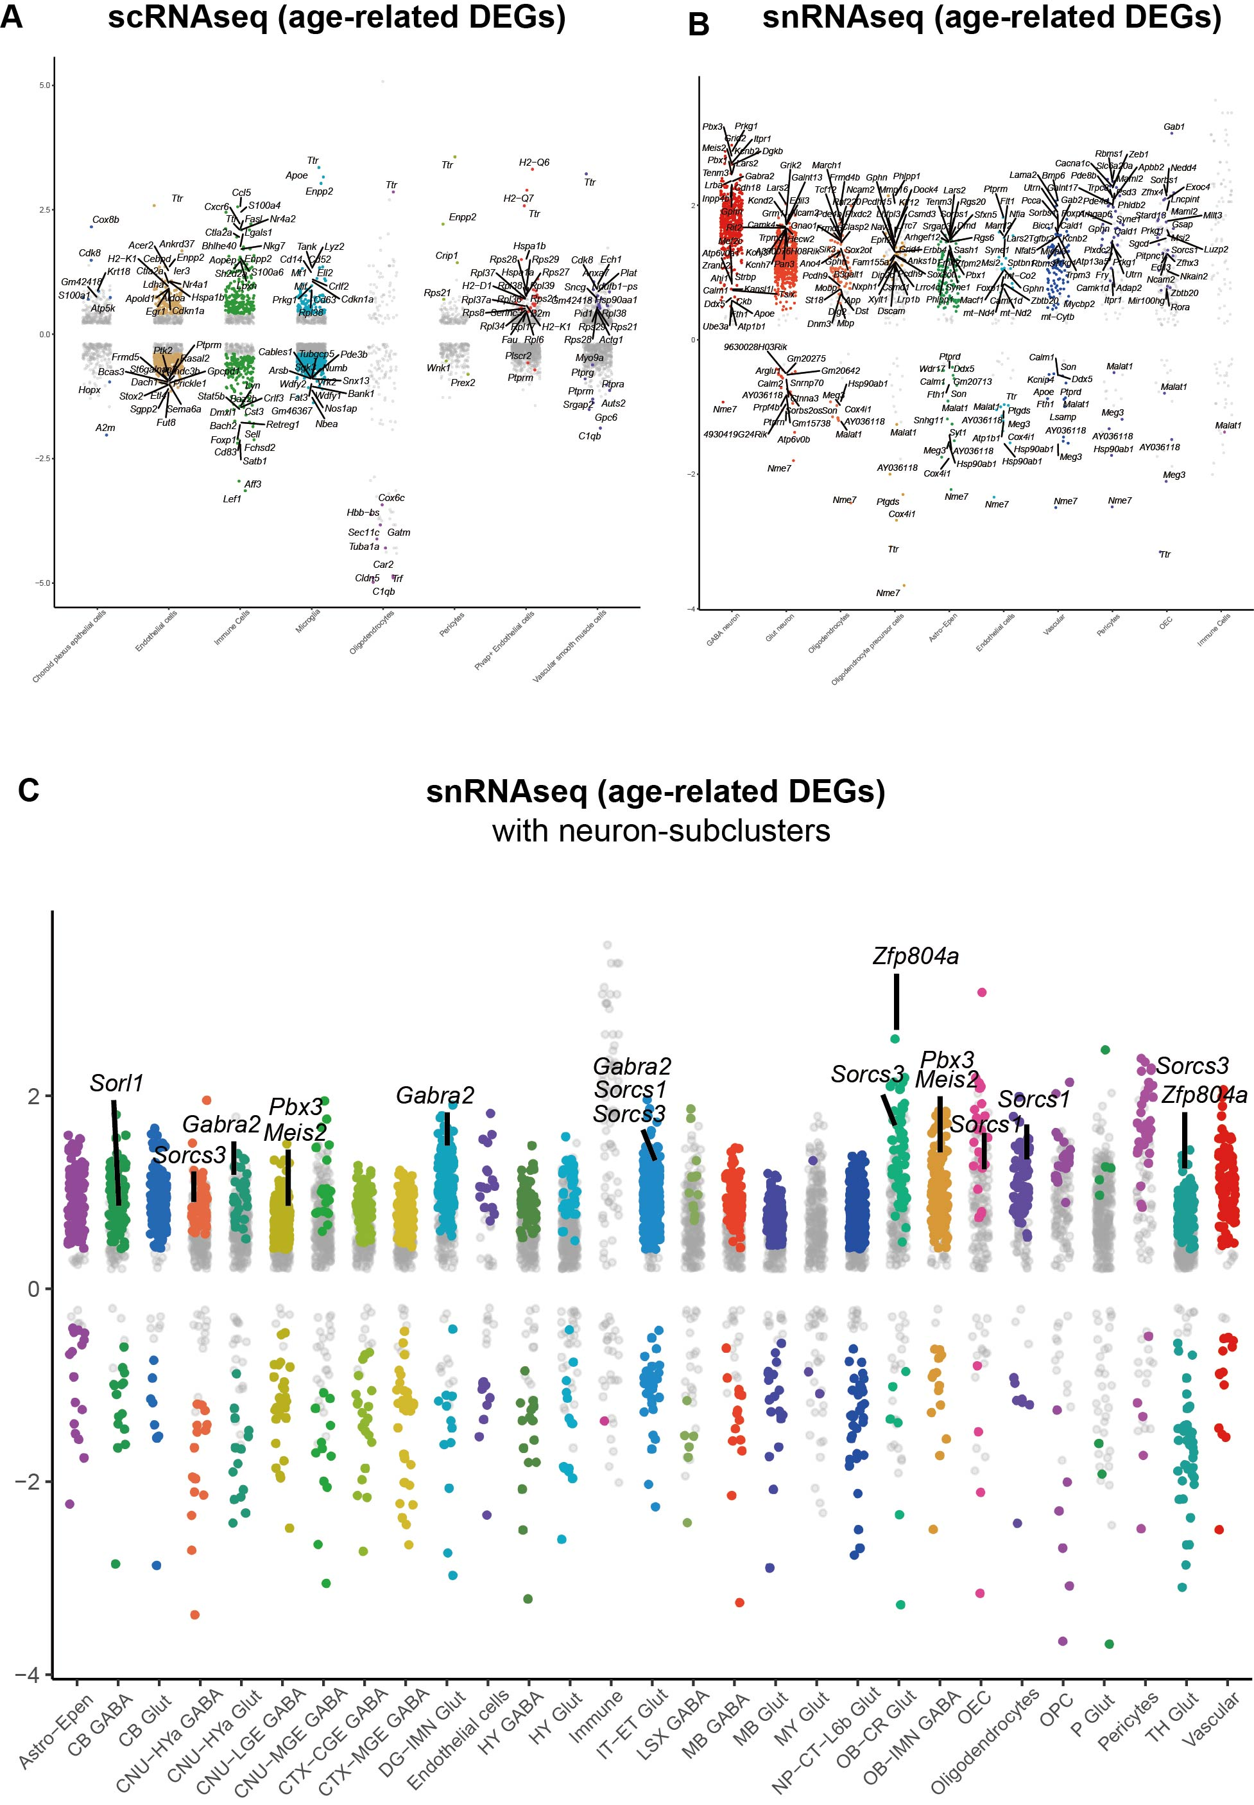

Figure S5. Visualization of aging-related differentially expressed genes (DEGs). A-B) Scatter plots showing significant age-related DEGs of (A) scRNA-seq and (B) snRNA-seq datasets across major cell types. Colored dots represent significantly differentially expressed genes, and labels indicate selected top DEGs. C) Scatter plots visualization of significant neuronal subtype aging related from neuron-subclustered snRNA-seq data. Colored dots represent significantly differentially expressed genes, and labels indicate selected representative DEGs. Cell-type abbreviations correspond to those described in Figure S2.

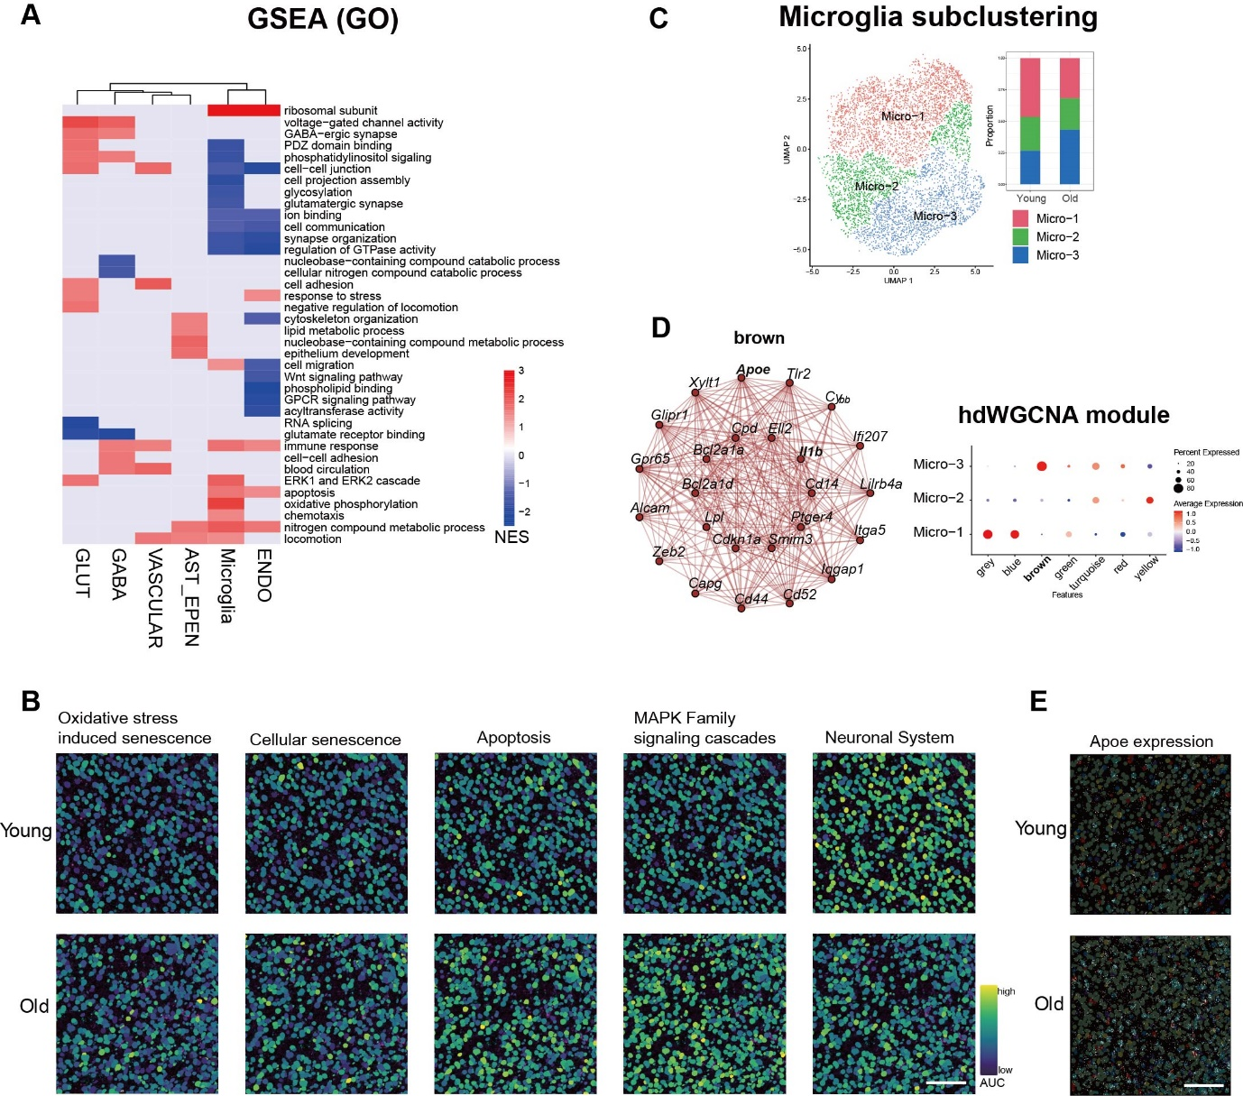

Figure S6. Aging-associated pathway enrichment and microglial reprogramming. A) Gene Ontology (GO) enrichment analysis of cell-type-specific differentially expressed genes (DEGs) in major brain cell types. The heatmap shows significantly enriched biological processes (p < 0.05, gene count ≥ 6), with normalized enrichment scores (NES) indicating directionality (red: upregulated, blue: downregulated). B) CosMx spatial transcriptomic visualization of representative aging-associated pathways including oxidative stress, senescence, apoptosis, MAPK signaling, and neuronal system in young (top) and aged (bottom) brains. C) Microglial subclustering using UMAP and proportional analysis between young and aged brains. D) High-resolution WGCNA (hdWGCNA) analysis showing a co-expression network (brown module) enriched in Micro-3, and dot plot showing expression of selected module genes across microglial subclusters. E) Spatial transcriptomic images showing increased Apoe expression in aged frontal cortex.

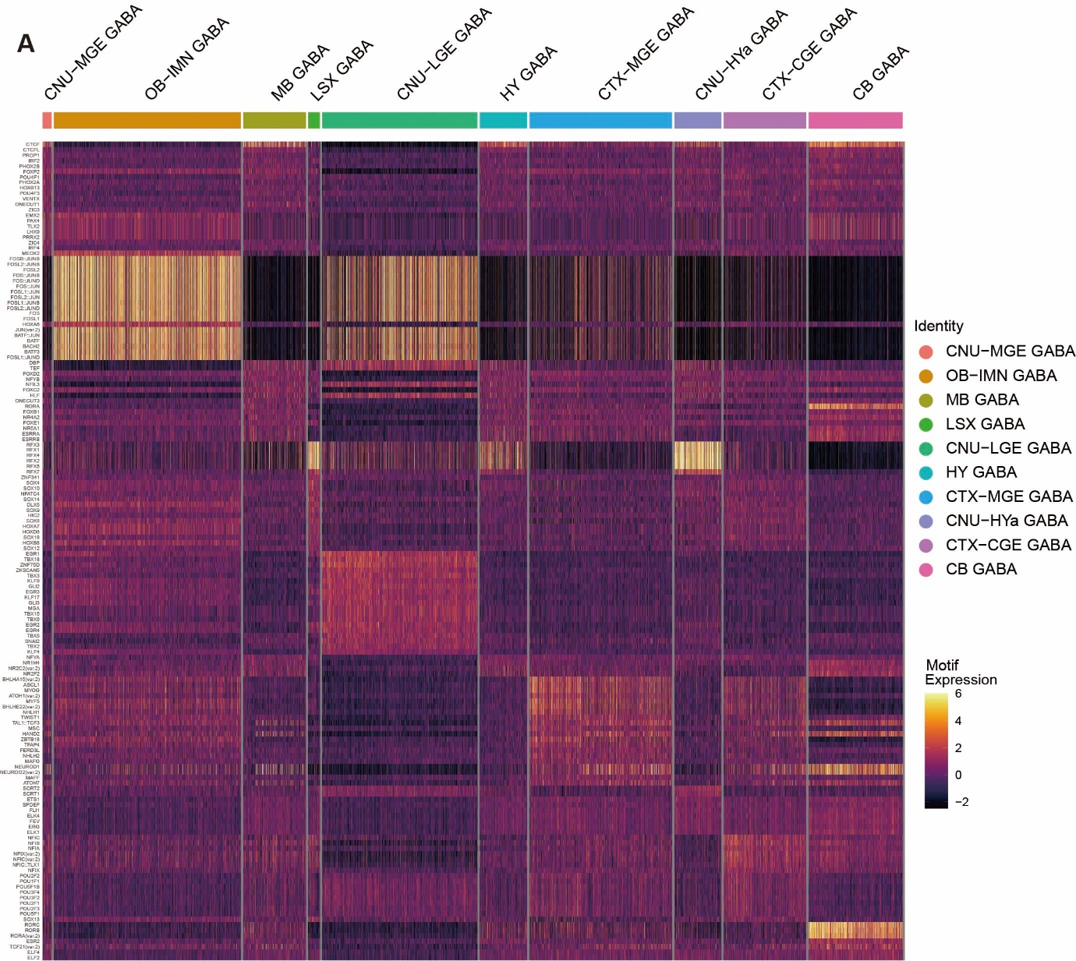
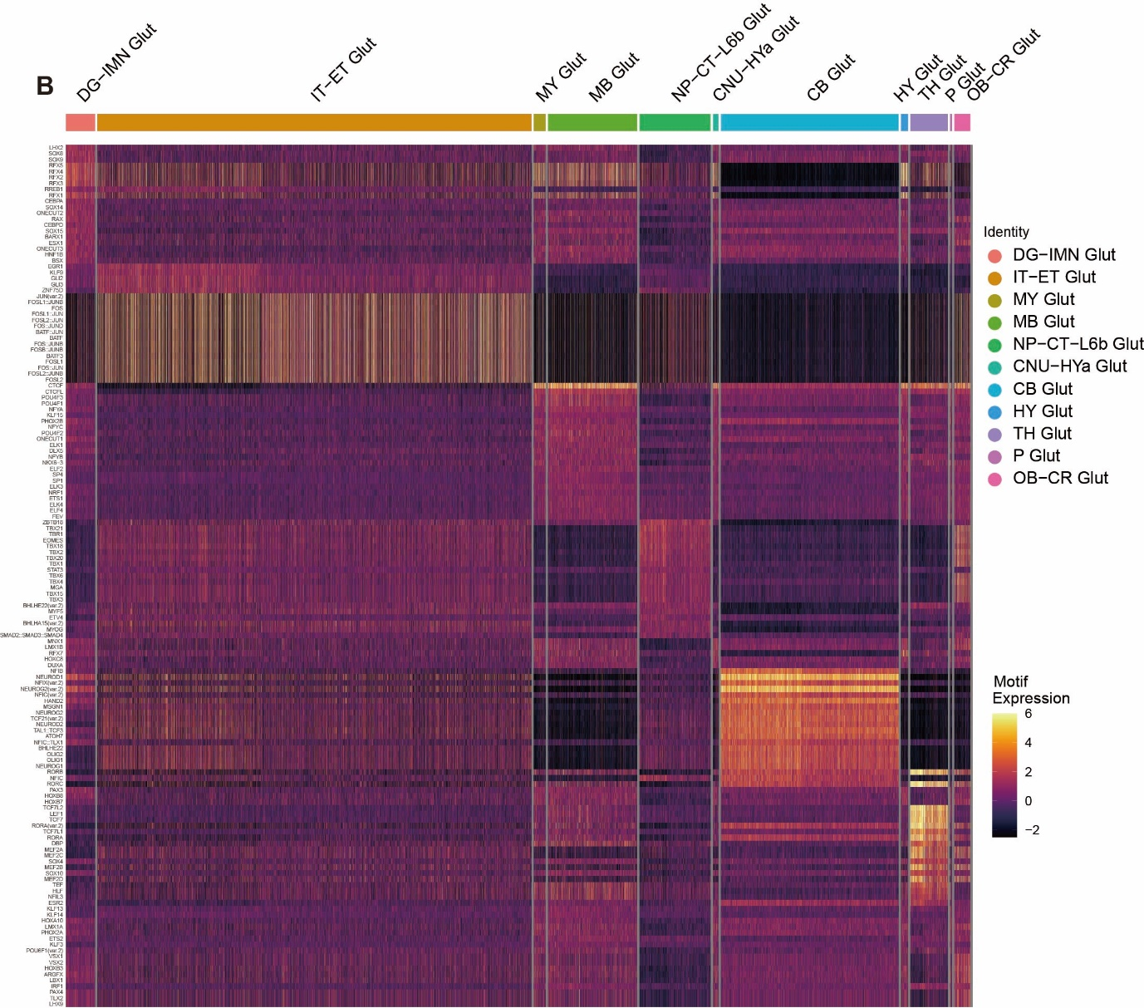

Figure S7. Transcription factor (TF) motif enrichment analysis for neuronal cell types based on integrated snATAC-seq data. A-B) Heatmap showing enrichment of TF motifs derived from the JASPAR core database across neuronal cell types, (A) GABAergic neurons and (B) Glutamatergic neurons. The color gradient (purple to yellow) indicates scaled motif expression scores, reflecting relative enrichment of TF binding motifs within chromatin accessibility peaks. A higher motif expression score (yellow) denotes stronger enrichment, suggesting active binding of the respective transcription factors. Cell-type abbreviations correspond to those described in Figure S2.

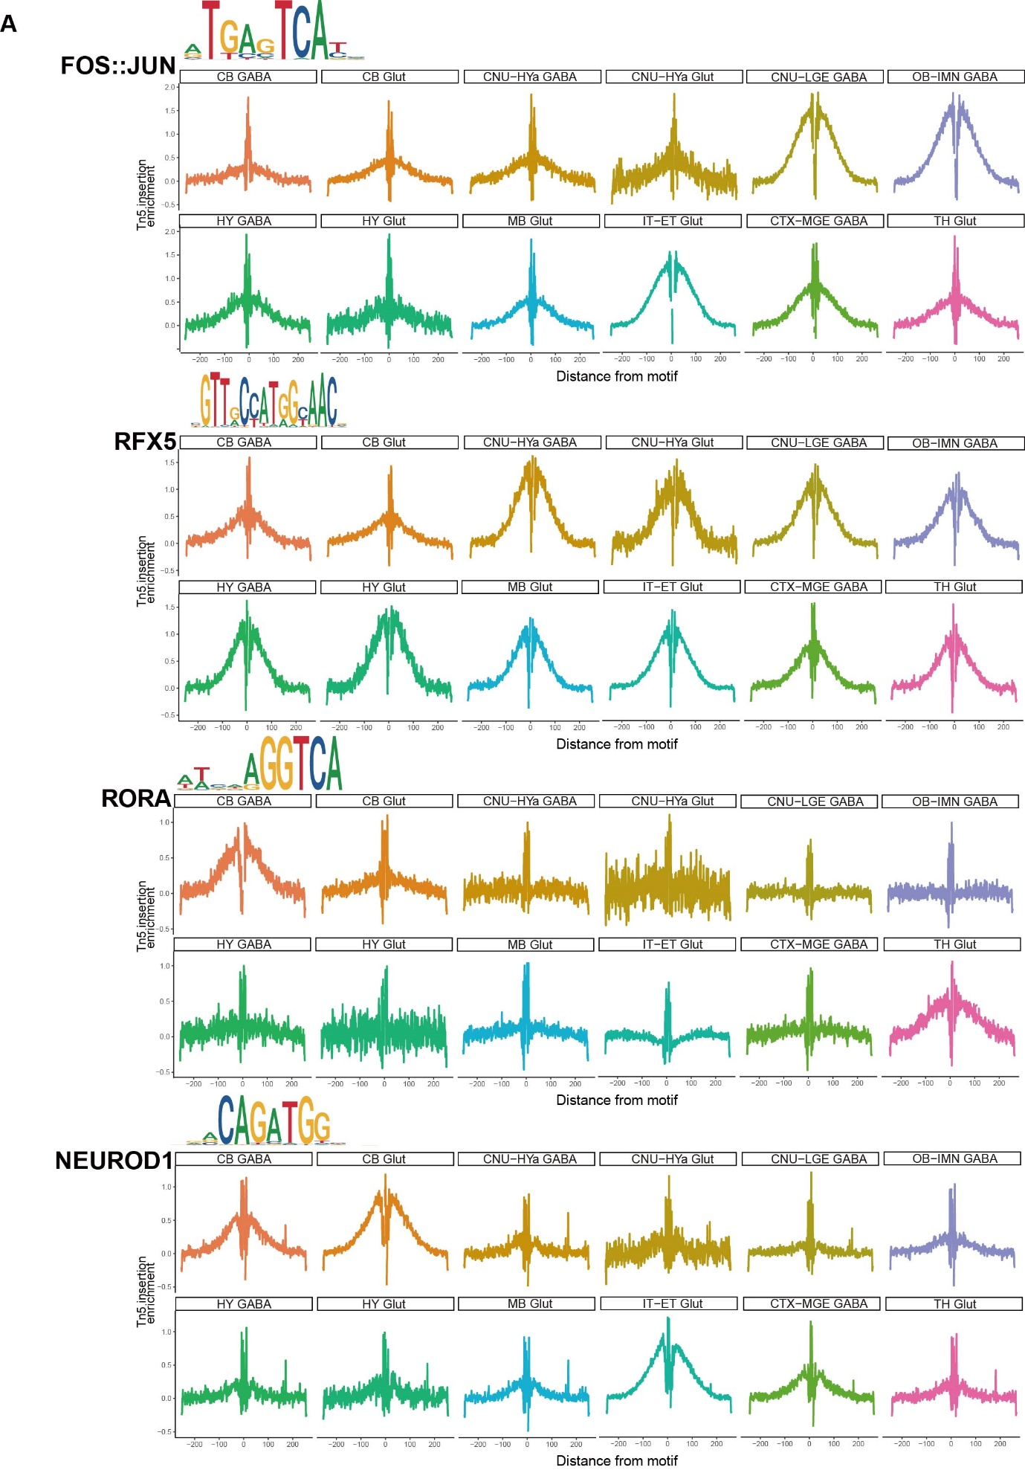

Figure S8. Footprint analysis illustrating motif activities across selected neuronal cell types in snATAC-seq data. A) The transcription factor (TF) footprints for FOS::JUN, RFX5, RORA, and NEUROD1 motifs are shown across different neuronal cell populations (CB GABA, CB Glut, CNU-HYa GABA, CNU-HYa Glut, CNU-LGE GABA, OB-IMN GABA, HY GABA, HY Glut, MB Glut, IT-ET Glut, CTX-MGE GABA, TH Glut). For each TF, the corresponding motif logo is displayed at the top-left corner of each panel. The x-axis represents the distance from the motif center (base pairs), and the y-axis indicates the average Tn5 insertion enrichment, corresponding to chromatin accessibility at motif regions bound by transcription factors. Higher enrichment signals around the motif center reflect active transcription factor binding and increased chromatin openness.

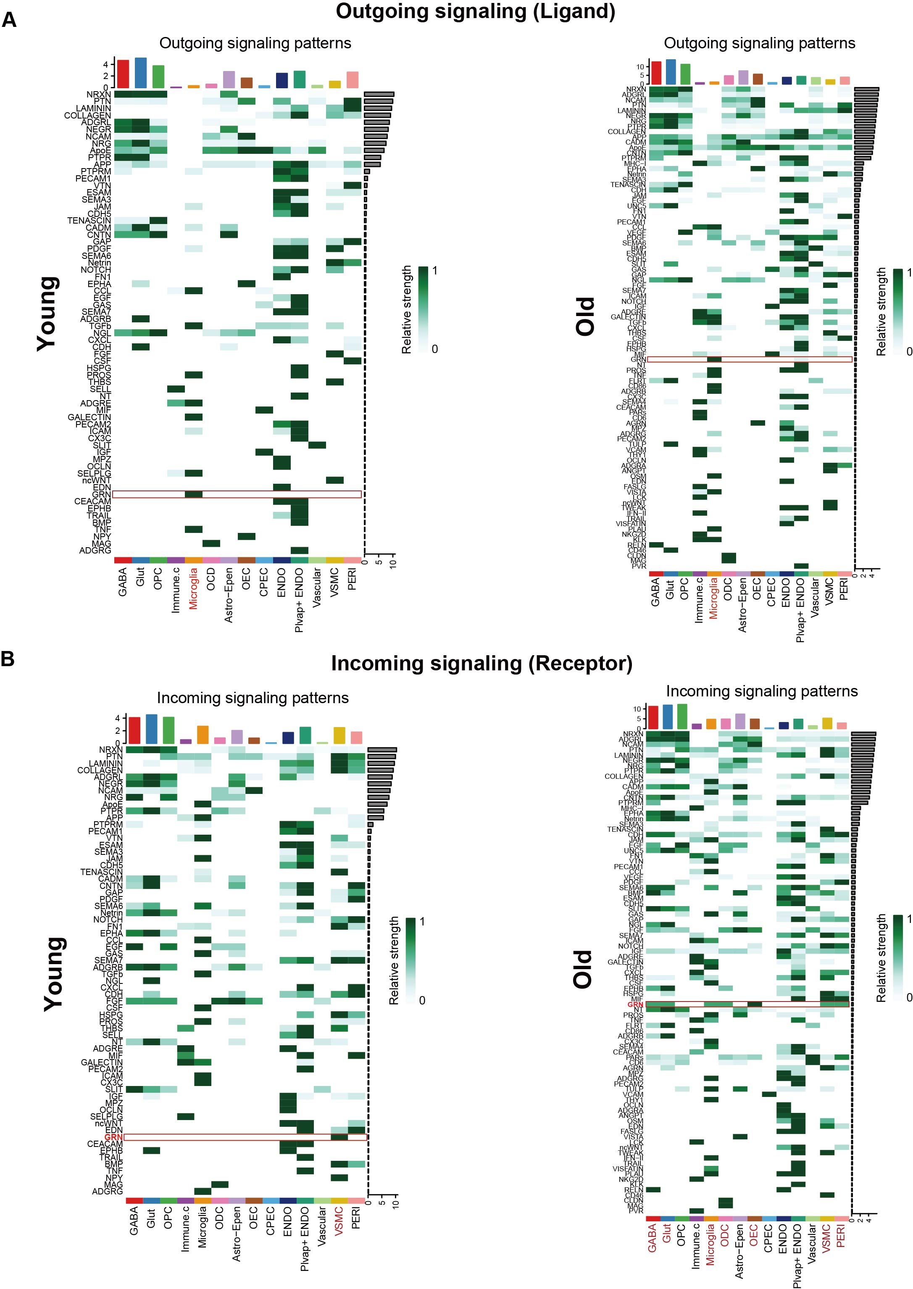

Figure S9. Comparison of overall cell-cell interaction patterns between young and old mouse brains in the integrated transcriptomic data. A) Heatmap showing overall outgoing signaling strength (ligand expression) of signaling pathways across each cell population from young (left) and old (right) mouse whole brains. B) Heatmap illustrating overall incoming signaling strength (receptor expression) of signaling pathways across each cell population from young (left) and old (right) mouse whole brain. The signaling strength values (relative strength) are normalized and indicated by the intensity of green color (from white indicating low/no signaling strength, to dark green indicating high signaling strength). GRN signaling pathways are highlighted with red boxes, and cell populations participating in GRN signaling are indicated by red text. Cell populations analyzed include neuronal (GABA, Glut), oligodendrocyte precursor cells (OPC), immune cells, microglia, oligodendrocytes (ODC), astrocytes, ependymal cells (Epen), oligodendrocyte progenitor cells (OPC), endothelial cells (ENDO), vascular smooth muscle cells (VSMC), pericytes (PERI), and others as labeled. Pathways are ranked by overall signaling strength, as indicated by bar graphs alongside each heatmap.

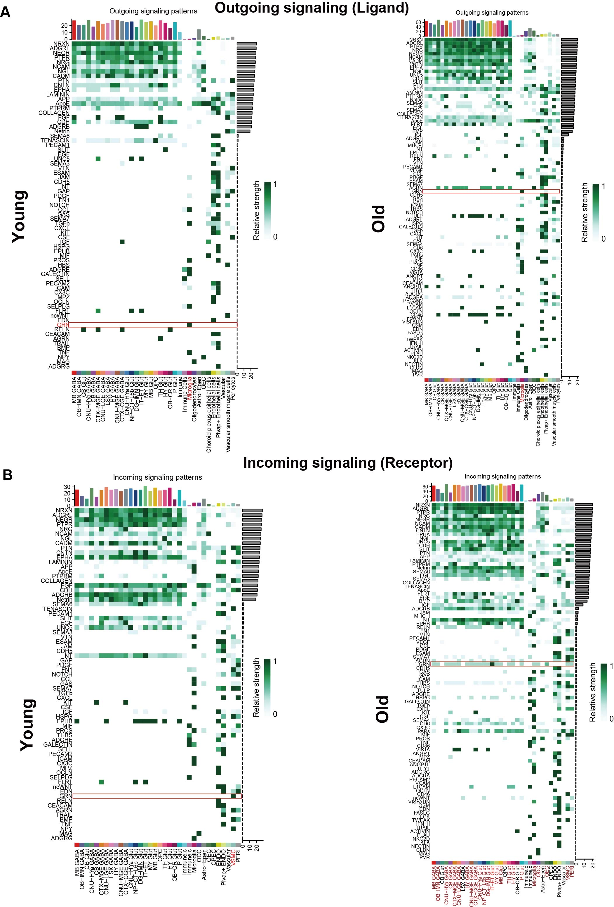
Figure S10. Comparison of overall cell-cell interaction patterns between young and old mouse brains in the integrated transcriptomic data, with subclustered neuronal cell types. A) Heatmap showing overall outgoing signaling strength (ligand expression) of signaling pathways across detailed neuronal subclusters and non-neuronal cell populations from young (left) and old (right) mouse whole brains. B) Heatmap depicting overall incoming signaling strength (receptor expression) of signaling pathways across detailed neuronal subclusters and non-neuronal cell populations from young (left) and old (right) mouse whole brains. GRN signaling is highlighted with red boxes and the GRN-signaling participating cell types are highlighted in red. Pathways are ranked based on overall signaling strength, shown in the adjacent bar plots. Cell-type abbreviations correspond to those described in Figure S2.

