Title: Surgical and survival outcomes of laparoscopic versus open gastrectomy after neoadjuvant chemotherapy in patients with locally advanced gastric cancer: A meta-analysis of randomized controlled trials and propensity-score matched studies

Authors: Huayang Pang1†; Zehua Chen1†; Menghua Yan1; Yan Chen1; Xiufeng Chen1; Bo Yi 1#; Hao Sun1#.

¹Affiliation: Department of Gastrointestinal Cancer Center, Chongqing University Cancer Hospital, Chongqing 400030, China.

Corresponding author. Hao Sun, PhD and Bo Yi, PhD; Department of Gastrointestinal Cancer Center, Chongqing University Cancer Hospital, 181 Hanyu Road, Shapingba District, Chongqing 400030, China; Email: sunhao68@sina.com and yb13786179533@163.com, respectively.

Supplementary Materials - Index

Supplementary Figures and Tables
Supplementary file item 1. The search strategy of each online database. | pag. 3
Supplementary file item 2. Comparison of parameters related to neoadjuvant chemotherapy between the LG and OG groups in the included studies. | pag. 4
Supplementary file item 3. Pooled outcomes of intra-operative outcomes between the LG and OG groups. A. estimated blood loss; B. surgical time; C. number of retrieved lymph nodes; D. proximal margin; E. distal margin; F. R1/R2 resection rate. | pag. 5-6
Supplementary file item 4. Pooled outcomes of Postoperative recovery outcomes between the LG and OG groups. A. time to first liquid intake; B. time to first flatus; C. time to remove gastric tube; D. time to remove drainage tube; E. postoperative hospital duration. | pag. 7-8
Supplementary file item 5. Forest plot assessing postoperative complications between the LG and OG groups. A. overall morbidity; B. minor morbidity; C. major morbidity; D. mortality. E. anastomotic leakage; F. pancreatic complications; G. intra-abdominal hemorrhage; H. intra-abdominal infection; I. surgical site infection; J. lymphatic leakage; K. pulmonary infection; and L. Ileus. | pag. 9-11
Supplementary file item 6. Original and reconstructed survival curves from the included studies. | pag. 12-16
Supplementary file item 7. Subgroup analyses. Figure S1-7. | pag. 17-23
Supplementary file item 8. Sensitivity analyses of pooled outcomes. A: Retrieved lymph nodes; B: Estimated blood loss; C: Surgical time; D: Time to first liquid diet; E: Time to first flatus; F: Postoperative hospital stay; G: Minor complications. | pag. 24
Supplementary file item 9. Publication bias assessment of pooled outcomes with at least ten studies included using Begg’s and Egger’s tests. All p values>0.05. A: Retrieved lymph nodes; B: Estimated blood loss; C: Surgical time; D: Postoperative hospital stay; E: Overall complications; F: Major complications; G: Minor complications. | pag. 25

Supplementary Figures and Tables

Supplementary file item 1. The search strategy of each online database.
Database | Search strategy | Number of retrieved studies
PubMed | (“open” [Title/Abstract] OR “laparotomy” [Title/Abstract]) AND (“laparoscopic” [Title/Abstract] OR “laparoscopy” [Title/Abstract]) AND (“neoadjuvant” [Title/Abstract] OR “preoperative” [Title/Abstract] OR “perioperative” [Title/Abstract]) AND (“gastric cancer” [Title/Abstract] OR “stomach cancer” [Title/Abstract] OR “stomach neoplasm” [Title/Abstract]) | 420
Web of Science | (“open” OR “laparotomy”) AND (“laparoscopic” OR “laparoscopy”) AND (“neoadjuvant” OR “preoperative” OR “perioperative”) AND (“gastric cancer” OR “stomach cancer” OR “stomach neoplasm”) | 651
Embase | (“open” OR “laparotomy”) AND (“laparoscopic” OR “laparoscopy”) AND (“neoadjuvant” OR “preoperative” OR “perioperative”) AND (“gastric cancer” OR “stomach cancer” OR “stomach neoplasm”) | 439
Cochrane library | (“open” OR “laparotomy”) AND (“laparoscopic” OR “laparoscopy”) AND (“neoadjuvant” OR “preoperative” OR “perioperative”) AND (“gastric cancer” OR “stomach cancer” OR “stomach neoplasm”) | 196
CNKI | “胃癌” AND “新辅助” AND “腹腔镜” AND “开腹” | 212

Supplementary file item 2. Comparison of parameters related to neoadjuvant chemotherapy between the LG and OG groups in the included studies.
Reference | Neoadjuvant regimen | Comparability of NACT regimens | Comparability of the number of NACT cycles | Comparability of the intervals between NACT and surgery | Comparability of NACT efficacy | Comparability of NACT-related adverse events
Li, 2019 | XELOX | Yes | Yes | Yes | Yes | Yes
Van der Wielen, 2020 | ECC/ ECF/ EOX/ FOLFOX/ FLOT/ other | Yes | NA | NA | NA | NA
Xi, 2020 | SOX/ XELOX | Yes | NA | NA | Yes | NA
Hu HT, 2022 | SOX/ XELOX/ CS/ FOLFOX/ TP/ ECF/ DCF/ DCX/ Concurrent chemoradiotherapy with S-1 | Yes | Yes | NA | Yes | NA
Hu M, 2022 | SOX/ FLOT | Yes | Yes | NA | Yes | NA
Zhong, 2023 | SOX/ FLOT/ DOS/ DCF | Yes | Yes | NA | Yes | Yes
Oh, 2023 | NA | NA | NA | NA | NA | NA
Yang, 2023 | SOX/ XELOX/ CapeOx/ FLOT/ DOS/ FOLFOX/ PD-1/PD-L1 inhibitors | No | Yes | NA | Yes | NA
Zhang, 2023 | FOLFOX/ SOX / XELOX/ FLOT | Yes | Yes | NA | Yes | NA
Shang, 2024 | SOX/ XELOX/ FLOT/ DOS | Yes | Yes | Yes | Yes | NA
Wang, 2021/2025 | DC/ DS/ DX/ EP/ FOLFIRI/ POS/ S-1/ SEEOX/ SOX/ CapeOX | Yes | Yes | Yes | Yes | NA
Shangguan, 2025 | SOX/ XELOX/ CapeOx/ FLOT/ DOS/ FOLFOX | Yes | Yes | NA | Yes | NA
Sugimura, 2025 | SP/ SOX/ XP/ DCX/ DOS | Yes | Yes | NA | NA | Yes
NACT: neoadjuvant chemotherapy; NA: not available.

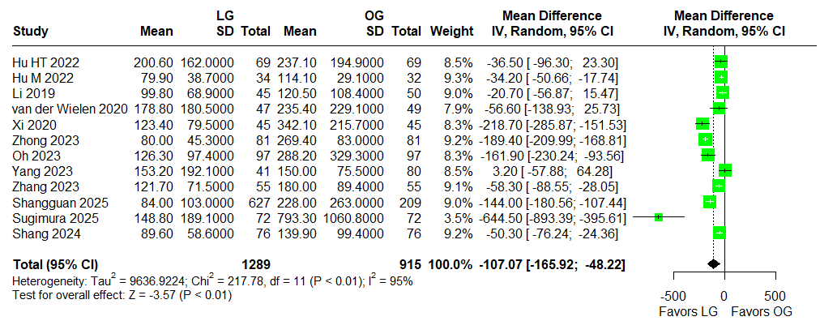
A
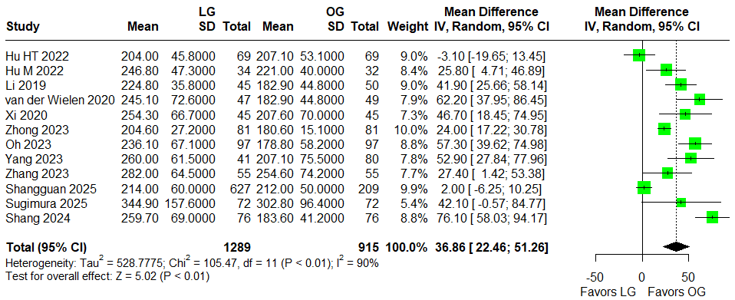
B
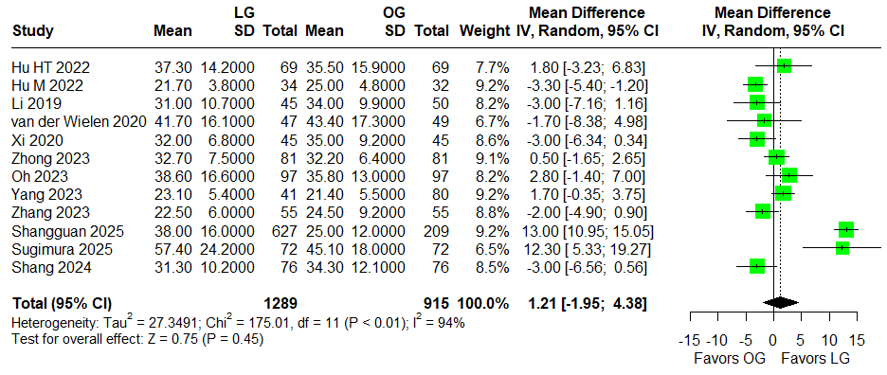
C
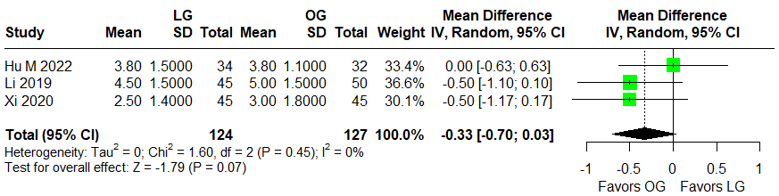
D
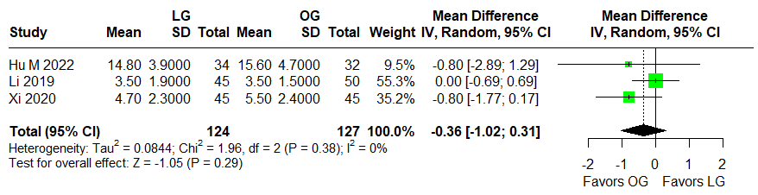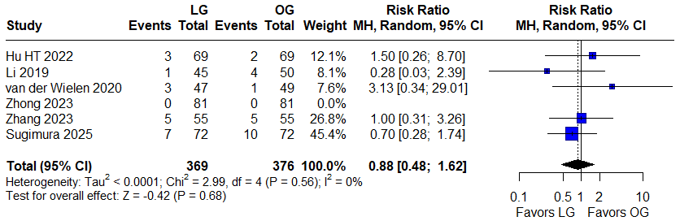
E
F
Supplementary file item 3. Pooled outcomes of intra-operative outcomes between the LG and OG groups. A. estimated blood loss; B. surgical time; C. number of retrieved lymph nodes; D. proximal margin; E. distal margin; F. R1/R2 resection rate.

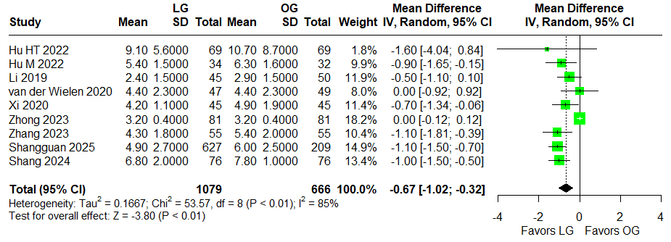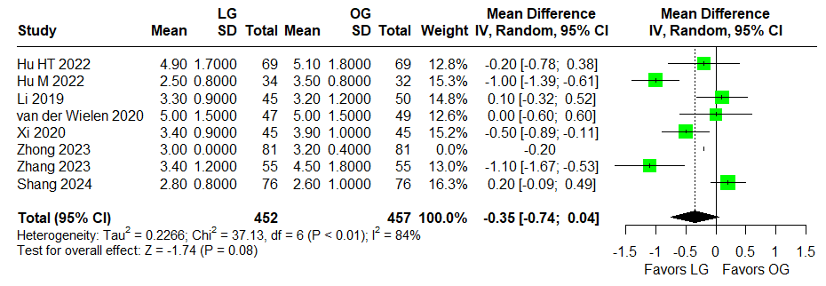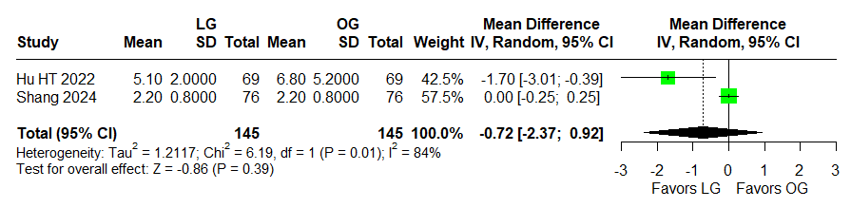
C
B
A
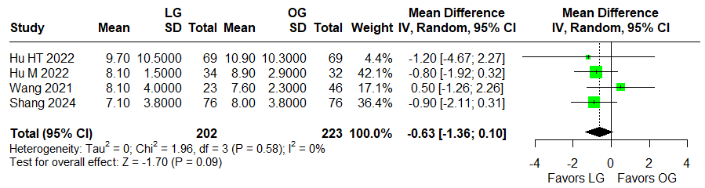
D
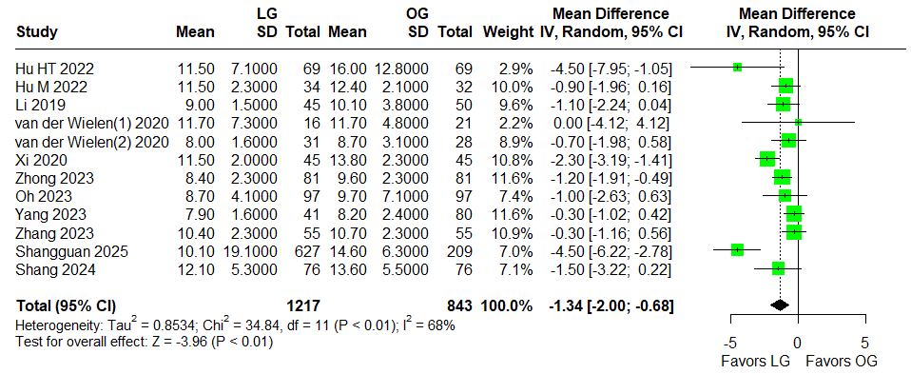
E
Supplementary file item 4. Pooled outcomes of Postoperative recovery outcomes between the LG and OG groups. A. time to first liquid intake; B. time to first flatus; C. time to remove gastric tube; D. time to remove drainage tube; E. postoperative hospital duration.

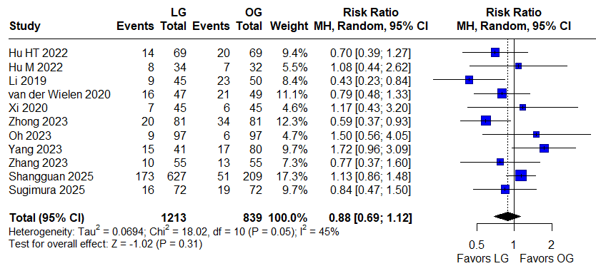
A
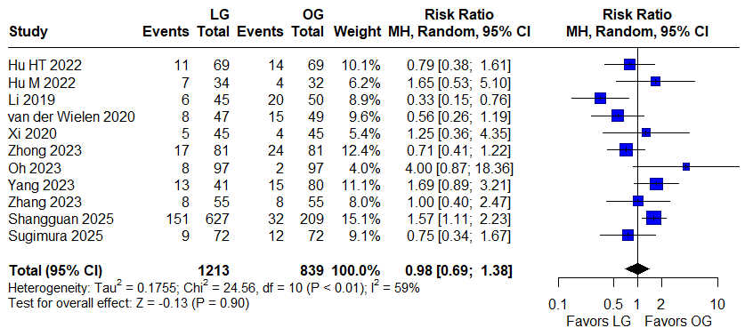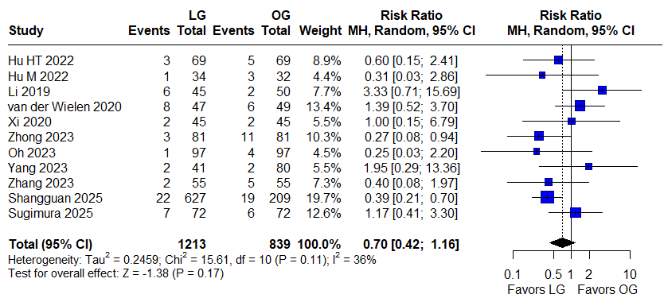
C
B
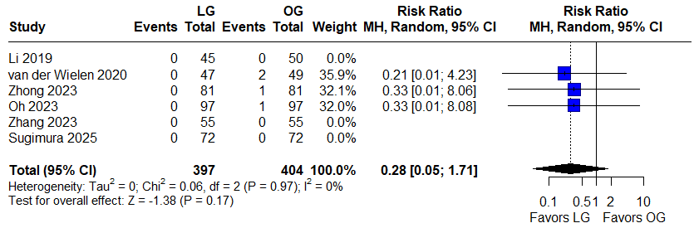
D

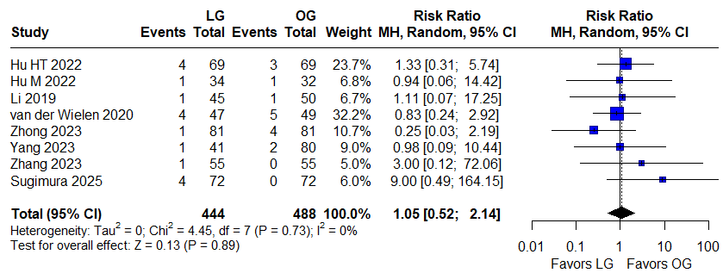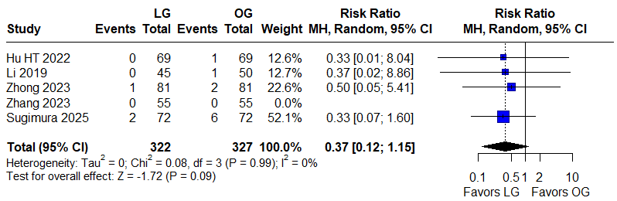
F
E
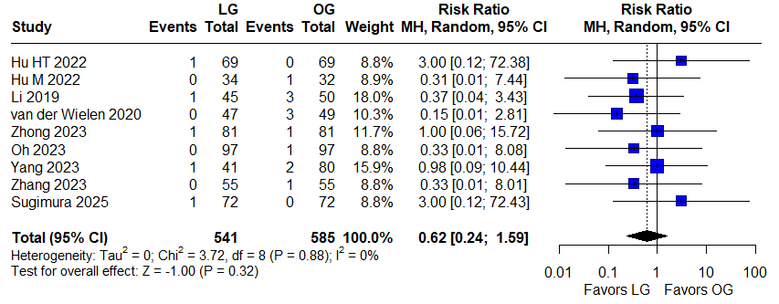
G
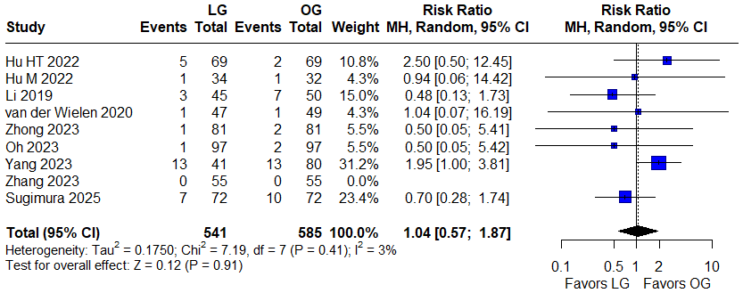
H
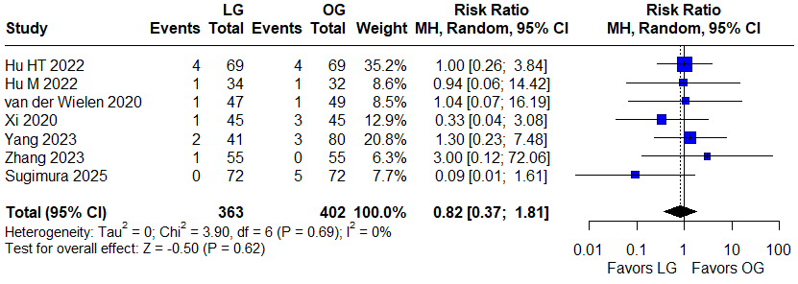
I
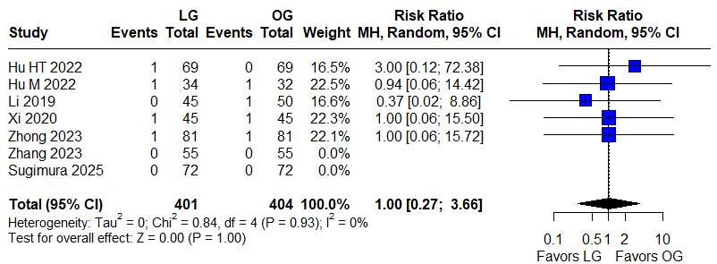
J
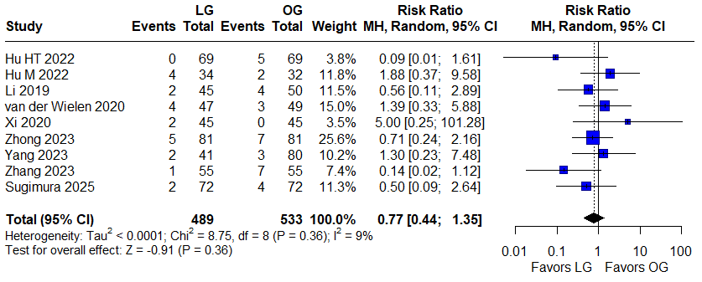
K
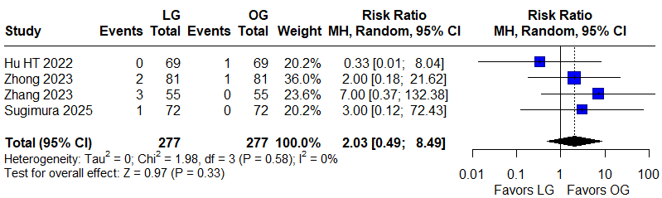
L
Supplementary file item 5. Forest plot assessing postoperative complications between the LG and OG groups. A. overall morbidity; B. minor morbidity; C. major morbidity; D. mortality. E. anastomotic leakage; F. pancreatic complications; G. intra-abdominal hemorrhage; H. intra-abdominal infection; I. surgical site infection; J. lymphatic leakage; K. pulmonary infection; and L. Ileus.

Supplementary file item 6. Original and reconstructed survival curves from the included studies.
Reference | Original | Reconstructed
Hu M,2022 (OS) | 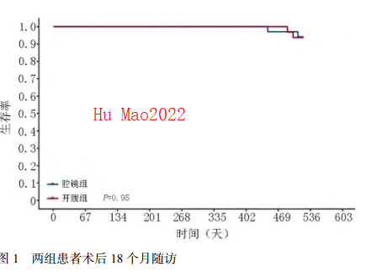 | 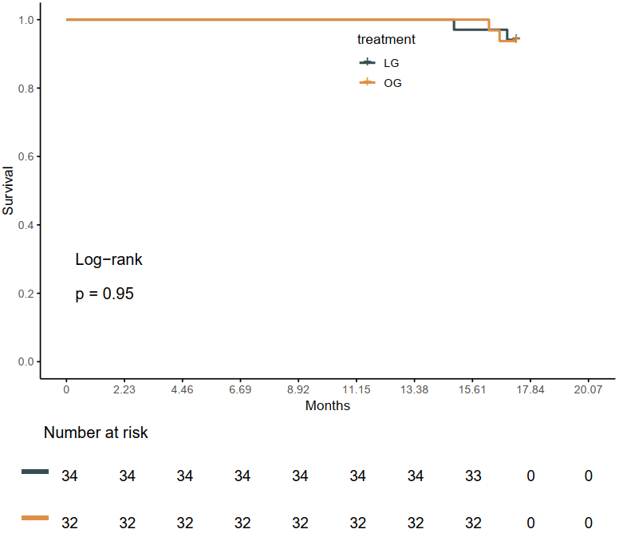
Van der Wielen, 2020 (OS) | 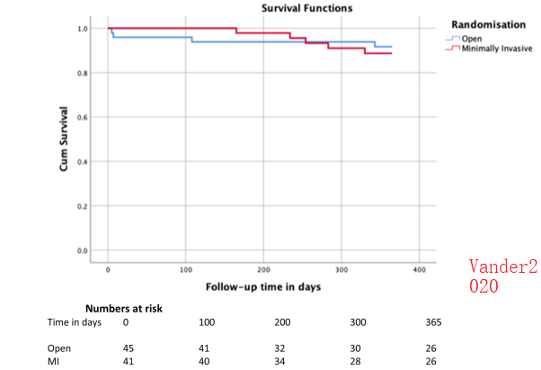 | 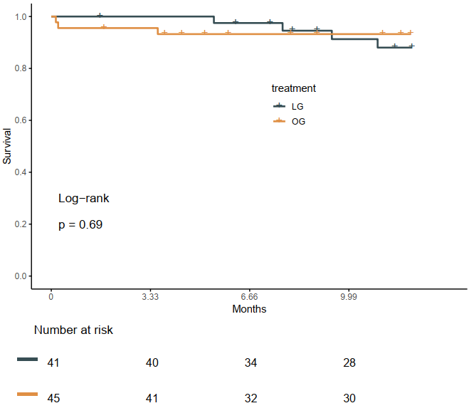
Xi,2020 (OS) | 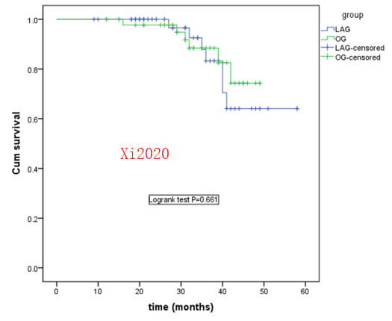 | 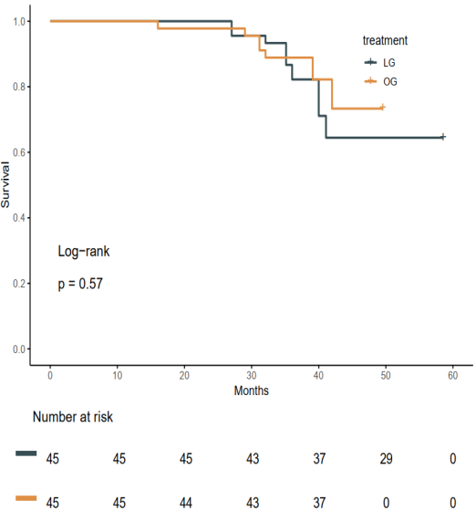
Hu HT,2022 (OS) | 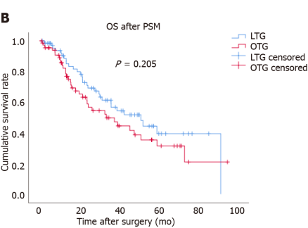 | 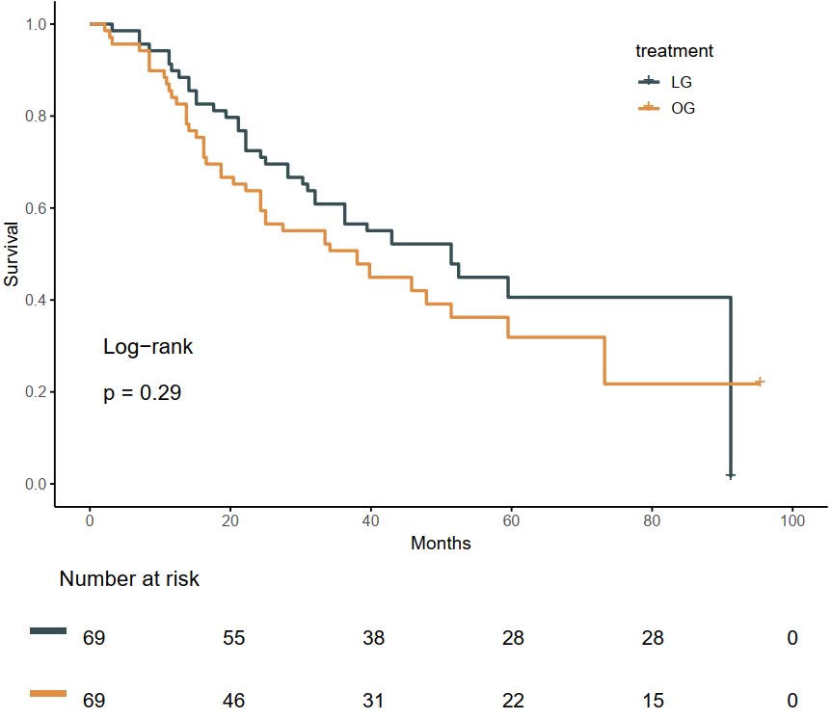
Zhang,2023(OS) | 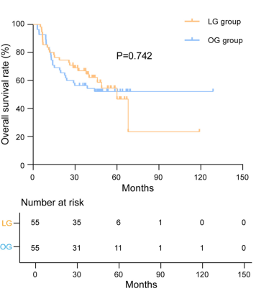 | 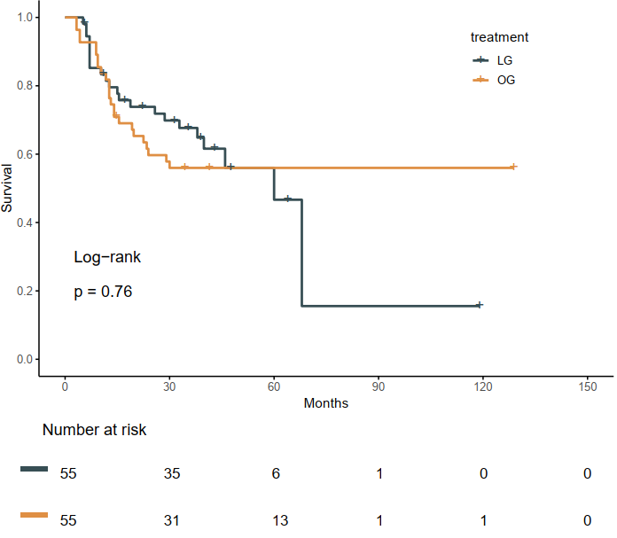
Zhang,2023(RFS) | 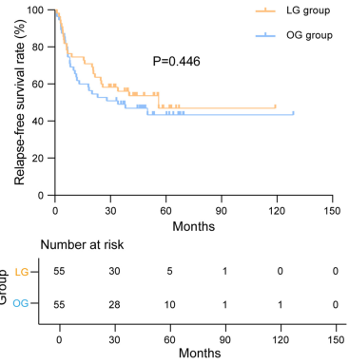 | 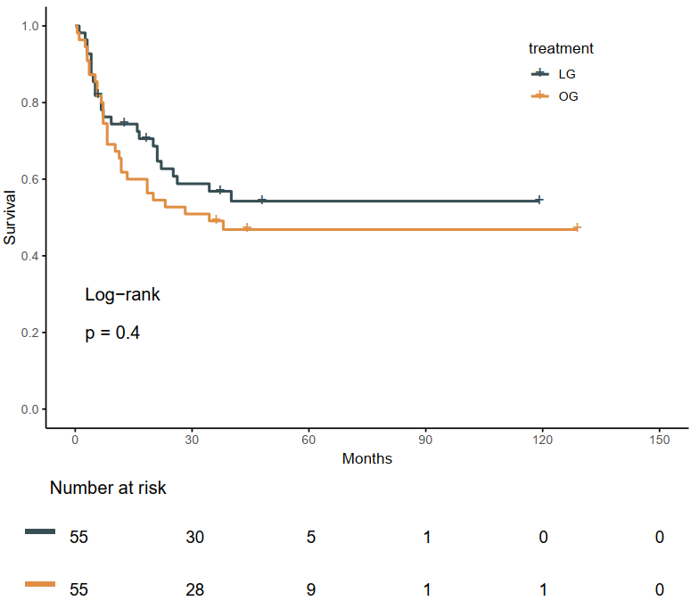
Zhong,2023 (OS) | 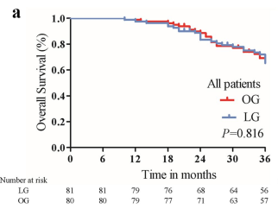 | 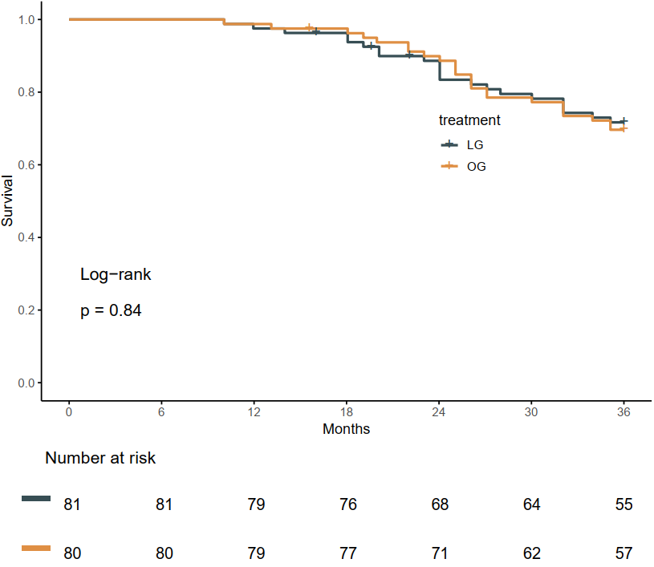
Zhong,2023 (RFS) | 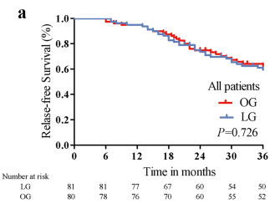 | 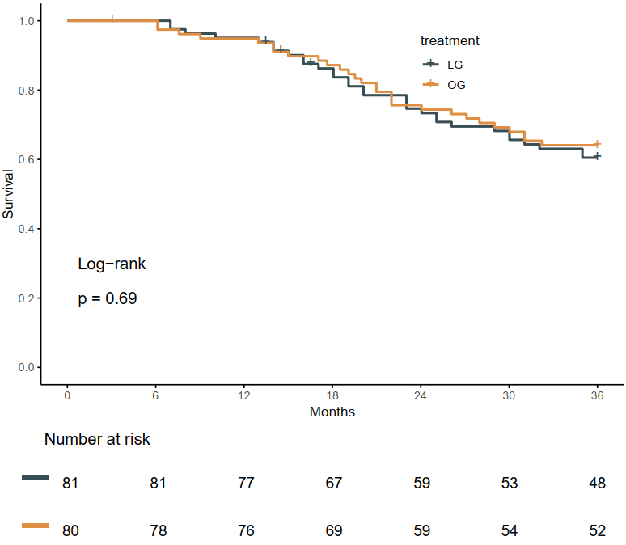
Yang,2023 (OS) | 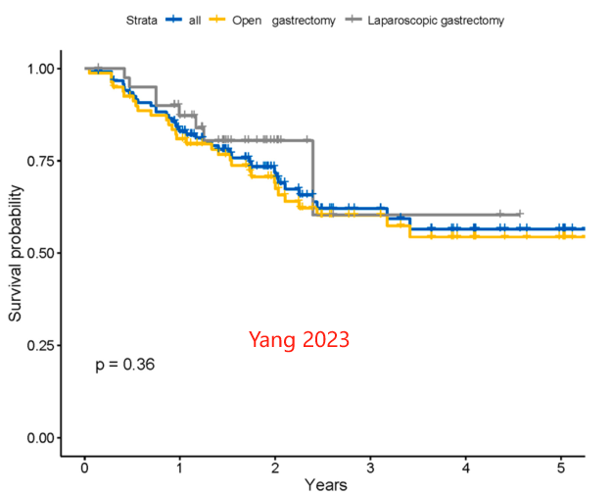 | 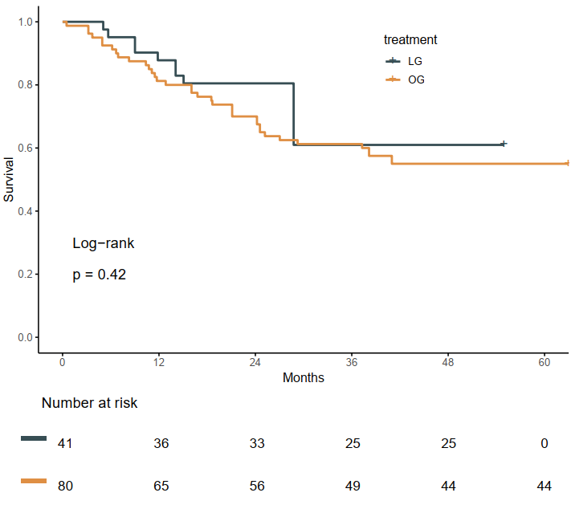
Shang, 2024 (OS) | 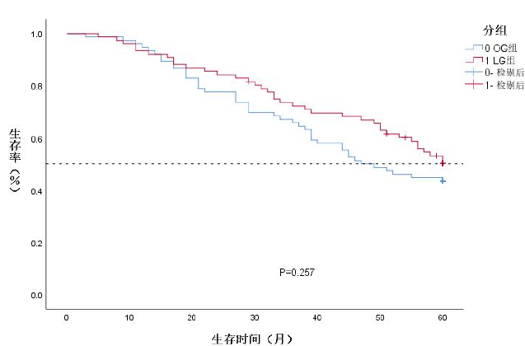 | 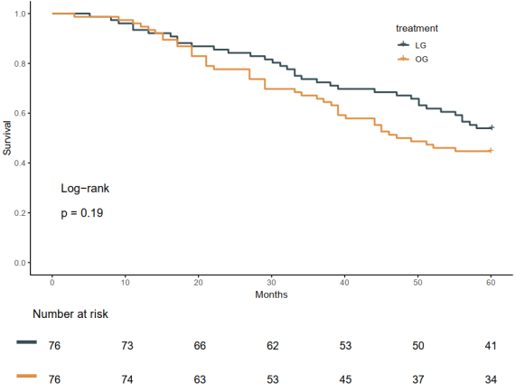
Shang, 2024 (DFS) | 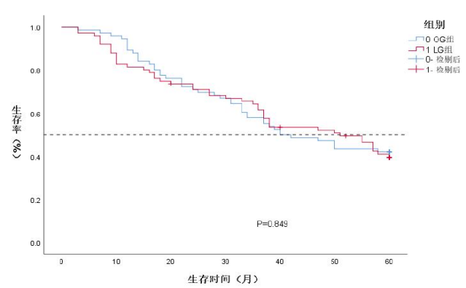 | 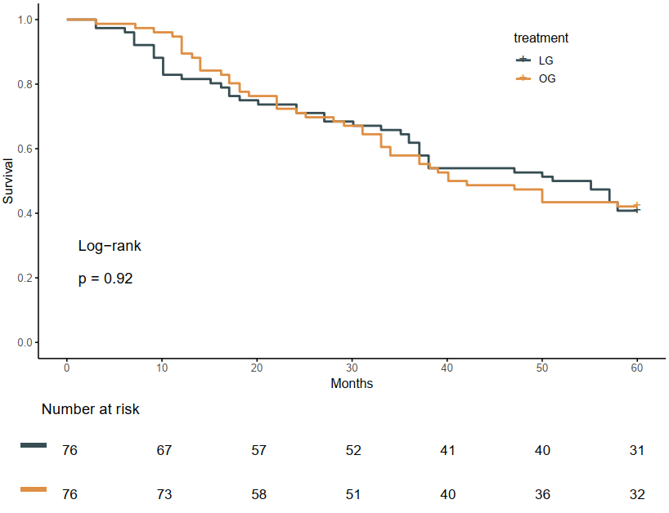
Wang,2025 (OS) | 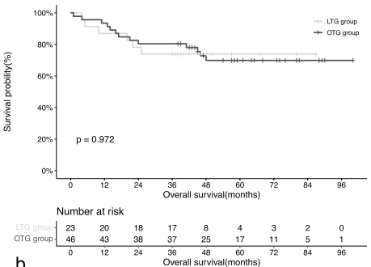 | 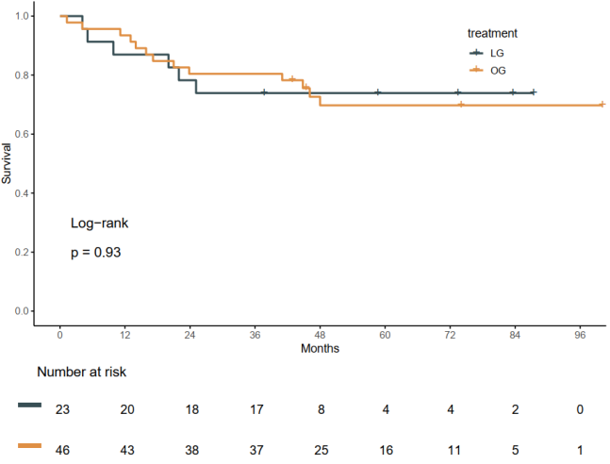
Wang,2025 (DFS) | 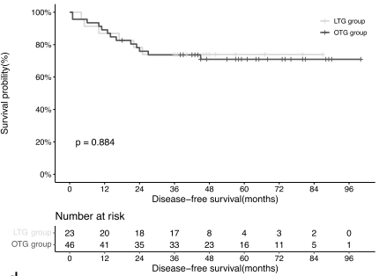 | 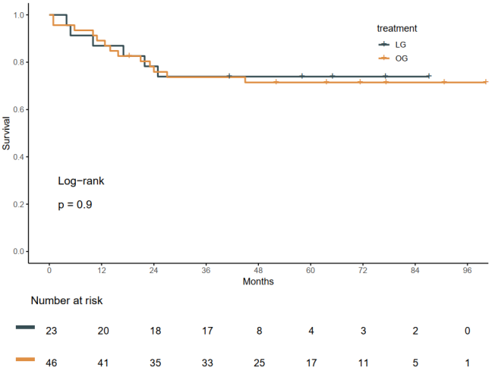
Shangguan,2025 (OS) | 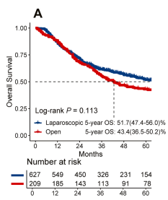 | 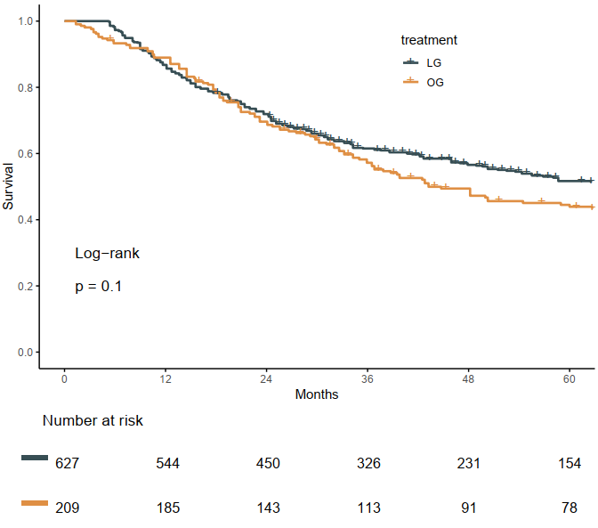
Shangguan,2025 (DFS) | 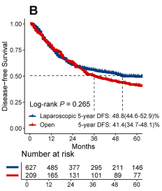 | 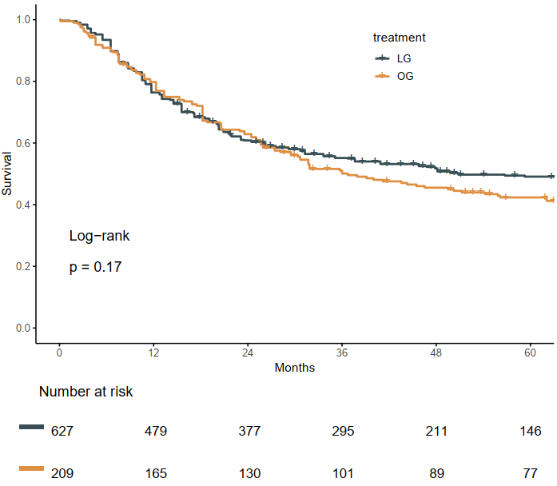
Sugimura, 2025 (OS) | 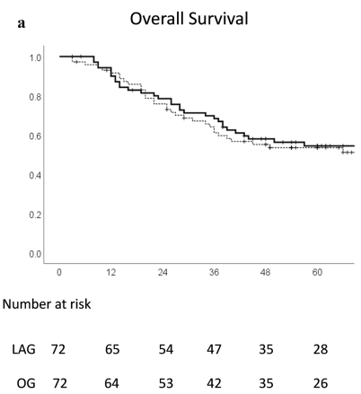 | 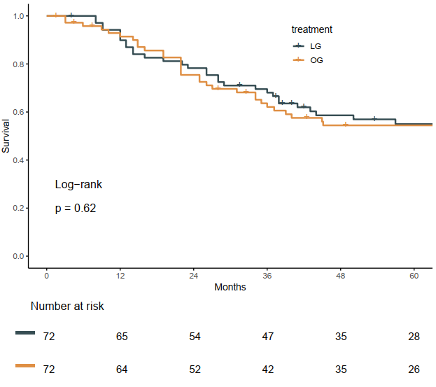
Sugimura, 2025 (PFS) | 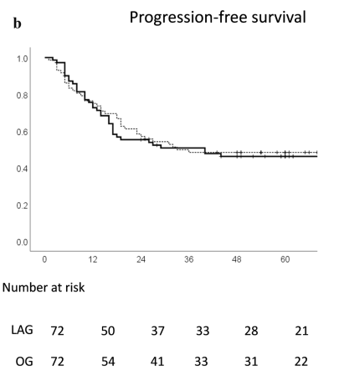 | 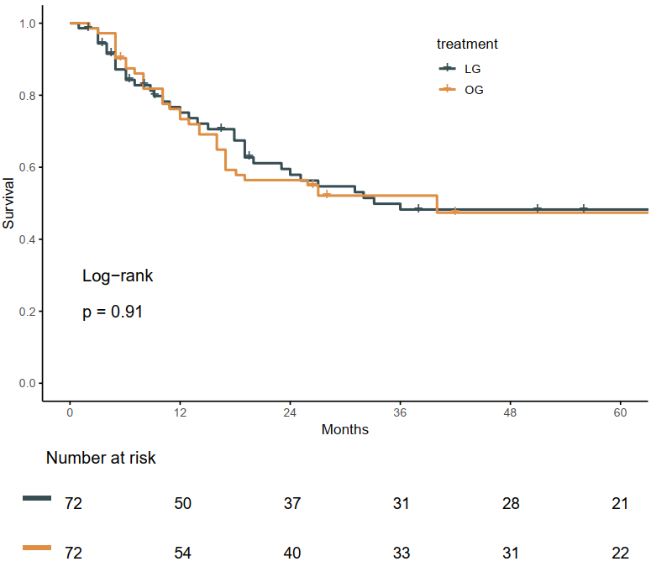

Supplementary file item 7. Subgroup analyses. Figure S1-7.

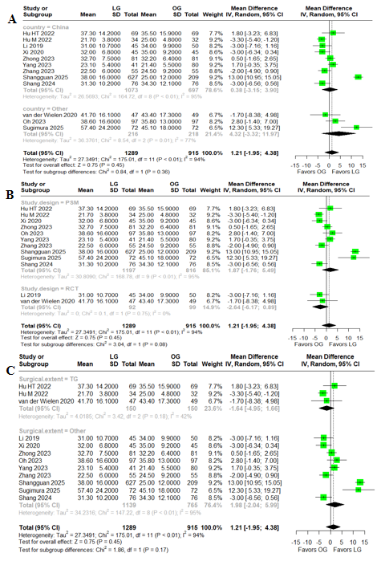
Figure S1. Subgroup analyses of retrieved lymph nodes. A: Country (China vs. Other); B: Study design (PSM vs. RCT); C: Surgical extent (TG vs. Other). PSM: Propensity-score matched study; RCT: Randomized controlled trial; TG: Total gastrectomy.
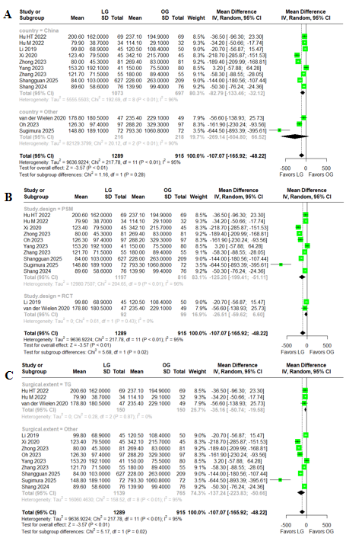
Figure S2. Subgroup analyses of estimated blood loss. A: Country (China vs. Other); B: Study design (PSM vs. RCT); C: Surgical extent (TG vs. Other). PSM: Propensity-score matched study; RCT: Randomized controlled trial; TG: Total gastrectomy.

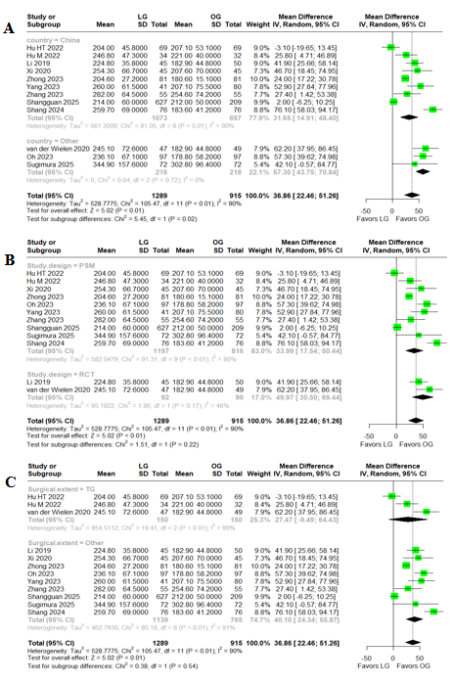
Figure S3. Subgroup analyses of surgical time. A: Country (China vs. Other); B: Study design (PSM vs. RCT); C: Surgical extent (TG vs. Other). PSM: Propensity-score matched study; RCT: Randomized controlled trial; TG: Total gastrectomy.

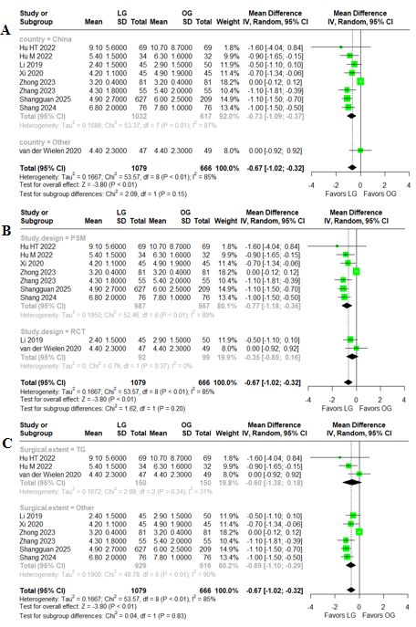
Figure S4. Subgroup analyses of time to first liquid diet. A: Country (China vs. Other); B: Study design (PSM vs. RCT); C: Surgical extent (TG vs. Other). PSM: Propensity-score matched study; RCT: Randomized controlled trial; TG: Total gastrectomy.

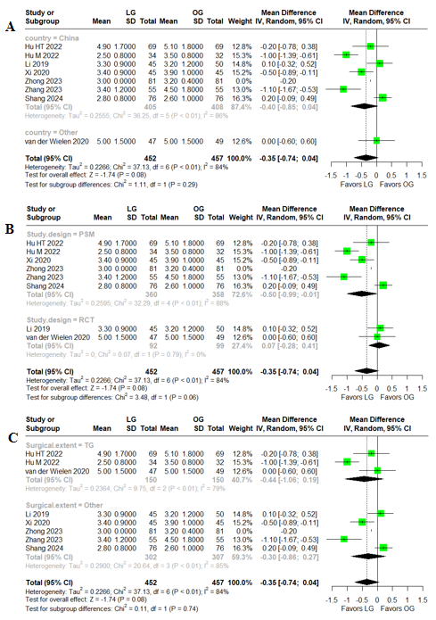
Figure S5. Subgroup analyses of time to first flatus. A: Country (China vs. Other); B: Study design (PSM vs. RCT); C: Surgical extent (TG vs. Other). PSM: Propensity-score matched study; RCT: Randomized controlled trial; TG: Total gastrectomy.

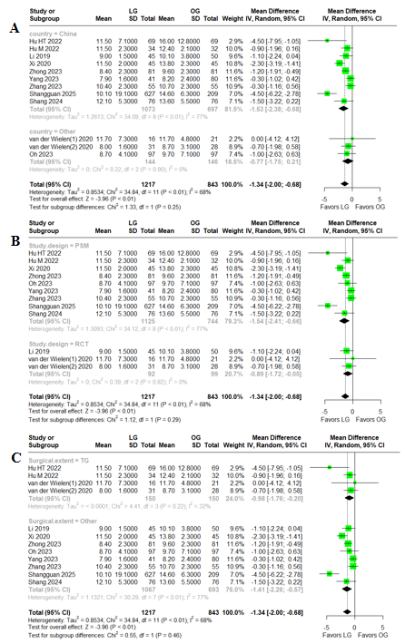
Figure S6. Subgroup analyses of postoperative hospital stay. A: Country (China vs. Other); B: Study design (PSM vs. RCT); C: Surgical extent (TG vs. Other). PSM: Propensity-score matched study; RCT: Randomized controlled trial; TG: Total gastrectomy.

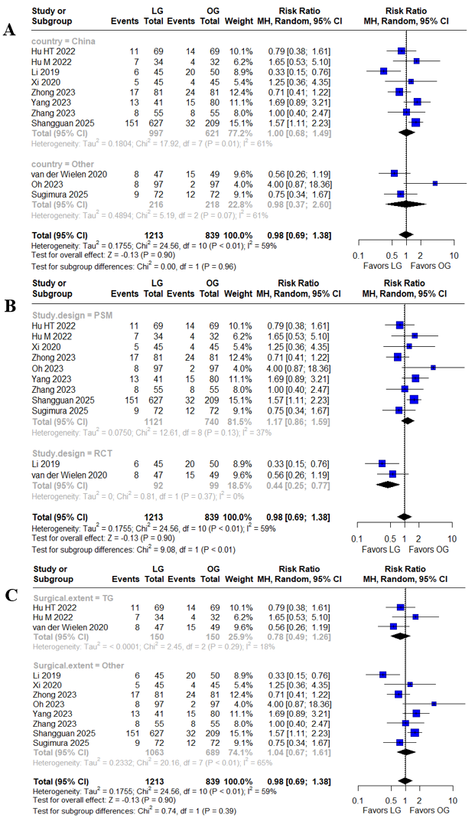
Figure S7. Subgroup analyses of minor complications. A: Country (China vs. Other); B: Study design (PSM vs. RCT); C: Surgical extent (TG vs. Other). PSM: Propensity-score matched study; RCT: Randomized controlled trial; TG: Total gastrectomy.

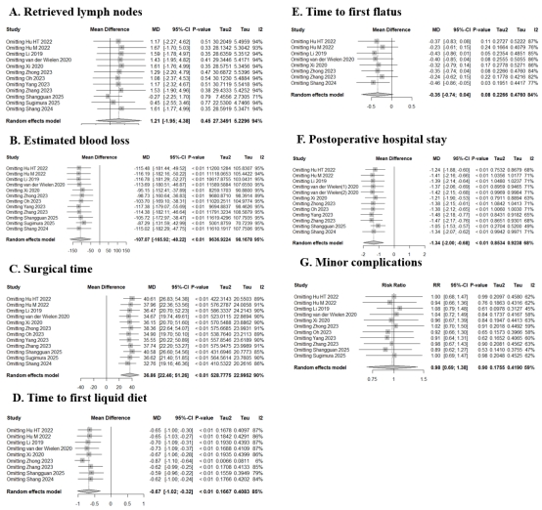
Supplementary file item 8. Sensitivity analyses of pooled outcomes. A: Retrieved lymph nodes; B: Estimated blood loss; C: Surgical time; D: Time to first liquid diet; E: Time to first flatus; F: Postoperative hospital stay; G: Minor complications.

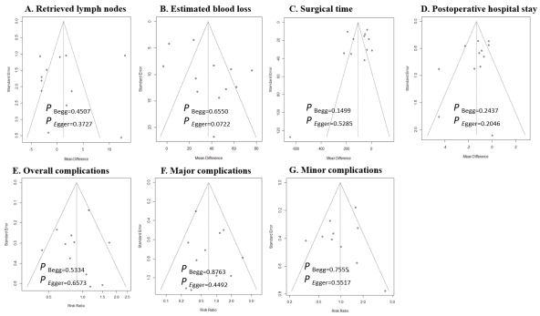
Supplementary file item 9. Publication bias assessment of pooled outcomes with at least ten studies included using Begg’s and Egger’s tests. All p values>0.05. A: Retrieved lymph nodes; B: Estimated blood loss; C: Surgical time; D: Postoperative hospital stay; E: Overall complications; F: Major complications; G: Minor complications.

