Comparative Gut Microbiota Profiling of Obese and Normal-Weight Indian Adults Using 16S rRNA Sequencing
Ranjeet Kumar Vishwakarma¹, Priyanka Gautam², Minakshi Sahu³, Gopal Nath³, *Bhupendra Singh Yadav¹,
Supplementary information

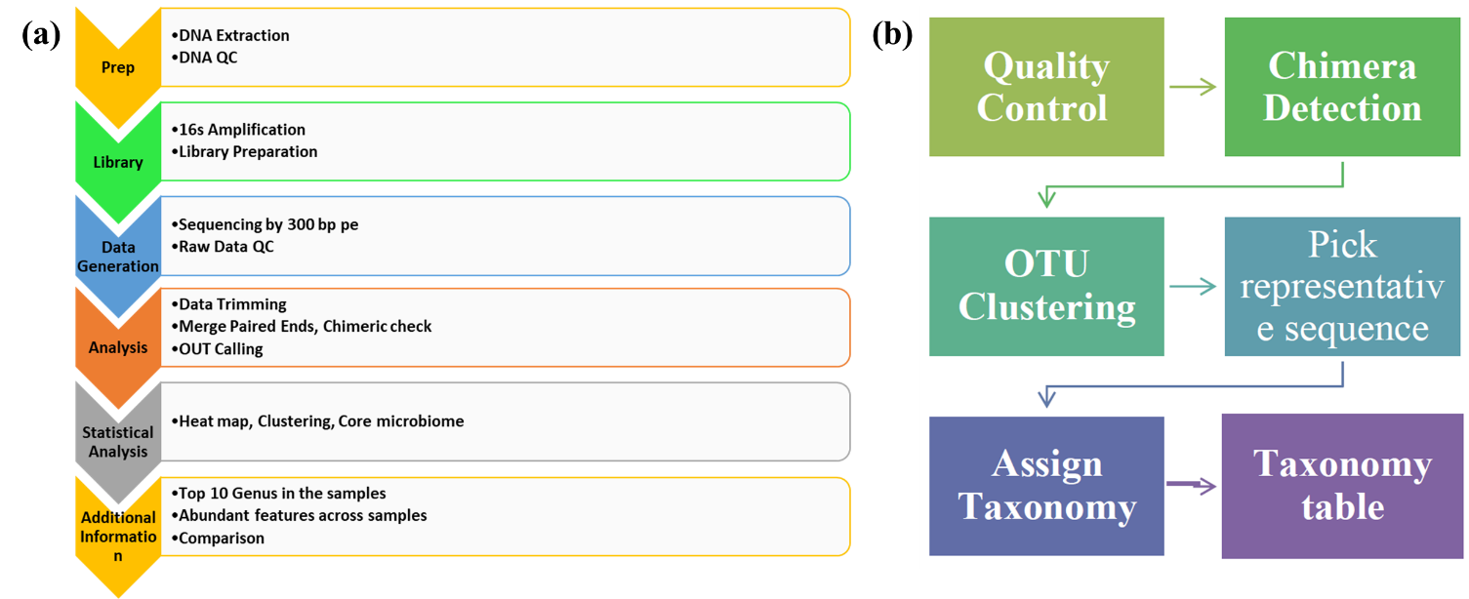
Fig S1: Workflow for data filtration and processing
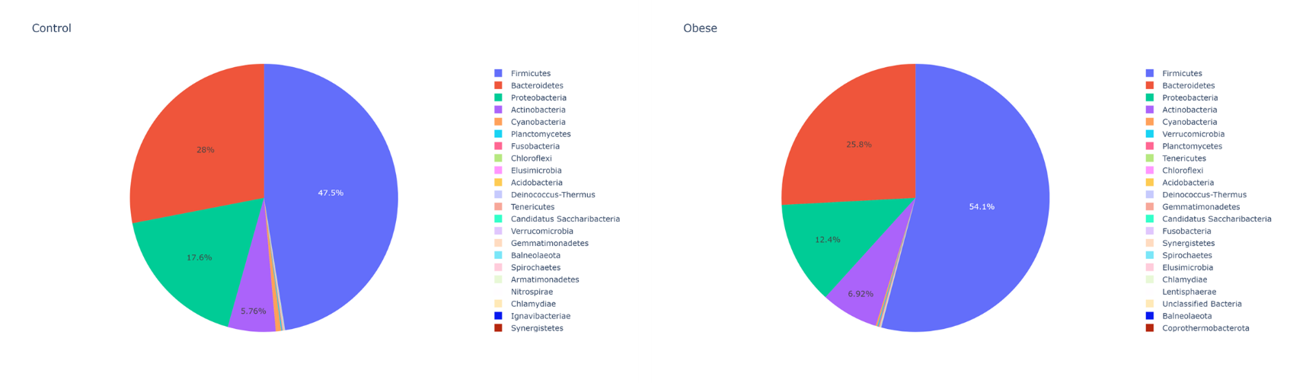
Fig S2: Average for both the control and obese groups at the phylum level

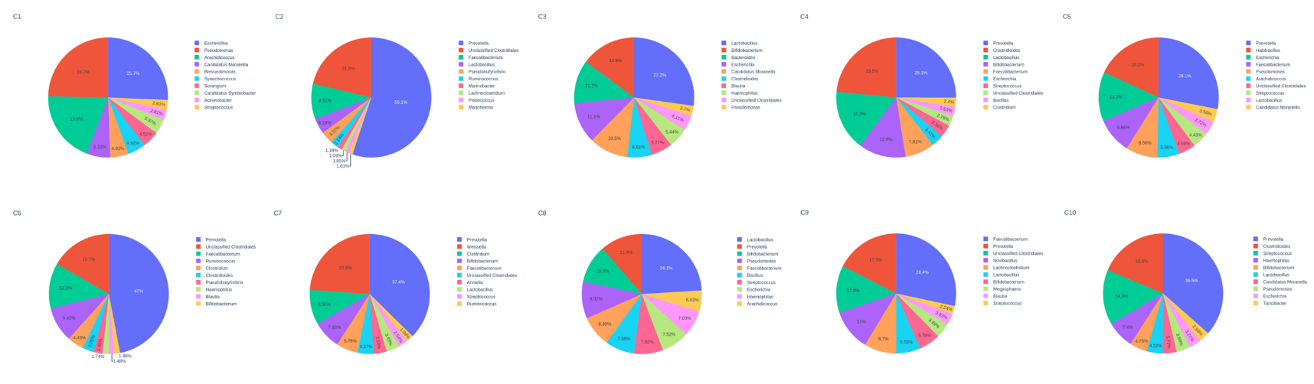
Fig S3 (a): Top 10 genera in control individuals (C1-C10) are shown in a pie chart
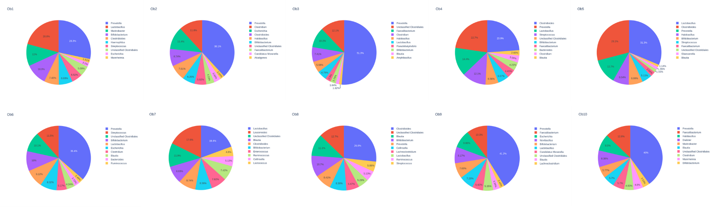
Fig S3 (b): Top 10 genera in obese individuals (Ob1-Ob10) show in a pie chart

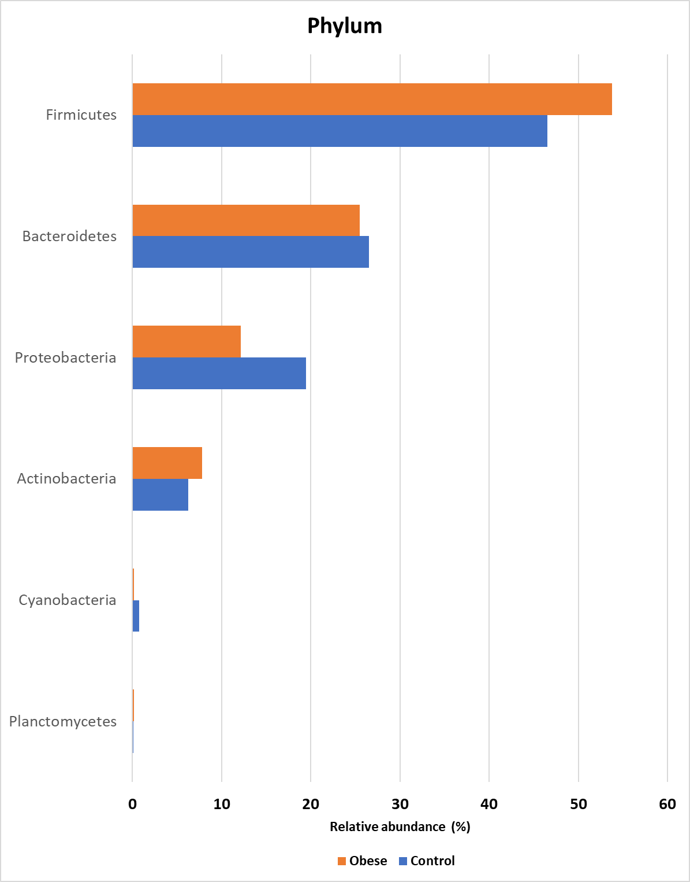
Fig S4: Abundant phylum detected in the control and obese individuals (excluding phylum detected in lower than 0.1% of relative abundance among the samples).
Table S1: Relative abundance at the genus level in both control and obese groups
Genera | Control Mean | Obese Mean | p-value
Acholeplasma | 0.00172472 | 0.0261805 | 0.015
Anaerostipes | 0.104874 | 0.520763 | 0.013
Anaplasma | 0.00247746 | 0.000421479 | 0.054
Desulfarculus | 0.00247199 | 0.000260729 | 0.057
Dichelobacter | 0.00304768 | 0.000203126 | 0.024
Eggerthella | 0.0212655 | 0.0962759 | 0.034
Fusobacterium | 0.0604624 | 0.00908309 | 0.059
Halomonas | 0.0412798 | 0.00643941 | 0.054
Leptotrichia | 0.0176522 | 0.00226913 | 0.024
Magnetospirillum | 0.00343493 | 0.0592241 | 0.032
Micavibrio | 0.0218257 | 0.00271756 | 0.057
Paenarthrobacter | 0.0154231 | 0.00343272 | 0.041
Pantoea | 0.0322434 | 0.00704892 | 0.050
Phascolarctobacterium | 0.0072549 | 0.109449 | 0.045
Ramlibacter | 0.00114776 | 0 | 0.050
Rhodopirellula | 0.000837929 | 0 | 0.017
Rhodothermus | 0.00122603 | 0 | 0.026
Serratia | 0.0742308 | 0.0133752 | 0.044

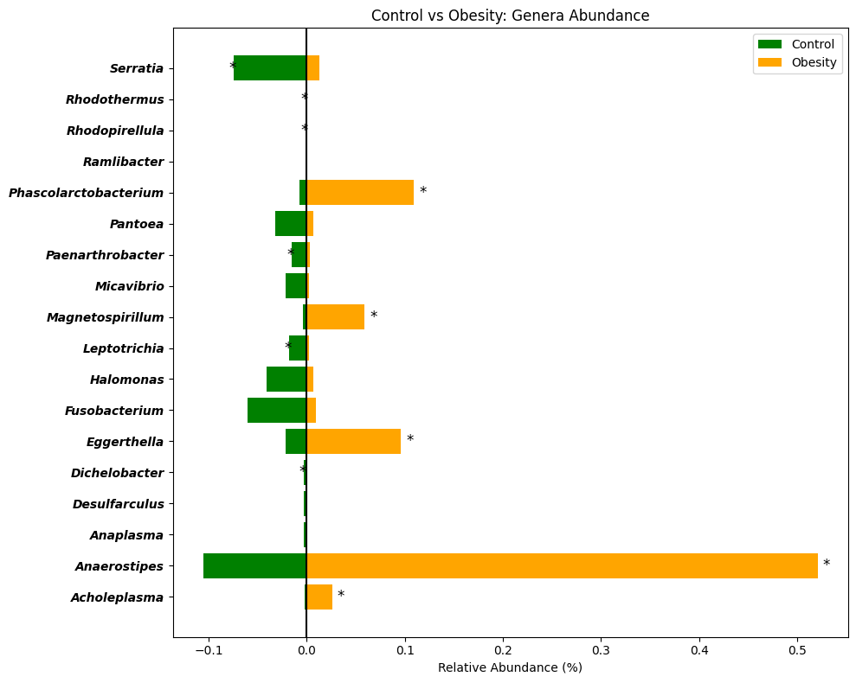
Fig S5 (a): Relative abundance at the genus level in both control and obese groups

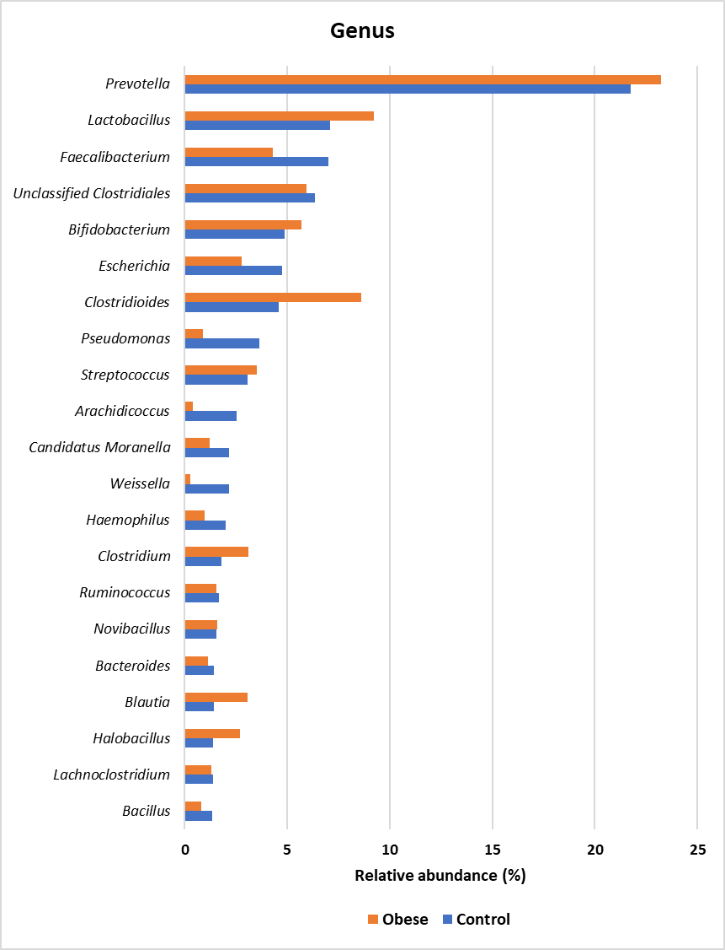
Fig S5 (b): Abundant genus detected in the control and obese individuals (excluding species detected in lower than 1% of relative abundance among the samples).

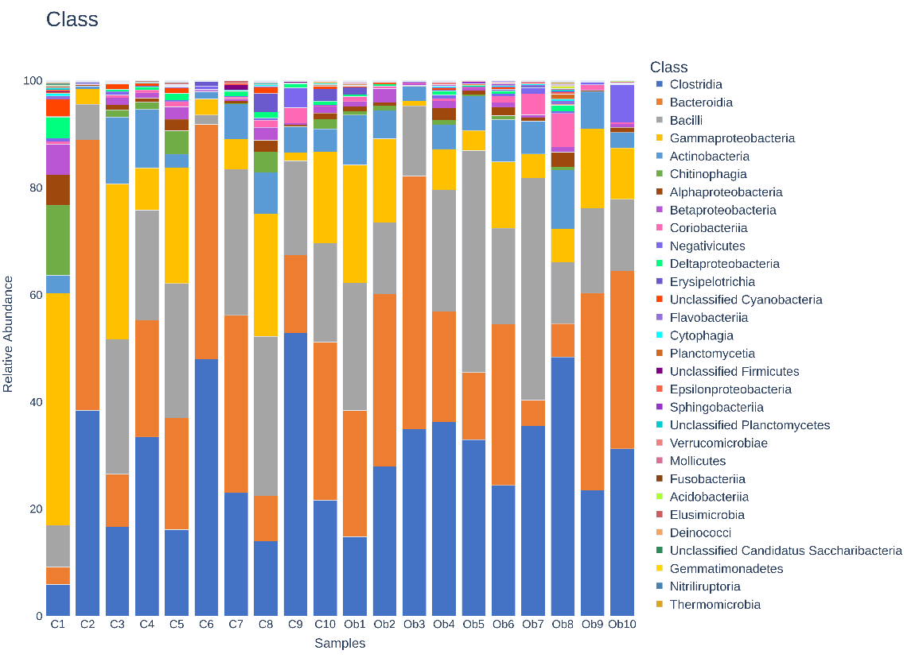
Fig S6: Class-level gut microbiome composition of control and obese individuals (excluding classes detected in lower than 1% of relative abundance among the samples).

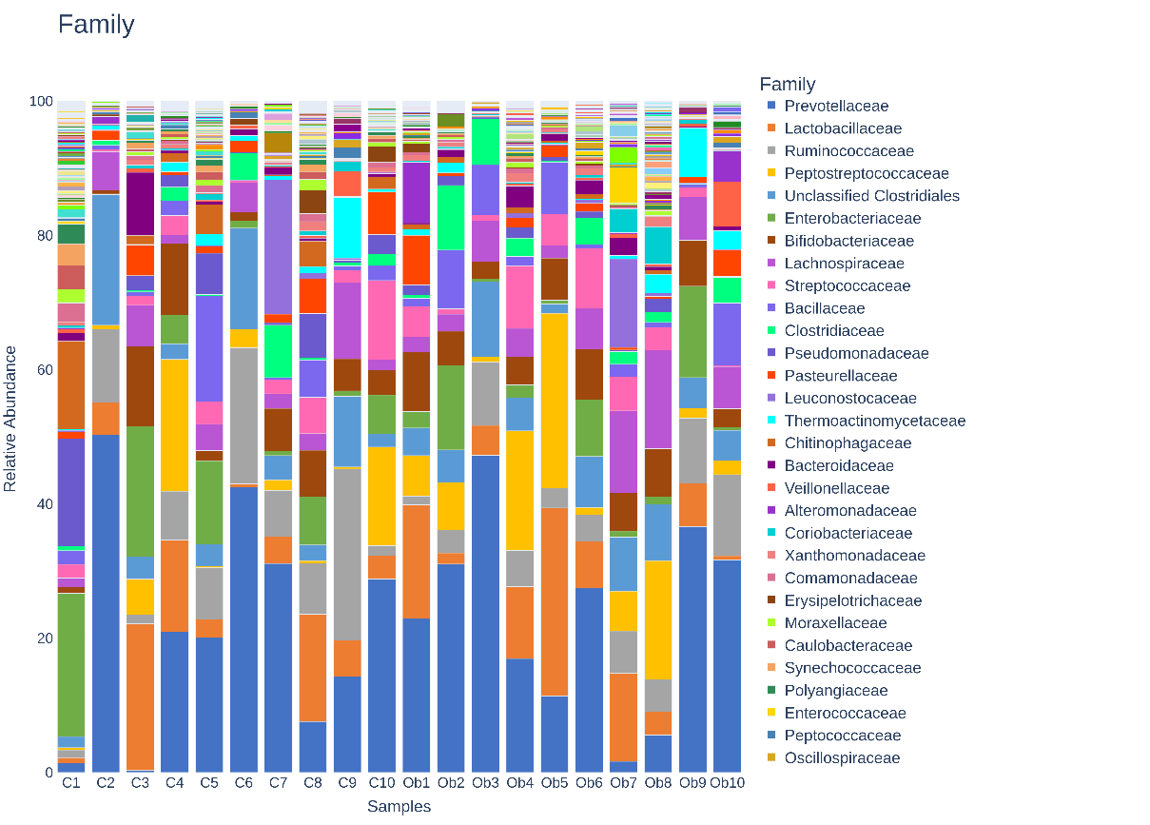
Fig S7: Family-level gut microbiome composition of control and obese individuals (excluding families detected in lower than 1% of relative abundance among the samples).

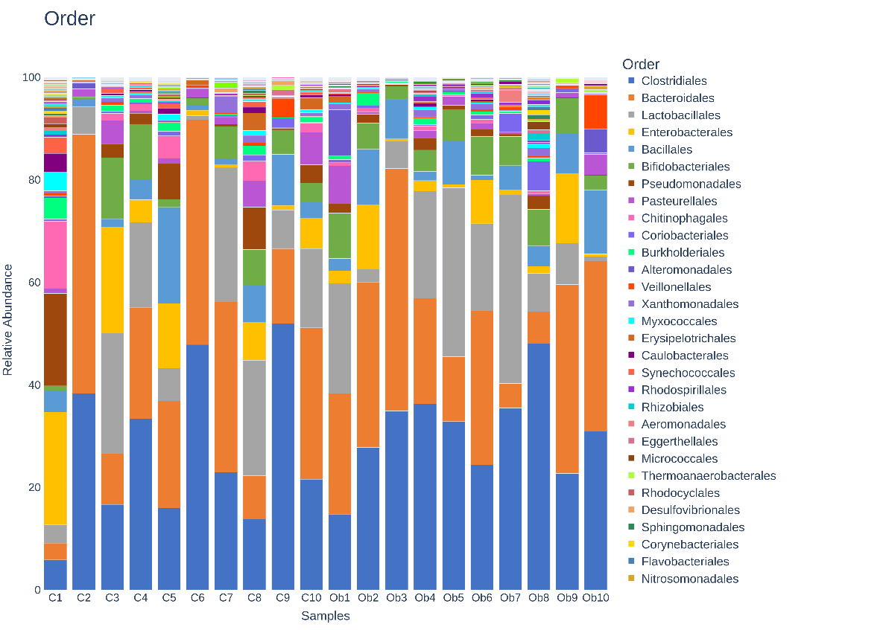
Fig S8: Order-level gut microbiome composition of control and obese individuals (excluding orders detected in less than 1% of relative abundance among the samples).
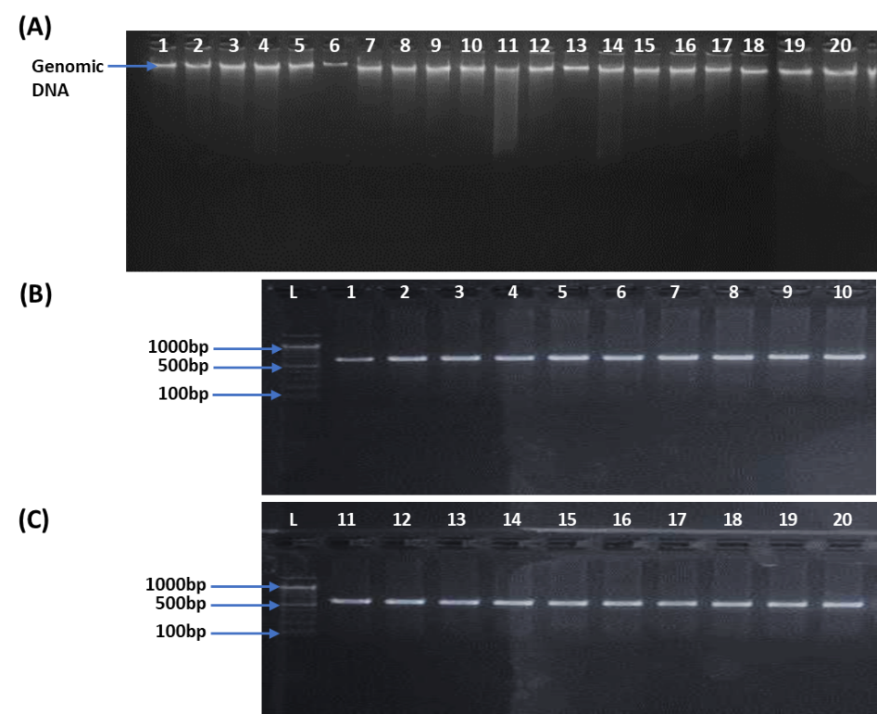
Fig S9: Isolated genomic DNA from obese and control subjects shows distinct gel electrophoresis bands, indicating similar quality and quantity, (b-c) Shows PCR results of 16s rRNA primers on DNA from obese and control subjects; gel electrophoresis displays clear bands indicating successful amplification.

