Full uncropped Gels and Blots image(s)

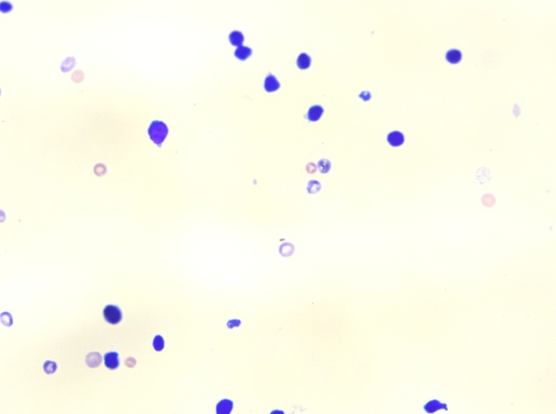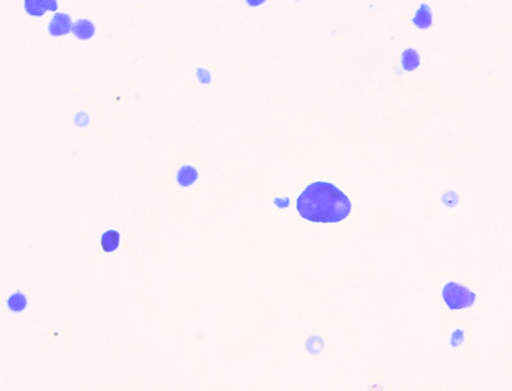
MNPCEs
NCEs
PCEs
( a ) ( b )

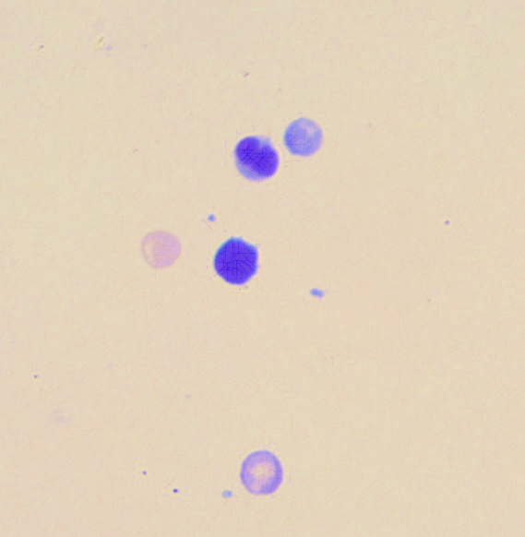
PCEs
NCEs
PMNCs
MNNCEs
MNNCEs
( c ) ( d )

Fig. 1: Representative images showing micronuclei in bone marrow cells of mice observed under 40X magnification of light microscope. Plate (a) shows normochromatic erythrocytes (NCEs) and polychromatic erythrocytes (PCEs). Plate (b) shows micronucleated polychromatic erythrocytes (MNPCEs). Plate (c) shows micronucleated normochromatic erythrocytes (MNNCEs). Plate (d) shows polymorphonuclear cells (PMNCs)

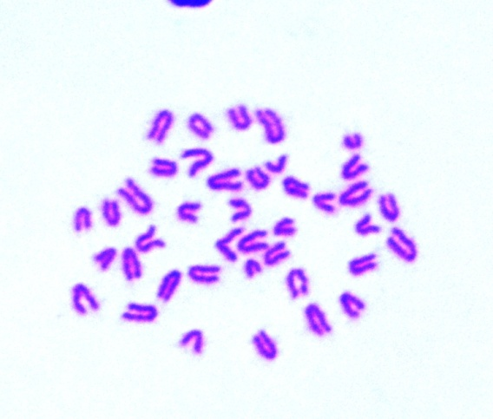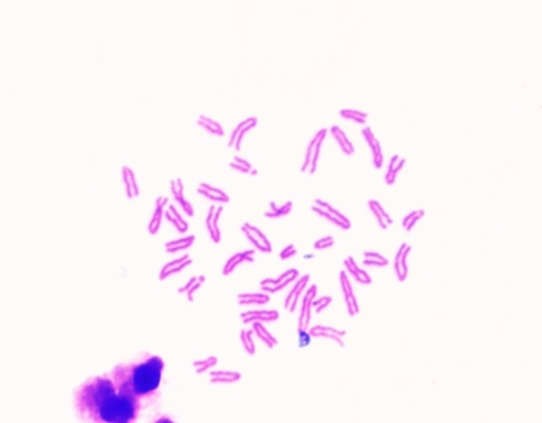
ICGGG
CF
(a) (b)
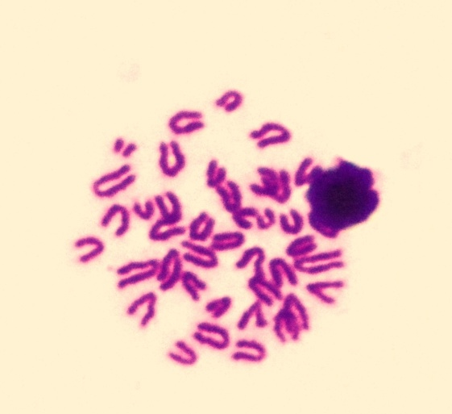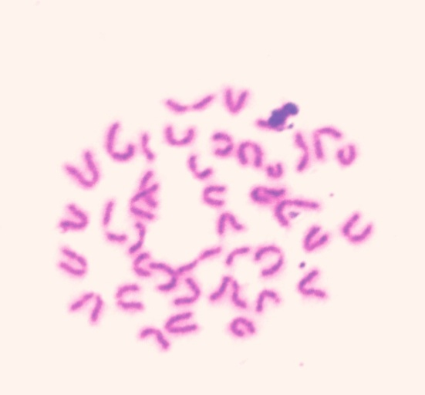
CD

CG
CB
(c) (d)

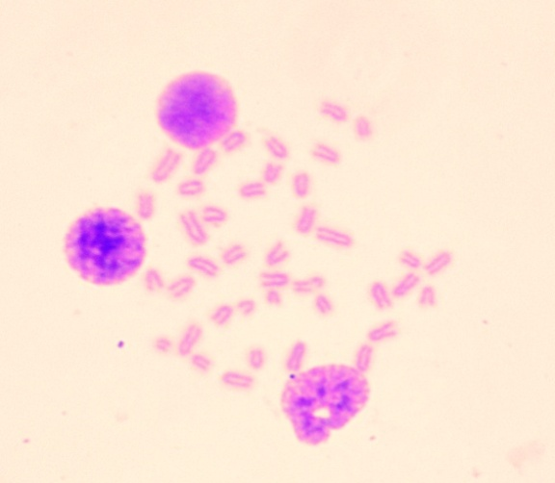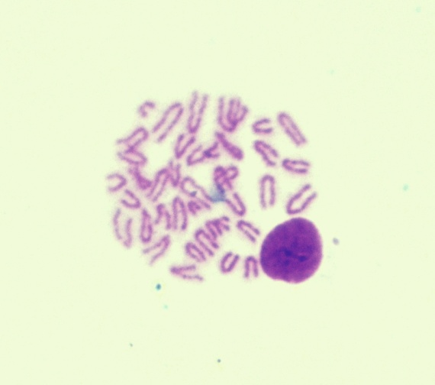
Cg
Cb
(e) (f)
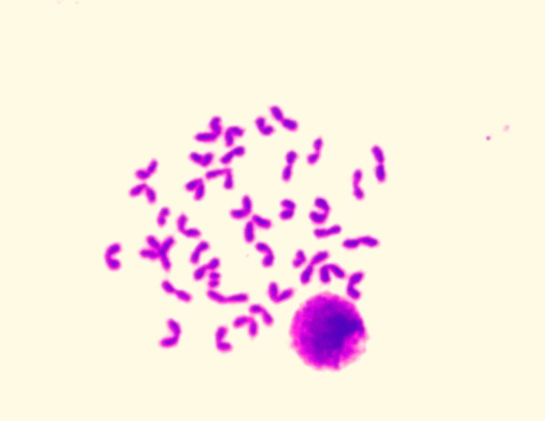
(g) (h)

Fig. 2: Representative images of different types of chromosomal aberrations induced in bone marrow cells of mice showing effects of subacute oral exposure of mice to QNP, piperine and their combination observed under ×100 objective (oil) in light microscope; a: Normal metaphasic spread; b: centric fusion (CF); isochromatid gap (ICG); c: chromatid break (CB); d: chromatid gap (CG); centromeric deletion (CD); e: centromeric break with fragments (Cb); f: centromeric gap (Cg); g: Polyploidy; h: Endoreduplication
a
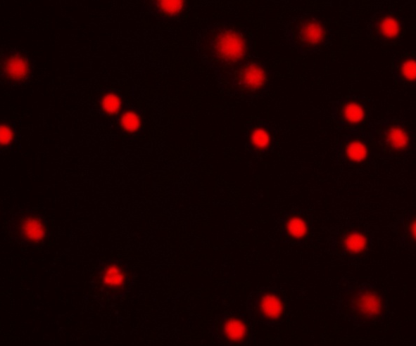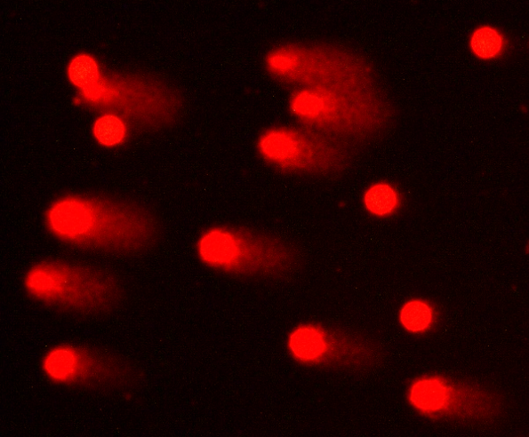
b
Control QNP I-treated group
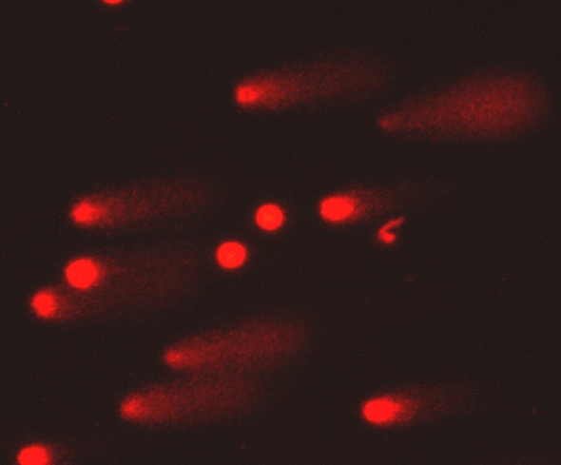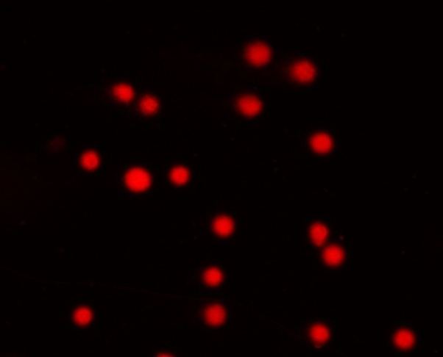
c
d
QNP II-treated group PIP-treated group
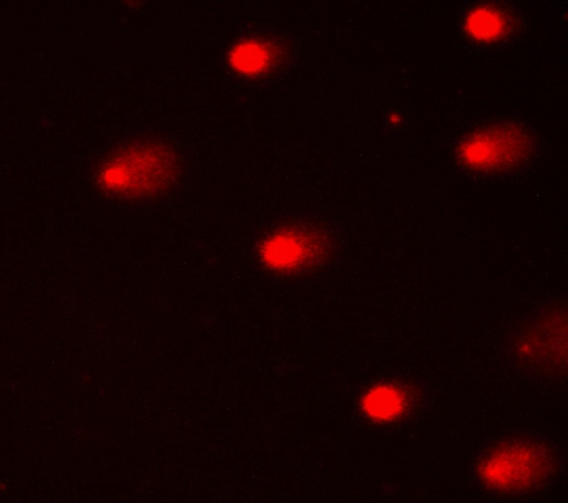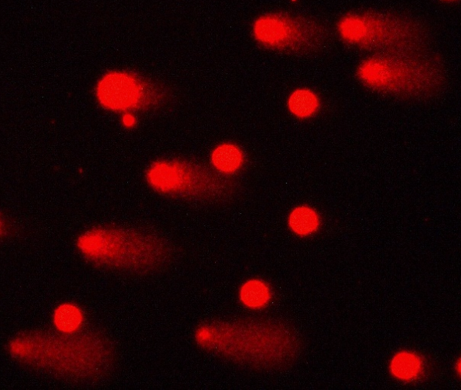
f
e
QNP I + PIP-treated group QNP II + PIP-treated group
Fig.3: Representative images showing effects of subacute oral exposure of mice to QNP, piperine and their combination on DNA damage (comet assay) in bone marrow cells observed at 200x magnification of fluorescent microscope
. b.
Fig. 4: Effects of subacute oral exposure of QNP, piperine and their combination in the mRNA expression of apoptosis related gene Bax and Bcl-2 of mice. QNP: quinalphos; PIP: piperine (10 mg/kg). Fig. a and b represent fold changes in the mRNA expression of apoptosis related gene Bax and Bcl-2 of mice. The values were compared using one-way ANOVA followed by Tukey post-hoc test. Means bearing a, b, and c superscripts differ significantly (P<0.05) vs. control, QNP I, and QNP II, respectively

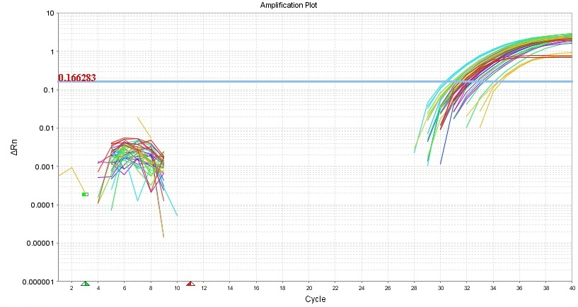
Amplification plot of Bax gene

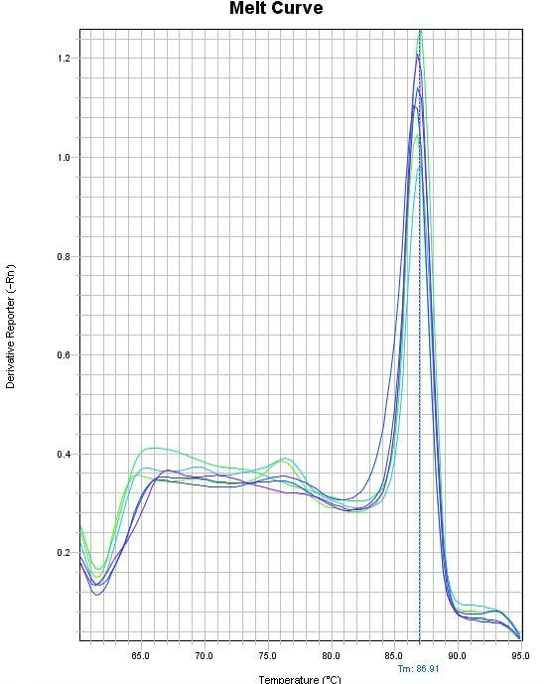
Melt curve of Bax gene

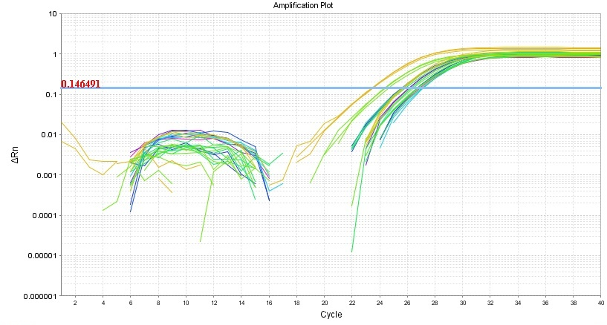
Amplification plot of Bcl-2 gene

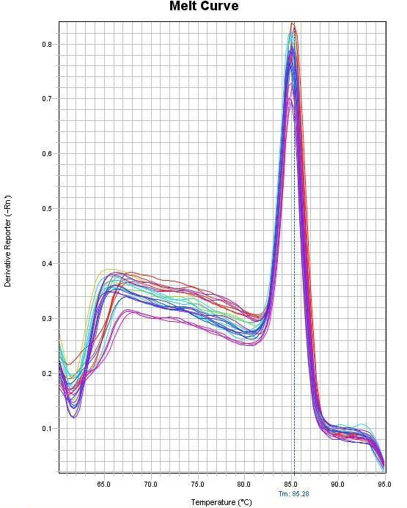
Melt curve of Bcl-2 gene
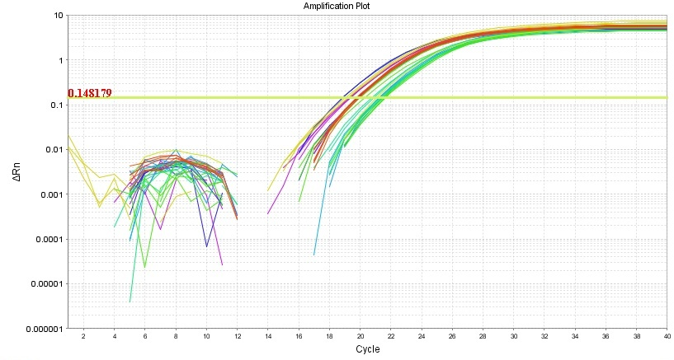
Amplification plot of ß-actin gene
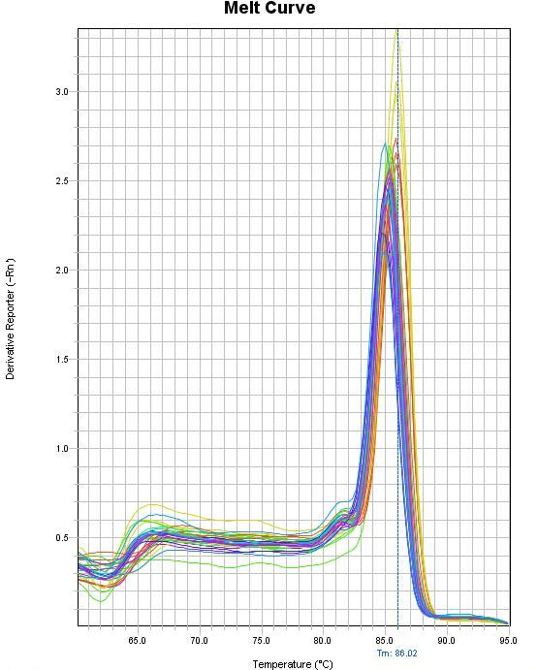
Melt curve of ß-actin gene

Fig. 5: Representative images showing amplification plot and melt curve of Bax, Bcl-2 and ß-actin gene in bone marrow of mice

