Supplementary Material
of
“Revealing the relationship between ENSO and the annual cycle of the East Asia and western Pacific monsoon using a low-level circulation weather-type calendar”

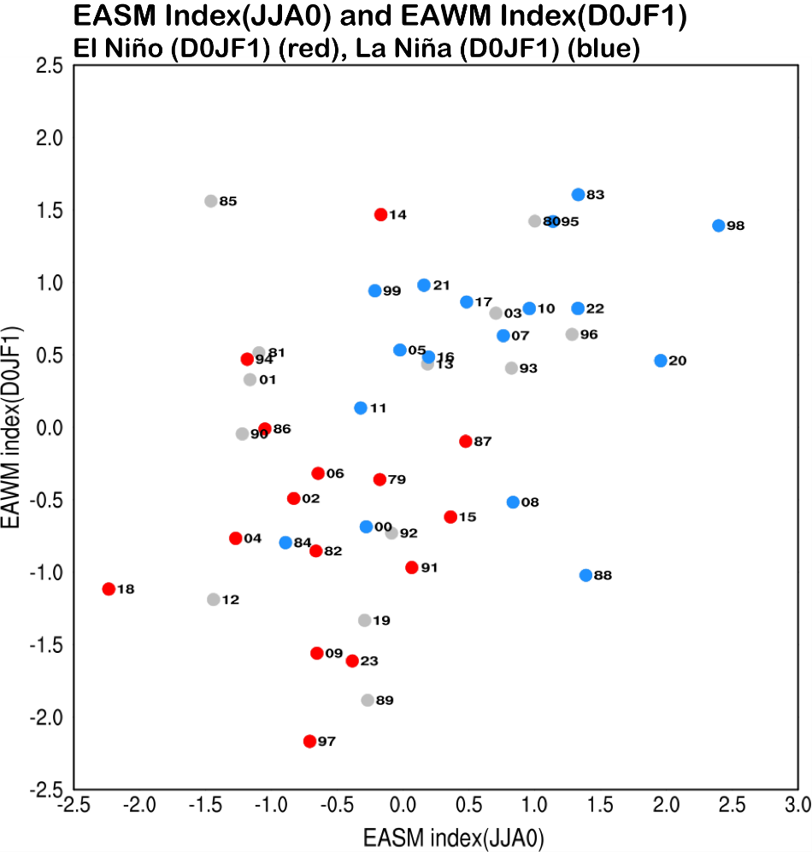
Figure S1. Scatterplot of the standardized EASMI in summer (JJA0) and the EAWMI in the ensuing winter (D0JF1). The indices are the same as that used in Yu et al. (2021) and explained in Section 2.3 in the text. The correlation of two indices is 0.4.

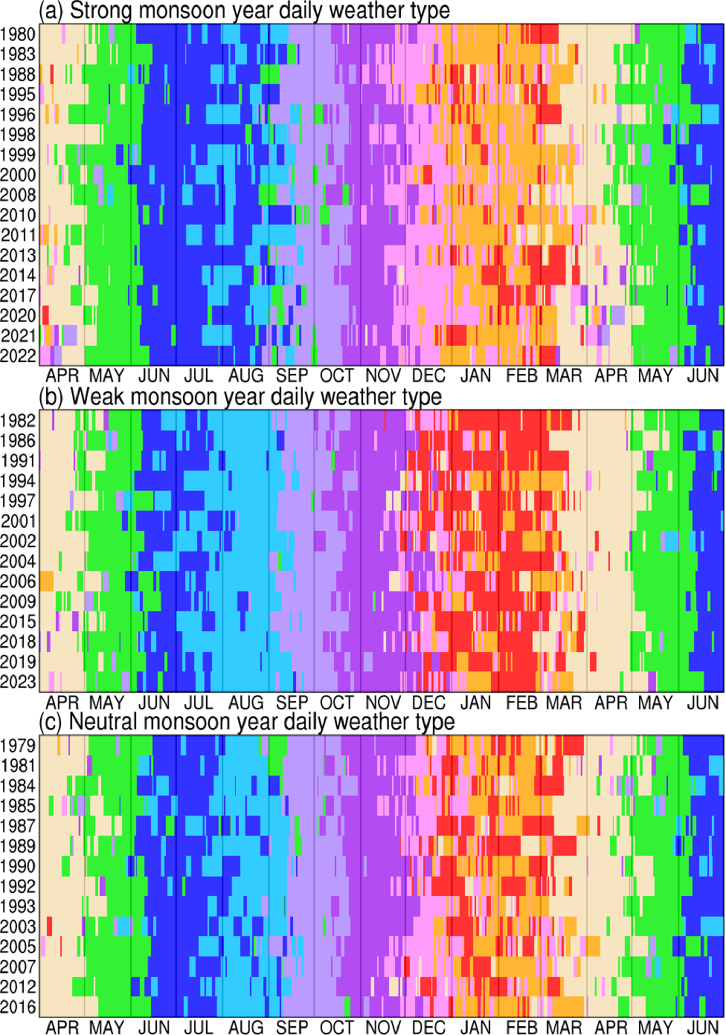
Figure S2. The weather type calendar for (a) 17 strong monsoon years, (b) 14 weak monsoon years, and (c) 14 neutral monsoon years. The weather type color is the same as in Fig. 4. The x-axis shows the date from April 1 to June 30, which includes one month before the beginning and two months after the end of a monsoon year.

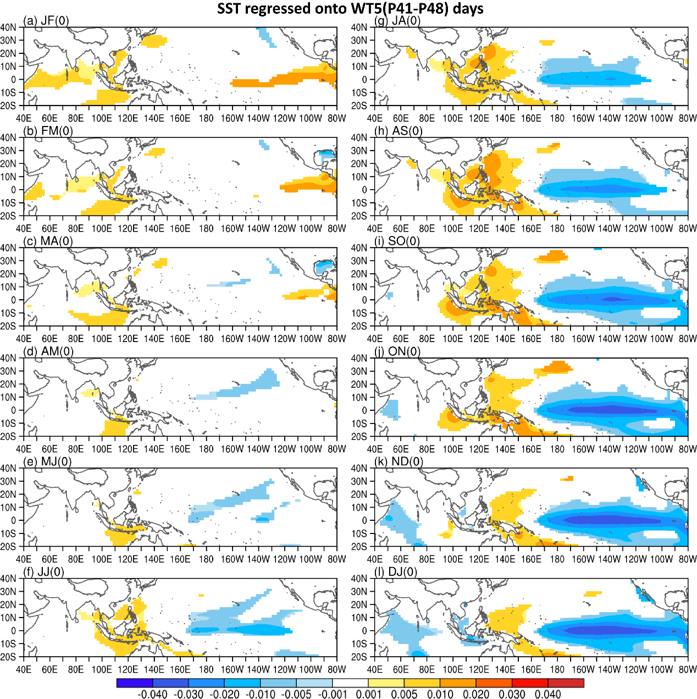
Fig. S3 Regressions of bi-monthly mean sea surface temperature on the total number of WT5 days during pentad 41-48 from 1979-2024. Only significant at the 95% confidence level are shown. The panels correspond to (a) January-February, (b) February-March, (c) March-April, (d) April-May, (e) May-June, (f) June-July, (g)July-August, (h) August-September, (i) September-October, (j) October-November, (k) November-December, and (l) December-January.

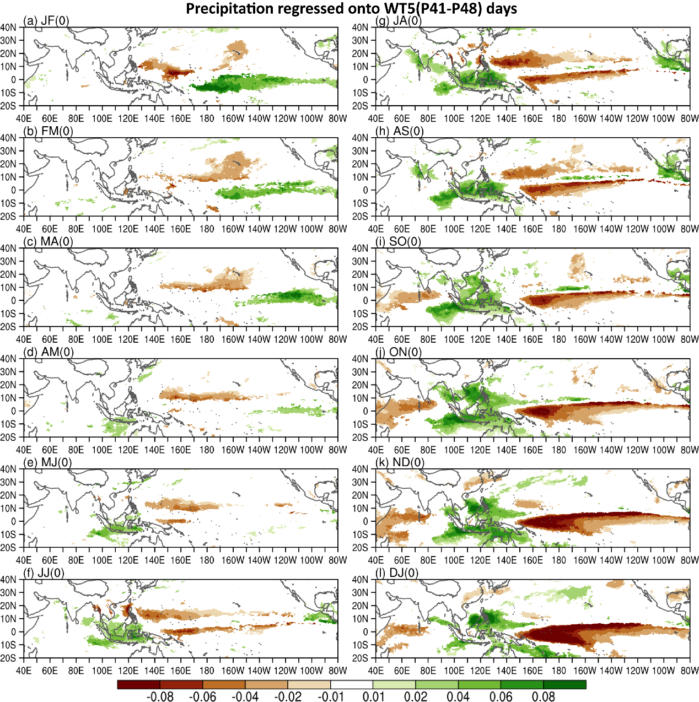
Fig. S4 Regressions of bi-monthly precipitation on the total number of WT5 days during pentad 41-48 from 1979-2024. Only significant at the 95% confidence level are shown. The panels correspond to (a) January-February, (b) February-March, (c) March-April, (d) April-May, (e) May-June, (f) June-July, (g)July-August, (h) August-September, (i) September-October, (j) October-November, (k) November-December, and (l) December-January.

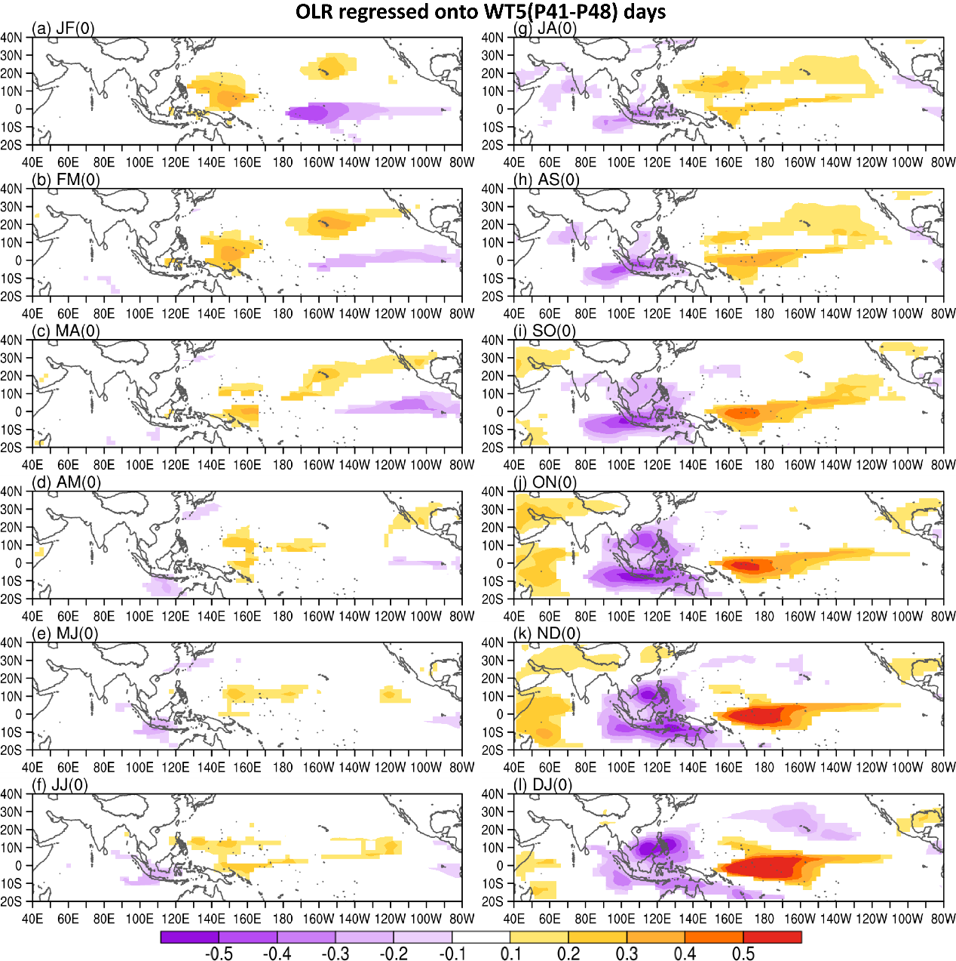
Fig. S5 Regressions of bi-monthly outgoing longwave radiation on the total number of WT5 days during pentad 41-48 from 1979-2024. Only significant at the 95% confidence level are shown. The panels correspond to (a) January-February, (b) February-March, (c) March-April, (d) April-May, (e) May-June, (f) June-July, (g)July-August, (h) August-September, (i) September-October, (j) October-November, (k) November-December, and (l) December-January.

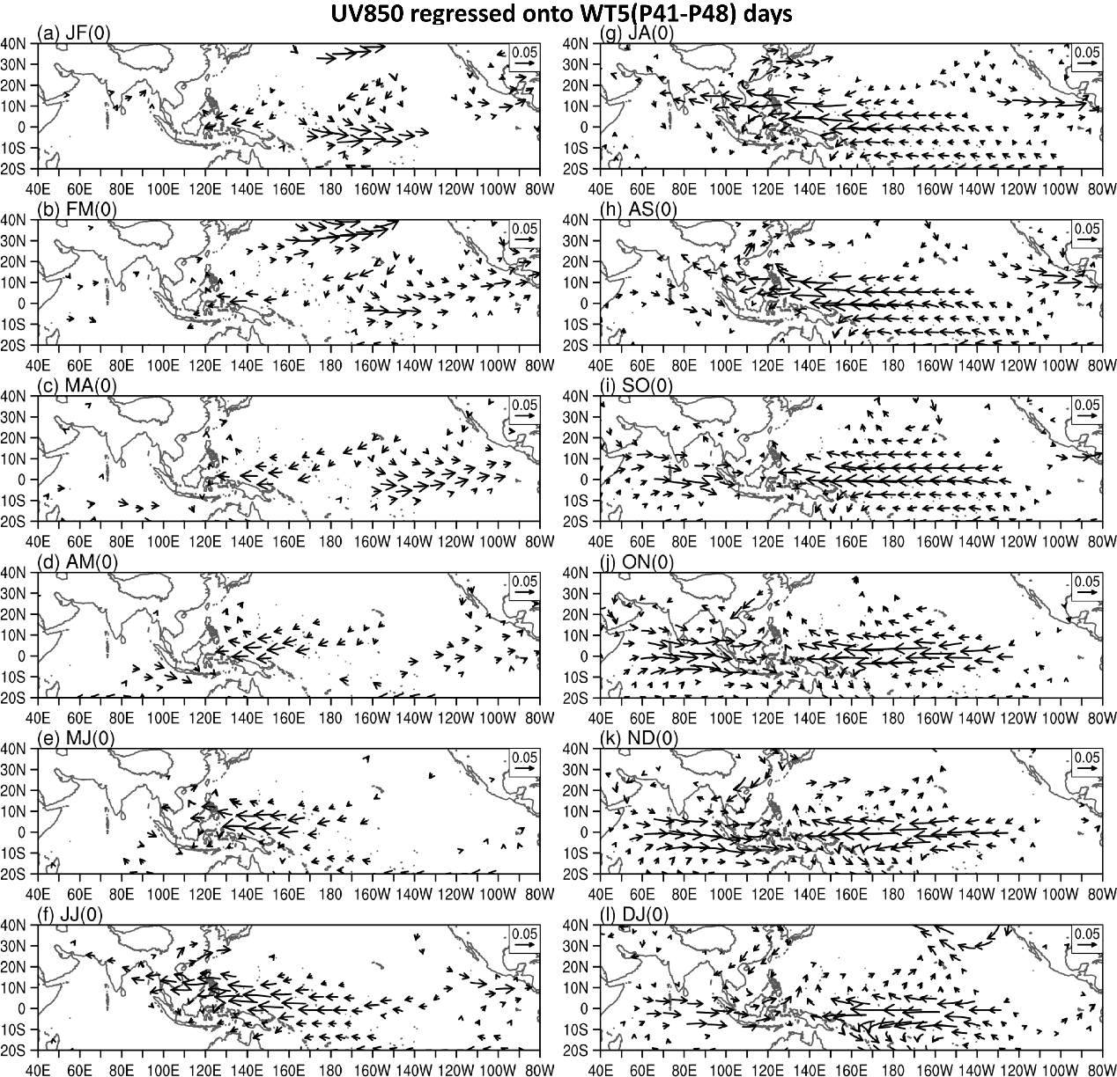
Fig. S6 Regressions of bi-monthly 850hPa winds on the total number of WT5 days during pentad 41-48 from 1979-2024. Only significant at the 95% confidence level are shown. The panels correspond to (a) January-February, (b) February-March, (c) March-April, (d) April-May, (e) May-June, (f) June-July, (g)July-August, (h) August-September, (i) September-October, (j) October-November, (k) November-December, and (l) December-January.

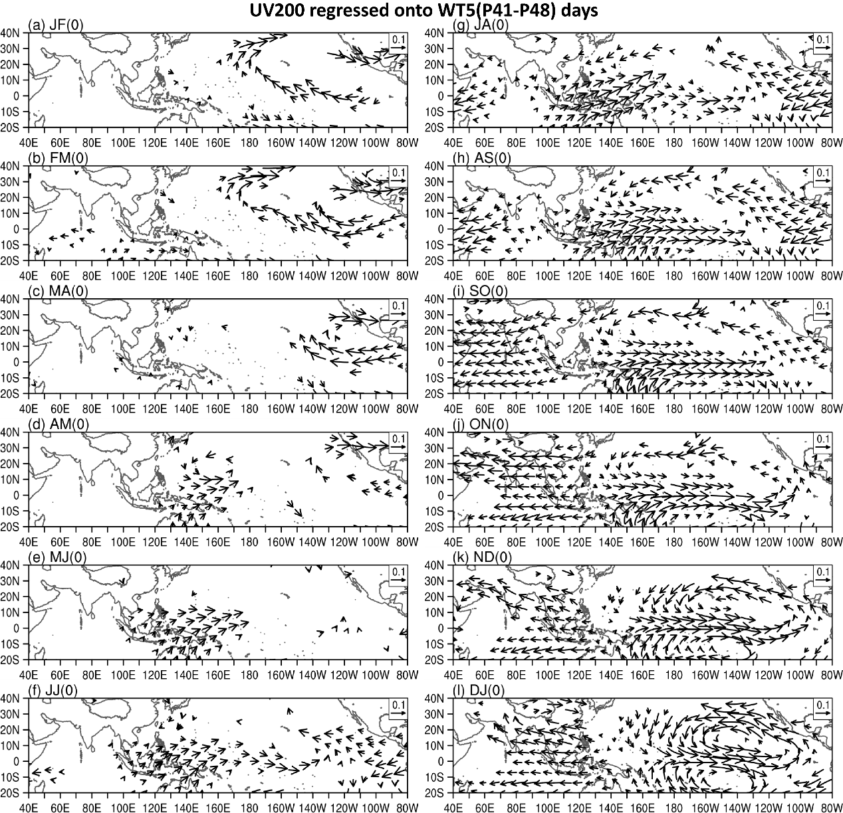
Fig. S7 Regressions of bi-monthly 200hPa winds on the total number of WT5 days during pentad 41-48 from 1979-2024. Only significant at the 95% confidence level are shown. The panels correspond to (a) January-February, (b) February-March, (c) March-April, (d) April-May, (e) May-June, (f) June-July, (g)July-August, (h) August-September, (i) September-October, (j) October-November, (k) November-December, and (l) December-January.

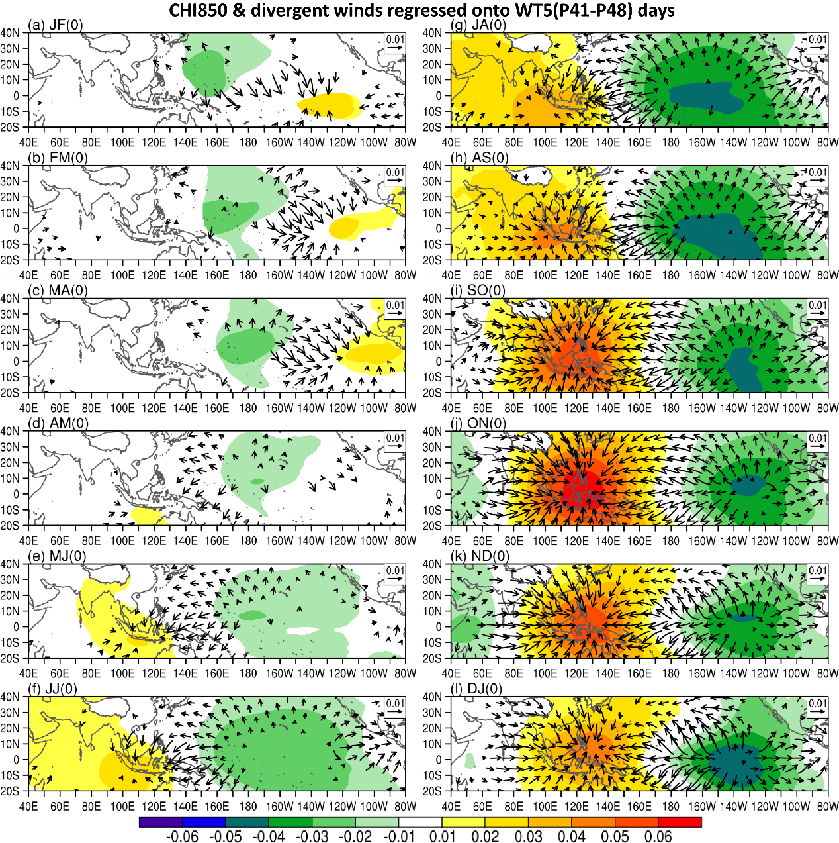
Fig. S8 Regressions of bi-monthly 850hPa velocity potential (shading) and divergent winds (vectors) on the total number of WT5 days during pentad 41-48 from 1979-2024. Only significant at the 95% confidence level are shown. The panels correspond to (a) January-February, (b) February-March, (c) March-April, (d) April-May, (e) May-June, (f) June-July, (g)July-August, (h) August-September, (i) September-October, (j) October-November, (k) November-December, and (l) December-January.

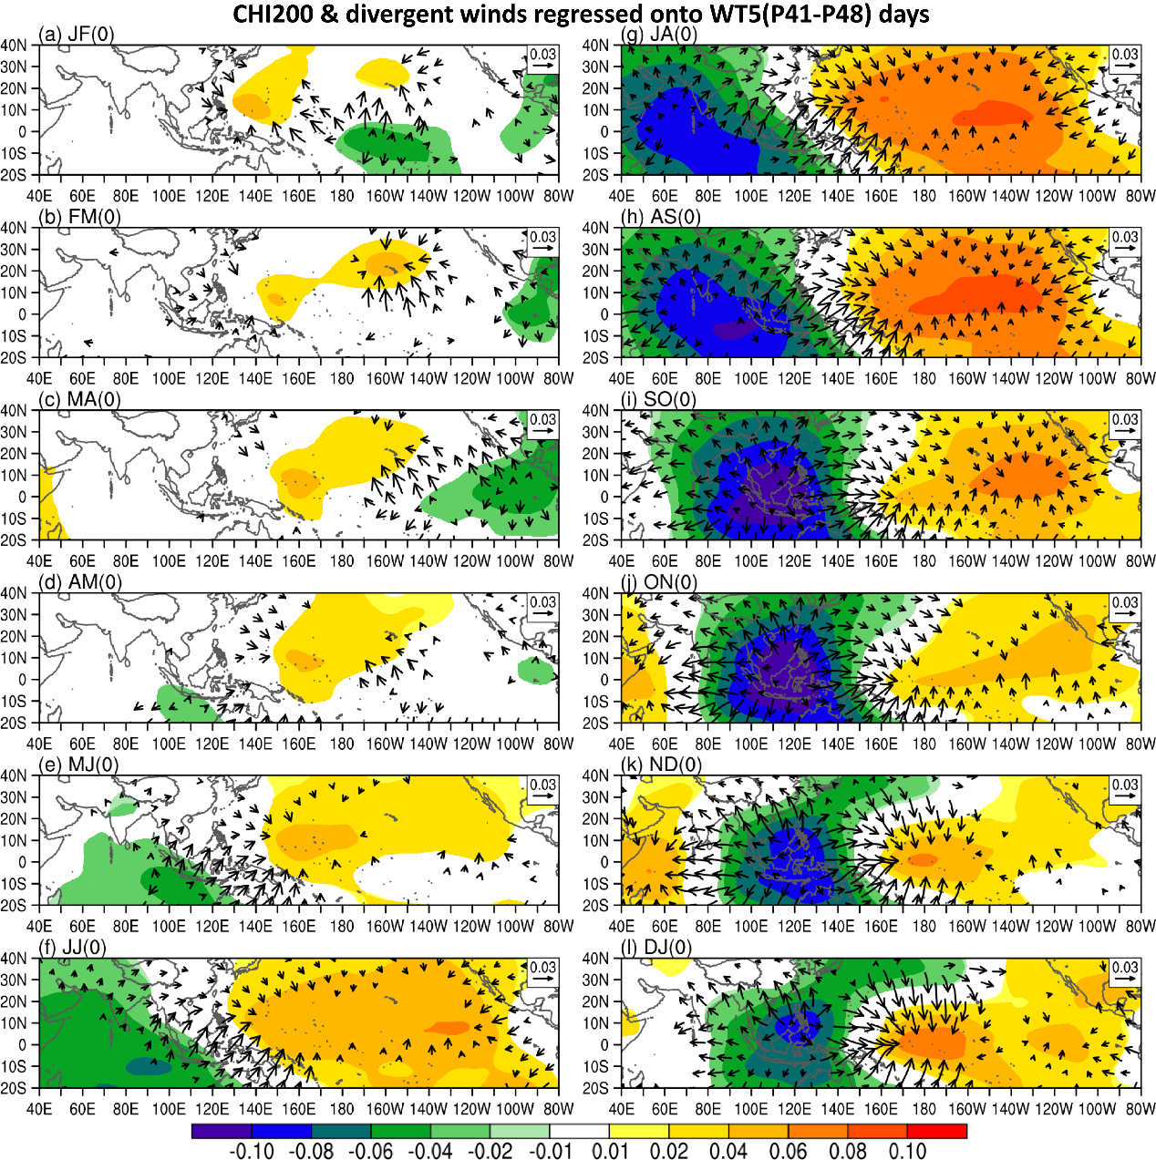
Fig. S9 Regressions of bi-monthly 200hPa velocity potential (shading) and divergent winds (vectors) on the total number of WT5 days during pentad 41-48 from 1979-2024. Only significant at the 95% confidence level are shown. The panels correspond to (a) January-February, (b) February-March, (c) March-April, (d) April-May, (e) May-June, (f) June-July, (g)July-August, (h) August-September, (i) September-October, (j) October-November, (k) November-December, and (l) December-January.

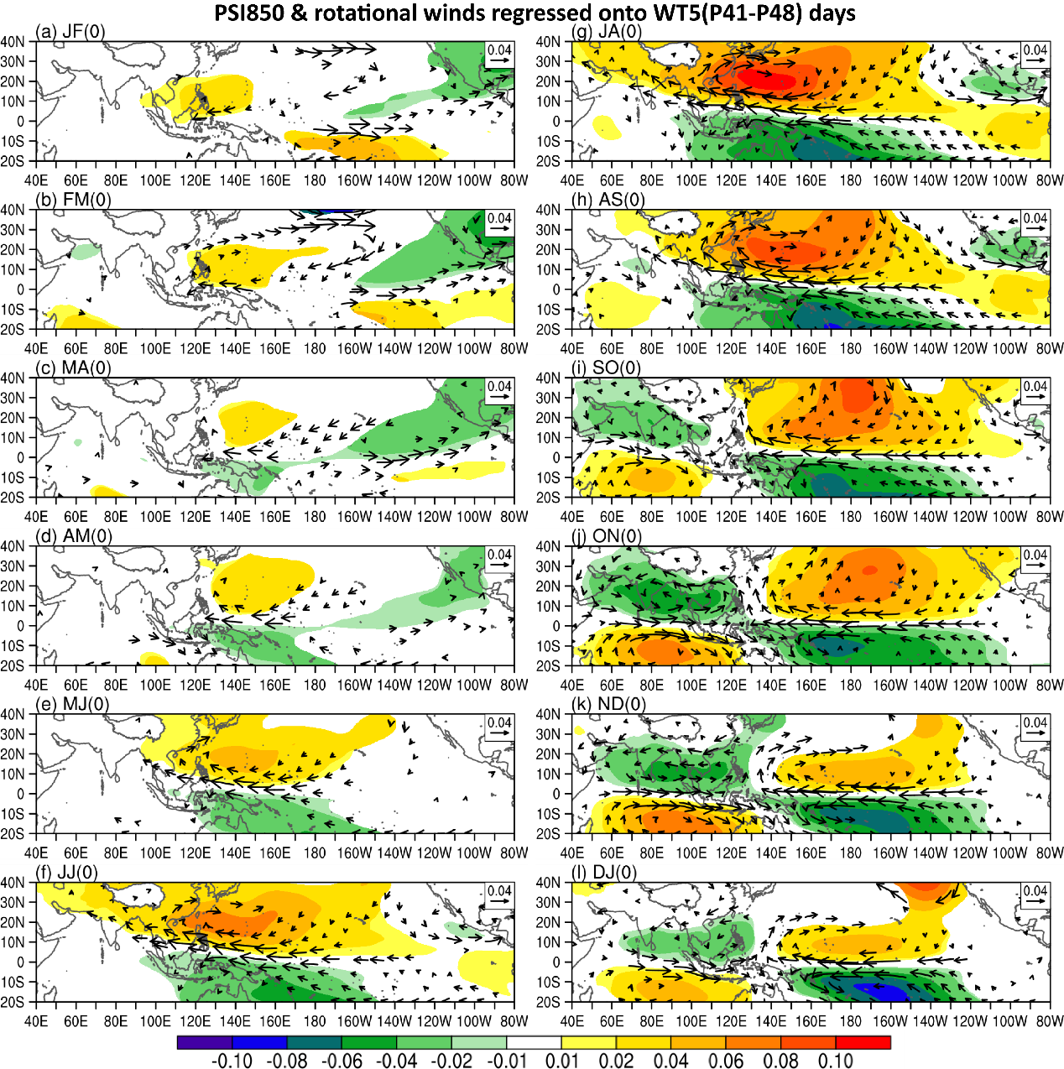
Fig. S10 Regressions of bi-monthly mean 850hPa stream function (shading) and rotational winds (vectors) on the total number of WT5 days during pentad 41-48 from 1979-2024. Only significant at the 95% confidence level are shown. The panels correspond to (a) January-February, (b) February-March, (c) March-April, (d) April-May, (e) May-June, (f) June-July, (g)July-August, (h) August-September, (i) September-October, (j) October-November, (k) November-December, and (l) December-January.

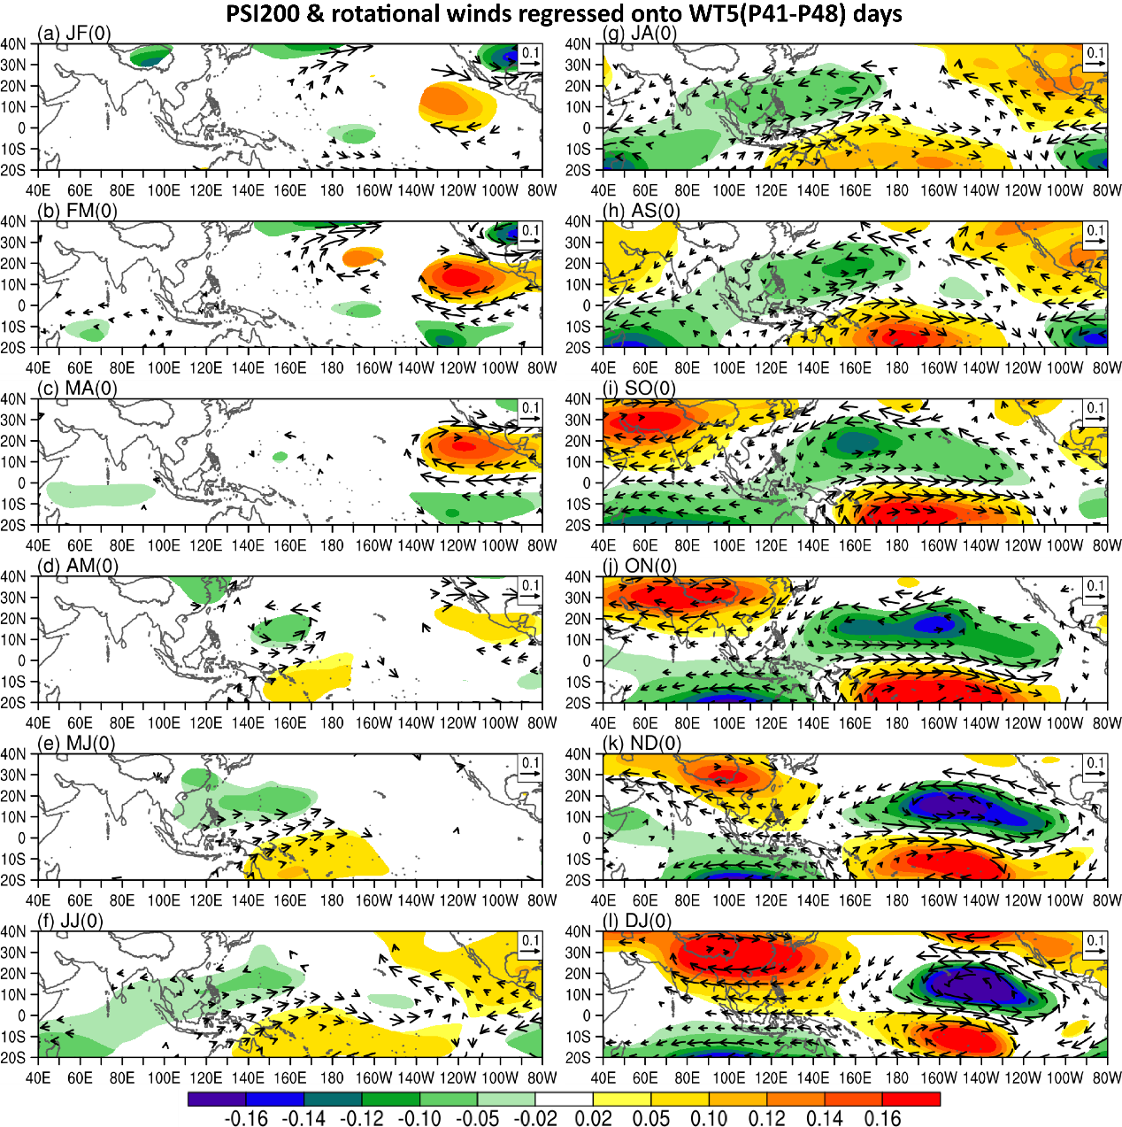
Fig. S11 Regressions of bi-monthly mean 200hPa stream function (shading) and rotational winds (vectors) on the total number of WT5 days during pentad 41-48 from 1979-2024. Only significant at the 95% confidence level are shown. The panels correspond to (a) January-February, (b) February-March, (c) March-April, (d) April-May, (e) May-June, (f) June-July, (g)July-August, (h) August-September, (i) September-October, (j) October-November, (k) November-December, and (l) December-January.

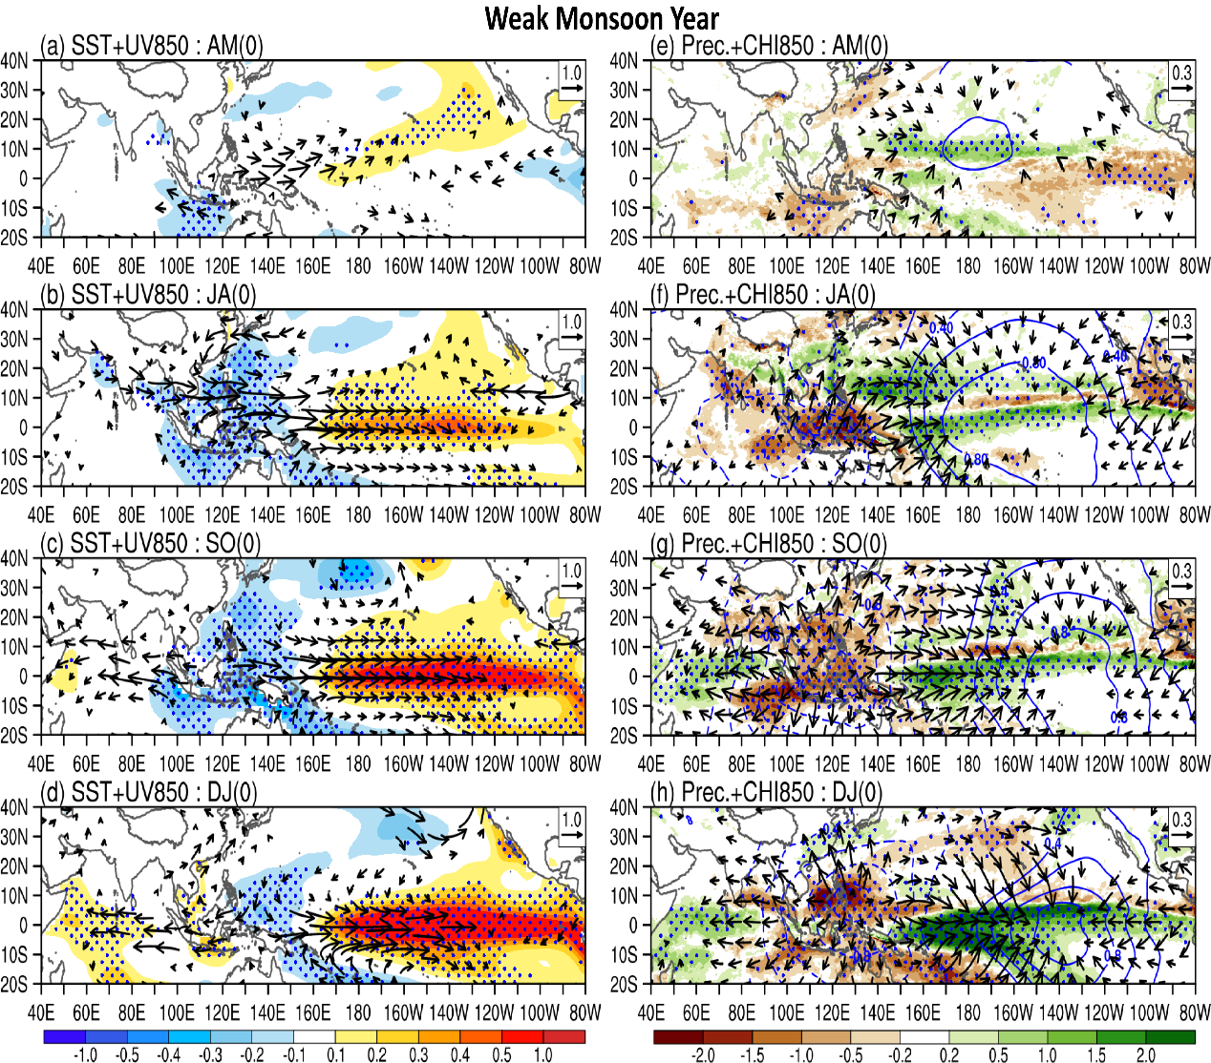
Fig. S12 Composite maps of the regressed (a-d) sea surface temperature (shading, ℃) and 850hPa wind fields (vectors, m s⁻¹), and (e-h) precipitation (shading, mm day⁻¹), low-level velocity potential (contour, m2 s⁻¹, contours with 0.2 interval), and divergent winds (vectors, m s⁻¹) on the total number of WT5 days during pentads 41-48, for the weak monsoon years. The panels correspond to (a, e) April-May, (b, f) July-August, (c, g) September-October, and (d, h) December-January.

