Table S1 Association between baseline UHR (median split) and CMM
UHR | Model 1 |  |  | Model 2 |  |  | Model 3
UHR | HR(95%CI) | P |  | HR(95%CI) | P |  | HR(95%CI) | P
＜median | Reference |  |  | Reference |  |  | Reference
≥ median | 1.50 (1.36-1.65) | <0.001 |  | 1.60 (1.45-1.76) | <0.001 |  | 1.16 (1.05-1.29) | 0.004
P value |  | <0.001 |  |  | <0.001 |  |  | 0.004

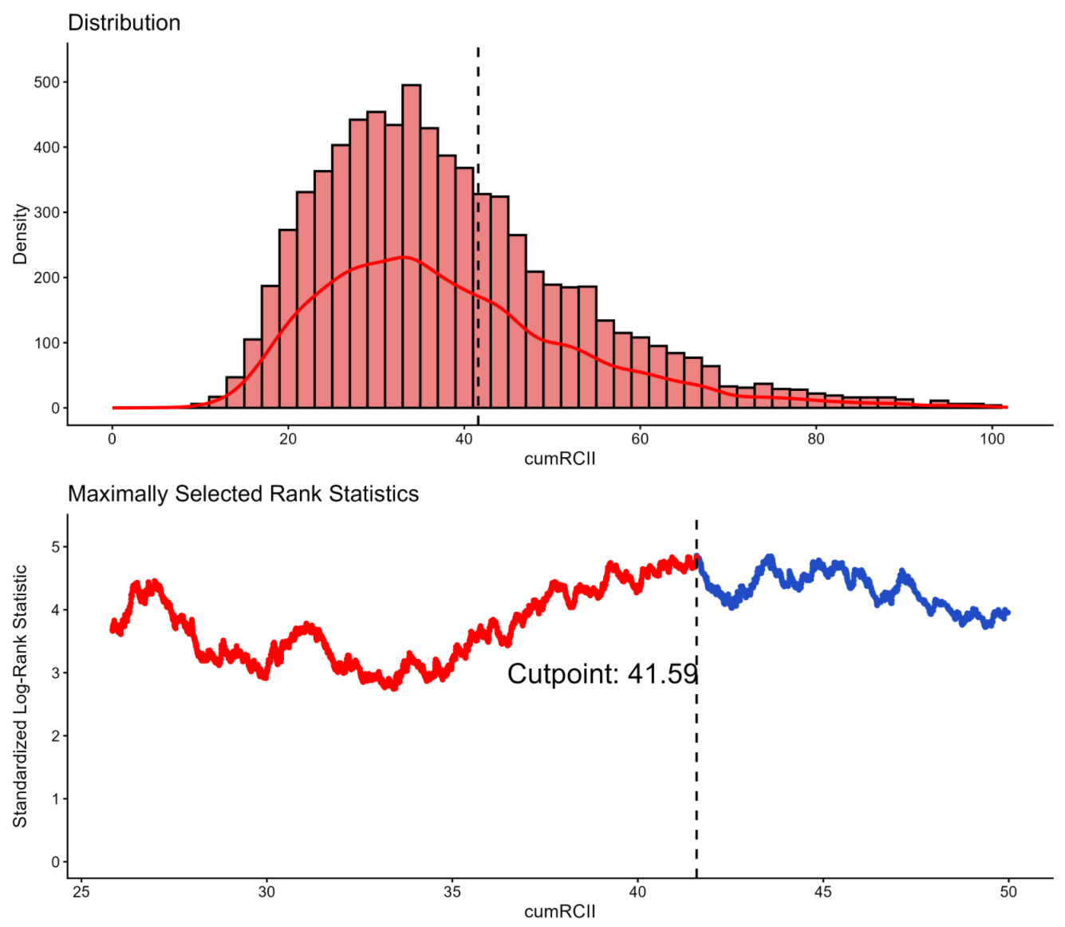

Figure S1. Determination of the optimal cut-off value for cumulative UHR using maximally selected rank statistics.

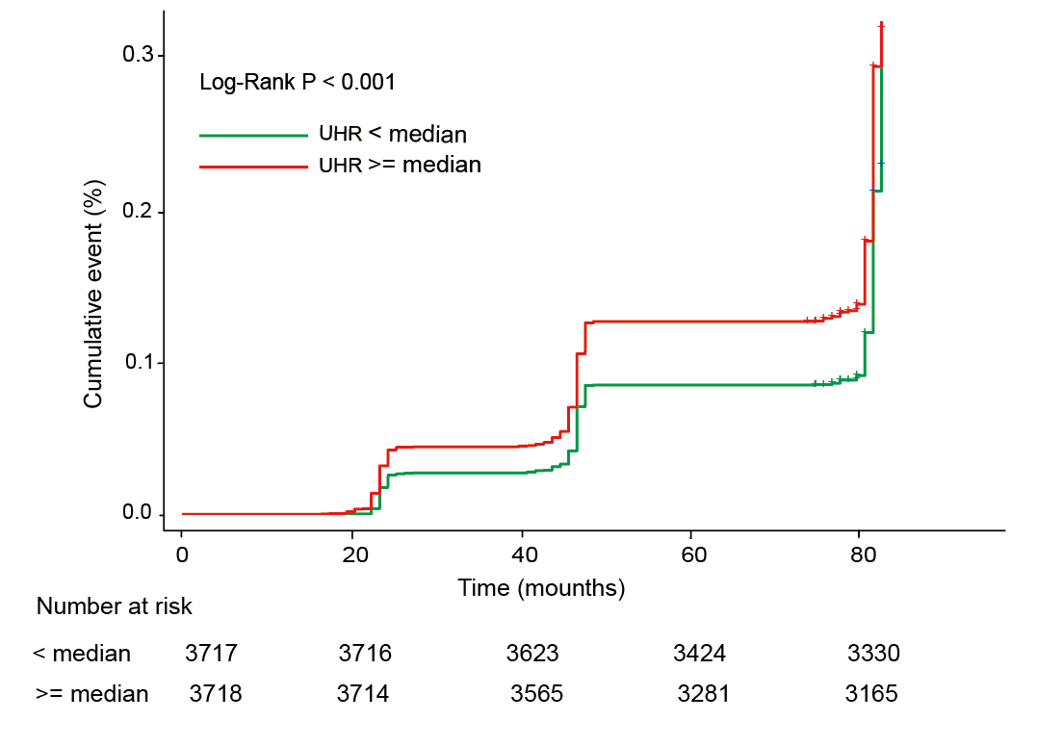
Figure S2. Kaplan–Meier curves for cumulative events of CMM according to baseline UHR (median split)

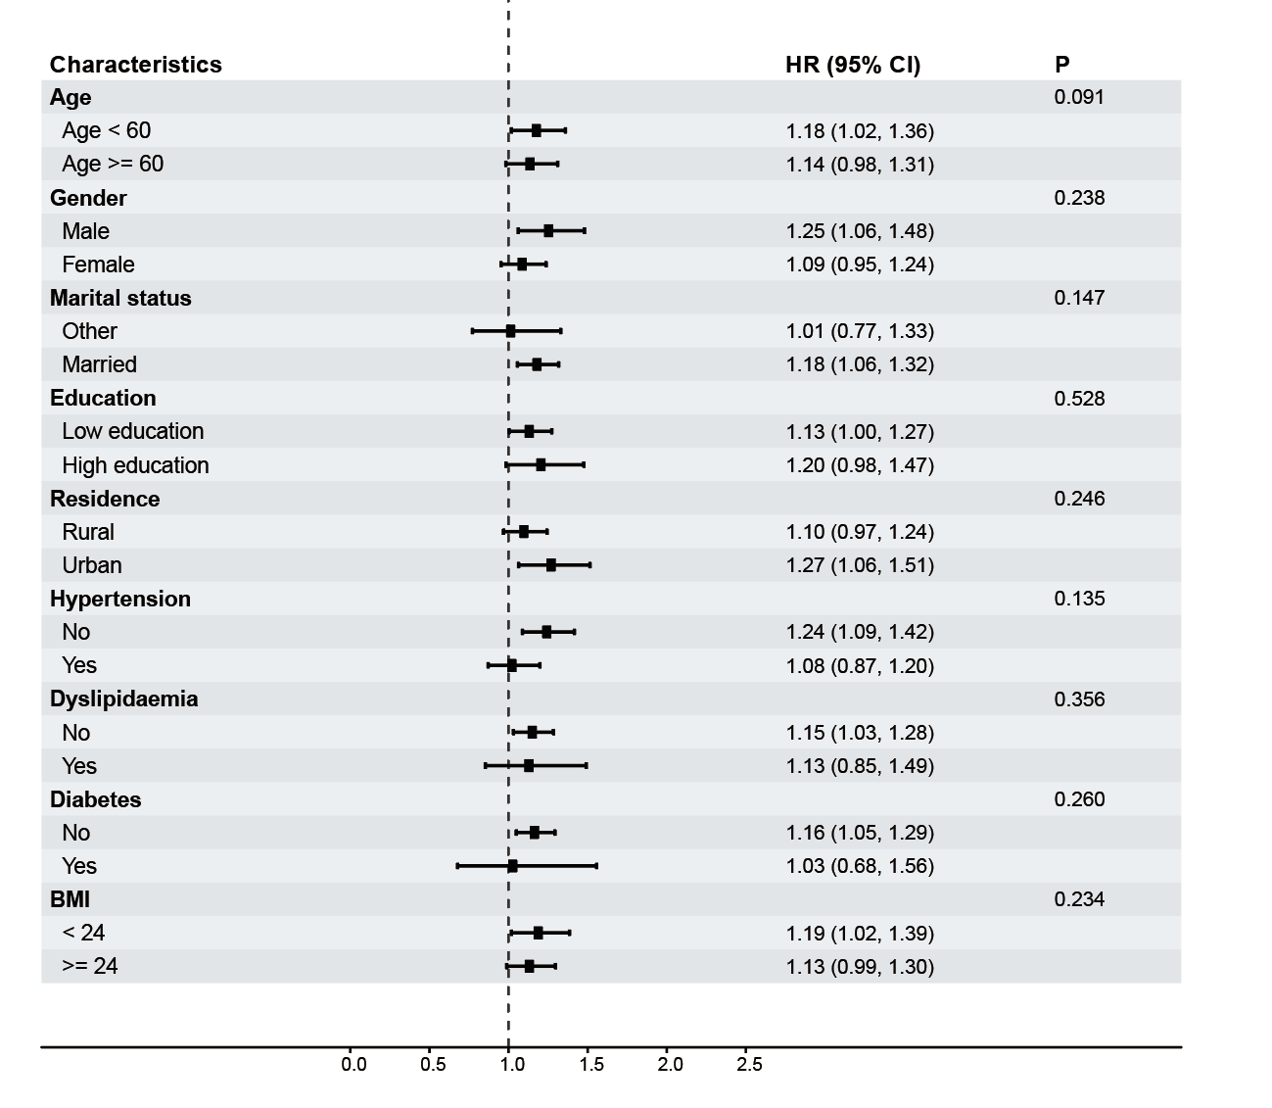
Figure S3. Subgroup and interaction analyses of the association between median UHR and risk of CMM

