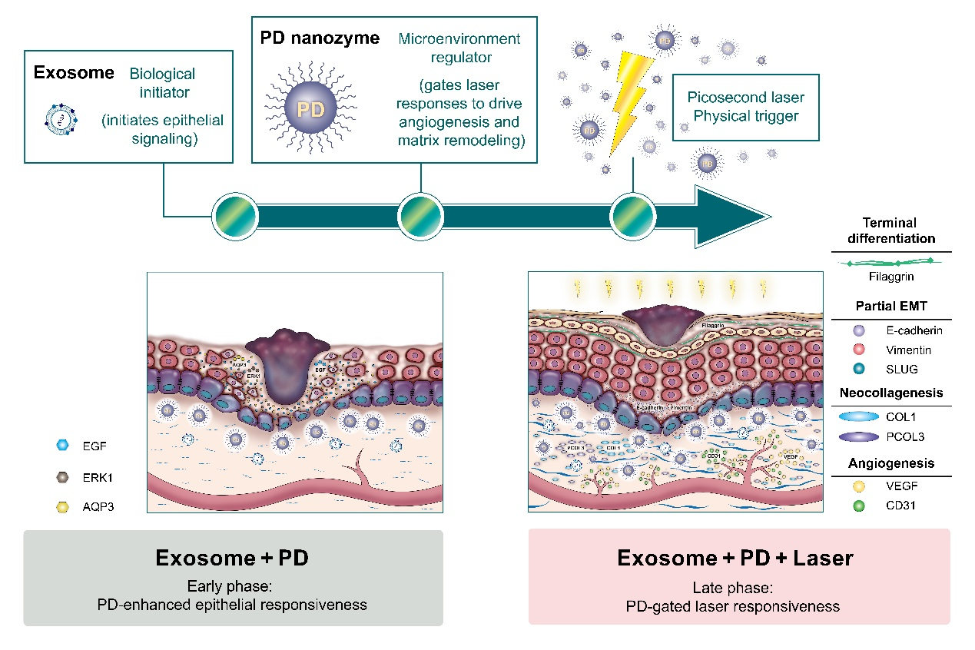
Graphical Abstract

Nanozyme-enabled phase-programmable wound regeneration integrating exosomes, polymer dot nanozymes, and picosecond laser stimulation.

