Supporting Information

An efficient room-temperature H₂ production system containing hypophosphite and CuPd/TiO₂ catalyst

Characterization
X-ray diffraction (XRD) patterns were measured using the XRD6100 polycrystalline X-ray diffractometer (Shimadzu, Japan) with Cu Kα radiation as the X-ray source. Scanning electron microscopy (SEM) images were obtained from an SU8020 (HITACHI, Japan) with a working voltage of 30 kV. Transmission electron microscopy (TEM) and high-resolution TEM (HR-TEM) images were obtained from a Titan G260-300 microscope operating at 300 kV. X-ray photoelectron spectroscopy (XPS) analyses were obtained on the ESCALAB250xi photoelectron spectrometer (Thermo Scientific) using monochromatized Mg Kα X-Ray resource (150 W) with C 1s = 284.8 eV as an internal reference. N₂ gas adsorption/desorption isotherms were measured on the ASAP 2460 nitrogen adsorption apparatus (Micromeritics Instruments, USA). The actual amounts of Pd and Cu in the catalysts were measured by inductively coupled plasma optical emission spectrometry (ICP-OES, Agilent 730, USA). CO-infrared Fourier transform spectroscopy (CO-IR) measurements were performed on a Bruker Tensor 27 instrument with a Hg-Cd-Te (MCT) detector. The catalysts were pretreated with 100 mL/min of 10% H₂/Ar at 300°C for 30 min. The CO adsorption was performed at room temperature. 10% CO/Ar was introduced into the cell at a flow rate of 100 mL/min. After the CO saturation, Ar purge at a flow rate of 100 mL/min was performed to remove gas phase CO from the cell. The electron spin resonances (ESR) spectrum was tested by a Bruker A300 instrument, the PBN(N-tert-Butyl-α-phenylnitrone) was employed as the trapping agent to detect the HPO₂⁻ radicals generated in the hydrogen production system. Fourier transform infrared (FTIR) spectra were recorded in transmission mode from 400 to 4000 cm⁻¹ at a resolution of 8 cm⁻¹ on a Nicolet Magna 560 IR spectrometer using the KBr pellet technique.

Computational method
All the DFT calculations were conducted based on the Vienna Ab initio Simulation Package (VASP). The exchange-correlation potential was described by the Perdew−Burke−Ernzerhof (PBE) generalized gradient approach (GGA). The electron-ion interactions were accounted by the projector augmented wave (PAW). All DFT calculations were performed with a cut-off energy of 450 eV, and the 2×2×1 Gamma centered Monkhorst-Pack grids k-points were selected to sample the Brillouin zone integration. The energy and force convergence criteria of the self-consistent iteration were set to 10⁻⁵ eV and 0.08 eV Å⁻¹, respectively. DFT-D3 method was used to describe van der Waals (vdW) interactions. Adsorption energy (E_{ads}) was calculated by using the following definitions:
E_{ads} = E_{total} - E_{slab} -E_{adsorbate} (3)
Where the E_{total} is the total electronic energy for the adsorbate and slab; E_{slab} is the electronic energy of slab, E_{adsobate} is the electronic energy of the molecules.
In our study, we employed the computational hydrogen electrode (CHE) model to calculate the Gibbs free energy change (ΔG) of the proton-coupled electron transfer (PCET) step. The CHE model uses one-half of the chemical potential of hydrogen as the chemical potential of the proton-electron pair. The ΔG value was determined using the following equation:
ΔG= ΔE + ΔZPE – TΔS (4)
In this equation, ΔE represents the electronic energy difference between the initial and final states of the PCET step. ΔZPE is the zero-point energy difference between the initial and final states. TΔS represents the entropy difference between the initial and final states, where T is the absolute temperature.

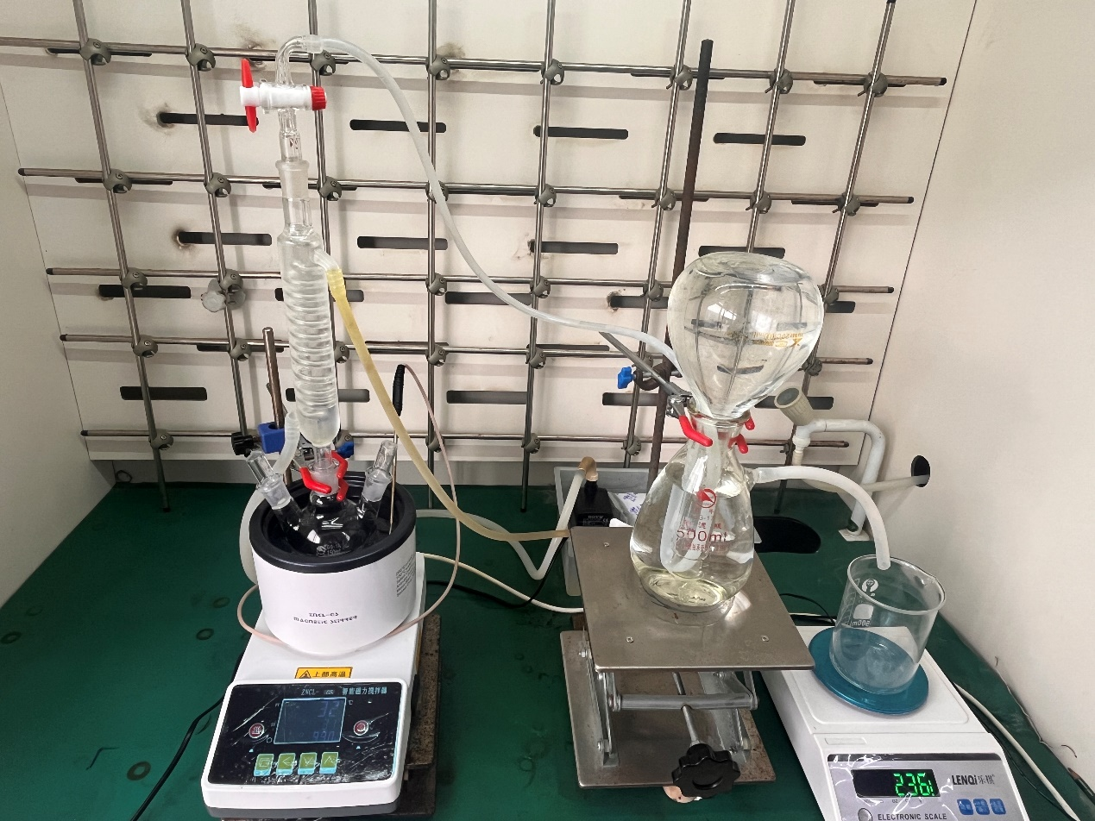
Fig. S1 Experimental set-up for H₂ production from NHP and water

Fig. S2 XRD patterns of 10%CuPd/TiO₂, 10%Pd/TiO₂, 10%Cu/TiO₂

Fig. S3 XPS spectra of CuPd/TiO₂, Pd/TiO₂, Cu/TiO₂ and TiO₂

For pure TiO₂, the BE of Ti 2p_{3/2} and 2p_{3/2} is 459.00 and 464.77 eV, respectively, matching the standard value for Ti⁴⁺ in TiO₂. The BE of Ti 2p in the Pd/TiO₂ shifts low direction to 458.76 and 464.50 eV (Fig. S3a), suggesting a ‌slight electron transfer‌ from Pd to Ti⁴⁺, likely due to the interaction between Pd and TiO₂ surface oxygen. The BE of Ti 2p in the CuPd/TiO₂ further shifts lower direction to 458.61 and 464.32 eV, ascribing to the stronger interaction between Cu and TiO₂ (Fig. S3a), which induces the formation of Cu^{δ+},^{1,2} and the Cu^{δ+} could withdraw electrons from Pd. A similar phenomenon was observed in the O XPS results (Fig. S3b). The electron transfer from Pd and Cu were further supported by the Ti and O XPS analyses.

Fig. S4 N₂ adsorption-desorption isotherm plots of the samples

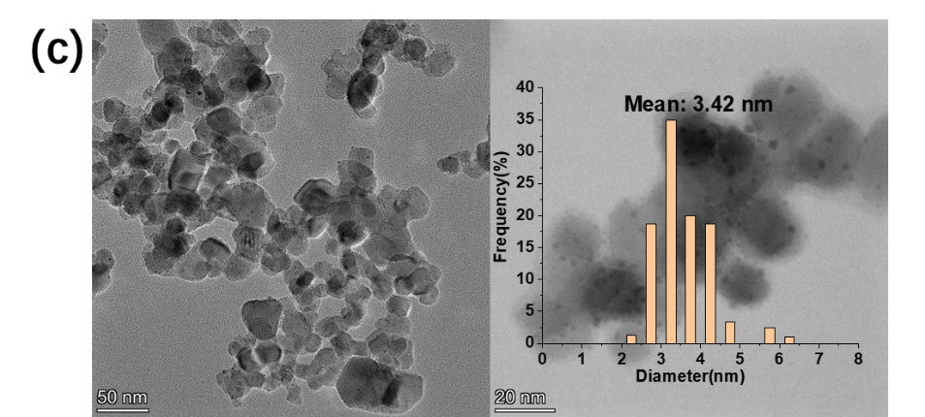
Fig. S5 (a) Pd 3d, (b) Cu 2p XPS spectra of CuPd/TiO₂ catalyst before and after use, and (c) TEM micrographs of CuPd/TiO₂ after use.

Fig. S6 The effects of the second metal on hydrogen production. (a) initial activity and (b) time course of hydrogen production from aqueous NHP solution using MPd/TiO₂ with different M metals.

The results (Fig. S6) imply that the choice of the second metal is crucial for optimizing the H₂ production activity of the catalyst, MnPd/TiO₂, NiPd/TiO₂, CoPd/TiO₂, and FePd/TiO₂ cannot effectively promote the initial activity compared with Pd/TiO₂, but MnPd/TiO₂, NiPd/TiO₂, and CoPd/TiO₂ can increase the final conversion of NHP to ~100%. The CuPd/TiO₂ obviously has the highest initial activity and the shortest time for reaching equivalent conversion, indicating its outstanding performance in catalyzing HPH reaction.
Fig. S7 The effects of the supports on hydrogen production. (a) initial activity and (b) time course of hydrogen production over CuPd/Support catalysts supported by different supports.

Among the selected supports, the catalyst loaded with TiO₂ (CuPd/TiO₂) exhibited the highest activity, which was significantly higher than that of the other supports. The second tier in terms of activity is C (Vulcan XC-72 carbon) or g-C₃N₄ (graphitic carbon nitride) supported CuPd (CuPd/C and CuPd/ g-C₃N₄). The activities of the catalysts with common oxide (such as SiO₂, γ-Al₂O₃, and ZnO) as supports are relatively low even inactive. The results indicate the supports also plays important role in H₂ production performance of CuPd catalysts. Previous studies have proved that the acidity of the TiO₂ may induce partial electron transfer from metal nanoparticle to TiO₂,³ this is supported by the Ti and O XPS analyses. Furthermore, the hydrogen spillover is enhanced due to the surface acidity of TiO₂, thus the superior H₂ production activity of CuPd/TiO₂ achieves.⁴

Fig. S8 The plots of lnr against 1/T over Pd/TiO₂ catalyst

Fig. S9 The effects of pH on hydrogen production

Fig. S10 (a) FT-IR spectra and (b) ³¹P-NMR spectra (D₂O solvent) of solid product from HPH reaction and pure NaH₂PO₃

As shown in Fig. S10a, the broad band ranging from 3300 to 3600 cm⁻¹ with the center at 3442 cm⁻¹ is assigned to the O–H stretching vibration ⁵. The band at 2402 cm⁻¹ is because of P-H stretching vibration ⁶. The band at 1655 cm⁻¹ is ascribed to P-O-H bending vibration, while the bands at 1173, 1072, 1004, and 904 cm⁻¹ are attributed to P-O stretching vibration ⁷. The band at 554 cm⁻¹ is attributed to the existence of Na-O bond ⁸. The FT-IR spectrum of solid product is highly consistent with that of pure NaH₂PO₃. As shown in Fig. S10b, the peak of 2.59 ppm is due to the P³⁺ in H₂PO₃⁻ ^{9,10}. The ³¹P-NMR spectrum of solid product is highly consistent with that of pure NaH₂PO₃.

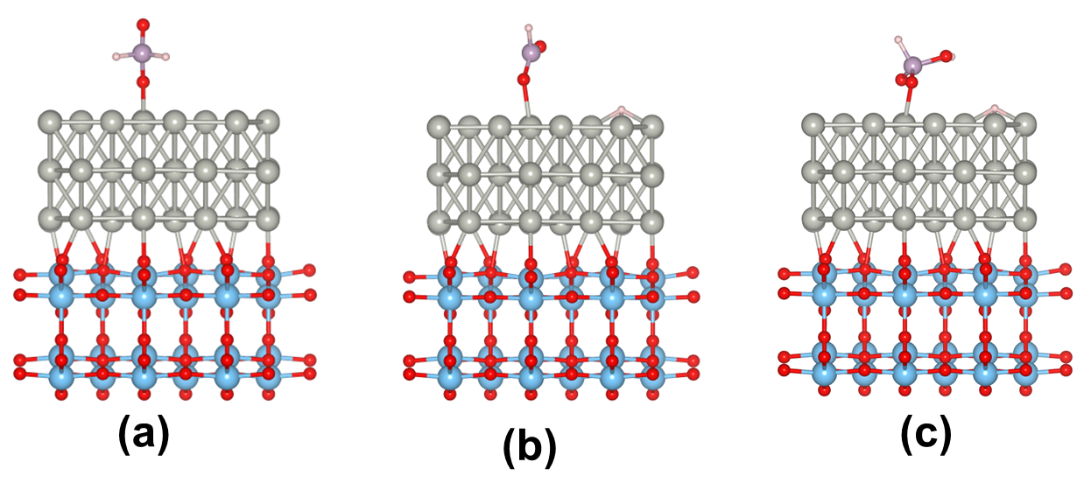
Fig. S11 Adsorption structures of (a) H₂PO₂−, (b) HPO₂⁻ and H, and (c) H₂PO₃⁻ and H on Pd (111) sites in Pd/TiO₂

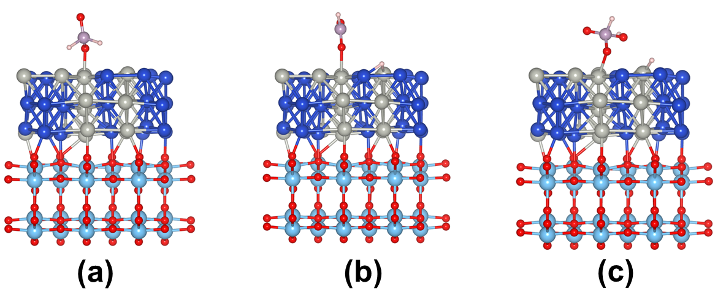
Fig. S12 Adsorption structures of (a) H₂PO₂−, (b) HPO₂⁻ and H, and (c) H₂PO₃⁻ and H on Pd (111) sites in CuPd/TiO₂

References
1. Ardila, A. N., Sánchez-Castillo, M. A., Zepeda, T. A., Villa, A. L. & Fuentes, G. A. Glycerol hydrodeoxygenation to 1,2-propanediol catalyzed by CuPd/TiO₂-Na. Appl. Catal. B Environ. 219, 658–671 (2017).
2. Yamauchi, M., Abe, R., Tsukuda, T., Kato, K. & Takata, M. Highly Selective Ammonia Synthesis from Nitrate with Photocatalytically Generated Hydrogen on CuPd/TiO₂. J. Am. Chem. Soc. 133, 1150–1152 (2011).
3. Liu, Y. et al. Highly efficient PdAg catalyst using a reducible Mg-Ti mixed oxide for selective hydrogenation of acetylene: Role of acidic and basic sites. J. Catal. 348, 135–145 (2017).
4. Ball, M. R. et al. AgPd and CuPd Catalysts for Selective Hydrogenation of Acetylene. ACS Catal. 10, 8567–8581 (2020).
5. Xu, H. et al. An Fe-doped Co₁₁(HPO₃)₈(OH)₆ nanosheets array for high-performance water electrolysis. Electrochim. Acta 334, 135616 (2020).
6. Xu, Z. et al. A new crystal Mg₁₁(HPO₃)₈(OH)₆ for daytime radiative cooling. Sol. Energy Mater. Sol. Cells 185, 536–541 (2018).
7. Menezes, P. W. et al. A structurally versatile nickel phosphite acting as a robust bifunctional electrocatalyst for overall water splitting. Energy Environ. Sci. 11, 1287–1298 (2018).
8. Tian, S. & Zhang, Z. Photo-electrochemical oxidation of hypophosphite and phosphorous recovery by UV/Fe²⁺/peroxydisulfate with electrochemical process. Chem. Eng. J. 359, 1075–1085 (2019).
9. Yoza, N., Ueda, N. & Nakashima, S. pH-dependence of ³¹P-NMR spectroscopic parameters of monofluorophosphate, phosphate, hypophosphate, phosphonate, phosphinate and their dimers and trimers. Fresenius J. Anal. Chem. 348, 633–638 (1994).
10. Liu, D. et al. Disproportionation of hypophosphite and phosphite. Dalton Trans. 46, 6366–6378 (2017).

