Supplementary File 1
Osteopontin receptors are involved in Th17 differentiation modulation by calcitriol and tacalcitol in E0771 and EMT-6 murine mammary gland cancers
Honorata Zachary¹, Beata Filip-Psurska¹*, Mateusz Psurski¹, Aleksandra Strzykalska-Augustyniak¹, Magdalena Milczarek¹, Dagmara Kłopotowska¹, Marta Świtalska¹, Martyna Stachowicz-Suhs¹, Natalia Łabędź¹, Michalina Gos¹, Arkadiusz Miążek^{1,2}, Joanna Wietrzyk¹
¹ Hirszfeld Institute of Immunology and Experimental Therapy Polish Academy of Science, R. Weigla 12, 53-114 Wroclaw, Poland
² current address: Department of Biochemistry and Molecular Biology, Wroclaw University of Environmental and Life Sciences, Norwida 31, 50-375 Wroclaw, Poland
* Beata Filip-Psurska
Hirszfeld Institute of Immunology and Experimental Therapy Polish Academy of Science, R. Weigla St. 12, 53-114 Wroclaw, Poland
Email beata.filip-psurska@hirszfeld.pl
Figure S1. General characteristics of tumor-bearing mice. (A) Uterine weight of aged OVX mice bearing E0771 (N=5-20) or EMT-6 (N=16-20) tumors. Statistical analysis: Dunn‘s multiple comparison test. (B) Body weigth of young and aged OVX mice bearing E0771 or EMT-6 tumors. Statistical analysis: Tukey’s multiple comparison test (blue stars – control vs calcitriol, green stars – control vs tacalcitol), E0771 young: N=15, E0771 aged: N=14–20, D24 N=4–6, EMT-6 young: N=10–15, D4 N=5, EMT-6 aged: D5 N=7, D7 – D0 N=17–20, D21 N=6–8; (C) 25(OH)D plasma level in young and aged OVX mice bearing E0771 or EMT-6 tumors. Healthy and sham operated are non-tumor bearing mice. Statistical analysis: Dunn‘s multiple comparison test. *p<0.05, **p<0.01, ***p<0.001, ****p<0.0001
Figure S2. The impact of calcitriol and tacalcitol on tumor angiogenesis in young and aged OVX mice bearing E0771 and EMT-6 mouse mammary gland tumors. (A) Young and (B) aged mice bearing E0771 tumors; (C) young and (D) aged OVX mice bearing EMT-6 tumors. VEGF plasma concentration in (E) E0771 and (F) EMT-6 tumor bearing mice. PE – peak enhancement, WiR – wash-in rate, maximum slope, WiPI – wash-in perfusion index, TTP – time to peak. N=4–7 mice. Statistical analysis: Sidak’s multiple comparison test. *p<0.05, **p<0.01, ***p<0.001, ****p<0.0001
Figure S3. Phenotypic characterization of CD4⁺ T lymphocytes isolated from lymph nodes and blood of young mice bearing E0771 tumors. Expression of CD29, CD51, CD44, IL-17, FOXP3, and CD61 in CD3⁺CD4⁺ lymphocytes as well as percentage of CD3⁺CD4⁺ and CD3⁺CD4⁻ lymphocytes isolated from: (A) lymph nodes, (B) blood. N=3–5. Statistical analysis: Dunn’s multiple comparison test. *p<0.05, **p<0.01
Figure S4. Phenotypic characterization of CD4⁺ T lymphocytes isolated from tumor, spleen, and lungs of young mice bearing E0771 tumors. Expression of CD29, CD51, CD44, IL-17, FOXP3, and CD61 in CD3⁺CD4⁺ lymphocytes as well as percentage of CD3⁺CD4⁺ and CD3⁺CD4⁻ lymphocytes isolated from: (A) tumor, (B) spleen, (C) lungs. N=3–5. Statistical analysis: Dunn’s multiple comparison test. *p<0.05,
Figure S5. Phenotypic characterization of CD4⁺ T lymphocytes isolated from tumor, spleen, and lungs of aged OVX mice bearing E0771 tumors. Expression of CD29, CD51, CD44, IL-17, FOXP3, and CD61 in CD3⁺CD4⁺ lymphocytes as well as percentage of CD3⁺CD4⁺ and CD3⁺CD4⁻ lymphocytes isolated from: (A) tumor, (B) spleen, (C) lungs, (D) lymph nodes, (E) blood. N=3–5. Statistical analysis: Dunn’s multiple comparison test. *p<0.05,
Figure S6. Phenotypic characterization of CD4⁺ T lymphocytes isolated from tumors and various organs of young mice bearing EMT-6 tumors. Expression of CD29, CD51, CD44, IL-17, FOXP3, and CD61 in CD3⁺CD4⁺ lymphocytes as well as percentage of CD3⁺CD4⁺ and CD3⁺CD4⁻ lymphocytes isolated from: (A) tumor, (B) spleen, (C) lung, (D) lymph nodes, and (E) blood. N=4–7. Statistical analysis: (A) Tukey’s, (B) – (E) Dunn’s multiple comparison tests. *p<0.05, **p<0.01
Figure S7. Phenotypic characterization of CD4⁺ T lymphocytes isolated from tumors and various organs of aged OVX mice bearing EMT-6 tumors. Expression of CD29, CD51, CD44, IL-17, FOXP3, and CD61 in CD3⁺CD4⁺ lymphocytes as well as percentage of CD3⁺CD4⁺ and CD3⁺CD4⁻ lymphocytes isolated from: (A) tumor, (B) spleen, (C) lung, (D) lymph nodes, and (E) blood. N=4–7. Statistical analysis: Dunn’s multiple comparison tests. *p<0.05, **p<0.01
Figure S8. Selected gene expression in CD3⁺CD4⁺ splenocytes isolated from E0771 mouse mammary gland tumor bearing young (A) and aged OVX (B) mice treated with calcitriol and tacalcitol. After completion of the reaction, endogenous controls (Actb and Sdha) were selected and a comparative ΔΔCt analysis was performed. Samples from the group of control mice were selected as calibrators to obtain the RQ parameter. Analyses were performed using ExpressionSuite Software v1.3. N=3–5. Statistical analysis: Dunn’s multiple comparison test; *p<0.05, **p<0.01,
Figure S9. Selected gene expression in CD3⁺CD4⁺ splenocytes isolated from EMT-6 mouse mammary gland tumor bearing young (A) and aged OVX (B) mice treated with calcitriol and tacalcitol. After completion of the reaction, endogenous controls (Actb and Sdha) were selected and a comparative ΔΔCt analysis was performed. Samples from the group of control mice were selected as calibrators to obtain the RQ parameter. Analyses were performed using ExpressionSuite Software v1.3. N=3–5. Statistical analysis: Dunn’s multiple comparison test; *p<0.05, **p<0.01,
Figure S10. Simple Western analysis of protein expression in CD4⁺ splenocytes isolated from young and aged OVX mice bearing E0771 mouse mammary gland tumors. CD4+ splenocytes were incubated for 4h with PMA (50 ng/mL) + ionomycin (500 ng/mL). The level of (A) ERK, and p-ERK, (B) p38, and p-p38, (C) JNK, and p-JNK, (D) NF-κB, and p-NF-κB (E) Akt, and p-AKT. Quantification by densitometry was performed using the area of targeted proteins and normalized to the total protein. N=3–5. Statistical analysis: Dunn’s multiple comparison test; *p<0.05, **p<0.01
Figure S11. Simple Western analysis of protein expression in CD4⁺ splenocytes isolated from young and aged OVX mice bearing EMT-6 mouse mammary gland tumors. CD4+ splenocytes were incubated for 4h with PMA (50 ng/mL) + ionomycin (500 ng/mL). The level of (A) ERK, and p-ERK, (B) p38, and p-p38, (C) JNK, and p-JNK, (D) NF-κB, and p-NF-κB (E) Akt, and p-AKT. Quantification by densitometry was performed using the area of targeted proteins and normalized to the total protein. N=4. Statistical analysis: Dunn’s multiple comparison test; *p<0.05, **p<0.01, ***p<0.001
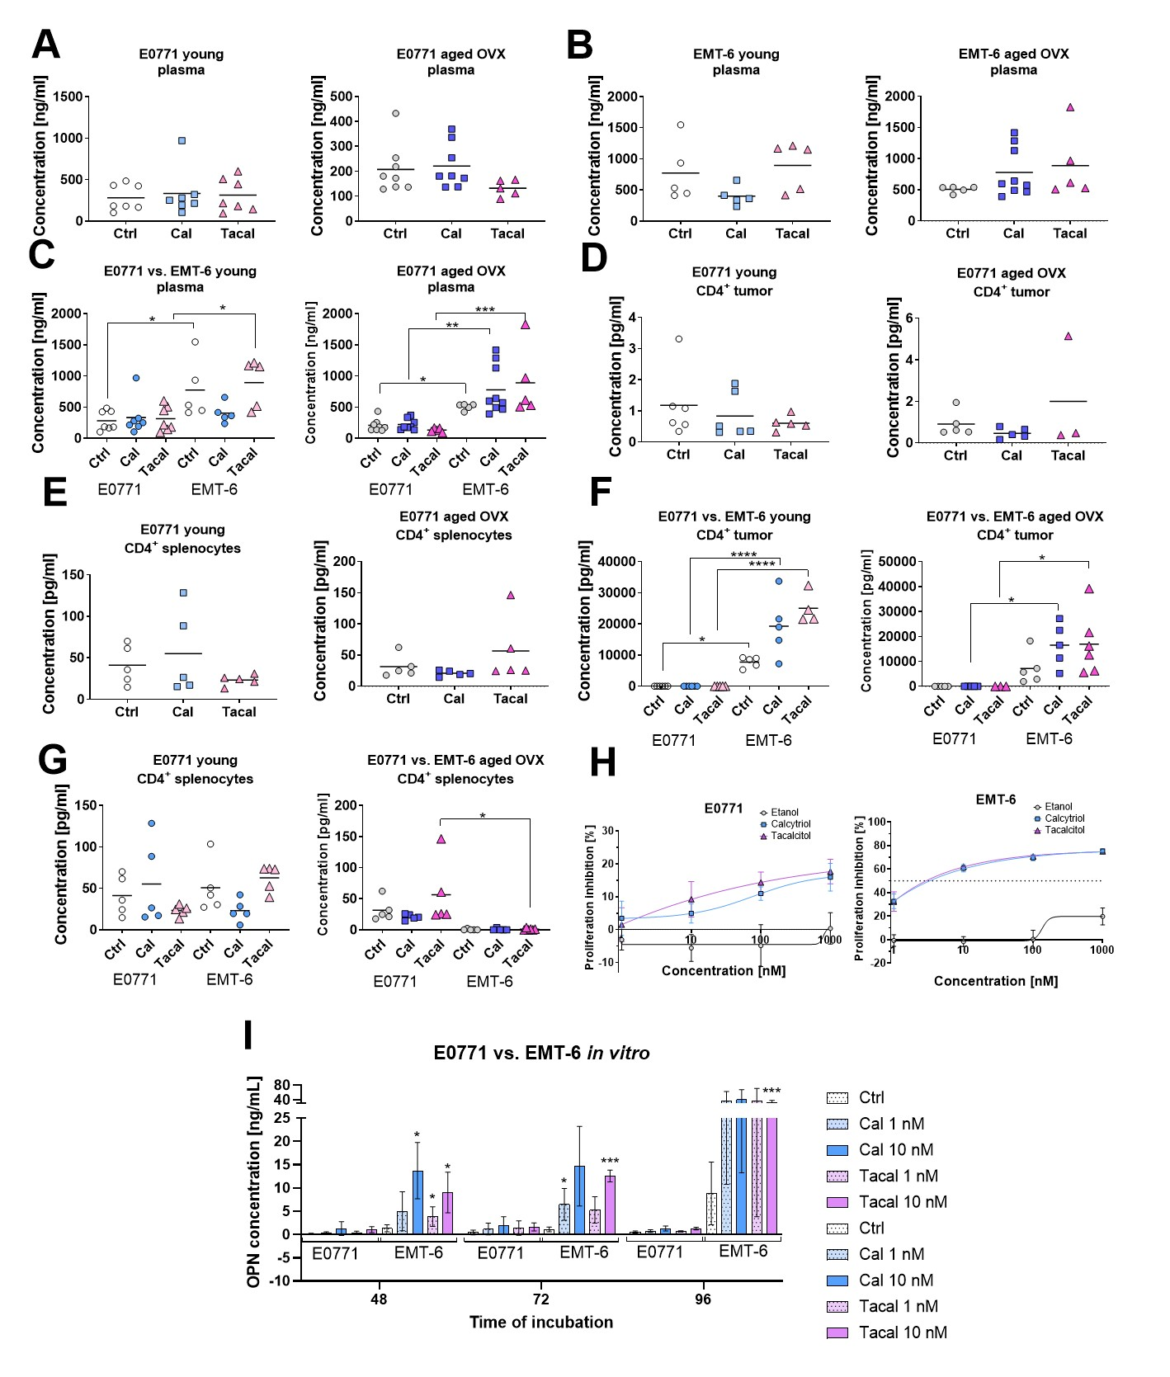
Figure S12. The impact of calcitriol and tacalcitol on the secretion of OPN by various cells. Plasma concentration of OPN in (A) E0771 and (B) EMT-6 tumor bearing mice; (C) comparison of OPN plasma level between tumors. CD4+ splenocytes were incubated for 4h with PMA (50 ng/mL) + ionomycin (500 ng/mL). The secretion of OPN to the culture media by CD4⁺ lymphocytes isolated from (D) tumor tissue or (E) spleen of E0771 tumor bearing mice; comparison of OPN concentration in supernatants between tumors: (F) tumoral CD4⁺ and (G) CD4⁺ splenocytes. (H) Proliferation curves of in vitro cultured E0771 and EMT-6 under influence of calcitriol and tacalcitol. (I) OPN secretion by cancer cells of E0771 and EMT-6 cell lines cultured in vitro in the presence of calcitriol or tacalcitol (1 and 10 nM) for 48, 72 and 96 h. N=4–5 (A – G), N=3 (H and I). Statistical analysis: Sidak’s (A – G) or Dunnett’s (I) multiple comparison tests; *p<0.05, **p<0.01, ***p<0.001, ****p<0.0001

