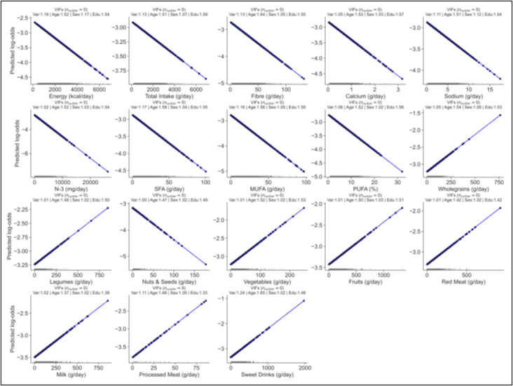

Appendix 1
PHQ: NB1: Logistic model fitted with Poisson family + binarised PHQ and GAD scores​
NB2: Black text labels indicate individuals that are identified as outliers (VIFs shown in the plot title)​

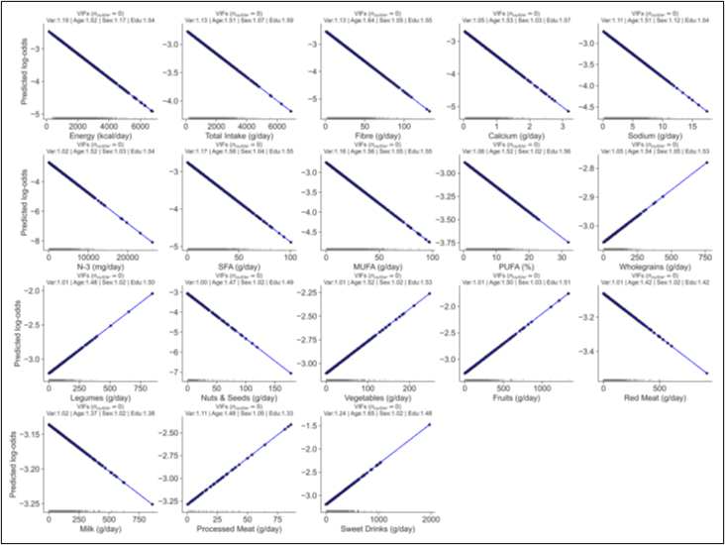
Appendix 2
GAD: NB1: Logistic model fitted with Poisson family + binarised PHQ and GAD scores​
NB2: Black text labels indicate individuals that are identified as outliers (VIFs shown in the plot title)​
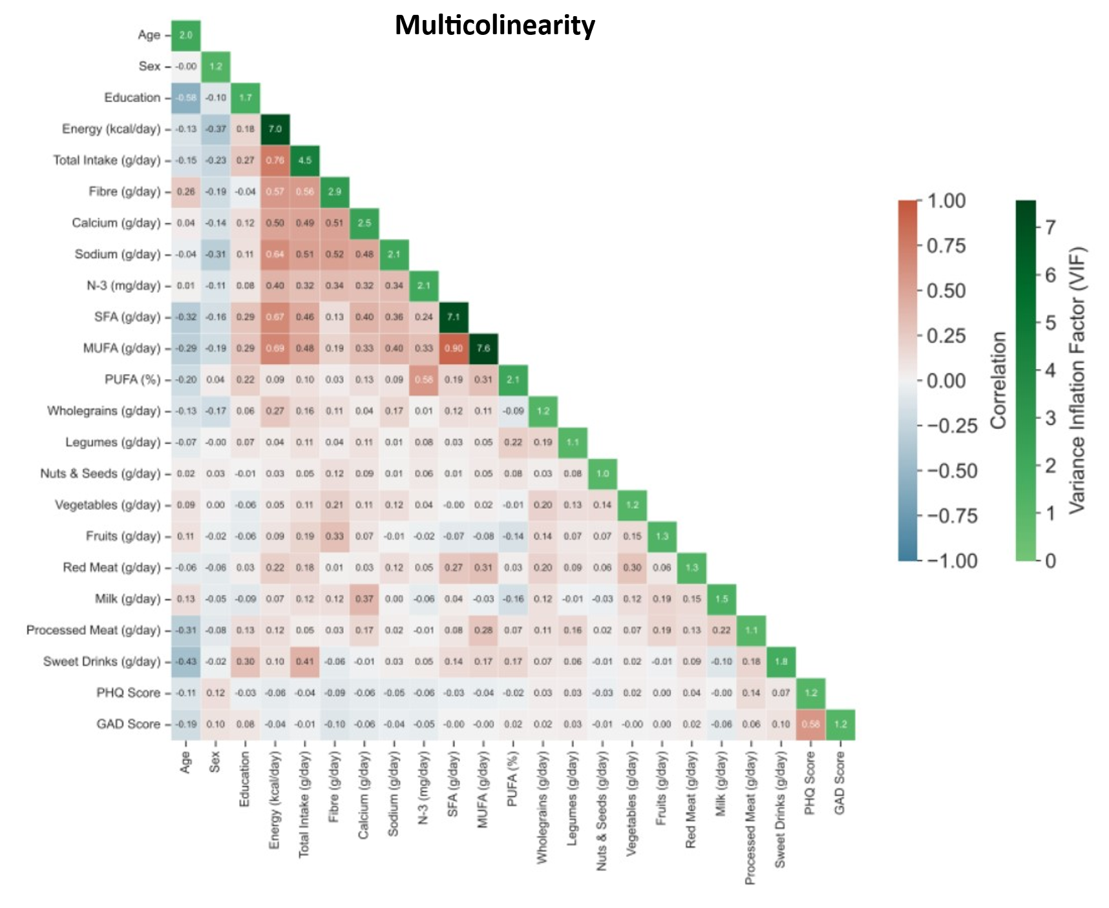

Appendix 3. Multicollinearity analysis of all variables.

