SUPPLEMENTARY MATERIAL
Supplemental Table S1. Strategic action schedule: clinical and environmental intervention milestones (2014-2026).
Supplemental Table S2. Implementation barriers encountered and adaptations applied, by domain.
Supplemental Table S3. Workforce, Capacity, Training and Education Indicators (2015-2025)
Supplemental Figure S1. Kaizen/PDCA framework for continuous improvement in asthma services.
Supplemental Figure S2. Traffic redesign schematic: 4th Ring Road underpass and traffic redirection.

Intervention Domain | Action | Timeline | Status | Responsible Parties
Clinical Care Improvement | Expand controller formulary: add inhaled combination therapies previously hospital-only; introduce spacer devices on-site (pre-2014 formulary: Ventolin, beclomethasone inhaler, montelukast) | 2014–2015 | COMPLETED | Family Medicine Dept; PHC Management
Clinical Care Improvement | Replace outdated asthma protocol with current GINA-aligned version; second revision in 2019 incorporated the GINA 2019 anti-SABA-only recommendation | 2015; revised 2019 | COMPLETED | Clinical Quality Committee
Clinical Care Improvement | Deploy spirometry (PFT): first device community-donated (2015); MoH added 2 units — 1 portable + 1 desktop (2016); staff training in use and interpretation | 2015-2016 | COMPLETED | Family Medicine Dept; CME Unit
Clinical Care Improvement | CME-accredited workshops: spirometry, inhaler technique, patient education | Annual; refresher courses | COMPLETED; ONGOING | CME Unit; Family Medicine
Clinical Care Improvement | Establish electronic asthma registry linked to PCI monthly reporting | 2015 | COMPLETED | Health IT; Clinical team
Clinical Care Improvement | Apply Kaizen/PDCA cycles: monthly QI team reviews | From month 4; every 6 months | ONGOING | QI team; All clinical staff
Environmental Health Integration | 4th Ring Road underpass: traffic redirection from clinic zone | 2015 | COMPLETED | Municipality; Ministry of Public Works
Environmental Health Integration | Green space expansion within Yarmouk catchment area | 2015-2019 | COMPLETED | Municipality; WHO Healthy City
Environmental Health Integration | Integrate AQ monitoring data with clinical asthma records | Periodic 2014-2018; continuous from 2022 | COMPLETED; EXPANDING | Health IT; Env. Public Authority
Environmental Health Integration | Asthma-AQ dashboard with high-pollution clinical alerts | Fully operational 2022 | IN USE | IT team; Public Health Unit
Community Awareness & Engagement | Culturally sensitive campaigns: schools, mosques, social media | Seasonal/annual | ONGOING | Health Promotion; Community health workers
Community Awareness & Engagement | Indoor trigger education: incense, tobacco smoke, poor ventilation | Annual (ongoing) | ONGOING | Clinic staff; Community health workers
Community Awareness & Engagement | Distribute patient education materials (written + digital) | Annual (ongoing) | ONGOING | Clinic staff

Supplemental Table S1. QI Programme Strategic Action Schedule
The quality improvement programme comprised three integrated streams implemented sequentially through PDCA cycles, 2014-2024. Status reflects position as of March 2026.
GINA = Global Initiative for Asthma. CME = Continuing Medical Education. MoH = Ministry of Health. PCI = Primary Care Information system. PDCA = Plan-Do-Check-Act. QI = Quality Improvement. AQ = Air Quality. PHC = Primary Health Centre. IT = Information Technology

Supplemental Table S2. Implementation Barriers and Adaptations
Key barriers encountered during programme implementation, the adaptations developed in response, and the observed or expected effects on programme delivery and outcomes.
Domain |  | Barrier | Adaptation Implemented | Observed Effect / Outcome
Clinical Capacity |  | Spirometry/PFT equipment unavailable on-site | Community fundraising enabled donation of the first on-site spirometer (2015); MoH subsequently supplied two additional units (one portable, one desktop) in 2016 | Enabled objective lung function testing; staff trained in use and interpretation (2015-2016)
Clinical Capacity |  | Narrow controller formulary at primary care (pre-2014: Ventolin, beclomethasone, montelukast only); newer combination inhalers and spacers hospital-only | Worked with MoH supply chain to expand primary care formulary: added combination inhalers and introduced spacer devices on-site from 2014 onward | Broader controller options and spacer availability enabled guideline-recommended step-up therapy in primary care; likely contributor to the early R:C ratio decline (2015-2018)
Workforce Development |  | Inadequate staff training in asthma protocols, spirometry, inhaler technique | Organised CME-certified workshops in collaboration with MoH; peer coaching established | Improved staff competence; reinforced adherence to standardised protocol and GINA guidelines
Data Infrastructure |  | Absence of a baseline asthma registry | Created electronic asthma case log linked to PCI primary care files and monthly reporting | Enabled systematic outcome tracking; provided data backbone for this evaluation
Environmental Integration |  | Lack of AQ data integration with clinical system | Collaborated with Environmental Public Authority to access pollution monitoring data feeds | Allowed linkage of AQ exposure data with clinical activity; enabled high-pollution clinical alerts (2022+)
Governance & Partnerships |  | Resistance to traffic diversion for emission reduction | Formed Study Area Asthma Task Force; shared accountability across stakeholders | Built municipal consensus; 4th Ring Road underpass completed 2015
Community Engagement |  | Community under-awareness of asthma triggers (incense, smoking) | Launched culturally sensitive campaigns through schools, mosques, and social media | Enhanced public health literacy and prevention-seeking behaviour
Workforce Development |  | Difficulty sustaining educational momentum post-training | Established refresher training schedule and peer coaching programme | Maintained staff performance; protocol adherence sustained across years

Supplemental Table S3. Workforce, Capacity, Training and Education Indicators (2015-2025)
Indicators of clinical capacity, workforce training, prescribing quality, and patient education activity.
Indicator | 2015 | 2016 | 2018 | 2019 | 2022 | 2025 | Notes
A. Clinical Workforce & Training
Total physicians at clinic (FTE) | 12 | 12 | 14 | 16 | 17 | 17 | From HR records
Physicians with GINA-accredited asthma training (n) | 4 | 4 | 6 | 5 | 6 | 7 | Seniors running clinics; juniors/trainees via Family Practitioners Board
Nurses trained in asthma education delivery (n) | 1 | 1 | 1 | 2 | 2 | 3 | CME registers
Annual CME workshops delivered per department | 1 | 1 | 1 | 1 | 1 | 1 | Refresher course (new guidelines/meds) delivered annually
Staff completing refresher training (n, cumulative) | 5 | 5 | 6 | 7 | 8 | 10 | Annual refresher course from QI logs
B. Spirometry / PFT Capacity
Spirometers available on-site (n) | 1 | 1 | 1 | 1 | 2 | 2 | mix of small and full units
Staff certified in spirometry use (n) | 5 | 5 | 6 | 7 | 8 | 10 | From training records
C. Prescribing Quality Indicators
R:C prescribing ratio (annual) | 2.77 | 2.25 | 2.02 | 1.50 | 1.27 | 0.78 | From SAS analysis
Patients on controller medication (annual, n) | 758 | 728 | 818 | 807 | 930 | 616 | From SAS analysis
Annual hospital referrals for asthma (n) | 107 | 74 | 105 | 95 | 83 | 65 | From PCI
% asthma patients who are current smokers (annual) | 5.2 | 5.6 | 6.0 | 6.1 | 5.5 | 4.7 | From PCI
D. Patient Education & Community Outreach
Asthma education sessions delivered (annual n) | 31 | 20 | 33 | 37 | 70 | 39 | QI logs / patient records
Education rate per 100 asthma visits (%) | 0.82 | 0.67 | 1.07 | 1.45 | 2.87 | 2.81 | From SAS: trend p<0.001
Primary education delivery role | Doctors | Doctors | Nurse + Dr | Nurse + Dr | Health educator | Health educator | Task-shifting evolution
Community awareness events held (n/year) | 2 | 2 | 2 | 2 | 2 | 2 | Programme activity log

Supplemental Figure S1. Kaizen/PDCA framework for continuous improvement in asthma services.
The PDCA cycle illustrates the iterative structure of a decade-long quality improvement programme integrating clinical and environmental interventions. Plan defines guideline-based care, key performance indicators (including asthma visits % and the reliever-to-controller (R:C) ratio), and system gaps. Do implements interventions such as medication access, standardised protocols, spirometry with training, patient education, and air quality integration. Check evaluates outcomes using routinely collected data, including visit trends, prescribing patterns, audit and adherence, and environmental context. Act refines and scales interventions, addresses system gaps, and supports continuous improvement through repeated PDCA cycles.
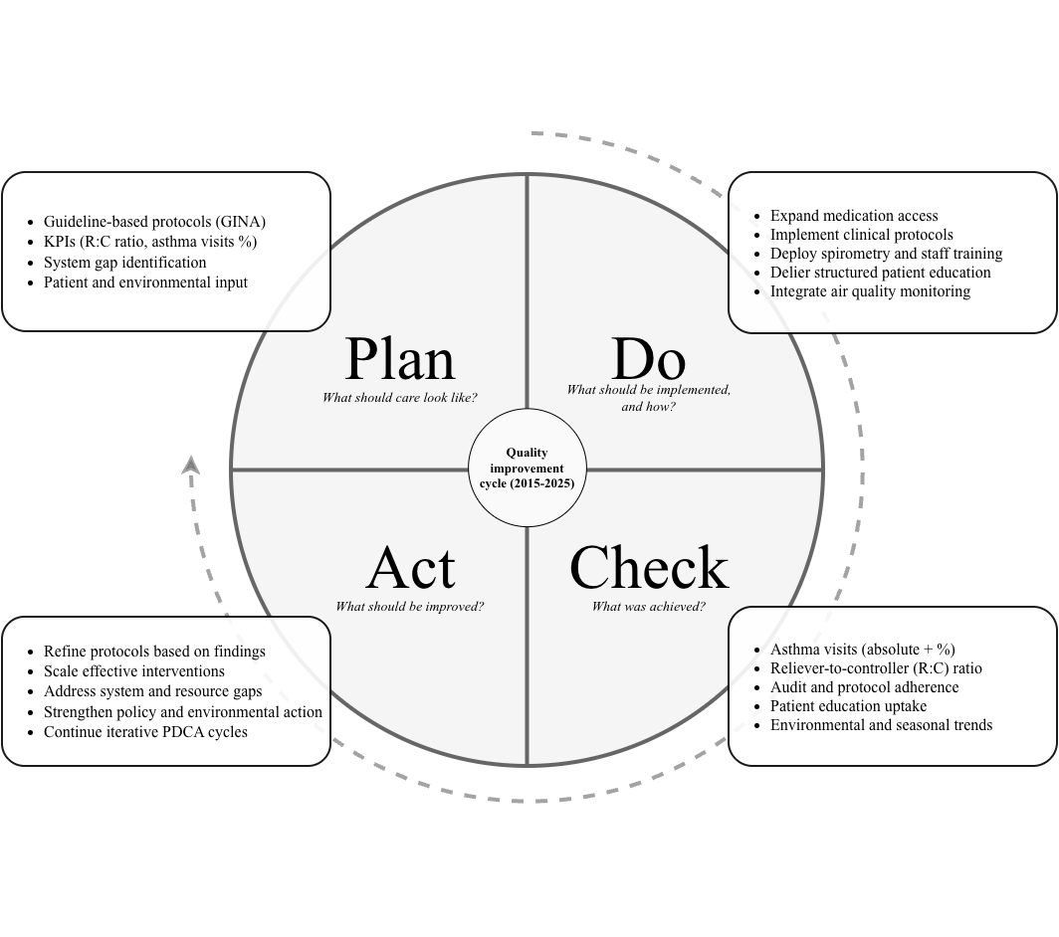

Supplemental Figure S2. Traffic Redesign and Emission-Reduction Intervention
Map showing the highway underpass project (2015), which redirected traffic away from residential streets and the clinic zone to reduce local congestion and exposure to vehicle emissions.

