SUPPLEMENTAL TABLES
Supplemental Table 1. Strategic action schedule (intervention plan)
Intervention Domain | Action | Timeline | Responsible Parties
Clinical Care Improvement | Develop standardised asthma protocol | Months 12–24; ongoing updates per GINA | Clinical Quality Committee; PHC Management
 | Train staff (spirometry, inhaler technique, education) | Months 12–24; refreshers as guidelines update | Family Medicine Dept; CME Unit
 | Apply Kaizen/PDCA cycles to reduce care variability | Start month 4; review every 6 months | QI team; nursing & medical staff
Environmental Health Integration | Integrate air-pollution data with clinical asthma records | Every 6–12 months | Health IT; Environmental Public Authority
 | Develop asthma–air-quality dashboard with alerts | Months 12–24 | IT team; Public Health Unit
Community Engagement | Public awareness campaigns on environmental triggers; support road redesign | Seasonal/annual | Health Promotion Team; Municipality
 | Distribute educational materials via schools, clinics, social media | Annual (ongoing) | Community health workers; clinic staff

Supplemental Table 2. Implementation barriers and adaptations
Barrier | Adaptation | Effect
Limited availability of spirometry (PFT) equipment | Partnered with private donors and the cooperative society to fund and purchase devices | Enabled access to diagnostic testing and inclusion of lung function data
Inadequate staff training in asthma protocols and device use | Organised CME-certified workshops in collaboration with the Ministry of Health | Improved staff competence and adherence to standardised care
Lack of air quality data integration into clinical system | Collaborated with the Environmental Public Authority to access pollution data feeds | Allowed linkage of environmental exposure data with patient records
Resistance to traffic diversion for emission reduction | Formed the Study Area Asthma Task Force to build consensus and share accountability | Increased stakeholder buy-in for environmental interventions
Community under-awareness of asthma triggers (e.g., incense, smoking) | Launched culturally sensitive campaigns through schools, mosques, and social media | Enhanced public knowledge and engagement with prevention strategies
Difficulty sustaining educational momentum post-training | Established refresher training and peer coaching programme | Maintained consistent staff performance and reinforced protocol use
Absence of a baseline asthma registry | Created an electronic asthma case log linked to primary care files and monthly reporting | Standardised data collection and enabled monitoring of trends

SUPPLEMENTAL FIGURES
Supplemental Figure 1. Framework for Kaizen-based continuous improvement in asthma services
Overview of system, human resource, non-human resource, and environmental interventions implemented under the Plan–Do–Check–Act (PDCA) quality improvement cycle.
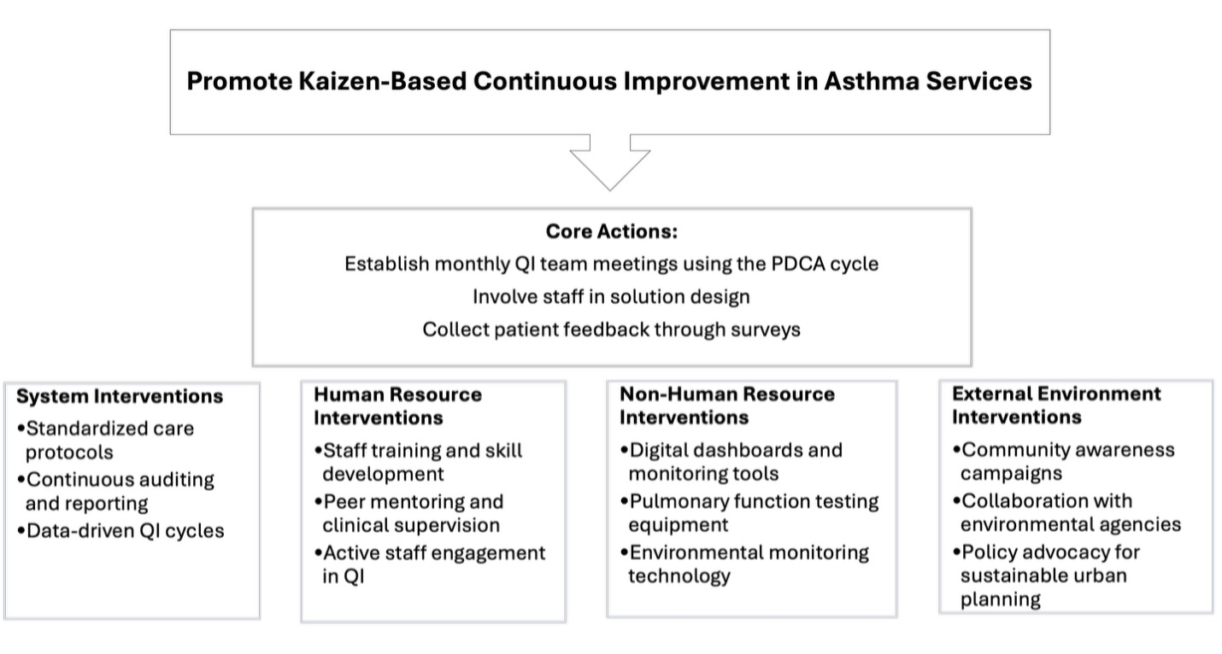
Supplemental Figure 2. Traffic redesign and emission-reduction intervention around study clinic
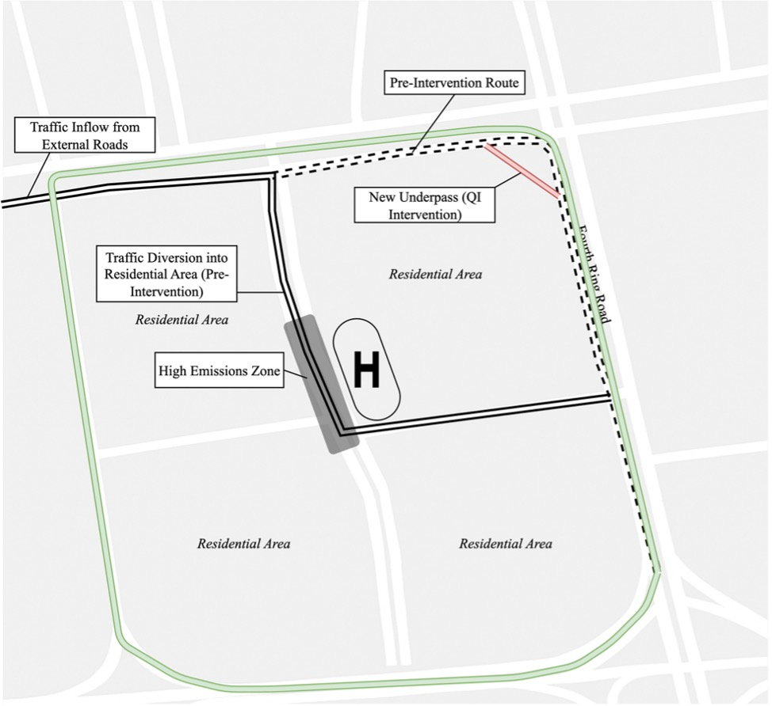
Map showing the highway underpass project (2015), which redirected traffic away from residential streets and the clinic zone to reduce local congestion and exposure to vehicle emissions.

