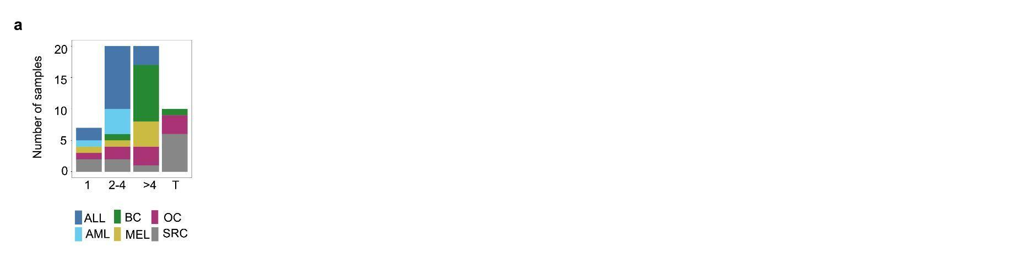
Supplementary figure 1.Subclonal composition across the dataset. a: X axis shows number of subclones across patients, colored by cancer type. T indicates transient samples.

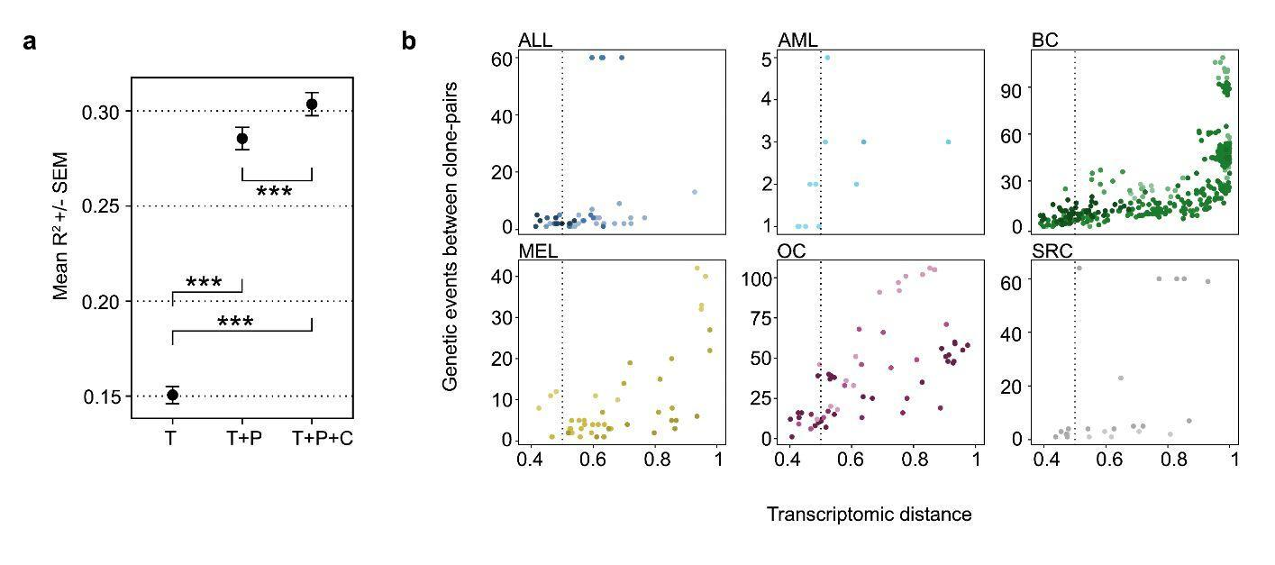
Supplementary figure 2. Genetic constraints on phenotype. a: Mean R² from a linear model given T (tumor type) (n: 1000, median: 0.11, IQR: 0.05-0.19) , T+P (patient) (n: 1000, median: 0.24, IQR: 0.14-0.39) and T+P+C (clone) (n: 1000, median: 0.25, IQR: 0.15-0.42) of all tumor cells from patients that have subclones. Error bars indicate standard deviation of the mean (SEM). Unpaired, two-sided wilcoxon rank sum test with continuity correction was performed for statistical testing, p value was adjusted with the holm method and all p values were <2.2x10⁻¹⁶. T vs T+P: W=246394, 95% CI: -0.13 -0.10, T vs T+P+C: W=227029, 95% CI: -0.14 -0.12, T+P vs T+P+C: W=472257, 95% CI: -0.03 -0.00. Tumor type explains most of the variance, while subclonality increases R2 by approximately 5% of total, or 10% of the additional variance explained by the patient identity. b: Pairwise analysis of clone pairs, genetic events plotted against transcriptomic distance. Vertical dotted line indicates 0.5.

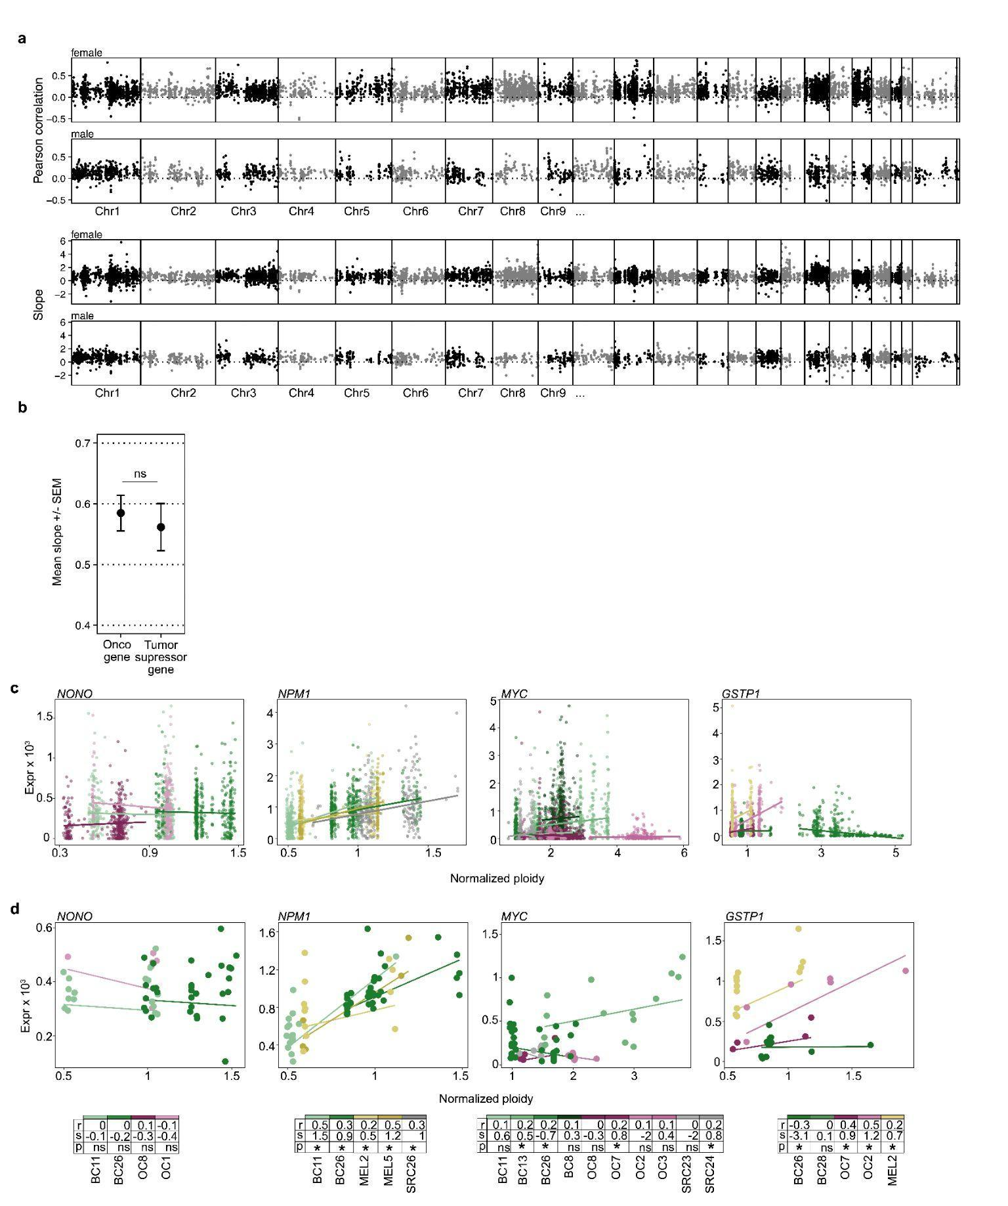
Supplementary figure 3. Genome-wide dosage effects across cancer types. a: Top: Pearson correlation across all chromosomes split by sex of the patient. Bottom: Normalised coefficient (slope) across all chromosomes split by sex of the patient b: Mean slope +/- standard error of the mean (SEM) of oncogenes (n: 455, median: 0.60, IQR: 0.27-0.91) and tumor suppressor genes (n: 289, median: 0.59, IQR: 0.26-0.96). Unpaired, two-sided wilcoxon rank sum test with continuity correction was performed for statistical testing. W=65449, p=0.92, 95% CI: -0.08 0.08. c: Dosage effects of individual genes. The slope of each line is from single-cell robust linear models and the data shown are single cells. Table values are Pearson correlation (r) and Pearson p value (p) and linear model slope (s) based on single-cell data, values same as in Figure 4e. d: Same as in c except the dots shown are subclones.

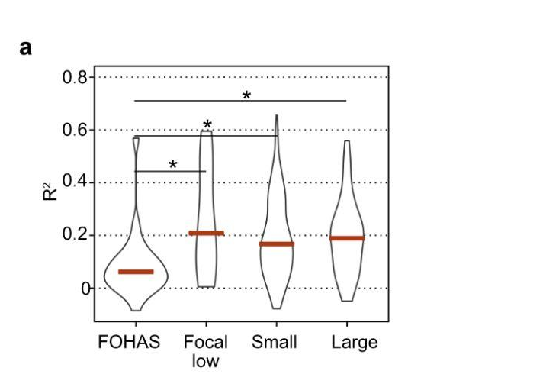
Supplementary figure 4. Predictions of CN by expression based on CNV segment size and amplification. a: Adjusted R squared of random forest predictions of CN by expression. FOHAS (n: 26, median: 0.06, IQR: 0.01-0.11), Focal low (n: 9, median: 0.21 0., IQR: 0.09-0.46), Small (n: 244, median: 0.17, IQR: 0.07-0.30) and Large (n:30, median: 0.19, IQR: 0.08-0.25). Unpaired, two-sided wilcoxon rank sum test with continuity correction was performed for statistical testing. FOHAS vs Focal low: W=58, p=0.03, 95% CI: -0.36 -0.02. FOHAS vs Small: W=1687, p=8.78x10⁻⁵, 95% CI: -0.16 -0.05. FOHAS vs Large: W=195, p=1.1x10⁻³, 95% CI: -0.18 –0.05. Star indicates significance p<0.05.

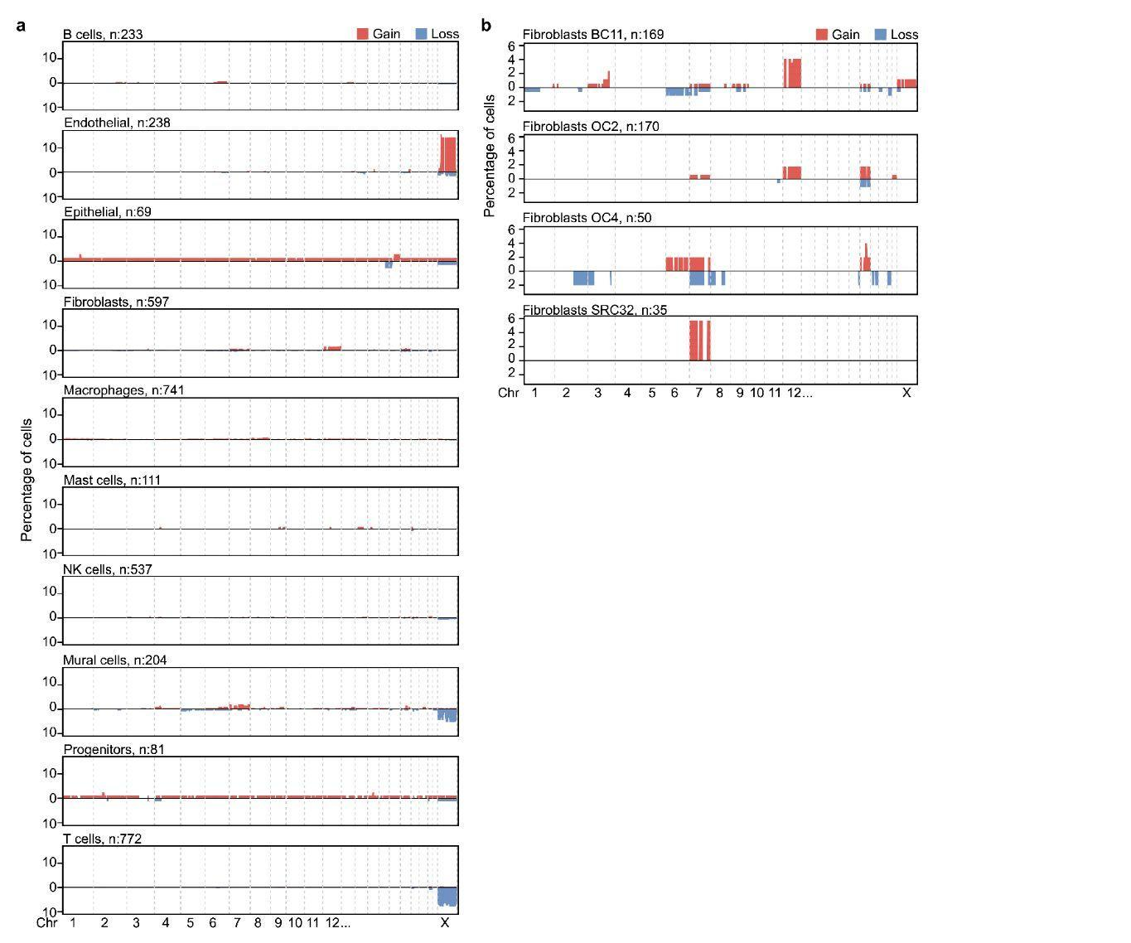
Supplementary figure 5. Non-cancer cell CNVs. a: All CNVs found in non-cancer cells, split by cell type, annotated by transcriptomic class. b: All fibroblasts with amplifications on chr 7, chr 12 or chr 18, split by patient.

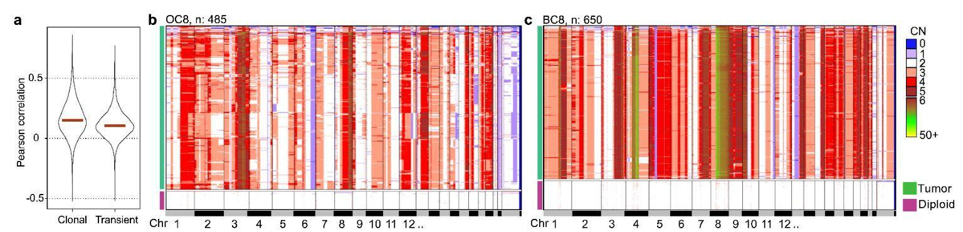
Supplementary figure 6.Transient clonality. a: Pearson correlation of dosage effect in clonal and transient samples. b: CN heatmap of OC8. Heatmap shows each single cell as a row and copy numbers are indicated by color. Aneuploid and diploid cells are separated as blocks. c: Same as b for BC8.

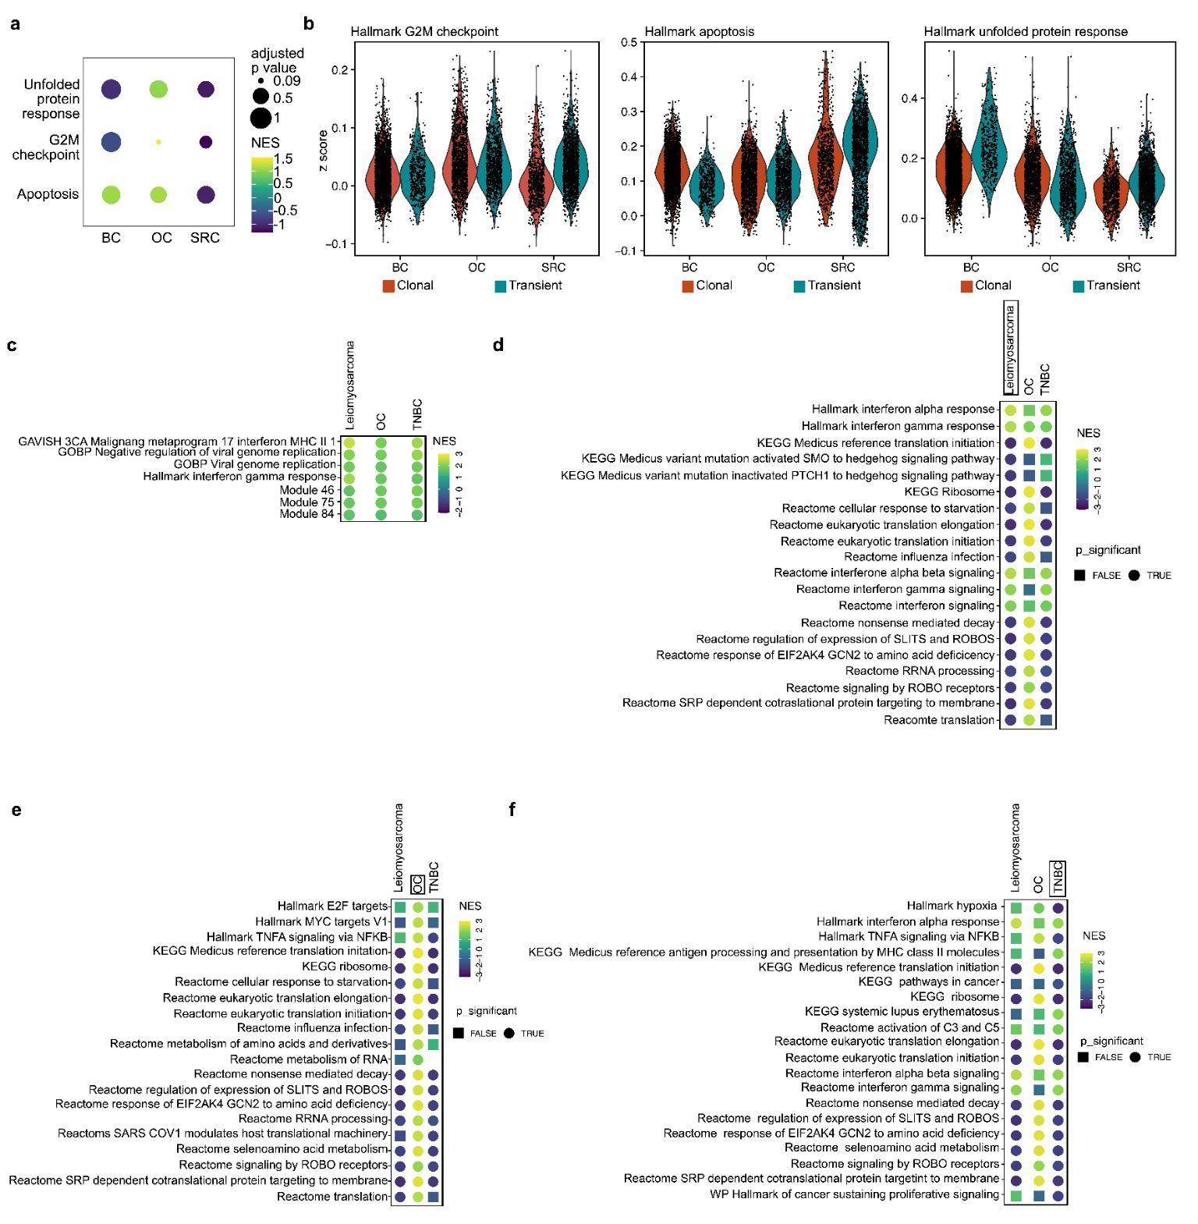
Supplementary figure 7. Phenotypic effects of transient clonality in solid tumors. a: Pathway analysis of BC, OC and SRC. Color shows normalized enrichment score (NES) clonal over transient cases. P value between the clonal and transient patients is shown as size. Pathways are hallmark pathways b: Z scores per tumor type for the three hallmark pathways from 6A split by genotype. c: All non-immune related pathways that have normalized enrichment scores (NES) in the same direction and are significant in all subtypes between transient and clonal samples. d: 20 most significantly enriched Reactome, Hallmark and KEGG pathways between transient and clonal leiomyosarcomas. Colored by NES, shape indicates significance (<0.05) e: Same as d for OC. f: Same as d and e for TNBC.

