04.30 PM
08.30 PM
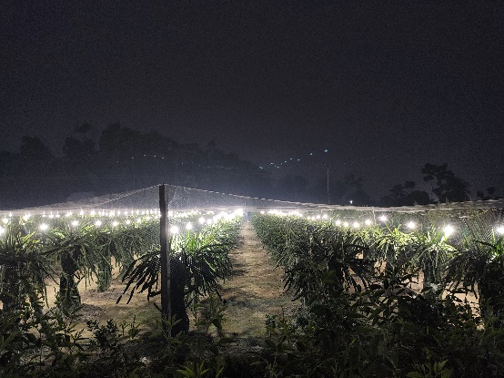
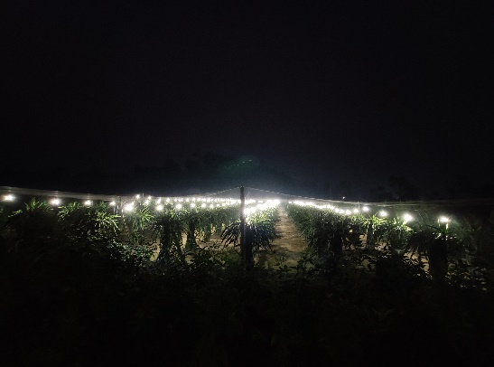

10.30 PM
06.30 PM
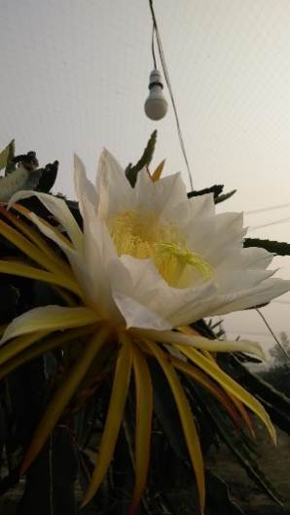
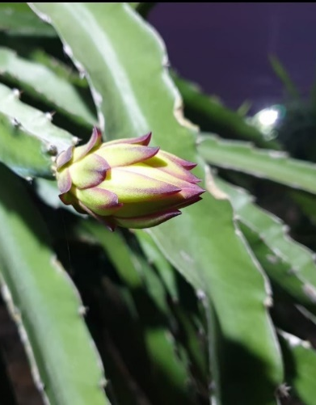
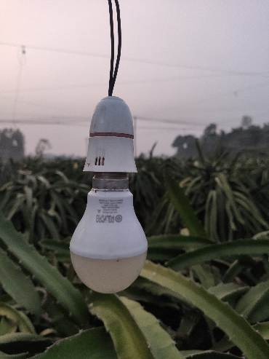

Flower opening in off-season
Flower induction under additional lighting
LED bulbs for additional lighting

Plate 1 General view of additional lighting with LED bulb

