Supplementary figures and Figure legends
Supplementary Fig. 1. Grooming microstructures under different conditions
A–C. Comparisons of the results obtained using machine learning and a manual analysis: ratio of the results obtained using the manual analysis to the results from machine learning (A), difference in the actual grooming time (B), and correlation analysis between the two groups (C) (n=66 mice). D. Proportion of grooming time across different stages in WT mice. E. Confidence intervals for different grooming parameters between the KO mice and restrained mice (n=37 restrained mice, n=36 KO mice). F. Comparison of grooming duration across different stages between KO and WT mice (n=25 WT mice, n=36 KO mice). G. Comparison of the grooming duration across different stages between the restraint and control groups (n=28 control mice, n=37 restrained mice). Statistical analyses were performed using two-tailed unpaired t test (F–G) and the Mann‒Whitney U test (F–G). The data are presented as the means±SEMs. *p < 0.05, **p < 0.01, ***p < 0.001, and ****p < 0.0001. Detailed statistics are provided in Supplementary Table 1.
Supplementary Fig. 2. Mapping the DLS-related brain regions governing grooming behavior
A. Brain regions (33 regions) showing statistically significant differences in c-Fos expression at 1.5 h after grooming behavior occurred between KO and WT mice (n=5 WT mice, n=4 KO mice). B. Brain regions (34 regions) showing statistically significant differences in c-Fos expression at 1.5 h after grooming behavior occurred between restrained and control mice (n=3 control mice, n=4 restrained mice). C. Representative images of grooming-related c-Fos expression in WT and KO mice. D. Representative images of grooming-related c-Fos expression in control mice and mice subjected to acute restraint stress. E. Representative image of virus expression and increased c-Fos staining after optogenetic stimulation, confirming DLS activation (n=5 control mice, n=6 ChR2 mice). F. The activation of DLS neurons did not affect the duration of total grooming (n=9 control mice, n=8 ChR2mice). G. DLS activation decreased the duration of grooming in stages 1 and 2. H. DLS activation decreased the proportion of stage 2 grooming. I. Comparison of the total number of transitions and grooming transition proportions across different stages between the ChR2 and control groups. Statistical analyses were performed using two-tailed unpaired t test (F‒I); two-tailed unpaired separate variance estimation t test (E); and the Mann‒Whitney U test (G‒H). The data are presented as the means±SEMs. *p < 0.05, **p < 0.01, and ***p < 0.001. All c-Fos results are provided in Supplementary Table 2.
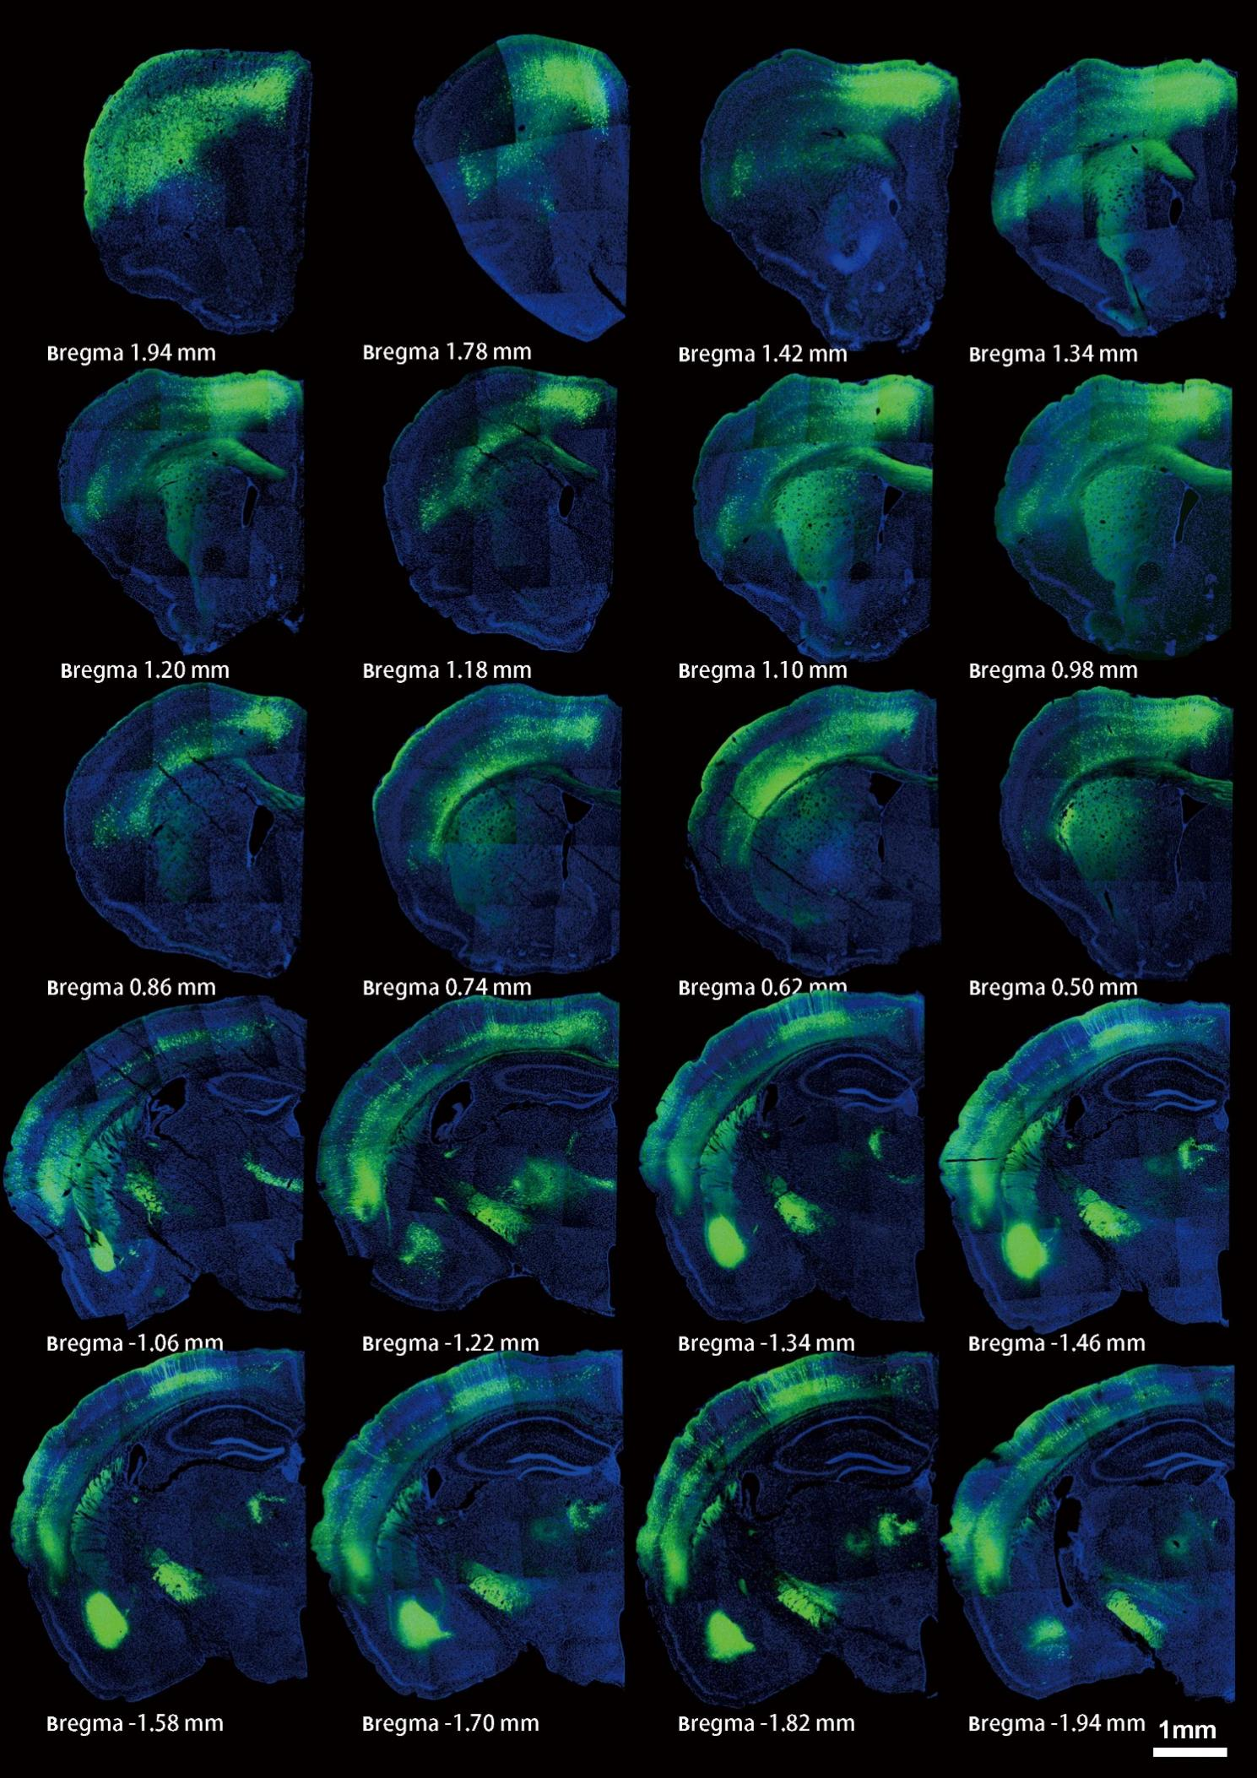
Supplementary Fig. 3. Representative images of GFP-positive cells at different bregma levels after DLS retrograde tracing
Supplementary Fig. 4. Direct anatomical connectivity between M2/S1 and the DLS
A. Densities of GFP-positive cells in brain regions projecting to the DLS. B. Schematic of virus (AAV2/Retro-hSyn-eGFP-3Flag-WPRE) injection into the DLS and subsequent retrograde tracing (n=4 mice). C. Distribution of GFP-positive cells at different bregma points in M2. D. Distribution of GFP-positive cells at different bregma points in S1. E. Fiber projections observed in the DLS following AAV-hSyn-mCherry injection into M2. F. Fiber projections observed in the DLS following AAV-hSyn-mCherry injection into S1.
Supplementary Fig. 5. Verification of the virus-infected regions of the MD and BLA
A. Representative confocal images showing the virus-targeted areas of the MD. B. MD activation increased the duration of grooming in stages 2, 3, and 4. C. Representative confocal images showing the virus-targeted areas of the BLA. D. BLA activation decreased the duration of grooming in stages 2, 3, and 4. Statistical analyses were performed using two-tailed unpaired t test (A–B) and the Mann‒Whitney U test (A–B). The data are presented as the means±SEMs. *p < 0.05, **p < 0.01, and ***p < 0.001. Detailed statistics are provided in Supplementary Table 1.
Supplementary Fig. 6. Acute BLA activation suppressed grooming behavior, whereas acute MD activation did not significantly affect grooming behavior
A. Acute optogenetic stimulation of the MD was delivered in 15 s pulses at 20 Hz, and was triggered when a grooming bout exceeded 3 s in duration. B–C. Similar percentages of grooming termination and total grooming duration were observed between the ChR2 group and the control group. D. Acute optogenetic stimulation of the BLA was delivered in 5 s pulses at 20 Hz, and was triggered when a grooming bout exceeded 3 s in duration. E–F. The majority of self-grooming behaviors were interrupted by blue light. G. The offset latency of self-grooming was shorter in the ChR2 group than in the control group. H. Increased percentage of grooming retrieval. I. The retrieval grooming time was much longer in the ChR2 group than in the control group. J. Light stimulation during grooming behaviors decreased the total grooming time. Statistical analyses were performed using two-tailed unpaired t test (B-C, F, J) and the Mann‒Whitney U test (G–I). The data are presented as the means±SEMs. *p < 0.05. Detailed statistics are provided in Supplementary Table 1.
Supplementary Fig. 7. The activation of M2 and S1 does not affect the grooming microstructure in WT mice
A. Schematic and representative image of calcium indicator virus injection into M2 (left panel); overall calcium responses initiated in all grooming stages (middle panel); calcium responses and AUCs for different grooming stages (right panel) (n=7 mice). B. Schematic of the virus injection and optogenetic stimulation strategy for activating M2 neurons in situ (left panel), and a representative image of virus expression and increased c-Fos staining after stimulation, confirming MD activation (right panel) (n=9 control mice, n=9 ChR2 mice). C–F. The activation of M2 neurons in the ChR2 group did not significantly alter the overall grooming duration, stage-specific durations, stage proportions, or transition frequencies in WT mice (n=10 control mice, n=9 ChR2mice). G. Schematic and representative image of calcium indicator virus injection into S1 (left panel); overall calcium responses initiated in all grooming stages (middle panel); and calcium responses and AUCs for different grooming stages (right panel) (n=6 mice). H. Schematic of the virus injection and optogenetic stimulation strategy for activating S1 neurons in situ (left panel), and a representative image of virus expression and increased c-Fos staining after stimulation, confirming S1 activation (right panel) (n=9 control mice, n=8 ChR2 mice). I–L. The activation of M2 neurons in the ChR2 group did not significantly alter the overall grooming duration, stage-specific durations, stage proportions, or transition frequencies in WT mice (n=9 control mice, n=10 ChR2 mice). Statistical analyses were performed using two-tailed unpaired t test (C–E, I–J, L); two-tailed unpaired separate variance estimation t test (J); and the Mann‒Whitney U test (B, D–F, H, J–K). The data are presented as the means±SEMs. ***p < 0.001 and ****p < 0.0001. Detailed statistics are provided in Supplementary Table 1.
Supplementary Fig. 8. Verification of the virus-infected regions of the M2 and S1
A. Representative confocal images showing the virus-targeted areas of M2. B. Representative confocal images showing the virus-targeted areas of S1.
Supplementary Fig. 9. Verification of the regions infected with the virus
A. Schematic showing the areas expressing mCherry in the MD (left panel) and optical fiber placements in the DLS (right panel). B. Schematic showing the areas expressing mCherry in the BLA (left panel) and optical fiber placements in the DLS (right panel). C. Optogenetic activation of the MD→DLS circuit primarily increased the duration of grooming in stages 2, 3, and 4. D. Optogenetic activation of the BLA→DLS circuit primarily decreased the duration of grooming in stages 2, 3, and 4. Statistical analyses were performed using two-tailed unpaired t test (C–D); two-tailed unpaired separate variance estimation t test (C–D); and the Mann‒Whitney U test (C–D). The data are presented as the means±SEMs. *p < 0.05, **p < 0.01, and ***p < 0.001. Detailed statistics are provided in Supplementary Table 1.

Supplementary Fig. 10. Chemogenetic manipulation of the MD→DLS circuit bidirectionally modulates the grooming microstructure
A. Viral injection strategy for the chemogenetic manipulation and recording of the MD→DLS circuit. B. Experimental timeline for the chemogenetic regulation of grooming behavior. C. Representative image of virus injection into the MD→DLS circuit. D-E. Chemogenetic activation of the MD→DLS circuit increased the duration of grooming, whereas its inhibition reduced the duration of grooming but did not affect the number of grooming bouts or the mean duration of grooming in WT mice (Gq, n=7 mice; GFP, n=6 mice; Gi, n=7 mice). F. Chemogenetic inhibition of the MD→DLS circuit primarily decreased the duration of grooming in stages 3 and 4. G. Chemogenetic inhibition of the MD→DLS circuit increased the proportion of grooming stage 1. H. Chemogenetic inhibition of the MD→DLS circuit decreased the total number of stage transitions, with distinct transition patterns observed between the different groups. I‒K. Chemogenetic manipulation of the control group did not affect the stage-specific grooming duration, stage proportions, or stage transitions. L. Chemogenetic excitation of the MD→DLS circuit primarily increased the duration of grooming in stages 3 and 4. M. Chemogenetic excitation of the MD→DLS circuit decreased the proportion of grooming stage 1 while increasing the proportion of stage 4. N. Chemogenetic excitation of the MD→DLS circuit increased the total number of stage transitions, with distinct transition patterns observed between the different groups. Statistical analyses were performed using two-tailed paired t test (E, G–N) and the Wilcoxon signed-rank test (E–G, I–J, L–M). The data are presented as the means±SEMs. *p< 0.05 and **p<0.01. Detailed statistics are provided in Supplementary Table 1.

Supplementary Fig. 11. Chemogenetic manipulation of the BLA→DLS circuit bidirectionally modulates the grooming microstructure
A. Viral injection strategy for the chemogenetic manipulation and recording of the BLA→DLS circuit. B. Representative image of virus injection into the BLA→DLS circuit. C–D. Chemogenetic activation of the BLA→DLS circuit decreased the grooming duration, whereas its inhibition increased the grooming duration (left panel); both chemogenetic activation and inhibition of the BLA→DLS circuit reduced the number of grooming bouts (middle panel), and only chemogenetic inhibition of the BLA→DLS circuit increased the mean grooming bout duration in WT mice (right panel) (Gq, n=6 mice; GFP, n=5 mice; Gi, n=7 mice). E. Chemogenetic inhibition of the BLA→DLS circuit primarily increased the duration of grooming in stages 3 and 4. F. Chemogenetic inhibition of the BLA→DLS circuit decreased the proportion of grooming stage 1 but increased the proportions of stages 3 and 4. G. Chemogenetic inhibition of the BLA→DLS circuit increased the total number of stage transitions, with distinct transition patterns observed between the different groups. H–J. Chemogenetic manipulation of the control group did not affect the stage-specific grooming duration, stage proportions, or stage transitions. K. Chemogenetic excitation of the BLA→DLS circuit primarily decreased the duration of grooming in stages 2 and 3. L. Chemogenetic excitation of the BLA→DLS circuit decreased the proportion of grooming stage 4. M. Chemogenetic excitation of the BLA→DLS circuit decreased the total number of stage transitions, with distinct transition patterns observed between the different groups. Statistical analyses were performed using two-tailed paired t test (D–J, K–L) and the Wilcoxon signed-rank test (D–F, H–I, K‒M). The data are presented as the means±SEMs. *p < 0.05 and ***p < 0.001. Detailed statistics are provided in Supplementary Table 1.

Supplementary Fig. 12. Characterization of the MD→DLS and BLA→DLS circuits
- Retrograde tracing of MD and BLA projections to the DLS by injecting AAV2/Retro-DIO-mCherry into the DLS of CamkⅡ-cre mice (n = 4 mice). B. Retrograde tracing of MD and BLA projections to the DLS by injecting AAV2/Retro-DIO-mCherry into the DLS of VGAT-cre mice (n = 4 mice). C. The activation of MD neurons resulted in a simultaneously recorded transient increase in calcium signals in the DLS (n = 4 mice). D. Representative image of virus injection for recording DLS calcium signals upon the optogenetic activation of upstream MD/BLA.
E. BLA activation in WT mice induced a biphasic calcium response in the DLS (an initial increase followed by a decrease). F. Optogenetic activation of the BLA^{VGAT}→DLS circuit primarily decreased the duration of grooming in stages 2, 3, and 4 (n=8 control mice, n=10 ChR2 mice). G–H. Optogenetic excitation of the BLA^{Vglut2}→DLS circuit did not affect the duration of grooming in mice (n=8 control mice, n=9 ChR2 mice). I–K. Optogenetic activation of the BLA^{Vglut2}→DLS circuit did not affect the stage-specific grooming duration, stage proportions, or stage transitions. Statistical analyses were performed using two-tailed unpaired t test (F, I–K); the Mann‒Whitney U test (F, H–J); two-tailed paired t test (E); and the Wilcoxon signed-rank test (C). The data are presented as the means±SEMs. *p < 0.05. Detailed statistics are provided in Supplementary Table 1.

Supplementary Fig. 13. The BLA inhibitory pathway specifically regulates the grooming microstructure
A. Optogenetic in situ activation of BLA^{Vglut2} neurons did not affect the duration of grooming in WT mice (n=8 control mice, n=10 ChR2 mice). B. Optogenetic in situ activation of BLA ^{VGAT} neurons decreased the duration of grooming in WT mice (n=6 control mice, n=8 ChR2mice). C–E. Optogenetic in situ activation of BLA^{Vglut2} neurons did not affect the stage-specific grooming duration, stage proportions, or stage transitions. F. Optogenetic in situ activation of BLA^{VGAT} neurons primarily decreased the duration of grooming in stages 2, 3, and 4. G. Optogenetic in situ activation of BLA^{VGAT} neurons reduced the proportion of grooming stage 4 but increased that of stages 1 and 3. H. Optogenetic in situ activation of BLA^{VGAT} neurons decreased the total number of stage transitions, with distinct transition patterns observed between the ChR2 and control groups. Statistical analyses were performed using two-tailed unpaired t test (C–H); two-tailed unpaired separate variance estimation t test (D, G); and the Mann‒Whitney U test (A–D, F–G). The data are presented as the means±SEMs. *p < 0.05. Detailed statistics are provided in Supplementary Table 1.
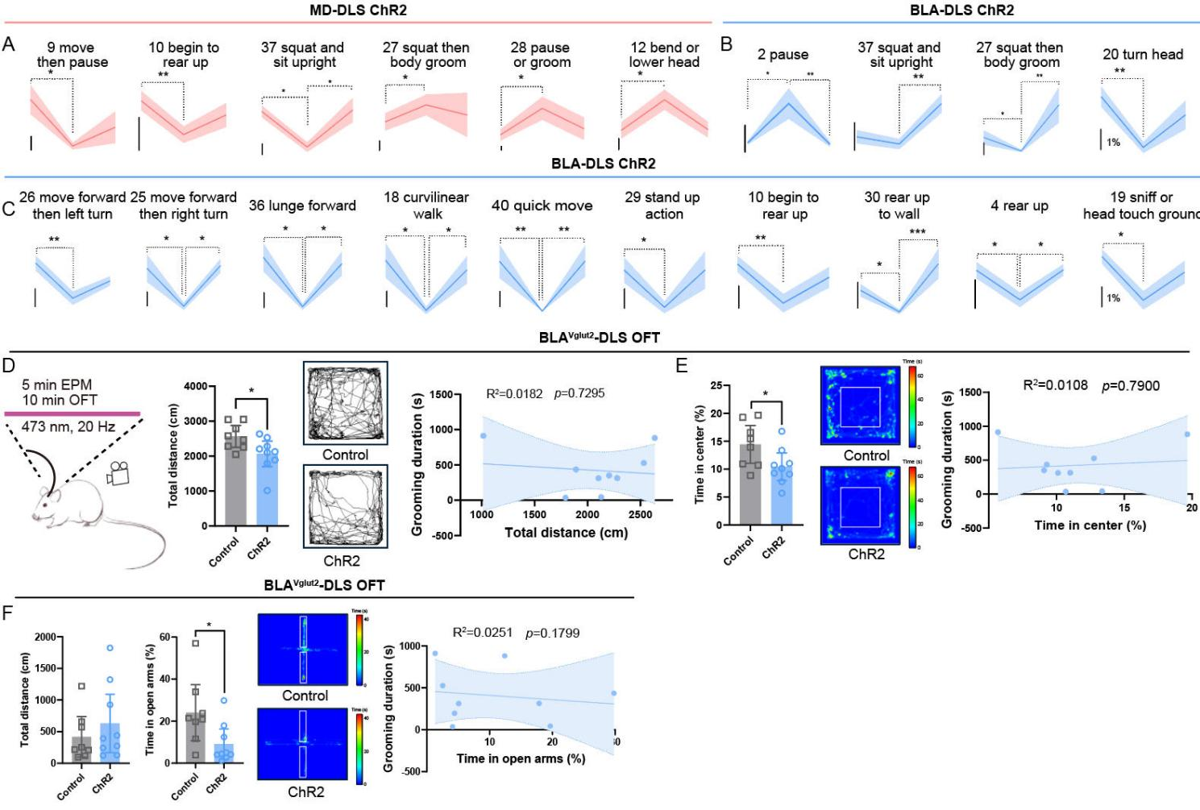
Supplementary Fig. 14. Divergent integration of motor and affective components in grooming by the MD→DLS and BLA→DLS circuits
A. Analysis of changes in behavioral modules before and after the optogenetic activation of the MD→DLS circuit. B–C. Analysis of changes in behavioral modules before and after the optogenetic activation of the BLA→DLS circuit. D. Optogenetic activation of the BLA^{Vglut2}→DLS circuit reduced the total distance traveled in the OFT (left panel), and a correlation analysis of individual mice revealed no significant correlation between the distance traveled in the OFT and the duration of grooming in the restricted chamber (right panel) (n=8 control mice, n=9 ChR2 mice). E. Optogenetic activation of the BLA^{Vglut2}→DLS circuit reduced the center zone time in the OFT (left panel), and no significant correlation was observed between the center zone time in the OFT and grooming duration in the grooming chamber for individual mice (right panel) (n=8 control mice, n=9 ChR2mice). F. Optogenetic activation of the BLA^{Vglut2}→DLS circuit did not affect the total distance traveled but did reduce the time spent in the open arms of the EPM (left panel); however, no significant correlation was observed between the time spent in the open arms of the EPM and the grooming duration in the grooming chamber for individual mice (right panel) (n=8 control mice, n=9 ChR2 mice). Statistical analyses were performed using two-tailed unpaired t test (D–E); the Mann‒Whitney U test (F); one-way ANOVA followed by Tukey’s multiple comparisons test (A–C); and the Kruskal‒Wallis H test followed by the Nemenyi multiple comparisons test (A–C). The data are presented as the means±SEMs. *p < 0.05 and **p < 0.01. Detailed statistics are provided in Supplementary Table 1.

Supplementary Fig. 15. The BLA→DLS circuit but not the MD→DLS circuit regulates the grooming microstructure in mice subjected to restraint stress
A. Calcium signals recorded from the DLS during grooming induced by restraint stress. B. Calcium responses in the DLS across different grooming stages in the restraint and control groups during grooming behaviors (n=8 mice in the control group, n=8 mice in the restraint group). C. Experimental timeline for manipulating the BLA→DLS and MD-DLS circuits following restraint-induced grooming in WT mice. D. Schematic of virus injection into the MD. E. Inhibition of the MD→DLS circuit did not affect restraint-induced grooming (n=6 control mice, n=8 NpHR mice). F. Schematic of virus injection into the BLA. G. Activation of the BLA^{VGAT}→DLS circuit significantly reduced restraint-induced grooming (n=6 control mice, n=6 ChR2 mice). H-I. Inhibition of the MD→DLS circuit did not significantly affect stage-specific grooming duration. K. Activation of the BLA^{VGAT}→DLS circuit reduced restraint-induced grooming primarily in stages 2, 3, and 4. L. An analysis of the proportions of the stages showed that the activation of the BLA^{VGAT}→DLS circuit decreased the proportion of stage 4 but increased the proportion of stage 2. M. Activation of the BLA^{VGAT}→DLS circuit reduced the total number of grooming transitions, with distinct transition patterns observed between the groups. Statistical analyses were performed using two-tailed unpaired t test (B, E-I, K‒M); two-tailed unpaired separate variance estimation t test (K–L); and the Mann‒Whitney U test (H–L). The data are presented as the means±SEMs. *p < 0.05, **p < 0.01, and ***p < 0.001. Detailed statistics are provided in Supplementary Table 1.

Supplementary Fig. 16. The TRAPed BLA→DLS circuit comodulates anxiety-like and grooming behaviors
A, C. The morphological analysis performed 1.5 hours after a subsequent restraint session revealed the properties of TRAPed cells in the MD (n=8 mice). B, D. Morphological analysis of the properties of TRAPed cells in the BLA (n=6 mice). E. Activation of the TRAPed BLA→DLS circuit reduced restraint-induced grooming primarily in stages 1, 3, and 5. F. Schematic of TRAPed MD neurons. G. Inhibition of the TRAPed MD→DLS circuit after restraint stress did not affect restraint-induced grooming (n=8 control mice, n=8 NpHR mice). H–J. Inhibition of the TRAPed MD→DLS circuit did not significantly affect stage-specific grooming duration. Statistical analyses were performed using two-tailed unpaired t test (E, G, H–J); two-tailed unpaired separate variance estimation t test (E); and the Mann‒Whitney U test (H–I). The data are presented as the means±SEMs. *p < 0.05. Detailed statistics are provided in Supplementary Table 1.
Supplementary Fig. 17. Activation of the BLA→DLS circuit reduced the grooming duration in Shank3B KO mice
A–B. Calcium signals recorded from the DLS across different grooming stages in WT and KO mice during grooming behaviors (n=8 WT mice, n=9 KO mice). C. Inhibition of the MD→DLS circuit in KO mice decreased the duration of grooming in stages 3 and 4. D. Activation of the BLA^{VGAT}→DLS circuit in the KO mice decreased the duration of grooming in all stages.
E. Optogenetic activation of the BLA→DLS circuit reduced the duration of grooming in the KO mice. F. Optogenetic activation of the BLA^{Vglut2}→DLS circuit did not affect the duration of grooming in KO mice. G. Optogenetic activation of the BLA→DLS circuit primarily decreased the duration of grooming in stages 3 and 4. H. Optogenetic activation of the BLA→DLS circuit reduced the proportion of grooming stage 4 but increased that of stages 1 and 2. I. Optogenetic activation of the BLA→DLS circuit decreased the total number of stage transitions, with distinct transition patterns observed before and after photostimulation. J–L. Optogenetic activation of the BLA^{Vglut2}→DLS circuit did not affect the stage-specific grooming duration, stage proportions, or stage transitions. Statistical analyses were performed using two-tailed unpaired t test (A-D); two-tailed unpaired separate variance estimation t test (B); the Mann‒Whitney U test (C–D); two-tailed paired t test (H–L); Wilcoxon signed-rank test (G–H, J–K); one-way repeated-measures ANOVA (F); and Friedman’s M test with the Wilcoxon signed-rank test (Bonferroni-corrected α=0.0167) for the post hoc analysis (E). The data are presented as the means±SEMs. *p < 0.05 and **p < 0.01. Detailed statistics are provided in Supplementary Table 1.
Supplementary Fig. 18. Decoupling of the grooming behavior from motor and anxiety-like behaviors by the MD→DLS and BLA→DLS circuits in Shank3B KO mice
A. Optogenetic inhibition of the MD→DLS circuit reduced the distance traveled but did not affect the center zone time in the open field test (OFT) in the KO mice (n=8 control mice, n=9 NpHR mice). B. A positive correlation was observed between the distance traveled in the OFT and the grooming duration in the grooming chamber for individual KO mice. C. No significant correlation was detected between the center zone time in the OFT and grooming duration in the grooming chamber for individual KO mice. D. Optogenetic inhibition of the MD→DLS circuit did not affect the distance traveled or the time spent in the open arms of the elevated plus-maze (EPM) (n=8 control mice, n=9 NpHR mice). E. No correlation was detected between the time spent in the open arms of the EPM and grooming duration in the grooming chamber for individual mice.
F. Optogenetic excitation of the BLA→DLS circuit did not affect the distance traveled but increased the center zone time in the OFT (n=6 control mice, n=10 ChR2 mice). G. A positive correlation was observed between the distance traveled in the OFT and the grooming duration in the grooming chamber for individual mice. H. A negative correlation was observed between the time spent in the center zone of the OFT and the grooming duration in the grooming chamber for individual mice. I. Optogenetic excitation of the BLA→DLS circuit did not affect the distance traveled but increased the time spent in the open arms of the EPM (n=6 control mice, n=10 ChR2 mice). J. A negative correlation was observed between the time spent in the open arms of the EPM and the grooming duration in the grooming chamber for individual mice. Statistical analyses were performed using two-tailed unpaired t test (A, D, I); two-tailed unpaired separate variance estimation t test (F); and the Mann‒Whitney U test (D, F, I). The data are presented as the means±SEMs. *p < 0.05. Detailed statistics are provided in Supplementary Table 1.

