Designing broad-spectrum antimicrobial peptides based on conditional feedback generation adversarial network

Yannan Bin^{1,#}, Zhaoyang Li^{1,#}, Kanglin Wang^{2,*} and Yansen Su^{3,*}

¹The Key Laboratory of Intelligent Computing and Signal Processing of Ministry of Education, School of Life Sciences and Medical Engineering, Anhui University, Hefei, Anhui 230601, China.
² Knature Biopharmaceutical Co. Ltd., Hefei, Anhui 231100, China
³ School of Artificial Intelligence, Anhui University, Hefei, Anhui 230601, China.

#These authors contributed equally to this work.
*Corresponding authors: wna2011@mail.ustc.edu.cn (N. W.), wangkanglin@knb-pharma.com (K. W.), and suyansen@ahu.edu.cn (Y. S.).

Supplementary Information:
Contents
1 Supplementary Figures
Figure S1. Schematic illustration of the module architecture in our proposed Conditional Feedback GAN (CFGAN).
Figure S2. Pathogen-specific targeting distribution of dataset_1.
Figure S3. FID scores under different noise levels.
2 Supplementary Tables
Table S1. Detailed implementation of hyperparameters used in the analysor.
Table S2. The bilayer and peptide-bilayer system composition.
Table S3. The top 20 peptides with the lowest predicted antimicrobial activity against E. coli.
Table S4. The top 20 peptides with the lowest predicted antimicrobial activity against S. aureusi.

- Supplementary Figures
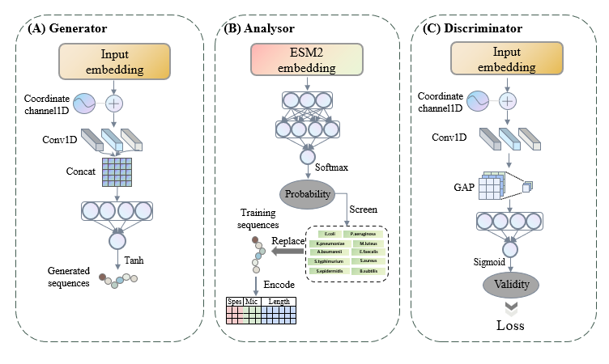
Figure S1. Schematic illustration of the module architecture in our proposed Conditional Feedback GAN (CFGAN). (A) Generator: Takes noise and conditional input (via coordinate channel embedding), applies 1D convolution and concatenation, followed by a stack of fully connected (linear) layers to model sequence-level dependencies, and outputs antimicrobial peptide sequences through a Tanh activation function. (B) Analysor: Utilizes a pretrained ESM2 model to extract functional embeddings, which are passed through linear layers to obtain softmax-based multi-label antimicrobial activity predictions. High-activity sequences are selected to replace training samples, while species, MIC, and length features are encoded to enable feedback reinforcement. (C) Discriminator: Similar to the Generator’s front end, it processes input sequences through 1D convolution, coordinate embedding, and a Global Average Pooling (GAP) layer, followed by linear layers and a final sigmoid unit to predict the validity score, which guides adversarial training.

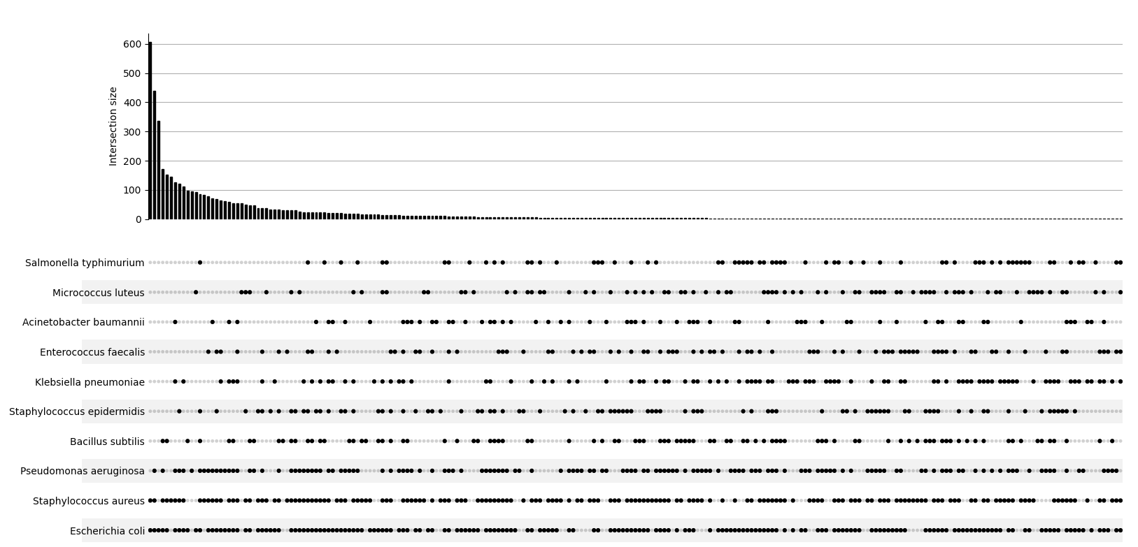
Figure S2. Pathogen-specific targeting distribution of dataset_1. The scatter plot shows which species the antibacterial peptide is active against, and the bar plot shows the number of antibacterial peptides that are active against the combination of the target species.
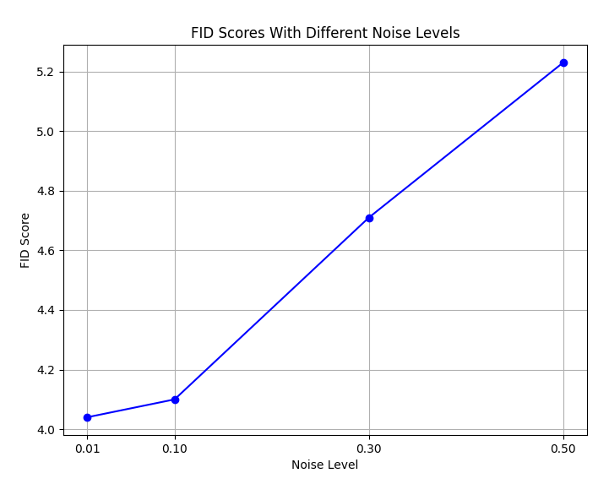
Figure S3. FID scores under different noise levels. As the noise level increases from 0.01 to 0.50, the FID score rises significantly, indicating a growing distributional discrepancy between generated and real peptide sequences. This result demonstrates that PepFID is sensitive to input perturbations and effectively reflects sequence quality.

2 Supplementary Tables
Table S1. Detailed implementation of hyperparameters used in the analysor
Layer | Type | Shape | Activation function | Batch normalization | Dropout
0 | Embedding | (None, 320) | None | None | None
1 | Dense | (None, 256) | LeakyReLU | Yes | 0.2
2 | Dense | (None, 128) | LeakyReLU | Yes | 0.2
3 | Dense | (None, 64) | LeakyReLU | Yes | 0.2
4 | Dense | (None, 2) | Softmax | No | 0.2

Membrane | Lipids |  |  |  | Water | SOD | CLA | Ion concentration | Lipid area | Peptide area | Distance
Membrane | POPE | POPG | TOCL1 | POPC
E. coli | 62 | 12 | 4 | 0 | 2.25 | 21 | 12 | 0.15 | 2447 | 241 | 3nm
S. aureus | 0 | 46 | 32 | 0 | 2.25 | 89 | 16 | 0.15 | 3443.6 | 191.4 | 3nm
Table S2. The bilayer and peptide-bilayer system composition.

Table S3. The top 20 peptides with the lowest predicted antimicrobial activity against E.coli.
Sequence | E.coli | S.aureus | Ec.Activity | Sa.Activity
KWKKWLKCIWKRVAKKIL | Yes | Yes | 3.1775 | 3.36856
KWKRIIQKPFKGVKKVTNGAIAIHL | Yes | Yes | 3.2317 | 7.0018
IGKLLVKKISKVIKCRNWRRAAKKTL | Yes | Yes | 3.34105 | 6.5712
WGRWQRRILARVQATGKVRKIAKKLIGKIAKNG | Yes | Yes | 3.4420 | 6.5643
RLNRVCRWIRKVLKTGIRR | Yes | Yes | 3.5028 | 7.6995
WARKLLKKLAKLISKIIERKVR | Yes | Yes | 3.5586 | 5.9710
KWLHTILKVKGIGKKLK | Yes | Yes | 3.6162 | 7.8201
GVCKIIKRLGKVAKILFAKKLWKKLSGKIKKFR | Yes | Yes | 3.7058 | 6.4333
GWWRKIKILKRFKKNLTKGKTRKKVIGKILFKK | Yes | Yes | 3.7067 | 8.9454
GIKKKLRRWGKFAKVLLTAKIRPKLFGCIVRPGAYKK | Yes | Yes | 3.7650 | 5.4035
SLKRKIKIAAKVAKRLKAYKPRPQRAGKISGTGAYCICRILHMLK | Yes | Yes | 3.7760 | 8.0782
WAKPPKKIRAKVRCFKGLWKIRPKVAGKILKKGATKI | Yes | Yes | 3.8029 | 8.5788
ALKKLLKKLAKVFAKRM | Yes | Yes | 3.9274 | 10.5385
GWFKTVKKIGKKIKNWLYHPIRPKKSRKITVKGAQ | Yes | Yes | 3.9560 | 6.8421
KWKLAKKALKPIK | Yes | No | 3.9786
KKKKLLKKLLKPSAKLIYAKVIIRNFG | Yes | No | 4.0039
VNWKQIKKIKDFRKVVIMGKLNAKLHKK | Yes | Yes | 4.0288 | 11.8963
GIASLLKKFLKKIAKNIKGRIAKKL | Yes | Yes | 4.0638 | 6.5778
AKKKWRHRMWKTWSNLGIWKVAKKE | Yes | Yes | 4.0797 | 8.3196
RWGRKIGHAGRGAKMLVTYHPRPCFAGKIVGVGASCICKPHH | Yes | Yes | 4.0805 | 6.4337

Table S4. The top 20 peptides with the lowest predicted antimicrobial activity against S. aureusi.
Sequence | E.coli | S.aureus | Ec.Activity | Sa.Activity
KWKKWLKCIWKRVAKKIL | Yes | Yes | 3.1775 | 3.3685
WRKIAKKRFWKLVPKWVI | Yes | Yes | 5.1572 | 3.4182
RLRRWRWALKWVK | No | Yes |  | 3.7491
KWKRWFKWLRRWV | Yes | Yes | 7.2419 | 3.7686
RRWRRWLRLARIKKL | No | Yes |  | 3.8958
LKKLFRLWRLKKIWKKIL | No | Yes |  | 4.1526
IWKFWWKKVALRIW | No | Yes |  | 4.1546
FWWRVFVKVAKKI | Yes | Yes | 10.3222 | 4.2815
GLLAIKKWLKRLPHLV | Yes | Yes | 6.1486 | 4.4707
RWKRRWRRW | No | Yes |  | 4.4867
FIWKLIPKIIGRVL | Yes | Yes | 13.2618 | 4.7132
GLIKLIKKLLKFIKKL | Yes | Yes | 8.6806 | 4.8173
GKCAKFCRAGKVAPRPGYWHTRPCIAGFIVGCGATCICRIHHML | Yes | Yes | 5.0980 | 4.8342
KRKWWWKKKWKK | No | Yes |  | 4.8596
WWKKKIGTVFSVIFLVCFGKIAAKRL | Yes | Yes | 7.8390 | 4.9349
RWRRLLRRLLSGIAPYLQKKFWHHL | Yes | Yes | 4.2127 | 5.0056
KRRWRRRWR | No | Yes |  | 5.1761
AWRWPVKIFAKGAKILGPLQPRPCVAGKFVGQGAYCICRIHHMLK | Yes | Yes | 4.9229 | 5.2108
FLLKWVLKIIARCRLV | Yes | Yes | 10.8851 | 5.2754
GWFCPVKKVGKVAKILVTAKIRKKLAKKFLGLGAQCV | Yes | Yes | 5.1420 | 5.2931

