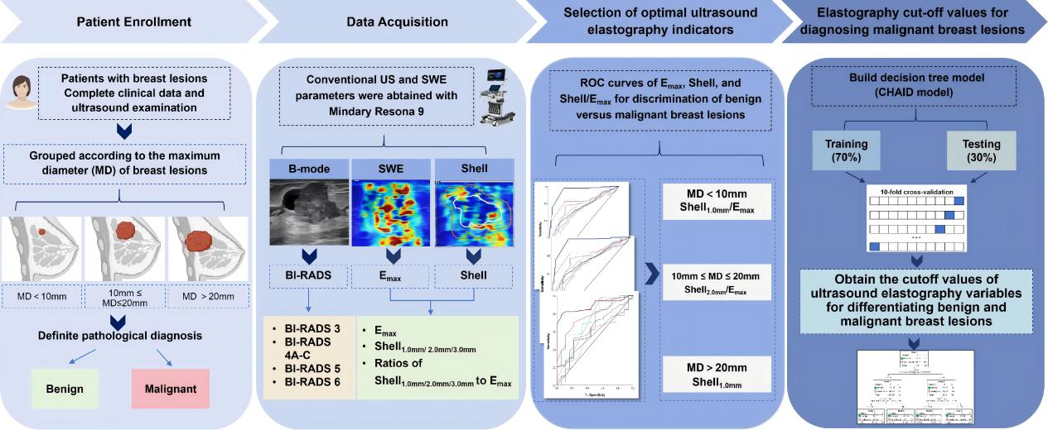
Figure S1. Flowchart of the study protocol for differentiating benign and malignant breast lesions using shear wave elastography (SWE). Patients with breast lesions were enrolled based on complete clinical and ultrasound data, stratified by maximum lesion diameter (MD: <10 mm, 10–20 mm, >20 mm) and pathological diagnosis (benign vs. malignant). Conventional ultrasound (B-mode) and SWE parameters (Emax, peritumoral Shell stiffness at 1.0-3.0 mm widths, and Shell/Emax ratios) were acquired using a Mindray Resona 9 system. Optimal SWE indices for each size subgroup were selected via ROC analysis (e.g., Shell 1.0 mm for <10 mm lesions). A CHAID decision tree model was developed to establish size-specific SWE cutoff values for malignancy differentiation.

Figure. S2. Enrollment proportions by participating center in the multicenter cohort.(A) Data represent the percentage of participants recruited from each of the three collaborating centers (n=523 total participants). Center 1 was the dominant contributor with 308 cases (59%), followed by Center 2 (105 cases, 21%) and Center 3 (110 cases, 20%). Enrollment data were standardized across centers prior to analysis. (B) Case counts of benign and maligant lesions in different centers.

