261,546 Participants in the final cohort

Excluded 45,527 individuals with cancer diagnosed prior to IBD onset or assessment date.
Excluded 45,379 individuals with missing biomarker data. (7,121 missing Polygenic Risk Score, 41,956 missing TyG index.
Excluded 66,844 individuals with incomplete or missing sleep pattern data.
Excluded 77,269 non-IBD individuals with comorbid inflammatory diseases.
Excluded 5,801 individuals with baseline Crohn's disease or ulcerative colitis.
306,925 Participants remining
373,769 Participants remining
451,038 Participants remining
496,565 Participants remining
502,366 Participants with available data

Supplementary Figure S1. Flowchart of the Study.

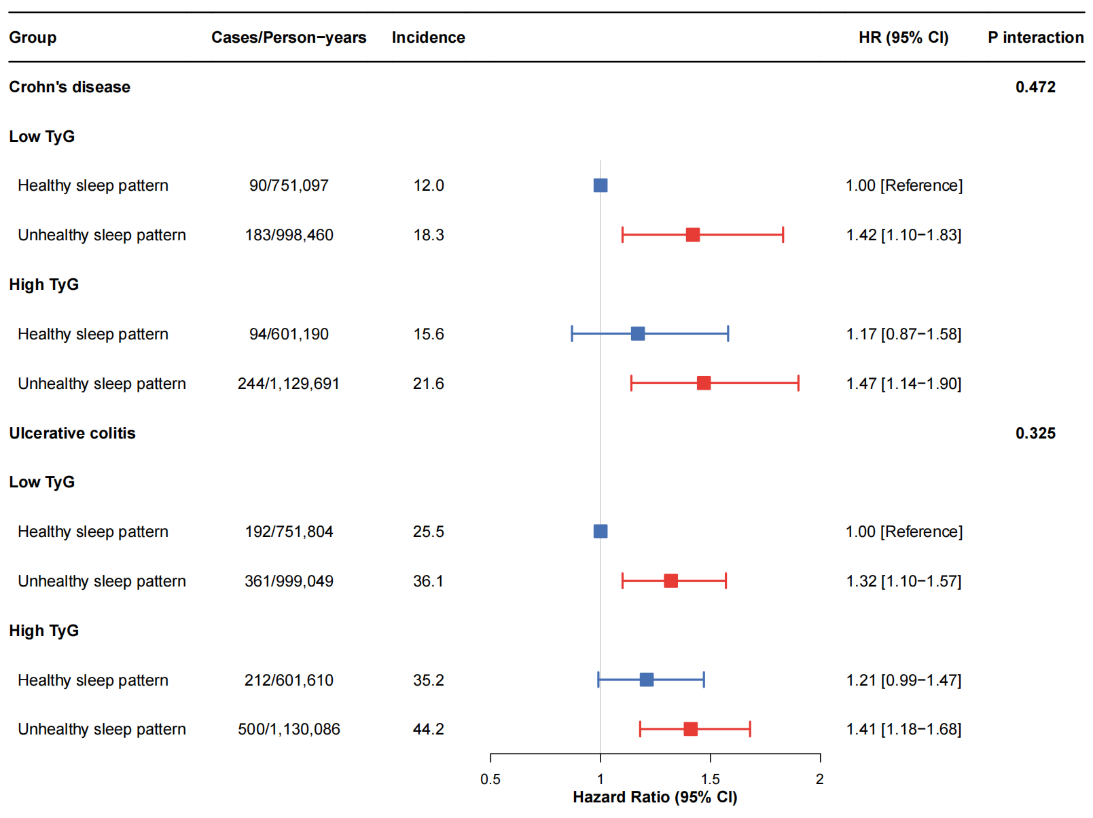

Supplementary Figure S2. Subgroup analyses of TyG levels and risk of Crohn's disease and ulcerative colitisª.
ªHazard ratios of Crohn’s disease and ulcerative colitis based on the combined classification of sleep pattern and TyG. ^{aa} Multivariate adjusted hazard ratios and 95% CIs were estimated from Cox regression models, stratified by sex, age, TDI, ethnicity, BMI, medication (vitamin, mineral, aspirin, cholesterol drug and antihypertensive drug use), baseline disease (cardiovascular diseases, and diabetes) and lifestyles (alcohol consumption, smoking status, and intake of fruit and vegetables).
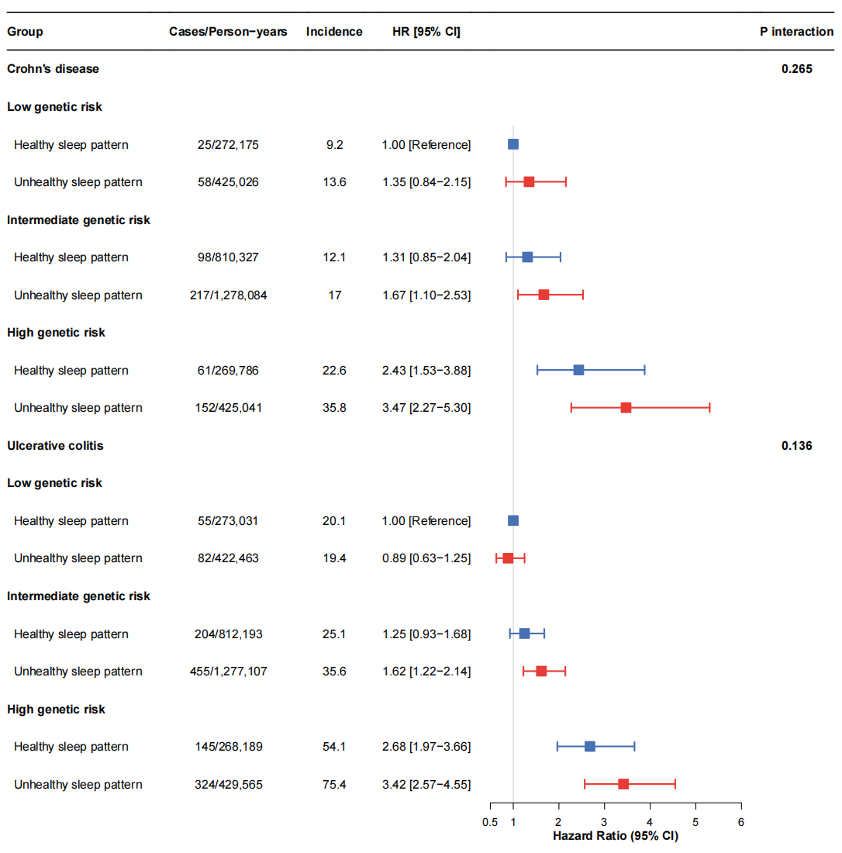

Supplementary Figure S3. Associations between sleep pattern and risk of Crohn's disease and ulcerative colitis stratified by PRS categoryª. ªHazard ratios of Crohn’s disease and ulcerative colitis based on the combined classification of sleep pattern and PRS. ^{aa} Multivariate adjusted hazard ratios and 95% CIs were estimated from Cox regression models, stratified by sex, age, TDI, ethnicity, BMI, medication (vitamin, mineral, aspirin, cholesterol drug and antihypertensive drug use), baseline disease (cardiovascular diseases, and diabetes) and lifestyles (alcohol consumption, smoking status, and intake of fruit and vegetables).

Supplementary Table S1. Characteristic distribution of participants.
 | Min | P25 | Mean | Median | P75 | Max
Age distribution at CD diagnosis | 40 | 49 | 55.87 | 57 | 63 | 70
Age distribution at UC diagnosis | 40 | 50 | 56.45 | 58 | 63 | 70
Follow-up time of participants with a CD outcome | 0.03 | 4.15 | 7.24 | 7.29 | 10.24 | 14.88
Follow-up time of participants with a UC outcome | 0.01 | 3.76 | 6.91 | 6.83 | 10.02 | 15.09
Follow-up time of participants without IBD outcome | 0.01 | 12.88 | 13.32 | 13.62 | 14.34 | 15.82
Baseline age | 39 | 50 | 56.18 | 57 | 63 | 73
Baseline BMI | 12.12 | 24.08 | 27.26 | 26.63 | 29.68 | 74.68
Baseline Townsend deprivation index | -6.26 | -3.7 | -1.44 | -2.26 | 0.27 | 11
CD, Crohn's disease; UC, ulcerative colitis; IBD,Inflammatory bowel disease; BMI, body mass index;

Supplementary Table S2. Associations between sleep pattern with risk of Crohn’s disease and Ulcerative colitis after further adjustment.
 | CD |  | UC
 | Healthy sleep pattern | Unhealthy sleep pattern | Healthy sleep pattern | Unhealthy sleep pattern
Further adjustment of immune-mediated inflammatory diseasesª, HR (95% CI) | 1.00 [Reference] | 1.21 (1.01-1.44)* | 1.00 [Reference] | 1.13 (1.00-1.27)
Further adjustment of irritable bowel syndrome^{b}, HR (95% CI) | 1.00 [Reference] | 1.28 (1.07-1.52)** | 1.00 [Reference] | 1.20 (1.06-1.35)**
Excluding non-white participants a, HR [95% CI] | 1.00 [Reference] | 1.32 [1.10-1.58]** | 1.00 [Reference] | 1.32 [1.10-1.58]**
Excluding incident CD/UC cases occurred  within the initial two years of the follow-up period b,  HR [95% CI] | 1.00 [Reference] | 1.33 [1.10-1.60]** | 1.00 [Reference] | 1.33 [1.10-1.60]**
Control competing risk of death | 1.00 [Reference] | 1.34 [1.12-1.60]** | 1.00 [Reference] | 1.25 [1.10-1.40]***
ª Multivariable adjusted model 3: multivariate-adjusted hazard ratios and 95% CIs were estimated from Cox regression models, stratified by covariates in model 2 and inflammation_diseases ("Asthma", "RA", "SLE", MS").
^{b} Multivariable adjusted model 4: multivariate-adjusted hazard ratios and 95% CIs were estimated from Cox regression models, stratified by covariates in model 2 and IBS.

Supplementary Table S3. Associations between TyG levels with risk of Crohn’s disease and Ulcerative colitis
 | CD |  | UC
 | Low TyG | High TyG | Low TyG | High TyG
Cases | 273 | 338 | 553 | 712
Person-years | 1 749 557 | 1 730 881 | 1 750 853 | 1 731 696
Incidence ratea | 15.6 | 19.5 | 31.6 | 41.1
Multivariate-adjusted model 1b, HR (95% CI) | 1.00 [Reference] | 1.11 (0.94-1.32) | 1.00 [Reference] | 1.14 (1.01-1.28)*
Multivariate-adjusted model 2c, HR (95% CI) | 1.00 [Reference] | 1.09 (0.92-1.29) | 1.00 [Reference] | 1.12 (1.00-1.26)
ª Per 100 000 person-years.
^{b} Multivariable adjusted model 1: multivariate-adjusted hazard ratios and 95% CIs were estimated from Cox regression models, stratified by sex, age, TDI, and
ethnicity, BMI, medication (vitamin, mineral, aspirin, cholesterol drug and antihypertensive drug use), and baseline disease (cardiovascular diseases, and diabetes).
^{c} Multivariable adjusted model 2: multivariate-adjusted hazard ratios and 95% CIs were estimated from Cox regression models, stratified by covariates in model 1 and lifestyles (alcohol consumption, smoking status, and intake of fruit and vegetables).
Asterisks indicate: *P < 0.05, **P < 0.01, ***P < 0.001.

Supplementary Table S4. Subgroup analyses of sleep pattern and risk of Crohn's disease and ulcerative colitis.
 | CD |  |  | UC
 | Cases/Person-years | HR [95%CI] a | P for interaction | Cases/Person-years | HR [95%CI] a | P for interaction
Age |  |  | 0.714 |  |  | 0.399
<60 | 371/2,068,995 | 1.36 [1.09-1.71]** |  | 712/2,070,693 | 1.30 [1.11-1.53]**
>=60 | 240/1,411,443 | 1.30 [0.98-1.71] |  | 553/1,411,855 | 1.17 [0.97-1.39]
Sex |  |  | 0.334 |  |  | 0.321
Male | 336/1,845,363 | 1.24 [0.96-1.62] |  | 605/1,847,082 | 1.17 [0.99-1.39]
Female | 275/1,635,076 | 1.37 [1.10-1.69]** |  | 660/1,635,467 | 1.17 [1.02-1.36]*
BMI |  |  | 0.641 |  |  | 0.21
<25 | 168/1,180,122 | 1.17 [0.99-1.39] |  | 359/1,181,146 | 1.17 [0.99-1.39]
>=25 | 443/2,300,316 | 1.17 [1.02-1.36]* |  | 906/2,301,403 | 1.17 [1.02-1.36]*
a Multivariate-adjusted hazard ratios and 95% CIs were estimated from Cox regression models, stratified by sex, age, ethnicity, BMI, medication (vitamin, mineral, aspirin, cholesterol drug and antihypertensive drug use), baseline disease (cardiovascular diseases, and diabetes) and lifestyles (alcohol consumption, smoking status, and intake of fruit and vegetables).

Supplementary Table S5. Associations between genetic susceptibility with risk of Crohn's disease.
 | CD
 | Low genetic risk of CD | Intermediate genetic risk of CD | High genetic risk of CD
Cases | 83 | 315 | 213
Person-years | 697 200 | 2 088 411 | 694 827
Incidence rateª | 11.9 | 15.1 | 30.7
Multivariate-adjusted model 1b, HR (95% CI) | 1.00 [Reference] | 1.27 (0.99-1.61) | 2.55 (1.98-3.29)***
Multivariate-adjusted model 2c, HR (95% CI) | 1.00 [Reference] | 1.26 (0.99-1.61) | 2.54 (1.97-3.27)***
ª Per 100 000 person-years.
^{b} Multivariable adjusted model 1: multivariate-adjusted hazard ratios and 95% CIs were estimated from Cox regression models, stratified by sex, age, TDI, and
ethnicity, BMI, medication (vitamin, mineral, aspirin, cholesterol drug and antihypertensive drug use), and baseline disease (cardiovascular diseases, and diabetes).
^{c} Multivariable adjusted model 2: multivariate-adjusted hazard ratios and 95% CIs were estimated from Cox regression models, stratified by covariates in model 1 and lifestyles (alcohol consumption, smoking status, and intake of fruit and vegetables).
Asterisks indicate: *P < 0.05, **P < 0.01, ***P < 0.001.

Supplementary Table S6. Associations Between Genetic Susceptibility with Risk of Ulcerative Colitis.
 | UC
 | Low genetic risk of UC | Intermediate genetic risk of UC | High genetic risk of UC
Cases | 137 | 659 | 469
Person-years | 695 494 | 2 089 301 | 697 754
Incidence rateª | 19.7 | 31.5 | 67.2
Multivariate-adjusted model 1b, HR (95% CI) | 1.00 [Reference] | 1.60 (1.33-1.92)*** | 3.40 (2.81-4.11)***
Multivariate-adjusted model 2c, HR (95% CI) | 1.00 [Reference] | 1.60 (1.33-1.92)*** | 3.39 (2.81-4.11)***
ª Per 100 000 person-years.
^{b} Multivariable adjusted model 1: multivariate-adjusted hazard ratios and 95% CIs were estimated from Cox regression models, stratified by sex, age, TDI, and
ethnicity, BMI, medication (vitamin, mineral, aspirin, cholesterol drug and antihypertensive drug use), and baseline disease (cardiovascular diseases, and diabetes).
^{c} Multivariable adjusted model 2: multivariate-adjusted hazard ratios and 95% CIs were estimated from Cox regression models, stratified by covariates in model 1 and lifestyles (alcohol consumption, smoking status, and intake of fruit and vegetables).
Asterisks indicate: *P < 0.05, **P < 0.01, ***P < 0.001.

