GRAPHICAL ABSTRACT
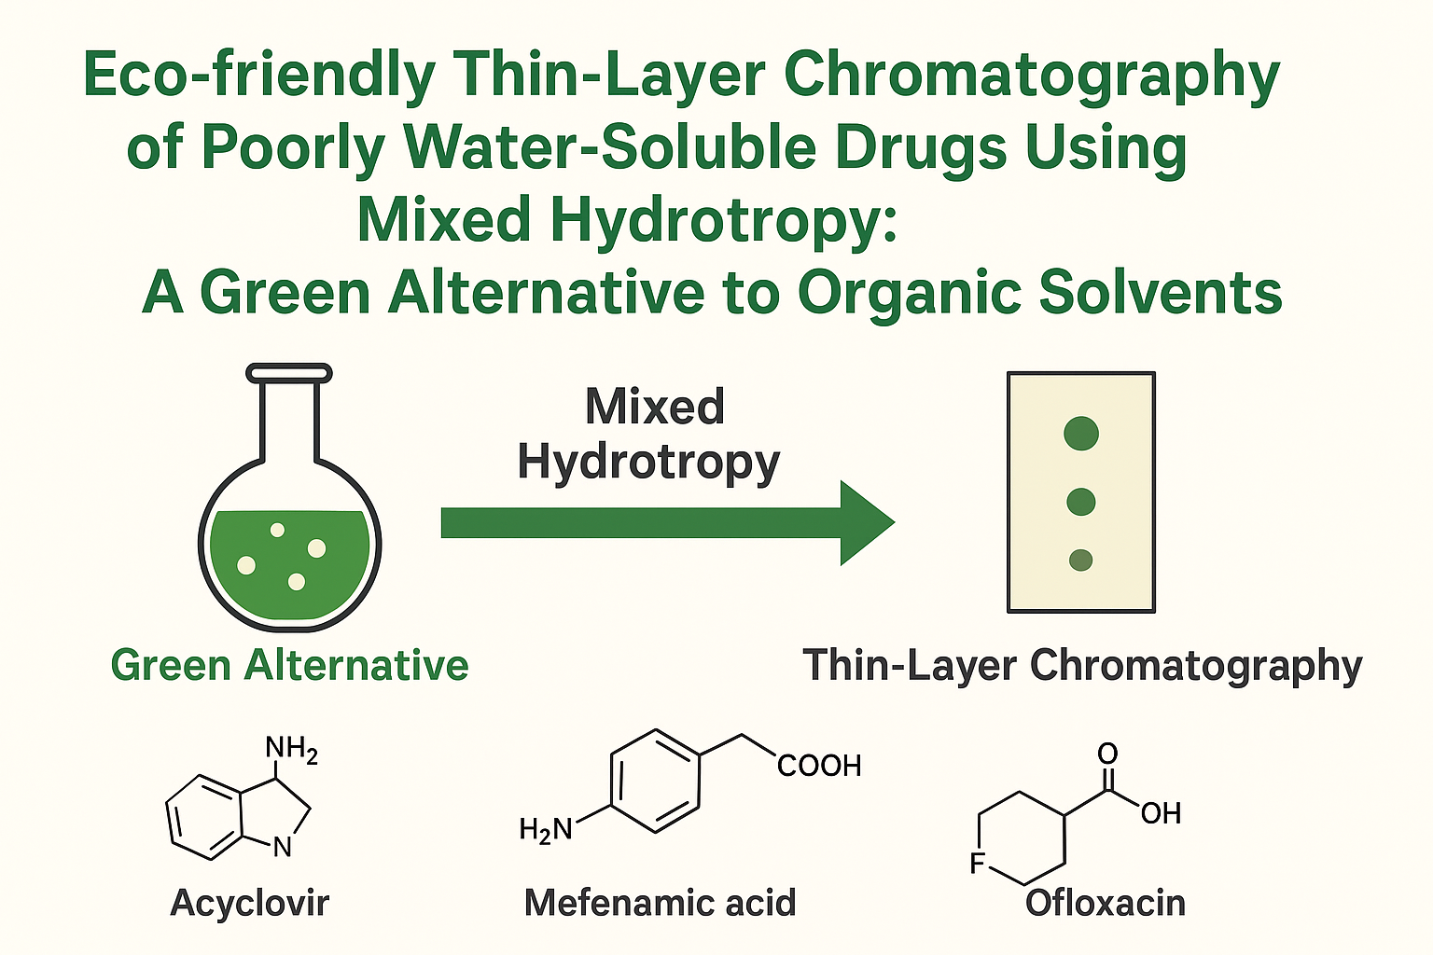

ABSTRACT
Thin-layer chromatography (TLC) is commonly used in pharmaceutical quality control, but the analysis of poorly water-soluble drugs often requires harmful and expensive organic solvents. This study presents a green and cost-effective alternative by developing a TLC method based on the principles of hydrotropy and mixed hydrotropy. Hydrotropy involves the use of concentrated aqueous solutions of hydrotropic agents to enhance drug solubility. In this work, combinations of agents such as sodium benzoate, sodium citrate, sodium acetate, phenol and urea were used to prepare environmentally friendly mobile phases. These hydrotropic blends successfully replaced organic solvents in TLC, showing improved Rf values and reduced tailing. The developed method demonstrated superior performance over conventional systems, highlighting the potential of hydrotropy as a sustainable solution in pharmaceutical analysis. This approach is aligned with the principles of green chemistry and offers a promising platform for wider application in analytical and formulation research.

