Supplementary appendix
Supplement to: Accuracy and clinical utility of near-point-of-care blood tests for predicting incident tuberculosis in exposed contacts: a multi-country observational cohort study

Supplementary Table of Contents
Methods 5
1. Definitions 5
1.1 Presumptive tuberculosis 5
1.2 Sputum expectorator 5
1.3 Index case 5
1.4 Contacts 5
1.5 Microbiological Reference Standard 6
1.6 Passive tuberculosis detection 6
1.7 Month 12 endpoint adjudication procedure 7
1.8 Classification of anemia as per WHO definition 7
1.9 Missed month 6 visit 8
1.10 Lost-to-follow-up 8
2. Reference standards for sensitivity analyses 8
2.1 Primary endpoint 8
2.2 Secondary endpoint 1 8
2.3 Secondary endpoint 2 8
3. Exploratory analysis 9
3.1 Biomarker trajectories exploratory analysis 9
4. Inclusion and exclusion criteria for index cases and contacts 9
5. Description of near point-of-care setting across study sites: 10
5.1 Manhiça, Mozambique: 10
5.2 Cape Town, South Africa: 11
5.3 Kampala, Uganda 11
Supplementary Table 1. Schedule of procedures and specimen collection 13
Supplementary Table 2: Demographic and clinical characteristics overall and by site 14
Supplementary Figure 1. Time to tuberculosis diagnosis and point-of-care testing timepoints for all incident cases 15
Supplementary Table 3: Xpert MTB-HR, Haemoglobin and CRP test results 16
Supplementary Figure 2. The follow-up time window and method of diagnostic confirmation for all 136 tuberculosis diagnoses 17
Supplementary Table 4. Xpert MTB-HR performance for predicting future tuberculosis, for a prespecified cut-off and Target Product-based performance thresholds. 18
Supplementary Table 5. Stratified prediction estimates over a six-months period against the MRS for the prespecified cut-off (<= -1.275) for M0 and M6 combined. 19
Supplementary Figure 3. Performance of Xpert MTB-HR, CRP, and haemoglobin, based on three reference standard definitions for predicting TB in six-months, for month 0 and month 6 combined 20
Supplementary Table 6. Haemoglobin performance for predicting future bacteriologically confirmed TB (MRS positive), for different levels of anemia cf. the WHO anemia definition (age-sex adjusted) 21
Supplementary Table 7. Stratified prediction estimates over a six-months period against bacteriologically confirmed TB (MRS positive), for any anemia cf. the WHO anemia definition (age-sex adjusted) for month 0 and moths 6 results combined. 22
Supplementary Table 8. Haemoglobin performance for predicting future bacteriologically confirmed TB (MRS positive), for various prespecified performance thresholds cf. the WHO Prediction TPP. 23
Supplementary Table 9. Performance of CRP for predicting future bacteriologically confirmed TB (MRS positive), at two predefined cut-offs 24
Supplementary Table 10. Stratified prediction estimates over a six-months period against bacteriologically confirmed TB (MRS positive) for the >=5 mg/L cut-off, by various stratifications, month 0 and moths 6 results combined. 25
Supplementary Table 11. Six-months prediction estimates for Extended and Stringent reference standards for Xpert MTB-HR, haemoglobin and CRP both at prespecified and TPP cutoffs, for M0 and M6 combined. 26
Supplementary Figure 4. Predictive performance of the longitudinal change (Δ) of the three biomarkers over six months. The longitudinal change for all three biomarkers did not improve the predictive performance compared to the measurement at each timepoint separately. 27
Supplementary Table 12. Comparison of the Area Under the Receiver-Operator Characteristic curves for the longitudinal change (Δ) of the three biomarkers 28
Supplementary Table 13. Predictive performance of two-test parallel and sequential algorithms at different cutoffs. 30
Supplementary Table 14. Standards for Reporting of Diagnostic Accuracy Studies check list 31
References 33

Methods

Definitions

Presumptive tuberculosis
A participant with tuberculosis symptoms including cough of any duration (haemoptysis, weight loss, fever, drenching night sweats). If HIV-negative, at least two symptoms were required. If PLWH, one symptom is required. In this study cough duration criterion was irrespective of HIV which was a lower threshold than that recommended by the WHO² however, this was done to accommodate the standard-of-care practice in Uganda (the site with the lowest symptom threshold for testing for tuberculosis disease).

Sputum expectorator
A contact who, irrespective of their symptoms, could produce at least one ≥1ml sputum specimen at a specific timepoint (M0, M6, or M12). Sputum had to contain solid or purulent material and not only saliva.

Index case
A presumptive tuberculosis patient (≥18 years) diagnosed as part of routine care with sputum-positive (bacteriologically confirmed) pulmonary tuberculosis. Index cases with rifampicin resistance for the current episode were ineligible.

Contacts
Any person aged ≥12 years and been exposed to an index case enrolled in the study. Contacts should have not been diagnosed with current tuberculosis and had not received tuberculosis treatment in the past two months.

types of contacts per the WHO¹
Household contacts: A person with whom an index case shared a communal space in the same structure, including but not limited to a bedroom, lounge or seating area, kitchen, or bathroom, for one or more nights or for frequent or extended periods during the day with the index case during the three months before commencement of the current treatment episode. Individuals who were homeless and shared a sleeping area were considered household contacts for the purpose of this study.
Close contacts: A person who was not in the household but shared an enclosed space, such as a social gathering place, workplace, school, or other facility, for extended periods during the day with the index case three months before commencement of treatment the current episode. This category included but was not limited to individuals who lived on the same plot of land but in a different structure (e.g., a shack in the backyard), occupational contacts, people that drank or took drugs together, and church congregants.

Microbiological Reference Standard
A positive sputum culture or a positive sputum Xpert MTB/RIF or Xpert Ultra result. In the absence of a positive culture and presence of a history of TB treatment in the preceding 24 months an Xpert Ultra “trace” result was regarded negative. Alternative definitions used in the sensitivity analyses for the different endpoints are defined below in section 2.

Passive tuberculosis detection
Passive tuberculosis detection refers to any tuberculosis disease diagnosis that occurred outside scheduled study visits, i.e., through routine health care pathways rather than study-led investigations. To capture these cases, study staff contacted participants at months 3 and 9 to ascertain whether they had started tuberculosis treatment since their last visit. In addition, clinic routine records were reviewed between visits to identify any tuberculosis diagnoses or treatment initiations among enrolled participants. This dual approach ensured that cases identified through routine care were systematically captured and documented.

Month 12 endpoint adjudication procedure
At the M12 visit, cohort participants had chest X-ray examination to identify incident tuberculosis disease in contacts who did not have tuberculosis suggestive symptoms (asymptomatic tuberculosis), followed by bacteriological testing for those with tuberculosis suggestive X-ray abnormalities. If such abnormalities were found while bacteriological testing remained negative or inconclusive, or was not done, decisions were made as to whether that participant were classified as having clinically diagnosed tuberculosis as follows. Two of three consultant pulmonologists not involved in the study assessed the DICOM files that were reported by the site physician or radiologist as abnormal, suggestive of tuberculosis; and for which M. tuberculosis culture was negative, not done or contaminated; and Xpert MTB/RIF or Ultra as negative, not done or indeterminate. Participants were classified as "probable tuberculosis " if both assessors classified the X-ray as such. If only one assessor classified the X-ray as “probable tuberculosis”, the third assessor served as the tie breaker.

Classification of anemia as per WHO definition
We defined haemoglobin-defined anemia and severity status as per the WHO criteria that takes into consideration haemoglobin cutoffs varying by age, sex, and physiological status. For adolescents, anemia was defined as haemoglobin <12.0 g/dL for both sexes. For adults and adolescents, anemia was defined as haemoglobin <12.0 g/dL for non-pregnant females aged ≥15 years, <13.0 g/dL for males ≥15 years; and haemoglobin <11.0 g/dL for pregnant females. Severity was categorized as mild (11.0–11.9 g/dL for non-pregnant females ≥15 years and adolescents; 11.0–12.9 g/dL for adult males), moderate (8.0–10.9 g/dL for all ages), and severe (<8.0 g/dL for all ages). These thresholds were applied to haemoglobin measurements at each study visit to classify participants as non-anemic, mildly anemic, moderately anemic, or severely anemic (1).

Missed month 6 visit
Refers to a contact who does not attend the M6 visit but returns to care at the M12 visit.

Lost-to-follow-up
Defined as a contact who does not attend the Month‑12 (M12) visit, regardless of whether they attended the M6 visit

Reference standards for sensitivity analyses

Primary endpoint
Microbiological reference standard (MRS): Pulmonary tuberculosis diagnosed among the cohort participants based on MRS.

Secondary endpoint 1
Extended reference standard (eRS; Any pulmonary tuberculosis)
Pulmonary tuberculosis diagnosed among the cohort participants resulting in tuberculosis treatment irrespective of the diagnostic procedure OR a month 12 X-ray assessed as “probable tuberculosis” by two independent assessors irrespective of subsequent treatment.

Secondary endpoint 2
Stringent microbiological reference standard (sMRS)
Laboratory-confirmed tuberculosis (see above) diagnosed within 15 months post-enrolment with a positive sputum Ultra result that was not “trace” OR any Xpert Ultra “trace” result in the presence of a positive sputum culture OR any Xpert Ultra “trace” result in the presence of at least two of the following symptoms: cough, fever, weight loss and night sweats, irrespective of their duration OR any Xpert Ultra “trace” result in the presence of a month 12 X-ray assessed as abnormal, “probable tuberculosis” by two independent assessors.

Exploratory analysis

Biomarker trajectories exploratory analysis
For participants with two Xpert MTB-HR measurements taken approximately six months apart, we calculated the delta (ΔHR) as the difference between the second (t2) and first (t1) score (ΔHR = HR_{t2} − HR_{t1}). Because Xpert MTB-HR values are typically negative, a positive ΔHR indicates movement toward zero, suggesting weakening response, whereas a negative ΔHR reflects a more negative score, suggesting enhanced response. Similar change metrics were computed for CRP and haemoglobin where repeat measurements were available. Logistic regression reporting odds ratios per 0.1-unit change with 95% confidence intervals.

Inclusion and exclusion criteria for index cases and contacts
Inclusion | Exclusion
Index cases
1. ≥18 years old.  2. Willing to provide the contact information of people who meet the definition of contacts, or willing to refer those people (which make require the distribution of study pamphlets) so that may contact study staff.  3. Willing to comply with study requirements i.e. provision of contact details and written, informed consent prior to enrolment.  4. Willing to provide sputa (expectorated or induced) for culture.  5. Meeting the definition for tuberculosis disease. | 1. No informed consent.  2. More than eight weeks has passed since the index case’s date of treatment initiation result for tuberculosis was reported, and  3. Patient was started on treatment based on empirical or clinical grounds (including CXR) alone
Contacts
1. ≥12 years old.  2. Meeting contact definition.  3. Able and willing to return for follow-up visits, with no plans to move soon.  4. Willing and able to provide sputum and blood.  5. Willing to comply with study requirements i.e. provision of contact details and written, informed consent or assent prior to enrolment.  6. Agree to potentially undergo CXR at M12 (women of childbearing age will undergo urine dipstick pregnancy testing). | 1. No informed consent or assent.  2. Not diagnosed with active TB (per diagnostic algorithms in Section 6.8).  3. Unwilling or unable to provide blood.  4. More than eight weeks has passed since reporting of the index case’s TB treatment initiation date, or  5. Has taken any form of TB treatment within the preceding two months (i.e., is currently on treatment). There are no exclusions based on any TB treatment more than two months prior.

Description of near point-of-care setting across study sites:

Manhiça, Mozambique:
Manhiça, a semi‑rural district north of Maputo, has a high burden of TB and HIV. The Manhiça District Hospital (MDH) serves as the main referral center, providing primary and secondary care and working in close partnership with the adjacent Centro de Investigação em Saúde de Manhiça (CISM). CISM supports clinical research, surveillance, and laboratory diagnostics, enabling a coordinated system for identifying TB cases through clinical staff, case managers, and laboratory teams. Routine TB and HIV services at MDH include clinical evaluation, HIV testing, chest radiography, and initiation of TB treatment under national guidelines. Sputum samples from presumptive TB cases are tested at the CISM laboratory using Xpert Ultra, with additional diagnostics, auramine smear microscopy, culture on Löwenstein–Jensen and MGIT, urine LAM for PLHIV, and immunological assays such as IGRA, performed as needed. TB treatment is provided free of charge across district facilities offering standard first‑line regimens.

Cape Town, South Africa:
Scottsdene, Wallacedene, and Bloekombos are low‑income communities on Cape Town’s northern periphery served by primary care clinics that provide integrated TB/HIV services, including on‑site TB assessment and treatment, HIV testing and counselling, and ART initiation. These facilities operate within the Western Cape’s metro TB program, where recent provincial data indicate high TB notification rates (≈571 per 100 000 among persons ≥5 years in 2024–25) and substantial childhood burden (≈547 per 100 000 in <5 years) in the province’s public sector. While most cases are drug‑sensitive, a smaller fraction present with drug‑resistant disease: nationally, ~5% of incident TB in 2023 was drug‑resistant (predominantly MDR/RR‑TB), and provincial surveillance systems (NHLS/NICD and the Western Cape TB Dashboard) routinely report resistance profiles to guide care and referral to specialized DR‑TB services when needed. HIV services at these clinics align with Western Cape protocols, offering free testing, immediate ART, and linkage for TB/HIV co‑infection management across the clinic network.

Kampala, Uganda
Makerere University College of Health Sciences (MaKCHS), Kampala, Uganda, is located within the complex of Mulago National Referral and teaching hospital (MNRH). MNRH is the largest hospital in Uganda and the main teaching site for CHS. The hospital, which has approximately 1,500 beds, is owned by the Government of Uganda and staffed and operated by the Ministry of Health (MoH). It provides a large patient population that provides a rich source of study participants with a diverse assortment of diseases. Key Centres of Excellence (CoEs) for HIV/AIDS care within MNRH are: Makerere University Infectious Disease Institute (IDI), Baylor International Aids Initiative (BIPAI) in Uganda, Makerere University–Johns Hopkins University (MUJHU), CoE in Paediatric HIV/AIDS research and clinical trials, and The AIDS Support Organization (TASO) Uganda Ltd, a 35-year-old HIV/AIDS care CoE. All these CoEs work together with the experts of the National TB and Leprosy program (NTLP) and the TB ward at MNRH for TB diagnosis, care, and Management. The PreFIT study in Uganda recruited participants from MNRH TB wards 5 and 6, the largest TB care clinic in Uganda. The PreFIT study extended its recruitment sites to the high-volume TB/HIV clinics within Kampala City Authority (KCCA), i.e., Kiswa HCIII, Kisenyi Health Center IV, Kawala Health Center IV, and Kitebi HCIII. All these health facilities have GeneXpert MTB/RIF as the primary test for TB diagnosis and Free TB treatment and care. Study samples were analysed and stored at MakCHS, which has advanced diagnostics in laboratories, including a College of American Pathologists (CAP, ISO15189) Accredited Mycobacteriology (BSL-3) Laboratory, Molecular Biology laboratory, Immunology Laboratory, Genomics Laboratory, as well as the home of H3 Africa Biorepository.

Supplementary Table 1. Schedule of procedures and specimen collection
Specimen type | Purpose | Number, blood volume and tube volume | Contacts without active TB at screening
Specimen type | Purpose | Number, blood volume and tube volume | Screening | Baseline | Month 6 | Month 12
Finger-prick blood | - HIV  - Xpert MTB-HR  - CRP  - Haemoglobin | 1-3 drops needed to be tested for each assay (not counting the first drop wiped away for a new prick) | ü  û  û  û | û  ü  ü  ü | ü  ü  ü  ü | ü  û  û  û
Sputum (expectorated or, if presumptive TB and unable to expectorate, induced) | MGIT960 liquid culture | 2 × ≥ 1ml | û | ü | ü | ü
Urine | Pregnancy (women ≤45 years) | 1 × < 1 ml | û | û | û | ü
CXR | Rule-out potential active TB | N/A | û | û | û | ü

Supplementary Table 2: Demographic and clinical characteristics overall and by site
Characteristic | Overall  (n=3031) | Mozambique (n=1107) | Uganda  (n=869) | South Africa (n=1055)
Age (median (IQR)) | 29 (19-44) | 27 (17-47) | 25 (18-34) | 33 (22-46)
Age group  12 - 24 years  25 - 44 years  45+ years | 1260 (42%)  1068 (35%)  702 (23%) | 527 (48%)  281 (25%)  298 (27%) | 379 (46%)  346 (40%)  126 (15%) | 335 (32%)  441 (41%)  278 (26%)
Adolescents (12-17 years) | 583 (19%) | 290 (26%) | 170 (20%) | 123 (12%)
Females  Males | 1841 (61%)  1190 (39%) | 719 (65%)  388 (35%) | 466 (54%)  403 (46%) | 656 (62%)  399 (38%)
HIV status at baseline  Positive  Negative | 449 (15%)  2576 (85%) | 223 (20%)  882 (80%) | 69 (8%)  798 (92%) | 157 (15%)  896 (85%)
Previous TB  Any episode  None | 276 (9%)  2749 (91%) | 33 (3%)  1072 (97%) | 26 (3%)  841 (97%) | 217 (21%)  836 (79%)
Household contact*  Other close contact | 2839 (94%)  192 (6%) | 829 (97 %)  29 (3%) | 786 (90%)  83 (10%) | 975 (92%)  80 (8%)
Missing data: previous TB =6, HIV status=6, Age =1
*Sharing communal spaces such as a bed, bedroom or living spaces. Abbreviations: IQR; interquartile range, TB; tuberculosis

Supplementary Figure 1. Time to tuberculosis diagnosis and point-of-care testing timepoints for all incident cases
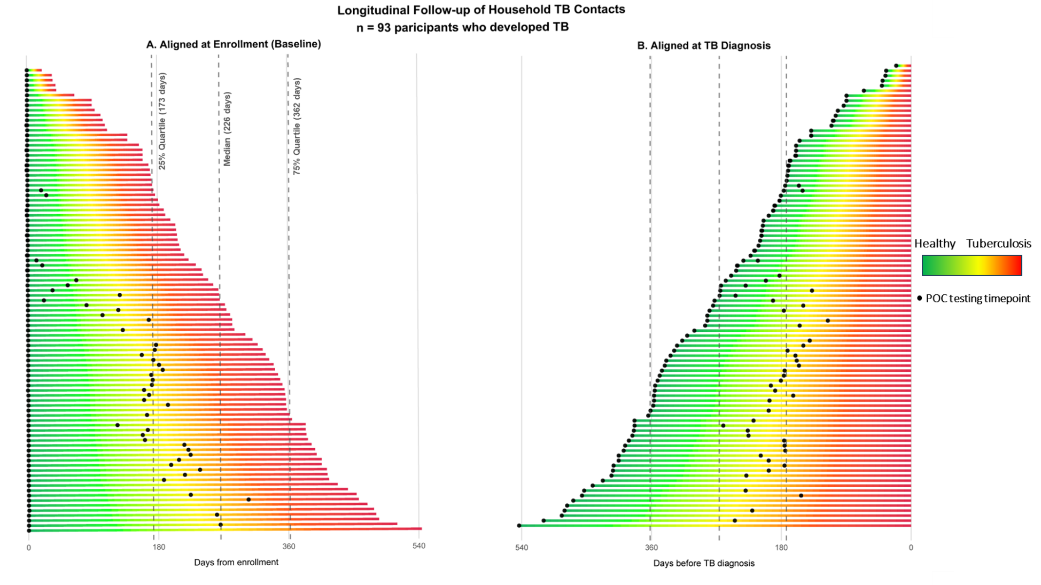
Time to tuberculosis diagnosis aligned to (A) date of enrolment and (B) date of tuberculosis diagnosis among the contact cohort participants. Each bar represents an incident (as defined by the extended reference standard). The gradient shading shows the transition from healthy to tuberculosis state. The timepoint at which point-of-care testing was performed is shown by the black dot. The median (interquartile range) time to tuberculosis is shown by the dashed grey lines. Abbreviations: TB; tuberculosis, POC; point-of-care.

Supplementary Table 3: Xpert MTB-HR, Haemoglobin and CRP test results
Seen for visit | Month 0 (n = 3031) | Month 6 (n=2730) | Total (n = 5761)
Xpert MTB-HR done | 2946 (97.2% eligible) | 2231 (73.6% eligible) | 5177 (89.9% eligible)
Xpert MTB-HR valid results | 2739 (93.0%) | 2018 (90.4%) | 4757 (91.9%)
Xpert MTB-HR valid results including repeats | 2815 (95.6%) | 2073 (92.9%) | 4888 (94.4%)
Haemoglobin done | 3031 (100% of eligible) | 2286 (83.7% eligible) | 5317 (92.2% eligible)
Haemoglobin valid results | 3008 (99.2%) | 2285 (99.9%) | 5293 (99.5%)
Haemoglobin valid results including repeats | 3031 (100%) | 2286 (100%) | 5315 (99.9%)
CRP done | 2885 (95.2% eligible) | 2077 (76.1% eligible) | 4962 (86.1% eligible)
CRP valid results | 2846 (98.6%) | 2027 (97.6%) | 4873 (98.2%)
CRP valid results including repeats | 2870 (99.5%) | 2048 (98.6%) | 4918 (99.1%)

Supplementary Figure 2. The follow-up time window and method of diagnostic confirmation for all 136 tuberculosis diagnoses

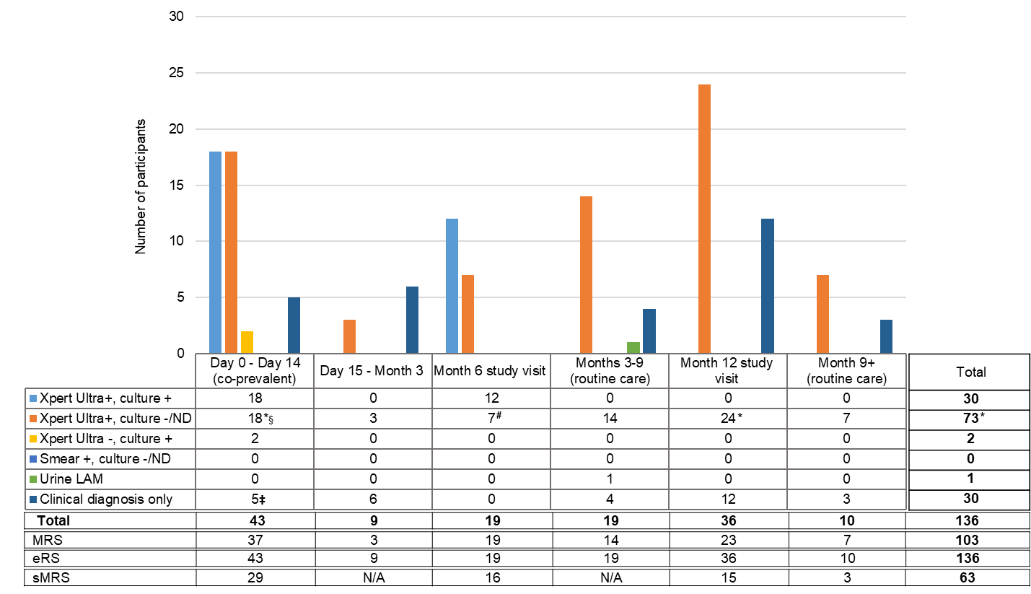
“Month 12 study visit” includes 3 Xpert Ultra positive cases diagnosed at a delayed study visit between M15 and M18. “Month 9+ routine care” includes 2 Xpert Ultra positive cases diagnosed in routine care between M15 and M18. N/A: could not be classified due to missing standardized symptom information.
# 1 also smear positive § includes two cases routinely diagnosed before D15 ‡ includes three cases routinely diagnosed before D15 * one case Xpert Ultra trace positive only with a history of TB treatment within the preceding 2 years. Abbreviations: ND; not done, LAM; Lipoarabinomannan, MRS; microbiological reference standard, eRS; extended reference standard, sMRS; stringent microbiological reference standard; N/A, not available.

Supplementary Table 4. Xpert MTB-HR performance for predicting future tuberculosis, for a prespecified cut-off and Target Product-based performance thresholds.

Prespecified performance | Threshold value (score) | TP | FP | FN | TN | Sensitivity (95% CI) | Specificity (95% CI)
Prediction of bacteriologically confirmed TB (MRS) over 6 months at M0:
M0 Xpert MTB-HR --> D15-M9 TB outcome (n=2788)
Area under the ROC curve 0.672 (95% CI 0.654 - 0.690)
Published cut-off | <= -1.275 | 16 | 606 | 14 | 2152 | 0.533 (0.343 - 0.717) | 0.780 (0.765 - 0.796)
75% sensitivity | <= -0.65 | 24 | 1661 | 6 | 1097 | 0.800 (0.614 - 0.923) | 0.398 (0.380 - 0.416)
75% specificity | <= -1.25 | 18 | 675 | 12 | 2083 | 0.600 (0.406 - 0.773) | 0.755 (0.739 - 0.771)
90% sensitivity | <= -0.35 | 27 | 2326 | 3 | 432 | 0.900 (0.735 - 0.979) | 0.157 (0.143 - 0.170)
90% specificity | <= -1.75 | 8 | 264 | 22 | 2494 | 0.267 (0.123 - 0.459) | 0.904 (0.893 - 0.915)
Prediction of bacteriologically confirmed TB (MRS) over 6 months at M6:
M6 Xpert MTB-HR --> M9 - end of FU outcome (n=2092)
Area under the ROC curve 0.755 (95% CI 0.736 - 0.774)
Published cut-off | <= -1.275 | 17 | 375 | 10 | 1690 | 0.630 (0.424 – 0.806) | 0.818 (0.802 – 0.835)
75% sensitivity | <= -0.85 | 22 | 855 | 5 | 1210 | 0.815 (0.619 - 0.937) | 0.586 (0.565 - 0.607)
75% specificity | <= -1.20 | 17 | 459 | 10 | 1606 | 0.630 (0.424 - 0.806) | 0.778 (0.760 - 0.800)
90% sensitivity | <= -0.55 | 25 | 1385 | 2 | 680 | 0.926 (0.757 - 0.991) | 0.329 (0.309 - 0.349)
90% specificity | <= -1.65 | 19 | 172 | 8 | 1893 | 0.296 (0.138 - 0.502) | 0.917 (0.905 - 0.929)
Prediction of bacteriologically confirmed TB (MRS) over 12 months at M0:
M0 Xpert MTB-HR --> Post D15 - end of FU outcome (n=2665)
Area under the ROC curve 0.663 (95% CI 0.645 - 0.681)
Published cut-off | <= -1.275 | 30 | 555 | 32 | 2048 | 0.484 (0.355 - 0.614) | 0.787 (0.771 - 0.802)
75% sensitivity | <= -0.75 | 47 | 1437 | 15 | 1166 | 0.758 (0.633 - 0.858) | 0.448 (0.429 - 0.467)
75% specificity | <= -1.25 | 32 | 620 | 30 | 1983 | 0.516 (0.386 - 0.645) | 0.762 (0.746 - 0.778)
90% sensitivity | <= -0.30 | 59 | 2348 | 3 | 255 | 0.952 (0.865 - 0.990) | 0.098 (0.087 - 0.109)
90% specificity | <= -1.75 | 14 | 236 | 48 | 2367 | 0.226 (0.129 - 0.350) | 0.909 (0.898 - 0.920)
Prediction of bacteriologically confirmed TB (MRS) over 6 months at M0 or M6:
M0 and M6 Xpert MTB-HR combined --> subsequent incident TB (n=4956) *
Area under the ROC curve 0.707 (95% CI 0.635 - 0.779)
Published cut-off | <= -1.275 | 33 | 1020 | 24 | 3879 | 0.579 (0.441 – 0.709) | 0.792 (0.781 - 0.803)
75% sensitivity | N/O | 43 | 2214 | 14 | 2685 | 0.754 (0.622 - 0.859) | 0.548 (0.534 - 0.562)
75% specificity | N/O | 35 | 1233 | 22 | 3666 | 0.614 (0.476 - 0.740) | 0.748 (0.736 - 0.760)
90% sensitivity | N/O | 52 | 3871 | 5 | 1028 | 0.912 (0.807 - 0.971) | 0.210 (0.199 - 0.221)
90% specificity | N/O | 16 | 490 | 41 | 4409 | 0.281 (0.170 - 0.415) | 0.900 (0.892 - 0.908)
Threshold values based on the ROC curve as estimated for the specified timepoint(s). TPP performance thresholds may not have been reached according to the ROC curve, in such cases the nearest performance threshold was chosen. TB cases include all cases diagnosed within the specified window. TP: true positives. FP: false positives. FN: false negatives. TN: true negatives. N/O: not obtained, as the cut-offs were based on the model’s predicted probabilities. *Based on multilevel mixed effects model adjusting for repeated measurement

Supplementary Table 5. Stratified prediction estimates over a six-months period against the MRS for the prespecified cut-off (<= -1.275) for M0 and M6 combined.

Prespecified cut-off <= -1.275 | N total | TP | FP | FN | TN | AUROC (95% CI) | Sensitivity (95% CI) | Specificity (95% CI)
Prediction of bacteriologically confirmed TB (MRS) over 6 months at M0 or M6:
M0 and M6 Xpert MTB-HR combined --> subsequent incident TB (n=4956)
Mozambique | 1676 | 3 | 247 | 4 | 1429 | 0.634 (0.601 - 0.664)* | 0.428 (0.099 – 0.816) | 0.853 (0.836 - 0.870)
South Africa | 1785 | 26 | 507 | 16 | 1236 | 0.674 (0.651 - 0.695) | 0.619 (0.456 – 0.764) | 0.709 (0.688 - 0.730)
Uganda | 1488 | 4 | 266 | 4 | 1214 | 0.693 (0.669 - 0.716) | 0.500 (0.157 – 0.843) | 0.820 (0.801 - 0.840)
Males | 1920 | 15 | 315 | 12 | 1578 | 0.734 (0.707 - 0.760)* | 0.556 (0.353 – 0.745) | 0.834 (0.817 - 0.850)
Females | 3036 | 18 | 705 | 12 | 2301 | 0.673 (0.656 – 0.690) | 0.600 (0.406 – 0.773) | 0.766 (0.750 - 0.781)
Age 12-29 yr | 2479 | N/A | N/A | N/A |  | N/A | N/A | N/A
Age 30-49 yr | 1527 | 19 | 342 | 12 | 1154 | 0.762 (0.703 – 0.749) | 0.613 (0.422 – 0.782) | 0.771 (0.750 - 0.793)
Age 50+ yr | 892 | 6 | 212 | 6 | 668 | 0.574 (0.541 – 0.607) | 0.500 (0.211 – 0.789) | 0.759 (0.731 - 0.787)
HIV negative | 4242 | 24 | 766 | 23 | 3429 | 0.699 (0.684 – 0.712) | 0.511 (0.361 – 0.659) | 0.817 (0.806 - 0.829)
HIV positive | 704 | 9 | 251 | 1 | 443 | 0.726 (0.691 – 0.759) | 0.900 (0.555 – 0.997) | 0.638 (0.603 - 0.674)
No previous TB treatment | 4500 | 23 | 878 | 16 | 3583 | 0.738 (0.724 – 0.750) | 0.590 (0.421 – 0.744) | 0.803 (0.792 - 0.815)
Previous TB treatment | 447 | 9 | 139 | 8 | 291 | 0.541 (0.494 – 0.588) | 0.529 (0.278 – 0.770) | 0.677 (0.633 - 0.720)
TP: true positives. FP: false positives. FN: false negatives. TN: true negatives. Confidence interval AUROC adjusted for repeated measurements, confidence intervals for sensitivity and specificity not adjusted. *AUROC for month 0 data only; multilevel mixed model for combined M0-M6 data did not converge. N/A: Numbers are too small for analysis.

Supplementary Figure 3. Performance of Xpert MTB-HR, CRP, and haemoglobin, based on three reference standard definitions for predicting TB in six-months, for month 0 and month 6 combined
Performance was consistent across the different reference standard definitions.
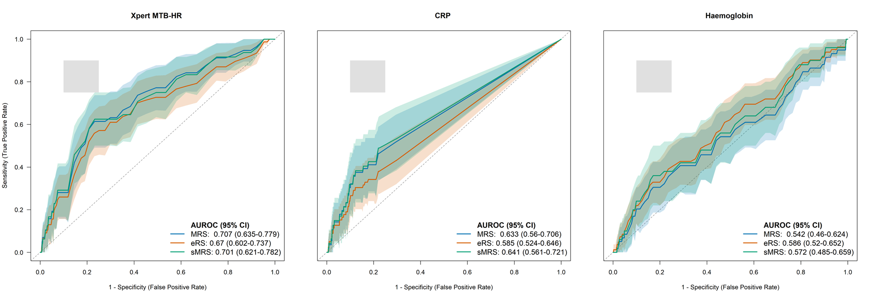
Area under the Receiver-operator Characteristics curve (AUROC) for the combined month 0 and 6 testing results, for the three near point-of-care tests based on the microbiological (MRS), extended (eRS) and stringent microbiological (sMRS) reference standards. The shaded area for each line represents the 95% confidence. interval. The grey shaded square corresponds to WHO minimum and optimum sensitivity and specificity TPP thresholds

Supplementary Table 6. Haemoglobin performance for predicting future bacteriologically confirmed TB (MRS positive), for different levels of anemia cf. the WHO anemia definition (age-sex adjusted)

Anemia classification | TP | FP | FN | TN | Sensitivity (95% CI) | Specificity (95% CI)
Prediction over 6 months at M0:
M0 Hb --> D15-M9 bacteriologically confirmed TB outcome (MRS, n=2968)
any anemia | 11 | 490 | 21 | 2446 | 0.343 (0.185 – 0.531) | 0.833 (0.819 – 0.846
moderate or severe anemia | 4 | 223 | 28 | 2713 | 0.125 (0.035 – 0.289) | 0.924 (0.914 – 0.933)
severe anemia | 0 | 9 | 32 | 2927 | 0 | 0.996 (0.994 – 0.998)
Prediction over 6 months at M6:
M6 Hb --> M9 - end of follow-up bacteriologically confirmed TB outcome (MRS, n=2228)
any anemia | 7 | 396 | 20 | 1805 | 0.259 (0.111 – 0.462) | 0.820 (0.804 – 0.836)
moderate or severe anemia | 6 | 205 | 21 | 1996 | 0.222 (0.086 -0.422) | 0.906 (0.894 – 0.918)
severe anemia | 0 | 10 | 27 | 2191 | 0 | 0.995 (0.992 – 0.998)
Prediction over 12 months at M0:
M0 Hb --> Post D15 - end of follow-up bacteriologically confirmed TB outcome (MRS, n=2834)
any anemia | 24 | 447 | 43 | 2320 | 0.358 (0.244 – 0.484) | 0.838 (0.824 – 0.852)
moderate or severe anemia | 10 | 201 | 57 | 2566 | 0.140 (0.073 – 0.257) | 0.927 (0.917 – 0.936)
severe anemia | 0 | 8 | 67 | 2759 | 0 | 0.997 (0.995 – 0.999)
Prediction over 6 months at M0 or M6:
M0 and M6 Hb combined --> subsequent bacteriologically confirmed incident TB (MRS, n=5282)
any anemia | 18 | 915 | 41 | 4308 | 0.305 (0.192 - 0.439) | 0.825 (0.815 - 0.835)
moderate or severe anemia | 10 | 447 | 49 | 4776 | 0.169 (0.084 - 0.290) | 0.922 (0.914 - 0.969)
severe anemia | 0 | 19 | 59 | 5204 | 0 | 0.996 (0.994 – 0.998)
TB cases include all cases diagnosed within the specified window. TP: true positives. FP: false positives. FN: false negatives. TN: true negatives. MRS: microbiological reference standard.
Combined M0 and M6 prediction estimates not adjusted for repeated measurement.

Supplementary Table 7. Stratified prediction estimates over a six-months period against bacteriologically confirmed TB (MRS positive), for any anemia cf. the WHO anemia definition (age-sex adjusted) for month 0 and moths 6 results combined.

Prespecified  any anemia | N total | TP | FP | FN | TN | AUROC (95% IC) | Sensitivity (95% CI) | Specificity (95% CI)
Prediction of bacteriologically confirmed TB (MRS) over 6 months at M0 or M6:
M0 and M6 any anemia combined --> subsequent incident TB (n=4956)
Mozambique | 1944 | 5 | 435 | 4 | 1509 | 0.693 (0.664 – 0.720)* | 0.556 (0.212 – 0.863) | 0.776 (0.758 - 0.795)
South Africa | 1812 | 13 | 355 | 29 | 1415 | 0.525 (0.501 – 0.548) | 0.310 (0.176 – 0.471) | 0.799 (0.288 - 0.818)
Uganda | 1517 | 0 | 125 | 8 | 1384 | 0.448 (0.423 – 0.474) | 0.000 (0.000 – 0.369) | 0.917 (0.903 - 0.931)
Males | 2036 | 9 | 203 | 18 | 1806 | 0.550 (0.528 – 0.572) | 0.333 (0.165 – 0.540) | 0.899 (0.886 - 0.912)
Females | 3246 | 9 | 712 | 23 | 2502 | 0.552 (0.534 – 0.569) | 0.281 (0.137 – 0.467) | 0.779 (0.764 - 0.793)
Age 12-29 yr | 2671 | 1 | 295 | 13 | 2362 | 0.560 (0.541 – 0.579) | 0.071 (0.002 – 0.339) | 0.889 (0.877 - 0.901)
Age 30-49 yr | 1607 | 12 | 372 | 19 | 1204 | 0.571 (0.546 – 0.595) | 0.387 (0.218 – 0.578) | 0.764 (0.743 - 0.785)
Age 50+ yr | 963 | 5 | 232 | 9 | 717 | 0.567 (0.535 – 0.599) | 0.357 (0.128 – 0.649) | 0.756 (0.728 - 0.783)
HIV negative | 4502 | 12 | 663 | 36 | 3790 | 0.540 (0.525 –0.554) | 0.250 (0.136 – 0.396) | 0.851 (0.841 - 0.862)
HIV positive | 771 | 6 | 251 | 5 | 509 | 0.549 (0.513 – 0.584) | 0.546 (0.234 – 0.833) | 0.670 (0.637 - 0.703)
No previous TB treatment | 4818 | 15 | 795 | 26 | 3982 | 0.636 (0.617 – 0.653)* | 0.363 (0.221 – 0.531) | 0.834 (0.823 - 0.844)
Previous TB treatment | 453 | 3 | 120 | 14 | 316 | 0.592 (0.545 – 0.637) | 0.177 (0.038 – 0.434) | 0.725 (0.684 - 0.766)
TP: true positives. FP: false positives. FN: false negatives. TN: true negatives. AUROC is for haemoglobin performance, unadjusted for age and sex. Confidence interval AUROC adjusted for repeated measurements, confidence intervals for sensitivity and specificity not adjusted. *AUROC for month 0 data only; multilevel mixed model for combined M0-M6 data did not converge.

Supplementary Table 8. Haemoglobin performance for predicting future bacteriologically confirmed TB (MRS positive), for various prespecified performance thresholds cf. the WHO Prediction TPP.

Prespecified performance | Threshold value (score) | TP | FP | FN | TN | Sensitivity (95% CI) | Specificity (95% CI)
Prediction over 6 months at M0:
M0 Hb --> D15-M9 bacteriologically confirmed TB outcome (MRS, n=2969)
Area under the ROC curve 0.582 (95% CI 0.564 - 0.600)
75% sensitivity | <= 14.5 | 24 | 2055 | 8 | 882 | 0.750 (0.566 - 0.885) | 0.300 (0.284 - 0.317)
75% specificity | <= 12.3 | 13 | 655 | 19 | 2282 | 0.406 (0.237 - 0.594) | 0.777 (0.762 - 0.792)
90% sensitivity | <= 15.2 | 29 | 2346 | 3 | 591 | 0.906 (0.750 - 0.980) | 0.201 (0.187 - 0.216)
90% specificity | <= 11.2 | 5 | 281 | 27 | 2656 | 0.156 (0.053 - 0.328) | 0.904 (0.894 - 0.915)
Prediction over 6 months at M6:
M6 Hb --> M9 - end of follow-up bacteriologically confirmed TB outcome (MRS, n=2228)
Area under the ROC curve 0.498 (95% CI 0.477 - 0.519)
75% sensitivity | <= 15.2 | 21 | 1801 | 6 | 400 | 0.778 (0.577 - 0.914) | 0.182 (0.166 - 0.198)
75% specificity | <= 12.2 | 8 | 545 | 19 | 1656 | 0.296 (0.138 - 0.502) | 0.752 (0.735 - 0.770)
90% sensitivity | <= 17.1 | 23 | 2111 | 4 | 90 | 0.852 (0.663 - 0.958) | 0.041 (0.033 - 0.049)
90% specificity | <= 10.9 | 6 | 205 | 21 | 1996 | 0.222 (0.086 - 0.423) | 0.907 (0.895 - 0.919)
Prediction over 12 months at M0:
M0 Hb --> Post D15 - end of follow-up bacteriologically confirmed TB outcome (MRS, n=2834)
Area under the ROC curve 0.567 (95% CI 0.548 - 0.585)
75% sensitivity | <= 14.7 | 50 | 747 | 17 | 2020 | 0.743 (0.625 - 0.845) | 0.270 (0.254 - 0.286)
75% specificity | <= 12.3 | 25 | 609 | 42 | 2158 | 0.373 (0.258 - 0.500) | 0.780 (0.765 - 0.795)
90% sensitivity | <= 16.5 | 63 | 2552 | 4 | 215 | 0.940 (0.854 - 0.983) | 0.078 (0.068 - 0.088)
90% specificity | <= 11.3 | 14 | 253 | 53 | 2514 | 0.209 (0.119 - 0.326) | 0.909 (0.898 - 0.919)
Prediction over 6 months at M0 or M6:
M0 and M6 Hb combined --> subsequent bacteriologically confirmed incident TB (MRS, n=5283)*
Area under the ROC curve 0.542 (95% CI 0.460 - 0.624)
75% sensitivity | N/O | 44 | 3914 | 15 | 1310 | 0.746 (0.616 - 0.850) | 0.251 (0.239 - 0.263)
75% specificity | N/O | 22 | 1322 | 37 | 3902 | 0.373 (0.250 - 0.509) | 0.747 (0.735 - 0.759)
90% sensitivity | N/O | 54 | 4765 | 5 | 459 | 0.915 (0.813 - 0.972) | 0.088 (0.080 - 0.096)
90% specificity | N/O | 12 | 520 | 47 | 4704 | 0.203 (0.110 - 0.328) | 0.901 (0.892 - 0.909)
Threshold values based on the ROC curve as estimated for the specified timepoint(s). TPP performance thresholds may not have been reached according to the ROC curve, in such cases the nearest performance threshold was chosen. TB cases include all cases diagnosed within the specified window. TP: true positives. FP: false positives. FN: false negatives. TN: true negatives. MRS: microbiological reference standard. N/O: not obtained, as the cut-offs were based on the model’s predicted probabilities.
*The multilevel mixed-effects model for the combined M0-M6 prediction over 6 months failed to converge, therefore the performance estimates are shown without adjustment of the confidence intervals for repeated measurements.

Supplementary Table 9. Performance of CRP for predicting future bacteriologically confirmed TB (MRS positive), at two predefined cut-offs

CRP classification (mg/L) | TP | FP | FN | TN | Sensitivity (95% CI) | Specificity (95% CI)
Prediction over 6 months at M0:
M0 CRP --> D15-M9 bacteriologically confirmed TB outcome (MRS, n=2947)
Area under the ROC curve 0.599 (95% CI 0.581 - 0.617)
Cut-off >=10 | 9 | 330 | 23 | 2585 | 0.281 (0.137 - 0.467) | 0.887 (0.875 - 0.898)
Cut-off >=5 | 12 | 687 | 20 | 2228 | 0.375 (0.211 - 0.563) | 0.764 (0.749 - 0.780)
Prediction over 6 months at M6:
M6 CRP --> M9 - end of follow-up bacteriologically confirmed TB outcome (MRS, n=2125)
Area under the ROC curve 0.684 (95% CI 0.664 - 0.704)
Cut-off >=10 | 9 | 198 | 15 | 1903 | 0.391 (0.197 - 0.615) | 0.899 (0.886 - 0.913)
Cut-off >=5 | 14 | 418 | 10 | 1683 | 0.583 (0.366 - 0.779) | 0.801 (0.784 - 0.818)
Prediction over 12 months at M0:
M0 Hb --> Post D15 - end of follow-up bacteriologically confirmed TB outcome (MRS, n=2813)
Area under the ROC curve 0.595 (95% CI 0.576 - 0.613)
Cut-off >=10 | 19 | 295 | 48 | 2451 | 0.284 (0.180 - 0.407) | 0.893 (0.881 - 0.904)
Cut-off >=5 | 24 | 632 | 43 | 2114 | 0.358 (0.245 - 0.485) | 0.770 (0.754 - 0.785)
Prediction over 6 months at M0 or M6: M0 and M6 combined --> subsequent incident bacteriologically confirmed TB outcome (primary, n=5153)
Area under the ROC curve 0.633 (95% CI 0.619 - 0.646)
Cut-off >=10 | 18 | 550 | 38 | 4537 | 0.321 (0.203 – 0.460) | 0.890 (0.882 – 0.899)
Cut-off >=5 | 26 | 1504 | 27 | 3593 | 0.518 (0.380 – 0.653) | 0.705 (0.693 – 0.717)
TP: true positives. FP: false positives. FN: false negatives. TN: true negatives. MRS: microbiological reference standard. 95% Confidence intervals for combined analysis NOT adjusted for repeated measurements.

Supplementary Table 10. Stratified prediction estimates over a six-months period against bacteriologically confirmed TB (MRS positive) for the >=5 mg/L cut-off, by various stratifications, month 0 and moths 6 results combined.

 | N total | TP | FP | FN | TN | AUROC (95% IC) | Sensitivity (95% CI) | Specificity (95% CI)
Prediction of bacteriologically confirmed TB (MRS) over 6 months at M0 or M6:
M0 and M6 CRP >=5 mg combined --> subsequent incident TB (n=4956)*
Mozambique | 1890 | 0 | 291 | 9 | 1590 | 0.999 (0.998 – 1.000) | 0.000 (0.000 – 0.336) | 0.845 (0.829 - 0.862)
South Africa | 1795 | 27 | 895 | 14 | 859 | 0.630 (0.538 – 0.722) | 0.659 (0.637 – 0.681) | 0.490 (0.467 - 0.513)
Uganda | 1468 | 2 | 318 | 4 | 1144 | 0.469 (0.433 – 0.484) | 0.333 (0.043 – 0.777) | 0.783 (0.761 - 0.804)
Males | 1996 | 18 | 534 | 8 | 1436 | 0.741 (0.721 – 0.760) | 0.692 (0.482 – 0.857) | 0.729 (0.709 - 0.748)
Females | 3157 | 11 | 970 | 19 | 2157 | 0.461 (0.443 – 0.478) | 0.367 (0.199 – 0.561) | 0.690 (0.674 - 0.706)
Age 12-29 yr | 2594 | 5 | 599 | 7 | 1983 | 0.610 (0.591 – 0.629) | 0.417 (0.152 – 0.723) | 0.780 (0.752 - 0.784)
Age 30-49 yr | 1575 | 20 | 539 | 10 | 1006 | 0.690 (0.666 – 0.712) | 0.667 (0.472 – 0.827) | 0.651 (0.628 - 0.675)
Age 50+ yr | 943 | 4 | 350 | 10 | 579 | 0.541 (0.509 – 0.574) | 0.286 (0.084 – 0.581) | 0.623 (0.592 - 0.654)
HIV negative | 4388 | 23 | 1254 | 22 | 3089 | 0.632 (0.618 – 0.647) | 0.511 (0.358 – 0.663) | 0.711 (0.698 – 0.725)
HIV positive | 755 | 6 | 249 | 5 | 495 | 0.623 (0.594 – 0.664) | 0.546 (0.234 – 0.833) | 0.665 (0.632 – 0.699)
No previous TB treatment | 4696 | 20 | 1290 | 18 | 3368 | 0.643 (0.629 – 0.657) | 0.526 (0.358 – 0.690) | 0.723 (0.710 – 0.736)
Previous TB treatment | 446 | 9 | 212 | 8 | 217 | 0.448 (0.402 – 0.496) | 0.529 (0.278 – 0.770) | 0.506 (0.459 - 0.552)
TP: true positives. FP: false positives. FN: false negatives. TN: true negatives. MRS: microbiological reference standard. *Confidence interval AUROC adjusted for repeated measurements, confidence intervals for sensitivity and specificity not adjusted.

Supplementary Table 11. Six-months prediction estimates for Extended and Stringent reference standards for Xpert MTB-HR, haemoglobin and CRP both at prespecified and TPP cutoffs, for M0 and M6 combined.
Prespecified performance | TP | FP | FN | TN | Sensitivity (95% CI) |  | Specificity (95% CI)
Xpert MTB-HR
Prespecified and TPP thresholds
Prediction of any TB (eRS) over 6 months at M0 or M6:
M0 and M6 Xpert MTB-HR combined --> subsequent incident TB (n=4956)
Area under the ROC curve 0.670 (95% CI 0.602 - 0.737)
TB score ≤-1.275 | 40 | 1013 | 37 | 3866 |  | 0.520 (0.403 - 0.635) | 0.792 (0.781 - 0.804)
75% sensitivity | 59 | 2829 | 18 | 2050 |  | 0.766 (0.656 - 0.855) | 0.420 (0.406 - 0.434)
75% specificity | 44 | 1224 | 33 | 3655 |  | 0.571 (0.454 - 0.684) | 0.749 (0.737 - 0.761)
90% sensitivity | 70 | 4229 | 7 | 650 |  | 0.909 (0.822 - 0.963) | 0.133 (0.124 - 0.143)
90% specificity | 20 | 486 | 57 | 4393 |  | 0.260 (0.166 - 0.372) | 0.900 (0.892 - 0.909)
Prediction of bacteriologically confirmed TB (sMRS) over 6 months at M0 or M6:
M0 and M6 Xpert MTB-HR combined --> subsequent incident TB (n=4956)
Area under the ROC curve 0.701 (95% CI 0.688 - 0.714)
TB score ≤-1.275 | 28 | 1025 | 20 | 3883 |  | 0.583 (0.432 – 0.724) | 0.791 (0.780 – 0.803)
75% sensitivity | 36 | 2425 | 12 | 2483 |  | 0.750 (0.604 – 0.864) | 0.506 (0.492 – 0.520)
75% specificity | 30 | 1140 | 18 | 3768 |  | 0.625 (0.474 – 0.760) | 0.768 (0.756 – 0.780)
90% sensitivity | 44 | 3688 | 4 | 1220 |  | 0.917 (0.800 – 0.977) | 0.249 (0.237 – 0.261)
90% specificity | 34 | 449 | 14 | 4459 |  | 0.292 (0.170 – 0.441) | 0.909 (0.901 – 0.917)
Haemoglobin
Prespecified: anemia classification
Prediction of any TB (eRS) over 6 months at M0 or M6:
M0 and M6 haemoglobin combined --> subsequent incident TB (n=5282)
any anemia | 27 | 906 | 55 | 4294 |  | 0.329 (0.229 – 0.442) | 0.826 (0.816 – 0.836)
moderate or severe anemia | 16 | 441 | 66 | 4759 |  | 0.195 (0.116 – 0.297) | 0.915 (0.908 – 0.923)
severe anemia | 0 | 19 | 82 | 5181 |  | 0 (0 – 0.044) | 0.996 (0.995 – 0.998)
Prediction of bacteriologically confirmed TB (sMRS) over 6 months at M0 or M6: M0 and M6 haemoglobin combined --> subsequent incident TB (n=5282)
any anemia | 18 | 915 | 32 | 4317 |  | 0.360 (0.229 – 0.508) | 0.825 (0.815 – 0.835)
moderate or severe anemia | 10 | 447 | 40 | 4785 |  | 0.200 (0.100 – 0.337) | 0.915 (0.907 – 0.922)
severe anemia | 0 | 19 | 50 | 5213 |  | 0 (0 – 0.071) | 0.996 (0.995 – 0.998)
TPP thresholds
Prediction of any TB (eRS) over 6 months at M0 or M6:
M0 and M6 haemoglobin combined --> subsequent incident TB (n=5283)
Area under the ROC curve 0.586 (95% CI 0.573 - 0.599)
75% sensitivity | 63 | 3751 | 19 | 1450 |  | 0.768 (0.662 - 0.854) | 0.279 (0.267 - 0.291)
75% specificity | 29 | 1133 | 53 | 4068 |  | 0.354 (0.251 - 0.467) | 0.782 (0.771 - 0.793)
90% sensitivity | 74 | 4366 | 8 | 835 |  | 0.902 (0.817 - 0.957) | 0.161 (0.151 - 0.170)
90% specificity | 18 | 928 | 64 | 3951 |  | 0.220 (0.136 - 0.325) | 0.901 (0.893 - 0.909)
CRP
Prespecified: ≥5mg/L and ≥10mg/L
Prediction of any TB (eRS) over 6 months at M0 or M6:
M0 and M6 C-reactive protein combined --> subsequent incident TB (n=5153)
Area under the ROC curve 0.585 (95% CI 0.572 - 0.599)
Cut-off >=10 | 21 | 557 | 58 | 4517 |  | 0.266 (0.172 – 0.377) | 0.890 (0.882 – 0.899)
Cut-off >=5 | 34 | 1499 | 45 | 3575 |  | 0.430 (0.319 – 0.547) | 0.705 (0.692 – 0.717)
Prediction of bacteriologically confirmed TB (sMRS) over 6 months at M0 or M6:
M0 and M6 C-reactive protein combined --> subsequent incident TB (n=5153)
Area under the ROC curve 0.641 (95% CI 0.561 – 0.721)
Cut-off >=10 | 15 | 563 | 32 | 4543 |  | 0.319 (0.191 – 0.471) | 0.890 (0.881 – 0.898)
Cut-off >=5 | 25 | 1508 | 22 | 3598 |  | 0.523 (0.381 – 0.679) | 0.705 (0.692 – 0.717)
Threshold values based on the ROC curve as estimated for the specified timepoint(s). TPP performance thresholds may not have been reached according to the ROC curve, in such cases the nearest performance threshold was chosen. TB cases include all cases diagnosed within the specified window. TP: true positives. FP: false positives. FN: false negatives. TN: true negatives. eRS: extended reference standard. sMRS: stringent microbiological reference standard

Supplementary Figure 4. Predictive performance of the longitudinal change (Δ) of the three biomarkers over six months. The longitudinal change for all three biomarkers did not improve the predictive performance compared to the measurement at each timepoint separately.
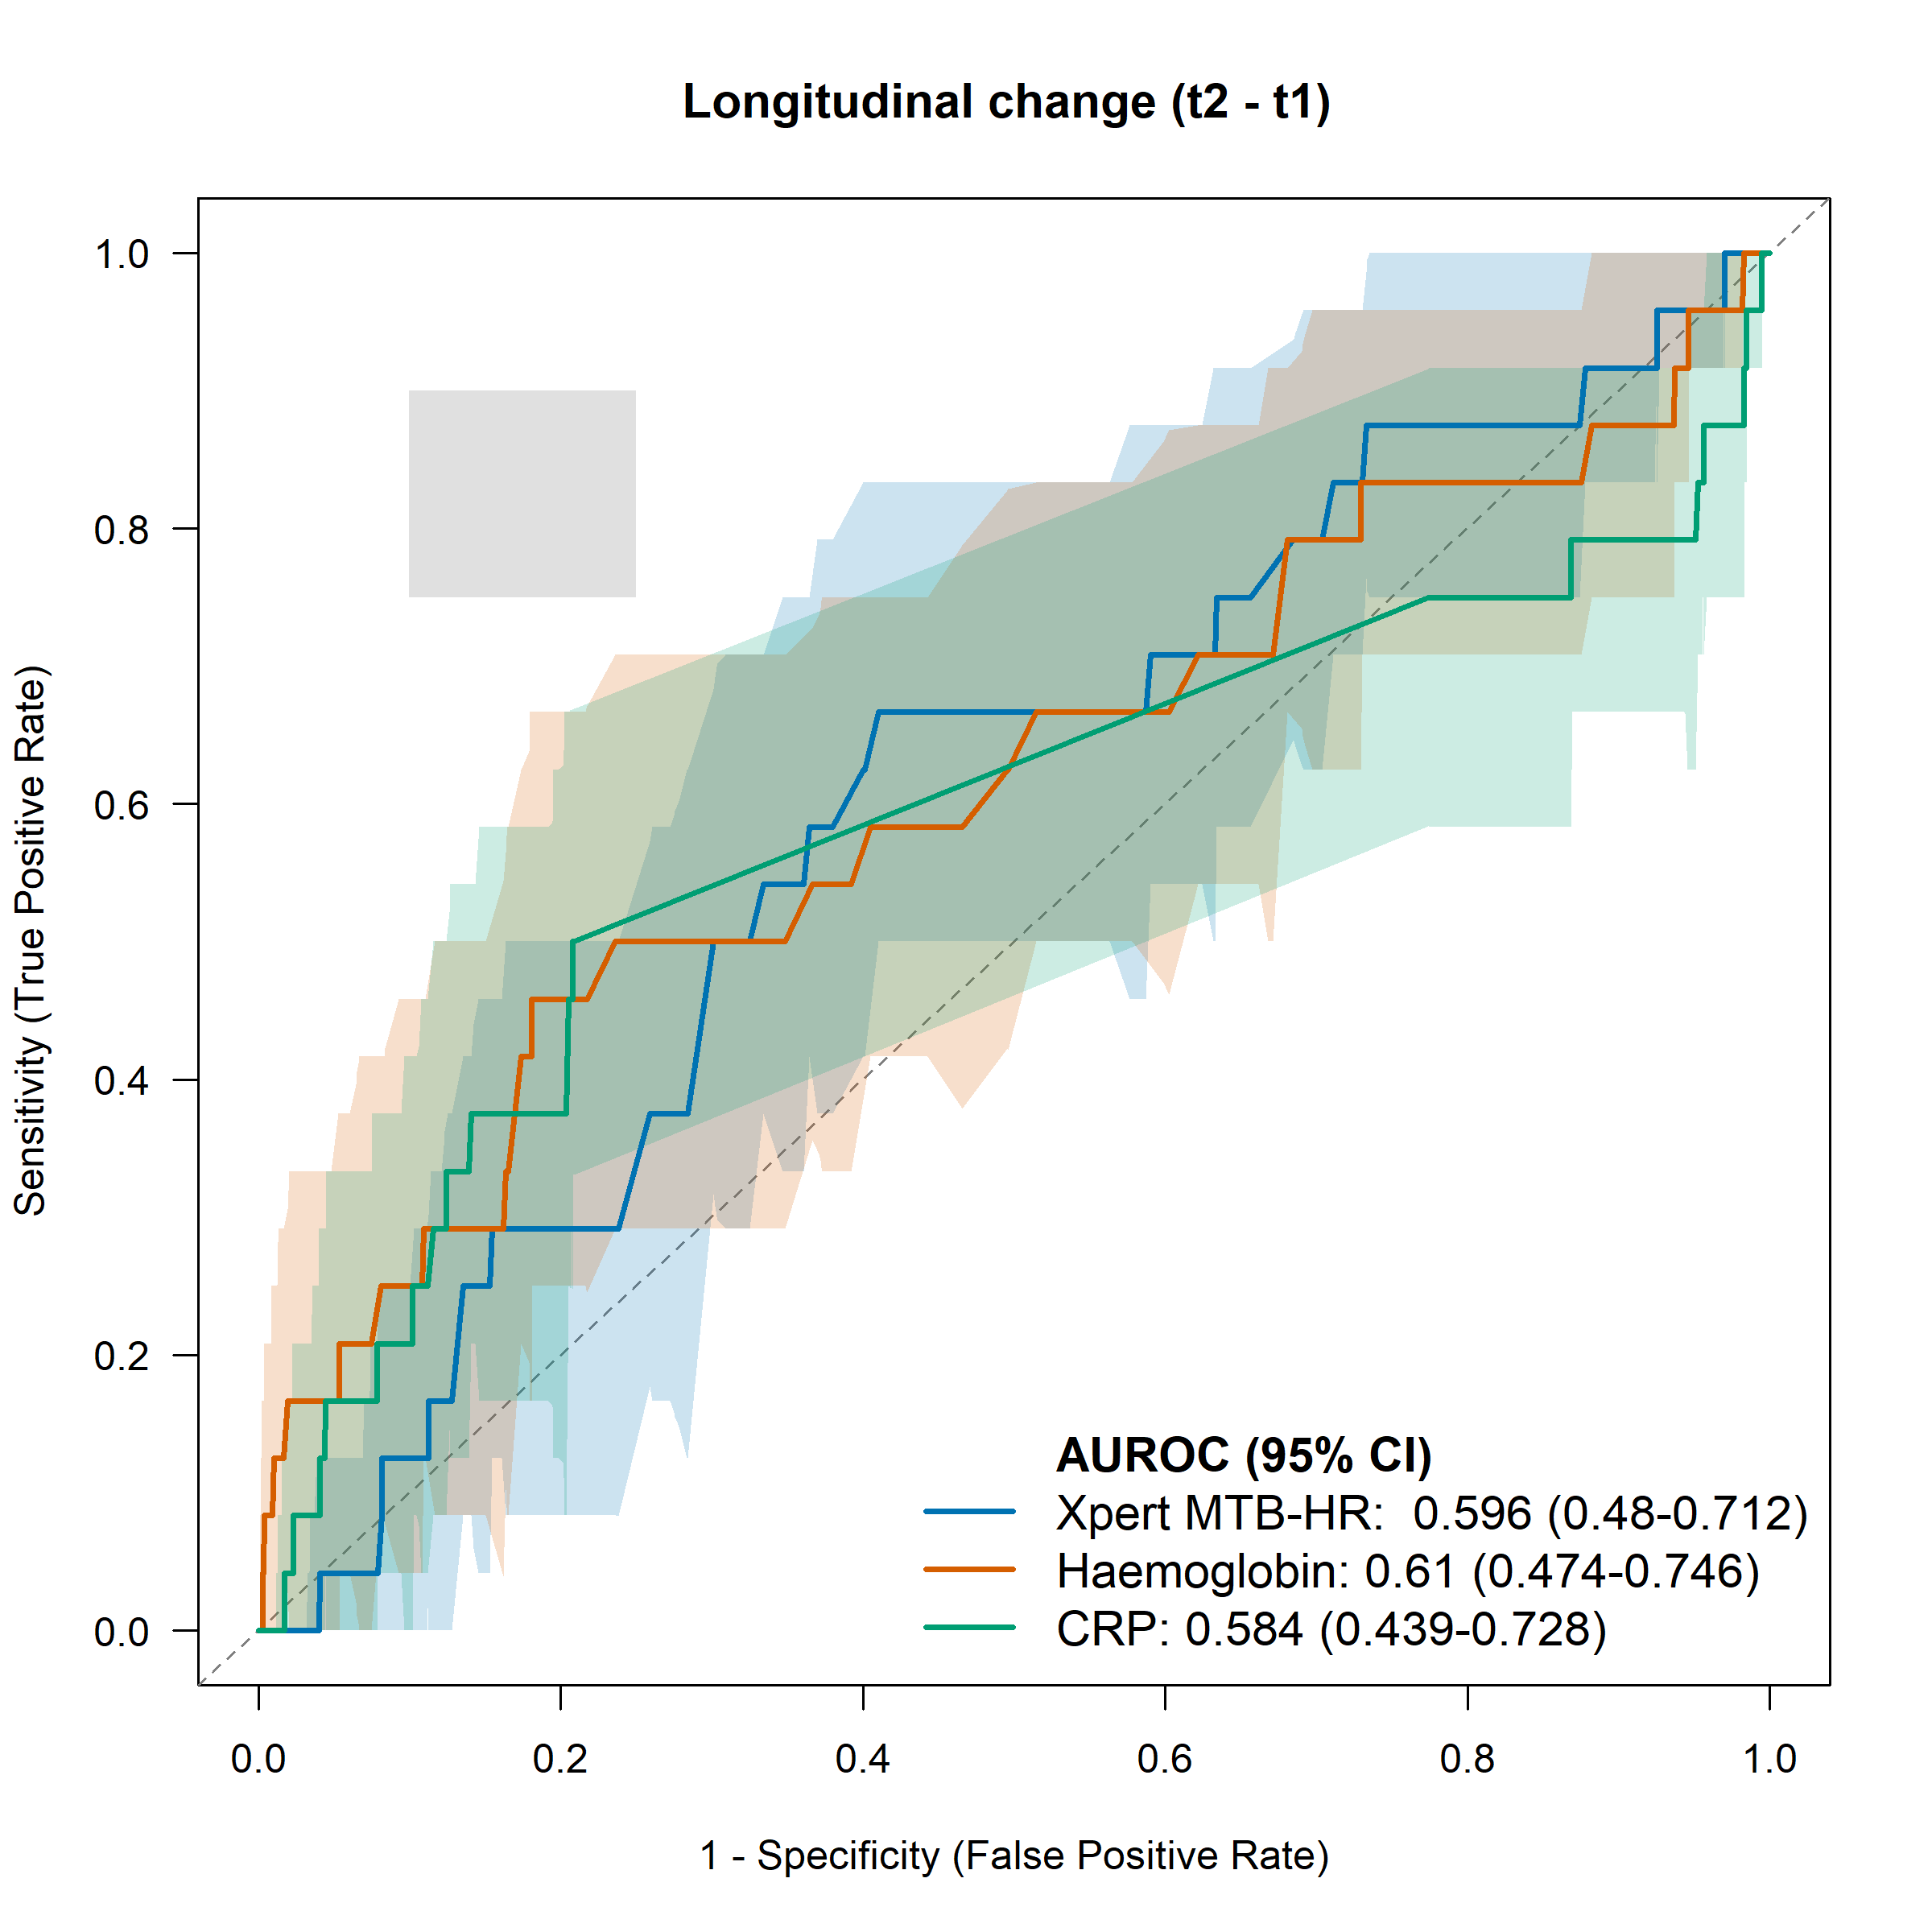
Area Under the Receiver-Operator Characteristics (AUROC) curve for predictive performance of the longitudinal change of the three near point-of-care tests
Δ (longitudinal change) for each biomarker was calculated t2-t1, as t2 is the M6 test result and t1 is the M0 test result. The shaded area for each line represents the 95% confidence. interval. The grey shaded square corresponds to WHO minimum and optimum sensitivity and specificity TPP thresholds.

Supplementary Table 12. Comparison of the Area Under the Receiver-Operator Characteristic curves for the longitudinal change (Δ) of the three biomarkers

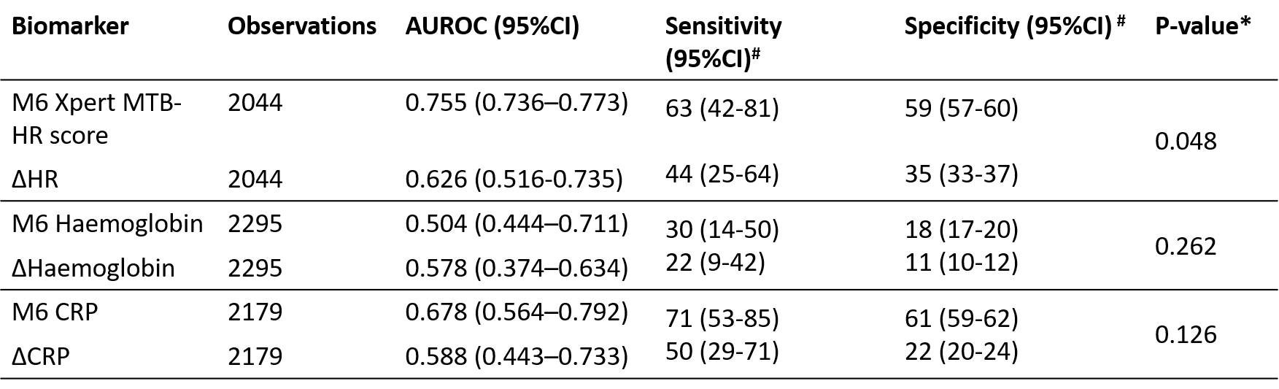

Δ for each biomarker was calculated t2-t1, as t2 is the M6 test result and t1 is the M0 test result
*calculated based on rocomp command in Stata which compares the difference between AUROCs.
# at the corresponding Targe Product Profile (TPP) cutoff of 75% sensitivity or 75% specificity

Supplementary Figure 6. Twelve-months predictive performance at prespecified cut-off and Target Product Profile-based performance thresholds.
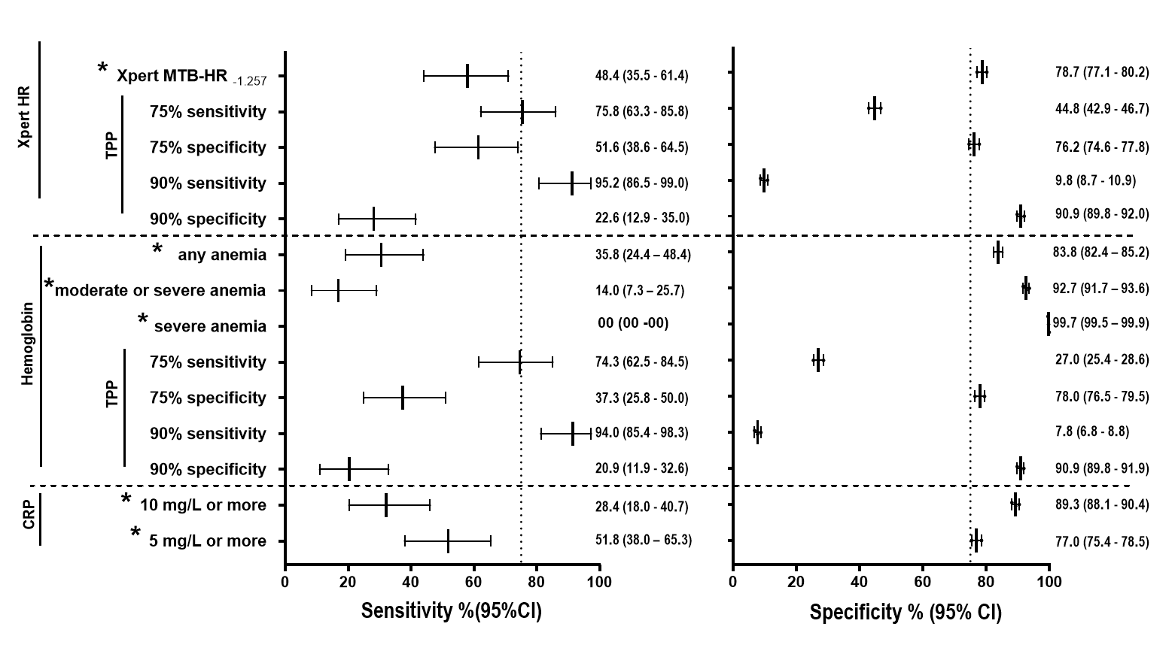
The sensitivity and specificity estimate and the 95% confidence interval for each of the three near point-of-care tests for prediction of incident tuberculosis among the contact cohort participants within 12 months. For all three near point-of-care tests prespecified (*) cutoffs (Xpert MTB-HR_{≤-1.257}, WHO anemia definitions, and C-reactive protein (CRP_{≥10}) or CRP_{≥5} and the WHO Prediction Test Target Product Profile (TPP) thresholds were used. The sensitivity- and specificity-defined threshold were based on the Receiver Operator Characteristics (ROC) curve at either month 0 or month 6. TPP performance thresholds may not have been reached according to the ROC curve, in such cases the nearest performance threshold was chosen. The vertical dotted line indicates the coordinates for the minimal (75%) TPP sensitivity and specificity cutoffs.

Supplementary Table 13. Predictive performance of two-test parallel and sequential algorithms at different cutoffs.

Test A | Test B | TP | FP | FN | TN | sensitivity (95% CI) | specificity (95% CI)
Parallel Algorithms: positive = either test A or test B is positive
Xpert MTB-HR_{≤1.275} | Any anemia | 34 | 1525 | 20 | 3202 | 0.629 (0.487-0.757) | 0.677 (0.664-0.690)
Xpert MTB-HR_{≤1.275} | Moderate-severe anemia | 32 | 1228 | 22 | 3499 | 0.592 (0.450-0.724) | 0.740 (0.727-0.752)
Xpert MTB-HR_{≤1.275} | CRP_{≥10} | 41 | 1933 | 13 | 2794 | 0.759 (0.623-0.865) | 0.591 (0.577-0.605)
Xpert MTB-HR_{≤1.275} | CRP_{≥5} | 38 | 1272 | 16 | 3455 | 0.703 (0.563-0.820) | 0.730 (0.718 -0.743)
Xpert MTB-HR_{≤1.225} | Any anemia | 34 | 1604 | 20 | 3123 | 0.629 (0.487-0.757) | 0.660 (0.647-0.674)
Xpert MTB-HR_{≤1.225} | Moderate-severe anemia | 34 | 1321 | 20 | 3406 | 0.629 (0.487-0.757) | 0.629 (0.707-0.733)
Xpert MTB-HR_{≤1.225} | CRP_{≥10} | 41 | 2000 | 13 | 2727 | 0.759 (0.623-0.865) | 0.576 (0.562-0.590)
Xpert MTB-HR_{≤1.225} | CRP_{≥5} | 38 | 1364 | 16 | 3363 | 0.703 (0.563-0.820) | 0.711 (0.698-0.724)
Any anemia | CRP_{≥10} | 34 | 1924 | 20 | 2803 | 0.629 (0.487-0.757) | 0.593 (0.579-0.606)
Any anemia | CRP_{≥5} | 25 | 1181 | 29 | 3546 | 0.463 (0.326-0.603) | 0.750 (0.737-0.762)
Moderate-severe anemia | CRP_{≥10} | 33 | 1668 | 21 | 3059 | 0.611 (0.468-0.740) | 0.647 (0.633-0.660)
Moderate-severe anemia | CRP_{≥5} | 24 | 840 | 30 | 3887 | 0.444 (0.309-0.585) | 0.822 (0.811-0.833)
Sequential Algorithms: positive = both test A and test B are positive
Xpert MTB-HR_{≤1.275} | Any anemia | 12 | 262 | 42 | 4465 | 0.222 (0.120-0.355) | 0.944 (0.938-0.951)
Xpert MTB-HR_{≤1.275} | Moderate-severe anemia | 8 | 133 | 46 | 4594 | 0.148 (0.066-0.271) | 0.971 (0.967-0.976)
Xpert MTB-HR_{≤1.275} | CRP_{≥10} | 19 | 488 | 35 | 4239 | 0.351 (0.226-0.493) | 0.896 (0.888-0.905)
Xpert MTB-HR_{≤1.275} | CRP_{≥5} | 11 | 246 | 43 | 4481 | 0.203 (0.106-0.335) | 0.948 (0.941-0.954)
Xpert MTB-HR_{≤1.225} | Any anemia | 14 | 294 | 40 | 4433 | 0.259 (0.149-0.396) | 0.937 (0.931-0.944)
Xpert MTB-HR_{≤1.225} | Moderate-severe anemia | 8 | 151 | 46 | 4576 | 0.148 (0.066-0.271) | 0.968 (0.963-0.973)
Xpert MTB-HR_{≤1.225} | CRP_{≥10} | 21 | 532 | 33 | 4195 | 0.388 (0.259-0.531) | 0.887 (0.878-0.896)
Xpert MTB-HR_{≤1.225} | CRP_{≥5} | 13 | 265 | 41 | 4462 | 0.240 (0.134-0.376) | 0.943 (0.937-0.950)
Any anemia | CRP_{≥10} | 10 | 316 | 44 | 4411 | 0.185 (0.092-0.314) | 0.933 (0.926-0.940)
Any anemia | CRP (5mg/L) | 8 | 156 | 46 | 4571 | 0.148 (0.066-0.271) | 0.967 (0.961-0.972)
Moderate-severe anemia | CRP_{≥10} | 5 | 146 | 49 | 4581 | 0.092 (0.030-0.203) | 0.969 (0.964-0.974)
Moderate-severe anemia | CRP_{≥5} | 3 | 71 | 51 | 4656 | 0.055 (0.011-0.153) | 0.985 (0.981-0.988)
Two-test parallel and sequential predictive algorithms performed using different cutoffs or definitions. TP: true positives. FP: false positives. FN: false negatives. TN: true negatives.

 |  | Supplementary Table 14. Standards for Reporting of Diagnostic Accuracy Studies check list
 |  | Section & Topic |  | No |  | Item |  |  | Reported
 |  |  | TITLE OR ABSTRACT
 |  |  |  |  | 1 |  | Identification as a study of diagnostic accuracy using at least one measure of accuracy  (such as sensitivity, specificity, predictive values, or AUROC) |  |  | Yes
 |  |  | ABSTRACT
 |  |  |  |  | 2 |  | Structured summary of study design, methods, results, and conclusions  (for specific guidance, see STARD for Abstracts) |  |  | Yes
 |  |  | INTRODUCTION
 |  |  |  |  | 3 |  | Scientific and clinical background, including the intended use and clinical role of the index test |  |  | Yes
 |  |  |  |  | 4 |  | Study objectives and hypotheses
 |  |  | METHODS
 |  |  | Study design |  | 5 |  | Whether data collection was planned before the index test and reference standard  were performed (prospective study) or after (retrospective study) |  |  | Yes
 |  |  | Participants |  | 6 |  | Eligibility criteria |  |  | Yes
 |  |  |  |  | 7 |  | On what basis potentially eligible participants were identified  (such as symptoms, results from previous tests, inclusion in registry) |  |  | Yes
 |  |  |  |  | 8 |  | Where and when potentially eligible participants were identified (setting, location and dates) |  |  | Yes
 |  |  |  |  | 9 |  | Whether participants formed a consecutive, random or convenience series |  |  | Yes
 |  |  | Test methods |  | 10a |  | Index test, in sufficient detail to allow replication |  |  | Yes
 |  |  |  |  | 10b |  | Reference standard, in sufficient detail to allow replication |  |  | Yes
 |  |  |  |  | 11 |  | Rationale for choosing the reference standard (if alternatives exist) |  |  | NA
 |  |  |  |  | 12a |  | Definition of and rationale for test positivity cut-offs or result categories  of the index test, distinguishing pre-specified from exploratory |  |  | NA
 |  |  |  |  | 12b |  | Definition of and rationale for test positivity cut-offs or result categories  of the reference standard, distinguishing pre-specified from exploratory |  |  | Yes
 |  |  |  |  | 13a |  | Whether clinical information and reference standard results were available  to the performers/readers of the index test |  |  | Yes
 |  |  |  |  | 13b |  | Whether clinical information and index test results were available  to the assessors of the reference standard |  |  | Yes
 |  |  | Analysis |  | 14 |  | Methods for estimating or comparing measures of diagnostic accuracy |  |  | Yes
 |  |  |  |  | 15 |  | How indeterminate index test or reference standard results were handled |  |  | Yes
 |  |  |  |  | 16 |  | How missing data on the index test and reference standard were handled |  |  | Yes
 |  |  |  |  | 17 |  | Any analyses of variability in diagnostic accuracy, distinguishing pre-specified from exploratory |  |  | Yes
 |  |  |  |  | 18 |  | Intended sample size and how it was determined |  |  | No
 |  |  | RESULTS
 |  |  | Participants |  | 19 |  | Flow of participants, using a diagram |  |  | Yes
 |  |  |  |  | 20 |  | Baseline demographic and clinical characteristics of participants |  |  | Yes
 |  |  |  |  | 21a |  | Distribution of severity of disease in those with the target condition |  |  | Yes
 |  |  |  |  | 21b |  | Distribution of alternative diagnoses in those without the target condition |  |  | No
 |  |  |  |  | 22 |  | Time interval and any clinical interventions between index test and reference standard |  |  | Yes
 |  |  | Test results |  | 23 |  | Cross tabulation of the index test results (or their distribution)  by the results of the reference standard |  |  | Yes
 |  |  |  |  | 24 |  | Estimates of diagnostic accuracy and their precision (such as 95% confidence intervals) |  |  | Yes
 |  |  |  |  | 25 |  | Any adverse events from performing the index test or the reference standard |  |  | No
 |  |  | DISCUSSION
 |  |  |  |  | 26 |  | Study limitations, including sources of potential bias, statistical uncertainty, and generalizability |  |  | Yes
 |  |  |  |  | 27 |  | Implications for practice, including the intended use and clinical role of the index test |  |  | Yes
 |  |  | OTHER INFORMATION
 |  |  |  |  | 28 |  | Registration number and name of registry |  |  | Not a clinical trial
 |  |  |  |  | 29 |  | Where the full study protocol can be accessed |  |  | No
 |  |  |  |  | 30 |  | Sources of funding and other support; role of funders |  |  | Yes

References

